Yohannes Zerzghi (P151368)

Managing a Hardware/Software Project for Disaster Recovery¬

Table of Contents
Background 2
Purpose 2
Objectives 2
Scope 3
Deliverables 3
Constraints 3
Assumptions 4
Business case 4
Benefits 4
Roles and Responsibilities 5
Initial Project Plan 6
Assignments 6
Schedule and Gantt chart 6
Resources 6
Project control 7
References 8

1. Background
The Driver and Vehicle Licencing Agency (DVLA) is a Swansea based organization, which hold database records of drivers and vehicle registration of the entire United Kingdom. The DVLA gives a number of online based services to drivers such as, checking vehicle’s information, MOT, driving licences and many other services [1].
However, the online based services can be interrupted or disrupted due to natural disasters, man-made disasters, network and hardware or application failure and so on.
Hence, the Network Disaster Recovery project which aims to create an alternate network which can restore the normal operation of the online services as soon as a disaster took place. The disaster can affect the Local Area Network (LAN), the Wide Area Network (WAN), the Internet access and wireless network services of the DVLA in Swansea.

2. Purpose
The purpose of this project is to create a redundant network in case a network disaster happens.

3. Objectives
The aim of this project is
- Provides an alternate network in the event of a disaster.
- To create a Database Backup copy plan.
- To establish a secure fault tolerance network when a disaster happens.
- To provide an alternate devices of network equipment’s, power supplies and other resources.
- To secure connectivity of networks and continuity of online based services.

4. Scope of the project

4.1 Inside the scope
- The project is concerned only of electronic data.
- The project is concerned only of internet based services.
- To implement a network disaster recovery for the DVLA based in Swansea.
- To provide service and maintenance for the network devices such as servers and end devices.
- To create a cloud server in case of the main and backup server fails for DVLA.

4.2 Outside the scope
- It will not include to Europeans drivers.
- It will not concern any network failure outside of DVLA such as public internet failure or Internet Service Provider (ISP) failure.
- It will not include the printing services for DVLA.

4.3 Deliverables
The output of this project is to provide an alternate network in the event when a disaster happens.
Here are some of the deliverables of this project
- Network design review.
- Documenting the network topology.
- Service report of the network design.
- Technical interpretation of the network infrastructure.
- It will be completed on 27 January 2019.

4.4 Constraints

- Time limit.
- Lack of Voice over IP (VOIP) skill.
- Implementation of security features are limited.
- Networking devices and protocols are confined to cisco property.
- Need of skilled professionals to implement the network design.

4.5 Assumptions
The project assumes the following factors
- Skilled network professionals available.
- Enough equipment and resources availability.
- Enough budget to fund the project.
- Software testing are provided.
- Key project team’s availability.
- Internet access availability.

5.0 Business case

5.1 Project Benefits

- Minimizing online services from being interrupted.
- Customers will be able to gain online services.
- Other organisation will be able to access the database of the DVLA.
- Saves database records of the DVLA.
- Implementing data security.

5.2 Roles and Responsibilities

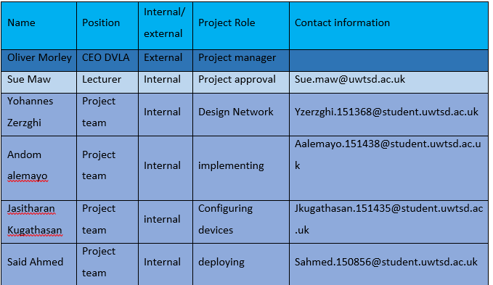

6.0 Initial Project Plan

6.1 Assignments
The key milestones are.
Key milestones | start date | end date
Project plan | Nov-1-2018 | Nov-16-2018
Design network | Nov-19-2018 | Nov-26-2018
Implement network | Dec -1-2018 | Jan-4-2019
System integration test | Jan-5-2019 | Jan-21-2019
Documenting network | Jan-22-2019 | Jan-27-2019

6.2 Schedule and Gantt chart

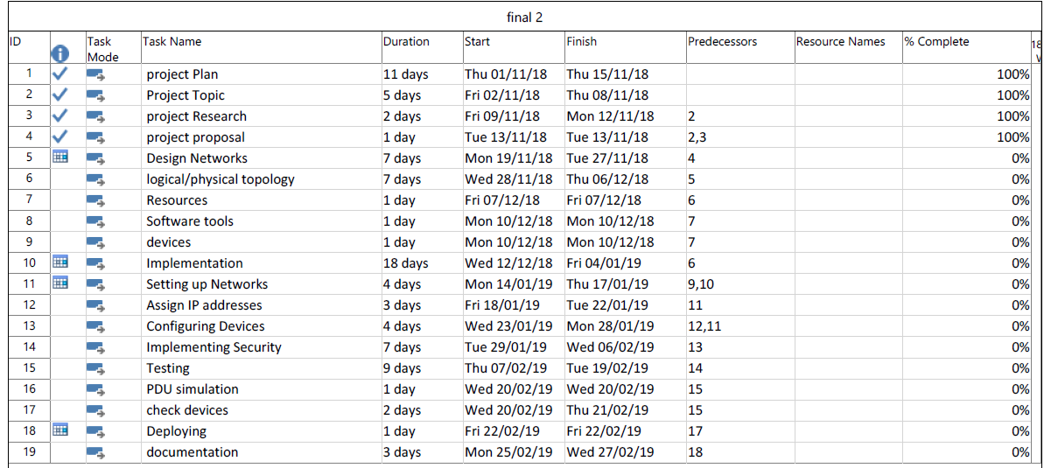

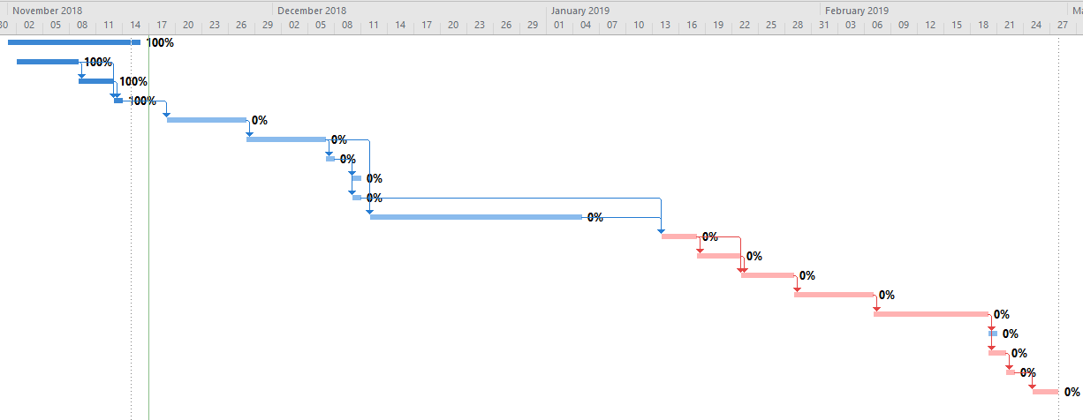

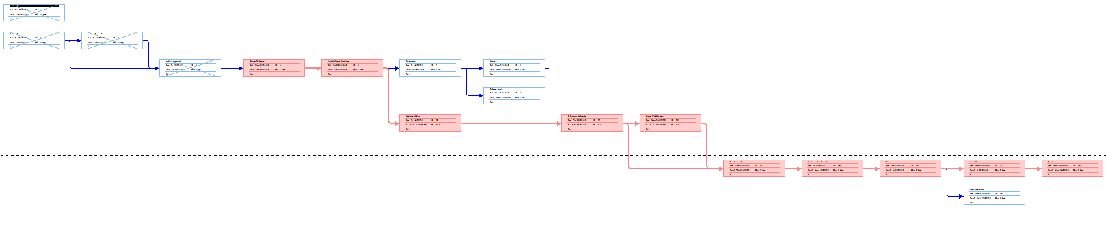

6.3 Resources
The following are needed for this project to be completed.
- Project team members.
- Lecturers and IT staff members of UWTSD.
- Internet access.
- Computers and laptops.
- Application software’s like packet tracer, MS-word, Excel and project 2016.
- Windows operating system.

6.4 Project control
The progress of the keys tasks will be monitored as shown in the diagram below.

References

[1] | G. D. SERVICES, “gov.uk,” the crown court, 1 february 2012. [Online]. Available: https://www.gov.uk/government/organisations/driver-and-vehicle-licensing-agency. [Accessed 10 11 2018].

