

LEVEL 5

Programme: | BA (Hons) Leadership and Management Skills for the Workplace
Module: | Understanding and Engaging Stakeholders
Module code: | LCLM5001
Lecturer: | Aso Abdullah | Student Name & Number: | Zain Mubarik  2424488
Assignment Title: | Understanding the importance of Stakeholder Engagement in successful commencement and completion of project. | Word count: | 4215

Executive Summary
In this report, stakeholder engagement is examined in the case of StaySmart+, a luxurious hotel service by Marriott International, which combines the elements of AI-based guest interaction, personalised travel planning, and sustainability-oriented amenities. With more than 1.5 million rooms in 130 plus countries, Marriott, through its Marriott Bonvoy application and Serve 360 sustainability platform, has enhanced its competitive differences and innovation.
The global launch will entail core internal stakeholders, such as senior management, IT, marketing, project managers, hotel managers, frontline employees, sustainability supervisors, and financial management, and external stakeholders, such as guests, technology suppliers, travel partners, investors, regulators, local communities and suppliers. The stakeholder analysis involved the application of Freeman Stakeholder Theory, Salience Model and the Power Interest Matrix, backed up with the real-life examples of partnerships with technology developers such as Microsoft.
The engagement frameworks applied are the RACI Matrix, communication, and consultation plans, the 4C Model (Communication, Collaboration, Consultation, Commitment) to mitigate possible conflicts and facilitate alignment. The advantages of the critical assessment include enhanced revenue, positive reviews of guests, efficiency of the operation, and sustainability, and it lists such challenges as resistance to change and cultural differences.
Recommendations are based on a global stakeholder structure, constant consultation, digital dashboards, cross-cultural leadership, and ethical governance to keep the legitimacy and trust. The appropriate stakeholder involvement is demonstrated as a key element to successful implementation of innovative hospitality services and guarantees the strategic alignment, competitive advantage, and the sustainability of Marriott in the long term.

Contents
Executive Summary 2
1. Introduction 4
2. Situational Analysis 5
2.1 SWOT Analysis 5
2.2 PESTLE Analysis 6
2.3 SMART Objectives 6
3. Identification and categorisation of key Stakeholders 7
3.1 Internal Stakeholders 7
3.2 External Stakeholders 8
4. Roles, Responsibilities, Benefits, and Challenges 9
4.1 RACI Matrix Application 9
4.2 Benefits Stakeholders Bring 10
4.3 Challenges Stakeholders May Face 11
5. Stakeholder Engagement Frameworks and Models 11
5.1 Power Interest Matrix 11
5.2 Stakeholder Engagement Plan 13
5.3 Communication Plan 13
5.4 RACI Matrix 14
6. Critical Process of Stakeholders Engagement and Conflict Management 14
6.1 Communication 15
6.2 Collaboration 16
6.3 Consultation 16
6.4 Commitment 17
6.5 Conflict Management 17
7. Evolution of Impact on Business Performance 18
7.1 Financial Impact 18
7.2 Brand Impact 19
7.3 Operational Impact 20
7.4 Sustainability Impact 20
Critical Evaluation 21
8. Recommendations for Future Stakeholder Engagement 21
Conclusion 22
References 24

1. Introduction
Marriott international is a global hospitality company with over 8,000 hotels spread across more than 130 countries and a global portfolio of luxury brands that include Ritz-Carlton, Sheraton, Westin, St. Regis, and JW Marriott (Horozhankina et al., 2024). This scale offers good recognition of the brand, operational capacity and reach to a wide range of customers, including business travellers and luxury leisure customers. Significant differentiation based on personalised service and customer loyalty is also a strategic positioning of Marriott supported by the Marriott Bonvoy digital ecosystem that combines reservations, mobile check-in, digital key access, and AI-assisted guest support to improve conveniently and the quality of experience (Correia, 2022). Simultaneously, the Serve 360 sustainability framework aligns the environmental and social priorities with the governance expectations to indicate the growing demands of the stakeholders in the responsible business performance (Neves, 2022).
Theoretically, Service Differentiation Theory justifies why Marriott focused on developing exceptional value by improving guest experience, as well as technology-sensitive service instead of competing on price. Also, Strategic Change Management Theory emphasizes the necessity of organized leadership, discipline of communication, and implementation in the case of introducing innovation to complex global operations, where change should be integrated at all levels and in many properties and cultures (Lewa et al., 2022).
StaySmart+ is a proposed upscale service, an AI-enhanced guest engagement, custom travel planning, and eco-friendly settings, which will be offered via a six-month gradual implementation of a range of hotels worldwide. Resource Dependence Theory (Celtekligil, 2020) in addition to the above argument supports the idea of stakeholder engagement because it describes how an organisation depends on other stakeholders to provide them with essential resources and how an organisation manages these dependencies to minimise uncertainties and save its performance. In the case of StaySmart+, Marriott relies on technology partners to provide AI services, capital investors to offer confidence in their funds, suppliers to provide sustainable input, and regulators to provide legal approval of data privacy and operational standards. Indeed, the key is to engage effectively to get resources, legitimacy and success of the project in the long run.

2. Situational Analysis
The situational analysis will be necessary to assess the external environment and internal capabilities of Marriott International before the establishment of StaySmart+. SWOT and PESTLE analysis offers systematic strategic thinking to aid in making decision.

2.1 SWOT Analysis

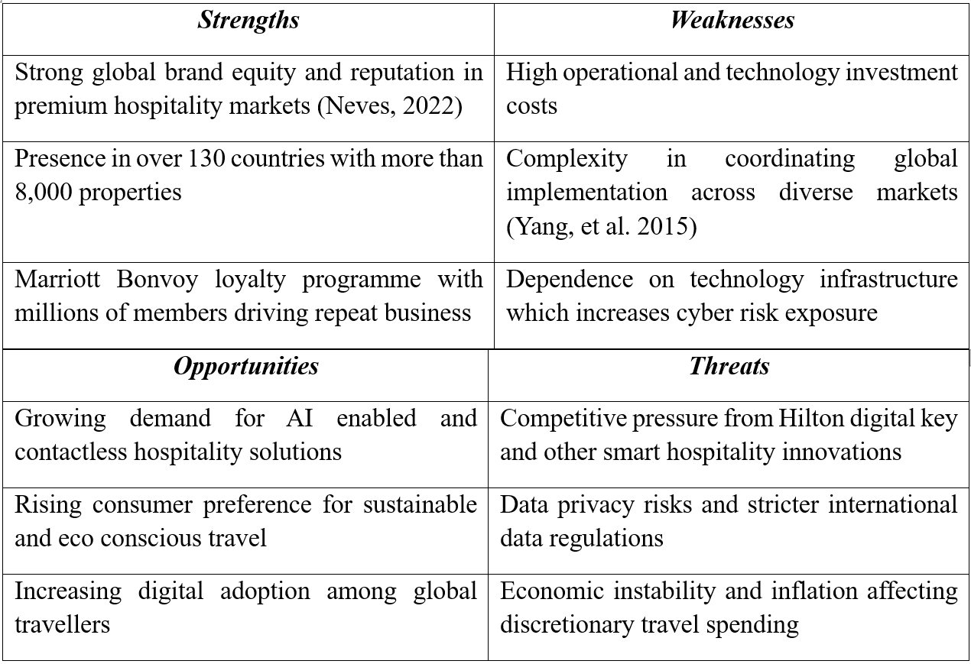
As evidenced by the SWOT analysis, a strong brand equity and digital capabilities of Marriott are a good foundation of the StaySmart+. Nonetheless, the complexity of implementation and the cost of technology should be handled in a strategic manner in order to reduce risks.

2.2 PESTLE Analysis
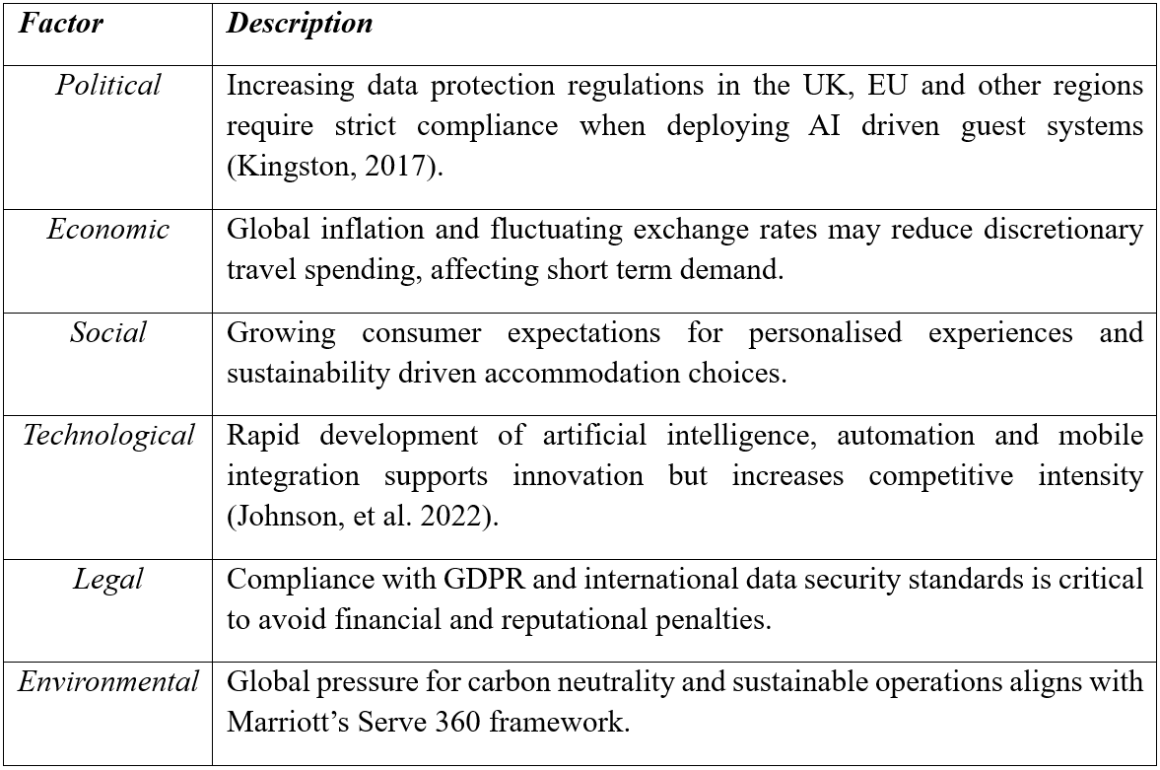
According to the PESTEL analysis, technological and environmental forces are also major strategic opportunities, and legal and economical forces should be closely monitored.

2.3 SMART Objectives
As per the Strategic Management Theory, the objectives of StaySmart+ should be specific, measurable and strategically oriented to corporate objectives. Some of the objectives are to ensure that the rating of guest satisfaction improves by 15 percent in 12 months of the launch, the adoption rate of AI tools amounts to 25 percent in six months, and energy consumption in pilot hotels decreases by 10 percent. These quantifiable results guarantee the strategic consistency in terms of innovation investment, stakeholder engagement and long-term competitive performance.

3. Identification and categorisation of key Stakeholders
The application of StaySmart+ needs to be delivered effectively by planning the identification and prioritisation of stakeholders. The primary theory is the Stakeholder Theory of Freeman who holds that organisations should generate value to all individuals that can influence or are influenced by organisational goals (Phillips, et al. 2019). Stakeholder management is essential in the case of the Marriott International because of its global operations with its complexity and brand image.

3.1 Internal Stakeholders
StaySmart+ involves planning and implementation that involve internal stakeholders directly. These are the top-level management, project manager, IT team, marketing team, hotel managers, front line team, sustainability officers and finance department.
The senior leadership has high power and legitimacy since they are strategic decision makers who have responsibilities to approve budgets and initiate directions on innovation (Cortes, & Herrmann, 2021). The project manager will do cross departmental coordination and implementation. The IT department plays the central role when it comes to integrating the AI driven guest tools, and marketing plays the strategic positioning of StaySmart+ in competitive markets. The frontline staff and hotel managers will have a critical operational role in the improved guest experience. The sustainability officers make the initiative consistent with the Serve 360 framework and the finance checks the investment performance and investment-capital performance.
Based on the Stakeholder Salience Model, the top management and the project manager are powerful, legitimate, and urgent, which makes them conclusive stakeholders (Mitchell, et al. 2017). Frontline staff possess legitimacy, urgency but relatively lesser power and thus they fall under the dependent stakeholders whose support is important to success of services.

3.2 External Stakeholders
The external stakeholders are guests, technology vendors, travel partners, investors, regulators, local communities and suppliers. Guests are the main stakeholders since their adoption is the measure of commercial success. The technology companies like Microsoft with whom Marriott has partnered in cloud and digital transformation projects are key partners that offer technical expertise (Appa, & Girija, 2025). Investors are the ones who divert the strategies, by provision of capital, and regulators, by keeping them within the check, especially the GDPR and data protection laws. Operational sustainability and brand legitimacy is supported by local communities and suppliers.
Using a Power Interest Matrix taxonomy, the senior leadership, investors and regulators are in the high power high interest category (Maqbool, et al. 2022). Technical dependence also makes the power of IT vendors high. Frontline staff and guests are of high interest and power, but of relatively lower power as individuals but as a group influential at the same time. Some of the suppliers may be in a lower power lower interest quadrant and this is where the local communities will need to be monitored in order to safeguard corporate reputation.
Using the criteria of internal versus external, primary versus secondary, and evaluating the power, legitimacy and urgency attributes, the Marriott can prioritize the engagement strategies to fulfill the purpose of the global implementation of StaySmart+.
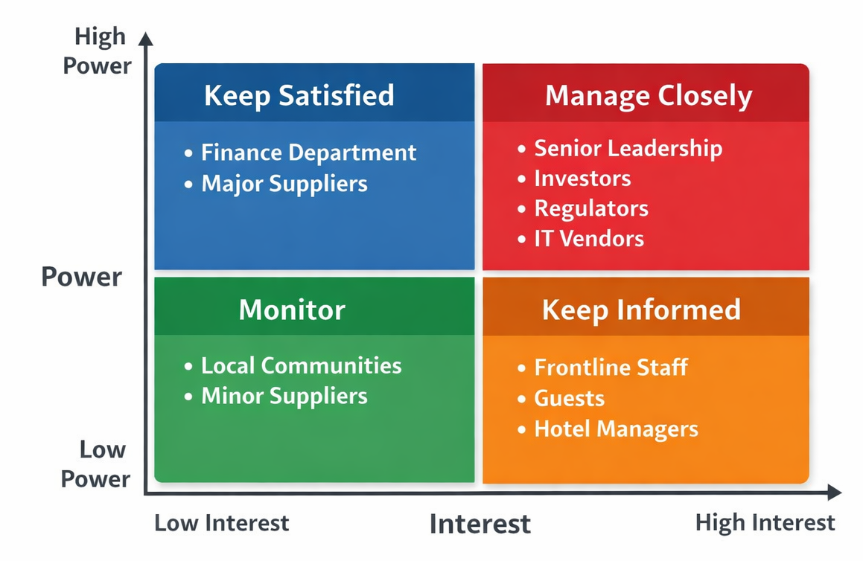
Figure 1: Stakeholder Map

4. Roles, Responsibilities, Benefits, and Challenges
StaySmart+ implementation needs responsibilities and coordination of stakeholders. The RACI matrix is clear and direct as it assigns the responsibility, accountability, consulting, and information to significant project actions (O'Connor, & Mock, 2020). This is in line with Change Management Theory that underlines role clarity, leadership commitment and communication to minimise uncertainty and resistance in the process of transformation.

4.1 RACI Matrix Application
Stakeholder | Responsible | Accountable | Consulted | Informed
Senior Leadership |  | ✔ Strategy, budget approval | ✔ | ✔
Project Manager | ✔ Overall project delivery |  | ✔ | ✔
IT Department | ✔ AI integration, system security |  | ✔ | ✔
Marketing Team | ✔ Brand positioning, promotion |  | ✔ | ✔
Hotel Managers | ✔ Local implementation |  | ✔ | ✔
Guests |  |  | ✔ Feedback, testing | ✔ Updates
Finance Department | ✔ Budget monitoring |  | ✔ | ✔

The accountability of Senior Leadership lies in the fact that they are highly powerful and legit in the Mitchell Stakeholder Salience Model. The IT Department and the Project Manager will be operational delivery (especially AI implementation and cybersecurity compliance). The distinction will be achieved through the differentiation which is guaranteed by the marketing in accordance with the Service Differentiation Theory, and Hotel Managers will adopt the changes on the property level. Customer centric innovation is achieved by consulting the guests via surveys and app analytics.

4.2 Benefits Stakeholders Bring
Strategic and operational value is provided by the stakeholders. The Senior Leadership presents vision and allocation of resources, which makes it competitive. The IT Department increases the innovation capacity through using AI applications and digital systems. With specific campaigns, marketing enhances the brand positioning and contributes to revenue increase. Hotel Managers maintain the consistency of quality of services offered in the different locations strengthening brand loyalty. Visitors provide useful data information, which optimizes the use of personalisation and sustainability. Financial stability and long-term growth is assisted by investors as it increases the flexibility of strategies.

4.3 Challenges Stakeholders May Face
Although it has advantages, there are several challenges. Frontline employees and managers are often resistant to change, especially when AI tools change their work processes. According to Change Management Theory, the lack of commitment may be decreased by the uncertainty and the evaluation of job insecurity, unless it is managed with training and communication (AlManei, et al. 2018).
Cultural obstacles can occur in the international activities of Marriott, which influence the rate of adoption. The risks associated with the technology integration are system incompatibility and operational disruption. AI induced personalisation and the need to comply with the GDPR make cybersecurity threats and data privacy concerns critical (Mbah, & Evelyn, 2024).
The Salience Model helps in ranking the highly power, legitimate and urgent stakeholders, including regulators and senior management, to ensure risk mitigation and compliance stays at the centre of focus (Krasovskaya, & MacInnes, 2019). StaySmart+ can be made to experience a sustainable implementation by harmonizing the roles of stakeholders, responding ahead of time and keeping governance control in order.

5. Stakeholder Engagement Frameworks and Models
Stakeholder engagement is a key to the success with the delivery of StaySmart+. Here, the Power Interest Matrix, RACI Matrix, Freeman Stakeholder Theory, Relationship Marketing Theory and Ashcroft Relational Lens are used to organize the engagement in a strategic and operational manner.

5.1 Power Interest Matrix
The Power Interests Matrix divides the stakeholders according to their effect of power (improvement) and their level of involvement or care (interest) in a project. This framework assists organisations to focus on the engagement strategies with various stakeholder groups. As Freeman has pointed out in his Stakeholder Theory, organisations have to deal with the stakeholders who are capable of shaping the organisational goals since their backing determines the long-term performance (Jones et al., 2017). This concept can also be developed by using the Resource Dependence Theory (Celtekligil, 2020) where organisations depend on external actors who have a grip on important resources like finance, technology, legitimacy and regulatory approval. This leaves the stakeholders that dominate these resources with a higher influence on the outcomes of the project and the stability of the organisations.
At the StaySmart+ project, the senior leadership, investors, regulators and IT vendors possess high power since they make strategic decisions, fund, regulatory approval and technological capability. Their impact renders them crucial to the implementation of a project and hence they have to be effectively controlled. In the meantime, the frontline workers, hotel managers and guests have high interest as they can feel the operational effect of the service and can determine the quality and adoption of the service.
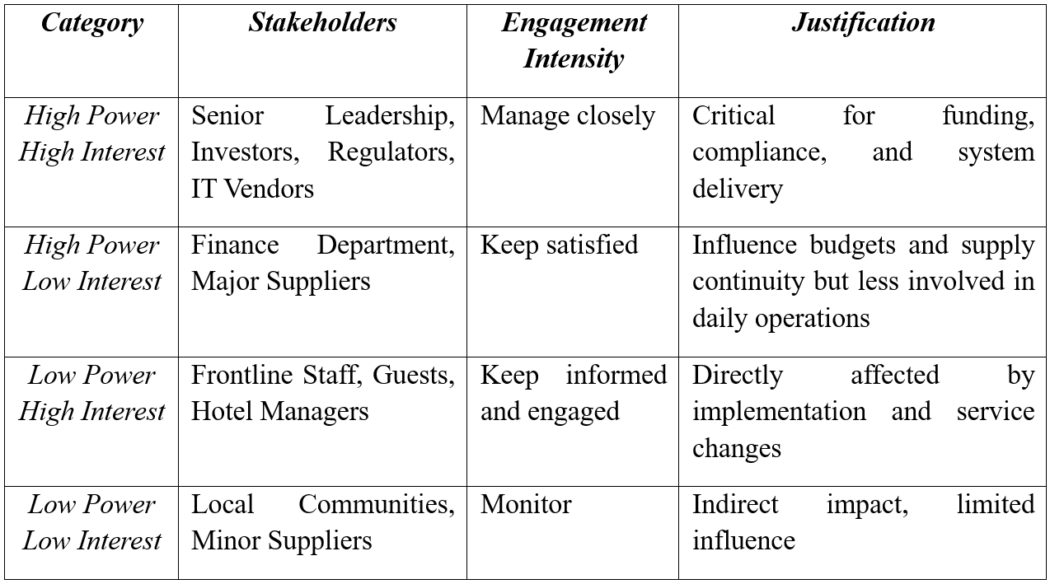

5.2 Stakeholder Engagement Plan
A systematic approach to stakeholder engagement plan would guarantee congruency, coordination of resources and communication. The Stakeholder Theory focuses on the balanced relations between organisations and stakeholder, whereas the Resource Dependence Theory focuses on the necessity to balance relations with actors possessing the access to the key resources.
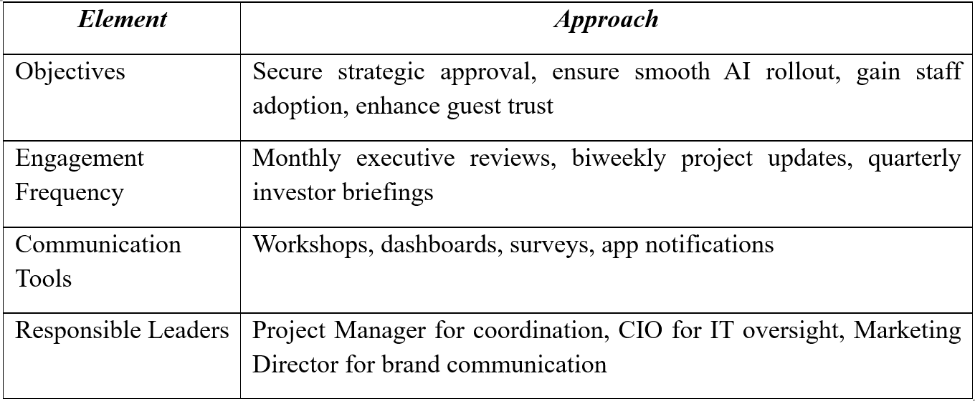
The Ashcroft Relational Lens is keen to point out that engagement must not be directed to pure exchange of information but rather aim to develop trust and cooperation and mutual understanding, developing long-term relationships with stakeholders and facilitating the effective implementation of StaySmart+.

5.3 Communication Plan
The communication channels should be based on the needs of the stakeholders and geographical diversity.
- Workshops for IT teams and hotel managers to support technical integration
- Leadership town halls to reinforce strategic vision
- Digital dashboards for real time performance tracking
- Email briefings for structured updates
- Cross cultural virtual meetings for global coordination
Relationship Marketing Theory emphasizes on trust, commitment and long term value creation. Open communication also improves the loyalty of the guests and commitment to the work among employees, and this strengthens Marriott competitiveness.

5.4 RACI Matrix
The RACI model enables operational transparency and assigns responsibility and accountability between departments (McGrath, & Whitty, 2018). Well defined governance processes minimize repetitions, confusion and hastens decision making.
Another similar case is the deployment of digital key by Hilton which involved effective executive sponsorship, IT integration and front office involvement. On the same note, StaySmart+ relies on the ability of a coordinated stakeholder alignment to attain strategic and operational success.

6. Critical Process of Stakeholders Engagement and Conflict Management
The effective implementation of StaySmart+ is achievable through a systematic involvement of the stakeholders within the project lifecycle. The 4C Model of Communication, Collaboration, Consultation, and Commitment is an effective model that can be used to organize the interaction of stakeholders, align them, and reduce resistance and promote shared ownership (Do, et al. 2023). Simultaneously, the management of conflicts should be an efficient way to balance the competing priorities, cultural differences, and operational constraints.
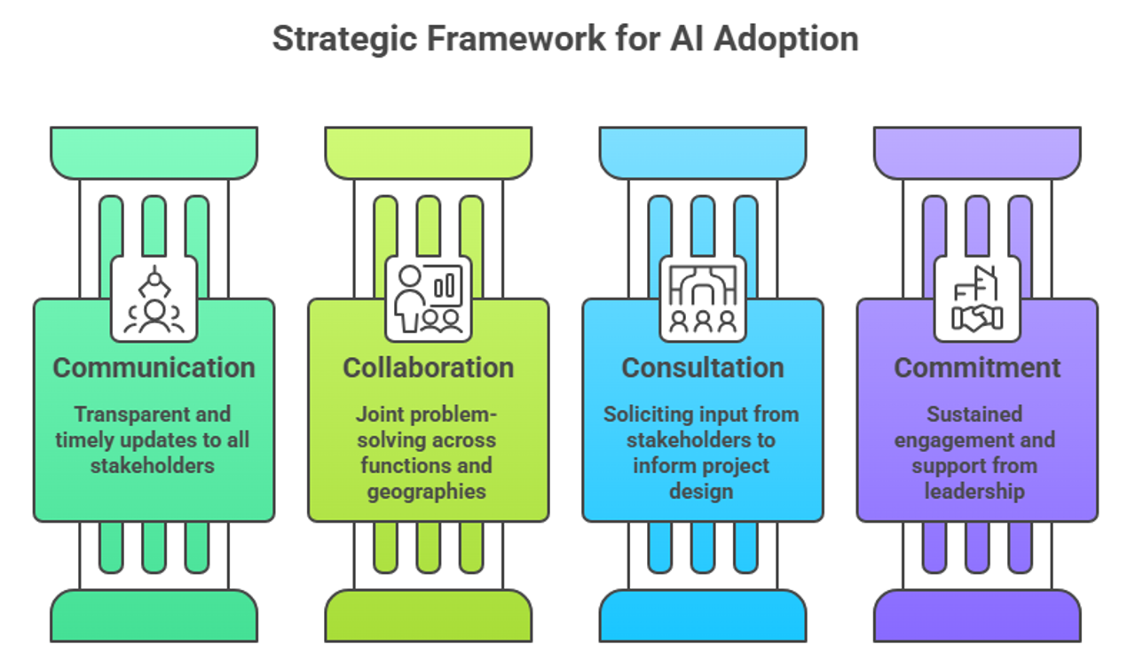
Figure 2: Strategic Framework For AI Adoption

6.1 Communication
Clear, punctual and culture appropriate communication plays a significant role during the involvement of internal and external stakeholders. The top management, project teams and frontline personnel must be regularly updated on the project goals, progress and expectations. Two-way communication makes certain that feedback loops are in place, where stakeholders can voice concerns, inquire and give solutions. As an illustration, the pilot testing of the Bonvoy app provides guests at Marriott with a chance to comment on the AI-based check-in experiences, which will form a data-driven conversation.
Most importantly, lack of effective communication may create a sense of uncertainty, resistance and low adoption. The Change Management Theory identifies ambiguity in project objectives and lack of information as the root causes of creating bad perceptions among employees, which consequently may result in disengagement (Sims, 2025). On a similar note, the Stakeholder Theory proposed by Freeman supports the necessity to balance the informational flow to all the parties that can either influence or be influenced by the project.

6.2 Collaboration
Collaboration entails coordination and problem-solving among the stakeholders both at the functional and geographical levels. Under the StaySmart+ project, IT, marketing and hotel operations team works together to harmonize the system requirements, the expectations of guests and its operations. The Strategic Alliance Theory is evident in partnerships with external technology providers, in this case Microsoft, where organisations join forces in order to gain a specialised knowledge and technological skills that improve the level of innovation and service quality. The possible risks of the AI system disruptions or the challenges of adopting a guest may be revealed through collaborative involvement and solved as a community.
Working together may, however, present difficulties as well. Having numerous stakeholders can delay decision making especially where roles are not defined. Different departments might have a different priority and power imbalance can enable senior stakeholders to exercise a domineering role. Formal governance techniques like RACI matrix thus aid in defining roles and ensuring that there is good cooperation.

6.3 Consultation
Consultation is a process in which stakeholders’ input is sought when designing and implementing the project. Employee workshops, pilot testing, guest surveys, stakeholder forums are some of the methods used in assisting organisations to bring on board operational insight and customer expectations in the decision-making process. As an illustration, by implementing a pilot of AI-based concierge services in a few hotels, frontline workers and guests can leave feedback that can be used to enhance the usability of the system, as well as its acceptance by the services (Gupta and Pareek, 2024). This exercise is in line with the Relationship Marketing Theory which focuses on trust, transparency and long-term relationships with stakeholders.
Nonetheless, consultation might also be problematic. Stakeholder engagement as a continuous process may result in stakeholder fatigue especially among the employees who must balance between work and work. Various views can also lead to procrastination of decision and tokenistic consultation can lead to lack of trust. As such consultation must be well organized so that the feedback is not futile and embedded in the decisions of the project.

6.4 Commitment
The term commitment is used to mean partnership of the leadership and stakeholders during the course of project implementation. Leadership sponsorship, training programmes and performance incentives make visible, confidence towards change in organisations. The Change Management Theory states that employees tend to embrace new practices more than others when they know the reason why change is necessary and realise that change will benefit them. The training of the frontline employees and the hotel managers to operate the AI-based systems thus enhance the operational competence and facilitates successful implementation of the StaySmart+.
Nonetheless, the level of commitment can differ among the stakeholders. Power inequality can also lead to less motivation and participation when the decisions are made by senior stakeholders, whereas the operational employees do not seem to be considered. There is also need of constant communication and resources to keep the promise. In the absence of the participative methods and the support of the leadership, the motivation of the stakeholders can decrease, lower the rates of adoption and raise operational risks.

6.5 Conflict Management
The engagement of stakeholders is always faced with a conflict of priority, cost, or cultural differences in the region. The implementation of the Thomas Kilmann Conflict Model makes it possible to respond to conflicts in a specific way:
- Competing: Applied in cases where strict compliance or regulatory policies need to be applied, e.g. GDPR compliance over the convenience of operation.
- Collaborating: Applied in cross-functional problem solving between IT and hotel operations to optimize AI system implementation.
- Compromising: Balances include sustainability goals and cost constraints within various markets.
- Avoiding: Acceptable for minor conflicts with low power/low interest stakeholders to maintain focus on strategic priorities.
- Accommodating: Useful in cases where maintaining guest satisfaction outweighs minor internal disputes (Trippe, & Baumoel, 2015).
More importantly, in global hospitality, stakeholder theory is limited. Cultural differences, operational variations, and legal systems bring in the issue of a one size fits all approach. Although the theory offers an idea of prioritizing the stakeholders, the real-life management needs flexibility, local knowledge and sensitivity.

7. Evolution of Impact on Business Performance

7.1 Financial Impact
Successful interaction with stakeholders has a positive influence on the financial performance and helps to enhance the efficiency of operations and quality of services. By involving employees, technology partners and managers in the implementation of StaySmart+, there will be a higher chance of them endorsing the introduction of AI-enabled tools and operational processes. Enhanced employee engagement will result in increased service delivery, quicker check-in procedures and more personalised guest experience. Such service enhancements make guests happier and ready to make repeat reservations, which eventually leads to better occupancy rates and better Revenue per Available Room (RevPAR).
In addition, the partnership with the technology vendors and strategic partners minimizes risks associated with the integration of systems and provides reliable digital infrastructure. Consultancy and training early will reduce operational breakage and resistance to change minimising downtime and implementation costs. The Resource Dependence Theory states that organisations need to have good relations with the stakeholders that possess the necessary resources that are crucial like the technology, capital and expertise (Pfeffer and Salancik, 1978). Thus, high stakeholder engagement contributes to Marriott maximising its resources, managing operation costs and long-term financial performance.

7.2 Brand Impact
The involvement of the stakeholders strengthens the brand equity and customer approval. Regular consultation and feedback cycles will make sure that StaySmart+ matches or surpasses the expectations of the guests meaning Net Promoter Scores (NPS) and the overall satisfaction. The Relationship Marketing Theory focuses on the fact that trust, transparency, and responsiveness enhance long-term relational value, which promotes repeat business and positive reviews (Alshurideh, et al. 2016).
Proper working relationships with the internal teams will make sure that brand messages are consistent across touchpoints that will maintain the premium hospitality experience. The aspect of engagement also dilutes the risk of reputational risk in that proactive approach to operational problems is essential to global brands such as Marriott competing in the space of AI-driven services against Hilton and Accor.

7.3 Operational Impact
The other way in which stakeholder engagement enhances organisational performance is through better operational coordination and reliability in services. Good governance structures like the RACI matrix and the effective communication channel will help departments to organize their responsibilities and eliminate confusion when it comes to implementation. When the frontline employees are involved in decision making, the hotel managers and IT teams can be able to figure out the operational problems early and ensure that they do not interfere with service delivery.
The involvement of employees is also a factor that determines the success of the operations. As soon as staff are informed, consulted and supported by training, their commitment towards organisational change will be enhanced. The increased employee engagement leads to better service quality, less operational mistakes and consistency within the hotel properties (Shin et al., 2019). With the improvement of the quality of the provided services, the satisfaction of the guests rises, which contributes to positive reviews and repeat-booking. This cause and effect relationship illustrates that the effectiveness of stakeholder engagement enhances the efficiency in operations and leads to the overall organisational performance.

7.4 Sustainability Impact
StaySmart+ will combine sustainability-oriented facilities, which will be backed by the Serve 360 programs. During this engagement, sustainability officers, suppliers, and hotel managers are involved, so the targets will be achieved in energy consumption, waste, and carbon footprint reduction. ESG reporting and compliance are assisted by regular communication and cooperation with internal and external stakeholders, which place Marriott in the niche of environmentally conscious travellers.
The sustainability integrated into the organization with the commitment of stakeholders at a strategic level creates differentiation in competition and also incorporates in a long-term organizational objective, balancing the economic performance of the organization with the social and environmental responsibility.

Critical Evaluation
Although it has its benefits, stakeholder engagement also has a number of constraints that should be handled with care. The massive consultation procedures can also add to operational expenses in the short term and lead to stakeholder burnout, especially when the employees and partners are constantly asked to take part in the engagement process. Moreover, with many stakeholders involved, the decision-making process will be sluggish and where various groups of stakeholders have conflicting priorities or strategic interests.
The engagement results may also be affected by power imbalances. Decision-making by the senior leadership, investors or technology partners who are the high-power stakeholders, may overshadow the frontline employees whose operational knowledge is useful. These imbalances can lead to decreased effectiveness of stakeholder engagement without organized form of governance and mechanisms of communication.

8. Recommendations for Future Stakeholder Engagement
According to the critical analysis of the StaySmart+, there are several actionable recommendations that have been provided to improve stakeholder engagement in the global operations of Marriott. To begin with, the structured global stakeholder engagement framework based on the Stakeholder Theory proposed by Freeman should be put in place to identify, prioritise, and manage stakeholders in a systematic manner following their power, legitimacy, and urgency (Miles, 2017). This framework ought to be combined with mechanisms of constant mapping and analysis of salience to make sure that it is aligned with changing project and organisational goals.
Two, the 4C Model Communication, Collaboration, Consultation, and Commitment of the arrangement should be operationalised among all the properties (Jimenez, et al. 2021). Constant, culturally translated communication channels, periodic consultations with frontline employees and guests, and working with technology suppliers will provide regular feedback to involve it in the continuous improvement of services. It is important that leadership commitment is visible and supported with training programs, incentives, and mentorship to maintain the commitment in the long run.
Third, the digital stakeholder dashboard must be implemented to present transparency, monitor the engagement activities, and assess the performance in relation to KPIs, including the rates of AI adoption, visitor satisfaction, and sustainability indicators. This complies with Relationship Marketing Theory, which guarantees trust, responsibilities and long-term relational value to internal and external stakeholders.
Lastly, the cross-cultural leadership development programmes should be implemented to allow managers to learn how to operate within different cultural norms, regulatory settings and operations (Mahmoud, et al. 2024). This will be beneficial in collaboration, lowering resistance, and increasing the satisfaction of stakeholders in international markets.

Conclusion
Marriott, the stakeholder engagement is a strategic factor in the effectiveness of the Success of the StaySmart+ program, which triggers adoption, operational efficiency, brand loyalty, and sustainability effects. The consideration of the Stakeholder Theory by Freeman and the systematic theory like the Power Interest Matrix, RACI Matrix and the 4C Model make sure that the internal and external stakeholders are controlled and aligned with the organisational goals.
Critical analysis proves that open communication, consultation at an early stage, and visible leadership commitment help reduce resistance, allow development of a project smoothly, and create relational value over the long term. The use of the Thomas Kilmann Model of conflict management will enable balancing of rival priorities without impacting upon project goals, whereas the structured interaction will provide quantifiable results in the form of increased guest satisfaction, revenue increase, and elevated ESG performance.
The proposed recommendations that include the continuity of consultations, digital dashboards, cross-cultural leadership, and ethical governance will be future-oriented and improve relationships with stakeholders and entrench engagement as a strategic strength. Through structured stakeholder management, Marriott will be able to maintain a competitive differentiation, increase innovation adoption, and have long-term business resilience.

References
AlManei, M., Salonitis, K., & Tsinopoulos, C. (2018). A conceptual lean implementation framework based on change management theory. Procedia cirp, 72, 1160-1165.
Alshurideh, M., Al Kurdi, B. H., Vij, A., Obiedat, Z., & Naser, A. (2016). Marketing ethics and relationship marketing-An empirical study that measure the effect of ethics practices application on maintaining relationships with customers. International Business Research, 9(9), 78-90.
Celtekligil, K. (2020). Resource dependence theory. In Strategic outlook for innovative work behaviours: Interdisciplinary and multidimensional perspectives (pp. 131-148). Cham: Springer International Publishing.
Appa, M. P. M., & Girija, P. (2025). Technological Evolution and Digital Transformation. Transforming the Service Sector With New Technology, 73.
Correia, H. F. P. R. N. (2022). Marriott International Inc Equity Research-Consolidating a Leading Position Amid Recovery (Master's thesis, Universidade NOVA de Lisboa (Portugal)).
Cortes, A. F., & Herrmann, P. (2021). Strategic leadership of innovation: a framework for future research. International Journal of Management Reviews, 23(2), 224-243.
Do, V., Maniate, J. M., Sultan, N., & Sonnenberg, L. (2023). The 4C’s of influence framework: fostering leadership development through character, competence, connection and culture. Leadership in Health Services, 36(4), 461-478.
Gupta, P., & Pareek, R. (2024). AI-Enabled Guest Experience: Disrupting Hospitality Through Next-Generation AI Technologies. In Technology and Luxury Hospitality (pp. 165-181). Routledge.
Horozhankina, N., Korneyev, M., & Farzullaev, R. (2024). Marriott International’s place in international hotel chains.
Jimenez, G., Matchar, D., Koh, G. C. H., Tyagi, S., van der Kleij, R. M., Chavannes, N. H., & Car, J. (2021). Revisiting the four core functions (4Cs) of primary care: operational definitions and complexities. Primary Health Care Research & Development, 22, e68.
Johnson, P. C., Laurell, C., Ots, M., & Sandström, C. (2022). Digital innovation and the effects of artificial intelligence on firms’ research and development–automation or augmentation, exploration or exploitation?. Technological Forecasting and Social Change, 179, 121636.
Jones, T. M., Wicks, A. C., & Freeman, R. E. (2017). Stakeholder theory: The state of the art. The Blackwell guide to business ethics, 17-37.
Kingston, J. (2017). Using artificial intelligence to support compliance with the general data protection regulation. Artificial Intelligence and Law, 25(4), 429-443.
Krasovskaya, S., & MacInnes, W. J. (2019). Salience models: A computational cognitive neuroscience review. Vision, 3(4), 56.
Lewa, P. M., Mburu, M. M., & Murigi, R. M. M. (2022). Transformational leadership and change management in dynamic contexts. In Leading with diversity, equity and inclusion: Approaches, practices and cases for integral leadership strategy (pp. 47-65). Cham: Springer International Publishing.
Mahmoud, R. S., Kamil, S. A., Mohammed, M., & Madhi, Z. J. (2024). Cross-cultural leadership approaches for managing diverse workforces globally. Journal of Ecohumanism, 3(5), 682-699.
Maqbool, R., Rashid, Y., & Ashfaq, S. (2022). Renewable energy project success: Internal versus external stakeholders' satisfaction and influences of power‐interest matrix. Sustainable Development, 30(6), 1542-1561.
Mbah, G. O., & Evelyn, A. N. (2024). AI-powered cybersecurity: Strategic approaches to mitigate risk and safeguard data privacy. World Journal of Advanced Research and Reviews, 24, 310-327.
McGrath, S. K., & Whitty, S. J. (2018). Accountability and responsibility defined. International Journal of Managing Projects in Business, 11(3), 687-707.
Miles, S. (2017). Stakeholder theory classification: A theoretical and empirical evaluation of definitions. Journal of business ethics, 142(3), 437-459.
Mitchell, R. K., Lee, J. H., & Agle, B. R. (2017). Stakeholder prioritization work: The role of stakeholder salience in stakeholder research. In Stakeholder management (pp. 123-157). Emerald Publishing Limited.
Neves, D. D. (2022). Marriott International Inc. Equity Research-the Hotel Giant´ s Recovery (Master's thesis, Universidade NOVA de Lisboa (Portugal)).
Neves, D. D. (2022). Marriott International Inc. Equity Research-the Hotel Giant´ s Recovery (Master's thesis, Universidade NOVA de Lisboa (Portugal)).
O'Connor, J. T., & Mock, B. (2020). Responsibilities and accountabilities for industrial facility commissioning and startup activities. Construction Innovation, 20(4), 625-645.
Phillips, R. A., Barney, J. B., Freeman, R. E., & Harrison, J. S. (2019). Stakeholder theory.
Salunke, N. (2024). Cost Optimization in Supply Chain Management Leveraging Vendor Development and Sourcing Strategies. Journal of Business and Management Studies, 6(5), 225-237.
Shin, H., Perdue, R. R., & Kang, J. (2019). Front desk technology innovation in hotels: A managerial perspective. Tourism Management, 74, 310-318.
Sims, W. (2025). Improving Employee Engagement Through Effective Change Management (Doctoral dissertation, Walden University).
Trippe, B., & Baumoel, D. (2015). Beyond the Thomas–Kilmann model: Into extreme conflict. Negotiation Journal, 31(2), 89-103.
Yang, Q., Kherbachi, S., Hong, Y. S., & Shan, C. (2015). Identifying and managing coordination complexity in global product development project. International Journal of Project Management, 33(7), 1464-1475.

