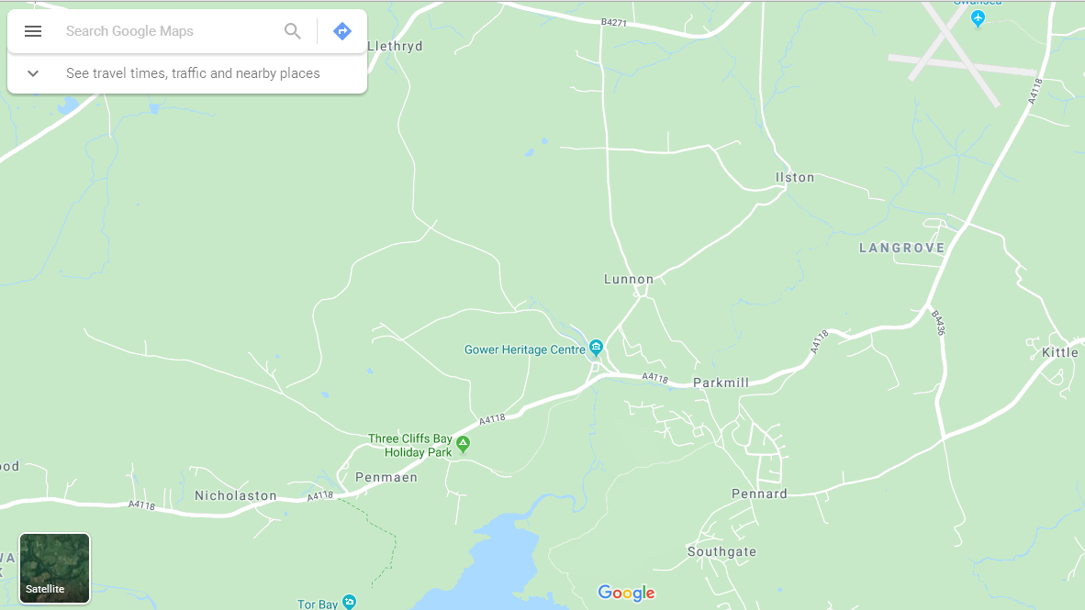
1 = ____________________
2 = ____________________
3 = ____________________
4 = ____________________
5 = ____________________
6 = ____________________

