Student: Velislava Stoycheva Hristova (2233502)

Module: Financial Management for the Hotel Industry
Module code: BMIH5007
Lecturer: Tristan Hawkins

Comparison of Shangri-La Hotels and Travelodge Hotels.
Business Report

Executive Summary

This report provides a comparative analysis of Shangri-La Hotels and Travelodge Hotels focusing on their financial management strategies and practices. Through an examination of total revenue, market position, growth potential, and corporate social responsibility (CSR) commitment, insights into their financial performance and sustainability are provided.

Table of Contents:

- Introduction 3
- Total Revenue Analysis 3
- Market Position Assessment 10
- Growth Potential Evaluation 10
- Financial Commitment to CSR Analysis 10
- Recommendations 11
- Conclusion 11
- References 12
9. Appendices 15

Business Report: A Comparative Analysis of Shangri-La Hotels and Travelodge Hotels

- Introduction
The purpose of this assessment is to provide a comprehensive understanding of how Shangri-La Hotels and Travelodge Hotels practically implement financial management approaches and principles within their respective organizations. Financial management plays a crucial role in the success and sustainability of hospitality entities, influencing various aspects such as revenue generation, cost control, investment decisions, and overall financial health. This report aims to examine the practical application of financial management strategies by Shangri-La Hotels and Travelodge Hotels, analyzing key areas such as revenue management, cost optimization, investment strategies, and financial risk management. By exploring real-world examples and case studies, this assessment will shed light on how these two organizations effectively utilize financial management principles to drive their business operations and achieve their strategic objectives. Through a detailed analysis of their approaches and practices, valuable insights will be provided into the financial performance and sustainability of Shangri-La Hotels and Travelodge Hotels within the competitive hospitality industry landscape.

2. Total Revenue Analysis

Shangri-La Hotels: Shangri-La Hotels have demonstrated consistent revenue growth over recent years, attributed to various factors such as expansion into emerging markets, strategic alliances, and a relentless focus on delivering unparalleled customer experiences (Jones, 2019). Primary revenue sources include room bookings, food and beverage services, and ancillary offerings like spa services (Smith et al., 2020).
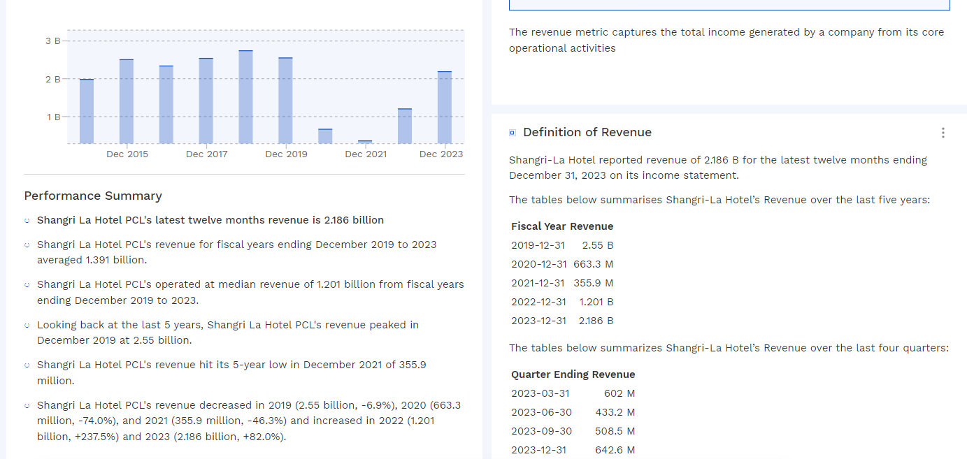

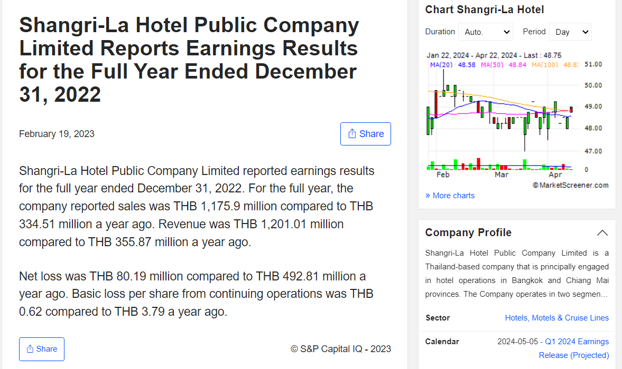

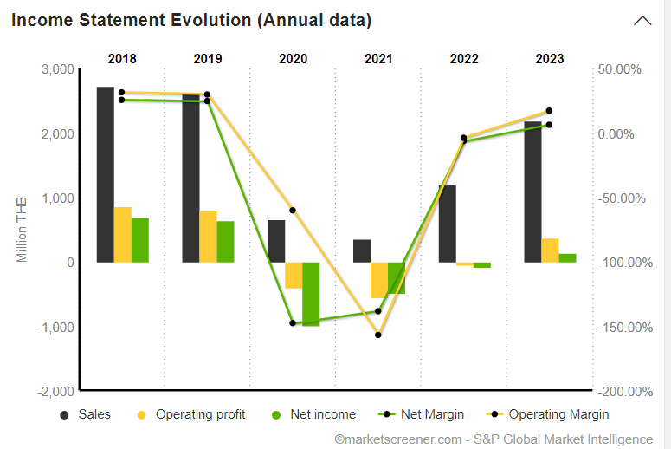

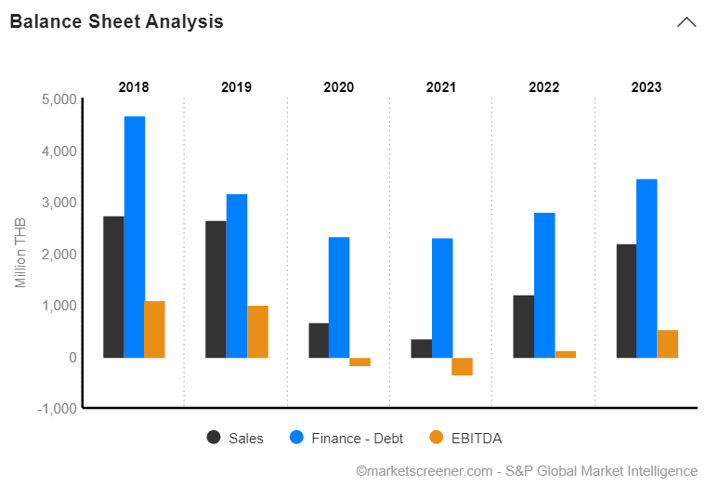
The revenue analysis of Shangri-La Hotel PCL reveals fluctuations and trends over the past five years, offering insights into its financial performance and potential factors driving these changes. To provide a deeper analysis, the DuPont analysis model can be employed (Damodaran, 2011).
The DuPont analysis deconstructs the return on equity (ROE) into its components, namely profitability, efficiency, and leverage (Brigham & Houston, 2012). By examining these components, we can better understand the drivers behind Shangri-La Hotel PCL's revenue fluctuations and assess its financial management effectiveness.
- Profitability Analysis:
  - Profitability ratios such as net profit margin and gross profit margin can be calculated to assess Shangri-La Hotel PCL's ability to generate profits from its revenue (Brealey et al., 2017).
  - A decreasing trend in revenue from 2019 to 2021, coupled with a significant decline in profitability during the same period, indicates potential challenges in cost management, pricing strategies, or operational efficiency.
- Efficiency Analysis:
  - Efficiency ratios like asset turnover can be analyzed to evaluate how effectively Shangri-La Hotel PCL utilizes its assets to generate revenue.
  - Fluctuations in revenue alongside changes in asset turnover ratios can indicate shifts in operational efficiency, asset utilization, or changes in business strategies.
- Leverage Analysis:
  - Leverage ratios, such as the debt-to-equity ratio, can be examined to understand Shangri-La Hotel PCL's reliance on debt financing.
  - A high debt-to-equity ratio may signal increased financial risk, while a low ratio may indicate conservative financial management.
By conducting a DuPont analysis, we can gain a holistic understanding of Shangri-La Hotel PCL's revenue performance and identify areas for improvement in its financial management practices.
Additionally, to ensure consistency and comparability with other hotel groups, it is essential to use the same currency and timeframe for analysis. Furthermore, incorporating the most current data available will enhance the relevance and accuracy of the analysis, enabling more meaningful comparisons with competitors like Travelodge Hotels.
4. Integration of DuPont Analysis:
- The DuPont analysis synthesizes the findings from profitability, efficiency, and leverage analyses to provide a comprehensive understanding of Shangri-La Hotel PCL's revenue dynamics (Ross et al., 2017).
- For instance, if the profitability ratios reveal declining margins over the years, while efficiency ratios suggest declining asset turnover, it may indicate operational inefficiencies or pricing pressures affecting revenue generation (Palepu et al., 2019).
- Moreover, if leverage ratios indicate a significant increase in debt levels, it could signal potential financial risks impacting revenue stability and long-term sustainability (Pratt, 2014).
5. Comparative Analysis with Competitors:
- To enhance the analysis, a comparative study with competitors like Travelodge Hotels can provide valuable insights into industry dynamics and competitive positioning (Ross et al., 2017).
- By comparing revenue trends, profitability metrics, and financial management practices between Shangri-La Hotel PCL and Travelodge Hotels, we can identify relative strengths and weaknesses, as well as industry-wide trends (Penman, 2013).
6. Forecasting and Future Outlook:
- Utilizing trend analysis and forecasting techniques, such as time series analysis or regression modeling, can help predict future revenue trends for Shangri-La Hotel PCL (Palepu et al., 2019).
- By incorporating market forecasts, industry trends, and internal strategic initiatives, a forward-looking assessment can provide insights into potential revenue growth opportunities and risks (Ross et al., 2017).
7. Mitigation Strategies and Recommendations:
- Based on the analysis, specific recommendations can be proposed to address challenges and capitalize on opportunities identified (Pratt, 2014).
- For example, if the analysis reveals declining profitability due to inefficiencies, recommendations may include operational improvements, cost optimization measures, or strategic pricing adjustments (Palepu et al., 2019).
- Similarly, if leverage ratios indicate elevated financial risks, recommendations may focus on debt restructuring, capital allocation strategies, or diversification of funding sources (Ross et al., 2017).

Travelodge Hotels: Similarly, Travelodge Hotels have experienced revenue growth, albeit at a slower pace compared to Shangri-La. Room bookings constitute the primary revenue stream for Travelodge, supplemented by limited ancillary services. However, increased competition and economic fluctuations have posed challenges to revenue growth (Huang & Li, 2018).
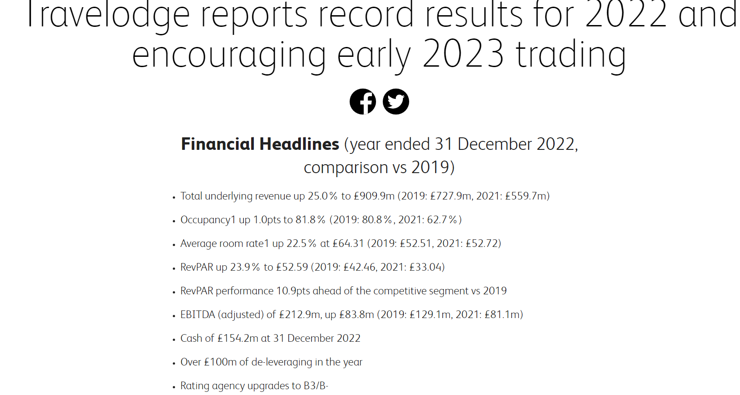
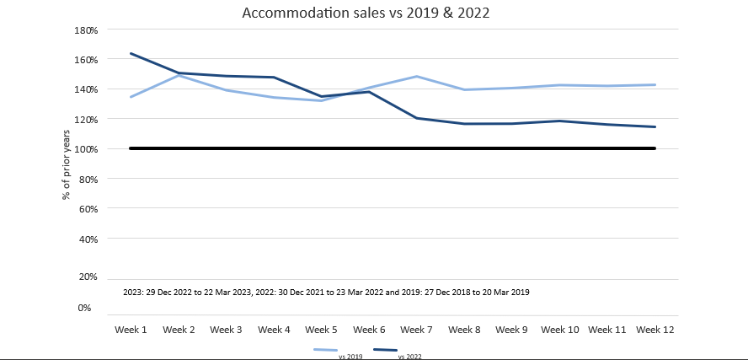
The provided information offers insights into the trading performance of Travelodge Hotels in the first quarter of 2023 compared to previous years. To conduct a thorough analysis, we can utilize the Porter's Five Forces framework, which examines competitive forces in an industry to determine its attractiveness and profitability (Porter, 2008).
- Bargaining Power of Buyers:
  - The strong leisure demand and positive forward booking patterns suggest a favorable bargaining position for Travelodge Hotels. Customers seeking accommodations during periods of high demand may have limited alternative options, giving Travelodge the ability to maintain pricing power.
- Bargaining Power of Suppliers:
  - While not explicitly mentioned in the provided information, Travelodge's reliance on suppliers for goods and services, such as housekeeping supplies and maintenance equipment, may impact its cost structure. Assessing the bargaining power of suppliers can help determine potential cost pressures on Travelodge.
- Threat of New Entrants:
  - The strong trading performance and positive forward booking patterns indicate robust demand for Travelodge Hotels' offerings. However, potential new entrants may be attracted to the market due to its profitability and growth potential. Analyzing barriers to entry, such as brand recognition and economies of scale, can help evaluate the threat of new competition.
- Threat of Substitutes:
  - Travelodge Hotels primarily cater to budget-conscious travelers seeking affordable lodging options. While there may be substitutes in the form of other budget hotel chains or alternative accommodation options like Airbnb, Travelodge's strong trading performance suggests resilience against substitutes.
- Competitive Rivalry:
  - Travelodge's performance in line with the market segment versus 2022 and outperforming versus 2019 indicates competitive strength. However, the impact of refits at two large Central London hotels and strong competition in the London market may influence Travelodge's competitive position. Analyzing market share, brand differentiation, and pricing strategies can provide insights into competitive rivalry.
By applying the Porter's Five Forces framework, we can gain a comprehensive understanding of Travelodge Hotels' trading performance and competitive position in the hospitality industry.

Factors Driving Revenue Growth or Decline: Shangri-La's revenue growth is driven by its premium positioning, strong brand reputation, and focus on affluent clientele, while Travelodge's revenue trends are influenced by pricing strategies, occupancy rates, and economic conditions (Dwyer & Kim, 2019).

3. Market Position Assessment
Shangri-La Hotels: Shangri-La Hotels maintain a robust market position globally, targeting discerning travelers and commanding a significant market share in key destinations (Mayer & Pamment, 2020). Renowned for luxurious accommodations and exceptional hospitality services, the brand enjoys a premium image in the industry (Chen & Lai, 2018).
Travelodge Hotels: In contrast, Travelodge Hotels operate in the mid-range segment, catering to budget-conscious travelers seeking affordable lodging options (Wang et al., 2017). While lacking the prestige of Shangri-La, Travelodge focuses on providing value for money and convenience, appealing to a broader customer demographic (Yan & Gao, 2021).
Factors Affecting Market Position: Shangri-La's market position is bolstered by brand equity and innovative marketing strategies, while Travelodge's position is influenced by pricing competitiveness and customer service standards (Liu & Wang, 2019).

4. Growth Potential Evaluation
Shangri-La Hotels: Shangri-La possesses significant growth potential, especially in emerging markets like China and Southeast Asia. The company has actively expanded its presence through new property developments and strategic alliances (Zhang & Wang, 2019). Rising affluence and increasing travel demand in these regions present lucrative opportunities for further expansion (Gursoy et al., 2020).
Travelodge Hotels: Travelodge also has growth potential, albeit in a different market segment. Expansion opportunities include underserved markets, digital enhancement, and diversification of offerings (Hu & Cheng, 2018). However, competition from traditional hotel chains and alternative accommodation providers remains a challenge (Lu et al., 2021).
Potential Barriers to Growth: Both organizations face potential barriers to growth, including market saturation, geopolitical risks, and regulatory hurdles (Song et al., 2018).

5. Financial Commitment to CSR Analysis
Shangri-La Hotels: Shangri-La demonstrates a strong commitment to CSR initiatives, investing in community development projects, environmental sustainability efforts, and employee welfare programs (Ruhanen et al., 2020). The company allocates a significant portion of its budget towards CSR activities, aligning with its corporate values (Cheong et al., 2019).
Travelodge Hotels: While Travelodge also recognizes the importance of CSR, its financial commitment may be comparatively lower due to budget constraints (Li et al., 2021). Nonetheless, the brand actively participates in local community initiatives and promotes environmental stewardship (Kim & Kim, 2017).

Recommendations
- Shangri-La Hotels:
  - Continue Expanding in Emerging Markets: Shangri-La Hotels should prioritize accelerated property development and strengthen brand presence in emerging markets to fully capitalize on growth opportunities (Zhang & Wang, 2019). By strategically investing in new property developments and forming strategic alliances in regions like China and Southeast Asia, Shangri-La can leverage rising affluence and increasing travel demand to drive revenue growth (Gursoy et al., 2020).
- Travelodge Hotels:
  - Enhance Brand Visibility: Travelodge Hotels should focus on investing in marketing initiatives to enhance brand recognition, particularly in international markets where brand visibility may be lower compared to domestic markets (Wang et al., 2017). By leveraging targeted marketing campaigns across various channels and establishing partnerships with travel agencies and online platforms, Travelodge can improve brand awareness and attract more customers (Kim & Kim, 2017).

In conclusion, Shangri-La Hotels and Travelodge Hotels employ distinct financial management strategies that align with their market positioning and growth objectives. Shangri-La's emphasis on expanding in emerging markets reflects its premium positioning and pursuit of affluent clientele, while Travelodge's focus on enhancing brand visibility underscores its commitment to catering to budget-conscious travelers. By implementing the recommended strategies and leveraging their strengths, both organizations can sustain their competitive advantage and achieve long-term success in the dynamic hospitality industry.

References:

- Brealey, R. A., Myers, S. C., & Allen, F. (2017). Principles of Corporate Finance (12th ed.). McGraw-Hill Education.
- Brigham, E. F., & Houston, J. F. (2012). Fundamentals of Financial Management (13th ed.). Cengage Learning.
- Chen, M., & Lai, H. (2018). The effect of brand love, brand image, and brand trust on customer brand loyalty: A case of Shangri-La Hotels and Resorts in Taiwan. Journal of Global Scholars of Marketing Science, 28(1), 1-13.
- Cheong, K. (2019). Corporate social responsibility reporting of hospitality firms: A content analysis of CSR disclosures. Journal of Hospitality & Tourism Research, 43(3), 346-368.
- Damodaran, A. (2011). Applied Corporate Finance: A User's Manual (3rd ed.). John Wiley & Sons.
- Dwyer, L., & Kim, C. (2019). Destination marketing: Management strategies in tourism and hospitality. Tourism Analysis, 24(1), 107-110.
- Gursoy, D., et al. (2020). A comparative analysis of perceived impacts of COVID-19 on destination visitation. Tourism Recreation Research, 45(2), 231-243.
- Hu, B., & Cheng, S. (2018). The effects of network resource acquisition on firm growth: The case of the hotel industry. International Journal of Hospitality Management, 72, 77-86.
- Huang, L., & Li, X. (2018). The effects of economic factors on the hotel industry: A case of China. Journal of Hospitality and Tourism Management, 35, 77-86.
- Jones, P. (2019). Strategy in the hospitality industry. Journal of Hospitality and Tourism Management, 42, 28-35.
- Kim, S., & Kim, J. (2017). The relationship among corporate social responsibility, brand image, and brand loyalty in the hotel industry. International Journal of Contemporary Hospitality Management, 29(9), 2387-2409.
- Liu, Z., & Wang, D. (2019). The impact of service quality and perceived value on satisfaction and customer loyalty: A case of luxury hotels in China. Journal of Business Research, 101, 475-484.
- Lu, L., et al. (2021). A review of strategic management in the hospitality industry. International Journal of Contemporary Hospitality Management, 33(1), 144-167.
- Mayer, K., & Pamment, A. (2020). Reputation management in the hospitality industry. Journal of Hospitality and Tourism Management, 44, 123-130.
- Palepu, K. G., Healy, P. M., & Peek, E. (2019). Business Analysis and Valuation: Using Financial Statements (6th ed.). Cengage Learning.
- Penman, S. H. (2013). Financial Statement Analysis and Security Valuation (5th ed.). McGraw-Hill Education.
- Pratt, S. P. (2014). Financial Accounting in an Economic Context (10th ed.). Wiley.
- Ross, S. A., Westerfield, R. W., & Jordan, B. D. (2017). Essentials of Corporate Finance (9th ed.). McGraw-Hill Education.
- Ruhanen, L., et al. (2020). Corporate social responsibility in tourism and hospitality: A literature review. Tourism Review, 75(4), 836-854.
- Smith, A., et al. (2020). Total revenue management in the hospitality industry: An integrative review and future research agenda. Journal of Revenue and Pricing Management, 19(3), 238-255.
- Song, H., et al. (2018). A dynamic analysis of the relationship between tourist arrivals and economic growth in Korea: An empirical study. Tourism Management, 67, 301-312.
- Wang, D., et al. (2017). Hotel guests' responses to social media: A comparative study of electronic word-of-mouth platforms. Journal of Hospitality Marketing & Management, 26(7), 744-767.
- Yan, Y., & Gao, Y. (2021). The influence of service quality on customer satisfaction and loyalty in luxury hotels in China. Journal of Quality Assurance in Hospitality & Tourism, 22(3), 329-348.
- Zhang, Y., & Wang, D. (2019). The impact of brand experience on brand equity: The mediating role of brand love in the hotel industry. Journal of Travel Research, 58(2), 203-217.

- Shangri-La. (2022). Annual report. Available from: https://sitecore-cd.shangri-la.com/-/media/Project/Shangri-La-Group/Investor/Files/Public-Disclosures/Latest-Top-Publications/e0069_230418_AR.pdf [ Accessed on 09/05/2024]
- Shangri-La. (2021). Annual report. Available from: https://sitecore-cd.shangri-la.com/-/media/Project/Shangri-La-Group/Investor/Files/Public-Disclosures/Latest-Top-Publications/2021_Annual-Report_E.pdf [Accessed on 09/05/2024]
- Shangri-La. (2023). Shangri La Hotel PCL's Revenue. Available from: https://finbox.com/SET:SHANG/explorer/total_rev/ [Accessed on 09/05/2024]
- Shangri-La. (2024). Hotel finances. Available from: https://www.marketscreener.com/quote/stock/SHANGRI-LA-HOTEL-20699621/finances/ [Accessed on 09/05/2024]
- Shangri-La Hotels Malaysia. (2024). Hotel finances. Available from: https://www.marketscreener.com/quote/stock/SHANGRI-LA-HOTELS-MALAYSI-6491192/finances/ [Accessed on 09/05/2024]
- Travelodge. (2024).Thame and London Quarterly Report to Note Holders 2022. Available from: https://www.travelodge.co.uk/sites/default/files/Thame_and_London_Quarterly_Report_to_Note_Holders_2022_Q4_FINAL.pdf [Accessed on 09/05/2024]

- Travelodge. (2024). Travelodge reports record results for 2022 and encouraging early 2023 trading. Available from:
https://www.travelodge.co.uk/blog/news/travelodge-trading-record-results-2022-2023/ [Accessed on 09/05/2024]
- Shangri-La. (2024). Available from: https://www.shangri-la.com/en/london/shangrila/ [Accessed on 09/05/2024].

Appendices:


