I think a lot of monsters were born from Chimera.

I want to research some “BLOODBORNE” and “DARK SOUL” monster in

Because they're all Gothic and Cthulhu-style monsters

Im interested it

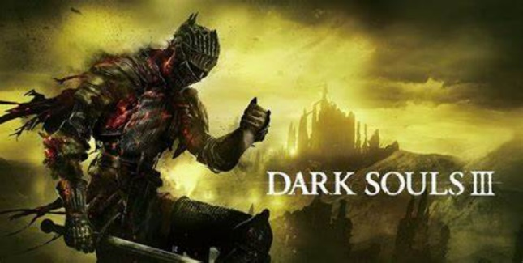
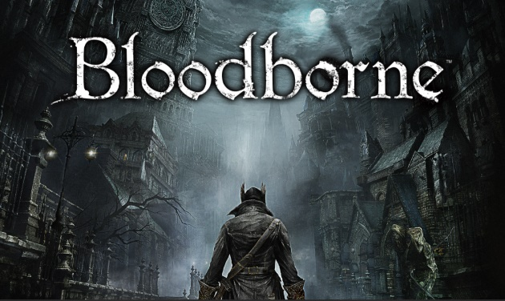

Part 1. The origin of Chimera(background)

Part 2. What Chimera and monster
The Origin of Chimera (Monsters from Greek Mythology)  Looks are a combination of different organisms, with the characteristics of three species | The Evolution of Chimera 1 (changes to date)  Lions, snakes, goats combined with ferocious monsters, slowly people in the follow-up legend to him plus dragon body, bat wings, etc. , more ferocious and terrible image, more reflect people's hearts at that time. | The Evolution of Chimera 2 (changes to date)  Chimera now appears more than ferociously, because in science Chimera is defined as a species produced by the chimera of two creatures, so the image is not fixed in a single, people will add more creatures to the creation of Chimera.
The Evolution of Chimera 3 (changes to date)
When Chimera's definition is broader, two factions emerge, one more ferocious than the primitive creatures, and one closer to the human form, both of which are called extrahuman.

Part 3. Analyze monsters through “BLOODBORNE” and “DARK SOUL” (Most of them are monsters of human characteristicss)
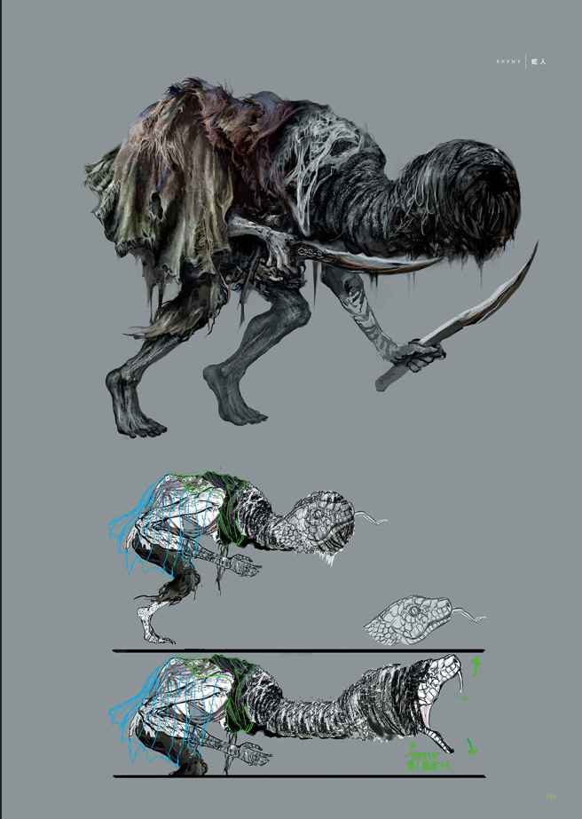

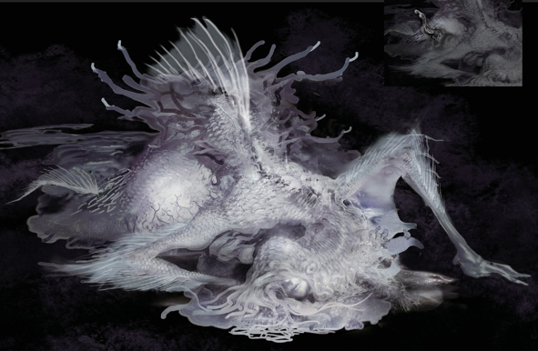

Part 4. Defining a proposal plan

