

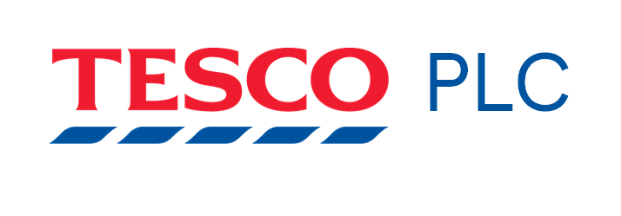

Marketing Management

Assignment - 1

NAME : SIMRANJIT KAUR

STUDENT ID : 2216400 NAME OF LECTURER : TUSHARA BALENDRAN

MODULE NAME : MARKETING MANAGEMENT
MODULE CODE : LCM7001
ASSIGNMENT TITLE : ASSIGNMENT 1

Table of Contents

1. Introduction 3
2. Background of the company 3
3. Communication in marketing process 4
3.1 Shannon-Weaver model of communication 4
3.2 Integrated Marketing communication 5
4. Online and offline new promotional strategy to raise brand awareness 7
4.1 Offline 7
4.2. Online 7
5. Brand equity 8
5. 1 Keller’s Brand Equity model 9
5.2 Advantages and demerits of Keller’s model 10
5.3 Critical analysis of Keller’s model 10
7. Customer journey map 11
7.1 Pre-purchase 11
7.2 During the purchase 11
7.3 Post purchase 11
8. Diagram and explanation of customer journey map for Tesco 11
9. Total engagement model 14
10. Conclusion 15
11. Reference list 16
12 Appendix 18

Co. Name: Tesco

1. Introduction
Integrated marketing proposes an even, consumer-aimed knowledge by joining all advertising communication rudiments, involving public connections, social media, and promotion. It suggests that the communications must have a unified appearance, texture, and quality crossways the stations. IMC proves the company has an advantage over contestants and increases sales. Through collaborating with the client, the brand constructs a connection with them and forms a seamless purchasing understanding ultimately contributing to an enduring, faithful consumer base. The report shed significance on the marketing awareness of the Tesco Company.

2. Background of the company
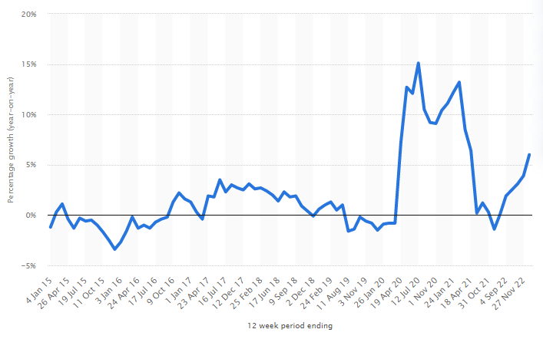
Figure 1: Tesco sales
(Source: Statista, 2023)
Tesco Plc is an MNC retailer of overall production and the firm transmits out commercials during multi-format supplies and online. In 1919, Tesco was founded by Jack Cohen, who chiefly operated a sole stand in London, England. Twitter is the main social channel that applies in the "Tesco Corporate Affairs" group for external interaction. Furthermore, a huge number of colleagues are on Twitter and use it to segment the idea that the company might intensify across their accounts. 2015 and 2016 (Statista, 2023). Further, the organisation observed lessening sales before the business achieved steady and arrived at a development stage for April 2019. Tesco functions only around 4,000 shops in the United Kingdom. Tesco ended with an income of 56.4 billion "British pounds in the UK and the Republic of Ireland" from 2020 to 2021 (Tescoplc, 2023). Tesco Plc is involved in transaction and retail banking. It functions during the next sections namely ROI, UK and Asia, and Tesco Bank. The vision of Tesco is to serve the clientele, groups and planet with a slight improvement each day. The mission of the firm is "We make what matters better, together.” The statement makes it clear that everyone is part and parcel of the success of this company.

3. Communication in marketing process
As commented by Treem et al., (2020), Communication is distinct as the philanthropic, receiving or swapping of evidence, views or thoughts so that the communication is totally unspoken by everyone incorporated.
For illustration, Tesco uses emails as they are valuable for sending a communication to employees or organisations. They are also decent for Tesco to connect with native twigs or global subdivisions and are earlier to send than literature and comprise as ample data as required. Moreover, Tesco applies verbal communication methods namely "face-to-face" and phone discussions. The benefit of the verbal message is that it lets workers connect significant info effortlessly with one another within the firm. Another procedure of verbal communication that might function face-to-face is board meetings. At Tesco, board meetings might permit attendees to connect evidence around upcoming tactics and growths within the business (Campuscrosswalk, 2023). Tesco might also apply face-to-face interaction with clientele to get immediate answers. Tesco also uses intelligence as a method of written evidence to interconnect among staff groups within the firm. The benefit of such is that they record and demonstrate facts of what occurred throughout the whole month o week in a shop. A report frequently encompasses material, sales figures and bar charts to demonstrate the general presentation of somewhat and Tesco applies reports to take evidence around how they did annually yearly to demonstrate persons the sales or gain of the firm.

3.1 Shannon-Weaver model of communication
In 1949, C. Shannon & W. Weaver created the widely used Shannon-Weaver model of interaction, which describes how people communicate. A sender, message, channel, receiver & feedback were the 5 basic components of the model. In this paradigm, message transmission from a sender to a receiver via a channel is considered as a streamline process of communication. In order to comprehend Tesco's communication strategy with its constituents, the Shannon-Weaver model might be used.
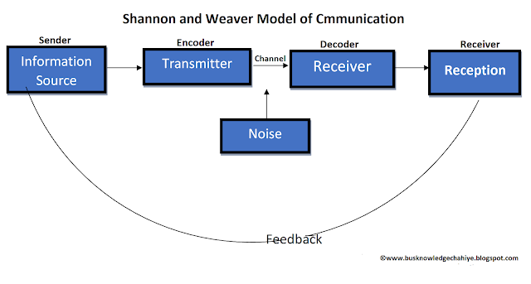
Figure 2: Shannon-Weaver model of communication
(Source: Xmatters, 2023)
Sender: In the instance of Tesco, the term "sender" alludes to the organisation as a whole, which includes its executives, marketing staff as well as other staff members who interact with customers (Yadav and Mishra, 2022).
Message: The information Tesco wishes to convey to its stakeholders is referred to as the message. This could include advertisements, news about business activity, or messaging about the company's goods and services.
Channel: The channel is the mechanism via which Tesco informs its stakeholders of its message. Advertising, networking sites, email & other digital as well as traditional media are examples of this.
Receiver: The term "receiver" refers to the target market that Tesco is attempting to reach, which may consist of its clients, its shareholders, staff members & other stakeholders.
Feedback: Feedback describes the receiver's reaction or emotional state to Tesco's message. Feedback can take many different forms in Tesco, including client feedback, revenue statistics, and other indicators that show the achievement or efficacy of its outreach initiatives.

3.2 Integrated Marketing communication
A method to brand communication called integrated marketing communication (IMC) seeks to guarantee uniformity & consistency across all facets of marketing communication. In order to offer a coherent message to the audience that is being addressed, every method of communication must be connected and in alignment.
IMC can be utilised in the case of Tesco to develop a unified brand message throughout every medium of marketing. As commented by Laurie and Mortimer, (2019), Integrated Marketing Communications or IMC is an advertising idea of the 1990s. It would be essential for existence in the 21st century. The arrival of addition is leading dealers to take a new appearance at all the mechanisms of advertising, exactly the sole measurement that public relatives carry to the marketing mix. IMC is distinct as the organisation and addition of all promotion communiqué methods, roads and foundations within a corporation into a unified package that exploits the influence on the purchaser and other end operators at a negligible price. This addition disturbs all companies' business-to-business, advertising networks, consumer-aimed, and inside-directed infrastructures. As per Kotler and Armstrong, Integrated Marketing Communications or IMC is an idea in which a firm prudently assimilates and organises the numerous message systems like personal selling, mass media promotional, sales promotion, public kindred, direct advertising, wrapping, and others to bring a strong, reliable, and convincing communication around the company and the goods. Businesses observe Integrated Marketing Communications as a method to organise and achieve the promotion of communication sequencers to guarantee that they provide patrons with reliable communication around the business or the firms. IMC signifies a development above the traditional technique of giving numerous advertising and message rudiments as almost distinct actions.
Companies such as Tesco smugly proclaimed that one of the details of its Achievement is hearing the issues of the dealers and clients. Tesco has accepted manifold qualitative investigation methods to influence the clientele like focus teams, attended workshops, and home visits to gather the response in order to uncurl the belongings and reply rapidly. In the wake of accounting disgraces that overwhelmed Tesco's standing from 2013 to 2014, vicissitudes had to happen. The firm then instigated a novel procedure of advertising in “Christmas commercial campaigns” (Tescoplc, 2023). By spending preceding profitable performers in a novel situation, the trade was able to maintain a familiar essence about a new idea. Rereading the marketing mix was also compulsory and one of the phases Tesco removed was to present an innovative line of original farm brand goods. This affected the rebranding of foodstuffs like fish, beef, fruits and so on permitting the corporation to apply to cost-conscious patrons who did not before worth Tesco's aid. Previous to the rebranding, Tesco's bag of farm-style goods was around 15% extra luxurious.
The brand identified the essential to contest in such a stage and values were abridged. The consequence was an affected upsurge in the farmhouse and fish sales at the novel cost point. In 2013, Tesco spent about £110 million on advertising labours in outdated openings. By 2014, that quantity had weakened by 10 per cent (Tescoplc, 2023). In 2015, Tesco's spending on marketing weakened abruptly to less than £80 million, a pattern of enormous change in contrast to the other two years. With such evidence, the firm was able to plan new wrapping projects and branding movements for substances in essential need of help. Numerous such original rebranding labours rotate around networks to farms, studs and other rudiments that cause images of home-grown exospheres. Due to such issues faced by the brand, offering buyers an additional carbon-based and locally-sourced texture in goods was a keen change. The brand observes an enormous essential for directing the discrete knowledge in the renaissance. Tesco's advertising group has dealt with a change of inordinate advertising philosophies for such methods. From bottomless reductions distributed by email to print campaigns brought straight to the door, customisation is the main aspect of the sphere of advertising.
Tesco has shaped Better Baskets, a campaign that aims to challenge the fences that consumers come up with when observing to fill the bag with improved selections each time consumers buy. As per Tesco’s buyers, 86% of them desire to eat extra fitness, with 77% deficient in the superstore’s assistance to attain it (Smartinsights, 2017). The campaign introduced would comprise in-shop Better Basket regions, obviously flagged with the Better Baskets symbol that would categorise goods comprising goods that are more in fibre, low alcohol drinks and many more. Tesco must convey its brand message clearly & consistently through all mediums, such as its website, societal networking sites, advertisements, and displays inside stores. Consumers should be made aware of the brand's values, goal or advantages through this message.

4. Online and offline new promotional strategy to raise brand awareness

4.1 Offline
At present, mobile marketing claims like the "Tesco club card app" assists clientele to maintain the points that they have increased. However, spending and the latest proposals that the stock have permitted the technology to advance interactions in an attentive and very personal background to cooperate with the consumers (Xmatters, 2023).

4.2. Online
Tesco has offered a domicile on the website where clients can deliberate around books obtainable at the shops and then choose whether they desire to acquire them. The company is resolute to carry a global-class ITSM company to the cleanest, Tesco enhanced its IT force and prepared across a “Service-Oriented Architecture (SOA)” (Hunt, 2019).

5. Brand equity
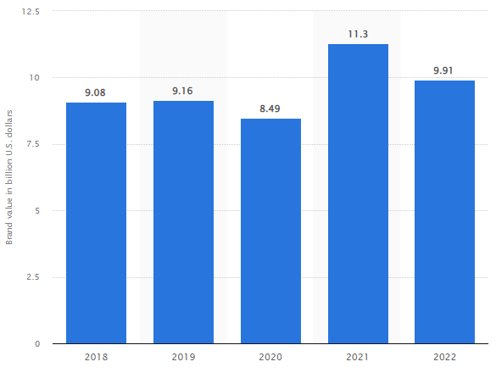
Figure 3: Tesco brand value
(Source: Statista, 2023)
As remarked by Hunt (2019), Brand equity mentions a worth premium that a business makes from a commodity with a familiar identity in contrast to a general correspondence. Organisations might form brand equity for the goods by forming them unforgettable, effortlessly familiar, and larger in excellence and dependability. When a firm has optimistic brand fairness, consumers freely pay an extraordinary price for the goods, although they might get similar goods from the rivalry with less. Consumers, as a result, pay a cost premium to trade with a company they distinguish and esteem. For example, companies such as Apple are regarded as one renowned greatest valued brand. It is a definitive instance of a firm with constructive fairness. The organisation constructed a positive image with Mac computers before spreading the product to iPhones, which carry on the brand potential probable by Apple's computer consumers.
Tesco has a robust picture which supports the publicity doings meaningfully. It applies to radio, television, social media, newspapers, and other openings to take its communication to the consumers. It is the main player in outdated publicity in UK grocery retail manufacturing. Moreover, Tesco has individual goods and facilities. Further, Tesco Lotus, Everyday Value, and F&F Clothing are certain of Tesco's individual brands. Though it is worth stating that the handiness of product classes is based on the kinds of shops customers stay in (Statista, 2023). From the position of price to societies, branding is an imperative feature that constructs market credit and a bearable client foundation. The instance of Tesco shows that a reliable selling code that the company encourages is a suitable advertising practice for enticing possible purchasers. The brand value of Tesco has varied in new years (Thegrocer, 2023). As of 2022, the supermarket chain of the UK had a brand value of unevenly 9.91 billion U.S. dollars, dented from 11.3 billion in 2021. Brand value is the quantity of a variety leading to the general worth of a company.
By applying the instance of the Tesco Company, one can control the possibility of growing the brand impartiality over advertising communication methods. For example, publicity facilities through the selling of foods and social media owing to digital requests upsurge the amount of clientele, thereby improving brand credit (Thegrocer, 2023).

5. 1 Keller’s Brand Equity model
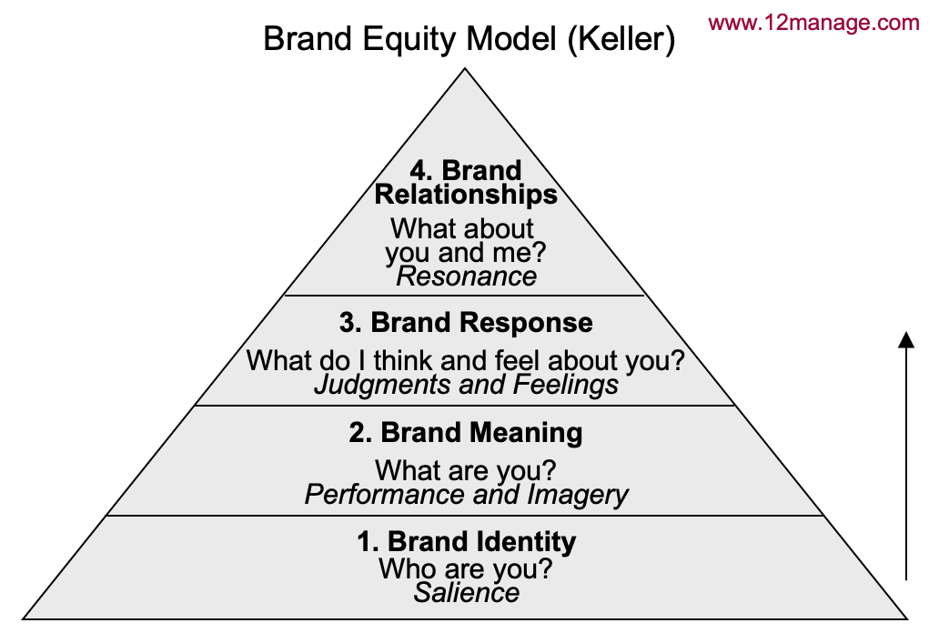
Figure 3: Keller’s model
(Source: Batheories, 2022).
As denoted by Tran et al., (2020), Reaching brand equity is the consecrated grail for any branding group of the firm. This might be undertaken in numerous conducts, comprising the application of expanding models advanced by brand management. The best-recognised CBBE model is the Keller Model, planned by Kevin Lane Keller.
Level 1: Brand identity - This is how clienteles observe the brand and differentiate it from others. It is the maximum significant phase and should be robust to provide the respite of the pyramid overhead it. Brand identity is constructed when clienteles are ignorant of the goods. The function of the brand here is to figure out a sturdy brand individuality for the advantage of the make and to entice the clientele. Since brand individuality is the chief stage in the equity model, it is the greatest significant stage and the improper of the Brand equity pyramid (Tran et al., 2020). If the foundation is robust, the pyramid would be sturdier.
- Level 2: Brand meaning- When clientele turns out to be conscious of the brand, they desire to understand further regarding it. The recital of the brand is significant for the purchaser's devotion. Businesses such as Bosch, Siemens, and so on have turned out to be what they are since the presentation across time.
- Level 3: Brand response- Once a client has accepted the brand, it increases the standard of publicity.
- Level 4: Brand resonance- When a buyer adores a brand so much they might not reflect purchasing from other brands' textures a connection with it and a linking with other purchasers, they are that actually infrequent and includes a brand attorney.
The application of Keller's model would support Tesco to construct a robust brand by forming how the consumers believe and think regarding the products of the firm. The application of this theory would also help the company to recognise the brand reputation of the firm and the steps in going ahead.

5.2 Advantages and demerits of Keller’s model
Advantages
- The brand fairness model by Keller is also recognised as the “Customer-Based Brand Equity (CBBE) model”.
- The tool assists businesses to discover the method to size a robust brand by determining how the clientele reason and texture regarding them. The model assists to recognise the phase that the product fits to and goes ahead.
Disadvantage
- Keller's model fails to take into thought the impartiality of builders' brand designations in dissimilarity to separate product products.
- A stimulating conclusion was the defendants' responses regarding one of the product slogans.
- Defendants moderated the rank of the brand component and articulated certain misperceptions.

5.3 Critical analysis of Keller’s model
Despite the fact which Keller's model offers a useful structure for examining brand equity, it's very vital to keep in consideration that the approach might not take into account all elements that influence brand performance. For instance, the model doesn't take into consideration outside variables that may have a bearing on how well a company does, like economic shifts, rivalry, or modifications in customer behaviour. The complexity of brand equity in the age of information, when social media & online comments can each have a big impact on the standing of a company, may also be missed by the model (Tran et al. 2020). While Keller's model can offer insightful analyses into Tesco's reputation, it is crucial that one approach the analysis critically and take the brand's larger operating environment into account.

7. Customer journey map

Pre-purchase
Brand building is a significant foremost measure of brand consciousness. As such, Tesco is suggested to have a clear understanding of the brand and the products it denotes. Dividends are central for the attainment of new addresses on social media. They guarantee that the content gets understood by the public outside Tesco’s supporter foundation and they construct organic reach in the wake of pesky algorithm vicissitudes.

7.2 During the purchase
Search engine optimization or SEO might be thought to be unapproachable, although it is easy to tool and it is important for Tesco's experience online. It includes getting the idea observed by search engines such as Google and positioning on search results pages.

7.3 Post purchase
One method to attain brand consciousness is during the wanted “word-of-mouth” advertising to guide the loyal consumers at the finest. A referral program is not just to assist loyal patrons to be the finest supporters. A referral database not just upsurges the reach and the number of persons who understands the identity but also carries that consciousness from the basis of that person's faith. Brand equity labels a brand's worth. It is strong-minded by customer skills with and completes awareness of the brand. Positive skills and acuity equal constructive brand impartiality, and the identical goes for negative ideas.

8. Diagram and explanation of customer journey map for Tesco
STAGE | AWARENESS | CONSIDERATION | DECISION | SERVICE | LOYALTY
Consumer actions | Identifying the goods through social media | Identifying the goods and contrasting   | Buying the goods | Contact consumer care, receive commodity | Share experiences of the customers, repeat buying
Various touchpoints | Word-of-mouth, social media, Facebook, Twitter | Websites, the worth of mouth | Mobile application, discussion over the call | Email, chat | Reviews locations, words of mouth
Business aims | Boost brand recognition | Grow the consumers on websites | Grow sales, grow conversion ratio | Grow consumer facilities | Increase retention ratio, positive responses
Group members | Interaction and advertising | sales and advertising | Growth through marketing, online sales and so on. | Increase the services of the customers | Boost retention rates
Key performance indicators | People reached | Newest website clients | Online sales | Responses to the rating | Satisfaction score by the company
Consumer expertise | Attentive but uncertain   | Inquisitive and enthusiastic | Happy   | Upset | Happy  

Table 1: Customer Journey map
(Source: Created by the learner)
[Refer to appendix 1]
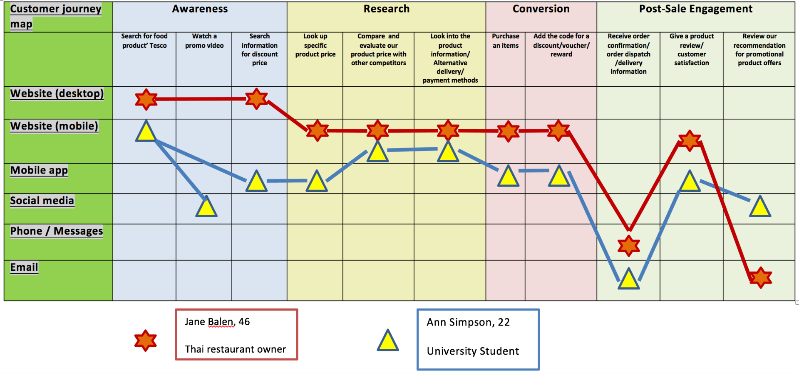
Figure 4: Tesco Customer journey map taking example of two customers
(Source: Treem et al. 2020)
Customer 1: 46-year-old proprietor of a Thai restaurant, Jane Balen
Knowledge: A friend introduces Jane to Tesco by saying that she can buy food there for a reasonable price.
Take into account: Jane browses Tesco's website to learn about their offerings. She also confirms the location, business hours, and parking options for Tesco. With the help of her Clubcard, she can accrue points and get deals.
Following her purchase, Tesco sends Jane a thank-you email and offers customised suggestions for upcoming purchases depending on her buying preferences.
Consumer 2: 22-year-old university student Ann Simpson

A search for neighbouring supermarkets on the internet leads Ann to Tesco. Ann visits Tesco's website to research their offerings and discounts. She discovers that Tesco provides a variety of goods at reasonable costs in addition to a variety of delivery options. She makes the decision to attempt online shopping.
Purchase: Ann orders groceries online & chooses the pickup date that works for her hectic life.
Post-purchase: Ann gets her order & is pleased with both the packing performance & the high level of the goods. Tesco sends her an email asking her to assess her shopping pleasure offering personalised product suggestions based on her past purchases.

9. Total engagement model
A concept called the Total Engagement Model places a strong emphasis on the value of involving stakeholders, employees & consumers at every stage of the consumer journey [Refer to appendix 2].
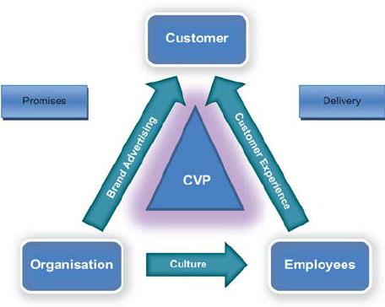
Figure 5: Total engagement model
(Source: Researchgate, 2022)
Pre-purchase Engagement: This phase entails interacting with clients ahead of time. Tesco interacts with customers through its websites, in-store displays, and marketing activities. Additionally, Tesco provides online purchasing and delivery options too.
Engagement with clients During the Purchase Process: During this phase, clients are actively engaged. Tesco attracts customers by providing a range of payment methods, such as mobile & cashless payments.
Post-buy Engagement: In this phase, customers are contacted after they have made a purchase. Tesco's Clubcard loyalty programme, which provides prizes & discounts to customers depending on their purchases, engages people. Customers may simply and swiftly resolve any difficulties with the company by using its website and social media platforms, which also provide customer service help.
Staff Engagement: During this phase, you must interact with your staff to make sure they are inspired, involved, and dedicated to providing outstanding service to customers. Tesco engages people through offering rewarding work environments, training opportunities, and employee appreciation programmes.
Stakeholder Engagement: During this phase, stakeholders like as suppliers, shareholders, and the neighbourhood community must be contacted.

10. Conclusion
In the end, Tesco's marketing plans & communication techniques have made a big difference in creating and sustaining the brand's success in the cutthroat retail market. Tesco's brand equity & strategy for engagement have been examined using Keller's Brand Equity Model & the Total Engagement Model as useful approaches. Tesco can continue to build upon its name and keep its standing as the market leader by prioritising customer service and engagement.

11. Reference list
Journals
Hunt, S.D., (2019). The ethics of branding, customer-brand relationships, brand-equity strategy, and branding as a societal institution. Journal of Business Research, 95, pp.408-416.doi: https://doi.org/10.1016/j.jbusres.2018.07.044
Laurie, S. and Mortimer, K., (2019). How to achieve true integration: the impact of integrated marketing communication on the client/agency relationship. Journal of Marketing Management, 35(3-4), pp.231-252. https://doi.org/10.1080/0267257X.2019.1576755
Tran, K., Nguyen, P.V., Do, H. and Nguyen, L.J.M.S.L., (2020). University students’ insight on brand equity. Management Science Letters, 10(9), pp.2053-2062.doi: 10.5267/j.msl.2020.2.006
Treem, J.W., Leonardi, P.M. and Van den Hooff, B., (2020). Computer-mediated communication in the age of communication visibility. Journal of Computer-Mediated Communication, 25(1), pp.44-59. Doi: https://doi.org/10.1093/jcmc/zmz024
Yadav, V. and Mishra, A.,(2022). Extension Communication Models and Strategies.https://www.researchgate.net/profile/Abhishek-Mishra-66/publication/342988014_Extension_communication_methods_and_strategies/links/60110fc845851517ef1a1a7c/Extension-communication-methods-and-strategies.pdf

Websites
Batheories, (2022). Keller’s model. [Online] Available at: https://www.batheories.com/kellers-brand-equity-model/ [Accessed: 15 March 2023].
Campuscrosswalk, (2023). Tesco communication. [Online] Available at: https://campuscrosswalk.org/tesco-uses-verbal-communication-such-as-face-to-face-and-over-the-phone-conversation/ [Accessed: 15 March 2023].
Communicationtheory, (2023). Berlo's theory. [Online] Available at: https://www.communicationtheory.org/berlos-smcr-model-of-communication/ [Accessed: 15 March 2023].
Researchgate, (2022). Total engagement model. [Online] Available at: https://www.researchgate.net/figure/The-total-engagement-model_fig2_49513186 [Accessed: 15 March 2023].
Smartinsights, (2017). Marketing campaign. [Online] Available at:https://www.smartinsights.com/online-pr/reputation-management-online-pr/tesco-turned-marketing-strategy-around/ [Accessed: 15 March 2023].
Statista, (2023). Brand value. [Online] Available at: https://www.statista.com/statistics/1337228/tesco-brand-value/ [Accessed: 15 March 2023].
Statista, (2023). Tesco sales. [Online] Available at: https://www.statista.com/statistics/386598/tesco-sales-percentage-change-great-britain-uk/ [Accessed: 15 March 2023].
Tescoplc, (2023). About Tesco. [Online] Available at: https://www.tescoplc.com/about/ [Accessed: 15 March 2023].
Tescoplc, (2023). Campaigns. [Online] Available at:https://www.tescoplc.com/news/2022/tesco-launches-better-baskets-campaign-to-help-customers-fill-their-baskets-with-better-choices/ [Accessed: 15 March 2023].
Thegrocer, (2023). Tesco must keep evolving. [Online] Available at: https://www.thegrocer.co.uk/supermarkets/tesco-must-keep-evolving-for-its-brand-journey-to-continue/598542.article [Accessed: 15 March 2023].
Xmatters, (2023). Tesco case study. [Online] Available at: https://www.xmatters.com/customer/tesco-better-service-through-communication [Accessed: 15 March 2023].

12 Appendix
Appendix 1
Customer journey and customer touchpoints

As part of Tesco's Project Reset inventiveness, the company is asked by the shop's in-house design group to assist in growing a new method for the in-store customer trip, by abridging it, constructing further acting and intensifying what makes Tesco dissimilar. Thus, taking signs from the original group of mainland hypermarkets, the organisation thrilled the interplanetary by applying the scale of the building, exploiting the size at a high standard. Moreover, the company applied resources, such as metal, wood, and brick, to form balminess, opposing this with a bold taking picture palette and stressed tint. Temporarily, slatted timber tranches are used to describe the space and run the buyer journey. Piloting the convenience scenery can demonstrate stimulating trades observing better services to clientele who need help for their incapacity. For clients who have concealed incapacities, it might be extra problematic for the company to foresee how they can great offer help.
Appendix 2
The total engagement model would help Tesco to put collaboration into a well-organised and real scheme. The application model would help the firm to connect with every task of the corporation on a united strategy for client appointment, involving publicity, facility, goods and the internal philosophy.

