Student name: Ionela Madalina Cananau
Student ID: 2243593
Module title: Markeding Essentials BMIH4005
Module Lead: Scott James
Word count:

MARKETING PLAN AND PPT PRESENTATION
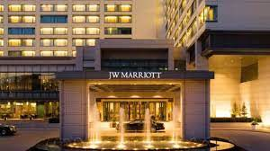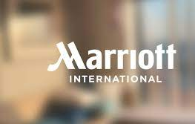



Table of content

Marketing Plan 3
Introduction 3
Situation analysis 3
Objectives 8
Strategy 8
Tactics 9
Action 10
Control 10
Conclusion 11
PPT Presentation 12
Introduction 12
Situation analysis 12
Objectives, strategy and tactics 12
Action and control 13
Conclusion 13
References 14
Marketing Plan 14
PPT presentation 16
Appendixes 17
Appendix 1: Marriott International website assistance 17
Appendix 2: PPT slides 18

Marketing Plan

Introduction
The marketing plan reflects the organisation's planning to use strategic advertisement for Marriott International to reach the prospective target market. The main focus of the marketing plan is to amplify the marketing opportunity for robust sustainability incorporation across Marriott International for supporting the environment and adding progressive values for the stakeholders. This marketing plan is prepared for the entire spectrum of stakeholders ranging from customers, government, community, stakeholders, employees and so on. The marketing plan will be evaluated with the help of using the 4Ps of the marketing mix to analyse the meticulous strategies that Marriott International deploys for publicity and marketing across the domains of product, price, place, and promotions.

Situation analysis
Company
Strengths | Weaknesses
- Global presence  - Brand reputation | - Intense market competition  - Damage to reputation due to lawsuits (Ridley, 2020)
Opportunities | Threats
- More global expansion  - Transition into other demographics | - Pandemic impacts  - Adverse impact of global war scenario (Ruta, 2022)
Table 1: SWOT analysis
(Source: Self-developed)
Analysis:
The SWOT analysis reflects that Marriott International has inherent strength from its global presence and brand reputation. But intense competitions and damage to the repetitions are also the major weakness. There are vast opportunities in terms of global expansion and expansion through other democracies. But the panamic impact and the global war situations can also create burden on the company.
Customer
STP
Segmentation | Demographic Segmentation  - Age group: visitors from 28- 54-year-olds  - Sex: Male, female  - Class: Sophisticated class  Behavioural Segmentation  - Customer Loyalty  - Benefit Driven
Targeting | - Website and social media strategies
Positioning | - Quality service with premium pricing
Table 2: STP analysis
(Source: Self-developed)
Analysis:
The company segments its customers on the basis of demographic and behaviour segmentations and targets with the help of social media website-oriented strategies. The proper quality of service with premium pricing are the positioning strategies of Marriott International.
Competitors
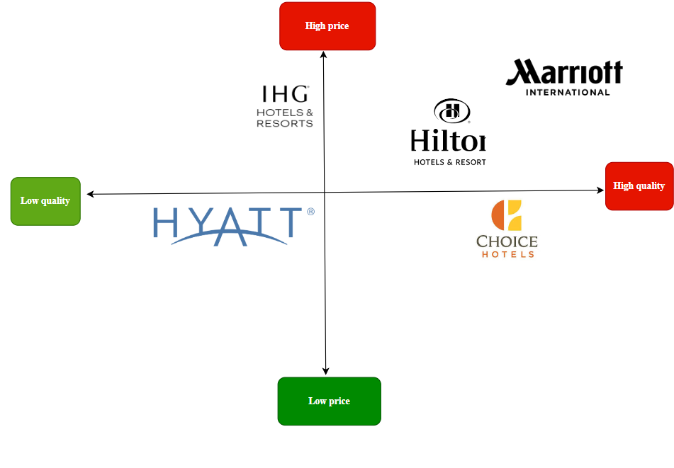
Figure 1: Perpetual positioning map
(Source: Self-developed)
Analysis:
It can be established from the figure one that Marriott International occupies a dominant position in terms of high prices and high quality of services. Other popular brand such as Hilton, Choice are also lagging in terms of quality and prices. Hence it has a positive situational perspectives.

Colloborators
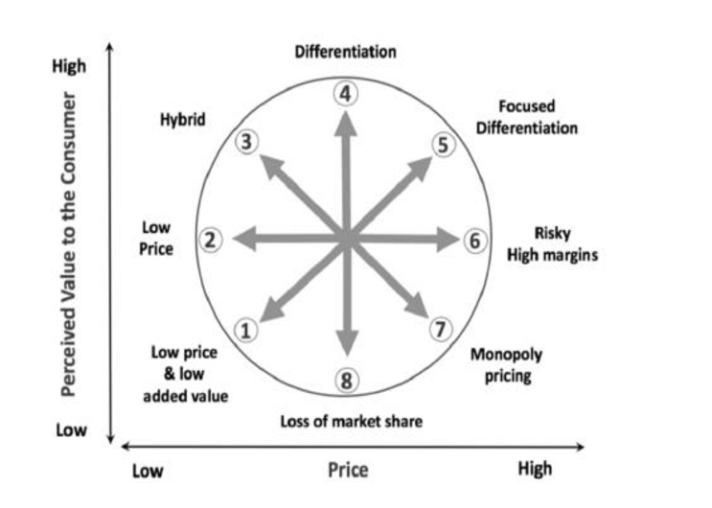
Figure 2: Bowman's strategy clock
(Source: Singagerda and Riadi, 2019)
Analysis:
As per the bowman's strategy clock it can be established that marriott International focuses on differentiation strategy by adding perceive value to the customers in its services. This is enhanced through quality attributes and customer services. The organisation has core value of placing people, supporting excellence, acting integrity with sustainable efforts (Marriott, 2023). This enhance the values to the stakeholders, it tries to keep it price in the premium category but not excessively high for customer integration.
Organisation has critical awareness about B2B relationships with partners and franchise. The sales steam provide effective B2B custom oriented solutions that helping escalating the scale of operations (Marriott International, 2023). These are provided across the personalised services and distribution channels to meet the specific needs. The company focuses on total account management strategy that develop the trust and ensuring holistic success of the organisation.
Climate
Factors | Description | Threat or opportunity
Political | - Stable government (Government of UK, 2023) | Opportunity
Economical | - 0.25% increase in GDP(Governments of UK, 2023) | Threat
Social | - Customer preference (Statista, 2022) | Opportunity
Technological | - Growing technology industry (Governments of UK, 2023b) | Opportunity
Legal | - Strong presence of data laws (Partridge, 2020) | Threat
Environmental | - Sustainability preference (Statista, 2022b) | Opportunity
Table 3: PESTLE analysis
(Source: Self-developed)

Analysis:
Out of all the factors the legal and the economical factors are mostly the threat of Marriott International.
Marketing mix

Factors mix | Marriott International
Product | Hotel and accommodation service
Price | Costly room
Place | Global presence
Promotion | Website, social media
Table 4: Marketing mix
(Source: Self-developed)
Analysis:
The marketing mix depics that Marriott international has high rooms with global presence deals with hotel and accommodation facilities and use social media and website for promotions.

Objectives
The aim of the marketing plan will be to focus on sustainability for more customer inflows and for supporting positive environmental impact with aim of generating values for the stakeholders across the internal structures and operations more effectively.

Strategy
Marriott International focuses on sustainability enforcement these are deployed through nurturing community, sustaining while expanding the global presence (Marriott, 2019). It is also done by empowering the underemployed and unemployed and supporting peace and holistic cultural understanding. However new value propositions can also be extended to sustainability operations across the internal structures more effectively.
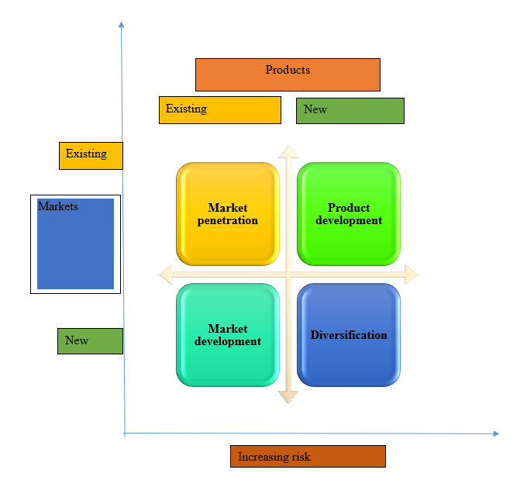
Figure 3: Ansoff matrix
(Source: Self-developed)
The Ansoff matrix conveys the spectrum of different strategies that will be relevant for Marriott International to create new value propositions. Product development of the matrix can be ideal strategy for improving sustainability operations in the internal structures. This can modify the existing service and product lines into new product and service lines across the existing market landscape. The promotional strategies of marketing mix needs to be changed to highlight these latest transitions for grabbing wider custom attention.

Tactics
The strategies pertaining to public relation of the communication mix can be deployed more effectively for Marriott International. This will help in turning the brand message into successful stories for sustainability in the internal operations to target audience. This also helps in creating more positive reviews and enabling strategic partnerships with various media partners and customer base (Ukaj, 2016). This can help in amplifying the revenue indices. Focusing on proper internal sustainability and advertisements can grab wide attention that can helping overcoming the pandemic shocks and market competition issues. Focussing on sustainability can also balance the threat of the legal enforcements on environmental laws. Marriott International current social media platform for communications reflects the presence of different brands on the same page (Marriott, 2023b) (Refer to Appendix 1). However it is immensely confusing for a beginner. Hence navigation route in the communication has be improved. Necessary simplification is missing in the communication platform. Proper website support, calling assistant should be more effectively be made available to the customer section.

Action
Table 5: Gnatt chart
(Source: Self-developed)
Analysis:
The gnatt chart represent the different marketing channels that will be used for Marriott International. The TV is still a popular mode of communication, hence that will be used. The website and social media platforms are interactive domain of communication in the presence scenario (Kapoor et al., 2018). Using website and social media as marketing channels for the new set of internal operations and activities can reach to more effective customer base in a cost effective manner and can generate stronger customer response.

Control
The success measurement towards marketing ventures of sustainability through modification the internal structures of Marriott International will be measured on the basis of new subscription of the customers across the website and social media platforms. The positive attitude towards the brand and direct impact on escalating the revenue indices will also be effective metrics in measuring the success of marketing this ventures.

Conclusion
The marketing plan focuses on the aspect of sustainability for amplify the customer inflows by modifying the internal structures more effectively towards sustainable operations. However challenges pertaining to resentment of employees, difficulty in deployment of technology and communication issues can dampan the success of the marketing plan. These challenges can be overcome by working on the communication loops, focusing on employee training towards sustainability, strategizing the organisational policies towards more sustainability enclosures.

PPT Presentation

Introduction
- Presentation deals with the marketing plan of Marriott International
- Marketing plan focuses on using sustainability
- In the domain of modifying the internal structures and operations
- For creating values and ensuring wider customer inflows
The presentation deals with the marketing plan for improving the advertisements of Marriott International to expand across the established target market. The marketing plan focuses on using sustainability in modifying the internal structures and operations for creating values and and ensuring wider customer inflows.The 4Ps in the marketing theories are used more effectively.

Situation analysis
- Global presence and brand reputation are strengths (Marriott, 2023)
- The pandemic impact needs to be considered.
- Marriott International enjoy the superior position
- Economic and legal factors are the threats
The strength of the company in terms of global presence and brand reputation are positive factors for the company. But intense market competition can damage the repetition. The pandemic impact needs to be considered. The customer targets the social media ,website and positions its services on the basis of quality and premium pricing. It enjoy the superior position as compared to the market competitors and uses differentiation strategy. However economic and legal factors are the threats for the company. The marketing mix reflects the global presence and premium pricing of the service ranges.

Objectives, strategy and tactics
- Objective of the marketing plan is to focus on sustainability parameters
- Product development can be idle strategy
- Public relations of the communication mix can be effective (Influenced by Todorova, 2015)
The objective of the marketing plan is to focus on sustainability parameters by recaliberation of the internal structures and operations and generating positive values for the stakeholders for wider customer inflows. The product development can be idle strategy for improving sustainability across the internal operations and structures. Public relations of the communication mix can be effective in publicity of the sustainability enforcement in the internal structures for positive value creations.

Action and control
- TV, websit and social media platform are the marketing channels
- Ensuring wider reach in a cost effective manner
- Success measurement through the new subscriptions and reviews
TV, website and social media platform are the marketing channels to be used. This will help in ensuring wider reach in a cost effective manner. The success measurement will be done through the new subscriptions and the positive attitude and reviews availed through the platforms.

Conclusion
- Marketing plan will face challenging terms of technology inclusions, communication problems employee resentment
- This can be overcome by working on the communication pattern
- Strategic training, prioritising organisation policies can be useful
The marketing plan will face challenging terms of technology inclusions, communication problems employee resentment. This can be overcome by working on the communication pattern, strategic training, prioritising organisation policies for sustainability.

References

Marketing Plan
Government of UK (2023). The UK Government’s Approach to Stabilisation. [online] Available at: https://assets.publishing.service.gov.uk/media/5c7ff0ebe5274a39d4e4736d/Chapter_1_The_UK_Government_s_Approach_to_Stabilisation__incl._exec_sum_.pdf [Accessed 2023].
Governments of UK (2023a). Gross Domestic Product (GDP) - Office for National Statistics. [online] Ons.gov.uk. Available at: https://www.ons.gov.uk/economy/grossdomesticproductgdp [Accessed 2023].
Governments of UK (2023b). Technology - great.gov.uk international. [online] www.great.gov.uk. Available at: https://www.great.gov.uk/international/content/investment/sectors/technology/ [Accessed 2023].
Kapoor, K.K., Tamilmani, K., Rana, N.P., Patil, P., Dwivedi, Y.K. and Nerur, S. (2018). Advances in Social Media Research: Past, Present and Future. Information Systems Frontiers, 20(3), pp.531–558.
Marriott (2019). csr-marriott. [online] csr-marriott. Available at: https://serve360.marriott.com/ [Accessed 2023].
Marriott (2023a). Core Values and Heritage | Marriott International Corporate Values. [online] Marriott International. Available at: https://www.marriott.com/culture-and-values/core-values.mi#:~:text=We%20Pursue%20Excellence&text=Marriott [Accessed 2023].
Marriott (2023b). Marriott Bonvoy Customer Service and Online Help. [online] help.marriott.com. Available at: https://help.marriott.com/s/article/Article-22423 [Accessed 2023].
Marriott International (2023). Hotel Platform & Reservation System | Marriott International. [online] www.hotel-development.marriott.com. Available at: https://www.hotel-development.marriott.com/power-of-marriott [Accessed 2023].
Partridge, J. (2020). Marriott International faces class action suit over mass data breach. The Guardian. [online] 19 Aug. Available at: https://www.theguardian.com/business/2020/aug/19/marriott-international-faces-class-action-suit-over-mass-data-breach [Accessed 2023].
Ridley, K. (2020). Marriott faces London lawsuit over vast data breach. Reuters. [online] 19 Aug. Available at: https://www.reuters.com/article/us-britain-marriott-dataprotection/marriott-faces-london-lawsuit-over-vast-data-breach-idUSKCN25F0S2/#:~:text=LONDON%20(Reuters)%20%2D%20Marriott%20International [Accessed 20 Nov. 2023].
Ruta, M. (ed ) (2022). The Impact of the War in Ukraine on Global Trade and Investment. openknowledge.worldbank.org. [online] Available at: https://openknowledge.worldbank.org/entities/publication/8a37c7fb-5fd8-56aa-bb7e-2a0970c468d9 [Accessed 2023].
Singagerda, F.S. and Riadi, S. (2019). Competitive Advantage of Family Business and the Barriers: Evidence from Indonesia SME’s. Proceedings of the Proceedings of the 1st Workshop on Multidisciplinary and Its Applications Part 1, WMA-01 2018, 19-20 January 2018, Aceh, Indonesia. [online] doi:https://doi.org/10.4108/eai.20-1-2018.2281916.
Statista (2022a). Marriott brand profile UK 2022. [online] Statista. Available at: https://www.statista.com/forecasts/1335619/marriott-hotels-brand-profile-in-the-uk#:~:text=In%20total%2C%2028%25%20of%20UK [Accessed 20 Nov. 2023].
Statista (2022b). Sustainable brands: reasons for preference in the U.S. & UK 2022. [online] Statista. Available at: https://www.statista.com/statistics/1318133/consumers-reasons-for-preferring-sustainable-brands/#:~:text=In%202022%2C%20one%20of%20the [Accessed 20 Nov. 2023].
Ukaj, F. (2016). Public Relations as Part of Integrated Communication of an Enterprise-Consumer Oriented On. Journal of Marketing Management, [online] 4(1), pp.2333–6099. doi:https://doi.org/10.15640/jmm.v4n1a7.

PPT presentation
Marriott (2023). Brand Value. [online] Available at: https://marriott.gcs-web.com/static-files/6c691ae7-0c1e-44ff-85c0-4a790721428b [Accessed 2023].
Todorova, G. (2015). Marketing Communication Mix. Trakia Journal of Science, [online] 13(1), pp.368–374. Available at: https://www.researchgate.net/publication/304418915_Marketing_communication_mix [Accessed 2023].

Appendixes

Appendix 1: Marriott International website assistance
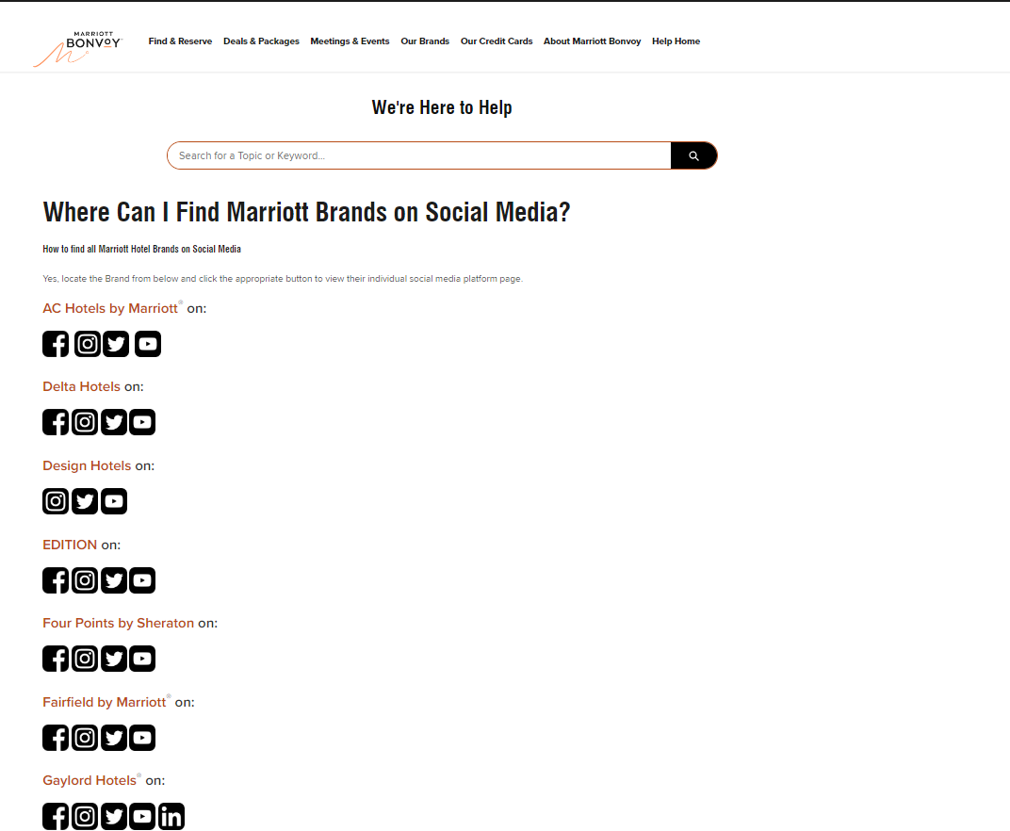
(Source: https://help.marriott.com/s/article/Article-22423)

Appendix 2: PPT slides



