

Programme: BA (Hons) Business Management
Module: Understanding Organisational Structure and Culture
Module code: LCBB4009
Assignment Title: Component 2: Coursework: Individual report
Investigating the Role of Communication in the Business Environment
A Case Study of Amazon
Student Name: Denisa-Amalia Torok
Student Id: 2410482

Table of Contents
1. Introduction 3
2. Communication and Methods 3
3. Common Issues 4
4. Recommendations 6
5. Conclusion 6
References 7

List of figures
Figure 1 Amazon Employment Trends (2023-2026) 4
Figure 2 Amazon Return-to-Office Timeline (2023–2025) 5

1. Introduction
Communication plays a significant part in the functioning and development of businesses. It involves the transfer of information, ideas and instructions from one person to another to ensure work is completed correctly and within a specified time (Robbins and Coulter, 2021). When communication fails, it leads to delays, conflict, loss of trust, and effective communication fosters teamwork and enhances performance (Aririguzoh, 2022). This report examines the concept of communication in the business world, applying it to the case organisation, Amazon. Amazon is a large global retail and technology company that relies on constant communication between all the divisions and departments. The report describes the concept of communication, discusses common forms of communication, addresses the challenges that Amazon is facing, and provides practical suggestions for improvement.

2. Communication and Methods
The concept of communication in a business context implies that meaning is transferred and understood by a sender and a receiver (Falkheimer and Heide, 2022). The process includes seven elements: sender, message, encoding, channel, decoding, receiver and feedback, and noise which is anything that interferes with the message (Mullins and McLean, 2019). Communication is essential since it can help managers provide instructions, keep employees informed about company goals, and it can aid with proper decision making between departments. There are a number of functions of communication in a business. It sets rules and procedures to control behaviour, clarifies expectations for staff motivation, gives space for emotional expression, and supplies information for decision making (Yue, Men and Ferguson, 2021).
In business, there exist three main communication methods. Oral communication encompasses meetings, phone calls and presentations. It gives fast feedback and personal connection, however messages can be remembered and forgotten or misinterpreted when they are transferred from one person to another (Falkheimer and Heide, 2022). In Amazon, oral communication is utilised every day in team meetings that take place within functional departments, like Operations and Human Resources, to coordinate and ensure tasks are carried out the right way, and to share updates in a timely manner (Olson, 2023).
Written communication involves e-mail, memos, reports and internal communication systems. It is for detailed or details, useful for a permanent record, yet it might be slower and susceptible to misinterpretation if no tone or body language is used. Written communication is extremely important to Amazon, as the predominant method of communication is through formal memos from senior-level leaders. These messages are used to communicate information to employees regarding policies, expectations and strategic decisions. For instance, CEO Andy Jassy announced the company's return-to-office policy via a company-wide memo to all corporate employees, demonstrating the use of written communication for changes at Amazon (Palmer, 2024).
Nonverbal communication comprises of body language, facial expression and voice tone. It can convey emotions that are not conveyed in words and can reinforce or undermine the spoken message (Huczynski and Buchanan, 2019). Nonverbal communication is especially crucial in face-to-face interactions in large companies, such as Amazon that has more than 1.5 million employees around the world (Revelio Labs, 2026). For instance, warehouse briefings and leadership town-halls rely on tone, gestures and facial expression to convey confidence, urgency and openness, which can determine whether the message is understood, interpreted, and acted upon appropriately by employees.
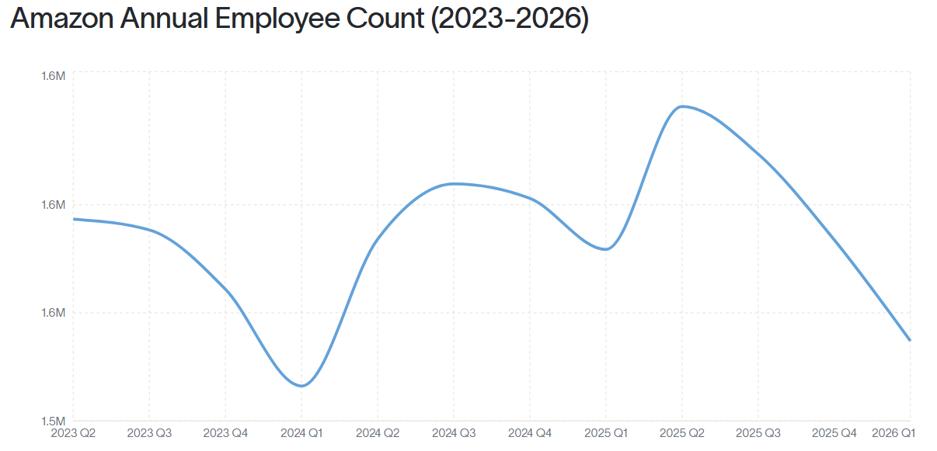
Figure 1 Amazon Employment Trends (2023-2026)
Source: (Revelio Labs, 2026)
It is important that the proper method is selected based on the urgency, confidentiality, cost, and whether or not a permanent record is required (Robbins and Coulter, 2021). Amazon's global size requires a mix of verbal, visual, and nonverbal communication, enhanced with digital tools. This blend helps the organisation to communicate effectively, stay informed in terms of clarity and consistency and keep the large, diverse workforce informed and aligned.

3. Common Issues
There are a number of common communication issues that Amazon struggles with due to its size. One common issue is miscommunication, where the person who sends the message does not match the person who receives it, because most often there is filtering or shaping of the information that occurs before it is sent out (Verhoeven and Madsen, 2022). This can be seen in Amazon's announced return to office decision in 2024. The memo by CEO Andy Jassy to all employees to work five days a week from the office caused many to feel the reasoning was not in sync with their true work experience, and thousands signed up to various internal channels to express frustration (Palmer, 2024). Many staff members interpreted the message of collaboration as an attempt to save money as there was a distinct difference between what was communicated and what was understood.
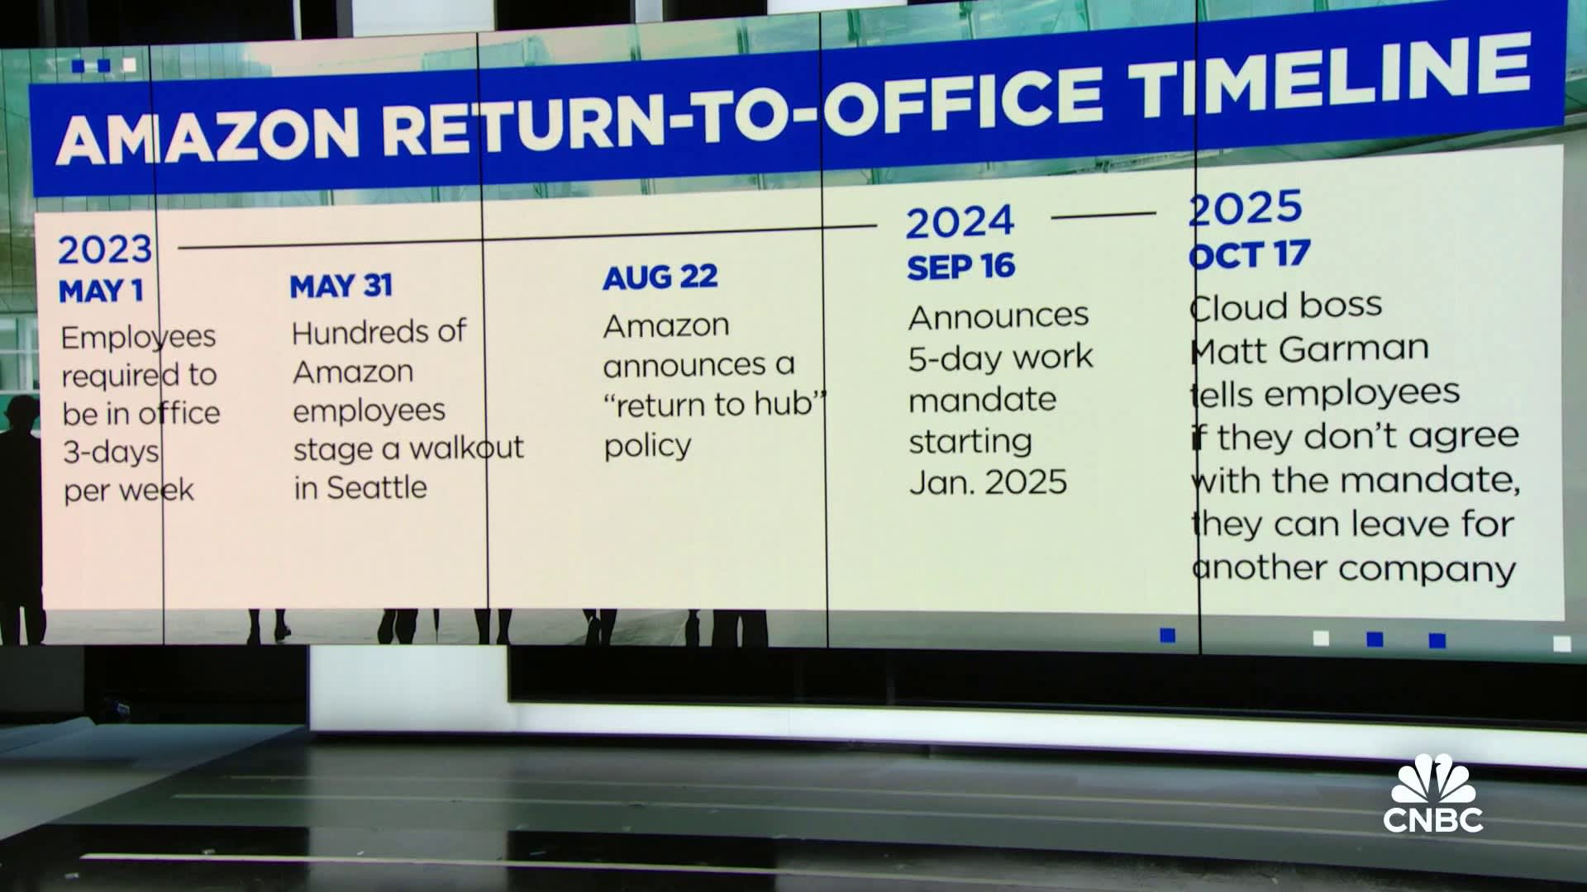
Figure 2 Amazon Return-to-Office Timeline (2023–2025)
Source: (Palmer, 2024)
Emotions also are a major obstacle as the receiver's feelings may affect the way the message is received (Mullins and McLean, 2019). This was clearly seen at Amazon after the return to the office memo, where a survey revealed that the majority of Amazon workers were not happy with the idea of going back to the office, and many are looking into the possibility of leaving Amazon (Battle, 2024). Strong negative emotion impacted the receiving and understanding of the policy by employees. As a result, it became more of a trust problem between employees and employers as part of a broader rollout of the new policy.
Cultural barriers also impact communication, as various national cultures tend to prefer various modes and styles of communication (Aririguzoh, 2022). Amazon is operating in over 25 countries with approximately 75,000 employees in the UK, 60,000 employees in Germany and 100,000 employees in India alongside its large workforce in the USA (Arishekar, 2026). The managers who manage multicultural teams across these regions need to be flexible in their approach as employees from each national culture have varying ideas of what constitutes direction, formality, and feedback. If managers are not aware of these differences, messages across country can be misinterpreted.
Another barrier which is related, but different is language, particularly with the multilingual nature of Amazon's workforce. Amazon's KCVG air cargo hub has been the workplace for many immigrants who speak English as a second language, but the company failed to initially translate basic safety and work-related information. This made the workplace more dangerous, and workers campaigned for guaranteed translation, with Amazon agreeing to provide translation later on (Center for Work and Democracy, 2023).
Lastly, there is also the fear of too much information in an organisation as large as Amazon's, with 1.5 million employees across multiple countries and time zones, all needing to be kept up to date (Revelio Labs, 2026). Regular, company-wide communication memos can result in messages being missed or ignored by employees, which can impact the effectiveness of communication (Campbell, Campbell-Phillips and Phillips, 2020).

4. Recommendations
Amazon can solve these problems in a number of practical ways. First, leadership should be more active in receiving feedback, including surveys and open forums discussions, prior to the implementation of large decisions, such as the return-to-office policy, to ensure that employee concerns are heard early on (Gibson et al., 2023). Second, Amazon should make the language of memos easy to read and provide translation services as a standard across all sites where there are a variety of workers, expanding on the translation rights obtained at KCVG (Center for Work and Democracy, 2023). Thirdly, managers need to be active listeners and invite employees to share their perspectives, ask questions, and give feedback during their team meetings rather than just taking instructions (Hofmeister, 2024). Fourth, Amazon should not delete employee posts on internal channels; rather, they should consider open discussion as beneficial feedback and not a threat. Lastly, key messages should be prioritised and limited in number to avoid information overload and to ensure staff remain truly informed.

5. Conclusion
Finally, communication is a key element of Amazon's operations, of how it brings people together from around the world to work for Amazon, and of how the organization manages change. This report has clarified about communication and stated its primary methods, such as oral communication, written communication and nonverbal communication. It's also pointed out the actual challenges Amazon encountered in communication, such as filtering, emotional reactions, language barriers and limited internal discussions that happened during the 2024 return-to-office memo and the KCVG translation case. Recommendations such as providing better feedback, using simpler language, providing translation support and active listening provide practical methods for Amazon to enhance. Good communication is still a vital aspect of any business, as it fosters trust, aids in collaboration, and helps organisations navigate change effectively.

References
Aririguzoh, S. (2022) ‘Communication competencies, culture and SDGs: effective processes to cross-cultural communication’, Humanities & Social Sciences Communications, 9(1). Available at: https://doi.org/10.1057/s41599-022-01109-4.
Arishekar, N. (2026) ‘How many people work for Amazon in 2026?’, AMZ Prep, 11 May. Available at: https://amzprep.com/how-many-people-work-for-amazon/ (Accessed: 15 August 2026).
Battle, P. (2024) Amazon’s new return-to-office mandate is starting to backfire, Thestreet.com. Available at: https://www.thestreet.com/employment/amazon-rto-mandate-backlash (Accessed: 15 August 2026).
Buchanan, D.A. and Huczynski, A. (2019) Organizational behaviour: Buchanan and huczynski. 10th edn. London: Pearson Education.
Campbell, S., Campbell-Phillips, S. and Phillips, D. (2020) ‘Lack of communication between management and employees’, SIASAT, 5(3), pp. 32–39. Available at: https://doi.org/10.33258/siasat.v5i3.67.
Center for Work and Democracy (2023) KCVG workers win translation rights for hundreds of workers, Asu.edu. Available at: https://cwd.asu.edu/kcvg-workers-win-translation-rights-hundreds-workers (Accessed: 15 August 2026).
Falkheimer, J. and Heide, M. (2022) Strategic communication: An introduction to theory and global practice. London: Routledge.
Gibson, C.B. et al. (2023) ‘Should employees be required to return to the office?’, Organizational Dynamics, 52(2), p. 100981. Available at: https://doi.org/10.1016/j.orgdyn.2023.100981.
Hofmeister, M. (2024) ‘Effective communication’, Clinical Laboratory Management. Wiley, pp. 123–134. Available at: https://doi.org/10.1002/9781683673941.ch8.
Mullins, L.J. and McLean, J.E. (2019) Organisational behaviour in the workplace. 12th edn. London: Pearson Education.
Olson, T.C. (2023) ‘Communication, conflict, and negotiation’, in Organizational Behavior. Cham: Springer International Publishing, pp. 157–182.
Palmer, A. (2024) Amazon CEO Andy Jassy denies that 5-day office mandate is a ‘backdoor layoff’, CNBC. Available at: https://www.cnbc.com/2024/11/05/amazon-ceo-andy-jassy-5-day-office-mandate-isnt-a-backdoor-layoff.html (Accessed: 15 August 2026).
Revelio Labs (2026) ‘Amazon Workforce Dataset - How many employees work at Amazon?’ Revelio Labs. Available at: https://www.reveliolabs.com/companies/amazon/employees (Accessed: 15 August 2026).
Robbins, S. and Coulter, M. (2021) Management. 15th edn. Global Edition: Pearson.
Verhoeven, J.W.M. and Madsen, V.T. (2022) ‘Active employee communication roles in organizations: A framework for understanding and discussing communication role expectations’, International Journal of Strategic Communication, 16(1), pp. 91–110. Available at: https://doi.org/10.1080/1553118x.2021.2014503.
Yue, C.A., Men, L.R. and Ferguson, M.A. (2021) ‘Examining the effects of internal communication and emotional culture on employees’ organizational identification’, International Journal of Business Communication, 58(2), pp. 169–195. Available at: https://doi.org/10.1177/2329488420914066.

