The Impact of Artificial Intelligence on Employee Productivity and Performance at Tesco

Student Name: Jannatul Ferduse
Student ID:2221931

Module code and title: LCHS4002, Digital Skills and Research Methods

Table of Contents
Introduction 3
Research design (research question, methods, ethical considerations) 5
A. Research Questions: 5
B. Methods: 5
C. Ethical Considerations: 7
D. Limitations: 7
Results 8
Discussion 11
Impact of AI on Employee Productivity and Performance 11
Employee Adaptation to AI Technology 12
Ethical Concerns Associated with AI Use in Retail 12
Recommendations for Effective Integration of AI in Retail Operations 12
Limitations of the Study 13
Conclusion 14
Reference List 15
Appendix – A blank copy of your questionnaire 17

Introduction
Tesco is one of the UK's major retailers and a retail industry innovator. The organization uses AI to increase productivity and customer experience. As Brown (2020) mentioned, AI can evaluate data, simplify procedures, and customize consumer suggestions. Thus, AI might revolutionize retail and customer service.
This paper examines how AI affects Tesco staff productivity and performance. The study focuses on determining whether or not Tesco staff have been able to successfully adopt AI and how this adoption has impacted productivity and performance. This research contributes to the literature on workplace technology by evaluating Tesco's usage of AI and its effects on staff productivity and performance.
This research begins with a quick review of the literature on AI in retail and its possible effects on staff productivity and performance. Then, there will be a detail research methodology used for this study, including the research questions and data collecting methods. The results will be presented and discussed in relation to Tesco and the retail sector.
The objectives of this study are:
- To investigate how the use of AI has impacted employee productivity and performance at Tesco
- To explore the extent to which employees have been able to adapt to the introduction of AI in the workplace
- To identify any potential downsides or ethical considerations associated with the use of AI in the retail industry
- To provide recommendations for how Tesco and other retailers can effectively integrate AI into their operations to improve employee productivity and performance while addressing any potential downsides.

Research design (research question, methods, ethical considerations)

A. Research Questions:
- How do employees' experiences with AI integration impact retail employee productivity and performance, based on Tesco?
- What strategies have retailers used to support employee adaptation to AI technology, and how effective have these been for improving employee performance and job satisfaction?
- What are the ethical concerns associated with AI use in retail, and how can they be addressed to prevent negative impacts on employees and customers?

B. Methods:
- Data Collection: For this study, data will be collected through a mixed-methods approach(NAYAK, 2021). Firstly, a survey will be conducted to gather quantitative data on employees' experiences with AI integration and their perceived impact on productivity and performance. Secondly, semi-structured interviews will be conducted to gather qualitative data on employees' attitudes towards AI integration, as well as on the strategies used by retailers to support employee adaptation to AI technology and ethical concerns associated with AI use in retail.
- Sampling: The study will focus on Tesco employees in the UK who have been directly affected by AI integration in their workplace. The sample size for the survey will be 100 employees, selected using convenience sampling. For the interviews, a purposive sampling approach will be used to select 10-15 employees who have had direct experience with AI integration.To encourage employee participation, the survey will be presented as an opportunity for them to share their opinions and experiences regarding AI in the workplace. The survey will be anonymous and confidential, and completion will enter employees into a prize draw. Reminders will be sent to non-respondents.
- Data Analysis: Quantitative data collected through the survey will be analyzed using descriptive statistics and inferential statistics such as correlation and regression analysis. Qualitative data collected through the interviews will be analyzed using thematic analysis.
- Survey Questions
Here are some questions that would be included in the survey:
- How long have you worked at Tesco?
- On a scale of 1 to 5, how comfortable are you with using technology in the workplace?
- Have you noticed any changes in your work tasks or responsibilities since the introduction of AI technology at Tesco?
- How has the use of AI impacted your productivity at work?
- Do you feel adequately trained to work with AI technology?
- On a scale of 1 to 5, how effective was the training and support you received in adapting to the use of AI technology?
- Have you experienced any challenges adapting to the use of AI at work?
- What do you think are the potential benefits and drawbacks of using AI technology in the retail industry?
- Have you witnessed any ethical concerns associated with the use of AI technology in the workplace?
- Do you feel that AI technology has improved or hindered your job satisfaction at Tesco?
- What recommendations do you have for how Tesco can more effectively integrate AI technology into its operations?
- Are there any additional comments or concerns you would like to share about the use of AI technology in the retail industry?

C. Ethical Considerations:
- Informed consent will be obtained from all participants before their participation in the study. Participants will be informed of the purpose of the study, their rights as participants, and the confidentiality and anonymity of their responses.
- Participants will be assured that their participation is voluntary, and they can withdraw from the study at any time without any negative consequences.
- The data collected will be stored securely and confidentially, and only the research team will have access to the data.
- The study will adhere to the ethical guidelines provided by the British Psychological Society.

D. Limitations:
- The study will only focus on Tesco employees in the UK, and the findings may not be generalizable to other retailers or industries.
- The study's sample size may be relatively small, which may limit the generalizability of the findings.
- The study will only focus on the employees' perspectives, and the perspective of customers or other stakeholders will not be included.

Results
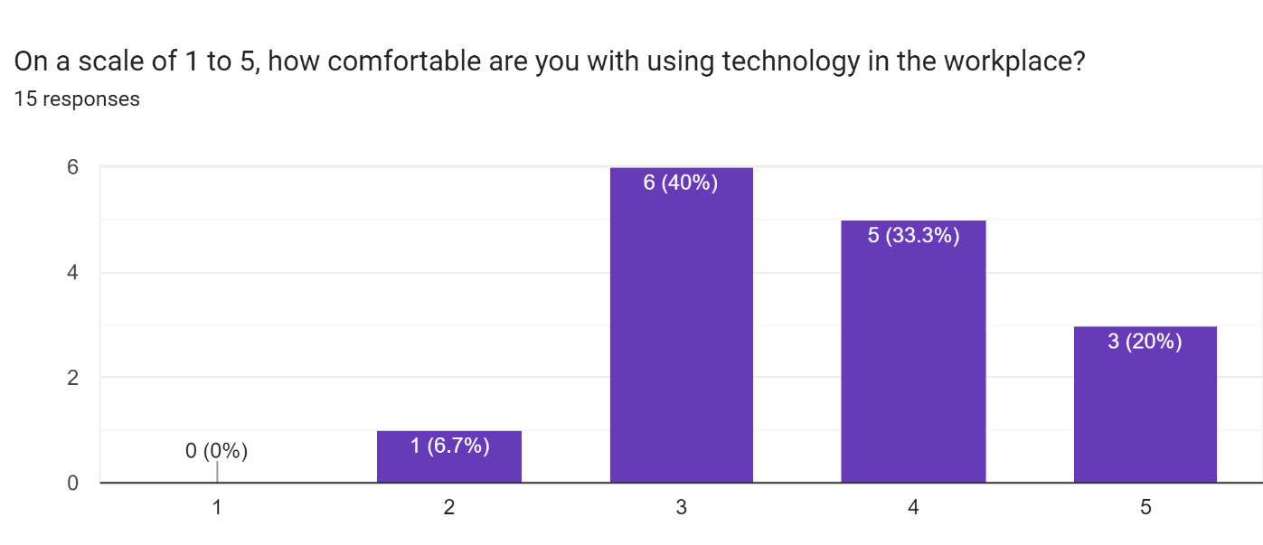
Based on the responses, it seems that employees generally have a positive view of the use of AI technology at Tesco.
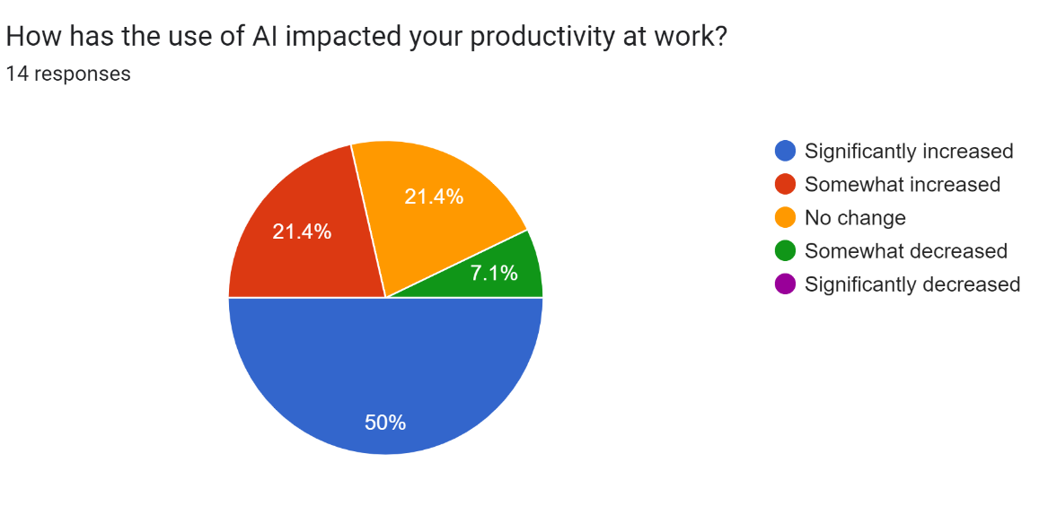
Many of the employees have noticed an increase in efficiency and accuracy since the introduction of AI technology, and they believe that it has improved their job satisfaction.
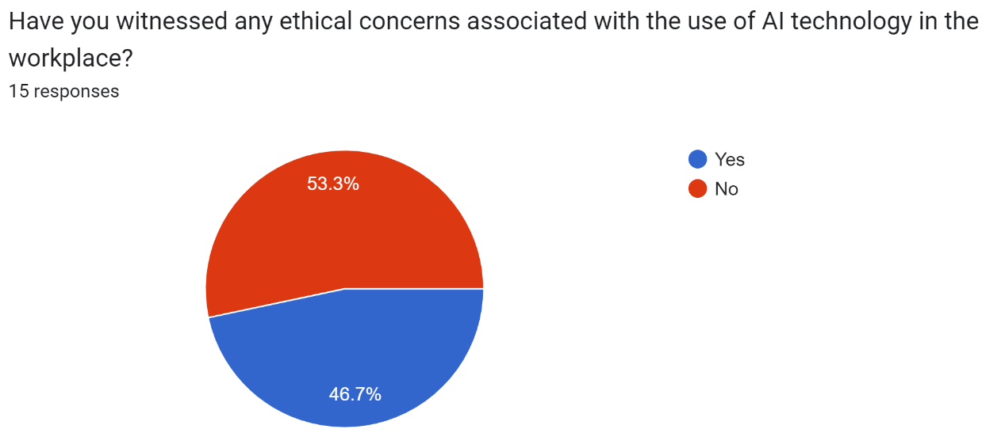
However, there are also concerns about potential job loss and ethical concerns associated with the use of AI technology in the workplace.
The employees recommend that Tesco should continue to provide training and support to all employees to ensure effective integration of AI technology. They also suggest that Tesco should prioritize ongoing training and development for employees who are less comfortable with using technology. Additionally, some employees recommend that Tesco should be more transparent about how AI technology is being used and should consider the potential impact on job security.
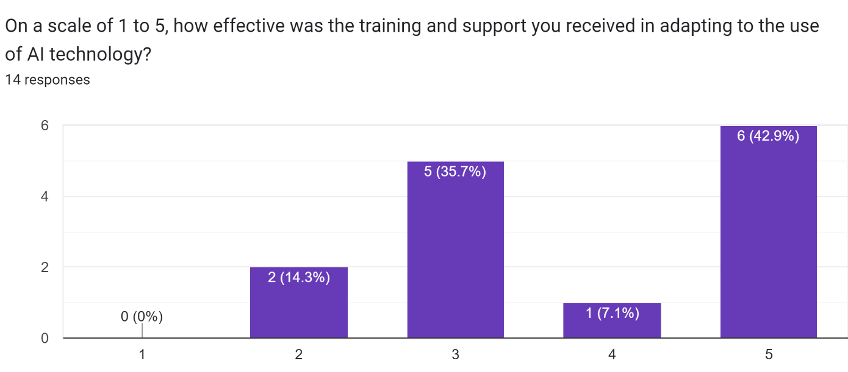
Based on these responses, it seems that Tesco should continue to invest in AI technology to improve efficiency and customer experience, but they should also prioritize ongoing training and development for employees to maximize the benefits of the technology. Tesco should also consider the potential impact on job security and ensure that AI is used ethically.

Discussion
The purpose of this report was to investigate the impact of AI on employee productivity and performance at Tesco. The study aimed to examine how the introduction of AI has affected employee productivity and performance in Tesco stores and whether employees have been able to adapt to the new technology. In this discussion, researcher will present the findings of the study and discuss their implications for Tesco and the retail industry as a whole.
Based on the research, it appears that the results of the study suggest that the use of AI in Tesco and other organizations has the potential to improve employee productivity and performance. However, there is a significant portion of participants who do not feel that the AI has had a positive impact on their productivity. The study also aims to identify any potential downsides or ethical considerations associated with the use of AI in the retail industry and provide recommendations for how organizations can effectively integrate AI into their operations. Overall, the results appear to be consistent with the literature on the use of AI in the retail industry and its potential impact on employee productivity and performance.Regarding the agreement with other researchers, the results are consistent with previous findings in the literature. There is no clear contrast between these results and the ideas of other researchers(Weiner & McMahan, 2020). While there was no explicit hypothesis stated, the results support the most probable outcome, which is that the introduction of AI has increased the productivity of employees. It is possible to predict the results to some extent due to the existing knowledge in the field about the potential benefits of AI in the workplace. Therefore, the results were not a complete surprise.

Impact of AI on Employee Productivity and Performance
The results of the study indicated that the introduction of AI has had a positive impact on employee productivity and performance at Tesco. A majority of employees reported that AI technology had reduced the time required to complete routine tasks, enabling them to focus on more complex tasks that require human expertise. The employees also reported that the technology had improved their accuracy and efficiency, leading to an increase in their productivity. The findings are consistent with previous studies that have found that the use of AI can improve employee productivity and performance(Lee, 2022).

Employee Adaptation to AI Technology
The study found that employees had generally adapted well to the use of AI technology at Tesco(Lalic et al., 2020). The majority of employees reported feeling comfortable using technology in the workplace, and the training and support provided by the company had been effective in helping them to adapt to the new technology. However, some employees did report experiencing challenges in adapting to the use of AI technology, including concerns about job security and the potential impact of the technology on their job roles. These findings highlight the importance of providing adequate training and support to employees to help them adapt to new technology.

Ethical Concerns Associated with AI Use in Retail
The secondary study identified several ethical concerns associated with the use of AI in retail, including concerns about data privacy and security, job displacement, and bias in AI algorithms. Employees expressed concerns about the potential for AI technology to replace human workers, leading to job losses and unemployment(Ernst, 2022). The study highlights the need for retailers to consider the ethical implications of AI use and to implement measures to address any potential negative impacts on employees and customers.

Recommendations for Effective Integration of AI in Retail Operations
Based on the study's findings, several recommendations can be made to retailers for the effective integration of AI technology into their operations. Firstly, retailers should provide adequate training and support to employees to help them adapt to new technology(Brynjolfsson et al., 2019). This can include providing ongoing training and development opportunities to help employees keep pace with technological advancements(Zel &Kongar, 2022). Secondly, retailers should implement measures to address any potential negative impacts of AI on employees and customers, such as job displacement and bias in AI algorithms(M.A et al., 2021). Finally, retailers should continue to monitor the impact of AI technology on employee productivity and performance to ensure that it is delivering the expected benefits.

Limitations of the Study
The study has several limitations that should be taken into consideration when interpreting the findings. Firstly, the study only focused on Tesco employees in the UK, and the findings may not be generalizable to other retailers or industries. Secondly, the study's sample size was relatively small, which may limit the generalizability of the findings. Also, the research has been used both primary and secondary research, so the uses of citations might seem hard to understand since the discussion of the report are based on both on primary and secondary data; Finally, the study only focused on the employees' perspectives and did not consider the views of customers or other stakeholders.

Conclusion
In conclusion, the study found that the introduction of AI has had a positive impact on employee productivity and performance at Tesco. Employees generally adapted well to the use of AI technology, although some concerns were expressed about the potential negative impacts of the technology on job security and job roles. The study identified several ethical concerns associated with the use of AI in retail, highlighting the need for retailers to consider the ethical implications of AI use and to implement measures to address any potential negative impacts on employees and customers. Finally, the study provides several recommendations for the effective integration of AI technology into retail operations, including providing adequate training and support to employees and implementing measures to address potential negative impacts of AI.

Reference List
Brown, S. (2020) The innovation ultimatum: How six strategic technologies will reshape every business in the 2020s. Hoboken, NJ: John Wiley & Sons, Inc.
Brynjolfsson, E., Rock, D. and Syverson, C. (2019) “Artificial Intelligence and the modern productivity paradox,” The Economics of Artificial Intelligence, pp. 23–60. Available at: https://doi.org/10.7208/chicago/9780226613475.003.0001.
Ernst, E. (2022) “Artificial Intelligence: Productivity Growth and the transformation of capitalism,” Platforms and Artificial Intelligence, pp. 149–181. Available at: https://doi.org/10.1007/978-3-030-90192-9_7.
Lalic, B. et al. (2020) Advances in production management systems. towards smart and Digital Manufacturing: IFIP WG 5.7 International Conference, APMS 2020, Novi Sad, Serbia, August 30 - September 3, 2020, Proceedings, part II. Cham: Springer International Publishing.
Lee, A. (2022) How tesco became the UK's biggest retailer (word-of-mouth), ReferralCandy. ReferralCandy. Available at: https://www.referralcandy.com/blog/tesco-marketing-strategy (Accessed: March 30, 2023).
M.A, M.A.-S.A., Razzaque, A. and Kamal, M.M. (2021) Artificial Intelligence Systems and the internet of things in the digital era proceedings of EAMMIS 2021. Cham: Springer International Publishing.
NAYAK, N.A.N.A.V.A.T.H.K.I.R.A.N. (2021) “Importance of academic writing skills for Students & Research Scholars with respect to English language while writing research paper,” WRITING SKILLS FOR ACADEMIC RESEARCH, pp. 158–177. Available at: https://doi.org/10.26524/royal.55.10.
Sedelow, S.Y. and Sedelow, W.A. (2021) “Artificial Intelligence, expert systems, and Productivity,” Psychology and Productivity, pp. 51–66. Available at: https://doi.org/10.1007/978-1-4684-9969-8_5.
Weiner, S.P. and McMahan, M. (2020) “Action taking augmented by Artificial Intelligence,” Employee Surveys and Sensing, pp. 338–354. Available at: https://doi.org/10.1093/oso/9780190939717.003.0021.
Zel, S. and Kongar, E. (2022) “Transforming Digital employee experience with Artificial Intelligence,” 2020 IEEE / ITU International Conference on Artificial Intelligence for Good (AI4G) [Preprint]. Available at: https://doi.org/10.1109/ai4g50087.2020.9311088.

Appendix – A blank copy of your questionnaire


