A Study on Marriott Hotel’s Response to the COVID 19 Crisis
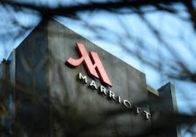

Student Name: Patel Uttam Bhai Kanu Bhai
Student Id: 2237232
Subject: Marketing Management
University: UWTSD (Birmingham)
Lecturer: Efua Adams

Abstract
This study investigates the Marriott Hotel's response to the COVID-19 incident. The study looks at the responses made by Marriott to the pandemic, including as operational changes, health and safety procedures, and consumer communication initiatives. This report clarifies the efficacy of the hotel chain's crisis management tactics and offers insights into the issues encountered by the hospitality sector during unprecedented times through a thorough review of Marriott's response.

Table of Contents
Abstract 2
1. Introduction 4
2. Discussion 4
Task 1: Critical Evaluation of Marriott International's Marketing Theories and Strategies During the Covid Crisis 4
1.1 Marriott International's Strategic Marketing Response to the COVID-19 Crisis 4
1.2 Marriott’s SWOT analysis in Covid 19 5
1.3 Marriott's Covid 19 Marketing Strategies 7
1.4 Competitive Analysis of Marriott International's Strategies during the Covid Crisis 9
1.5 Impact of Technology in Strategies Implemented During the Crisis 11
1.6 Evaluation of Marriott International's Strategies During the Covid Crisis 12
Task 2: Managerial implication on Marketing Strategies implemented by Marriott International during the Covid 19 Crisis 14
2.1 Managerial Implications on Marriott's Marketing Strategies 14
Task 3: Recommendations for Improving Marketing Strategies in the Post-Pandemic Era 17
3. Conclusion 19
Reference 20

1. Introduction
After the COVID-19 crisis, one of the largest hotel chains in the world, Marriott International, encountered problems that had never been seen before. Marriott quickly adjusted in response to the global pandemic's disruption of the tourism and hospitality sectors. This opening paragraph sums up Marriott's quick response to the issue perfectly and emphasizes the business' dedication to the security and welfare of its customers, employees, and communities. In these difficult conditions, Marriott sought to navigate the hazy environment, regain confidence, and provide its guests with a safe and enjoyable experience. It achieved this by employing a range of cunning tactics, novel concepts, and constant commitment (Kim et al., 2021).

2. Discussion

Task 1: Critical Evaluation of Marriott International's Marketing Theories and Strategies During the Covid Crisis

1.1 Marriott International's Strategic Marketing Response to the COVID-19 Crisis
Marriott Global confronted various difficulties during the Coronavirus emergency, starting in mid 2020 (Kim et al., 2021). The main deterrent was the unexpected and extreme decrease in movement and cordiality interest, as lockdowns and travel limitations were forced around the world. This uncommon circumstance constrained Marriott to quickly adjust its essential showcasing reaction to address contracting client sections, scratch-offs, and income misfortunes. The organization needed to turn its informing to zero in on security and cleanliness measures, carry out adaptable booking approaches, and influence computerized advertising channels to draw in with possible clients. Exploring these difficulties expected dexterity and imaginative showcasing answers for keep up with brand significance and client trust in the midst of the vulnerability of the pandemic (El-Said et al., 2023).
Staff cuts and cost savings: Marriott announced a 50% compensation cut for its leadership staff and laid off a sizable number of workers, mostly in its Maryland headquarters (El-Said et al., 2023). Subject to pandemic conditions, two-thirds of the headquarters personnel will take an initial 90-day unpaid leave of absence (Kim et al., 2021). Through cost-cutting measures, $140 million will be saved and reinvested in the areas that would be most negatively impacted (Sealy, 2020). Those on furlough will receive 20% of their wages for basics and healthcare, while those who return to work will be paid 20% less and work fewer hours each week (El-Said et al., 2023).
Closed Food & Beverage Outlets: Marriott has shut down its food and beverage businesses to halt the spread of COVID-19 and comply with social segregation laws (Sealy, 2020). The objectives of this decision are minimal human contact and reduced transmission risk. However, it also results in a decrease in revenue because there is less consumer demand. Marriott has upgraded cleaning procedures and introduced hand sanitizer in its properties rather than closing any businesses (Kim et al., 2021).
Delayed Audits & Renovations: Marriott hotels and franchises have made the decision to postpone brand standard audits and freeze renovations for a year (Sealy, 2020). To protect the Marriott brand, these examinations and improvements have been put off until at least 2021 (Sealy, 2020). The hotel management staff will presumably experience less stress because of this choice, and resources will be better allocated toward resolving pressing problems that have an impact on the hotel's long-term profitability. Hotels must exercise caution and adhere to brand guidelines, though, as these audits will resume in 2021 (Kim et al., 2021). Marriott wants to promote goodwill in the sector with this action.

1.2 Marriott’s SWOT analysis in Covid 19
Strengths  1. Strong market image  2. Global Presence (Jayati, 2020). | Weakness  1. Strike in various states  2. Limited capacity due to regulations (Jayati, 2020).
Opportunities  1. Develop new projects  2. Strong financial position for future (Jayati, 2020).  3. Use innovative ideas in business | Threats  1. A price war between competitors (Jayati, 2020).  2. Threat of Bankruptc .
Strengths
The company has a strong market image due to its well-known brands and diverse portfolio, which consists of 30 brands throughout 130 countries (Deng, 2022). Despite the challenges posed by COVID-19, Marriott enjoys the advantages of sizable financial reserves and a variety of funding sources that enable it to mitigate the effects of the outbreak (Jayati, 2020). The obstacle’s presented by Marriott's focus on North America due to the COVID-19 problem there, the region's strong economy provides a solid foundation for recovery. Overall, these benefits put Marriott in a position to be resilient over the long run (Jayati, 2020).
Weakness
Marriott's unionized workforce, which is represented by Unite Here and has increased in strength and membership because of successful strikes in various states, is one of the company's disadvantages (Jayati, 2020). Following recent triumphs in Baltimore, San Francisco, San Diego, and Irvine, 1,000 more union members have joined, potentially posing a threat to Marriott in the future (Deng, 2022). The company faces challenges because of its present debt as well, but its considerable cash reserves provide it with an advantage over smaller competitors in minimizing the effects (Jayati, 2020).
Opportunities
Marriott has a large backlog of development projects and cash on hand, which puts it in a strong position. Marriott will still be able to save money and seize chances after the outbreak has gone, even though COVID-19 has delayed development work until 2021 (Jayati, 2020). The travel sector will recover, and Marriott should continue to be ready everywhere.
Threats
Marriott, a prominent player in the intensely competitive hotel industry, faces two possible risks. a price war between competitors and the chance for insolvency due to COVID-19 (Deng, 2022). With Marriott's competitive advantage, it is conceivable to fend off price competition, but staff layoffs can cause controversy and provide valuable information to rivals. The company has taken action to mitigate COVID-19's consequences and avoid going bankrupt (Shin et al., 2021).

1.3 Marriott's Covid 19 Marketing Strategies
Marketing mix explanation with stakeholder’s analysis
Travel agents
Government
High power
Employees
Customers

Low power
Society

Suppliers

High interest

Low interest

Figure 1: Stakeholder’s matrix
Marriott's COVID-19 promoting procedures incorporated a thorough way to deal with address the difficulties presented by the pandemic (Deng, 2022). In the promoting blend, Marriott focused on.
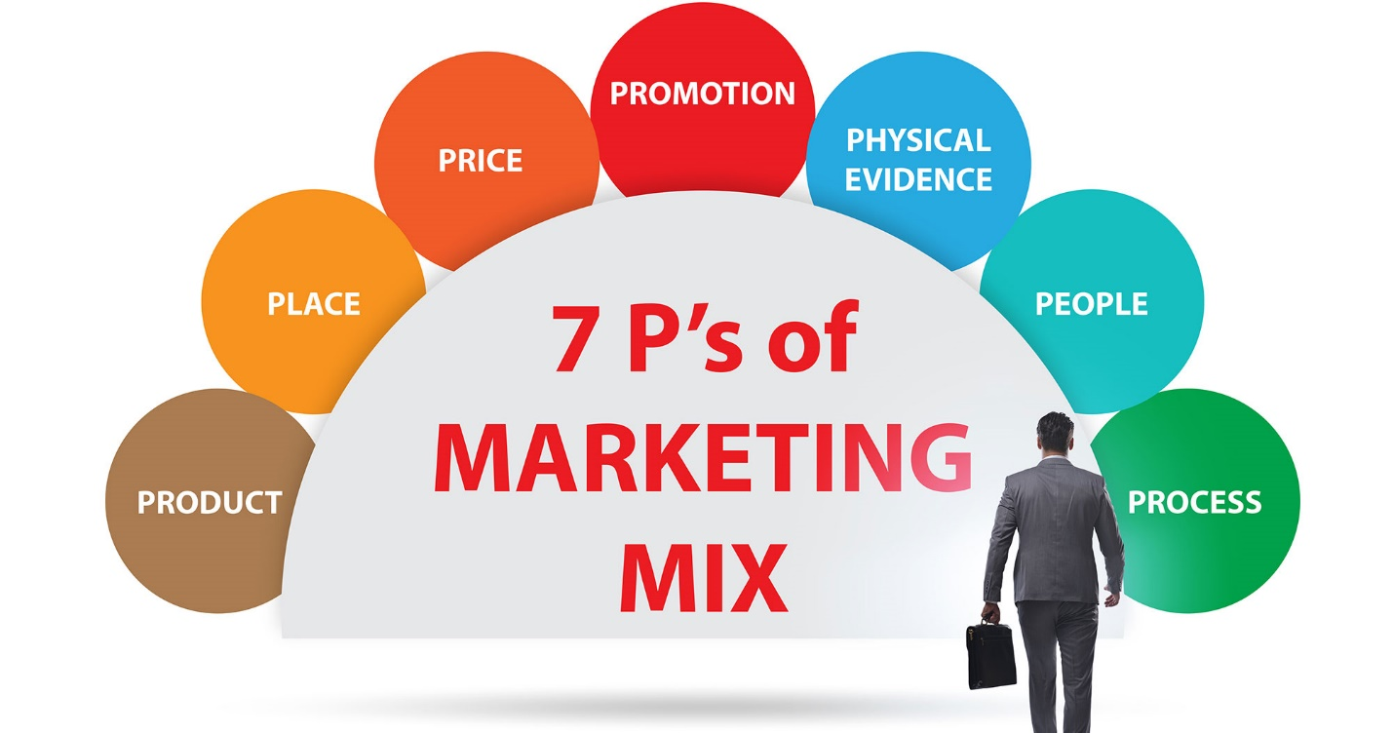
Figure 2: 7 P’s Marketing Mix
Source: (Deng, 2022).
Product: Marriott changed their product lines during the outbreak to cater to the various needs of its customers. They improved safety and sanitary protections by putting in place more rigorous cleaning methods, contactless check-in/check-out, and a variety of dining options. Some product improvements were implemented to safeguard the safety of both customers and personnel. In order to secure their safety and ability to deliver top-notch services, Marriott's staff will need training and procedural changes as a result of these internal changes (Deng, 2022).
Price: Marriott modified their pricing strategy throughout the crisis to keep itself competitive and attract customers. They offered accommodating cancellation policies, discounted rates, and packages created for extended stays and remote business. Marriott wanted to boost demand and convince visitors to stay there rather than somewhere else with this pricing strategy. This method increased occupancy rates and internal revenue sources while also giving external clients accessibility and flexibility (Deng, 2022).
Place: Restrictions on travel and a decline in demand compelled Marriott to alter its location strategy (Deng, 2022). They focused on promoting local tourism and chose areas with relatively permissive travel regulations. Additionally, Marriott improved client ease by utilizing its online reservation systems and digital channels. This internal shift demands collaboration among Marriott's numerous properties and staff in order to ensure seamless operations and resource allocation (Singh, 2021).
Promotion: Throughout the crisis, Marriott used focused marketing techniques to communicate with its customers. To inform people about their safety protocols, exclusive deals, and loyalty programs, they used digital marketing channels, email campaigns, and social media platforms. This advertising campaign aims to increase brand recognition, patron loyalty, and reservation activity. Customers were made aware of Marriott's initiatives from the outside, assuring them of their safety and giving them reasons to select Marriott. The marketing team's new communication channels and initiatives required internal adaptation (Singh, 2021).
People: Given their critical role in providing high-quality service, Marriott placed a high focus on the welfare of its staff. They developed health and safety regulations, gave teaching on modern procedures, and provided assistance. Marriott sought to maintain high levels of employee satisfaction and retention through safeguarding their workers. Externally, this dedication to employee well-being increased general guest happiness and bolstered customer loyalty (Singh, 2021).
Process: Marriott modified their operational practices to offer guests a safe and seamless experience. This necessitated changing check-in/check-out procedures, implementing contactless technology, and reconfiguring communal areas in order to enable physical distance. For these process changes, corporate coordination and departmental training were required to guarantee smooth operations and adherence to new protocols.
Physical Evidence: Marriott properties were urged to have observable signs of their cleanliness and security. Examples of this include enhanced cleaning procedures in public spaces and guest rooms, clear signage, and facilities for washing hands. By externally insuring guests' safety and comfort, these strategies enhanced their stays. To maintain a safe and orderly workplace, cooperation among internal housekeeping staff members and regular oversight were necessary (Singh, 2021).

1.4 Competitive Analysis of Marriott International's Strategies during the Covid Crisis
Five Forces Model Explanation
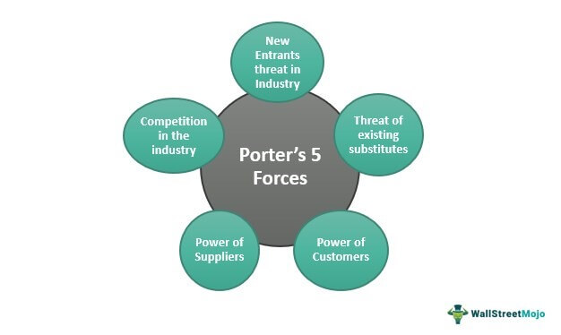
Figure 3: Five Forces Model
Source: (Kim and Han, 2022)
Michael Porter's Five Powers Model is a framework that inspects the cutthroat powers that impact an industry's engaging quality and productivity (Kim and Han, 2022). The model incorporates five key powers:
1. Industry Competition: The degree of contest inside the business. Industry rivalry is influenced by things like the number of competitors, the rate of market growth, and brand loyalty. High contention might prompt cost wars and diminished benefit (Kim and Han, 2022).
2. Supplier Power: The impact providers have over the business. Businesses' ability to compete can be hindered by increased costs and fewer options brought about by strong supplier power (Kim and Han, 2022).
3. Buyer Power: The impact clients have over the business. Profitability can be negatively impacted by low prices and higher customer expectations brought on by strong buyer power (Rodriguez-Anton and Alonso Almeida, 2020).
4. Threat of Substitutes: The accessibility of elective items or administrations that can supplant the business' contributions. A company's pricing power and attractiveness can be limited by high substitution threats (Rodriguez-Anton and Alonso Almeida, 2020).
5. Threat of New Participants: The simplicity with which new contenders can enter the market. Existing businesses may be safeguarded by high barriers to entry, whereas low barriers may increase competition and decrease profitability (Rodriguez-Anton and Alonso Almeida, 2020).
Analyses of the Competition
1. Industry Rivalry: The hotel business experienced extraordinary contention during the Coronavirus emergency, as inhabitance rates dove and incomes declined. Marriott's solid image notoriety and worldwide presence gave an upper hand, empowering them to endure the business’ serious tensions more readily (Rodriguez-Anton and Alonso Almeida, 2020).
2. Supplier Power: As a cordiality organization, Marriott depends on different providers for labor and products. The pandemic disturbed supply chains, causing potential provider power difficulties. Marriott's strong relationships with suppliers and capacity for bulk purchasing, on the other hand, probably helped to lessen this impact (Rodriguez-Anton and Alonso Almeida, 2020).
3. Buyer Power: With decreased travel interest, clients acquired dealing power during the emergency (Kim and Han, 2022). This issue was addressed by Marriott's adaptable cancellation and booking policies, which increased customer confidence and accommodated shifting travel plans.
4. Threats of Substitutes: The danger of substitutes expanded during the pandemic, as voyagers investigated elective facilities like get-away rentals and overhauled lofts. To counter this danger, Marriott zeroed in on advancing extraordinary encounters and accentuating their wellbeing measures to separate from elective choices (Kim and Han, 2022).
5. Threats of New Entrants: The pandemic's monetary strain made it trying for new contenders to enter the market (Kim and Han, 2022). Be that as it may, arising patterns, like remote work and computerized nomadism, could set out open doors for problematic contestants later on.

1.5 Impact of Technology in Strategies Implemented During the Crisis
Digital Marketing
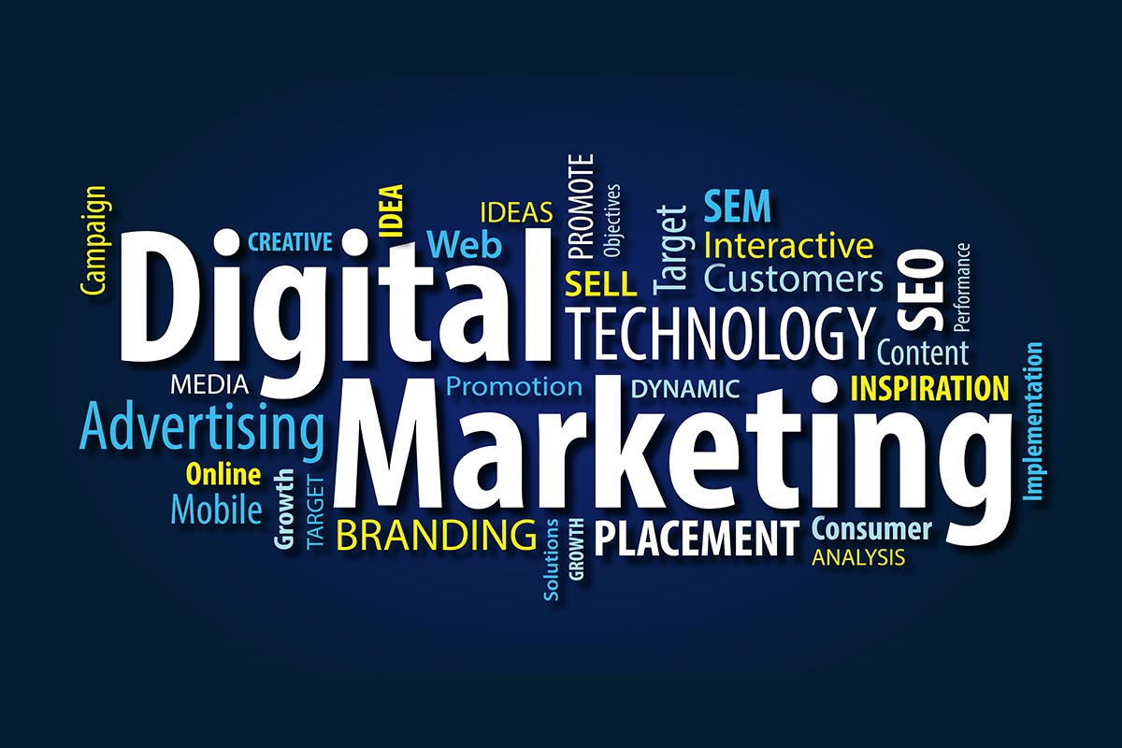
Figure 4: Digital Marketing
Source: (Fan, Lu and Mao, 2022)
During the COVID-19 outbreak, Marriott International's marketing strategies relied heavily on technology. With customary advertising channels disturbed because of movement limitations and social separating measures, Marriott embraced advanced promoting to really draw in with clients (Fan, Lu and Mao, 2022). They used virtual entertainment stages, email promoting, and web based publicizing to reach and speak with their interest group. Through connecting with content and customized messages, Marriott kept up with brand perceivability and importance during the emergency. Advanced advertising likewise permitted them to advance security measures and adaptable booking choices, consoling clients and encouraging dependability. The utilization of information examination and client experiences empowered Marriott to fit their advertising endeavors to explicit fragments, improving the viability of their missions (Alotaibi and Khan, 2022).
Communication
During the emergency, clear and opportune correspondence was essential for keeping up with entrust with partners (Fan, Lu and Mao, 2022). Marriott's efforts to communicate were made easier by technology, which enabled transparency and updates in real time. The organization utilized their site and web-based entertainment channels to give the most recent data on wellbeing measures, inn status, and functional changes. They likewise utilized virtual municipal centers and online classes to draw in with workers, tending to worries and offering help. Through these computerized correspondence channels, Marriott showed a client driven approach, taking care of the developing necessities of their visitors, representatives, and accomplices (Alotaibi and Khan, 2022).
Internationalization
Innovation assumed an imperative part in Marriott's internationalization systems during the Coronavirus emergency (Fan, Lu and Mao, 2022). With traverse nations, innovation empowered Marriott to adjust their techniques to explicit districts and nearby business sectors. They utilized advanced apparatuses to screen changing travel guidelines and shopper patterns in various nations, permitting them to likewise tailor their contributions. By teaming up with neighborhood accomplices and utilizing on the web stages, Marriott had the option to explore language and social boundaries, guaranteeing powerful correspondence with different worldwide crowds. Also, innovation worked with far off joint effort and navigation, empowering Marriott to facilitate its worldwide activities actually notwithstanding actual distance (Alotaibi and Khan, 2022).

1.6 Evaluation of Marriott International's Strategies During the Covid Crisis
The effectiveness of Marriott International's strategies in addressing the challenges and achieving the desired outcomes during the Covid-19 crisis can be evaluated. The outcome of their methodologies can be estimated utilizing a few key measurements:
1. Occupancy Rates and Revenue: One of the essential measurements for assessing Marriott's prosperity is the inhabitance rates and income produced during the emergency. In spite of the pandemic's impact on the travel industry, Marriott should have been able to maintain some level of occupancy and revenue with an effective strategy (Volgger, Taplin and Aebli, 2021).
2. Consumer loyalty and Satisfaction: Consumer loyalty and steadfastness are essential for supporting long haul achievement. Estimating client criticism, audits, and rehash appointments can give experiences into the viability of the procedures in addressing client needs and assumptions (Volgger, Taplin and Aebli, 2021).
3. Flexibility Metric: The progress of Marriott's adaptable booking and abrogation approaches can be assessed by following the quantity of clients using these choices and the effect on in general income and visitor fulfillment (Volgger, Taplin and Aebli, 2021).
4. Digital Marketing Engagement: The outcome of Marriott's advanced advertising methodologies can be estimated through measurements like site traffic, online entertainment commitment, email open rates, and change rates. Customers' engagement and online presence should have grown as a result of a successful digital marketing strategy (Sanjaya and Sari, 2021).
5. Employee Morale and Retention: Assessing representative fulfillment and degrees of consistency can demonstrate the outcome of systems in supporting and connecting with workers during the emergency (Sanjaya and Sari, 2021).
Marriott could have controlled the marketing functions in a number of ways if the marketing strategies failed:
1. Reassessing Customer Segments: Recognizing new client portions that showed request during the emergency and fitting promoting endeavors to draw in them (Sanjaya and Sari, 2021).
2. Adopting Innovative Marketing Channels: Investigating arising promoting channels and advances that lined up with changing client ways of behaving and inclinations (Sanjaya and Sari, 2021).
3. Revising Messaging and Promotion: Guaranteeing showcasing messages were delicate to the emergency, featuring security measures, and offering alluring arrangements and worth added administrations (Volgger, Taplin and Aebli, 2021).
4. Collaborating with Partners: Framing vital associations with aircrafts, travel services, and other industry players to grow reach and proposition packaged bundles (Volgger, Taplin and Aebli, 2021).
5. Investing in Training and Development: Increasing the adaptability, data analytics, and customer relationship management skills of marketing teams to improve marketing effectiveness (Volgger, Taplin and Aebli, 2021).

Task 2: Managerial implication on Marketing Strategies implemented by Marriott International during the Covid 19 Crisis

2.1 Managerial Implications on Marriott's Marketing Strategies
1. Infrastructure: The infrastructure of Marriott, which consists of its physical properties and technology systems, is crucial for delivering a seamless customer experience. Hotels had to temporarily close their doors due to the COVID-19 pandemic, and construction projects had to be postponed. This implies that if things start to improve, Marriott needs to properly manage its infrastructure to ensure efficient operations and cost savings. The management implication is that infrastructure investments and upgrades should be prioritised based on consumer demand and preferences while also taking the company's financial status into account (Nicola et al., 2020).
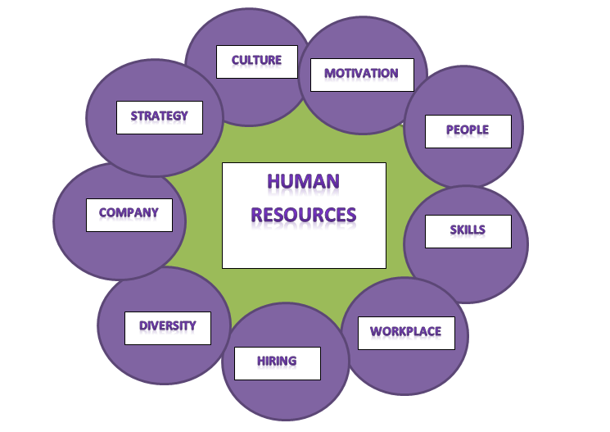
Figure 4: Human Resources Management
Source: (Nicola et al., 2020)
2. Human Resources Management: Marriott has implemented compensation measures like salary reductions and compressed workweeks in response to COVID-19. This highlights the importance of effective human resource management under tough situations. Maintaining open lines of communication with staff members, providing support, and looking out for their welfare are all managerial responsibilities. Working with labour unions like Unite Here will help you address employee problems and maintain a pleasant workplace culture. When business rebounds to pre-pandemic levels, Marriott should also plan for expanding its workforce by appointing new personnel and retraining current ones (Nicola et al., 2020).
3. Technological Development: Marriott is well-positioned for success after the pandemic because of its digital transformation projects, which include customized smartphone experiences and smart room prototypes. Artificial intelligence, analytics, and social media marketing can help Marriott better focus its services and entice new customers. To stay competitive in the market, managers must continue to make investments in technological innovation and advancement. This necessitates the incorporation of new technologies to enhance visitor experiences, the use of data analytics to get insight into customer needs, and the use of social media platforms for focused marketing campaigns (Nicola et al., 2020).
4. Procurement: Marriott must improve its procurement procedures to increase efficiency and reduce costs in light of decreased income. The managerial implication is to review supplier contracts, strike fair deals, and look for ways to cut costs without sacrificing the quality of goods and services. To improve overall procurement efficiency, work with suppliers to identify win-win solutions and consider alternative sourcing possibilities (Shin et al., 2021).
5.Inbound Logistics: At Marriott, inbound logistics include managing the supply chain to guarantee that goods and services are transported to its properties on schedule. During the outbreak, there have been significant supply chain bottlenecks (Nicola et al., 2020). The managerial implication is to strengthen relationships with suppliers, increase the number of suppliers, and develop backup plans to reduce future supply chain disruptions. If you want to effectively manage logistics, it will be crucial to maintain open lines of communication and be honest with suppliers (Shin et al., 2021).
6.Operations: Operations must be efficient for Marriott to offer exceptional customer service. The COVID-19 event has highlighted the importance of flexible and responsive operations. The management repercussions are the need to create operational plans that are responsive to shifting market conditions and consumer preferences. To create a secure and comfortable atmosphere for visitors and employees, this may include altering personnel levels, streamlining procedures, and putting health and safety policies in place (Shin et al., 2021).
7. Outbound Logistics: Marriott's outbound logistics also include managing distribution networks and providing a positive tourist experience. In the aftermath of the pandemic, customer expectations can change, making it necessary for Marriott to rethink its outbound logistics strategies. Through specialized marketing campaigns, efficient distribution channels, and cutting-edge delivery strategies, management must emphasize client connection and communication. Emphasizing cleanliness, safety, and health precautions will be necessary to win back visitors' trust and attract new ones (Shin et al., 2021).
8. Marketing and Sales: The pandemic has affected Marriott's marketing efforts as a result of decreased marketing expenditures and modifications in consumer behaviour. The management implication is that marketing campaigns need to be reassessed to account for changing client preferences and needs. This means using digital marketing platforms, utilizing social media for targeted campaigns, and emphasizing the value proposition of Marriott's brands and loyalty program. Pricing strategies and marketing initiatives must be adjusted to reflect shifting market conditions in order to boost demand and revenue (Masaki, John and Abel, 2021).
9. After-Sales Services: As the industry rebounds from the pandemic, Marriott's post-purchase services will be crucial in ensuring consumer satisfaction and loyalty. The managerial consequence is to prioritize post-stay follow-ups, gather consumer input, and make improvements in response to visitor feedback. Chatbots and real-time communication technologies can be used to improve customer care channels, resulting in an excellent after-sales experience (Masaki, John and Abel, 2021).
The COVID-19 marketing plan for Marriott calls for a thorough strategy that covers the entire value chain. Effective management of infrastructure, human resources, technology, procurement, logistics, marketing, and after-sales services is crucial to overcoming the challenges posed by the pandemic and positioning the company for long-term success. By balancing these elements with altering market realities, Marriott can adapt to the new normal and meet customer expectations in a highly competitive industry (Masaki, John and Abel, 2021).

Task 3: Recommendations for Improving Marketing Strategies in the Post-Pandemic Era
1. Customer-Centric Technology Adoption: Expanding on the administrative ramifications of innovation advancement, Marriott ought to keep putting resources into client driven innovation to improve visitor encounters (Pahurkar et al., 2022). Smart room features, mobile check-in and check-out, and personalized digital platform communication are all examples of this. Integrating man-made brainpower and information examination will empower Marriott to expect client requirements and inclinations, fitting administrations to individual visitors (Pahurkar et al., 2022).
2. Flexible Pricing and Packages: Considering the administrative ramifications of reconsidering evaluating procedures, Marriott ought to offer adaptable estimating and esteem added bundles that take special care of different client fragments. By giving unique estimating choices and limited time offers, Marriott can draw in cost touchy clients while keeping up with income age during top interest periods (Pahurkar et al., 2022).
2. Focus on Health and Safety: Marriott needs to emphasize health and safety in its marketing initiatives to win back the confidence and trust of its customers. This can be accomplished by showcasing and promoting the stringent hygiene standards and health protocols that have been established throughout its properties. Make sure that potential visitors are aware of these safety precautions by showcasing them through social media platforms and digital marketing channels (Pahurkar et al., 2022).
3. Implement Targeted Marketing Campaigns: The post-pandemic era may have seen changes in consumer behaviour and tastes. Marriott should conduct market research in order to notice these trends and develop specific marketing strategies in response. Accentuate the distinctive value proposition of Marriott's brands, such as luxury, sustainability, or family-friendly experiences, to appeal to specific client categories. Utilizing social media channels and collaborating with influencers will broaden the impact and reach of these activities (Hao, Xiao and Chon, 2020).
4.Enhance Loyalty Programs: Marriott's incentive schemes, like Marriott Bonvoy, are fantastic tools for boosting customer loyalty and repeat business. In the aftermath of the epidemic, reexamine and enhance the benefits of loyalty program to provide members more for their money. Consider offering privileged discounts, tailored offers, and unusual experiences to entice reservations and foster client loyalty. Utilize customer information to create rewards and messaging that are specific to each person (Hao, Xiao and Chon, 2020) .
5. Optimize Pricing Strategies: As the market dynamics change and the sector begins to recover from the pandemic, pricing strategies should also evolve. Keep an eye on patterns in demand to determine how to adjust pricing to boost sales. Take into account factors like seasonality, occupancy rates, and clientele while developing your pricing strategy by employing dynamic pricing techniques. To enhance demand during off-peak hours, provide appealing bargains and packages as well (Hao, Xiao and Chon, 2020) .
6. Foster Partnerships and Collaborations: Marriott may have potential to grow its clientele and develop distinctive experiences through strategic alliances and collaborations with complimentary companies. For instance, collaborating with regional attractions or airlines might offer bundled packages or perks from loyalty program, luring guests to pick Marriott over other hotels. Work with influencers and travel bloggers to promote properties and develop sincere content that appeals to target markets (kim et al., 2023).
7. Leverage User-Generated Content: User-generated content (UGC) could be included into Marriott's marketing strategies to boost authenticity and engage customers. Inspire visitors to take part in giveaways or to use specific hashtags while sharing their experiences on social media. On Marriott's social media channels, re-post and share user-generated content (UGC) to emphasize real experiences and encourage a sense of community among users (kim et al., 2023).
8. Strengthen Customer Service and Engagement: To keep customers happy and loyal, customer care and after-sale services are crucial. Use chatbots, AI-powered customer care systems, and real-time communication technologies to give personalized support and speed up response times. Actively collect and analyse customer feedback to identify issue areas and make the necessary changes to enhance the overall customer experience (kim et al., 2023).
9. Sustainability and Social Responsibility: Marriott should incorporate sustainability and social responsibility into their marketing strategy given its growing prominence. Promote the business' efforts and achievements in community service, environmental protection, and ethical travel. To attract environmentally conscious tourists, highlight eco-friendly practices such as waste reduction, energy saving, and eco-friendly services (kim et al., 2023).

3. Conclusion
Marriott International handled the COVID-19 issue with exceptional flexibility and resilience. By acting quickly to adopt health and safety laws, assist personnel, and provide flexible booking options, Marriott prioritized the health and safety of both guests and employees. Because of their proactive attitude and commitment to client satisfaction, they have distinguished themselves as a well-known example of excellent crisis management in the hotel sector.

Reference
Alotaibi, E. and Khan, A. (2022). Impact of Covid-19 on the Hospitality Industry and Responding to Future Pandemic through Technological Innovation. Procedia Computer Science, 204, pp.844–853. doi:https://doi.org/10.1016/j.procs.2022.08.102.
Deng, J. (2022). Hotel Brands and the Impact of Brand Differentiation on the Success of the Global Hotel Brands. Highlights in Business, Economics and Management, 1, pp.265–276. doi:https://doi.org/10.54097/hbem.v1i.2582.
El-Said, O.A., Smith, M., Al-Yafaei, Y. and Salam, S.A.A. (2023). From complexity to evolution: Mapping resilience management practices in the hospitality industry during the COVID-19 crisis. International Journal of Hospitality Management, 110, p.103435. doi:https://doi.org/10.1016/j.ijhm.2023.103435.
Fan, A., Lu, Z. and Mao, Z. (Eddie) (2022). To talk or to touch: Unraveling consumer responses to two types of hotel in-room technology. International Journal of Hospitality Management, 101, p.103112. doi:https://doi.org/10.1016/j.ijhm.2021.103112.
Hao, F., Xiao, Q. and Chon, K. (2020). COVID-19 and China’s Hotel Industry: Impacts, a Disaster Management Framework, and Post-Pandemic Agenda. International Journal of Hospitality Management, [online] 90(102636), p.102636. doi:https://doi.org/10.1016/j.ijhm.2020.102636.
Jayati, M. (2020). OPERASIONAL DI TANG PALACE RESTORAN HOTEL JW MARRIOTT SURABAYA PADA SAAT PANDEMI COVID-19. [online] doi: http://repository.unmuhjember.ac.id/11311/9/ARTIKEL.pdf.
Kim, C., Kang, H.J., Chung, K. and Choi, K. (2021). COVID-19 and Hotel Productivity Changes: An Empirical Analysis Using Malmquist Productivity Index. Service Science, 13(4), pp.243–257. doi:https://doi.org/10.1287/serv.2021.0283.
Kim, E.J., Kim, E.L., Kim, M. and Tanford, S. (2023). Post-Pandemic hotel cancellation policy: Situational cues as perceived risk triggers. Journal of Hospitality and Tourism Management, [online] 55, pp.153–160. doi:https://doi.org/10.1016/j.jhtm.2023.03.019.
Kim, J.J. and Han, H. (2022). Saving the hotel industry: Strategic response to the COVID-19 pandemic, hotel selection analysis, and customer retention. International Journal of Hospitality Management, [online] 102, p.103163. doi:https://doi.org/10.1016/j.ijhm.2022.103163.
Masaki, E.A., John, Mr.W.F. and Abel, Mr.C. (2021). IMPACT OF ICT TOOLS AND APPS ON TOURISM DESTINATION MARKETING. A CASE OF RDB AND MARRIOT HOTELS, KIGALI, RWANDA . International Journal of Social Science and Economic Research, 6(4), pp.1232–1249. doi:https://doi.org/10.46609/ijsser.2021.v06i04.008.
Nicola, M., Alsafi, Z., Sohrabi, C., Kerwan, A., Al-Jabir, A., Iosifidis, C., Agha, M. and Agha, R. (2020). The Socio-Economic Implications of the Coronavirus and COVID-19 Pandemic: A Review. International Journal of Surgery, [online] 78(1), pp.185–193. doi:https://doi.org/10.1016/j.ijsu.2020.04.018.
Pahurkar, R.N., Jarad, R., Kinikar, Y., Wankhede, V. and Bhadade, D. (2022). Reframing the Rules of Business in Indian Hotel and Restaurant Sector Post Pandemic. Journal of Positive School Psychology, [online] pp.6837–6846. doi: https://journalppw.com/index.php/jpsp/article/view/8218.
Rodríguez-Antón, J.M. and Alonso-Almeida, M. del M. (2020). COVID-19 impacts and recovery strategies: The case of the hospitality industry in Spain. Sustainability, 12(20), p.8599. doi:https://doi.org/10.3390/su12208599.
Sanjaya, I.W.K. and Sari, N.P.S. (2021). The implementation of chse program in courtyard hotel by marriott bali nusa dua resort in post-covid-19 pandemic. Journal of Business on Hospitality and Tourism, 7(3), p.329. doi:https://doi.org/10.22334/jbhost.v7i3.329.
Sealy, W. (2020). A Commentary on Risk and Resilience in the Hospitality, Tourism, Aviation and Events Industry: Responses to COVID –19 and Lessons Learned. Journal On Tourism & Sustainability, [online] 4(1), pp.82–93. doi: https://ontourism.academy/journal/index.php/jots/article/view/93.
Sharma, A., Shin, H., Santa-María, M.J. and Nicolau, J.L. (2021). Hotels’ COVID-19 innovation and performance. Annals of Tourism Research, 88, p.103180. doi:https://doi.org/10.1016/j.annals.2021.103180.
Shin, H., Sharma, A., Nicolau, J.L. and Kang, J. (2021). The impact of hotel CSR for strategic philanthropy on booking behavior and hotel performance during the COVID-19 pandemic. Tourism Management, [online] 85, p.104322. doi:https://doi.org/10.1016/j.tourman.2021.104322.
Singh, A. (2021). Impact of COVID-19 on the Hospitality Industry and Implication for Operations and Asset Management. [online] doi: https://www.bu.edu/bhr/files/2021/05/Singh_Impact-of-COVID_BHR-PDF-TEMPLATE-July-2021.docx.pdf.
ȘTEFAN HINT, M., MARIN-PANTELESCU, A. and ȚÎRĂU, A.I. (2023). MANAGEMENT STRATEGIES FOR TOURISM POST-PANDEMIC FUTURE. PROCEEDINGS OF THE INTERNATIONAL MANAGEMENT CONFERENCE. doi:https://doi.org/10.24818/imc/2022/01.06.
Volgger, M., Taplin, R. and Aebli, A. (2021). Recovery of domestic tourism during the COVID-19 pandemic: An experimental comparison of interventions. Journal of Hospitality and Tourism Management, 48. doi:https://doi.org/10.1016/j.jhtm.2021.07.015.

