Davion Linton Gowie (2216147)
2216147@student.uwtsd.ac.uk
Abstract
Student ID:2216147
Student Name: Davion Linton Gowie
Student Name: Renuga Jayakumar
Module code: ACCA6020
DeadLine: 02/04/2026
BSc Applied Computing L6
Music Smart

Table of Contents
Introduction 2
Problem statement 3
Purpose of literature review 4
Project Title: Music Smart 5
Aim: 5
Research Objectives 5
Scope of the Review 5
Project Timeline (10 February 2026 – 14 August 2026) 6
Music Smart Story board: 6
1. Understanding the Domain: Looking at and analysing how blockchain can be used in the music business 8
2. The tools you have to make your project idea happen 8
3. Making the Functional Music App and Designing It 9
4. Using smart contracts to split up royalties 9
5. Adding a digital wallet for safe transactions. 10
6. Making a decentralised storage system 10
Current Gaps: 12
Conclusion 13
Appendix 14

Abstraction
• The research aims to create Music Smart, a blockchain-based music streaming and buying platform. • Addresses industry issues like copyright management, artist payments, and royalty transparency. Decentralised technologies: Blockchain smart contracts automatically distribute royalties.
Digital wallets for secure payments
o IPFS for decentralised music and metadata storage
• The system architecture combines frontend, backend, and blockchain layers for simplicity and efficiency.
• Testing includes checking its speed, security, usability, and effectiveness.
• Finds scalability, user adoption, and integration issues.
• Says blockchain can make music distribution open, fair, and safe.

Introduction
Music creation, sharing, and listening have changed due to the music industry's digital transformation. Online music streaming makes it easier for people around the world to listen, but royalty transparency, copyright management, and artist pay are still issues. Traditional music distribution systems include record labels and streaming platforms, which can delay payments and obscure money distribution. Blockchain technology could solve these issues by providing a decentralised, open, and secure digital transaction method. Blockchain technology may enable a music streaming and purchasing platform, according to this study.

Problem statement
Despite the rapid growth of digital music streaming services, artists still face unfair revenue sharing, late royalty payments, and financial transparency issues. Middlemen manage music licensing, payments, and distribution on traditional music platforms. This structure can reduce efficiency and artist control over money and IP. Centralised digital music storage may have security issues and hinder business. Decentralised blockchain technology could simplify, automate royalty payments, and secure transactions. Blockchain music streaming services require more research and development.
The remaining, including:
- Unfair royalty distribution
- Delayed payments to artists
- Lack of financial transparency
Traditional systems rely on centralised intermediaries, limiting artist control over their work and earnings.

Purpose of literature review
Blockchain technology and its use in the music industry are the focus of this literature review. The review investigates how blockchain can solve royalty management, copyright tracking, and secure digital transactions. It also examines smart contracts, decentralised storage systems, and digital wallets used to create blockchain-based apps. The literature review examines academic studies and field research to theoretically support this project. It also highlights research gaps and technological constraints that must be considered when creating a blockchain-based music streaming and buying platform.

Project Title: Block Music Smart

Aim:
- To develop a Blockchain-Based Music Streaming and Purchasing Platform, to improve transparency, security, and collaboration between artists and listeners.

Research Objectives
- To critically evaluate and analyse blockchain use case scenario in the music industry.
- To evaluate the toolset available to implement the project idea.
- To identify interactive and communication gaps in project idea.
- To design and develop a functional application within the development period of 6 months that enables music lovers to stream and purchase music using blockchain technology.
- To implement blockchain-based smart contracts to automate royalty distribution and ensure transparency in transaction processing.
- To integrate a digital wallet system that enables secure peer-to-peer payments and cryptocurrency transactions.
- To develop a decentralised storage mechanism (for example: IPFS) to securely store music files and metadata.
- Ensure transparent and fair royalty distribution.

- Reduce reliance on intermediaries.
- Enable direct interaction between artists and users.

- Develop a functional blockchain, streaming and purchasing music platform within the project timeline.
- To test and evaluate the system’s performance, security, and usability through user testing and technical analysis.

Scope of the Review
Define boundaries of research:
- Time frame (10th, 02 2026 – 14th, 08 2026)
- Geographic focus (global / EU / UK / US)
- Industry focus (music, publishing, digital media)
- Type of sources (peer-reviewed journals, conference papers, reports)

Project Timeline (10 February 2026 – 14 August 2026)
Phase | Duration | Dates | Key Activities
1. Research and Evaluation | 4 weeks | 10 Feb – 7 Mar 2026 | Explore blockchain's potential in the music industry and list its pros and cons.
2. Selecting Tools and Conducting a Feasibility Study | 3 weeks | 8 Mar – 28 Mar 2026 | Consider decentralised storage, smart contract tools, and blockchain frameworks.
3. Gap Analysis and Requirement Definition | 2 weeks | 29 Mar – 11 Apr 2026 | Determine communication and interaction gaps and system requirements and user roles.
4. System Design & Architecture | 4 weeks | 12 Apr – 9 May 2026 | Design the system's architecture, UI/UX wireframes, and smart contract logic.
5. Development Phase | 8 weeks | 10 May – 4 Jul 2026 | Build streaming, buying, wallet integration, and smart contract modules.
6. Integration and Testing | 5 weeks | 5 Jul – 9 Aug 2026 | Integrate the blockchain, wallet, and IPFS and test performance, security, and usability.
7. Final Review and Launch Prep | 1 week | 10 Aug – 14 Aug 2026 | Finish testing, get user feedback, and prepare for launch.

Music Smart Story board:

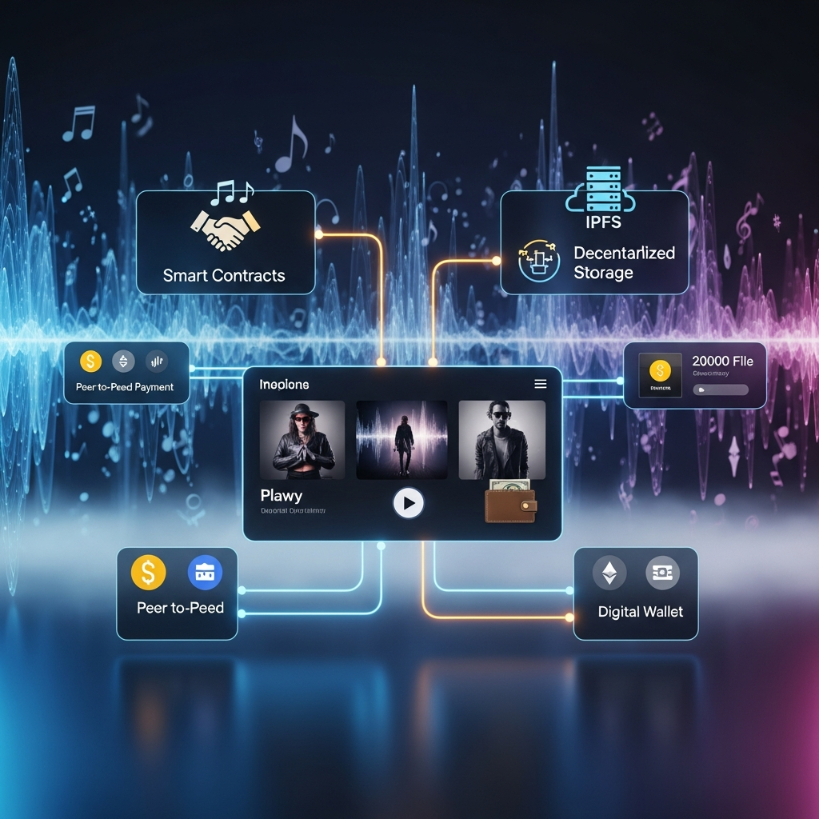

1. Understanding the Domain: Looking at and analysing how blockchain can be used in the music business
• The music industry struggles with royalty payments, ownership rights, and artist pay. Record labels, streaming services, and distributors are centralised middlemen in traditional music distribution. These middlemen calculate and pay royalties, which can delay payments.
Not clarifying
Money distribution injustice
• Blockchain technology provides decentralisation by:
o Clear transaction records
Unchangeable data storage
Automated music ownership and payment systems Blockchain can help with the following issues:
Poor royalties tracking
Mismanagement of intellectual property
Slow license-getting processes
Artist payments that take too long
• Compare traditional and blockchain-based systems in blockchain use cases:
Trust, cost-effectiveness
Openness, automation
• Important people include artists
Listeners o Record labels
People running the platform
• Evaluation typically involves:
Analysing needs
A feasibility assessment
Proving a concept
• Blockchain's decentralisation, immutability, and smart contracts can simplify music ownership and artist payment.
• Examining current blockchain music platforms can help you determine how to set up, govern, and promote the system.
• Blockchain can improve music distribution fairness, openness, and efficiency.
2. The tools you have to make your project idea happen
• A blockchain-based music streaming and purchasing platform requires blockchain tools, web technologies, and decentralised storage systems. Blockchain platforms like Ethereum allow decentralised apps and smart contracts. You can write Solidity smart contracts and deploy them with frameworks like: A hardhat
The Truffle Suite
• These tools simplify contract creation, deployment, and testing.
• Build the web app front end with modern technologies:
• React
• HTML5
• CSS3
JavaScript
• React creates music browsing, streaming, and shopping interfaces.
• Frontends can communicate with blockchain networks using Web3.js or Ethers.js.
• Peer-to-peer storage systems like InterPlanetary File System can store music and metadata without central servers.
• Connecting your digital wallet to MetaMask lets you manage cryptocurrency accounts and approve blockchain transactions. Node.js and Express.js can build backend services for:
• Application logic
• Metadata management
Communication via APIs
• These technologies create a safe, growing, and decentralised music platform.
3. Creating the Functional Music App and Designing It
• A blockchain-powered music app needs a well-organised system architecture with simple web interfaces and decentralised backends. The platform lets users browse music.
Online song play
Buy songs
Artists upload and track music ownership.
There are three main application architecture layers:
Frontend and backend layers
Layer of blockchain
• Frontend users can sign up and log in, find new music,
View artist profiles
Create playlists
Buy music.
• Interfaces are simple and look like modern streaming services, but they use blockchain. Backend layer handles:
Metadata and indexing
o Frontend-blockchain messaging
Verifying users and platform analytics
• The backend of decentralised storage systems like the InterPlanetary File System stores music file references.
• The blockchain layer handles payment, music ownership, and licensing smart contracts. When musicians upload songs, a blockchain record includes:
Artist information
Ownership percentage
License information
IPFS storage hash
• System design emphasises fast transactions
Effective streaming
Easy to buy
• Decentralised infrastructure and modern web technologies create an open, easy-to-use platform.

4. Using smart contracts to split up royalties
• Smart contracts automate royalty payments and clarify financial transactions.
• A smart contract is a blockchain program that performs its stated tasks under certain conditions.
• Each song has a smart contract governing ownership and royalties.
• When a song is streamed or bought, the smart contract automatically pays stakeholders like:
A artist
Creator
songwriter, record label
• Artist gets 70% of royalties
20% producer, 10% songwriter
• Participants' blockchain wallets receive payments automatically, reducing manual accounting and delays.
• Blockchain records show your earnings in real time, making collaboration more transparent. Testing smart contracts during development is crucial for security.
Code audits
Avoiding weaknesses like reentrancy. • Well-designed smart contracts ensure safe, reliable, automatic royalty payments.
5. Adding a digital wallet for safe transactions.
. • A digital wallet lets music platform users securely pay each other.
• Keep cryptocurrency, approve transactions, and use smart contracts.
• Login users link their wallet (like MetaMask) to the platform.
• The wallet is the user's identity and payment method. When users buy music or stream premium content, the wallet checks payment.
• Blockchain tracks transactions, smart contracts execute them.
• Listeners can directly support artists with peer-to-peer payments. Giving artists tips is an example.
Buying exclusive music or digital collectibles Security measures include not storing private keys on the platform and approving transactions through wallets.
API security and encryption
• Digital wallets enable new revenue streams like subscription content.
Few music releases o Token-based fan experiences
• This system gives artists more freedom and simplifies fan interaction.

6. Making a decentralised storage system
• Traditional music streaming services store and send files on centralised servers.
• Centralised storage can cause data loss
Possible censorship
High infrastructure costs
• The peer-to-peer InterPlanetary File System stores files decentralizedly.
• Different nodes store smaller music files.
• Each file has a permanent cryptographic hash. When musicians post songs online:
IPFS receives the file and metadata. The blockchain smart contract stores the hash.
• The stored hash receives and plays network music.
• Decentralised storage improves:
o System reliability
Censorship and inability to descend
Artists' digital asset control
• Metadata may include song name
Artist name
Information about the album, royalty percentages • Blockchain and decentralised storage create a secure, tamper-proof music management system.
7. Checking and testing the system's performance, security, and ease of use:
- Blockchain-based music platforms need rigorous testing, which includes:
Functionality and performance testing
A security analysis
Usability testing
  - Functional testing ensures feature functionality:
Posting music online
Playing music online
Buy things
Smart contract royalty distribution
The automated frameworks act like blockchain transactions. • Performance testing evaluates a system's ability to handle more users and respond quickly:
Many users and transactions
o Measures transaction completion, streaming latency, and data retrieval from storage.
  - • Security testing protects funds:
Smart contract audits
Testing backend and web app security • Usability testing involves real users:
Easy to use and navigate
Getting musician and fan feedback • Technical analysis tools monitor blockchain transactions
Network performance
Storage efficiency • Technical metrics and user feedback ensure a safe, effective, and easy-to-use system.

Current Gaps:
      - Most blockchain research focuses on theoretical frameworks, not music platform implementation.
      - Research on decentralised music streaming apps' performance, growth, and usability is scarce.
      - Blockchain and decentralised storage technologies like the InterPlanetary File System are still difficult to integrate. Decentralised infrastructure for large-scale streaming isn't well-studied.
      - Blockchain apps must understand digital wallets and cryptocurrency transactions, which hinders user adoption.
      - Communication barriers.
      - Many platforms have complicated interfaces for non-techies
- Scalable, easy-to-use, and safe blockchain-connected music streaming systems require more research.

Proposed Solutions
Smart blockchain Music platforms
Blockchain Base Smart contract
Integrate digital wallet
IterPlanetary file storage systems
Transparency enabling artists to see their music statistics as well as royalty and streaming.
Scalable web applications
Data protection and security of user credentials and copyright

Significance of the Proposed Idea
The importance of this project lies in its potential to:
- Empower artists financially by ensuring fair and real-time royalty payments
- Increase transparency in music ownership and revenue distribution
- Reduce dependency on intermediaries, lowering costs and inefficiencies
- Enhance trust between artists, producers, and listeners through verifiable blockchain records
- Promote innovation in digital music consumption through decentralised technologies

Future developments
Enabling fans to invest in their favourite artist music or favourite song.
Artist and fans interaction and communication

Conclusion
In conclusion, blockchain technology has the potential to significantly transform the music industry by addressing long-standing challenges related to transparency, copyright management, and royalty distribution. Traditional music platforms often rely on centralised systems that obscure financial flows, delay payments, and limit artist control. By contrast, blockchain introduces a decentralised and immutable infrastructure that ensures trust, traceability, and efficiency.
Through the use of smart contracts, this project demonstrates how royalty payments can be automated and distributed instantly among stakeholders, eliminating intermediaries and reducing disputes. In addition, decentralised storage systems such as IPFS enhance the security and availability of music assets, while digital wallets enable secure peer-to-peer transactions between artists and listeners.

Appendix

