

Module name: Introduction to Health and Social Care
Module code: LCHS4003



Evaluating the Impact of Communication on Patient Care:
The Case Study of Mr Ahmed

Student name: Katherine Elizabeth Montero Coello
Student ID: 2512506
Lecturer’s name: Eleni Koutsogeorgou

Abstract
The study focuses on three main elements, which are effective communication, administrative practices and teamwork as essential factors for delivering safe and person-centred care through the assessment of Mr Ahmed, who is a 68-year-old stroke patient receiving home medical treatment. The study investigates how communication barriers, poor record-keeping and insufficient professional coordination create obstacles that lead to worse patient outcomes. The report establishes the requirements for inclusive communication, correct data management, and inter-agency teamwork by applying theoretical frameworks and key legal regulations, including the Equality Act 2010 and the Data Protection Act 2018. The report states that to achieve improved healthcare outcomes, which include better patient safety, enhanced care quality and increased overall healthcare performance, organisations must combine all present elements.

Table of Contents
1. Introduction 4
2. Importance of Effective Communication 4
3. Importance of Good Administrative Skills 6
4. Importance of Working Collaboratively 8
5. Conclusion 10
6. References 11

1. Introduction
The report investigates Mr Ahmed's case, demonstrating how effective communication, administrative skills, and teamwork achieve quality healthcare outcomes. It highlights three key problems health and social care groups must address: language difficulties, coordination issues, and deficiencies in record-keeping. The problems healthcare providers encounter in medical environments pose serious threats to patient safety, healthcare quality, and patient health outcomes.
Patients who have suffered strokes face challenges, according to Mr Ahmed's health status, he will struggle with speaking, walking and controlling emotions. His condition increases reliance on medical staff, demanding more from professionals providing treatment. The report examines three elements that create safe, efficient healthcare delivery through interconnected relationships.
The discussion uses theoretical models such as Berlo's communication model to support its arguments, including UK laws such as the Equality Act 2010 and the Data Protection Act 2018. The assessment uses a critical approach to determine which elements matter most while showing how poor practice causes negative effects and which methods enhance results. The report demonstrates that healthcare organisations achieve top-level patient care through staff expertise, legal compliance, and teamwork.

2. Importance of Effective Communication
Effective communication is an indispensable requirement for health and social care practice because it enables professional staff, patients, and their families to share information effectively. White (2021) states that communication involves more than delivering information because it requires listeners to comprehend complex healthcare messages.
Berlo’s (1960) Sender–Message–Channel–Receiver (SMCR) model provides a structured framework for understanding communication processes. The model identifies multiple elements that affect successful communication, including the sender's communication abilities and message content, the selected communication method, and the receiver's understanding capability (Chen et al., 2024). The model applies directly to Mr Ahmed's situation because his post-stroke condition affects his information processing and response abilities. Healthcare professionals need to adjust their communication approach to support his requirements.

Mr Ahmed's treatment faces its biggest obstacle because he cannot communicate effectively. The barriers include language differences, which affect communication, cognitive impairments and emotional distress, and cultural factors. Week 6 materials explain that communication obstacles lead to misunderstandings, which decrease patient satisfaction and increase the risk of errors. The incomplete understanding of medication instructions by Mr Ahmed will cause him to misuse his medication, which will result in severe health problems (Ghari, 2016).

Medical practitioners need to implement language simplification methods alongside the visual aid work and teach-back feedback system to support comprehension verification. Active listening is a crucial tool that enables professionals to understand patients' needs and provide appropriate responses. Understanding people depends on non-verbal communication, as body language and facial expressions are essential in establishing trust (O'Toole, 2024).

The process of effective communication creates a connection with person-centred care, which strives to recognize and respect diverse needs and preferences of everyone who uses the service. According to the NHS (2021), effective communication helps patients by providing better experiences, which lead to safer environments and fewer complaints. Mr Ahmed needs to participate in decision-making about his care plan to maintain his dignity while protecting his autonomy (Ismail et al., 2024).

The Equality Act 2010 requires healthcare providers to make reasonable adjustments for individuals who have protected characteristics, including disability and language barriers, which demonstrates the need for inclusive communication.
The process may involve offering interpreters alongside various communication solutions. The failure to make required adjustments will lead to discrimination, creating barriers that prevent people from accessing healthcare services.

Effective communication remains essential in medical practice, yet busy healthcare settings present challenges due to limited time and resources. The need for training and organisational support exists because organisations must make communication the focus. Effective communication is a crucial ability that serves as both a legal requirement and an ethical obligation, supporting the safe delivery of high-quality healthcare services (Silva and Jothimuni, 2025).

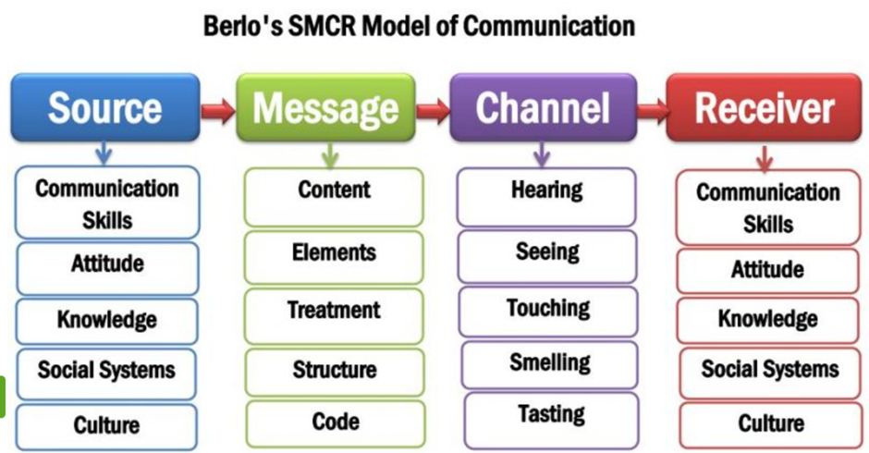
Figure 1: David Berlo’s SMCR Model of Communication (Newsmoor, 2026).

3. Importance of Good Administrative Skills
The development of administrative skills requires training because the successful application delivers benefits to health and social care services secure, effective service delivery complies with legal standards and professional obligations. The skills include record-keeping, scheduling, documentation and data management, which together enhance care quality (Wright et al., 2022).

The practice of administrative work requires record-keeping as its essential element. A patient's healthcare records provide medical information, including their current health status, past medical treatments, and upcoming needs, which healthcare professionals use to plan ongoing treatment. Hoyle et al. (2019) state that records function as historical evidence, requiring precise and complete information.

The case of Mr Ahmed requires precise documentation because multiple medical experts will be involved in his treatment. The failure to properly document information leads to treatment interruptions, duplicated efforts, and critical mistakes. Documenting a domiciliary visit is essential because its absence increases the risk of medication delays or omissions (Elkomy et al., 2023).

The tracking records system functions as an essential corporate component because it permits businesses to show their fiscal responsibility while meeting governmental obligations. Law enforcement departments treat healthcare records as official evidence, which they require to conduct inquiries, deal with allegations, and execute their judicial responsibilities (SCIE 2023). Moreover, organisations must present their records with information that meets both professional standards and precise accuracy requirements while delivering complete records at the designated times.

The Data Protection Act 2018 and UK GDPR establish the legal requirements for processing personal data. The laws require data to be processed in a way that satisfies legal requirements, maintains fairness and provides clear information about its usage. Data processing should occur exclusively for functions which have been established in advance. Individuals are entitled to access their personal information and to learn how it is used. Mr Ahmed needs protection because his medical data needs protection. Medical professionals who treat him are the only ones authorised to access it.

Administrative operations must comply with confidentiality requirements, which are among the core standards that govern their execution. Healthcare workers must protect patient information by refusing to disclose it without their patients' consent except for situations that require legal or essential security measures. Patient confidentiality violations create safety hazards which can lead to patient harm and damage to professional trust.
The assessment of information-sharing methods is needed because their excessive use results in more value destruction than value creation. The healthcare system experiences delays in patient treatment while safety risks increase because professionals choose not to share essential information, believing it violates data protection laws. Employees need organisations to establish systems that enable them to keep sensitive data secure while still sharing information with others (Politi et al., 2022).

Medical administrative systems, including staff scheduling systems, patient medication documentation systems, and systems for handling incident reports, serve as the foundation for delivering safe medical care. Effective system design, together with successful implementation, produces a secure environment that minimises errors while enhancing operational efficiency. Mr Ahmed's situation demonstrates that inefficient administrative processes lead to decreased operational efficiency for an organisation. The use of administrative capabilities enables organisations to protect patient safety, meet legal requirements, and provide top-notch medical services (Gupta, 2023).
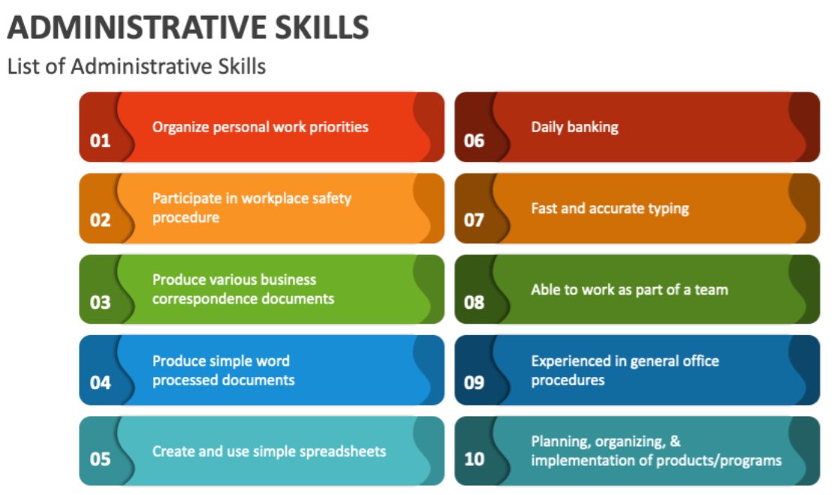
Figure 2: Administrative Skills (Collidu, 2025).

4. Importance of Working Collaboratively
Healthcare and social services require collaborative work to support all patients, but especially those with complex needs like Mr Ahmed. Multi-agency working requires professionals from different fields to collaborate to deliver their healthcare services synchronously. Partnership working enables professionals to share knowledge, responsibilities, and decision-making, leading to improved patient outcomes, according to Glasby and Dickinson (2014). The GP, district nurse, domiciliary carers, and speech and language therapist work together in Mr Ahmed's case to provide comprehensive coverage of his healthcare requirements.

Effective collaboration requires professionals to establish clear communication pathways, develop shared objectives, and maintain mutual respect. The team members establish their duties through regular meetings and shared records while monitoring the patient's changing medical state. The speech and language therapist needs to share information about swallowing difficulties with other professionals to reduce the risk of choking (Sim et al., 2020).

Organisational culture differences create obstacles to collaborative work, as poor communication and time constraints hinder progress. The situation creates problems because it leads to confusion, duplicate efforts, and breaks established procedures. Mr Ahmed suffers because these problems lead to missed visits and delayed medical treatment.

Implementing care coordination through dedicated personnel, standardised communication tools, and shared digital records helps address these problems. Through these methods, health and social care professionals can coordinate their work, as all will have access to the information required to complete their tasks. The equality, diversity and inclusion rights outlined in the Equality Act 2010 support inter-agency work between organisations. Health and social care professionals must provide an equal standard of care, yet at the same time enable the individual to be treated differently. The service user must work together with other parties who participate in the collaborative process (Bechir and Bechir, 2025).

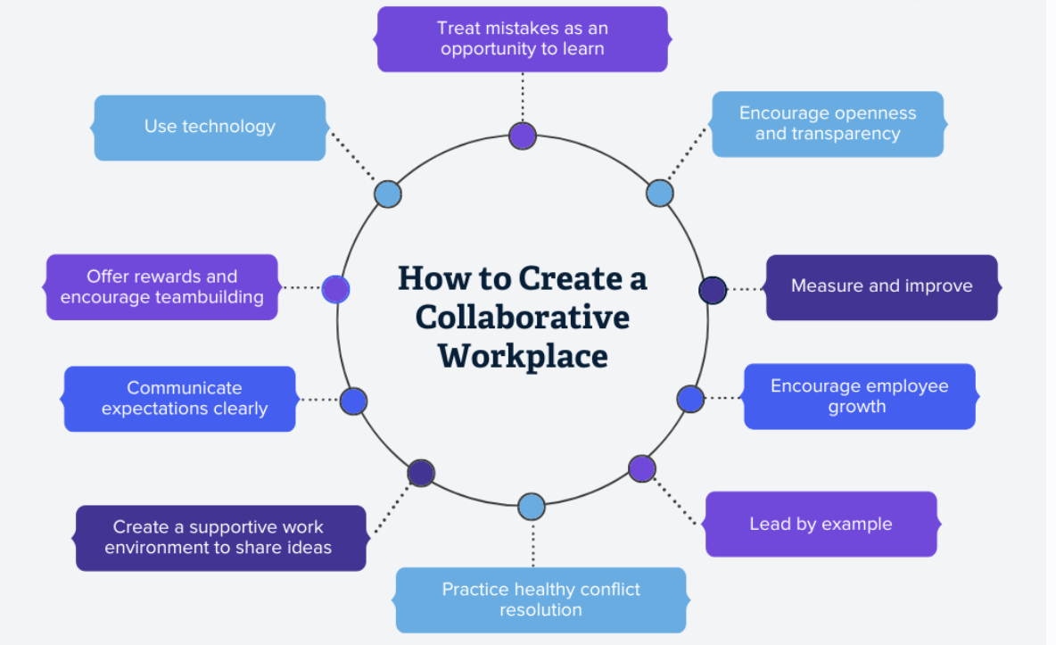
Figure 3: Creating Collaborative Workplace (Cornerresources, 2024).

5. Conclusion
The report shows that high-quality health and social care requires three fundamental elements: effective communication, administrative practices, and collaborative working between healthcare teams. The elements play a crucial role in providing Mr Ahmed with safe, personal care that meets legal requirements. Effective communication enables people to understand information, allowing patients to participate in their medical treatment. Administrative skills enable organisations to maintain records that meet legal requirements while providing continuous patient treatment. Collaborative working enables professionals to coordinate efforts and respond effectively to complex needs.
The Equality Act 2010, together with the Data Protection Act 2018, establishes a legal framework that guides organisations in conducting operations in accordance with ethical standards. The effectiveness of care depends on professionals' ability to implement these principles in their work. High-quality care requires a comprehensive approach that combines three elements: communication, administration, and collaboration. Healthcare professionals who focus on these areas achieve better patient outcomes, reduce risks and provide care that upholds the dignity and needs of patients like Mr Ahmed.

6. References
Barnard, C. (1938) The Functions of the Executive. Cambridge: Harvard University Press.
Bechir, G. and Bechir, A. (2025) ‘Reducing delays, improving flow: the importance of a dedicated discharge coordinator in hospital discharge planning’, Cureus, 17(6).
Benson, L. and Winship, G. (2024) Working collaboratively in health and social care. London: Sage.
Berlo, D.K. (1960) The Process of Communication. New York: Holt.
Care Quality Commission (2024) Regulation 17: Good governance. Available at: https://www.cqc.org.uk (Accessed: 18 March 2026).
Chen, Q., Jin, Y., Zhong, L., Li, Y., Fu, L., Zhang, W. and Xu, Q. (2024) ‘Application effect of the online and offline mixed education mode in nursing practice based on the SMCR communication model’, Frontiers in Medicine, 11, p.1350975.
Data Protection Act 2018 (2018) Available at: https://www.legislation.gov.uk/ukpga/2018/12/contents (Accessed: 18 March 2026).
Deetz, S. (1992) Democracy in an Age of Corporate Colonization. Albany: State University of New York Press.
Dickerson, J.E. (2022) ‘Privacy, confidentiality, and security of healthcare information’, Anaesthesia & Intensive Care Medicine, 23(11), pp. 740–743.
Elkomy, S., Murad, Z. and Veleanu, V. (2023) ‘Does leadership matter for healthcare service quality? Evidence from NHS England’, International Public Management Journal, 26(2), pp. 147–174.
Equality Act 2010 (2010) Available at: https://www.legislation.gov.uk/ukpga/2010/15/contents (Accessed: 18 March 2026).
Ghari, Z. (2016) ‘The cognitive, psychological and cultural impact of communication barrier on deaf adults’ content of speech in Iran’, Communication Disorders Studies, 4(3).
Glasby, J. and Dickinson, H. (2014) Partnership working in health and social care. Bristol: Policy Press.
Glasby, J. and Dickinson, H. (2021) Partnership working in health and social care: What is integrated care and how can we deliver it? 2nd edn. Bristol: Policy Press.
Gupta, A. (2023) Hospital administration and management: A comprehensive guide. Academic Guru Publishing House.
Health and Social Care Act 2008 (2008) London: The Stationery Office.
Hoyle, V., Shepherd, E., Flinn, A. and Lomas, E. (2019) ‘Child social care recording and information rights’, British Journal of Social Work, 49, pp. 1856–1874.
Information Commissioner’s Office (2024) Guide to the UK GDPR. Available at: https://ico.org.uk (Accessed: 18 March 2026).
Ismail, N.A.S., Mageswaran, N., Bujang, S.M. and Awang Besar, M.N. (2024) ‘Beyond words: analysing non-verbal communication techniques in a medical communication skills course’, Frontiers in Medicine, 11, p.1375982.
Kersner, M. and Wright, J.A. (2012) Speech and language therapy. London: Routledge.
Khatri, R., Endalamaw, A., Erku, D., Wolka, E., Nigatu, F., Zewdie, A. and Assefa, Y. (2023) ‘Continuity and care coordination of primary health care’, BMC Health Services Research, 23(1), p.750.
Lee, E. (2023) Effective communication in health and social care. CPD Online.
NHS (2021) Improving communication between healthcare professionals and patients. Available at: https://www.england.nhs.uk (Accessed: 18 March 2026).
NHS England (2024) Person-centred care. Available at: https://www.england.nhs.uk (Accessed: 18 March 2026).
Nursing and Midwifery Council (2018) The Code: Professional standards of practice and behaviour for nurses, midwives and nursing associates. London: NMC.
O’Hair, D., Wiemann, M., Mullin, J. and Teven, J. (2020) Real communication: An introduction. 4th edn. Boston: Bedford/St. Martin’s.
O’Toole, G. (2024) Communication: Core interpersonal skills for healthcare professionals. Elsevier Health Sciences.
Politi, R.E., Mills, P.D., Zubkoff, L. and Neily, J. (2022) ‘Delays in diagnosis, treatment, and surgery’, Journal of Patient Safety, 18(7), pp. e1061–e1066.
Roleska, M., Roman-Urrestarazu, A., Griffiths, S., Ruigrok, A.N., Holt, R., Van Kessel, R., McColl, K., Sherlaw, W., Brayne, C. and Czabanowska, K. (2018) ‘Autism and the right to education in the EU’, PLOS ONE, 13(8), p.e0202336.
Royal College of Speech and Language Therapists (2023) Communication after stroke. Available at: https://www.rcslt.org (Accessed: 18 March 2026).
SCIE (2023) Record keeping guidance. Available at: https://www.scie.org.uk (Accessed: 18 March 2026).
Silva, R.P. and Jothimuni, M.S. (2025) ‘The importance of non-verbal communication in mediation’, International Journal of Law, Social Science and Humanities, 2(1), pp. 151–160.
Sim, T.F., Hattingh, H.L., Sunderland, B. and Czarniak, P. (2020) ‘Effective communication and collaboration with health professionals’, PLOS ONE, 15(6), p.e0234580.
Thompson, N. (2019) Communication and language: A handbook of theory and practice. London: Palgrave Macmillan.
White, D. (2021) Communication Skills. London: Routledge.
Wright, D., Gabbay, J. and Le May, A. (2022) ‘Determining the skills needed by frontline NHS staff’, BMJ Quality & Safety, 31(6), pp. 450–461.

