

Student Name :- Patel Manthan Sureshbhai
Student Id :- 2241308
Programme :- MBA- Master Of Business Administration
Module :- International Marketing
Module Code :- LCMB7006
Lecturer Name :- Tushara Balendran
Date :- 20/12/2023

INTERNATIONAL MARKETING STRATEGY OF JOHNSON & JOHNSON
Table of Contents
Introduction 3
Company Background 3
Macro and Micro-environmental analysis 5
PESTLE analysis by comparing Japan and the USA 5
Hofstede’s Cultural Dimension model 7
Advantages and Disadvantages 9
Similarities and Dissimilarities 9
Porter’s 5 Forces 9
Similarities and Dissimilarities 11
SWOT Analysis 11
Similarities and Dissimilarities 12
STP about Japan and the USA 12
Similarities and Differences 14
Marketing Mix Elements 15
Product 15
Price 16
Place 16
Market entry strategy in USA 16
Market entry strategy in Japan 16
Promotion 17
Combination of Promotions 17
Similarities and Differences 18
People 19
Process 19

Physical Evidence 19
Directional Development Strategy 21
BCG matrix 21
Merits and Demerits 22
Conclusion 22
Recommendations using TOWS matrix 23
References 25

Introduction
Companies that want to break into and succeed in global markets in today's worldwide economy need a strong branding strategy. Branding is more than just identifying a product and it represents the core beliefs, character, and consumer promises of a company. Companies have the difficulty of connecting with distinct social, economic, and cultural aspects when they expand into diverse worldwide markets. To overcome these challenges, a company needs a well-thought-out branding plan building trust and loyalty among customers all around the world is easier with a consistent and easily identifiable brand image that can change with the times while staying true to its fundamental principles. In highly competitive global marketplaces, strong branding can set a firm apart from the competition and attract customers from all walks of life (Doole et al., 2019). Essentially, a powerful international branding strategy involves more than simply being visible on a worldwide scale it also involves creating meaningful relationships with customers in many locations to guarantee long-term development and success in the global marketplace.

Company Background
Johnson & Johnson is an old healthcare brand that has been around for a long time and is known for making reliable goods, particularly those for babies. It started small but has already expanded into more than 60 nations, becoming a worldwide behemoth. Products formulated for the sensitive skin of newborns have helped the business become famous for its baby skincare line and establish a strong emotional connection with buyers. It has become well-known for its dedication to creating products that are safe, mild, and based on research (Kernan, 2021). Trusted by parents throughout the globe for their newborns' skin care requirements, Johnson & Johnson's baby skin care portfolio remains a market leader, expressing the company's spirit of love and protection.

Macro and Micro-environmental analysis :-

PESTLE analysis by comparing Japan and the USA
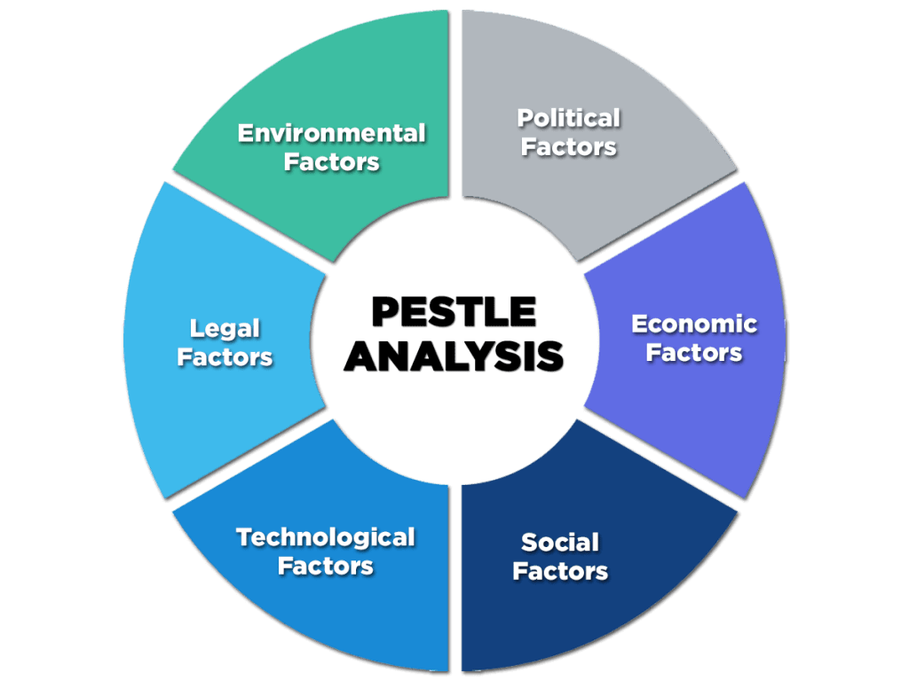
Figure 1: PESTLE analysis
Source: (Barik and Kumar, 2018)

Political Factors
USA: The political environment in the USA is relatively stable, with regulatory bodies like the FDA imposing strict regulations on product safety and advertising. Johnson & Johnson must adhere to these regulations, which influence their product formulation and marketing strategies (Galperina and Klen, 2017).
Japan: Japan also boasts a stable political climate but with more stringent regulations, especially in product safety and quality. The Japanese Ministry of Health, Labour, and Welfare imposes tight controls, requiring Johnson & Johnson to navigate more complex bureaucratic processes for product approval (Galperina and Klen, 2017).
Economic Factors
USA: The United States, with its large economy, offers significant market potential for baby skincare products. The purchasing power is high, allowing Johnson & Johnson to position its products across various price segments. However, the market is also highly competitive.
Japan: Japan's economy is characterized by high consumer spending power but also faces issues like population decline and a shrinking customer base for baby products. Johnson & Johnson must adapt its strategies to a market with high-quality expectations and willingness to pay for premium products (Galperina and Klen, 2017).
Socio-Cultural Factors
USA: American consumers emphasize safety and convenience in baby products. There is a growing preference for organic and natural products, influencing Johnson & Johnson’s product development. The diverse population also requires catering to a broad range of consumer needs and preferences (Barik and Kumar, 2018).
Japan: Japanese consumers place immense value on product quality and natural ingredients. There is a cultural emphasis on gentleness and care in baby products, which influences Johnson & Johnson’s branding and product formulation. The Japanese market also values minimalistic and aesthetically pleasing packaging.
Technological Factors
USA: The USA is at the forefront of technological innovation, which offers opportunities for Johnson & Johnson in terms of advanced manufacturing processes, product innovation, and digital marketing strategies (Barik and Kumar, 2018).
Japan: Japan is a global leader in technology, particularly in manufacturing and quality control. This presents opportunities for Johnson & Johnson to leverage advanced technology in product development and also poses challenges to meet high technological standards set by the market.
Legal Factors
USA: Legal considerations in the USA include adherence to safety standards, labor laws, and environmental regulations. Johnson & Johnson must ensure compliance with these laws to avoid legal repercussions and maintain its brand reputation (Barik and Kumar, 2018).
Japan: In Japan, compliance with local regulations is even more stringent, especially concerning product safety and ingredient disclosure. The legal framework is comprehensive, requiring Johnson & Johnson to be meticulous in compliance to operate successfully in the market.

Environmental Factors
USA: There is an increasing emphasis on sustainability and environmental responsibility in the USA. This trend affects Johnson & Johnson's manufacturing processes, packaging, and waste management practices.
Japan: Environmental consciousness is also high in Japan, with consumers and regulations demanding eco-friendly products and sustainable practices. This influences Johnson & Johnson's approach to product packaging, ingredients, and corporate social responsibility initiatives.

Hofstede’s Cultural Dimension model
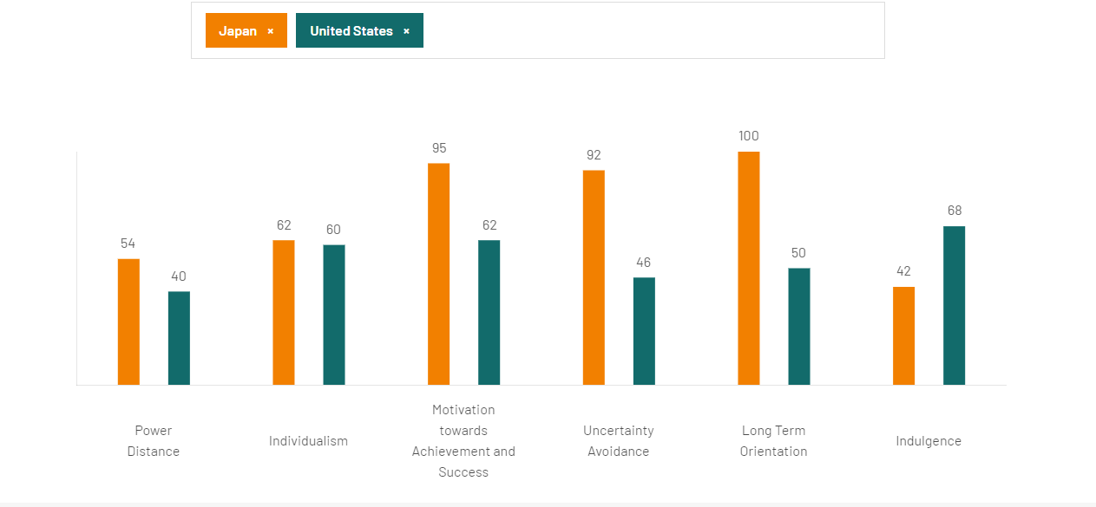
Source :- (hofstede insights,2023)

Power Distance
USA: With a lower power distance, American culture values equality and challenges to authority. This influences Johnson & Johnson to maintain transparent and ethical practices, as consumers expect brands to be accountable and approachable (Zhao et al., 2016).
Japan: The high power distance in Japan suggests a more hierarchical society. Consumers may place greater trust in authoritative brands and experts’ opinions, impacting how Johnson & Johnson positions its products and expertise in the market.
Individualism vs. Collectivism
USA: The USA scores high in individualism, reflecting a society that values individual rights and personal achievements. Johnson & Johnson might emphasize personal choice and the individual benefits of their products in marketing strategies (Zhao et al., 2016).
Japan: As a collectivist society, Japan places importance on group harmony and family. Johnson & Johnson’s marketing in Japan might focus more on how their products contribute to family well-being and societal approval.
Masculinity vs. Femininity
USA and Japan: Both countries score relatively high on masculinity, valuing achievement and success. For Johnson & Johnson, this could mean highlighting the product's effectiveness and superiority in nurturing a child's health (Kaur and Noman, 2015).
Uncertainty Avoidance
USA: With moderate uncertainty avoidance, American consumers are relatively open to trying new products, beneficial for innovative product introductions by Johnson & Johnson.
Japan: Higher uncertainty avoidance in Japan suggests a preference for familiar, well-established products, indicating Johnson & Johnson should focus on building brand trust and heritage (Kaur and Noman, 2015).
Long-Term Orientation and Indulgence vs. Restraint
USA: The USA's lower long-term orientation and higher indulgence score suggest a focus on immediate results and gratification, guiding Johnson & Johnson to emphasize the quick and visible benefits of their products.
Japan: Higher long-term orientation and lower indulgence in Japan imply a focus on future benefits and moderation, suggesting Johnson & Johnson should emphasize long-term skin health and product safety (Kaur and Noman, 2015).

Advantages and Disadvantages
Global companies greatly benefit from Hofstede's Cultural Dimension model because it provides a systematic framework for understanding and comparing cultural variations across nations. Improving cross-cultural communication and creating tactics that are responsive to other cultures are both helped by this. The model isn't without its flaws, however, stereotyping may result from the oversimplification of intricate cultural processes into generalized terms. The methodology has also come under fire for using data from only one company, which some argue limits its usefulness in other types of businesses (Kaur and Noman, 2015). Also, it could not apply to contemporary, ever-changing civilizations since it doesn't take subcultures or shifts in cultural views into sufficient consideration.

Similarities and Dissimilarities
In their approach to different cultures, Johnson & Johnson adapts its marketing based on Hofstede’s dimensions. Both the USA and Japan value masculinity, directing J&J to emphasize product effectiveness. However, differences arise in other dimensions: the USA's low power distance and high individualism lead to marketing focused on transparency and personal choice, while Japan's high power distance and collectivism orient marketing towards authority trust and group harmony. Additionally, America's lower long-term orientation and higher indulgence contrast with Japan’s future-focused and restrained approach, influencing J&J's product benefit communication.

Porter’s 5 Forces :-
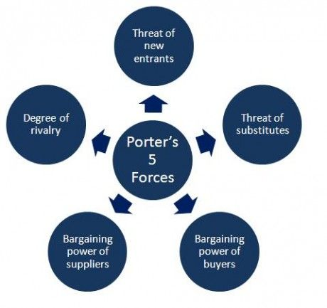
Figure 2: Porter’s Five Forces
Source: (Bruijl, 2018)

Threat of New Entrants
USA: Medium. While the U.S. market has significant barriers like established brand reputation and stringent regulatory standards, there's still room for niche players, particularly in natural and organic product segments.
Japan: Medium to High. Japan's market, known for its high standards, can be challenging for new entrants. However, niche and high-quality products, especially those with a unique value proposition, have potential entry opportunities (Bruijl, 2018).
Threat of Substitutes
USA: Medium. Alternatives like organic and homemade skincare products are becoming more popular, providing moderate competition to traditional offerings.
Japan: High. The Japanese market exhibits a strong preference for natural and traditional skincare products, presenting a significant substitute threat to conventional baby skincare products.

Bargaining Power of Buyers
USA: High. American consumers are well-informed and have a wide array of choices, granting them significant influence in the market.
Japan: Medium to High. Japanese consumers are discerning and value high-quality products, giving them considerable bargaining power, though brand loyalty also plays a significant role (Bruijl, 2018).
Bargaining Power of Suppliers
USA: Low to Medium. The presence of numerous suppliers and the ability to source globally reduces their bargaining power.
Japan: Medium. Dependence on local suppliers, especially for specialized products that meet Japanese quality standards, may increase their bargaining power.
Competitive Rivalry
USA: High. The U.S. market is intensely competitive, with numerous established and emerging players in the baby skincare segment (Partonezhad et al., 2016).
Japan: High. Japan's market, while more consolidated, is competitive with both domestic and international brands vying for consumer preference, especially in high-quality and innovative product categories.

Similarities and Dissimilarities
When looking at the newborn skincare products made by Johnson & Johnson in the US and Japan through the lens of Porter's Five Forces, we see intense competition and a danger of alternatives, caused by consumers' demands for high-quality, all-natural goods. The danger of new entrants is medium to high in Japan because of the country's distinctive or high-quality goods, while it's medium to low in the United States because of the prevalence of specialized possibilities (Partonezhad et al., 2016). American customers have a lot of negotiating power because they have so many options and are well-informed, but Japanese consumers are quality-conscious and have a medium to high amount of negotiating power. While local sourcing is vital for quality adherence in Japan, supplier power is medium in the internationally diversified USA market.

SWOT Analysis
Strengths
USA/Japan: Strong brand reputation, high-quality product standards, and extensive research and development capabilities. Johnson & Johnson’s long-standing market presence and trust factor are significant strengths in both markets (Nazarko et al., 2017).
Weaknesses
USA: Intense competition in the baby care market and increasing consumer shift towards organic and natural products could be challenging.
Japan: Adaptation to local consumer preferences and stringent regulatory standards might pose operational challenges.
Opportunities
USA: The growing market for natural and organic baby care products offers an opportunity for product line expansion. Technological advancements in marketing and e-commerce can enhance reach and consumer engagement (Nazarko et al., 2017).
Japan: There is a significant opportunity to tap into Japan’s preference for high-quality and specialized skincare products. Collaborations with local brands and tailored marketing strategies can further market penetration.
Threats
USA: The threat includes the rapidly changing consumer preferences and the high rate of new product introductions by competitors.
Japan: The competitive landscape with both local and international brands is a threat. Additionally, cultural nuances in marketing and product formulation pose challenges (Nazarko et al., 2017).

Similarities and Dissimilarities
In both the USA and Japan, Johnson & Johnson enjoys a strong brand reputation and high-quality standards. However, while the USA presents challenges with intense competition and a shift towards organic products, Japan faces hurdles in adapting to local preferences and stringent regulations. Opportunities in the USA include expanding into organic products and leveraging technology, whereas in Japan, tapping into high-quality skincare preferences and local collaborations is key. Threats in the USA involve changing consumer preferences and competitive product launches, while Japan contends with a competitive market and cultural marketing nuances.

STP about Japan and the USA
Segmentation
Johnson & Johnson employs a multifaceted approach to market segmentation for its baby skincare products, considering various factors such as demographics, psychographics, behavioral patterns, and geographic differences.
Demographic Segmentation: The company segments its market based on age (infants and toddlers), gender of the child (often unisex products), and the parents' age group, typically targeting young and middle-aged parents (Andaleeb, 2016).
Psychographic Segmentation: This involves understanding parents' attitudes, values, and lifestyles. For example, some segments prioritize organic and natural ingredients, while others may value cost-effectiveness and product availability.
Behavioral Segmentation: Johnson & Johnson considers factors like brand loyalty, usage rate, and parents' attitudes toward baby care and wellness. This helps in tailoring products for brand-loyal customers, first-time parents, or health-conscious families.
Geographic Segmentation: The brand adjusts its product offerings based on regional preferences and climatic conditions, recognizing that skincare needs can vary significantly in different geographic locations.
Targeting
After segmenting the market, Johnson & Johnson identifies its target segments to direct its marketing efforts effectively.
Primary Target Market: The primary target audience includes new parents and families with young children, focusing on those who prioritize safety and gentleness in baby care products.
Secondary Target Market: This includes gift-buyers and healthcare professionals. Hospitals and pediatric clinics can be significant influencers and recommenders of baby skincare products (Andaleeb, 2016).
Targeting by Location: In the USA, the brand may target a broad market, focusing on accessibility and familiarity. In contrast, in a market like Japan, the targeting might be more niche, focusing on consumers who prioritize premium and specialized skincare products.
Positioning
Johnson & Johnson’s positioning strategy aims to create a unique and favorable image of its baby skin care products in the minds of the target consumers.
Positioning in the USA: In the United States, Johnson & Johnson positions itself as a trusted, safe, and reliable brand for baby care. The positioning is built around a strong emotional connection, emphasizing the care and love parents have for their children. Marketing campaigns often highlight the brand's heritage, trustworthiness, and commitment to safety.
Positioning in Diverse Markets: In international markets, such as Japan, the positioning may emphasize local adaptation in product formulation, aligning with cultural preferences for natural and gentle ingredients. The brand also positions itself as a global leader in baby skincare, leveraging its international reputation to gain trust in new markets (DeSarbo et al., 2017).
Care and trust in infant products are cornerstones of Johnson & Johnson's worldwide positioning. However, the business expertly adjusts its targeting and market segmentation tactics to fit local customer tastes, cultural subtleties, and market forces. By taking this tack, the brand may continue to resonate with parents in different areas while still appealing to a global audience. Johnson & Johnson maintains its position as the market leader and customer favorite in the infant skincare business by skillfully using segmentation, targeting, and positioning.

Similarities and Differences
Segmentation Similarities:
Demographic Segmentation: In both the USA and Japan, Johnson & Johnson segments the market demographically, focusing on parents, especially new and expectant mothers, as primary consumers.
Behavioral Segmentation: The brand considers factors like parental concern for safety and gentleness in baby skincare products across both markets.
Segmentation Differences:
Geographic and Cultural Segmentation: In the USA, products might be designed for a more diverse demographic, considering various ethnicities and climatic conditions across the country. In Japan, geographic segmentation is more nuanced, with a focus on urban versus rural consumers and specific Japanese cultural practices and preferences in baby care.
Targeting Similarities:
Primary Target Market: Both countries see young and middle-aged parents as the primary target market for baby skincare products.
Targeting Differences:
Secondary Market Focus: The USA might have a broader secondary target market, including gift-buyers and healthcare providers. In Japan, the focus might be more on building relationships with healthcare professionals who influence new parents' buying decisions.
Positioning Similarities
Global Brand Image: In both countries, Johnson & Johnson positions itself as a trusted, safe, and reliable brand for baby skincare, leveraging its global reputation.
Positioning Differences:
Cultural Adaptation: In the USA, Johnson & Johnson’s positioning may emphasize the brand's heritage and emotional connection with consumers. In Japan, the positioning could be more focused on aligning with local preferences for natural and gentle ingredients, and the perception of high-quality international products.
Although Johnson & Johnson employs a worldwide consistent positioning strategy that emphasizes trust and safety and uses consistent demographic and behavioral segmentation in both Japan and the United States, there are clear variations in geographic segmentation, secondary targeting, and cultural adaptations of positioning. To succeed in these varied areas, the brand must be able to combine its global strategy with local subtleties.

Marketing Mix Elements
The marketing mix, often encapsulated by the 4Ps framework, is a vital concept in marketing strategy that encompasses four key components: Product, Price, Place, and Promotion. Product refers to the goods or services offered to meet customer needs. Price involves setting a cost that balances affordability for customers and profitability for the company. Place denotes the distribution channels and locations where the product is sold, ensuring accessibility to the target market (Darmawan and Grenier, 2021). Lastly, Promotion encompasses the various methods of communicating and advertising the product to the target audience, including advertising, public relations, and sales promotions. This mix is designed to optimize market appeal and business success.

Product
USA: Johnson & Johnson in the USA offers a diverse range of baby skincare products, focusing on safety and hypoallergenic formulations. They often incorporate innovative features responding to American preferences for effectiveness and convenience (Pomering and Johnson, 2018).
Japan: In Japan, the product range may include items specifically formulated to meet the local demand for natural and gentle ingredients, aligning with Japanese preferences for purity and skin sensitivity.

Comparison of Branding Strategy of Johnson & Johnson in USA and Japan
Brand Messaging and Positioning
USA: In the United States, Johnson & Johnson's branding strategy for baby skincare products emphasizes trust, safety, and emotional connection. The messaging often highlights the brand's legacy and reputation as a leader in gentle baby care (Ko et al., 2016). The company positions itself as a reliable and caring partner for parents, focusing on the well-being of their children.
Japan: In Japan, the brand tailors its messaging to resonate with cultural values of purity, gentleness, and high-quality care. The focus is more on the product's ability to be in harmony with the delicate nature of a baby's skin, often integrating concepts of nature and softness that align with Japanese aesthetics.
Marketing and Promotional Tactics
USA: Marketing tactics in the USA include a broad range of channels, including television commercials, online marketing, and social media campaigns. These often feature emotional storytelling, focusing on the parent-child bond, to connect with American audiences.
Japan: In Japan, marketing tends to be subtle and often relies on in-store promotions, targeted online campaigns, and collaborations with local influencers who embody the brand's values. The approach is more nuanced, reflecting the Japanese consumers’ preference for less direct marketing techniques (Ko et al., 2016).
Adaptation to Local Preferences
USA: The branding strategy in the USA aligns with the general preference for trusted and established brands, with a focus on product safety and effectiveness being paramount.
Japan: In Japan, the strategy incorporates a deeper understanding of local cultural nuances, emphasizing attributes like gentleness, natural ingredients, and aesthetic appeal in its branding.
Customer Engagement
USA: Johnson & Johnson engages with its American audience through interactive social media platforms, customer service, and community involvement, emphasizing a family-centric brand image (Seyedghorban et al., 2016).
Japan: Engagement strategies in Japan may include more personalized communication, loyalty programs, and community initiatives that align with local customs and social norms (Seyedghorban et al., 2016).

Price
USA: Pricing strategy in the USA may lean towards competitive pricing, considering the broad market and diverse consumer base. Discounts and promotions are common to attract price-sensitive segments.
Japan: The pricing strategy in Japan might focus on premium pricing, reflecting the high-quality standards and consumers' willingness to pay more for perceived superior products (Pomering and Johnson, 2018).

Place

Market entry strategy in USA
Advantages
- Full Control: J&J maintained complete control over its operations, ensuring alignment with its global standards and policies.
- Market Penetration: Direct investment allowed J&J to establish a significant presence, enhancing brand recognition and market share.
- Strategic Acquisitions: Acquiring established companies provided immediate access to new markets, technologies, and expertise.
Disadvantages
- High Investment and Risk: Direct investment requires substantial capital, carrying a higher financial risk.
- Complex Integration: Integrating acquisitions can be challenging, especially in terms of corporate culture and operational systems.
- Regulatory Hurdles: Navigating the complex regulatory environment in the healthcare and pharmaceutical sectors in the USA can be demanding and time-consuming.

Market entry strategy in Japan
Advantages
- Local Expertise: Partnering with Japanese companies provided J&J with essential local market knowledge, helping navigate Japan's complex regulatory environment.
- Shared Risk and Investment: Joint ventures reduced the financial burden and risks associated with entering a new market.
- Cultural Sensitivity: Collaboration with local firms helped J&J adapt its products and marketing to suit Japanese consumer preferences and cultural norms.
Disadvantages
- Limited Control: Joint ventures meant sharing decision-making authority with local partners, potentially leading to conflicts or compromises.
- Dependency on Partners: J&J's success in the Japanese market became partly dependent on the reliability and competence of its local partners.
- Integration Challenges: Merging business practices and corporate cultures with Japanese partners could be challenging.

Promotion
USA: Promotional strategies include advertising across various media, digital marketing, and influencer partnerships. Emotional branding through storytelling is a key tactic.
Japan: Promotion in Japan often involves subtler marketing techniques, with a focus on building brand credibility and trust through quality assurance and endorsements from trusted figures.

Combination of Promotions
Promotions in the USA:
Johnson & Johnson in the USA employs a combination of traditional and digital marketing strategies to promote its baby skincare products.
Television and Print Advertising: The brand has historically used emotional advertising on TV and in print media. Commercials often feature tender moments between parents and babies, emphasizing the safety and gentleness of their products.
Digital Marketing: With the increasing relevance of online platforms, Johnson & Johnson leverages social media, influencer partnerships, and content marketing (Kent et al., 2016). For example, they might collaborate with parenting bloggers or influencers who share their personal experiences using the products.
Promotional Offers and Coupons: The brand frequently uses promotional offers, discounts, and coupons, especially through retail partnerships and online platforms, to attract price-sensitive consumers.
Community and Healthcare Engagement: Johnson & Johnson engages with healthcare professionals and participates in community events, positioning itself as a brand that cares about child health beyond just selling products.
Promotions in Japan
In Japan, Johnson & Johnson's promotional strategies are tailored to align with the cultural nuances and consumer behavior in the market.
In-Store Promotions: The company places significant emphasis on in-store promotions in Japan. This includes visually appealing displays and product demonstrations in retail stores, which are critical in a market where consumers value the physical shopping experience.
Collaborations with Local Influencers: Similar to the USA, Johnson & Johnson in Japan collaborates with influencers, but with a focus on local celebrities or trusted figures in the parenting community, who resonate with the Japanese audience.
Digital Marketing: The brand’s digital marketing in Japan is more focused on providing in-depth product information and educational content about baby care, reflecting the Japanese consumers’ preference for detailed knowledge before making a purchase.

Similarities and Differences
Similarities
Digital Marketing: In both countries, the brand leverages digital platforms, including social media and influencer partnerships, albeit with different content focuses.
Brand Messaging: Across both markets, Johnson & Johnson maintains a consistent core message emphasizing safety and trust in their baby skincare products.
Differences
Advertising Approach: In the USA, advertising tends to be emotionally driven, featuring relatable family moments. In contrast, Japanese promotions are more informative and subtle, often featuring endorsements from healthcare professionals.
Promotional Tactics: The USA sees more direct promotional tactics like discounts and coupons, appealing to cost-conscious consumers. In Japan, emphasis is placed on in-store promotions and visual merchandising, catering to the Japanese preference for a tangible shopping experience.
Influencer Marketing: While both regions utilize influencers, the USA focuses on parenting bloggers and broad-reach influencers, whereas in Japan, local celebrities or trusted parenting figures are preferred, reflecting cultural differences in consumer trust and appeal.

Process
USA/Japan: The emphasis is on ensuring a smooth customer experience, from product discovery to purchase and post-purchase support. Online purchasing processes are streamlined for convenience.

Physical Evidence
USA: The brand’s physical presence, like product packaging and in-store displays, is designed to be appealing and informative, aligning with American consumer expectations.
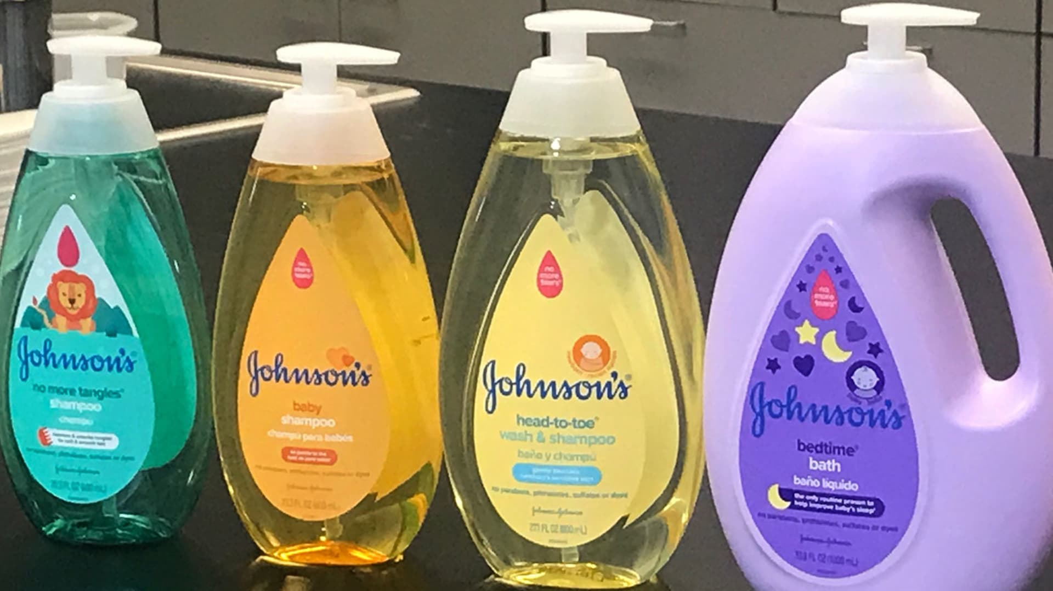
Figure 3: Packaging of Johnson&Johnson in the USA
Source: (Tirrell, 2018)

Japan:
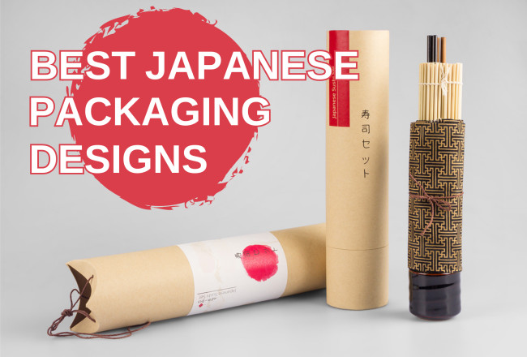
Figure 4: Packaging of Johnson&Johnson in Japan
Source: (designrush.com, 2018)
The use of the 7Ps by Johnson & Johnson in both the United States of America and Japan demonstrates custom-tailored strategies for each market. In the United States of America, the emphasis is focused on wide accessibility, competitive prices, and emotional advertising. On the other hand, in Japan, the emphasis is placed on premium pricing, smart distribution relationships, and discreet marketing. Both markets can reap the benefits of robust product offers as well as customer-centric service and procedures and the implementation of price, place, and promotional activities is matched with the cultural and market characteristics of each nation.

Directional Development Strategy
A directional development strategy is a framework used by businesses to guide their growth and expansion plans. It encompasses various approaches a company might adopt to develop its operations and increase its market presence (Jelinčić and Vukić, 2015). This strategy typically includes four main directions: market penetration, market development, product development, and diversification.
Market Penetration: This involves increasing the market share within existing markets, often through competitive pricing, increased promotion, and enhanced distribution efforts (Jelinčić and Vukić, 2015). It focuses on selling more of the existing products to current customers or finding new customers within existing markets.
Market Development: This strategy aims at entering new markets with existing products. It includes geographic expansion or targeting new segments within or beyond the current market.
Product Development: This direction involves developing new products or improving existing ones to meet changing customer needs or to target new customer segments within the existing markets.
Diversification: The most ambitious of the strategies, diversification involves introducing new products into new markets. This can be related to the company’s current offerings (concentric diversification) or entirely new (conglomerate diversification).

BCG matrix
Stars
In the context of Johnson & Johnson, "Stars" could represent their highly popular and innovative baby skincare products in markets where they hold a strong market share and the market itself is growing. For instance, their line of natural baby products in environmentally-conscious markets like the USA, where demand for organic and safe baby products is rising, could be considered a "Star". These products require continuous investment to maintain their market position and to capitalize on growth opportunities.
Cash Cows
"Cash Cows" are products with high market share in a slow-growing market. Johnson & Johnson’s traditional baby skincare products like baby lotion and shampoo in established markets like the USA and Japan fall into this category. These products generate consistent revenue without the need for significant investment. The company can use the profits from these products to support other segments in the portfolio.
Question Marks
These products have a low market share in a high-growth market. For Johnson & Johnson, this could include newer product lines or expansion into emerging markets where the brand is not yet well-established. For example, entering into new Asian markets with innovative baby skincare products could be seen as a "Question Mark". These areas require strategic decision-making to determine whether to increase investment to gain market share or to divest.
Dogs
Products or business units with low market share in a mature, slow-growing market are classified as "Dogs". Johnson & Johnson might have certain older or less popular products in saturated markets that fall into this category. These products typically don’t generate significant profits and might be candidates for divestiture or repositioning.
Using the BCG Matrix, Johnson & Johnson can assess the foreign market potential of its product line. Resource allocation, product development, and product phasing out or re-strategization may all be better understood with its help. Keeping a well-rounded and lucrative product line up in the ever-changing global market requires this research.

Merits and Demerits
The BCG (Boston Consulting Group) Matrix is a strategic tool for portfolio analysis. Its merits include providing a simple visual representation of a company's product or service portfolio, aiding in resource allocation decisions based on market growth and relative market share. However, its demerits involve oversimplification of market dynamics, as it reduces complex strategic decisions to two dimensions. It also overlooks external factors like competition and market trends, and can lead to short-term thinking, neglecting potential long-term opportunities or threats.

Conclusion
Analysing Johnson & Johnson's US and Japanese business strategies using different frameworks shows how dynamic and complicated the global market is. Segmentation, targeting, and positioning (STP) show that the organization is good at adapting its strategies to meet the demands of various cultures and demographics of consumers. By tailoring each component of the 7Ps marketing mix to the unique needs of each country's market, Johnson & Johnson demonstrates its strategic adaptability. Product portfolio management and the competitive environment may be better understood with the use of the BCG Matrix and Porter's Five Forces, respectively. These studies show that Johnson & Johnson was able to overcome obstacles including competition among competitors, difficulty entering new markets, and changing customer preferences. The company's knowledge of the specifics of each market is further shown by its strategic use of diverse market entrance strategies in the US and Japan, especially under the 'Place' component of the marketing mix. In addition, the promotional methods used in Japan and the United States demonstrate a great understanding of cultural differences in marketing and consumer interaction. To appeal to local market sensibilities, the company's advertising strategies vary widely, yet its essential theme of safety and trust remains similar internationally. The significance of cultural awareness, market research, and flexibility in global trade is shown by Johnson & Johnson's strategy approaches in these two varied marketplaces. Their achievements in these markets demonstrate the power of well-planned and tailored tactics in the international business world.

Recommendations :-

TOWS Analysis :
Maximizing Strengths to Exploit Opportunities (S-O):
- Leverage R&D Excellence: Johnson &Johnson's strong research and development capabilities can be utilized to innovate products tailored to emerging health concerns and trends in different markets, such as developing region-specific pharmaceuticals or healthcare products.
- Brand Power for Market Penetration: Use J&J’s well-established brand to penetrate emerging markets, particularly in regions with growing healthcare needs, by emphasizing the brand’s reliability and history of quality.

Using Strengths to Neutralize Threats (S-T):
- Combat Regulatory Challenges: Utilize J&J’s experience in navigating complex regulatory environments to efficiently manage diverse international healthcare regulations, maintaining compliance while expanding in global markets.
- Respond to Competitive Pressures: Employ the company's extensive resources and global network to innovate and stay ahead of competitors, particularly in fast-growing sectors like biotech and digital health.

Addressing Weaknesses by Seizing Opportunities (W-O):
- Diversify Product Portfolio: Broaden the product range to include affordable options for developing markets, addressing the weakness of over-reliance on certain product segments or markets.
- Expand Digital Presence: Enhance online marketing and telemedicine services, tapping into the increasing demand for digital healthcare solutions and overcoming limitations in physical market presence.
Mitigating Weaknesses to Avoid Threats (W-T):
- Supply Chain Resilience: Strengthen the supply chain against geopolitical risks and pandemics by diversifying suppliers and production sites, addressing vulnerabilities in global operations.
- Cultural Sensitivity in Marketing: Develop culturally sensitive marketing campaigns to resonate with diverse international audiences, tackling the challenge of varying consumer preferences and social norms.
By following these recommendations, Johnson & Johnson can strengthen its international marketing strategy, ensuring sustained growth and a competitive edge in the global market. This approach balances leveraging strengths with addressing weaknesses, while proactively responding to external opportunities and threats.

References
Andaleeb, S.S., 2016. Market segmentation, targeting, and positioning. In Strategic marketing management in Asia: case studies and lessons across industries (pp. 179-207). Emerald Group Publishing Limited.
Barik, B. and Kumar, S., 2018. Macro Environment of Indian Life Insurance Business: A PESTLE Analysis. Bimaquest, 18(3).
Bruijl, D.G.H.T., 2018. The relevance of Porter's five forces in today's innovative and changing business environment. Available at SSRN 3192207.
Darmawan, D. and Grenier, E., 2021. Competitive Advantage and Service Marketing Mix. Journal of Social Science Studies (JOS3), 1(2), pp.75-80.
DeSarbo, W.S., Blanchard, S.J. and Atalay, A.S., 2017. A new spatial classification methodology for simultaneous segmentation, targeting, and positioning (STP analysis) for marketing research. In Review of marketing research (pp. 75-103). Routledge.
designrush.com, 2018. 11 Best Japanese Packaging Designs That Show Cultural Flair. [Online]
Available at: https://www.designrush.com/best-designs/packaging/trends/best-japanese-packaging-designs
Doole, I., Lowe, R. and Kenyon, A., 2019. International marketing strategy: analysis, development and implementation. Cengage Learning.
Galperina, L.I.U.B.O.V. and Klen, Y.U.L.I.I.A., 2017. Global trends of international mergers and acquisitions in the energy sector. International Economic Policy, (1), pp.43-68.
Jelinčić, D.A. and Vukić, F., 2015. Creative industries as carriers of urban identity and drivers of development: from directional towards participative branding. Annales Series Historia et Sociologia, 25(3), pp.527-536.
Kaur, A. and Noman, M., 2015. Exploring Classroom Practices in Collectivist Cultures Through the Lens of Hofstede's Model. The Qualitative Report.
Kernan, A.B., 2021. Samuel Johnson and the Impact of Print:(Originally Published as Printing Technology, Letters, and Samuel Johnson). Princeton University Press.
Ko, E., Phau, I. and Aiello, G., 2016. Luxury brand strategies and customer experiences: Contributions to theory and practice. Journal of Business Research, 69(12), pp.5749-5752.
Nazarko, J., Ejdys, J., Halicka, K., Magruk, A., Nazarko, Ł. and Skorek, A., 2017. Application of enhanced SWOT analysis in the future-oriented public management of technology. Procedia engineering, 182, pp.482-490.
Partonezhad, N., Shakib, A.S. and Moosivand, M., 2016. Ranking The Competitive Factor According To Their Importance By Using Michael Porters Five Forces Model.
Pomering, A. and Johnson, L.W., 2018. Building Sustainability into Services Marketing: Expanding decision-making from a mix to a matrix. Sustainability, 10(9), p.2992.
Rupprecht, C.D., Fujiyoshi, L., McGreevy, S.R. and Tayasu, I., 2020. Trust me? Consumer trust in expert information on food product labels. Food and Chemical Toxicology, 137, p.111170.
Seyedghorban, Z., Matanda, M.J. and LaPlaca, P., 2016. Advancing theory and knowledge in the business-to-business branding literature. Journal of Business Research, 69(8), pp.2664-2677.
Tirrell, M., 2018. Johnson & Johnson to relaunch baby-care line after its 20% sales decline. [Online]
Available at: https://www.cnbc.com/2018/05/16/jj-to-relaunch-baby-care-line-after-its-20-percent-sales-decline.html
Zhao, H.Y., Kwon, J.W. and Yang, O.S., 2016. Updating Hofstede's Cultural Model and Tracking Changes in Cultural Indices. Journal of International Trade & Commerce, 12(5), pp.85-106.

