CREATING AN ORIGINAL PIECE OF SOCIO-POLITICAL THEATRE
A transfer of skills and experience as an actor to playwriting
What If Cymru?

Independent Project
Presented to:
Jonathan Pugh
Performance, Dance & Musical Theatre
University of Wales Trinity Saint David
For
BA Acting (Hons)

By

Betsy Downes (23304420)
March 2026

INTRODUCTION
I believe the arts can be a real window for political and social issues affecting our world today. I have gained the skills and knowledge as an actor to voice opinions on these issues through art, specifically theatre. I believe myself to be a sympathetic and empathetic person, with the ability to see things from more than one perspective. I believe this helps me to be a good actor and prepare me for roles in the creative industry.
I wanted to explore whether I could transfer these skills into playwriting to create my own material.
I believe that peace, understanding and kindness is the route to repairing the world and I wanted to create a theatrical piece which promotes these values within my own context and provoke thought and questioning around these issues.
I share both Welsh and English heritage. I was born in England to a Welsh father and an English/Welsh mother but was raised and educated in Wales. Because of my mother’s upbringing I have an English (“posh”) accent, I knew that this makes me seem less Welsh to others who have a strong Welsh accent. I was confused by the animosity that exists between the Welsh and the English. Whilst this often manifests itself as light-hearted and humorous, the underlying hostility feels dark. I was interested in exploring the origins of this seemingly deep-rooted distrust and misunderstanding.
I am starting to understand many of the reasons why the Welsh may have a distrust of the English. They believe that the English are responsible for taking away their independence and eroding their culture and language. It seems there is a lack of understanding about the very real humiliations that Welsh people have suffered throughout their history and arguably continue to suffer at the hands of their closest neighbours. Today many Welsh towns and villages are suffering from the lack of affordable housing and any meaningful job opportunities because their towns are full of holiday homes empty for large parts of the year but enjoyed for a few weeks by holiday makers. I believe that as individuals we need to look and learn from history and understand how it continues to affect the modern world.
As an artist I instinctively turn to my preferred media to explore this, theatre. A beginner playwright, I have created a short three act play with historical references which explores English and Welsh relationships at both a national and an individual level.
What I want the audience to reflect on through the play is not just the differences that may exist between Welsh and English people and why we still feel that way in the twenty first century, but also on the similarities. The hope is that by re-imagining a different dynamic between Llewellyn the Great of Wales and the English King John, audiences will be able to see that as kings they were not so very different and the same could be said of the Welsh and the English in the twenty first century.
The conflict between the Welsh and the English has set a divide between the countries and its people. It is my aim through the play to share a reversed view of history; to consider what might have been and share my beliefs that it doesn’t matter whether we are English or Welsh, we are human. This was true in thirteenth century and it’s true today.
What if the outcome of the Welsh Monarchy was different? In a personal dramatised version of history, I have created a premise where Wales is the dominant country. If the roles were reversed, I want to show that the aggression and repression would be no less shocking. I will use my knowledge, skills and experience as an actor to share my values and show the audience how the world could benefit from kindness and understanding. For the avoidance of doubt, this is a dramatic re-imagining of a specific period of history and not in any way meant to be a factual reconstruction.
Whilst I am focusing on the English and the Welsh in this particular play, I want audiences to understand that this is a metaphor for a fractious relationship between any two nations, sides or individuals and this is a message that translates into the many and various conflicts that exist today.
The aim is not to blame but to create empathy; the intention is to show what it is to feel repressed, to be human, and the temptations, fears and pressures of leadership. If this piece of theatre can develop a greater understanding of the past and of each other and make even one member of the audience self-reflect on their own attitude to others from different nations, or be inspired to look further into Welsh history (the real one) I will consider it to be a success.

OBJECTIVES
Research Welsh History
To write my play I knew that I needed a better understanding of the medieval friction between the English and the Welsh so some historical research would be required, especially into the Welsh Princes. It was strange to me that I knew so little. Despite growing up in Wales and being educated in Wales, the history that I had learned at school was centred around other nations and predominantly England. We learned about the Second World War and the holocaust but learned very little that was Wales specific and nothing of the Welsh Princes of thirteenth century. It was only in my late teens when I started to wonder about the history of Wales, and not the history from the perspective of the victor England.
Emily Price quotes Dr Huw Griffiths, a Senior Lecturer at University of Wales Trinity Saint David who said (2025), “Dr Griffiths said: If you were to ask the majority of young people in Wales what happened in 1966 they are far more likely to say that England won the World Cup. That shouldn’t be the answer, the answer should be Aberfan. There are certain dates in Welsh history that are very important.”
Emily further quotes Dr Huw Griffiths, (2025) “1282 was when Llywelyn, the last Prince of Wales, was killed. 1847 was the Blue Books report which had a massive impact on the Welsh language. These are the dates people in Wales should know about.” This is Llywelyn ap Gruffudd, not Llywelyn the Great

Research on contemporary cultural differences and attitudes to Welsh History
Having been born in England and raised in Wales I have direct experience of the cultural differences between the two nations and their attitudes to each other. To dig a little deeper into this, I sought out contemporary commentary and to do this I conducted a simple poll amongst friends / colleagues. (See Appendix 11 for responses.)

Research Playwriting
Creative writing has always been an interest of mine since school, but I haven’t written anything this extensive before, so I wanted to do some research into the craft of playwriting. I wanted to find my own way of writing with my own voice and not adopt another’s methods or ways, finding a style that works for me and is uniquely me. Arguably I’ve been researching how to write a play for some time given how many plays I read as a matter of course in my studies both for classes and performance, but I also felt that I needed some guidance, particularly on where to start which in my experience is always the most challenging thing.

Testing the Creative Process /Professional Practice
Following discussion with tutors I decided it would be too ambitious for my Independent Project to write the play and produce a wholescale performance of it as well as writing my dissertation and presentation. However, I felt strongly that as a performance piece, there needed to be an element of performance to test the material. I decided to run a series of read-throughs to generate peer feedback and inform my own edits/evaluation.
By the end of this project What if Cymru? will still be a work in progress, but the aim is that it will be well on its way to being a finished play which with a bit more work and design will be ready for full scale production.
My vision for the play is deliberately simple. I want this play to be adaptable and suitable for both small-scale school hall productions as well as a more elaborate and scaled production appropriate for a larger theatre space.

Collaboration
Collaboration is a required element of the Independent Project; however, as it is such a crucial component of the creative industries, I would always seek to collaborate as part of the process. Writing is a much more solitary activity than acting and whilst I have enjoyed embracing this different way of working and the autonomy that it has brought, at the same time working with others is essential to bring a project like this to life. I was delighted to have been able to work with my peer group on both my project and some of theirs.

Applying acquired skills and experience
This Independent Project is the opportunity for me to demonstrate the skills I have learned and developed throughout the three years of my Acting degree at UWTSD. It is a particular objective of mine to prove that I have acquired and advanced the skills required for a successful career in the creative industries, and improved on academic skills, not just to my tutors who will be grading my work but to myself.
RESEARCH & METHODOLOGY
Welsh History
The historical element of What if Cymru? is loosely based on the period of Llywelyn the Great’s reign, until there is a dramatic change in direction away from Welsh history as we know it. The “What if?” question being investigated is what the consequences may have been if King John had never invaded Wales and the roles had been reversed. What if Llywelyn had continued to unite Wales and gone on to conquer England, resulting in the English being the repressed minority and what might that look like in our contemporary relationships.
In A Chronicle of Welsh Events by John May, (May, 1994, p. 25 – p. 26). May describes Llywelyn the Great as one of the most famous Welsh icons in history. He came into power in 1194 by defeating his uncle Dafydd. Another uncle, Rhodri was also defeated by Llywelyn the Great. May goes further to explain that in 1201, King John recognised Llywelyn the Great as “Prince of North Wales”, Llywelyn has been calling himself that when he captured Mold castle in 1199. Once King John recognised Llywelyn as the “Prince of North Wales”. John May explains that Llywelyn and King John even went to battle together at the Scottish borders in 1209. Unfortunately, this act proved to be irrelevant as later in 1211, their relationship started to weaken as Llywelyn was constantly making efforts to take land. This offended King John and it led to King John leading an expedition to Wales and caused a big setback for Llywelyn as he lost a lot of land; he managed to gain a lot of it back however this was an end to a friendly agreement between Llywelyn and King John. Knowing now that the relationship was already starting to weaken between King John and Llywelyn in 1211, I decided that this is where my “change” would be set. Simply for the purposes of the play the peace treaty would happen in 1211 even though in history it happens in 1201. The reason I chose to do this is because I needed a motivation to have King John and Llywelyn in the same place and to show the tensions rising between each other and to show King John’s paranoia.
My re-telling of history starts at a time before Llywelyn was united in marriage with Joan. A video on Welsh history, (Dragon Heart, The Prince of Wales, 2018) shows that Llywelyn marrying King John’s daughter Joan was a sound political tactic. This gave Llywelyn the Great a political advantage in his aspirations to acquire more land for Wales. Historical sources have not been able to be completely accurate in terms of the date when the union between Joan and Llywelyn took place but the date it somewhere between 1203 and 1205. Due to this uncertainty, I have chosen to place the first scene of the play in 1202 when Llywelyn and his advisors are discussing the pros and cons of this potential marriage.
The play examines the relationship between Llywelyn and Joan but as history has focused on the political, but I wanted to find out more about their personal relationship. Unfortunately, I haven’t been able to find much historical evidence about this. However, according to The History Press, (2018) “Joan and Llywelyn’s marriage appeared to be a happy one, and there is evidence that the prince doted upon his bride.” One such piece of evidence quoted is that the church at Trefriw where the couple often resided is said to have been built by Llywelyn for his wife because she had tired of making the up-hill journey to the church at Llanrhychwyn. The Trefriw church features the couple in a stained-glass window. Whilst the match was undoubtedly a political union, my piece dramatises this sketchy evidence and portrays their relationship as a personal partnership of mutual support. The notion that Llywelyn would have valued the opinion of his wife is in great contrast to historical evidence on the general view of women during this period. The Magna Carta itself makes clear the level of respect for a woman’s point of view at the time where it states in Clause 54 that “No one shall be taken or imprisoned upon the appeal of a woman …” (Morris 2016 cited in Bennet, S 2020, p. 14) It goes on to say that the testimony of a woman was not considered reliable enough to result in a conviction except in the case of the murder of her own husband.
In my reimagining, Joan represents both the English and Welsh cultures, portraying the best of each. She is both the loyal daughter of the King of England and Llywelyn’s wife, basically the Welsh people’s Queen although not in name. Joan presents an alternative view and is What if Cymru?’s advocate for peace rather than war and glory.
In contrast, the portrayal of Llywelyn in Welsh history is one of a warrior Prince. As clear chronological evidence of this period is patchy at best, historians make much reference to the work of poets of the time. In his book on the protagonist of my play, Roger Turvey refers to the information gleaned from poems by Cynddelw Brydydd Mawr and Llywarch ap Llywelyn who he says speaks about Llywelyn’s “prowess in battle, his resourcefulness and, in spite of his youth, his courage.” (Turvey, 2007, p.34 – p.35) Turvey goes on to point out that the poetry of the time had a tradition of exaggerating individual’s contributions in battle but describes Llywelyn as part of a “warrior elite … men for whom the call to arms and the blood and fury of battle were a way of life inculcated almost from birth” (Turvey, 2007, p.34 - p.35).
For context it’s important to understand the extent of the Welsh lands ruled over by Llywelyn to give us an appreciation of what he was fighting for. The play is written against this background.
The website Fourteenthcenturyfiend speaks of the geographical areas of Wales ruled over by Llywelyn and subsequently his sons,
“Yet prior to 1282, the lands in Wales were in the north and west of the modern geographical principality, ruled by native Welsh princes until Edward I overcame and defeated Llewelyn ap Gruffudd who was killed in a skirmish in December 1282. The execution of his brother Dafydd, briefly titular prince in 1283, brought to an end native Welsh rule and with it the title passed to the English crown, laying dormant for the next two decades.”
(Fourteenthcenturyfiend, 2017)
Llywelyn the Great was a fearsome and respected leader, was politically successful and showed great ambition for Wales and its people. Unfortunately, after his death his descendants did not show the same prowess or success and were unable to continue their father’s mission. Llewelyn ap Gruffudd and Dafydd were descendants of Llywelyn the Great, his youngest son Dafydd ap Llywelyn, only reigned for six years compared to his father’s forty-six years. On the website Historic UK, Ben Johnson writes about Llywelyn the Great’s descendants, “In August 1241, the King invaded, and after a short campaign Dafydd was forced to give up his hands,” (Johnson, B). Johnson describes how Dafydd’s older brother, Gruffydd, was taken hostage when Henry III forced Dafydd to give his brother up and he later died in an escape attempt. This signified the end of any kind of Welsh monarchy and the start of English rule.
King John’s character is crucial to the narrative of my play. Much has been made of his inadequacies as a King and a person by historians and in popular culture. He is known as a childish King, someone lacking the maturity and sense of duty to rule a country. Shakespeare’s treatment of King John’s character in his history play The Life and Death of King John is one of a deeply flawed character who is weak and treacherous.
“Within me is a hell; and there the poison Is, as a fiend, confin’d to tyrannize On unreprievable condemned blood” (Proudfoot et all., 2001, p. 630).
My portrayal of King John is a little more complex. I wanted to play with the relationship and compare the characters of Llywelyn and John to create a dramatic juxtaposition where John shows a more sensitive side, and the treachery is switched to Llywelyn.
Charles J Lockett discusses further on the website, Medieval Ware, “King John, the only English monarch of that name, has become a by-word for monarchical cruelty and excess. This is due in no small part to the most popular portrayal of John in modern culture: as the cowardly, scrawny lion in the Disney animated film Robin Hood (1973).” (Lockett, 2024)
This character of King John has been very over dramatised, which I wanted to challenge in the play. I want the character to display his entitlement and status, fitting for the king he was but also to show a more human side. To understand why he has had such a bad reputation; an article written by Laura Mackenzie, on the website of History Hit states, “When King Richard was captured and held for ransom on his way back from fighting the Third Crusade, John even negotiated with his brother’s captors to keep him in prison.” (Mackenzie, 2018)
Mackenzie continued to discuss his older brother Richard, “Loyalty was not a virtue amongst Henry II’s sons. Richard himself had only won the English crown in 1189 after revolting against his father.” (Mackenzie, 2018).
In his book on Llywelyn the Great, Roger Turvey (Turvey 2023, p.44) explains that there are some who believe that John had the makings of a good King and see him as being a good leader in a military sense, hardworking, intelligent and overall able but his character flaws may have got the better of him.
This information was vital for me to develop the characters in my play and informed the narrative in which roles are reversed and the repressed became the repressors. Although my play is very much a dramatised re-imagining of history, an understanding of the historical backdrop helped me set the tone and create atmosphere.

Contemporary Social Differences & Attitudes
I wanted the audience to reflect through the play on the perceived dislike between my two nations, between Welsh and English people and why this should still exist today.
The history of a nation is so important in terms of creating a sense of identity. The history of Wales and how it transformed from an independent nation to one conquered by its English neighbours seems to have fed into the modern attitudes of distrust and disrespect between these two proud nations.
The book, Welsh [Plural] Essays on the future of Wales, has multiple essays about Wales. One essay, Embracing and Escaping History Martin Johnes refers to the words of a nineteenth century Liberal M.P. who said that there was “a fierce and vindictive patriotism” in Wales. In his essay Johnes speaks about the view that the Welsh maintained their dignity through history by looking back to a time when they were self-governing. Given the lack of education around Welsh history, it seems that today whilst the “vindictive” patriotism remains, many Welsh and English people are not altogether sure where it comes from. Johnes goes on to refer to the famous travel book Wild Wales written by George Borrow in 1862 in which he says “All conquered people are suspicious of their conquerors. The English have forgotten that they ever conquered the Welsh, but some ages will elapse before the Welsh forget that the English have conquered them” (Johnes, 2022, p. 6 and 7). (Borrow, 1862).
For a more contemporary look at attitudes between the nations, I looked at the Blog by Kieren Windsor who talks about a dislike towards the English by the Welsh and he states-
For many Welsh people, the decline of the use of the Welsh language is representative of an overall loss of Welsh culture at the hands of the English.
According to the Annual Population Survey conducted by the Welsh government, around 30% of the population of Wales can speak some Welsh and around 15% speak it daily. Whilst the general impression is that the use of the language is declining, those who can speak it are not. (Windsor, 2023)
He continues with more reasons and expresses an issue that many countries and areas struggle with,
As of January 2022, the number of second homes in Wales seems only small at just 23,974 of the 1.43 million dwellings in Wales. However, the high concentration of these second homes in their often small town and villages makes it such a prominent issue for Welsh people.
For example, 10.76% of the homes in Gwynedd are holiday homes, 9.15% of those in Pembrokeshire and 8.26% in Anglesey. This creates a number of issues for locals, not least it drives up the prices of the houses in the area. (Windsor, 2023)
Windsor highlights the theme of my play; he speaks about why the Welsh dislike the English.
There are also deep-rooted, historical and cultural reasons for the resentment towards the English. For example, as far back as the Anglo-Saxon period, English kings and rulers were attempting to march into Wales and take it for themselves, despite the country having its own kings. (Windsor, 2023)
I share both Welsh and English heritage, and I understand the animosity felt by the Welsh towards the English. They believe that the English have eroded their culture largely through the loss of their language. On a real practical level I also understand how difficult it must be for young Welsh people to be priced out of living in their own hometowns because of English people inflating the prices of property in Wales by purchasing second homes for holidays. In a way this must feel like they are being invaded and conquered all over again.
The conflict between the Welsh and the English has set a divide between the countries and its people. It is my aim through the play to educate the audience. Through the scenes in the play where Mrs Evans tries to share the history between the two nations, my hope is that audience will consider the point of view of their opposing nation and question their own position on this. By reversing the historical dominance, I am asking the audience to consider how things might have been different and imagine a scenario where the English language and culture was in decline. What if the outcome of the Welsh Monarchy was different? In a personal dramatised version of history, I have created a premise where Wales is the dominant country. If the roles were reversed, I want an English audience to empathise and understand how hard this would feel but I also want the Welsh audience to question whether Llywelyn the Great would have acted any differently from King John, had he had the opportunity to conquer. In my version of the history of our two great nations, aggression, distrust and repression still exist, only this time the hero has become the villain of the piece.
This message can be translated into the many current conflicts and wars today. There is always a back story, and it is seldom black or white. I hope with the help of Mrs Evans teaching in What if Cymru? I can show the audience that the world could benefit from kindness and forgiveness. I hope the audience will share my view that whilst this kind of change would be a challenge, it is no reason not to try.
I believe myself to be a sympathetic and empathetic person, and can see other people’s point of view, which I believe makes me a good actor and writer, and these qualities will prepare me for roles in the creative industry.
Playwriting / Socio-political commentary through theatre
Creative writing has always been an interest of mine, but I haven’t written anything to this extent before, so it was important to research the craft of the playwright. I want to find my own way of writing and my own voice and not adopt another’s methods or ways. I want to find a style that works for me.
As part of my research, I found some useful advice in Do It Yourself: Making Political Theatre by Common/Wealth, and Several short sentences about writing by Verlyn Klinkenborg. In their book Do It Yourself Making Political Theatre they offer a great starting point / structure for creating a project. The questions they pose can be applied to anything:
- Why are you making it?
- What do you want to say?
- Who is the audience?
- What form should it take?
- What site holds the world?
- What change do you want to make?
- What do you want to see?
- Why are you and your gang the people to make it? What do you bring?
- Who do you need in the room as makers?
- Who do you need to talk to?
(Common/Wealth, 2025, P.66)
In preparing for my Independent Project, the main questions for me in terms of my processing and improvement are 1, 2, 6 and 9. I have written What if Cymru? to explore the themes of political aggression and repression. What I want the audience to take away is to ask themselves the question how they would feel if the roles were reversed; if the boot were on the other nation’s foot. The hope is that this could result in a change in attitude, a better understanding between two nations still distrustful of each other over seven hundred years on from the conflict that is the backdrop to my play.
During my early drafts, I found it very hard to keep the dialogue short. I felt the need to over explain the events that effect the characters with dialogue and because of this, the text felt less natural and more like a novel rather than a script for theatre. Verlyn Klinkenborg, talks about this in their book Several Short Sentences About Writing. They explain-
“You’ve been taught to believe that short sentences are childish, Merely, a first step toward writing longer sentences. You’d like to think your education has carried you well past short sentences. But you’ve been delivered into a wilderness of false assumptions and bad habits.”
(Klinkenborg, V, 2012, P.5)
This put my writing into perspective, having the dialogue and even the stage directions shorter are more impactful rather than a massive number of unnecessary words that lose the meaning in the sentence. It also gives me much greater freedom in my writing as Klinkenborg’s work encouraged me to find my own style of writing. “The things that make you wonder, “Am I allowed to…?” (Yes, you’re allowed to. Not forever and always, but until you decide for yourself what works and what doesn’t.)” (Klinkenborg, V, 2012, P. 6) As someone who always struggles with knowing and having the confidence and reassurance that I am making the right decisions and completing a task correctly, understanding this has given me some confidence back as I can re-learn what works and what doesn’t at my own pace. Understanding this will help me improve further in practice.
During our early process on this module, we were fortunate enough to take part in a workshop with a writer from the BBC. This workshop was based around “soap writing” and it was to show us how the writing works in that line of work in the industry, so the purpose of the workshop was to create a show that was gripping for the other people attending the workshop, to come up with a cliff hanger after every episode and I found this both inspirational and extremely useful because then I could use this style of writing, the “gripping” side of writing to captivate the audience. I took this opportunity to speak to the BBC scriptwriter about my Independent Project, and he was kind enough to offer to read an early draft and give me some feedback (See Appendix 1 for the feedback). This was invaluable advice and I was able to incorporate this into my later drafts by combining the feedback from them, from a writer's point of view, with a historical point of view.
Inspired by this I also consulted the BBC writers page as part of my research and considered their eight “Scriptwriting Essentials”. These have been very useful and given me things to think about when re-drafting my scripts. I found the “Developing Your Idea” section particularly useful, firstly with regards to grabbing the audience’s attention.
The road that the characters take needs to be interesting but easy to follow so rather than having to work hard trying to understand what the story is about the audience can lose themselves in the world and the story that I am creating. World building is crucial in the creative process of writing, it establishes relationships, rules, characters and their roles in this story. The historical backdrop offered me a starting point to create a story about Llywelyn the Great, some of those rules and characters have been done for me. However, I still needed to think about the rules - “the writer needs to know all the rules and background – but the audience only needs enough to stay hooked without being confused.” (BBC, Developing your idea, no date). The history my play is based upon is vast and complicated but whilst I needed to understand that as part of the creative process, the audience only needs to understand my story, which uses “artistic license” to reimagine the lives of my characters.
What if Cymru? is not an historical documentary. The BBC article talks about the importance of establishing what genre your story is and What if Cymru?, is a historical fiction play. They ask you to consider “What is it that’s different about your idea?” (BBC, Developing your idea, no date). Welsh people or Welsh culture is not shown much in modern media, especially outside of Wales. My play is different because the historical relationship between the Welsh and English is reflected into relationships today. Conflict features a great deal in modern creative arts, for example, Avatar which was written and directed by James Cameron. We also see a lot of historical drama wanting to show what war is / was really like, such as Dunkirk which was directed and written by Christopher Nolan.
Avatar and Dunkirk are two examples of modern creative media that can highlight political issues of today through historical or fictional events and share similar themes of conflict, repression and leadership as my play. Avatar is fiction but highlights the greed of people stealing land from native people because they deem them as “savages”, something that has happened countless times in our history. Dunkirk highlights the hardships of war and what it costs and how many innocent people are killed in its name. I think I am doing something differently because I am re-telling the story of Llywelyn the Great to show that conflict and war always end the same, irrespective of the history or characters involved. In this case the repression will be thrust upon the English rather than the Welsh. I hope this will present something new to audiences, something that they can learn from and be inspired to research into the history of the Welsh and English Leaders.
The BBC mentions the tone and making it consistent. Something to think about when writing is to keep the theme of the story the same, there can be twists and turns, but the outcome needs to be the concept that the characters’ journey was leading to from the start of the play. Adding more to the story makes sense because having a story with one straight line is not something that is interesting or something that someone would want to watch again, but it needs to be something that is blended nicely into the story rather than a big step in a different direction, it always has to add to the story rather than steering the audience away from it and then be confused when they go back to the main story line. It talks about how the theme and story needs to stay consistent and sure of itself throughout the material.
“What the experience feels like for the audience is also crucial. What is the tone and feel of the story? Are they consistent and coherent? There's nothing more frustrating than a slasher movie that suddenly turns into a romcom (or vice versa). But then sometimes clashing genres can work if they’re handled intelligently.”
(BBC Writers, Developing your idea, no date)
Knowing this and writing the drafts of the play really helped me stay consistent with the theme and message that I have chosen to be the basis of the play. Something that has been my focus and I feel should be every writer's focus, is character development. I want the audience to join the characters on their journey throughout the play; their rise and fall and to feel a reaction to their qualities and their flaws. The characters are the ones who engage the audience with the story; they could be the person the audience is routing for or the one they wish to be defeated. Either way their nature and values need to be on display but at the same time I feel it’s important to hold something back to encourage the audience to look deeper into the story and the characters. In the fifth essential, “Characters bring Your Words to Life”, the BBC explains-
Great characters are active, not passive. They are always on some kind of journey – physical, emotional, psychological or otherwise – and are always trying to do or get or reach something. What they want may well not be clear, or even remotely what they need. But they should always want and need something. From this comes dilemma and choices. And from this comes drama and comedy.
(BBC Writers, Characters bring your words to life, no date)
During my writing of this play, I have tried to keep characters to a minimum. Whilst there are the obvious main characters, all the characters are crucial to the narrative and bring value to the drama. My aim was for the characters to act as a mirror for the audience, to reflect their own values and attitudes and show the impact of their choices on the modern world. My interpretation of Llywelyn is of a man who grows in ambition. He becomes more driven towards power and leadership, he wants to gain more land and, in the end, to conquer England making its people the minority. This contrasts with the start of the play where he wanted only independence for his people and peace. Towards the end of the play his character becomes more treacherous, reflecting that of King John in the earlier scenes and we see how that effects the other characters and the future of Wales and England. The characters in my play bounce off each other’s choices and are influenced by them whether they are good or bad, and I think this will engage the audience more as it is never clear who they should be rooting for from one scene to the next.
In her article in the Los Angeles Times HS Insider Blanka Pillar states that the arts are essentially a mirror to the audience:
“Political theatre can be understood as a kind of reflective surface, a mirror, held up to us by the playwright (even from another time and another life situation), which both speaks to us about ourselves by giving us the space to ask ourselves what we would do in the situation the play is depicting”
(Pillar, B, 2024)
My aim as a writer is to show the problems this history has created in the modern world. I want to provoke thought in the audience about the themes in the play, as these issues of aggression and repression of nations were very real both in thirteenth century and today. Through the play I want to ask Welsh and English people, or those with mixed heritage, to reconsider their history and imagine it re-told from another perspective in the hope that they will see that whilst reversed, the outcomes of hate, mistrust and ignorance may well have been the same. What the world needs now is forgiveness and kindness, compromise and cooperation not long held animosity and mistrust.
The play relates to current problems that we face today but told through an historical backdrop. It follows the story of Llywelyn the Great as a central theatrical almost heroic character and uses his relationship with his wife Joan, the illegitimate daughter of England’s King John as a vehicle to create a reverse fictional interpretation of history to show the effects that this different outcome may have had in the modern day world.
Next steps for What if Cymru?
Because I have been enjoying the process of writing, I wanted to research the next steps and what to do with the play once I’d written it. Of course, the ideal would be whether to get it published or performed on stage. Looking at a blog from the Writers Write, Troy Hughes, (Hughes, no date) discusses what happens after you write a play.
Proof reading is a massive aspect of this process and needs to be a priority when writing if you are wanting to publish it. The best way to proofread and to make sure that everything is in a consistent form is to ask a trusted outside party to read your script to make sure that there aren’t any spelling mistakes and that the punctuation is properly written, and that basically it makes sense to someone other than yourself. The best way of doing this is to print off the script and make physical changes to the paper, go in with a pen or pencil. It needs to be done consistently, if anything is re written I should make sure to go through the proofreading process again, always looking for improvement. Only make the changes that can be improved; something from the first proofreading session may not be the right changes anymore and I should always be on top of that. I know that a weakness of mine can be to over explain especially in the stage directions because I know what I want my world to look like. Something that Hughes explains in the text is that I am just the writer, “Avoid writing, "There is a couch centre stage." Just furnish the room; the production team will do the rest.” (Hughes, no date). This is very important to me, because I do not want to make my play something that is always “set in stone”, I want to make it something that is adaptable and mouldable into something that a director, producer or actor can play with.
I shared Hughes’s view that having chosen actors would help the process go more smoothly, because then I can listen, or witness parts of the script and dialogue that may not quite work for that actor and I can make live changes to the script. It's very important that the actors come in early in the process, because they can give a different insight into the script. To hear the words that I have written spoken back can be a massive help, as I can see if something doesn’t work so well. Having different people looking at and feeding back on the script helps widen the appeal of the play which in turn could widen future audiences.
Within my journey of attempting writing for the first time, I have expressed that I have wanted to find my own sense of writing as well as research on “how to write a play”, so I do find some disagreement with Hughes over how characters’ speech should be formatted. I believe that it should be formatted to how you read best, I read best when the character names are in all caps on the left-hand side of the page, followed by their dialogue. Hughes believes that the best way a script can look on paper is to have the character name in the middle of the page, with the dialogue from that character underneath the name. Looking at this with an actor's mind set, I find this format hard to read. Hughes explains the reason behind this is to make your script look good for the publishers to read. Knowing this now will be good for my future projects as I can use this piece of information and edit my script to look like the ones that the publisher wants.

Professional Practice - Testing the Creative Process and Collaborative Working
For improvements and self-evaluation, I wrote successive drafts of the play and engaged in some read-throughs with fellow actors to test and judge the success of the work and to help make amendments to the characters and the narrative throughout this process to achieve my aims.
(See Appendix 2-6 for all drafts of the scripts. Drafts 1-5)
As well as collaborating with my fellow actors, another thing that has proved to be successful is collaborating with three students on the historical elements. Caradoc Ewing and Evan Davies who are doing BA Archaeology and History and Caleb Rees who is doing Archaeology single honours, share a similar interest in what I am trying to achieve and agreed to collaborate. They have extensive knowledge of this era of Welsh history and of Llywelyn the Great himself. The collaboration has involved discussions about Llywelyn as a person and King and about courtly relationships.

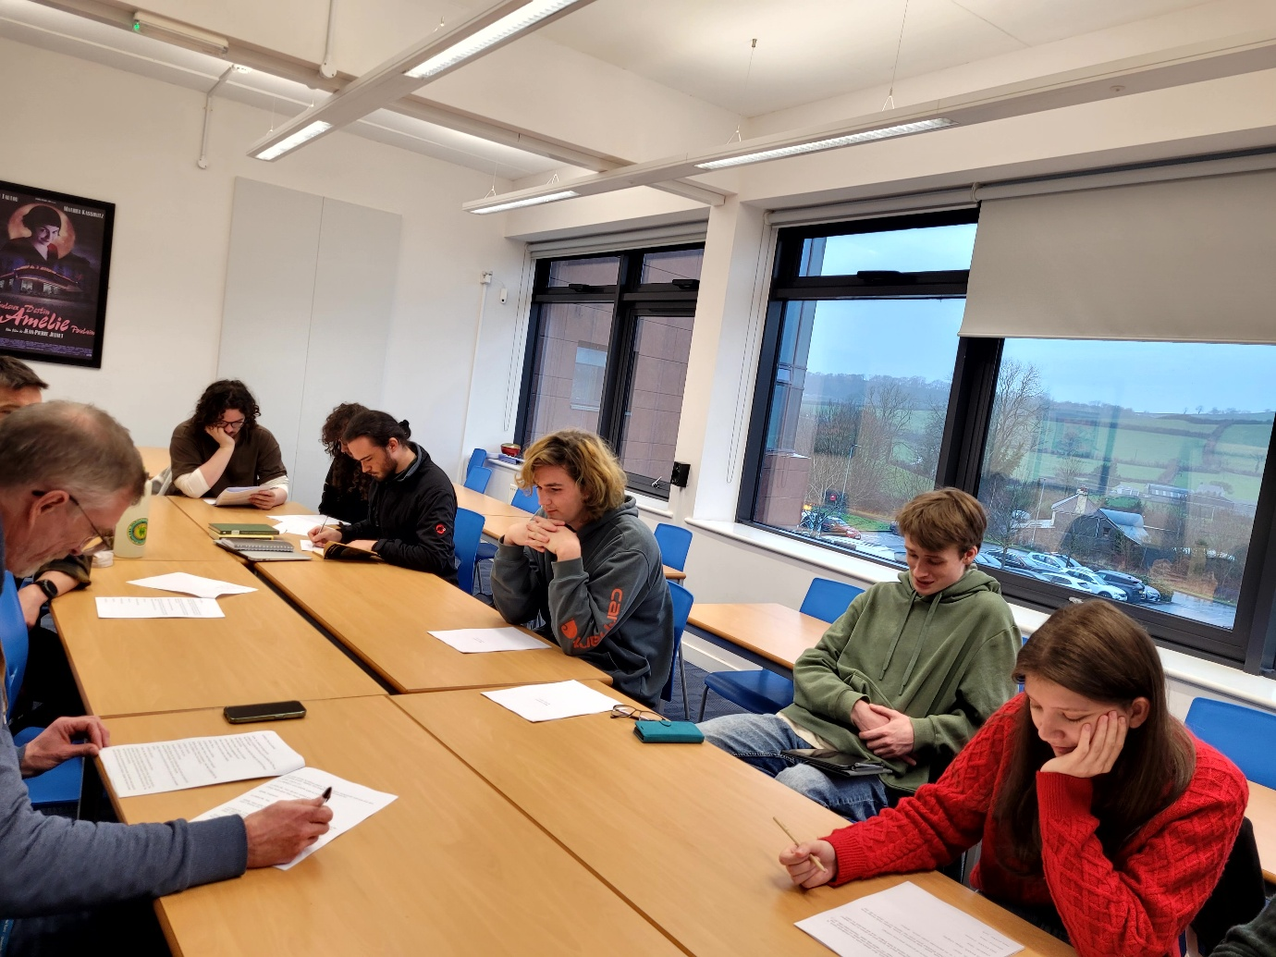
(First Readthrough, 8th January 2026)
I found that the read throughs and meetings that I had with the cast and historical advisors were the best use of my time where writing was concerned. This time was valuable for self-improvement and evaluation; it helped to hear the characters so I could make the necessary changes to the story or dialogue. The first readthrough was a new experience as I have always been in this environment and point in the “devising stage” as an actor, but that experience helped me organise a readthrough. I was comfortable with the people chosen for the readthrough and having had the historical collaborators there was valuable because I got instant feedback which helped with re-writes.
Using the research that I gained for script writing and the feedback that I got from the collaboration my writing skills have improved. Looking at examples of my writing: Act 1 Scene 2 Draft 1 and comparing them to Act 1 Scene 2 in Draft 5, I feel I have made a big improvement in character development and had the confidence to allow the actors to make decisions that work for the character and the story rather than listening to too many stage directions.
I found the stage directions a challenge at first. I had a clear view of what I wanted everything to look like and how the characters should behave and form relationships but listening to the dialogue being delivered during the read throughs made me realise the number of stage directions were not beneficial to the story or the cast and they needed some independence to take the characters in their own direction.
Themes
Knowing why I was writing this play and what my aim was, really helped me underline the importance of the themes. The summary of the play is a re-telling of history from the era of Llywelyn the Great. In this new story, Llywelyn gains Welsh independence and eventually takes over Britain and makes England the minority. We see Llywelyn’s character development affect the characters around him and how his actions change the course of history all the way to a modern-day classroom. The outcome of this re-telling of history shows that repression is now being put onto English heritage and culture, and we see how it effects children from the twenty first century.
Swapping the dynamic between Wales and England were the themes of repression and ignorance are concerned, I believe will really show the audience that no matter what country, religion, language, culture or heritage that you identify with repression shouldn’t normalised in our world.

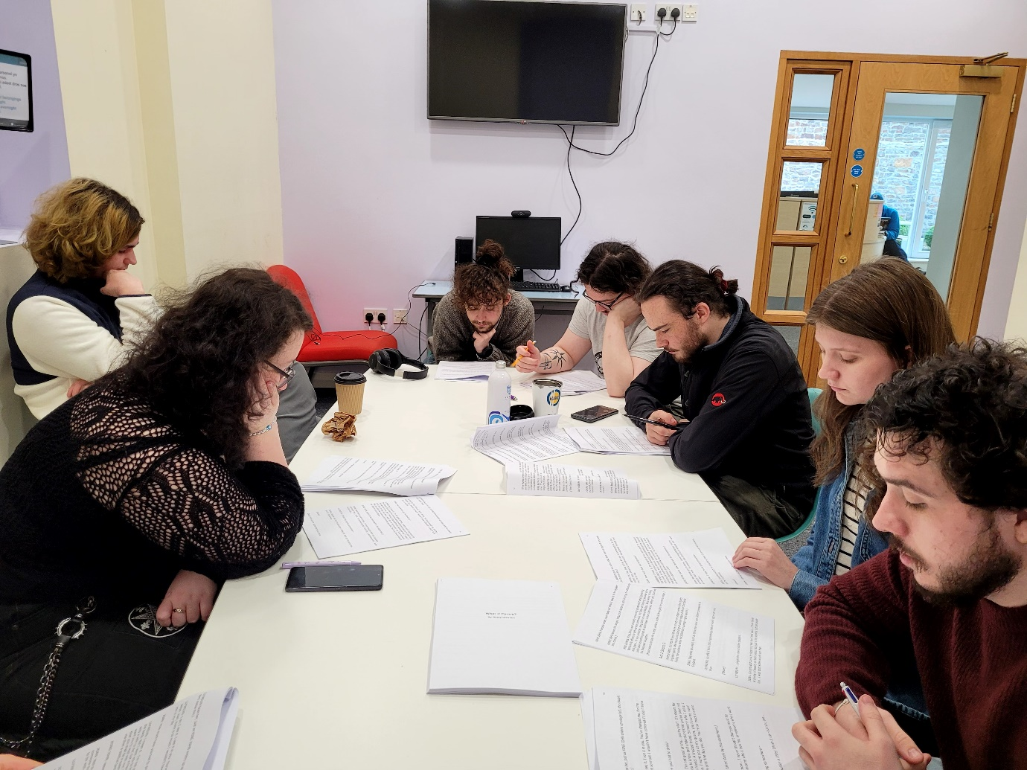
(Second Readthrough 16th January 2026)

The feedback from my third draft was a lot more positive, and overall, it was a good session. However, the historical accuracy needed to be discussed, and changes were made to the next draft. The process reassured me and I was feeling more confident in the improvements I was making; draft three was an improvement that continued in the writing of draft four.
After the second read through, I had started collaborating with Nicole Evans, who is also studying BA Acting, her IP is focusing on creating a personal approach to theatre directing that is influenced by feminist ideologies, and also playing Joan in What If Cymru? She was focusing on directing for her independent project. We worked together collaboratively on how we should showcase my script and her directing ability. We started to work together at what our initial ideas were for the play and how we could pull it off with the impact that we wished to show, while allowing the cast time and space to be completing their own projects and work. To make this work for everyone that was involved, we made it a “structured read through”, which meant that the actors wouldn’t have to be off script, research anything or wear a costume for the show. We decided that it would be simply audience members coming to see a run through while the actors were on script.
In our initial meeting Nicole and I discussed some of the themes of the play such as repression, ignorance, culture and heritage and relationships. Nicole was interested in my vision for the play, but we discussed the fact that as a writer, I now needed to let go and let her develop her own vision. Nicole created a digital mood board featuring colours, thrones, Welsh cultural emblems etc which really helped establish the tone and overall feel of the play. (See mood board, by Nicole Evans, in Appendix 7)
Rehearsals were arranged and took place at the beginning of February; I didn’t make too many changes to draft four as I wanted to see the draft up on its feet during the rehearsal process. This was a good decision as it allowed me to make live changes to the script while watching the cast and the director in action creating different intentions, blocking and making basic decisions for the characters which would affect how I viewed the story.
Going into the rehearsal process was a very different experience to what I’m used to. I wasn’t sure of my role as playwright. However, when the rehearsals started it was very clear that my role was now “done” and this was Nicole’s time as Director. As a person who is now in writing mode, I needed to figure out how to “fit in” to this familiar situation but as a writer and not an actor. I found the best use of time was to identify any weak points in the script when actors couldn’t get along with a line. I made live changes to the script in the rehearsal space and started planning the next draft. It was very useful to be able to see my story up on its feet and being performed with one hundred percent effort and I was so grateful to my fellow students for agreeing to be part of my process. The actors made the script so clear to me, and I was able to see the things that didn’t quite work in the script and could either replace them or remove the issues entirely. This process helped me a great deal to improve as a writer and to improve the play.
(See more rehearsal pictures Photographed by Kimberley Skeels, in Appendix 8)
Draft five, was the final script that I was happy to show for my independent project. As I’ve mentioned before, I would like to take more time to improve this play for a possible future published version. The final read through went very well. We started as a cast in the morning for a rehearsal so that the blocking and new ideas that Nicole came up with were cemented. The fact that no one needed to be off script helped with the process as we all felt comfortable to still experiment with new ideas and character choices even though we had our final performance with an audience. Thanks to Callum Casey who is studying set design and focusing his IP on the relevancy of miniature models in modern film making, we were able to be provided with lighting and a tech run. This made a small but very impactful difference to the show, and I think it helped the characters’ places in the story have their points made.
(Please see all Google form responses and feedback in Appendices 9-10)
Thanks to the cast, crew and audience, I was able to receive some great feedback from the final show. I wanted to see the difference in experience , from the cast and crew and from the audience members. I believe that there are a lot of themes in my play and important ones, but I am also glad that people can take away something new from the play that is just as important. For example, an anonymous who was a part of the cast/crew answered the question – “What do you think the message was, in the story?” with – “As someone who isn't a big history buff, I took it as a learning message and outcome. I found it really interesting to learn about Llywelyn the Great from an actor’s perspective. I found a love and appreciation for both cultures, learning about their stories and the reason they made their course of actions.” (Anonymous, no date). I’m glad that someone who considered themselves as someone who isn’t a “history buff”, took away an interest in the cultures that were shown in my play.
I am reassured with the outcomes from the audience members that I have written something I wanted to write successfully. It was important to me that I made sure that I got my point across, that there is no need for this divide to continue. We need to learn from the damage that has been done and heal together, respect each other and love each other. An anonymous audience member answered the same question as the cast/crew – “how the reason the divide in English and Welsh cultures has been formed over years of sort of power struggles and that it could so easily be either way. Also, that neither way would be good, as cultural division (sorry I can't think of the word and it's really annoying me) is bad in whichever way it is. I think it would be especially powerful to an English audience as it shows them what it could be like.” (Anonymous, no date).
Conclusion
I am overall very happy with the outcome that is my play. I will continue to improve on it and get it to a satisfactory level to publish as I have learned what publishers want when looking and reading a script. My journey as a writer has opened so many new doors for me as a creative, whether it is something that I want to pursue or if it can help me with my preferred medium of creativity which is acting. I am very proud of myself to have achieved what I originally set out to do, which was to write a play about a political issue that I am passionate about. This process has been a challenge for me but has had a very satisfactory ending for me as I am proud with the outcome regarding my journey.

Reference List:
Price, E. (2025) Welsh historian calls for urgent overhaul of GCSE history qualification. Available at: Welsh historian calls for urgent overhaul of GCSE history qualification (Accessed: 12 March 2026).
May, J. (1994) A Chronicle of Welsh Events. Christopher Davies (Publishers).( p. 25 – p. 26).
DragonHeart, The Prince of Wales. (2018) Llywelyn The Great | Welsh History – (History with Dragonheart). Available at: Llywelyn The Great | Welsh History - (History with Dragonheart) (Accessed: 7 March 2026).
The History Press. (2018) Joan, Lady of Wales. Available at: Joan, Lady of Wales - The History Press (Accessed: 7 November 2025).
Bennett, S. (2020) Ladies of Magna Carta: Women of Influence in Thirteenth Century England. Pen & Sword Books.
Morris, M. (2016) King John: Treachery, Tyranny and the Road to Magna Carta United Kingdom. Windmill Books.
Turvey, R. (2007) Llywelyn the Great. Y Lolfa. (p.34-35)
Fourteenthcenturyfiend. (2017) Principe Wallie: The First English Prince of Wales, 1302. Available at: Principe Wallie: The First English Prince of Wales, 1301 fourteenthcenturyfiend.com
Johnson, B. (No date) Historic UK. Available at: Kings and Princes of Wales (Accessed: 3 November 2025).
Proudfoot, R., Thompson, A., Scott Kastan, D. and Jenkins H. (2001) The Arden Shakespeare Complete Works. Revised edn. Bloomsbury.
Lockett J, C. (2024) Was King John Really That Bad? – Part 1: The Inconstancy of Prince John. Available at: Was King John Really That Bad? – Part 1: The Inconstancy of Prince John - Medieval Ware (Accessed: 7 March 2026).
Machenzie, L. (2018) 10 Facts About King John. Available at: 10 Facts About King John | History Hit (Accessed: 24 January 2026).
Turvey, R. (2007) Llywelyn the Great. Y Lolfa. (p. 44)
Chetty, D., Issa, H., Muse, G. and Tyne, I. (2022) Welsh [Plural] Essays on the Future of Wales. Repeater Books.
Borrow, G. (1862) Wild Wales. John Murray, publishing house.
Windsor, K. (2023) Why Do the Welsh Hate the English? Available at: Why Do the Welsh Hate the English? (Accessed: 6 March 2026).
Common/Wealth. (2025) Do It Yourself: Making Political Theatre. Manchester: Manchester University Press.
Klinkenborg, V. (2012) Several Short sentences about writing. Penguin Random House. (p.5)
Klinkenborg, V. (2012) Several Short sentences about writing. Penguin Random House. (p.6)
BBC. (no date) Scriptwriting Essentials. Available at: 1. Developing your idea (Accessed: 8 December 2025).
BBC. (no date) Scriptwriting Essentials. Available at: 5. Characters Bring Your Words to Life (Accessed: 8 December 2025).
Pillia’r, B. (2024) Opinion: What is political theatre, and why do we need it? Available at: Opinion: What is political theatre, and why do we need it? | HS Insider (Accessed: 7 November 2025).
Hughes, T. (no date) You’ve Finished Writing the Play: Now What? Available at: You've Finished Writing the Play: Now What? (Accessed: 14th March 2026).

Appendix:
- Feedback from BBC Writer, “Redacted”, on Draft 1 of What If Cymry?
“Be very sparing with your stage directions and don’t be too prescriptive. Leave enough freedom for the actors and director. They can also stop the flow of dialogue to the reader.

What is the goal or the journey within the plot? I know the play isn’t finished, but it’s not quite clear what the goal of the protagonist is. Set this up early in the play.

What’s at stake/what’s the jeopardy? What could your main character lose if they do not succeed? Make sure this is also clear early in the play.

Very funny writing!

Perhaps you could return to the classroom setting a bit more often, to get the pupils’ reactions to these alternative events.

Be careful the dialogue doesn’t become too expositional/educational (e.g. Mrs Evans’ speech at the end of scene 1)”

by Nicole Evans.

by Kimberley Skeels.

