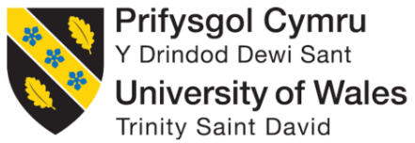

BA Business Management
Strategic Management and Sustainability
Assessment 1

Student Name: Stefania Prohnitchi
Student ID:1917713
Course Module: LCBB6004
Executive Summary
Strategic management for sustainable strategic improvement requires extensive business environmental analysis along with resource analysis. The information and market trend analysis can increase the accuracy of pricing, distributing and other positioning decisions. The report has discussed how the internal capabilities, resources, external business environment, competitive advantages and past 5-year strategic decisions influenced the market proposition Volkswagen. The report has thereby contrasted the internal and external environment interactions extensively.

Table of Contents
1. Introduction 4
2. Background of Volkswagen 4
3. Identification of key business strategies over the past five year 5
3.1 Ansoff Growth matrix 5
3.2 Porter’s generic strategy 6
4. Explaining how Volkswagen has Developed its Resource and Capabilities According to its Current Business Setup and Market Responsiveness 8
4.1 VRIO Analysis 8
5. Focus on increasing competitiveness by Volkswagen considering the environment and sustainability 11
5.1 PESTLE Analysis 11
5.2 Porter’s five forces 13
6. Recommendation 14
7. Conclusion 15
References 17

1. Introduction
The development that meets the needs of the present without compromising the ability of the future generation to meet their needs is called sustainable development (Sustainable Development Commission, 2022). Volkswagen has lost the trust of the customers because their vehicles failed to meet the EU pollution standard. They lost the trust of the customers and had to repay £193 million to more than 90,000 drivers (BBC, 2022). In this situation, the company needs to rethink using sustainable technology that emits less nitrous oxide. This report will throw light on its key business strategies, resources, capabilities, and effectiveness of its resources to meet its current business strategies with the help of various frameworks. At last, recommendations will also be provided for developing strategies for the company.

2. Background of Volkswagen
Volkswagen is a German motor vehicle manufacturing company founded by the German Labour Front in 1937. According to ‌Volkswagen Group (2021), they were the largest motor vehicle company in terms of sales in 2016 and 2017. Its sales became highest in 2019 (€252.63 billion) and after covid-19, almost the same revenue was reached by the company expressing its brand preference by the people (Carlier, 2022). Asia Pacific region especially China is the largest area of operation of the company. Volkswagen has a 24% share in the Chinese market and people in Hong Kong buy cars more than ten times that of US people. The company is the world’s largest employer employing around 6,62,575 people worldwide in 2020 (Volkswagen, 2021). This huge number of employees will make their workforce strong which will help to complement more sustainable practices. According to Volkswagenag (2021), they have 120 production plants in 19 European countries, and 10 countries in America, Asia, and Africa. Their current focus is on electric vehicles to make their operation more sustainable and the planet greener in 2017. Thus, their area of operation, number of employees, and financial status have led them to successful operations.
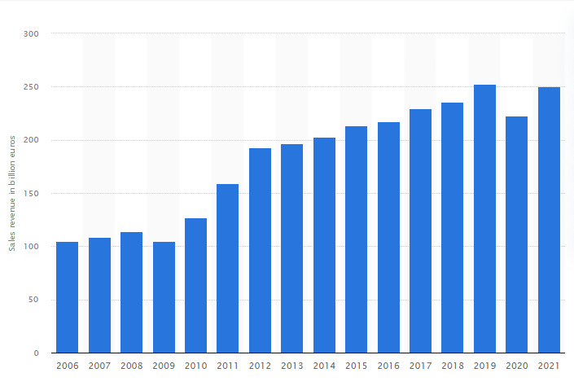
Figure 1: Sales of Volkswagen from 2006 to 2021
(Source: Carlier, 2022)

3. Identification of key business strategies over the past five year

3.1 Ansoff Growth matrix
Market penetration: Volkswagen has focused on approaching the market by investing more in electric vehicles and developing its market in the past five years (‌Mindtools, 2021). An extensive production capacity of the company in all major areas has contributed to the growth of the company. They have focused on transforming their global footprint into a sustainable and complete mobility power since 2020.
Product development: Battery cell production and battery-electric vehicles are the main two products on which they have focused in recent times. These two products have helped them to add more than 25 models to their product portfolio. They have announced US $7.1 billion to boost their research and development process and manufacturing in 2021 (Ingram, 2022). Their fully electric models and technologies require a huge interment in the R&D process. So, the company increased its expenditure by 10% in the automotive division.
Market development: A special emphasis was made by the company on the North American region in 2018. A growth plan has been implemented by the company especially for the USA to achieve 10% of their market share. Similarly, maintaining a high market share in China is accelerated by electrification and digitisation. The pandemic has reduced their revenue in 2020 but a quick emergence from the situation was made by Volkswagen. According to Ingram (2022), their teams managed the disruption of the supply chain in the first quarter of 2021 which has helped them to cope with the market demand in China.
Diversification: Plants have been developed by the company in Qingdao, Navistar San Antonio, and San Jose Chiapa in China, the United States, and Mexico respectively since 2017. The company’s focus is more on these two regions as those are profitable enough. Opening a plant will reduce the cost of transportation thus, business growth could easily be achieved by them.

3.2 Porter’s generic strategy
Cost leadership: The strategy of cost leadership includes gaining a competitive advantage by lowering the cost. According to Volkswagenag (2021), efficient value chain management by the company has helped to lower their cost in the locations in Africa, America, and Southeast Asia. This is the reason behind setting up several plants in different locations to reduce their production cost and maximise the supply chain efficiency. A few percent of the customers belong to the middle class who consider price as an important factor for purchasing a car from a premium brand. According to the University of Cambridge (2016), moderate to high prices of the cars sometimes made it unaffordable for the customers to purchase cards from this brand.
Differentiation: Unique features of the cars such as one-touch-up and down windows, great engine tuning, and gear shifts have made them different from their competitors. TSI Technology has made the engine power and that also reduces carbon dioxide emission (Volkswagen Group, 2021). Studying the changing behaviour of the customers the company also extended the product line Which has helped them to make a loyal customer base. After Sales Service and great customer satisfaction formed the basis for the marketing of the company. The application of intelligent technology, comfort, and reliability of the engine is the most special about the cars of Volkswagen. All of these have been reflected in their increasing market share and revenue.
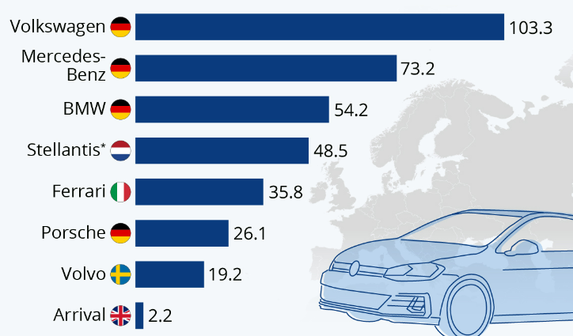
Figure 2: Differentiation of Volkswagen from its competitors
(Source: Carlier, 2022)
Cost focus: Volkswagen has concentrated on targeting a particular segment of a market that gives them a competitive advantage. According to University of Cambridge (2016), they have changed their design of the products based on the customer's requirements and needs at the lowest possible price. From middle-class people to high-class people aged between 26-54 are their target. The company also tries to provide its premium quality products at affordable prices to the greater segment of the customers. Thus, the company continues to hold the top position in terms of loyalty in the European automobile market.
Differentiation focus: The differentiation focus of the company relies on its target segment. The middle-class people to high-class people who are the target customers of the company generally pay less attention to the price while buying luxury items like cars. According to ‌Volkswagen (2022), the best supply chain management, with various comfortable systems, has enabled the company to retain its large customer base and high revenue.

4. Explaining how Volkswagen has Developed its Resource and Capabilities According to its Current Business Setup and Market Responsiveness

4.1 VRIO Analysis
Valuable
Embedded Purpose-driven Capabilities of Volkswagen: Volkswagen with multiple of its environmental strategies like ‘goTOzero’ and ‘TOGETHER - Strategy 2025+’ values carbon emission reduction and usage of sustainable energy sources in its operating market domain. The company has proclaimed to reach NetZero status around 2025 and the company is constantly trying to reduce the N2O emission and GHG emissions for the B4, B6 and B7 engine or hybrid vehicles. After the diesel gate in September 2015, Volkswagen has taken multiple measures to change the entire product range from fuel to electric energy. This resource of the company is extremely valuable.
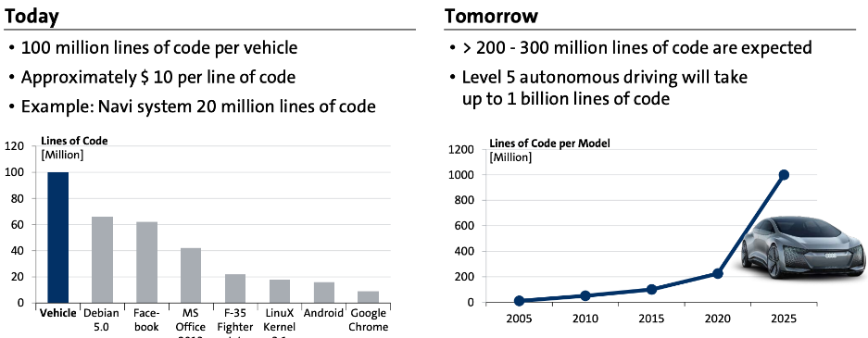
Figure 3: Volkswagen Present and Future Market Expansion Graphical Representation
(Source: Alamalhodaei, 2021)
Large production Units: Volkswagen is a German-originated automotive manufacturer and retailer operating in more than 150 countries with around 662,570 employees. Volkswagen has more than 135 production units worldwide creating a massive distribution channel ensuring massive production and distribution in different countries. According to Meckling and Nahm (2019), the company solely has 120 production facilities in only 19 countries in Europe. Therefore, this can be stated as a valuable asset that can increase the competitive position of the company.
Brand Image and Global Presence: Volkswagen has created a £235 billion revenue globally in 2019. The company was the best car brand in 2021 according to the report submitted by the Society of Motor Manufacturers and Traders (SMMT). Therefore, the image of the company in the UK market is a valuable asset for Volkswagen.
Rare
R&D for Vast Demographic Analysis: Research and Development facilities are funded with the 28% profit of the company according to its annual budget allotment. The company has been spending an average of £2.8 billion between 2017 and 2020. The vast demographic knowledge, suspension requirements, and cage construction requirements allow the company to co-create potential vehicle models capable of handling multiple types of roads in different countries (Alamalhodaei, 2021)‌.
Extensive Supply Chain: Extensive supply chain includes the raw material allocations and engineering circuitry. The company has partnered with more than 1,200 local and big-sized organisations in Europe only between 2018 and 2021 to increase its supply potential.
Inimitable
Vast Product portfolio: Volkswagen has produced a total of 56 continued and 26 discontinued models. Some cars like The Beetle, Golf, Atlus and some other models are extremely popular in the global market as well as the UK market (Volkswagenag.com, 2022)‌. In the last 5 years vehicles are being replaced with transmission exchanges,
GPS integrated and energy resource replacements.
Organised
Workplace Culture: Fostering design initiatives and innovative approaches have been the core strategies of Volkswagen in the past 5 years (Notesmatic, 2018)‌. The company started organising a global car exhibition in the capital of the operating country in 2019.
Resources and Capabilities | Valuable | Rare | Inimitable | Organised | Competitive Advantage
Embedded Purpose-driven Capabilities of Volkswagen | Yes | No | No | Yes | Competitive advantage in the job market
Large production Units | Yes | No | No | Yes | Capability to retail affordable vehicles
Brand Image and Global Presence | Yes | No | Yes | No | Customer loyalty
R&D for Vast Demographic Analysis | No | Yes | No | No | Demographic Responsiveness
Extensive Supply Chain | No | Yes | No | Yes | Retail Expansion
Vast Product portfolio | No | No | Yes | No | Capabilities of Targeting Vast range of Customers
Workplace Culture | Yes | No | No | Yes | Enhanced employee performance
Table 1: VRIO Analysis
(Source: Author)

5. Focus on increasing competitiveness by Volkswagen considering the environment and sustainability

5.1 PESTLE Analysis
Factors | Description | Impacts
Political | Motor cars powered by fossil fuels emit a huge amount of carbon. The UK government aims to reduce carbon emissions by 78% by 2035 ‌(Crown Commercial Service, 2022). | Volkswagen targeted to be carbon neutral by 2050 and they also plan to reduce their greenhouse gas emission by 30% in comparison to 2015 (Volkswagen Group, 2021).
Economic | The revenue from the luxury market in the UK amounts to £11.83 billion in 2022 and it is growing by 7.28% annually. | According to ‌Volkswagen Group (2021), Volkswagen has made their cars premium quality and thus the preference for their cars has been increasing. This is reflected by the sales of 15,600 cars in the UK in 2020.
Social | The popularity of motor vehicles has been increasing in the developed countries of the European Union. People are using motor vehicles to reach common places as well as for family outings. | Airbags for the drivers, hatchback systems, and above all the reliability of the engines of cars of Volkswagen have made them popular among people all over the world.
Technological | The increasing popularity of cars has made car companies think about the Technologies that could improve the cars. According to ‌Volkswagen (2022), cruise control, biometric seat, GPS Car tracker, and automatic high beam control are some of the innovative technologies that are being used in cars in the UK. | Features like parking assistant, traffic jam assistant, gesture control, active info display, and many more are included in the company's car. the company is not focusing on making its cars from the materials like bamboo and paper
Legal | The cars in the UK need to have working headlights, rear lights, and number plate lights. Besides this, companies need to maintain employment laws to provide a healthy and safe environment for their employees. | Breaking and not maintaining the standards have cost the company around £193 million to repay (‌BBC, 2022).
Environmental | The vehicles in the UK need to be properly certified on mission control including CO2 and NOx ‌(Crown Commercial Service, 2022). | Volkswagen had to pay £193 million to 90,000 England drivers for cheating the drivers and EU pollution standards. After that, they announced an action plan to agree with the Technical Solutions and measures that will reduce the emission of harmful gases.
Table 2: PESTLE Analysis
(Source: Author)

5.2 Porter’s five forces
Bargaining power of suppliers: The bargaining power of the suppliers in the automobile industry is low in comparison to other industries. There are a total of 17 suppliers present in the UK providing raw materials for wheel, body and cage manufacturing. The company has increased its supplier power by 6 new suppliers in the Leeds location creating a sustainable resourcing and distribution chain (Volkswagenag.com, 2019)‌. That has reduced the bargaining power of suppliers. Therefore, the bargaining power of Volkswagen suppliers is moderate in the UK market.
Bargaining power of buyers: Volkswagen has maintained an effective affordable pricing strategy in the operating market. The company focuses on the convenience market and lifestyle-centric market to penetrate the existing market. The company has a subtle recognition among middle-aged customers (Volkswagenag.com, 2019)‌. The sales rate has been maintained at 15% CAGR in the last 5 years. Therefore, the bargaining power of buyers is low for Volkswagen.
Threats of new entrants: The automobile industry in the UK has a high barrier that prevents new farmers from entering (‌Mindtools, 2021). Big manufacturers are present there who could bear the start-up costs along with the market operation cost. Apart from these licensing, establishment, expansion, and purchasing of different kinds of parts have restricted the new competitors to enter the market.
Availability of substitute goods: Premium quality goods having various comfort and safety measures could not be acquired in any other vehicles. The government has inspired more eco-friendly transportation but Volkswagen has also focused on making electric vehicles running on batteries. As these vehicles are not dependent on fossil fuels so they do not emit any harmful gas.
Rivalry power: The automobile industry is highly competitive because there are several competing brands present in the UK. According to ‌Volkswagen (2022), the efficiency and quality of the products made by Jaguar Land Rover, Audi, Nissan, and others are quite similar and all of them invest a lump sum amount in research and development making the intensity of rivalry high.

6. Recommendation
Recommendation 1 (NEW AUTO Strategy): The new auto strategy refers to a complete redefinition of design, engine structure, energy utilisation, software implementation and new aerodynamics of the vehicle. Volkswagen is recommended to implement the hybrid formation process, surplus allocation and redefined financing situation to exchange EVs with the existing vehicles.
Recommendation 2 (Autonomous Driving Front and Centre): According to Allwood (2018), the pedestrian logistics analysis, cloud connectivity with the software and sensory integration in the new models are the foundation of the autonomous driving front and centre strategy. Volkswagen is investing more than £3 billion of its R&D investment in the core development of applications focused on autonomous driving assistance. The company needs to tweak the automation transmission research and implement the newly integrated thermal conditioning technology to increase sales in tropical as well as tundra regions.
Recommendation 3 (Green Strategy): The green strategy is one of the most important strategies which is recommended to be adhered to by Volkswagen. The September 2015 dieselgate settlement has allowed Volkswagen to accelerate its communication and cultural expansion. The company has taken the ‘goTOzero’ initiative to reach carbon emission neutrality around 2025. It needs to ensure the proper distribution of vehicles and customer engagement to activate this situation effectively.
Recommendation 4 (Expansion Strategy): Volkswagen is recommended to increase its servicing outsourcing process to local registered automotive stores. The company needs to expand its flagship vehicle production in the Asia Pacific region since the GDP of these countries have been increasing abruptly. Therefore, the expansion of new production units and new product categories can be an opportunistic decision for the new marketplace. Volkswagen can further expand its resource allocations, service centre and premium, and loan facilities based on demographic requirements.

7. Conclusion
A strategic analysis of Volkswagen needs to be developed for the 2015 situation of the company. The strategic analysis has been introduced in the company synthesising the relevant frameworks. The first part of the report has discussed the market competitive situation of the company by analysing Porter's generic and Ansoff's matrix. The internal resources have been analysed by using the VRIO analysis model. After that, Porter's five forces and PESTLE analysis have been discussed to elaborate on the external market situation of the company. The report has further provided some strategic recommendations to improve the business position and market position of the company.

References
Alamalhodaei, A., (2021). Volkswagen’s new business strategy puts software and autonomous driving front and center. Available at: https://techcrunch.com/2021/07/13/volkswagens-new-business-strategy-puts-software-and-autonomous-driving-front-and-center/ [Accessed 9 September 2022]
Allwood, J.M., (2018). Unrealistic techno-optimism is holding back progress on resource efficiency. Nature materials, 17(12), pp.1050-1051.
‌BBC, (2022). Volkswagen to pay out £193m in ‘dieselgate’ settlement. Available at: https://www.bbc.com/news/business-61581251 [Accessed 9 September 2022]
Carlier, M., (2021). Revenue of Volkswagen 2006-2021. Available at: https://www.statista.com/statistics/264349/sales-revenue-of-volkswagen-ag-since-2006/ [Accessed 9 September 2022]
‌Crown Commercial Service, (2022). Carbon Reduction Policy. Available at: https://www.gov.uk/government/publications/carbon-reduction-policy/carbon-reduction-policy#:~:text=CCS%20aims%20to%20reduce%20its,net%20zero%20emissions%20by%202050 [Accessed 9 September 2022]
‌Environmental Protection UK, (2013). Car Pollution - Environmental Protection UK. Available at: https://www.environmental-protection.org.uk/policy-areas/air-quality/air-pollution-and-transport/car-pollution/#:~:text=All%20new%20cars%20must%20comply,diesel%20vehicles%20only%20at%20present). [Accessed 9 September 2022]
Ingram, A., (2022). Volkswagen T-Roc. Available at: https://www.autoexpress.co.uk/volkswagen/t-roc/108183/new-volkswagen-t-roc-r-2022-review [Accessed 9 September 2022]
Meckling, J. and Nahm, J., (2019). The politics of technology bans: Industrial policy competition and green goals for the auto industry. Energy Policy, 126, pp.470-479.
‌Mindtools, (2021). The Ansoff Matrix: Understanding the Risks of Different Strategic Options. Available at: https://www.mindtools.com/pages/article/newTMC_90.htm [Accessed 9 September 2022]
Notesmatic, (2018). Strategic Analysis of Volkswagen AG. Available at: https://www.notesmatic.com/strategic-analysis-of-volkswagen-ag/ [Accessed 9 September 2022]
Sustainable Development Commission, (2022). What is sustainable development. Available at: https://www.sd-commission.org.uk/pages/what-is-sustainable-development.html [Accessed 9 September 2022]
University of Cambridge, (2016). Porter’s Generic Competitive Strategies (ways of competing). Available at: https://www.ifm.eng.cam.ac.uk/research/dstools/porters-generic-competitive-strategies/ [Accessed 9 September 2022]
‌Volkswagen Group, (2021). Sales and Marketing. Available at: https://annualreport2021.volkswagenag.com/group-management-report/sustainable-value-enhancement/sales-and-marketing.html [Accessed 9 September 2022]
‌Volkswagen, (2022). Innovations. Available at: https://www.volkswagen.co.in/en/innovations-technology/innovations.html [Accessed 9 September 2022]
Volkswagenag, (2021). Portrait & Locations. Available at: https://www.volkswagenag.com/en/group/portrait-and-production-plants.html# [Accessed 9 September 2022]
Volkswagenag.com, (2019). Volkswagen with New Corporate Mission Statement Environment. Available at: https://www.volkswagenag.com/en/news/2019/07/goTOzero.html# [Accessed 9 September 2022]
Volkswagenag.com. (2022). Strategy. Available at: https://www.volkswagenag.com/en/strategy.html [Accessed 9 September 2022]

