ENVIRONMENTAL ANALYSIS OF AN INDUSTRY: TESLA

By Luiza Luciana Marin
The Global Business Environment
14-01-2022
*

Environmental Analysis of an industry: Tesla

Introduction
Tesla’s development in the automotive industry has gained interest. The company, founded in 2003, is more competitive than its rivals that were developed in the 20th century. Business investors and analysts focus on Tesla’s rapid growth and how the brand has shaped the sector. However, the coronavirus pandemic has affected all industries, including the automotive sector. The global pandemic affected businesses in different perspectives. Thus, it is relevant to evaluate Tesla’s performance before, during, and after the pandemic. Tesla made substantial decisions and strategies that helped it overcome the conditions. This report, therefore, outlines the impact of the pandemic on Tesla, and how the corporation handled its challenges.

Before the Pandemic
Tesla struggled before the onset of the pandemic. In early 2019, the corporation experienced numerous challenges. First, Tesla faced a steep dip in sales. In January 2019, the corporation’s stock slumped by 13 percent (Levy, 2019). This drop was the highest since public listing in 2010. Besides, the company announced it would slash about 7 percent of its full-time employment opportunities (Levy, 2019). At this time, the company was struggling with the production of the Model 3 vehicles (Levy, 2019). These experiences impacted the company’s financial performance. Previously, in 2018, the CEO, Elon Musk courted controversy when the Securities and Exchange Commission sued him for fraud. This situation led to a 14 percent slump (Levy, 2019). The leader’s controversial demeanour was evident in Tesla’s struggles (Boudette, 2020). However, the company seemed to manage these conditions, since the stock price had risen from $17 in 2010 to more than $300 in 2019 (Levy, 2019). These aspects are critical since they showed the corporation’s hope in achieving greater performance. While investors had concerns about the leadership mistakes, they believed in Musk.
The concept of stocks is not the only performance indicator for comparing Tesla with its competitors. An important concept to consider is the market shares, which underscores the number of vehicles each automaker sold globally. For instance, in 2019, Toyota had a 10 percent market share, followed by Volkswagen at 7 percent and Ford at 5 percent. The strange part is that Tesla was not among the top ten competitive brands in that year. Specifically, the corporation had less than 2 percent market share worldwide. While the stiff competition affected Tesla, the brand depended on innovations to improve its performance.
Besides, the concept of all-electric vehicles by Tesla was necessary in global scales. The continuous discussion about environmental pollution and climate change culminated into the production of electric vehicles. Tesla took advantage of this situation and developed all-electric cars. Meanwhile, the traditional giants such as General Motors, Toyota, BMW, Chrysler, and Ford have failed to develop competitive electric vehicles. These corporations mainly produced hybrid vehicles to counter Tesla’s dominance. Tesla designed vehicles that could last long on the road before recharging. These aspects encouraged the corporation to maintain high performance despite the challenges it faced during the pre-COVID 19 eras.

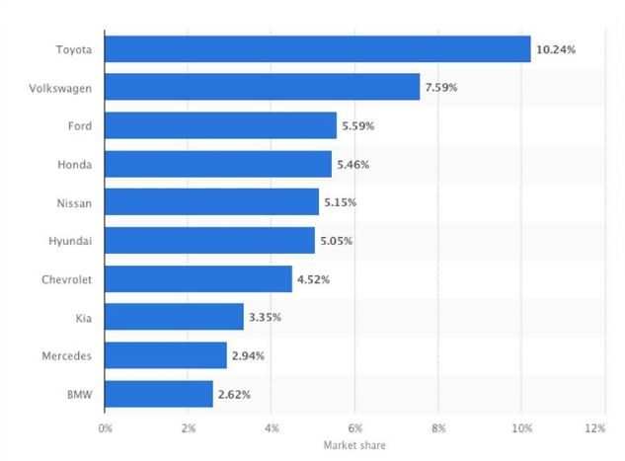
Automakers’ 2019 Market Share (Koetsier, 2020)

Impact of Pandemic on Tesla
During the coronavirus pandemic, automotive industry suffered like other industries. The major challenge associated with COVID-19 was the disruption of business activities. Most families directed their funds on health maintenance and treatment. Many deaths, isolation, and hospitalisation had significant negative effects on the financial stability of the public. Besides, most governments set guidelines on lockdown. Staying at home ensured that people mainly worked remotely and millions lost their jobs. These conditions mainly forced businesses to shut down. The automakers experienced tumultuous times due to people focusing on other essential services.
During the pandemic, the number of vehicles sold by most of the automakers reduced significantly. The following figure indicates the 2020 figures of the market share of these companies in percentage. Based on the data, Toyota had reduced its global market share from 10 percent in 2019 to 8.5 percent. Meanwhile, Volkswagen maintained its market share, although Ford and other companies had reduced market share. Tesla also had a market share of less than 2 percent. These figures represented poor performance in the automotive sector.

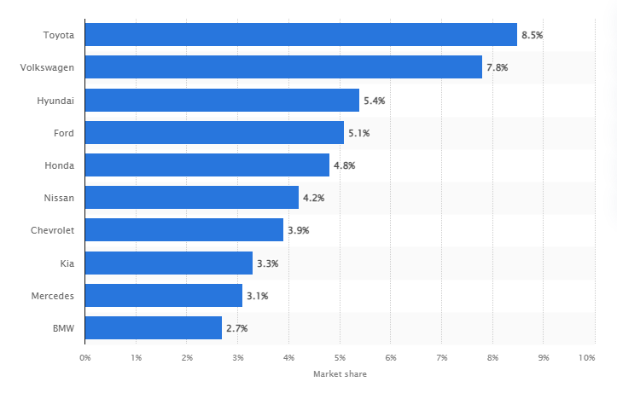
Global Automakers’ Market share in 2020 (Carlier, 2021a)
However, Tesla’s case study was different in the number of units sold and the stock prices during the pandemic. The company went beyond its expectations to sell many vehicles and make extensive profits. In the third quarter of 2020, Tesla made $8.7 billion in revenue due to an increased delivery of 54% (BBC News, 2020). Besides, it made a quarterly profit of $311 million during the same period. This amount was twice the profits Tesla got in 2019 (BBC News, 2020). Meanwhile, the corporation almost reached a target of 500,000 vehicles sold within a year. By October 2020, Tesla had sold more than 300,000 units (BBC News, 2020). These statistical figures show the company’s performance against its rivals during the pandemic. Overall, Tesla continued to dominate the industry when other automakers were struggling.
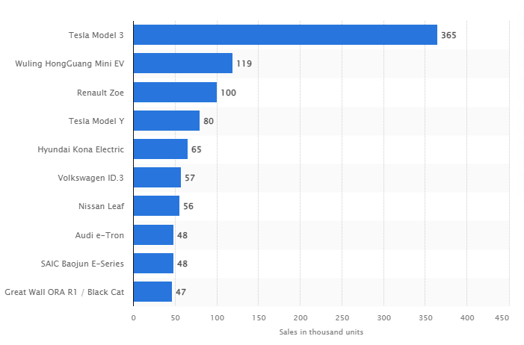
Sales in ’000 of Plug-in EV Models in 2020 (Carlier, 2021b)

The primary concept that expresses Tesla’s unimaginable growth during the pandemic is the unexpected rise in its stock. At the beginning of 2020, the company’s stock price was about $83. However, the value of the stock shot up to $700 at the start of 2021 (Macrotrends, 2021). The high stock performance was different from its competitors such as GM who have a stock price of $82. Tesla surpassed Toyota’s stock and also its value. Currently, the company trades at a minimum of $1000 (Macrotrends, 2021). Besides, it became the most valued automaker in the world during the pandemic. Specifically, Zhao and Jiang (2021, p.1) confirmed that Tesla overtook Toyota’s value in 2020. Toyota had maintained the top position for decades. Due to its rise in stock price, Elon Musk’s wealth rose to more than $200 billion, making him the richest man on earth.
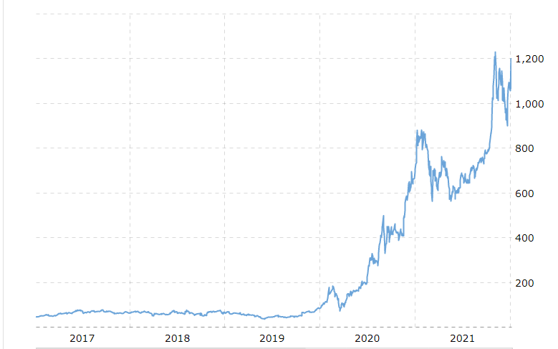
Tesla’s Stock Between 2017 and 2021 (Macrotrends, 2021)

Reasons for Tesla’s Upsurge during Pandemic
Tesla’s positive performance during the pandemic occurred contrary to what many investors expected. However, the company achieved this success due to various factors.
First, Tesla has mainly focused on all-electric vehicles. The company took advantage of the current concerns about climate change to build attractive automotive options. During the pandemic, the discussion about environmental destruction was a major priority, since people learnt the relevance of lockdown. Specifically, the pollution in cities had significantly declined due to people staying at home (DeBord, 2020). This situation further raised concerns on how humanity can improve environmental conditions in different perspectives. Climate change and environmental pollution has been a major concern in the transport industry. As people around the world embrace renewable technology, they consider electric vehicles as a sustainable option (DeBord, 2020). These conditions encouraged individuals to consider purchasing Tesla’s vehicles, since they considered social responsibility to conserve the environment.
The second concept that helped Tesla during the pandemic is how consumers would get their vehicles. Unlike other competitors who depended on car dealers, the company mainly sells its vehicles online (Klender, 2020). Car dealership was greatly affected by the pandemic. Due to lockdown, many clients could not visit the auto-yards to select the vehicles they need. Meanwhile, they could get Tesla through online reservation. Tesla created a value chain system that ensured that consumers had no struggles in getting their vehicles (Klender, 2020). Besides, online customisation was a critical concept for the company. For instance, a client would order a Tesla vehicle through the phone and remotely configure their car. This aspect enabled them to just visit a Tesla showroom and take their machine without much interaction with the staff. This aspect reduced the concept of overcrowding or direct interaction with staff, which was essential in curbing the pandemic. The experience encouraged buyers to get their products, which is quite different from the traditional salespeople that try to woo them to make car dealership decisions. Besides, Tesla gained by minimising the costs of managing sales for the company and its clients.
Apart from consumer treatment, Tesla’s vehicles were essential during the pandemic. For instance, the strict guidelines on lockdown and social distancing needed adequate practices that would minimise social interactions. The gas and petrol vehicles mainly depend on refilling stations. Besides, the energy crisis during the coronavirus pandemic raised growing concerns about gas and petrol vehicles. On the other hand, Tesla vehicles could be easily serviced at home or at service stations (DeBord, 2020). Tesla has set up service stations at designated areas, and thus, car owners can recharge their vehicles at lower costs. The battery performance also helps consumers to recharge at home, and hence, minimised social interactions.
The third concept about Tesla is its strategy in its technological practices. While the company mainly focuses in production of vehicles, its primary business model depends on battery performance. Tesla became the first car maker to reach the $1 trillion valuation. This achievement is mainly based on the corporation’s performance in technology, and not vehicle production. The company has an edge over its rivals through the establishment of the appropriate EV batteries (Lang, Reber, Aldori, 2021, p.385). Cars are the medium by which Tesla is establishing the battery technological advancement. During the pandemic, Tesla continued improving its batteries to last longer and provide the much needed performance for electric vehicles. For instance, Model 3 has three battery options depending on coverage ability per single charge: 423 kilometres, 507 kilometres, and 568 kilometres (Vijayraghvan, 2021). Besides, the company announced that it would introduce the LFP batteries, which are an upgrade to the current lithium-ion batteries. This approach encouraged individuals and investors to be part of the company through buying vehicles and stock investment, respectively.
Another critical concept is Tesla’s investment in establishing production plants in designated countries. For instance, in Europe, the corporation has mainly built its sites in Netherlands and Germany. These countries are strategic in the sale of electric vehicles in Europe. Tesla mainly targets Norway, Netherlands, and Germany (Klesty, 2022; Wagner, 2021; Schmidt, 2021). Meanwhile, the corporation built and is still building plants in China. Mass production of vehicles is cheaper in China due to availability of raw materials.
Tesla’s Approach to Managing Pandemic Challenges
While Tesla made substantial gains during the pandemic, the company still has various challenges that it needs to resolve. First, the company struggles with balancing between producing more vehicles and saturating the market. Tesla’s supply chain mainly focuses on fixed production of cars according to target demands. One major reason for this approach is to avoid product saturation, which may further reduce its prices. However, as the company invests in new battery technology, it should determine how to lower the prices while increasing production. This aspect can only be achieved through adequate research and design. Tesla has the capacity for mass production, and thus, they need to develop strategies that coincide with the battery development.

Conclusion
Based on the business analysis of Tesla, the company benefited during the coronavirus pandemic while its rivals struggled with sales. The company’s stock and valuation significantly increased. The main reason for this performance was due to the high demand for electric vehicles. Electric cars are environmental friendly, and the target clients are conscious about environmental sustainability. Besides, the pandemic unravelled concerns about the petrol and gas vehicles. The energy crisis and convenience of managing electric vehicles was a prospective idea for Tesla customers. Another concept is the advancement of battery technology. This concept increased hopes among car owners who needed batteries with lasting charge. While Tesla made significant business achievements, it still needs to evaluate the best strategies of increased production to meet the growing demand for electric vehicles.

Reference List
BBC News, 2020. Tesla shrugs off pandemic as sales hit new record [WWW Document]. BBC News. URL https://www.bbc.com/news/business-54636005 (accessed 1.7.22).
Boudette, N.E., 2020. Tesla Shines During the Pandemic as Other Automakers Struggle. The New York Times. https://www.nytimes.com/2020/07/02/business/tesla-sales-second-quarter.html
Carlier, M., 2021a. Automobile market share worldwide 2018. Statista. URL https://www.statista.com/statistics/316786/global-market-share-of-the-leading-automakers/ (accessed 1.7.22).
Carlier, M., 2021b. Worldwide electric vehicle sales by model 2020. Statista. URL https://www.statista.com/statistics/960121/sales-of-all-electric-vehicles-worldwide-by-model/ (accessed 1.7.22).
DeBord, M., 2020. If you want to buy a car post-coronavirus, you should consider a Tesla. Here are some pros and cons. Insider. https://www.businessinsider.com/reasons-to-buy-a-tesla-after-covid-19-pandemic-ends-2020-5?r=US&IR=T
Klender, J., 2020. Tesla maintained demand through pandemic because of online ordering, Musk says. TESLARATI. URL https://www.teslarati.com/elon-musk-covid-19-online-ordering-demand/ (accessed 1.7.22).
Klesty, V., 2022. Electric cars hit 65% of Norway sales as Tesla grabs overall pole. Reuters: Electric cars hit 65% of Norway sales as Tesla grabs overall pole | Reuters
Koetsier, J., 2020. Why Tesla = GM + Honda + Ford + Fiat Chrysler + Daimler. Forbes.
Lang, J.W., Reber, B., Aldori, H., 2021. How Tesla created advantages in the ev automotive paradigm, through an integrated business model of value capture and value creation. Business & Management Studies: An International Journal 9, 385–404. https://doi.org/10.15295/bmij.v9i1.1790
Levy, A., 2019. The 7 best days for Tesla shorts, and what caused them. CNBC. https://www.cnbc.com/2019/01/19/7-times-teslas-stock-has-taken-a-nosedive-.html
Macrotrends, 2021. Tesla - Stock Price History [WWW Document]. MacroTrends. URL https://www.macrotrends.net/stocks/charts/TSLA/tesla/stock-price-history (accessed 1.7.22).
Schmidt, B., 2021. Germany is now Tesla’s largest Europe market, and Model 3 is number one car sold. The Driven. https://thedriven.io/2021/11/12/germany-is-now-teslas-largest-europe-market-and-model-3-is-number-1/
Vijayraghvan, S., 2021. Tesla’s Battery Technology Explained. CarandBike. https://www.carandbike.com/news/teslas-battery-technology-explained-2368329
Wagner, I., 2021. Netherlands: sales volume of Tesla cars 2012-2020. Statista: https://www.statista.com/statistics/777866/sales-volume-of-tesla-in-the-netherlands/
Zhao, D. and Jiang, Z., 2021, March. The Summary of NEV Business Model Based on Four-Elements Model. In Journal of Physics: Conference Series (Vol. 1802, No. 3). IOP Publishing

