The Global Business Environment
Assessment 1

Name: Alexandru Sebastian Melinte Student ID: 1907706
Module Title: The Global Business Environment (LCBB4005)
Assignment Title: The Global Business Environment – Assessment 1
Module LECTURE’S NAME: Dr. Hossein Shokri

TABLE OF CONTENTS
Introduction 1
a) Analyse the impact of the pandemic and explain the major forces that have shaped the business environment of the fashion industry. 2
b) In light of the COVID19 pandemic, critically assess the opportunities and challenges that these forces have presented to the key players in the fashion industry and explain why and how some firms have been able to adapt better than others to this changing business environment. 6
Conclusion 9
References 10

Introduction
Global business environment are the external factors that affect on business strategies and effect on the key operations of the business. The current report is about analysing the key effect of pandemic on the fashion industry. The key effect of the pandemic is being observed on the forces that have shaped the business environment of the fashion industry. Report explains the application of different models that are applied within the case study of H&M that is one of the fashion retailers of clothing and accessories. Apart from this, some of the opportunities and challenges have been discussed that has occurred from the effect of COVID and it has been elaborated that how firms are being able to adapt the changes of such business environment.

a) Analyse the impact of the pandemic and explain the major forces that have shaped the business environment of the fashion industry.
Global Fashion Market
The value of the global fashion market is around $3 trillion and that is overall the world’s 2% of the GDP. The retail value of the luxury goods market is around 339.4 billion dollars. In which the men’s industry is $ 402 billion and women’s wear industry is $621 billion. The overall global fashion market generally generates job opportunities of around 4% and overall fashion industry market value is $406 million. The unemployment rate is observed as 5.8 percent and there are overall 3,384.1 million labour forces working in the overall fashion industry (Fashion United, 2021).
With COVID, overall fashion industry has declined because of major lockdowns in different countries. Also due to many losses of Job and shut down of businesses, consumer spending has lowered down and they are spending only on essentials. Thus, COVID has affected on reduction of market share and overall sales and stores shut down of brands (refer below image).
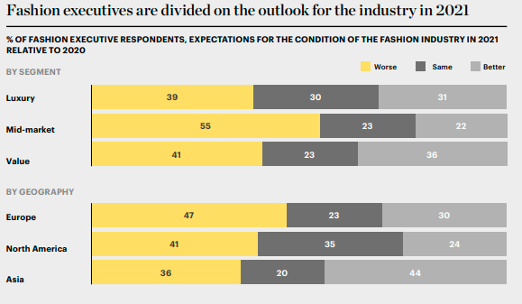
Figure 1: Fashion in 2021
(Source: Mc Kinsey, 2021)
Key players in the market
New businesses are hitting the market on a regular basis to serve the 3,000 billion dollar clothing and garment industry. The majority of these firms are relatively new to the general public; individual brands that are part of this multinational fashion that are already playing are succeeding in the market.
The Luxury fashion corporation Louis Vinton Mot Hennessy is actually the world's largest apparel business. In 2017, LVMH's annual sales were €42.6 billion, and the firm is worth about €122 billion. For designer designers such as Louis Vuitton, Fendi, and Dior, the group owns a network of independent stores and shop-in-shops. LVMH is known for more than just high-end fashion (Jin and Cedrola, 2019). The Spain fast-fashion Behemoth is the third largest apparel group, with a market capitalization of nearly 92 billion dollars. Inditex owns H&M, Pull&Bear, and Stradivarius, among other labels. The Spanish business is worth €75 billion, with a turnover of €25.34 billion in 2017. Every major city in Europe has Inditex outlet, which accounts for the bulk of the company's revenue (Fashion United, 2021).
Market structure
Since companies have distinct brands and consumer control, the garment industry is monopolistically dominant. A monopoly is not the same as monopolistic rivalry. When an individual or company is the only provider of a product or service in a market, it is called a monopoly. This means have strongly differentiated items, which mean that the goods are perceived to be distinct for reasons other than price. Thus, this firm get a larger platform in delivering the product or service; firms can enter and leave the market easily in the long run; firms can make their own decisions (Shen and Chen, 2020). There is some pricing force, which means that manufacturers have some price pressure, and consumers and sellers have imperfect bargaining power.
Key success factors
The firms operate on the key success factors. Thus means each of the firm try to provide the best of design of products to remain competitive. According to the quality factor firm offer the best quality so that this makes customers to identify the brand by its quality. In addition, technology factor used by business is in terms of number of followers over social media accounts, the key online sales of products and effective management of operations. In context of marketing, firms are adopting the digital platform after COVID so that maximum online sales could be increased. In context of branding, firms offer adequate discounts and offer that attract the customers.
Fashion Industry Analysis
Product Life Cycle
Indeed, according to the McKinsey Global Fashion Index, fashion businesses will report a profit this year. After a 4% increase in 2019, economic profit is expected to drop by 90% in 2020. Given the current state of volatility, our forecasts for market results are conservative (Mc Kinsey, 2021). COVID impact has lead H&M to close down 2500 stores worldwide but the 10 per cent rise in online sales is being observed The net profit dropped its net profit to 3.1 billion in 2020, a drop of 56% on the previous year (Shen, 2014). Thus net profit falls 40% to €4m on sales of €5.3 billion and with response to such change the current industry is on the decline stage as pandemic has lead to close down many stores and also downfall in purchasing behaviour of the customers is being observed.
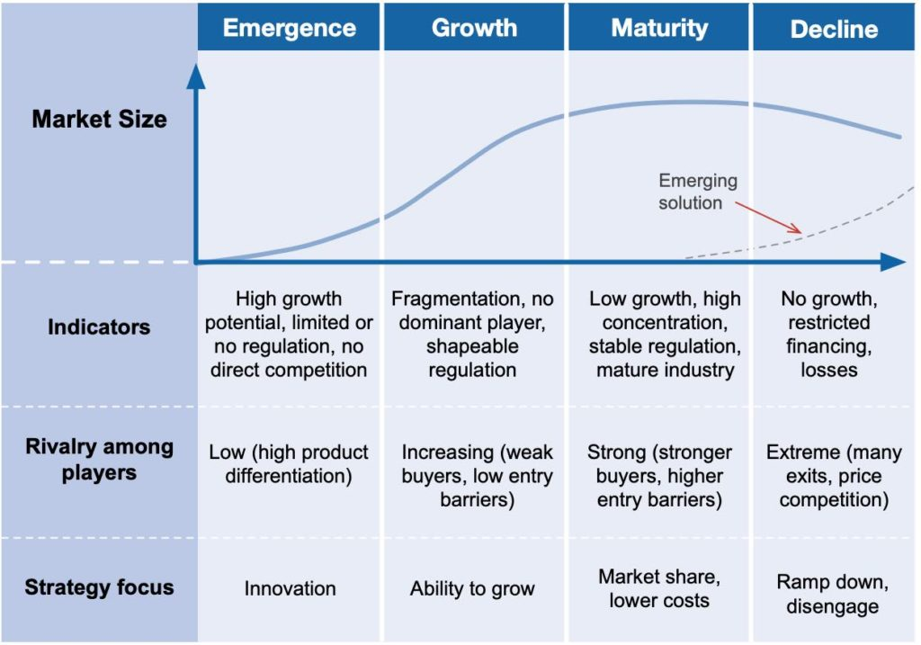
Figure 2: Industry life cycle analysis
Porter’s Five Forces Analysis
Forces | Effect (High, moderate, low) | Description
Bargaining power of buyers | Moderate | H&M has established stronger brand image in terms of quality and offering the high fashion end. H&M is loyal to the customers and regularly focus on offering the best of fashionable good. But due to COVID the consumer spending has decreased on high end fashion that can affect on business sales (Shabir and AlBishri, 2021).
Bargaining power of suppliers | Moderate | Due to global expansion and high end brand image, H&M have stronger relationships with the suppliers and it has licensed contract that leads to achieve maintained of balance between demand and supply.
Industry Rivalry | High | The key competitors of the H&M are ZARA, Benton and TED BAKERS majorly compete on the same level. H&M respond to constantly launch of products in the market that adds to competitive edge. But still face fear of high competition.
Threat of entrant | Low | With the growing fashion, consumers are looking for economical goods. H&M generally charge premium prices because of its high quality and choose to locate its stores in premium locations. To compete on the same level of H&M it is very challenging for the new entrant (Shen, 2014).
Threat of substitute | Moderate | The substitute can only be in the form of quality and affordability that is offered by H&M. Thus, H&M supply effective response in terms of regular launch of fashion products.

External Analysis
PESTEL Analysis
Factors | Description
Political | H&M operate to enjoy the benefits of European Union and it makes easy for business to export its products and have timely supply of raw materials. COVID has lead to major disturbances in the economy and shortage of supply of raw material was observed that overall disturbed the process of supply chain (McMaster et.al. 2020).
Economic | H&M is a brand that originated in Sweden. Since Sweden is in one of highest unemployment, it has a low labour cost compared to other Swedish countries. COVID lead to disturbance of economic conditions, GDP was low and thus H&M was not able to take the advantage of imports of exports due to country shut down. Thus overall affected on sales (Shen, 2014).
Social | This includes the change in lifestyle and behaviour of the customers. For example, consumers have changed their way of traditional shopping towards purchasing products online. Thus, H&M observed the benefits of increasing its online sales even after slow delivery process was observed.
Technological | Technology was the major factor for the business to sustain because it sales of H&M in context of selling online increasing with effective expansion. Thus, technology was major opportunity for business to sustain in the changing environment (Fashion United, 2021).
Environmental | H&M is classified as the fast fashion brand that is accused to wastage of resources. Thus, H&M contributes to sustainable supply chain and majority of resources have been saved.
Legal | H&M operate in legal context with having copyright laws and that act as business competitive edge to operate in legal manner.

b) In light of the COVID19 pandemic, critically assess the opportunities and challenges that these forces have presented to the key players in the fashion industry and explain why and how some firms have been able to adapt better than others to this changing business environment.
Opportunities and Challenges of COVID19 Pandemic
In context of opportunity, the world's largest apparel retailer prefers to have the bulk of its inventory in shops that often double as ecommerce distribution centres, rather than have a huge warehouse. However, with about 2500 stores closing around the world, this deliberately balanced just-in-time of products was nearing its end. Digital networks will continue to be the primary engine of development in the coming year, showing people's dis-satisfaction to purchase in crowded places in several countries. In comparison to 2019, the Earlier Recovery scenario forecasts dynamic digital development across geographies in 2021, with more than 30% online growth (Mc Kinsey, 2021).
In context of challenge, majority of the stores were closed and footfall on the physical stores was adequately observed. Thus, to meet the consumer demand was very tough as a lot of change in the consumer spending is being observed (Mc Kinsey, 2021). COVID lead to overall economic crisis and lead to cause major disturbance in fall in GDP and decline the supply chain. Therefore, COVID has led to change the overall patterns of selling as slow delivery process was majorly observed and that hit a lot of sales of the business.
Economic crisis was the major challenge as target audience of the H&M was only that is brand conscious because the tourist arrivals has decreased in countries and overall shopping behaviour of consumers have changed. With the current pandemic conditions, the high end fashion industry would face the major challenges of achieving the expected sales of physical stores (Mc Kinsey, 2021). Thus, it is necessary for brands to focus on the relevant outcomes that are related to enhancing the sales through digital medium.
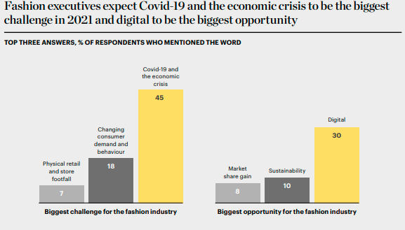
Figure 3: The challenge and opportunity
(Source: Mc Kinsey, 2021)
Strategies to Sustain Competitive Advantage
Millions of people's lives and livelihoods have been affected by the Covid-19 crisis, which has disrupted foreign commerce, transport, the environment, and customer behaviour. Companies should focus on their operational models to allow consistency and quicker decision-making in the year ahead, and balance rate and stability in the pursuit of innovation to continue to handle unparalleled levels of complexity (Digital Commerce, 2021). During this time, digital penetration has majorly adopted and many brands have finally moved to online, and brands are welcoming new technologies such as live streaming, customer service video chat, and social shopping. When the number of people using the internet grows, so does the demand from customers.
Consumers have been more conscious of the maintaining the protocols of COVID and thereby have changed their shopping behaviour. Thus, H&M has sustained to focus on focussing on stores that were responding and generally products that can be supplied to the local areas.

Conclusion
From the overall report, it can be concluded that overall fashion industry has been declined due to COVID due to a major shift in income and spending of the consumers on luxury brands. Thus, H&M in COVID has shut down many of its stores and is struggling in terms of downfall of profits. Thus, to sustain within such business environment, brand such as H&M focussed on utilising must aspects of technology and focussed on providing the online sales. The factor of technology was the important factor of business environment that lead fashion brand to sustain.

References
Business Today, 2021 [Online] [Accessed through] <https://www.businesstoday.in/current/world/coronavirus-impact-H&M-owners-shut-down-stores-worldwide/story/398717.html> [Accessed on 28th April, 2021]
Digital Commerce, 2021[Online] [Accessed through] https://www.digitalcommerce360.com/2020/06/09/H&M-owner-mitigates-damage-from-covid-19-shutdown/ [Accessed on 28th April, 2021]
Fashion United, 2021 [Online] [Accessed through] https://fashionunited.com/global-fashion-industry-statistics/ [Accessed on 28th April, 2021].
Jin, B.E. and Cedrola, E. eds., 2019. Process innovation in the global fashion industry. Palgrave Macmillan US.
Shen, B., 2014. Sustainable fashion supply chain: Lessons from H&M. Sustainability, 6(9), pp.6236-6249.
Mc Kinsey, 2021 [Online] [Accessed through] https://www.mckinsey.com/~/media/McKinsey/Industries/Retail/Our%20Insights/State%20of%20fashion/2021/The-State-of-Fashion-2021-vF.pdf> [Accessed on 28th April, 2021]
McMaster, M., Nettleton, C., Tom, C., Xu, B., Cao, C. and Qiao, P., 2020. Risk management: rethinking fashion supply chain management for multinational corporations in light of the COVID-19 outbreak. Journal of Risk and Financial Management, 13(8), p.173.
Shabir, S. and AlBishri, N.A., 2021. Sustainable Retailing Performance of H&M during COVID-19 Pandemic. Open Journal of Business and Management, 9(03), p.1013.
Shen, B. and Chen, C., 2020. Quality management in outsourced global fashion supply chains: an exploratory case study. Production Planning & Control, 31(9), pp.757-769.

