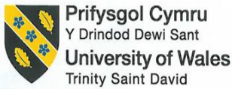

Assignment Title: Business Report - Comparison of Two Hospitality Organisations

MODULE: Financial Management for the Hotel Industry
MODULE CODE: BMIH5007
STUDENT ID: 2212616
STUDENT NAME: VLAD DANCEANU
LECTURER: TRISTAN HAWKINS

Table of Contents
1. Introduction 3
2. Total Revenue 3
3. Market Position Assessment 4
4. Growth Potential 5
5. Financial Commitment to CSR Analysis 6
6. Recommendation 7
7. Conclusion 8
8. References 9

Introduction
This study compares and contrasts the ways that Corinthia Hotels and Ibis Hotels handle their money. The study also looks at some important factors, such as total income, market place, growth potential, and financial commitment to corporate social responsibility. The study is mostly about trends, ways to make money, and personality traits that affect growth. The study looks at the market's future, possible problems, growth opportunities, and tactics for growth. According to Corinthia (2023), the Pisani family started Corinthia Hotels in 1962. The company is famous all over the world for its classic style and commitment to customer service. According to Accor (2023), Ibis Hotels was the biggest hotel company in London when it opened in 1974. It now has 700 hotels in 36 countries.

Total Revenue
The group IHI, which is based in Malta and runs the Corinthia hotel chain, made about €95.8 million at the end of June 2022, up from €34.6 million during the same time last year. However, sales went back up to 238 million Euros from 129 million Euros in 2021. Most of the restaurants in this group, on the other hand, are in the UK and have done better in 2019. IHI made a profit of €817,000 before taxes, which is a big jump from the €30.2 million loss the company had during the same time last year (Corinthia Group, 2022).
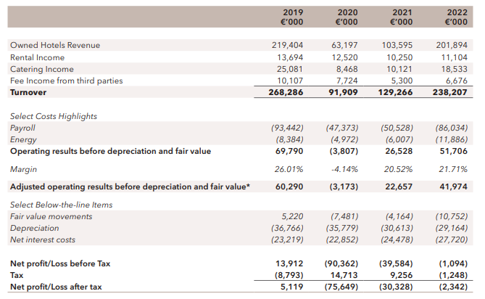
Figure 1: Financial Statement of Corinthia Group
(Source: Corinthia Group, 2022).
On the other hand, the figure below shows that from 2005 to 2022, Accor Group's world revenue changed in a bad way. In 2022, the hotel company Accor Group made close to 4.22 billion euros. This is a big jump from 2021, when they only made 2.2 billion euros. Accor, the owner of Ibis Hotels and the biggest provider of cheap and moderately priced hotels in the world (Statista, 2022) recently marked the opening of its 1,000th hotel around the world. The company also brought its health, simplicity, and modernism offerings together by bringing back its ibis, ibis budget line, and ibis Styles lines.
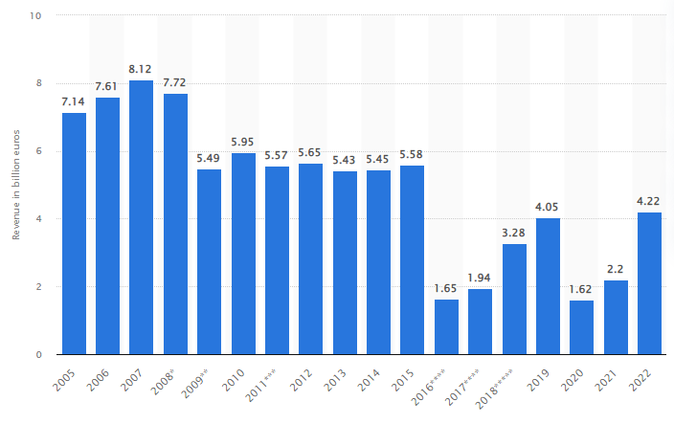
Figure 2: Revenue of Accor Group worldwide from 2005 to 2022
(Source; Statista, 2022)

Market Position Assessment
The Corinthia Hotel Group has a huge share of the market and caters to rich people who want to have unique experiences. But the company is known for its high-end products, great customer service, and fancy services. Because it has a small part of the market and a unique type of customer, Corinthia can charge higher costs than its rivals. Most of the people who live in Corinthia are rich tourists looking for expensive, personalised encounters.
Ibis Hotels also caters to a wide range of customers who are on a tight budget. People know that the company can be trusted and that it will always offer good products at fair prices. In addition, Ibis has a big part of the cheap hotel market and provides a wide range of services. Ibis has a wide range of customers, both in terms of age and income.
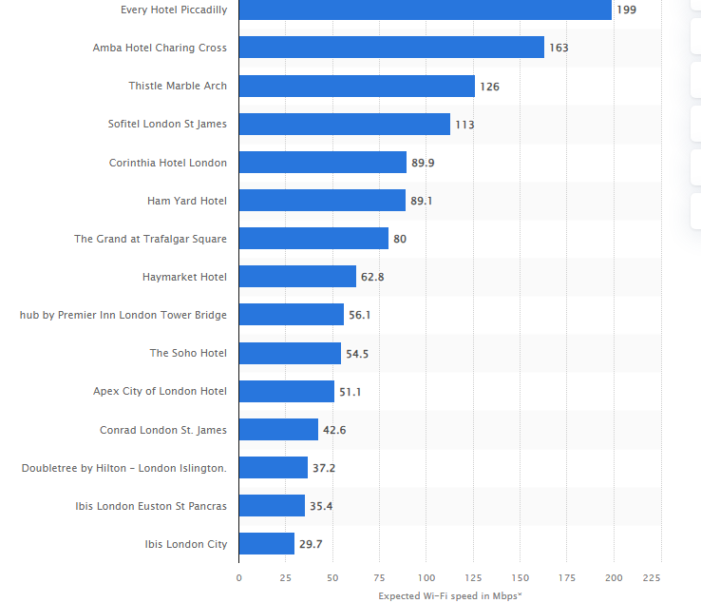
Figure 1: Wi-Fi Speed (Statista, 2023)
The Corinthia Hotel Group offers luxury rooms for wealthy guests to make experiences that will last a lifetime. The brand works on a particular upscale market niche, even though it has fewer locations than more well-known hotel chains. Corinthia might charge more per hotel because it values private more than its high-end competitors, even though it has a smaller part of the market overall. Ibis Hotels, a name of AccorHotels, advertises hotels with reasonable prices to tourists on a budget and in the middle range in order to grow their business. Ibis runs the low-cost hotel market around the world. Because it has a bigger network and more sites, Ibis has a great chance of becoming the market leader in the low-cost hotel business.
Ibis, on the other hand, has a bigger part of the low- and mid-range market than Corinthia, but it charges more in the luxury market. The comparison brings out the differences between the ways that each company tries to get new customers and find its place in the market.
Rich people who want beautiful, personalised experiences make up most of Corinthia's customers. The target market is made up of rich people, business leaders, and luxury tourists who value great comforts, unique services, and luxurious lodgings. The nicest and most picky tourists to Corinthia are treated with a special kind of kindness. Ibis Hotels also has reasonable prices for a lot of different types of visitors. The business serves a wide range of customers, including families, business travellers, and vacationers looking for cheap and handy places to stay. When it comes to tourists, Ibis tries to get people with all kinds of tastes and budgets by offering great quality and service.
Ibis, on the other hand, welcomes a wide range of tourists with different incomes and trip goals, while Corinthia caters to wealthy guests wanting luxury. On the other hand, the customer profiles show how each brand stands out in the market and how they try to meet the specific needs of each customer.
In contrast, Ibis and Corinthia serve different types of customers in the hotel business. Ibis, like Corinthia, has raised high prices and profit margins by using a unique strategy for marketing placement. Tests of Wi-Fi speed were done at a number of London hotels in August 2017. According to Statista (2023), the fastest link was found at Every Hotel London, which had a speed of 199 Mbps.

Growth Potential
The growth potential of the company relies on the general growth success of the brand. The growth potential of the brand is affected by a number of different factors. It means that a business can grow its sales, earnings, market share, and edge over its competitors over time. The hotel's location and how it draws possible customers are two of the most important factors for the brand's growth. If the brand wants to grow its market share, it should actively seek out chances that will help it grow. Modern hotels face problems and obstacles to growth in a globalised world that is always changing. To make the brand more productive, they will need to come up with new ways to meet customer needs and increase their potential for growth. They can do this by using different strategies to meet economic needs and boost their growth. There is room for growth at the Ibis hotel, and different methods are being used to make more money and keep customers profitable, all while keeping the customers' needs and the brand's management in mind at all times. By using methods that help increase customer loyalty and service towards the brand, companies can improve their long-term services and performance. One problem that might come up is figuring out what customers want and how to work together to make customers happier. The brand should work to fix these problems if they want to raise their success rate, which has been going down over the last few years.

Financial Commitment to CSR Analysis
Corinthia's measures are helping to reach the UN's goals for sustainable development. Corinthia Spirit is focused on improving people's lives and the places where the actions take place. People and towns will be safer and healthier as a result of the policies that support sustainable growth. The hotel is dedicated to meeting the needs of all parties and following all foreign rules and laws. The hotel organises and acts in a way that is sustainable and socially responsible.
The hotel wants to improve its reputation as a high-end hotel brand that makes people's lives better by bringing them together. The hotel really knows what their guests want and need, and they give them a great experience that lives up to their hopes. While IHI services and workers are important to the business, they are also the most important parts of the hotel's success. The hotel gives its workers chances to grow and reach their full potential. Corinthia is focused on new ideas for protecting the earth. The hotel is fully responsible for how its services and goods affect the world. We do this by constantly improving them. Corinthia CSR (2024) says that the hotel is using a creative, business-like method to make environmental projects that are good for the world.
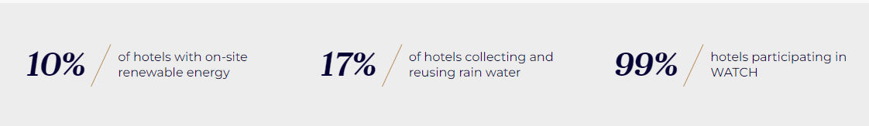
Figure 7 Ibis CSR initiative
(Source: group.accor.com. 2024)

Accor Group is dedicated to reducing its carbon output in a way that benefits everyone. The Ibis Hotel group is doing things to have less of an effect on the environment, and the hotel is in charge of meeting the needs of its guests who care about the environment. The hotel takes the lead in helping the community keep getting better through its CSR and environmental efforts. The hotel has a programme called WATCH (We Act Together for Children) that is open to both staff and guests. The program's goal is to stop kids from being sexually harassed. It saves money on running costs, which is one of the many perks of the hotel's CSR project. The hotel was chosen so that it can run as a business while also meeting environmental goals. Group.accor.com (2024) says that Ibis can build a good brand image and name by following its CSR policies.
The billion-dollar hotel business includes a lot of different services and things to do. The Pisani family opened the Corinthia Hotel in Malta in 1962. The French company Ibis runs a chain of cheap hotels. The Accor groups opened the hotel in Bordeaux in 1974. The most money that the Corinthia Hotel makes in a year is $62 million in 2022. In 2022, Ibis Hotel of Accor Group made about 4.22 billion euros in sales, which is 2.2 billion euros more than in 2021. By June 2022, the Corthinia Hotel Group, which is owned by International Hotel Investments (IHI) in Malta, had seen a rise in sales of €95.8 million. The money that Ibis made went up by 12.3% in 2023. Overall, Ibis Hotel's income is expected to keep rising at a rate of 1.1%, which would bring in $1.5 trillion. The Ibis Hotel group is doing things to have less of an effect on the environment, and the hotel is in charge of meeting the needs of its guests who care about the environment.

Recommendation
Using the above analysis, the Ibis Hotel should plan ways to make more money from different sources to keep its finances strong in the very competitive and always-changing hospitality industry. Corinthia should use the fact that it is an upscale brand to look into new areas. Also, the possibility for growth can be increased by providing money for new services and partnerships. Ibis, on the other hand, needs to keep growing globally and focus on making technology and ecology better, especially in new areas to draw a wider range of people. Both businesses should keep and even improve their CSR promises while taking shareholder feedback into account if they want to keep growing. Finding a mix between revenue growth and revenue growth is important for long-term success in the fast-paced hotel industry.

References
‌ Lee, M., Lee, S. and Koh, Y., 2019. Multisensory experience for enhancing hotel guest experience: Empirical evidence from big data analytics. International Journal of Contemporary Hospitality Management, 31(11), pp.4313-4337.
Abdullah, N.S., 2018. Corporate governance and performance of hotel industry (IHI).
Accor, 2023. About all our brands. [online] Available at: https://all.accor.com/brands/ibis.en.shtml [Accessed on 30th January 23]
Ali, B.J., Gardi, B., Jabbar Othman, B., Ali Ahmed, S., Burhan Ismael, N., Abdalla Hamza, P., Mahmood Aziz, H., Sabir, B.Y., Sorguli, S. and Anwar, G., 2021. Hotel service quality: The impact of service quality on customer satisfaction in hospitality. Ali, BJ, Gardi, B., Othman, BJ, Ahmed, SA, Ismael, NB, Hamza, PA, Aziz, HM, Sabir, BY, Anwar, G.(2021). Hotel Service Quality: The Impact of Service Quality on Customer Satisfaction in Hospitality. International Journal of Engineering, Business and Management, 5(3), pp.14-28.
Bello, C. and Sensini, L., 2020. Financing decisions of SMEs in the hotel industry. International Journal of Academic Research in Accounting, Finance and Management Sciences, 10(2), pp.9-14.
Cheng, J., 2019. Research and Suggestions on Declining Market Shares of Ibis Budget Hotels. Open Journal of Social Sciences, 8(1), pp.253-261.
Corinthia Group, 2022. Annual report and financial statements [online] Available at: https://www.corinthiagroup.com/wp-content/uploads/2023/06/37547-CORINTHIA-ANNUAL-REPORT-2022_WEB-min.pdf [accessed on 30th January 2024]
Corinthia, 2021. Who we are [online] Available at: https://www.corinthiagroup.com/about/ [accessed on 30th January 2024]
Corinthia, 2023. About Corinthia. [online] Available at: https://www.corinthia.com/en-gb/our-story/#:~:text=We%20are%20Corinthia%20A%20family,world's%20greatest%20cities%20and%20locations [Accessed on 30th January’23]
Corinthia. 2024. About Corinthia | Corinthia Hotels International | Corinthia.com. [online] Available at: https://www.corinthia.com/en-gb/our-story/.
Corinthia. 2024. SUSTAINABILITY AT CORINTHIA. [online] Available at: https://www.corinthia.com/en-gb/sustainability/.
D'Alessandro, W., Calabrese, S., Bellomo, S., Brusca, L., Daskalopoulou, K., Vigni, L.L., Randazzo, L. and Kyriakopoulos, K., 2020. Impact of hydrothermal alteration processes on element mobility and potential environmental implications at the Sousaki solfataric field (Corinthia-Greece). Journal of Volcanology and Geothermal Research, 407, p.107121.
Fabrizio Tabone. 2022. International Hotel Investments registers 176% increase in revenue in first six months of 2022. [online] Available at: https://whoswho.mt/en/international-hotel-investments-registers-176-increase-in-revenue-in-first-six-months-of-2022
group.accor.com. 2024. Environment & CSR. [online] Available at: https://group.accor.com/en/hotel-development/Optimise-your-costs/Environment-and-CSR.
Statista, 2022. Revenue of Accor Group worldwide from 2005 to 2022. Available at https://www.statista.com/statistics/266261/revenue-of-the-accor-group/. [Accessed on 30th January 2024]
Statista, 2023. Wi-Fi speed in selected hotels in London as of August 2017. Available at https://www.statista.com/statistics/314354/wi-fi-speed-in-selected-hotels-in-london/. [Accessed on 30th January 2024]

