Using the pupil profile given, identify how specific aspects of the child’s holistic development could be met within an educational setting. Underpin this with references to relevant theories, research and examples of excellent practice.
In Wales, educators within primary schools have statutory responsibilities to meet the needs and requirements of their learners, including a commitment to equality and diversity, communicating appropriately with young people and a duty of care towards all learners (Education Workforce Council, 2019, p. 3). Within the Foundation Phase, educators facilitate learning in the classroom with the child at the core of their learning. Educators within this phase of education must ensure that the delivery of topics within lessons meets the essential requirements of children in their development (Welsh Government, 2008, p. 12). When educators understand child development, they naturally focus on the holistic development of the child. The holistic approach to learning involves a broad view of children’s learning. It focuses on how the whole child develops, namely physically, intellectually, spiritually, and emotionally (St. Andrew’s International School, 2023). As this approach focuses on the whole child, implementing this would require much time. However, more schools are beginning to see the advantages of this approach to learning. Firstly, a holistic approach to learning has developed children’s appreciation for their needs and interests. Educators who allow their learners to identify their strengths and weaknesses whilst at school have found this supports children to become well-rounded individuals (St. Andrew’s International School, 2023). Friedrich Froebel, a German educationalist, would agree with the holistic approach to learning as it encourages the development of four concepts needed in childhood: feelings, play and language, thoughts, and actions (Welsh Government, 2008, p. 28).
Staff members at Ella’s school have voiced their concerns about Ella’s physical development within her profile. The profile states Ella cannot hop on one foot consistently, is unable to catch a ball, has not established a definite hand preference, can hold a pencil with a ‘splayed’ four-finger grip and can only come up and down steps; two feet to a step whilst holding onto an adult’s hand. Bee and Boyd (2009, p. 97) suggest that by the age of 4 years old, children will be able to grasp a pencil, walk downstairs one foot per step and throw and catch things. Ella appears to be two years behind in her physical development as she holds a pencil with a ‘splayed’ four-finger grip rather than between her two fingers and thumb. Ella’s profile indicates physical issues, and her physical developmental delays may be caused by an unrecognised diagnosis of dyspraxia. According to the National Health Service [NHS] (2023), dyspraxia, also known as developmental co-ordination disorder (DCD), is ‘’a condition that affects physical coordination. It causes a child to perform less well than expected in daily activities for their age and appear to move clumsily.’’ My view of Ella’s potential unrecognised diagnosis of dyspraxia is that she has not established a definite hand preference and cannot use both hands together when catching a ball (Dyspraxia Foundation, n/d). Whilst visiting a school in the local community, an approach that I think could benefit Ella’s physical development is Write Dance. This approach was developed by Ragnhild Oussoren, a graphologist from The Netherlands who based this approach on ‘writing psychology.’ Write Dance aims to provide children with the physical skills they need for handwriting (Write Dance Training, n/d). Schools that have adopted this approach into their curriculum have found that Write Dance helps children with their balance and coordination, particularly in the Foundation Phase. R. Hurton (2022) explains how learning sequences in dance can help children with dyspraxia. The repetitive movements in dance can improve a child’s hand-eye coordination whilst strengthening the upper body. Write Dance can help Ella to build her gross motor skills before the acquisition of fine motor skills. This approach will promote Ella’s development ‘holistically’ as not only does it address concerns about her physical development but also her literacy development as well. Arnold Gesell, an American psychologist and paediatrician, would argue that Ella does not need to be taught how to develop her motor skills. Instead, Gesell believed children would develop their motor skills in ‘genetically pre-determined stages.’ Also, Gesell implied that these ‘genetically pre-determined stages’ would occur without external experiences (Doherty and Hughes, 2014, p. 44/197). This idea was supported when Gesell & Thompson (1933) studied a pair of identical twins carrying out a motor task. One twin was given additional time to practice while the other did not. Both twins completed the task alike which led to Gesell & Thompson finishing their study with the idea that maturation is the main influence in the attainment of motor skills rather than experience (Crowley, 2017, p. 64). Gesell’s maturation theory highlights the role of ‘nature’ over that of ‘nurture’ in contrast to the ecologist view of Urie Bronfenbrenner. The ecological systems theory by Bronfenbrenner, a Russian-American psychologist, ‘’referred to several environments that influence children’s development, and which change as they grow older’’ (Doherty and Hughes, 2014, p. 103). In the ‘Microsystem’, children will spend most of their time interacting with their parents, school, and neighbourhood (Gray and Macblain, 2012, p. 99). The ecological environment is often interpreted as ‘’a set of nested structures, each inside the next, like a set of Russian dolls’’ (Bronfenbrenner, 1981, p. 3). Ella’s profile lacks information with regards to her home environment, but some of the things she is showing point to difficulties within her microsystem. For example, Ella’s difficulties with walking up and down the stairs whilst holding onto an adult’s hand could result from not having stairs within her home. Ella might be living with her parents in an apartment. As Ella has no stairs in her apartment to have an ‘external’ experience on, this would explain her difficulty walking up and down the stairs whilst holding onto an adult’s hand. Thus, Ella is not physically ‘ready’ to walk up and down the stairs as she has no experience of doing this by herself.
Another subject that staff members have voiced concerns about is Ella’s cognitive development. The profile states Ella cannot count over ten and does not seem to be willing to join in with sorting, matching, and counting games. According to the Foundation Phase Framework for Wales (2015), children in Reception should be able to count to 10 independently. However, with growing concerns about poor grades in GCSE maths being reflected in PISA scores, The Welsh Government has encouraged school staff to build on children’s mathematical skills early to be better prepared for their GCSEs (see Appendix 1). Jean Piaget, a Swiss psychologist, would place Ella within the pre-operational stage of cognitive development (Doherty and Hughes, 2014, p. 39). An example of Ella’s behaviour aligning with the pre-operational stage of development is that she has started to play ‘pretend’, which staff members have noticed is becoming increasingly imaginative. At the end of this stage, Ella will be able to use ‘’language, numbers, visual and spatial representations’’ (Crowley, 2017, p. 81). However, some of Ella’s behaviour in the classroom aligns with the sensorimotor stage. This stage of cognitive development is predominantly undertaken by children when they are 0 – 2 years old (Gray and Macblain, 2012, p. 46). Some examples of Ella’s behaviour aligning with the sensorimotor stage are using one-word responses and speaking in sentences of no more than 5 to 6 words. This indicates Ella’s two-year developmental delays, both physically and cognitively. An approach that I think could help Ella with her cognitive development is one-to-one support with a Learning Support Assistant (LSA). Some schools refer to this approach as Precision Teaching, where a staff member facilitates the learning process but lets the child set their own pace. One-to-one support links closely to the concept of ‘scaffolding’ by Lev Vygotsky, a Russian psychologist, in which a more knowledgeable other (MKO) provides support to promote a child’s cognitive development. We know that Ella is unable to count over ten by herself but can with help from a member of staff. According to Vygotsky (1978), Ella is within the Zone of Proximal Development (ZPD), which is a ‘’range of tasks that are slightly too difficult for a child to do alone but that can be accomplished successfully with guidance from an adult or more experienced child’’ (Bee and Boyd, 2009, p. 14). Through one-to-one support with an LSA, Ella can bridge the gap between what she can do by herself and what she cannot do without the support from an MKO. Through the LSA talking to Ella guiding her and extending her understanding of her tasks in class Ella is able to achieve these.
The language the adult uses with the child should be adapted to their needs but also stretch the child’s thinking in a supportive way which takes them to the limit of their potential learning (Urquhart, 2000, cited in Aubrey and Riley, 2022, p. 74).
Vygotsky believed that language plays a key role in cognitive development (Gray and Macblain, 2012, p. 74). Whereas Piaget placed little emphasis on the role of language in a child’s cognitive development.
In Ella’s profile, staff members have outlined their concerns about her emotional development. It appears that Ella is having difficulty separating from her mum each morning, causing her to be upset throughout the day at school. Knowing children’s emotions is crucial to understanding their behaviour and reactions to certain things. When children are emotionally underdeveloped, they can find it more difficult to learn new things. Children who are emotionally underdeveloped have difficulty with acceptance, resilience, confidence, and self-worth. Some children who are emotionally underdeveloped have difficulty processing their emotions and how they are feeling. According to John Bowlby, the type of attachment Ella is displaying towards mum is Anxious-Ambivalent. Guy-Evans (2023) states that children with this type of attachment to their caregivers have very little interaction with other children, do not explore their environments and can be hard to console when distressed. An approach that can be used to help Ella overcome her separation anxiety with her mum each morning is to read a book called ‘Wherever You’ll Be’ by Ariella Price Gutman. This book is about a working mother saying goodbye to her daughter for the day. The book features uplifting rhymes that reassure the reader the mother and daughter will see each other at the end of the day. We know from Ella’s profile that she enjoys listening to rhymes, so this book would be ideal for tailoring to Ella’s needs at school. Additionally, Ella’s profile says she rarely initiates talk and plays on her own a lot with no awareness of her peers. According to Pathways.org (n/d), Ella plays in ‘parallel’ with her peers. This type of play is when a child plays beside others but does not directly play with them. By the age of 4, children can modify their speech and discuss their emotions in complex sentences, unlike 2-year-olds who speak using simpler and shorter sentences (Crowley, 2017, p. 200). Erik Erikson, a German-American psychoanalyst, would place Ella in Stage 3 – Initiative vs. Guilt. At this stage, a child is more than capable of finishing tasks themselves and can establish their control and power through play (Maree, 2021, p. 1111). If this stage is completed successfully, children will develop the basic virtue of ‘purpose’ (see Appendix 2). The child’s immediate family are critical in aiding the child’s will to take the initiative: mum, dad, and grandparents (Sprouts, 2017). However, if children are not encouraged nor have the necessary skills needed to initiate play via social interactions, they can develop feelings of guilt. If Ella does not complete this stage nor develop a sense of purpose, she will mature with unhealthy personality traits and have low self-esteem. This will undoubtedly have a knock-on effect on Ella’s emotional well-being into adulthood. When visiting a school during my Bridging Test Day, an approach that I think could be used to encourage Ella to not only speak to her peers but also play with them is Circle Time. This approach is in widespread use across schools in the United Kingdom (UK) and allows children to discuss any issues that might concern them with a staff member. Sometimes, the teacher I observed at this primary school would pass around a ‘Tangle’ for the children to play with (see Appendix 3). The Tangle was used to imply whose turn it was next to speak in the group. This toy encouraged children to speak more openly during Circle Time because they were fixated on something other than thinking about what they would say. By using a Tangle during Circle Time, Ella will understand the importance of taking turns, listening to what other pupils say and help her find similar interests among her peers so she feels confident enough to play with them.
Reference List
Aubrey, K and Riley, A. (2022) Understanding and Using Educational Theories. 3rd edn. London: Sage.
Barnes, P (1995) Personal, Social and Emotional Development of Children. Oxford: Blackwell.
Bee, H and Boyd, D. (2009) The Developing Child. 12th edn. Boston: Pearson.
Bronfenbrenner, U (1979) The Ecology of Human Development. Cambridge: Harvard University Press
Crowley, K. (2017) Child Development. 2nd edn. London: Sage.
Doherty, J and Hughes, M. (2014) Child Development Theory and Practice 0 – 11. 2nd edn. Boston: Pearson.
Dyspraxia Foundation (n/d) Dyspraxia in Children. Available at: https://dyspraxiafoundation.org.uk/advice/dyspraxia-in-children/ (Accessed: 24th October 2023)
Education Workforce Council [EWC] (2019) Code of Professional Conduct and Practice. Available at: https://www.ewc.wales/site/index.php/en/fitness-to-practise/code-of-professional-conduct-and-practice/the-code (Accessed: 18th October 2023).
Gray, C and Macblain, S. (2012) Learning Theories in Childhood. London: Sage.
Guy-Evans, O (2023) How Anxious Ambivalent Attachment Develops in Children. Available at: https://www.simplypsychology.org/anxious-ambivalent-attachment.html (Accessed: 2nd November 2023)
Hurton, R (2022) What are the Benefits of Dance for SEND Children? Available at: https://synergydanceoutreach.co.uk/2022/05/09/what-are-the-benefits-of-dance-for-send-children/#:~:text=Learning%20dance%20sequences%20can%20also,walking%20and%20hand%E2%80%93eye%20coordination (Accessed: 23rd October 2023).
Maree, J.G. (2021) ‘The psychosocial development theory of Erik Erikson: critical overview’, Early child development and care, 191(7-8), pp. 1107–1121. Available at: https://doi.org/10.1080/03004430.2020.1845163.
National Health Service [NHS] (2023) Developmental co-ordination disorder (dyspraxia) in children Available at: https://www.nhs.uk/conditions/developmental-coordination-disorder-dyspraxia/ (Accessed: 22nd October 2023).
Pathways.org (n/d) How Kids Learn to Play: 6 Stages of Play Development. Available at: https://pathways.org/kids-learn-play-6-stages-play-development/ (Accessed: 31st October 2023).
Sprouts (2017) 8 Stages of Development by Erik Erikson [video]. Available at: https://www.youtube.com/watch?v=aYCBdZLCDBQ (Accessed: 30th October 2023).
St. Andrew’s School (2023) All That You Need To Know About the Holistic Approach to Children’s Education [blog]. Available at: https://www.standrewssukhumvit.com/holistic-approach-children-education/ (Accessed: 19th October 2023).
Welsh Government (2015) Foundation Phase Framework. Available at: https://hwb.gov.wales/api/storage/d5d8e39c-b534-40cb-a3f5-7e2e126d8077/foundation-phase-framework.pdf (Accessed: 26th October 2023).
Welsh Government (2008) Learning and Teaching Pedagogy. Available at: https://hwb.gov.wales/storage/8f0b360f-f1f6-4bec-b11a-df88168007f9/learning-and-teaching-pedagogy.pdf (Accessed: 2nd October 2023)
Write Dance Training (n/d) Welcome to Write Dance Training. Available at: https://writedancetraining.com/ (Accessed: 23rd October 2023)
Appendix
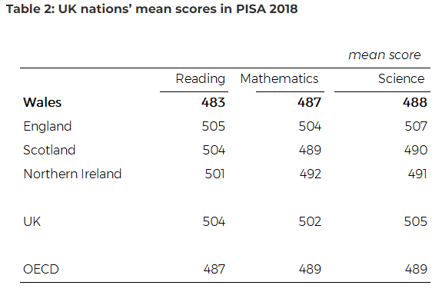

Senedd Research (2019) How did Wales perform in PISA 2018? Available at: https://research.senedd.wales/research-articles/how-did-wales-perform-in-pisa-2018/ (Accessed: 28th October 2023).
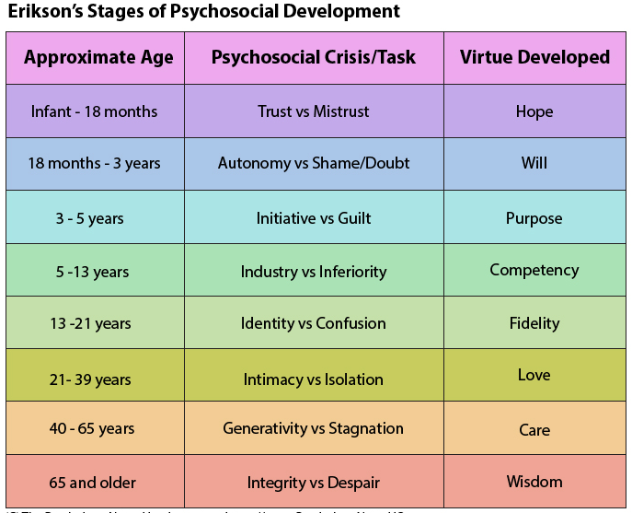

Orchard Valley Counselling Services (2020) Erikson’s Stages of Psychosocial Development. Available at: https://www.orchardvalleycounselling.ca/stages-of-psychosocial-development/ (Accessed: 3rd November 2019).



Sensory Direct (n/d) Sensory Toys for Autistic Children. Available at: https://www.sensorydirect.com/tangle-textured-metallic (Accessed: 31st October 2023)

