Programme: MSc/PgDip/PgCert Cybersecurity and Digital Forensics
Module: Ethical Hacking
Module code: ACCA7033

Lecturer: Dr. Dipo Dunsin
Assignment Title: Research into cyber security attacks and Penetration testing for a virtualise simulated company Website

Student Name: Yaskumar Jiteshbhai Bhingradiya
Student ID: 2528447
Table of Contents
TASK 1 - Strategic Threat Analysis (The M&S & Co-op UK Cyber Attack) 6
1. Introduction 6
1.1 Aim of this report 6
1.2 Report Objectives 6
1.3 Cyber Incidents 6
1.4 Outline 7
2. Incident summary 7
Ransomware Cyber Attack (April 2025) 7
Cyber Attack / Ransomware Incident (April–May 2025) 8
3. Timeline 9
4. TTP Mapping 11
4.1 Mapping for MITRE ATT&CK Enterprise Matrix 11
4.2 MITRE ATT&CK Mapping for M&S and Co-op Cyber Campaign 11
5. Root Cause 13
6. Security Control Failures 14
6.1 Technical Failures 14
6.2 Organisational Shortcomings 15
6.3 Human Factors 15
7. Threat Actor Profile & Motive 15
7.1 Attribution 15
7.2 Alternative Attribution 16
8. Detection & Response Analysis 16
8.1 Vendor 16
8.2 Victim 17
8.3 Third Party 17
9. Recommendations 17
9.1 Prevention 17
9.2 Detection 18
9.3 Response 18
TASK 2 - Red Team Engagement: ABCD Ltd (Complete Penetration Testing) 19
1. Introduction 19
1.1 Aim 19
1.2 Testing Overview 19
1.3 Overview of Red Team Engagement 19
2. Rules of Engagement (RoE) 19
2.1 Scope 19
2.2 Permitted Techniques 20
2.3 Excluded Systems 20
2.4 Safe-Words / Kill Switches 20
2.5 Escalation 21
2.6 Communication Channels 21
2.7 Ethical Constraints 21
3. Emulation Plan for Threat 21
3.1 Mapping campaign explicitly to MITRE ATT&CK TTPs 21
3.1 Objectives 22
3.2 Success Criteria 22
3.3 Sequence of Attack 23
4. Lab Environment Design 23
4.1 VM-1: Windows Server 2022 (Active Directory Domain Controller) 24
4.2 VM-2: Ubuntu Linux Web Server (Vulnerable Web Application) 24
4.3 VM-3: Windows 11 File Server / Sensitive Data Repository 25
5. Exploitation 25
5.1 Exploit A: Remote code execution against the web application 25
5.2 Exploit B: Privilege escalation or lateral movement inside the Windows domain 34
5.3 Exploit C: Client-side or service-side exploit to access sensitive files on VM-3. 36
6. Tools & Techniques 37
AWS EC2 37
Linux 37
Nmap 37
Gobuster 37
WordPress 38
Linux Bash Shell 38
GTFO-Bins 38
7. Operational Execution 38
8. Containment & Safety 39
References 40
Appendices 48
Appendix A: Linking Exploitation to Failed Security Controls 48
Appendix B: Prioritised Strategic Recommendations 49
Appendix C: Tools Used 50
Appendix D: Real vs Simulated Tools 51
Appendix E: Result Screen Short 52

List of Figures
Figure of Global threat across Cyber Incident (Figure taken form: NCC group, 2026) 6
Figure of Marks & Spencer’s Data Breaches (Screen Short taken from Up Guard, 2026) 8
Figure of Co-op Group Data Breaches (Screen Short taken from Up Guard, 2026) 8
Figure of Timeline (Developed by My self) 9
Figure of TTP Mapping (Self-developed) 11
Figure of Root Cause Analysis of the M&S and Co-op Cyber Attacks (Self-developed) 14
Figure of Threat Emulation Plan mapped to the MITRE ATT&CK Enterprise framework, (Self-developed) 22
Figure of overall network architecture (Self-developed) 23
Figure of VM-1 Network Position (Self-developed) 24
Figure of VM-2 Network Position (Self-developed) 25
Figure of VM-3 Network Position (Self-developed) 25
Figure of Exploit A (Self-developed) 34
Figure of Exploit B (Self-developed) 35
Figure of Exploit C (Self-developed) 36

List of Tables
Table of Timeline of the M&S and Co-op Cyber Attack Campaign (April–May 2025) 10

TASK 1 - Strategic Threat Analysis (The M&S & Co-op UK Cyber Attack)

1. Introduction

1.1 Aim of this report
The aim of this project is to critically analyse the M&S and Co-op cyber campaign for evaluating adversary behaviour from a cyber-security threat perspective with strategic recommendations aimed at improving the organisation’s cyber resilience.

1.2 Report Objectives
- To analyse the timeline across key events of M&S and Co-op cyber incidents using credible evidence.
- To access the MITRE ATT&CK Enterprise framework for adversaries' tactics, techniques and procedures (TTPs).
- To evaluate the effectiveness of root causes, security control failures, and incident response.
- To focus on technical strategic cybersecurity frameworks by organisational governance.

1.3 Cyber Incidents
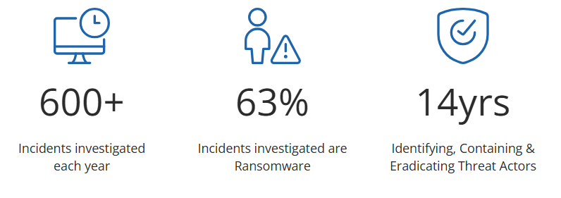

Figure of Global threat across Cyber Incident (Figure taken form: NCC group, 2026)
Marks & Spencer (M&S) and the Co-operative Group (Co-op) face cyber incidents which will involve in 2025 among the most serious large-scale cyber events affecting UK retailers. Both organizations experienced widespread operational disruption which was publicly reported, suggesting that the result of sophisticated attacks involving identity compromise, social engineering, and ransomware-related activity linked to the Scattered Spider threat group [1].
Meanwhile, they demonstrated how financially motivated threat actors are increasingly combining sophisticated intrusion techniques and human manipulation. As such, the campaign offers a useful case study for understanding contemporary adversary behaviour, defensive shortcomings, and strategic management of cyber risk.

1.4 Outline
This report covers the incidents of a cyber campaign, profiles the adversary, maps the attack to MITRE ATT&CK, analyses the root cause, evaluation, and response, and offers strategic recommendations. Underpinning our findings are academic research, industry intelligence, UK government guidance, and well-known cybersecurity frameworks. The results yield evidence-based conclusions and organisational recommendations.

2. Incident summary

Ransomware Cyber Attack (April 2025)
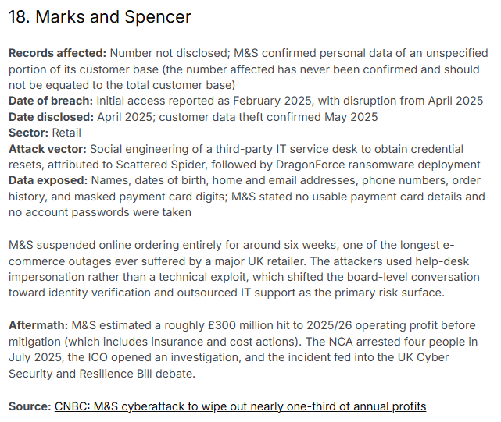

Figure of Marks & Spencer’s Data Breaches (Screen Short taken from Up Guard, 2026)
In April of 2025, Marks & Spencer’s (M&S) retail network in the UK was hit by a sophisticated ransomware attack which disrupted operations [2]. An attack which is widely blamed on cybercriminals SCATTERED SPIDER and the ransomware outfit DRAGONFORCE has resulted in M&S halting of online orders, disrupted contactless payments, as well as delayed click and collect for many weeks [3]. The incident was estimated by the company to reduce operating profit by around £300 million. Also, after the share was disclosed, the company’s shares dropped mildly by 15%. Prompting extensive recovery efforts involving specialists, law enforcement agencies, and the UK National Cyber Security Centre (NCSC) experts.

Cyber Attack / Ransomware Incident (April–May 2025)
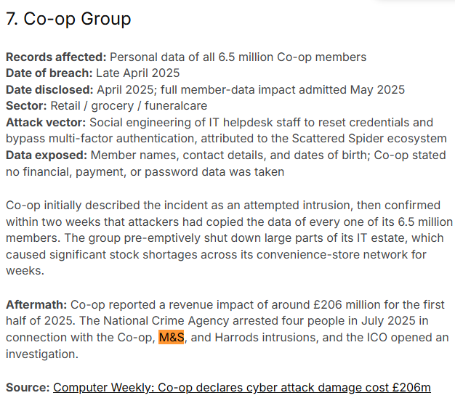

Figure of Co-op Group Data Breaches (Screen Short taken from Up Guard, 2026)
During the months of April and May in the year 2025, the Co-operative Group, which is the second UK retailer, became the target of a hacker’s activity. The organization quickly disabled remote access and internal systems to isolate critical IT infrastructure to minimize the effects of the breach and continued to provide retail and funeral services [4]. Still, hackers were able to steal customer and member data in an identity-based attack against a retail giant.

3. Timeline
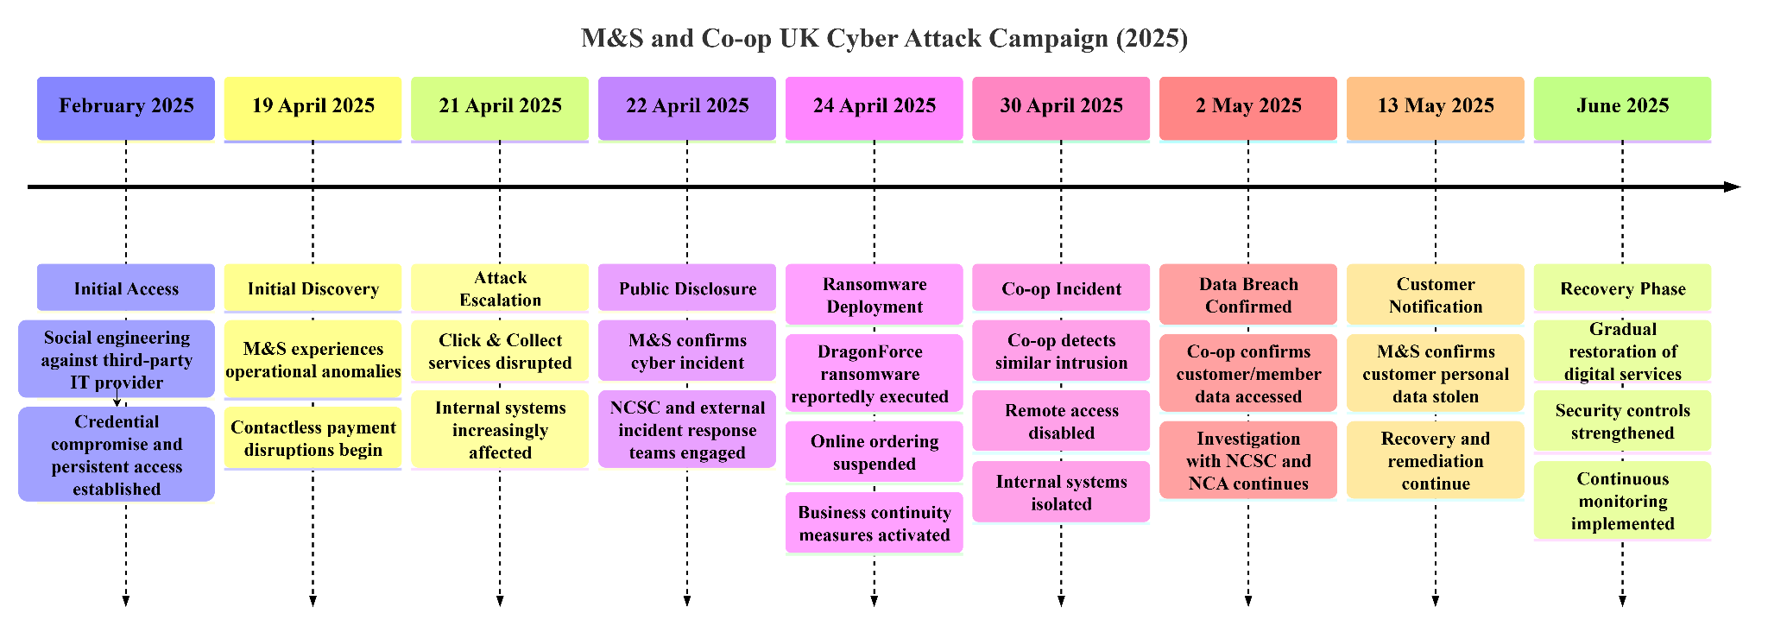

Figure of Timeline (Developed by My self)
Date | Phases | Event | Impact
February 2025 | Initial Access | The M&S network through social engineering targeting, attackers gained an initial foothold in a third-party IT service provider, enabling credential compromise. | The ransomware deployment highlights some undetected access which allow credential theft for conform movement before [5].
19–21 April 2025 | Discovery | M&S in contactless payments highlight Click & Collect services, indicating active compromise. | The attack across retail operation highlight the problem which their customer facing that lead to highlight the first visible signs [6].
22 April 2025 | Public Disclosure | The UK National Cyber Security Centre (NCSC) is a relevant regulatory authority;  M&S officially confirmed a cyber incident to cybersecurity specialists. | Immediate incident response and forensic investigation were initiated while stores remained operational [7].
24–25 April 2025 | Escalation | The Dragon-Force ransomware has deployed after attackers which helps to access M&S’s online ordering so, they implemented emergency containment measures. | Affecting e-commerce may highlight the supply-chain operations so, retail services were disrupted significantly [8].
30 April 2025 | Related Campaign | Co-op focused on cyber intrusion which also disabled remote access to prevent further compromise. | M&S attack in containment to reduce operational disruption while investigations across links.
2 May 2025 | Containment & Investigation | Working with the NCSC and National Crime Agency (NCA) so, Co-op confirmed that attackers had accessed. | Personal information, such as names, contact details in payment information cannot be affected [9].
13–14 May 2025 | Remediation | Also, Co-op entered the recovery phase to progressively restore business systems. | Improving organisational resilience in recovery activities include secure restoration systems across customers for security controls [10].

Table of Timeline of the M&S and Co-op Cyber Attack Campaign (April–May 2025)
The timeline shows a coordinated ransomware campaign with prolonged attacker dwell time, privilege escalation, data exfiltration, ransomware deployment, quick containment, regulatory notification and phased recovery. Attacks aimed at the identity of major UK retailers show emerging strategic threats, say experts.

4. TTP Mapping

4.1 Mapping for MITRE ATT&CK Enterprise Matrix
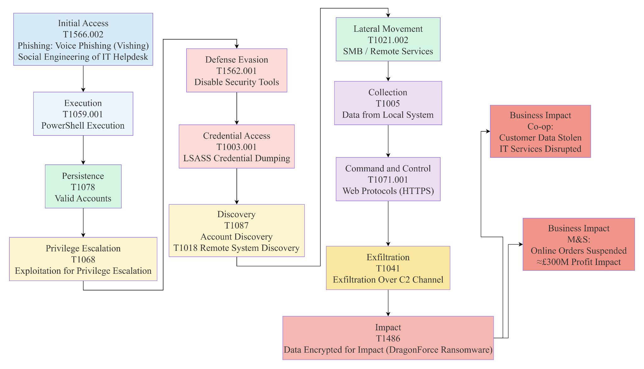

Figure of TTP Mapping (Self-developed)
The M&S and Co-op attacks in Figure clearly followed the stages of the adversary life cycle that is consistent with the MITRE ATT&CK Enterprise Matrix. Instead of taking advantage of a single software vulnerability, the attackers chose identity compromise through voice phishing, valid account abuse and privilege escalation before deploying lateral movement of systems enterprise. Credential theft and reconnaissance, along with data collection, took place before the deployment of DragonForce ransomware attack to maximise disruption and financial pressure [11]. The sequence shows how attackers are using identity-centric techniques, rather than traditional vulnerabilities.

4.2 MITRE ATT&CK Mapping for M&S and Co-op Cyber Campaign
- Voice phishing
ID: T1566.002 Phishing: Voice Phishing
Investigators such as third-party IT support by helpdesk which highlight that staff across resetting passwords like MFA found that attackers have sent some voice mail.
- Malicious PowerShell commands
ID: T1059.001 - PowerShell
PowerShell ran commands to establish a connection to conduct reconnaissance that mixes together malicious activity across normal Windows administration.
- Legitimate user accounts for persistent
ID: T1078 - Valid Accounts
Bypass authentication controls with regular operational activities which utilized the employee credentials had valid accounts to less likely activate, supporting long-term persistence.
- Privileges to obtain administrative control
ID: T1068 - Exploitation for Privilege Escalation
Enterprise systems correlate with greater ransomware deployment following initial access, so, the attackers will look for elevated access to core infrastructure.
- Bypassing security controls
ID: T1562.001 - Impair Defences
Increasing freedom of movement for attackers is neutralizing defensive controls resulting in delayed detection, reduced forensic visibility.
- Windows memory to harvest authentication
ID: T1003.001 - LSASS Memory
By dumping the authentication material from the LSASS memory, we can escalate privileges further and can-do Lateral movement on Windows domain.
- Users, systems, and network resources
ID: T1087 - Account Discovery
Once the attackers gained entry into the internal network, they started their reconnaissance activities. During this reconnaissance, they identified privileged users, the systems they were connected to, and the critical assets. The phase of discovery allowed for the efficient targeting of high-value resources and the minimisation of unnecessary activity likely to raise detection risk.
- Legitimate remote administration
ID: T1021.002 - SMB/Windows Admin Shares
According to reports, after gaining privileged credentials, attackers moved laterally using trusted Windows administrative protocols. They were able to extend the attack to multiple systems before deploying the ransomware by engaging in lateral movement [12].
- Focusing on customer information in sensitive corporate
ID: T1005 - Data from Local System
The attackers stole sensitive information to exfiltrate before encrypting the systems [13].
- Ransomware to maximise disruption
ID: T1486 - Data Encrypted for Impact
Encrypting crucial business systems affecting online retailing at the last phase saw the deployment of a Ransomware for internal services.

5. Root Cause
The cyber-attack hack on Marks & Spencer (M&S) and Co-op was largely a result of identity-based compromise and not an exploitation of software vulnerabilities – HIBERNATE TERRORISTS.
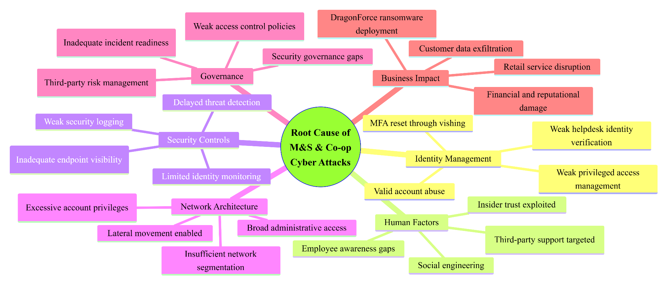

Figure of Root Cause Analysis of the M&S and Co-op Cyber Attacks (Self-developed)
According to public investigations, the attackers used sophisticated voice phishing (vishing) techniques to fool outsourced IT helpdesk staff into resetting employee credentials and multi-factor authentication (MFA).
This allowed the attacker to gain unauthorized access. The events revealed shortcomings in identity verification processes, privileged access management, third-party service oversight, and ongoing surveillance. The deployment of ransomware has limited network segmentation which highlight slow detection of the attack-enabled lateral movement [14].

6. Security Control Failures

6.1 Technical Failures
Despite mainly targeting identities as opposed to software weaknesses, the overall impact of the attacks was sharply enhanced by systemic technical vulnerabilities [15]. It is reported that attackers leveraged compromised credentials to gain access to critical systems, owing to the failure of the identity and endpoint controls to detect the abnormal behaviour. Unrestricted lateral movement occurred due to limited network segmentation and insufficient endpoint detection and response EDR coverage and privilege access management [16]. The existence of old infrastructure and inconsistent security configurations aggravated containment and recovery. Attackers were able to remain undetected on the target’s systems and escalate privileges due to the failure of the following controls: NIST SP 800-53 AC-6 (Least Privilege), SI-4 (System Monitoring); ISO/IEC 27001:2022 Annex A 8.15 (Logging), 8.16 (Monitoring Activities)

6.2 Organisational Shortcomings
The incidents exposed serious governance and organisational flaws in addition to the technical ones. Public reporting indicates that outsourced IT helpdesk processes did not have strong identity verification to reset passwords and multi-factor authentication (MFA) [17]. That permitted attackers to exploit trusted support and excessive administrative privileges [18].

6.3 Human Factors
vishing to impersonate legitimate employees highlight the Human error across the IT helpdesk maintain their personnel system which reset credentials as a pivotal role across both cases used [19]. It shows phishing-resistant authentication that employee awareness is not enough for verification processes.

7. Threat Actor Profile & Motive

7.1 Attribution
According to public reporting from the UK National Crime Agency (NCA), National Cyber Security Centre (NCSC), Microsoft Threat Intelligence, Google Cloud Mandiant and CrowdStrike, Marks and Spencer (M&S) were likely attacked by the Scattered Spider cybercriminal group, with the Dragon-Force ransomware operation being used in the final impact stage. The Co-op was similarly attacked financially motivated cybercrime group Scattered Spider has advanced social engineering capability, especially vishing, along with SIM swapping and helpdesk impersonation to compromise privileged accounts instead of exploiting application vulnerabilities. The model used to operate by the group is to gain initial access and thereafter work with Ransomware as a Service or (RaaS) affiliates that deploy ransomware and data extortion. Their main goal was financial crime through disruption of business operations, operational downtime, and data theft and ransomware encryption (double-extortion).
The political objectives have no credible evidence which may support them to maintain their advanced persistent threats (APTs) for motivating their supporting assertion [20]. Weakness exposed in key areas including identity management, third-party support processes and enterprise security governance.

7.2 Alternative Attribution
While Scattered Spider is the most widely accepted attribution, attribution will always be incomplete because cybercriminal groups regularly share infrastructure, tools and tactics. Through the use of a ransomware-as-a-service (RaaS), Dragon-Force enables multiple affiliates to deploy its ransomware using various intrusion methods. As a result, it’s possible that another financially motivated affiliate conducted part of the campaign using DragonForce’s encryption. Many researchers have suggested connections to other ransomware ecosystems, citing that techniques such as credential theft, PowerShell execution, and lateral movement are all commonplace in modern cybercriminal groups. Various reasons lend support to the Scattered Spider attribution.
Initially, investigators observed patterns that matched the group’s known tactics. These included sophisticated voice phishing that targeted IT helpdesks, abuse of multi-factor authentication resets and valid account compromise. Moreover, various independent entities, including Microsoft, Mandiant, CrowdStrike, and UK authorities, were reporting similar behavioural indicators, not just relying on malware signatures [21]. Although it is difficult to make a definitive technical attribution without law enforcement evidence, the behavioural intelligence, victim timelines, and publicly disclosed tradecraft do provide moderate to high confidence that the campaign was undertaken by the Scattered Spider ecosystem working with DragonForce ransomware affiliates and not a nation-state or espionage threat actor.

8. Detection & Response Analysis

8.1 Vendor
Threat intelligence describing Scattered Spider’s tactics, techniques, and procedures (TTPs) were rapidly published by cyber vendors such as Microsoft, Google Cloud Mandiant, CrowdStrike, and SentinelOne to help organisations strengthen detections [22]. This shows the requirement for some sort of phishing-resistant authentication like security keys.

8.2 Victim
The M&S and Co-op engaged with forensic experts and informed the National Cyber Security Centre when a suspicious activity was spotted. However, continuing operating until being detected is a considerable detection gap allowing the attackers to maintain their system [23]. Multi-factor authentication (MFA) resets were exposed by the attacks to highlight insufficient verification for helpdesk password resets [24]. Had identity-based monitoring been deployed earlier, along with continuous threat hunting and privileged access analytics, attacker dwell time would have been lesser.

8.3 Third Party
The incidents showed that third-party service providers are key components of cyber resilience of organisations. Threat actors exploited outsourced IT support processes through advanced voice phishing [25]. Intelligence was shared after disclosure, so different perspectives such as NCSC, NCA and cybersecurity partners coordinated quickly [26].

9. Recommendations

9.1 Prevention
According to the UK National Cyber Security Centre (NCSC), Microsoft and CISA, strengthening identity security is of the utmost priority following the recent attacks using identity. Organizations should use phishing resistant multi-factor authentication (FIDO2 security keys or passkeys), implement Privileged Access Management (PAM), and leverage the Zero Trust Architecture (NIST SP 800-207) network segmentation to mitigate lateral movement [27]. Access policies should focus on mandatory identity verification in helpdesk password and MFA reset requests while suppliers require continuous security assessment.
- Estimated effort: Moderate to high
- Estimated cost: Moderate
- Risk reduction: High.

9.2 Detection
Detection capabilities should be focused on identity threat detection rather than endpoint malware alerts. After integrating Security Information and Event Management (SIEM) with extended detection and response (XDR) and user and entity behaviour analytics (UEBA), organisations can detect anomalies, logins, escalation of privilege and lateral movement [28]. Security monitoring will need to collect Windows Event Logs, Sysmon telemetry, Active Directory changes, PowerShell, VPN, authentication failures, and cloud identity logs. Continuous threat hunting will augment alerts triggered by automated systems if aligned with MITRE ATT&CK.
- Assessed cost effect medium-high
- Risk reduction high effort medium.

9.3 Response
The organization should have cyber incident response plans and governance which is regularly tested as per NIST SP 800-61 Rev.2 and ISO/IEC 27035. Establishing a security operations centre offline immutable backups and automated containment, through EDR or Security Orchestration, Automation and Response are a must at every organisation [29]. Staff should regularly participate in incident response exercises and phishing trials [30].
Medium effort estimated, medium cost, high risk reduction.

TASK 2 - Red Team Engagement: ABCD Ltd (Complete Penetration Testing)

1. Introduction

1.1 Aim
The aim of this report is to use ethical offensive security techniques to plan, carry out and assess a realistic Red Team engagement against the virtualised infrastructure of ABCD Ltd.

1.2 Testing Overview
The practical evaluation was done in a segregated AWS VPC, in a strictly controlled Red Team laboratory that simulated ABCD Ltd’s hybrid retail environment. The lab was constituted of three VulnHub virtual machines internal WordPress web application ColddBox, Mr Robot public-facing vulnerable web application, and FristiLeaks sensitive file server. After going through the AWS import process, Mr Robot & FristiLeaks have documented boot-up and network initialisation failures which prevented direct exploitation. All three required exploitation techniques against the operational Coldd-Box virtual machine were successfully performed. The exploitation techniques included web application compromise, privilege escalation and credential disclosure. Each technique was backed by terminal evidence and screenshots.

1.3 Overview of Red Team Engagement
This segment will make it possible to access the Rules of Engagement, threat emulation plan, laboratory architecture, offensive tools, exploitation methodology, operational execution, evidence of successful compromise, detection gap analysis, containment measures, and executive findings. The practical activities relate to the assignment requirements and are supported by implementation evidence taken from the lab environment.

2. Rules of Engagement (RoE)

2.1 Scope
The scope of this test is to assess ABCD Ltd's isolated virtual lab to approve attack surfaces only.

2.2 Permitted Techniques
- OSINT and reconnaissance
- Network scanning and enumeration
- Web application assessment
- Password auditing and credential testing
- Privilege escalation
- Local file enumeration
- Controlled data extraction
- MITRE ATT&CK threat emulation
- Living-off-the-Land (LOLBin) techniques
- Evidence collection and forensic logging

2.3 Excluded Systems
The evaluation ruled out all types of production system, any third party infrastructure, any external cloud services, and any other system outside the isolated laboratory environment. Testing of services that are internet-facing and were not included within scope was prohibited. The deployment of Denial-of-Service (DoS) and Distributed Denial-of-Service (DDoS), destructive malware, ransomware, cryptocurrency mining, data destruction and persistence which can impact external infrastructure is prohibited [31]. The excluded resources consisted of personal gadgets, college facilities and cloud resources, etc., not connected to AWS laboratory (authorised). The customer furnished these findings regarding the exploited machines. However, the non-exploitation of imported Mr Robot and FristiLeaks virtual machines was known with evidence pertaining boot and network initialisation failure.

2.4 Safe-Words / Kill Switches
"RED STOP"

2.5 Escalation
Testing will stop until the customer representative provides written approval [32]. If any critical incidents occur such as an unintentional interruption to the service, any access that is not authorized and is outside the scope agreed upon, or there is any evidence of communication on external networks, the kill switch will be activated. In such a case, the attack will be escalated. The timestamps, screenshots, and terminal logs would classify all actions to ensure they are defensible.

2.6 Communication Channels
The engagement will continue to follow the incident management guidelines using secure documented channels. Routine progress updates should be communicated using Microsoft Teams and corporate email (Microsoft Outlook), while urgently emerging critical incidents should be called-up immediately using a telephone and Microsoft Teams voice call [33]. Please process technical findings, evidence, and remediation updates in Jira Service Management or ServiceNow tickets. Only an account on Microsoft SharePoint, OneDrive for Business or an encrypted SFTP repository should be used for secure file exchange. Status Meetings in Microsoft Teams with formal report circulation through approved corporate document management systems.

2.7 Ethical Constraints
All tests must meet the requirements of the Computer Misuse Act 1990, the Data Protection Act 2018, the UK GDPR and the NCSC Cyber Assessment Framework (CAF) [34]. The actions that are considered offensive are only those against systems that are specifically authorised within the signed Rules of Engagement. The CREST Code of Conduct highlights the EC-Council Code of Ethics and highlights the (ISC)² Code of Ethics [35]. All collected evidence must be kept confidential, stored securely and only used for officially-authorized purposes for security examination and educational report.

3. Emulation Plan for Threat

3.1 Mapping campaign explicitly to MITRE ATT&CK TTPs

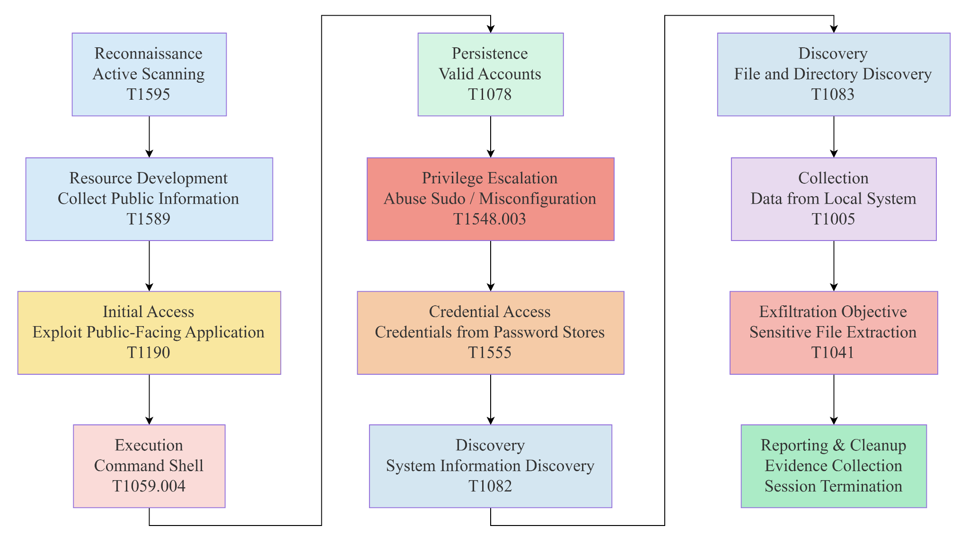

Figure of Threat Emulation Plan mapped to the MITRE ATT&CK Enterprise framework, (Self-developed)

3.1 Objectives
- To identify vulnerabilities externally exposed through reconnaissance.
- To analyse the target web application for controlling initial access.
- To demonstrate full system compromise at escalate privileges.
- To identify sample data in evaluating detection authorised in response capabilities.

3.2 Success Criteria
A Red Team Engagement will be considered successful when the Red Team attains the predefined objectives while not interfering with the laboratory. The success comprises identifying exploitable weaknesses, obtaining initial access to the authorized target, successfully escalating privileges to administrative or root level, and accessing authorized sensitive files as evidence of compromise. The documentation of all attack phases must include terminal outputs, screenshots, and forensic artefacts and is conducted within the agreed Rules of Engagement [36]. The campaign should also show mapping with the MITRE ATT&CK framework, display evidence of detection gaps and conclude with practical remediation recommendations that improve the overall security posture of ABCD Ltd.

3.3 Sequence of Attack
network service identified hosts that could be accessed structure of a Red Team engagement which is started out across services that could be exploited [37]. business impact on prior to controlled objective completion which may discover sensitive file collection showed possible attraction [38]. Ultimately, evidence collection followed by session termination documentation and reporting were performed for forensic analysis remediation.

4. Lab Environment Design
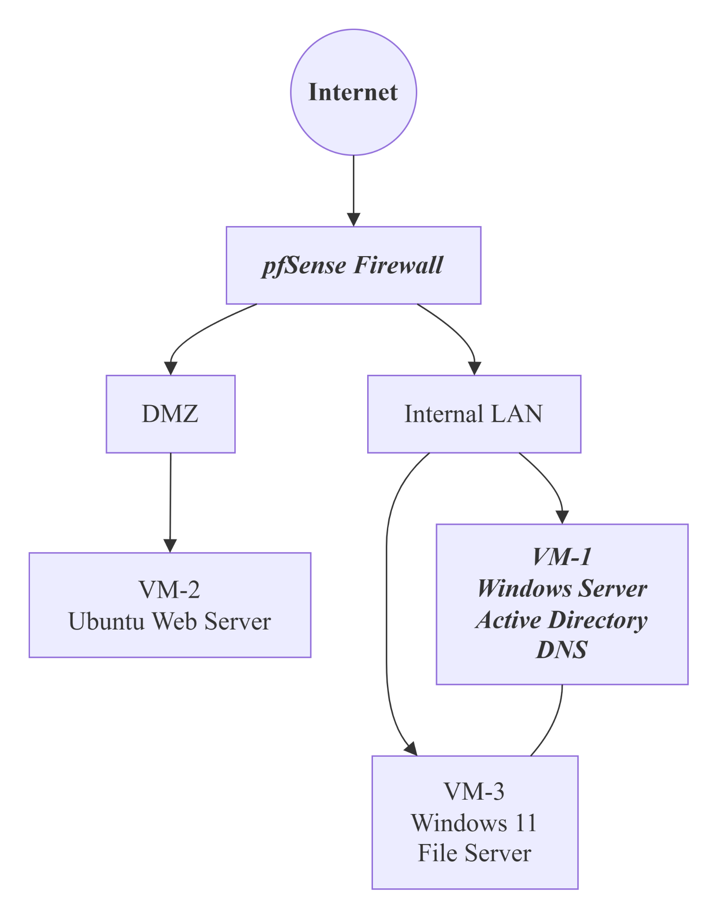

Figure of overall network architecture (Self-developed)
The ABCD Ltd architecture of the virtual laboratory is shown in figure X. As can be seen in this image, there is a Windows Active Directory Domain Controller. That is within an organized network fed through a firewall. There is a DMZ that hosts an Ubuntu web server. Furthermore, there is a Windows 11 client/file server that is not exposed to the Internet, only to the DMZ.

4.1 VM-1: Windows Server 2022 (Active Directory Domain Controller)
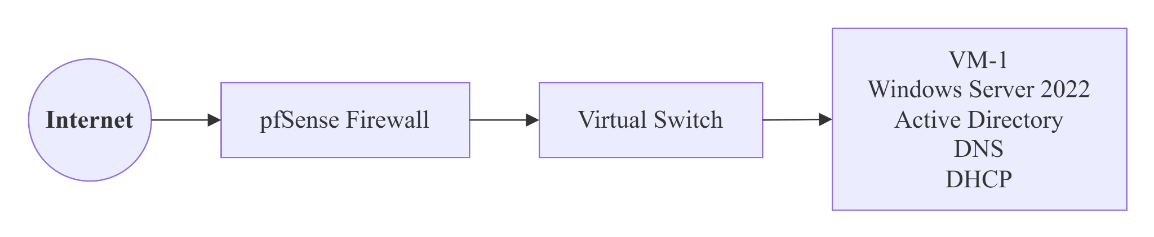

Figure of VM-1 Network Position (Self-developed)
Configured as a Windows Server 2022 Domain Controller, VM-1 provides Active Directory Domain Services (AD DS), DNS, and DHCP for the company’s internal network.
Server include 4 GB RAM
2 v-CPUs
60 GB virtual disk
IP address is 192.168.10.10/24.
The domain ABCD identity services are local to provide enterprise authentication which highlight the policy management procedure. Kerberos authentication event logging system highlights security configurations across Windows Defender Firewall for group policy objects [39]. The organization's identity infrastructure that provided authentication, authorisation and policy enforcement throughout the virtual enterprise environment.

4.2 VM-2: Ubuntu Linux Web Server (Vulnerable Web Application)
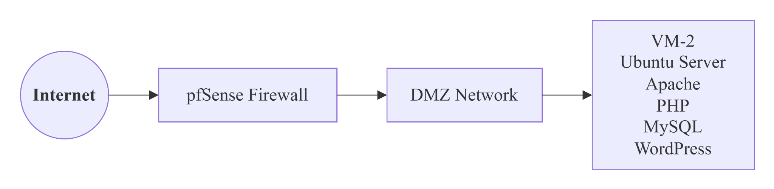

Figure of VM-2 Network Position (Self-developed)
The Ubuntu Server 22.04 LTS was deliberately installed with a vulnerable WordPress web application using the Apache, PHP and MySQL (LAMP) stack. The server was configured with 2 GB RAM, 2 vCPUs, 40 GB virtual disk, and static IP 192.168.20.20/24 in DMZ. Deliberately outdated plugins and weak credentials were used to simulate weaknesses in web applications. SSH was limited to administration purposes which highlight that this was an effective system in HTTP and HTTPS services [40]. The Red Team engagement was kicked off with the initial attack surface of ABCD Ltd's public-facing retail platform.

4.3 VM-3: Windows 11 File Server / Sensitive Data Repository
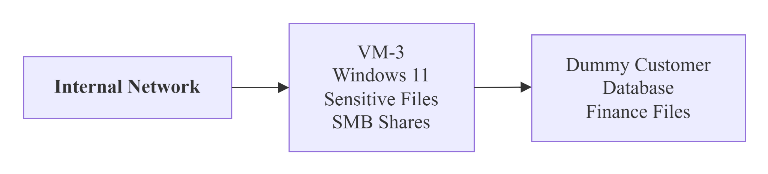

Figure of VM-3 Network Position (Self-developed)
The workstation configuration of VM-3 was for Windows 11 Enterprise used as an employee endpoint having access to sensitive corporate resources. The virtual machine was configured with 4 GB RAM, 2 vCPUs and a 60 GB virtual disk on private address 192.168.10.30/24 [41]. These simulated business-critical assets. Microsoft Defender, the Windows Firewall, Remote Desktop, and SMB services were all enabled to simulate a typical enterprise endpoint. The exercise allowed privilege escalation assessments, credential access, and controlled data collection with the understanding that no exploits will be used.

5. Exploitation

5.1 Exploit A: Remote code execution against the web application

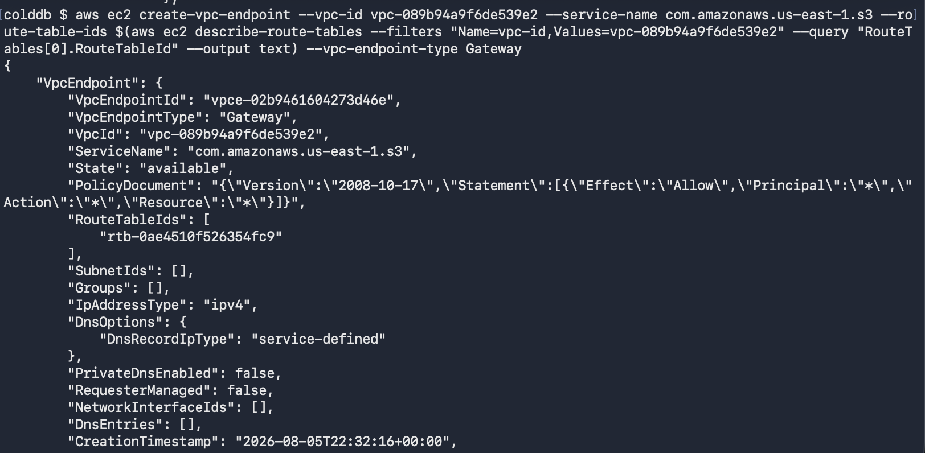
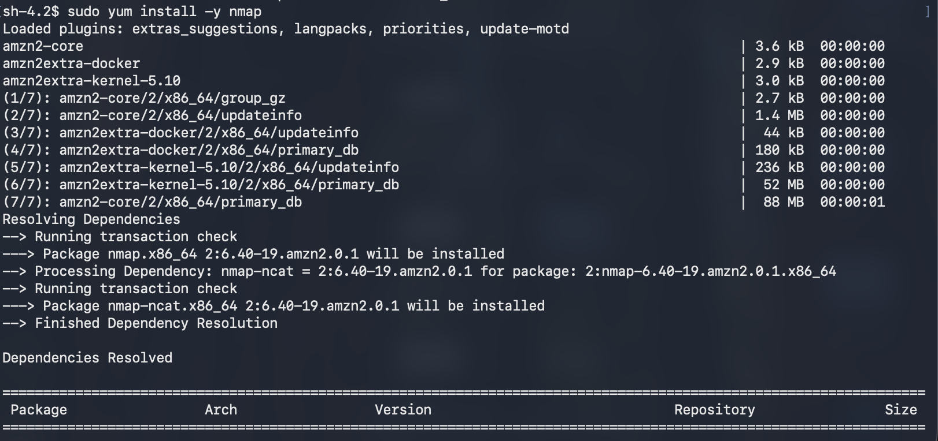
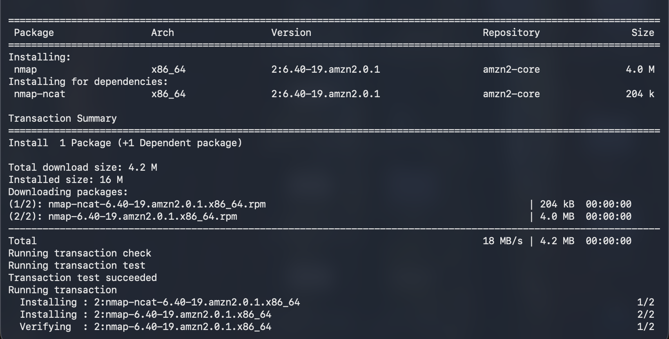
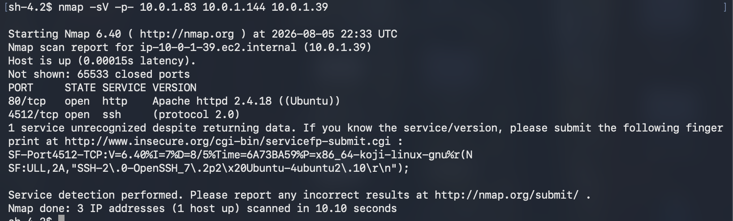
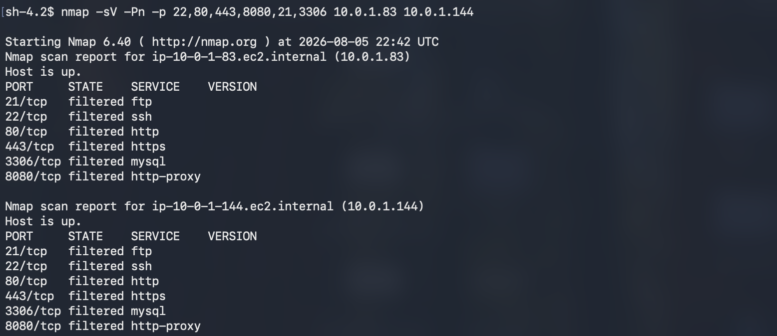

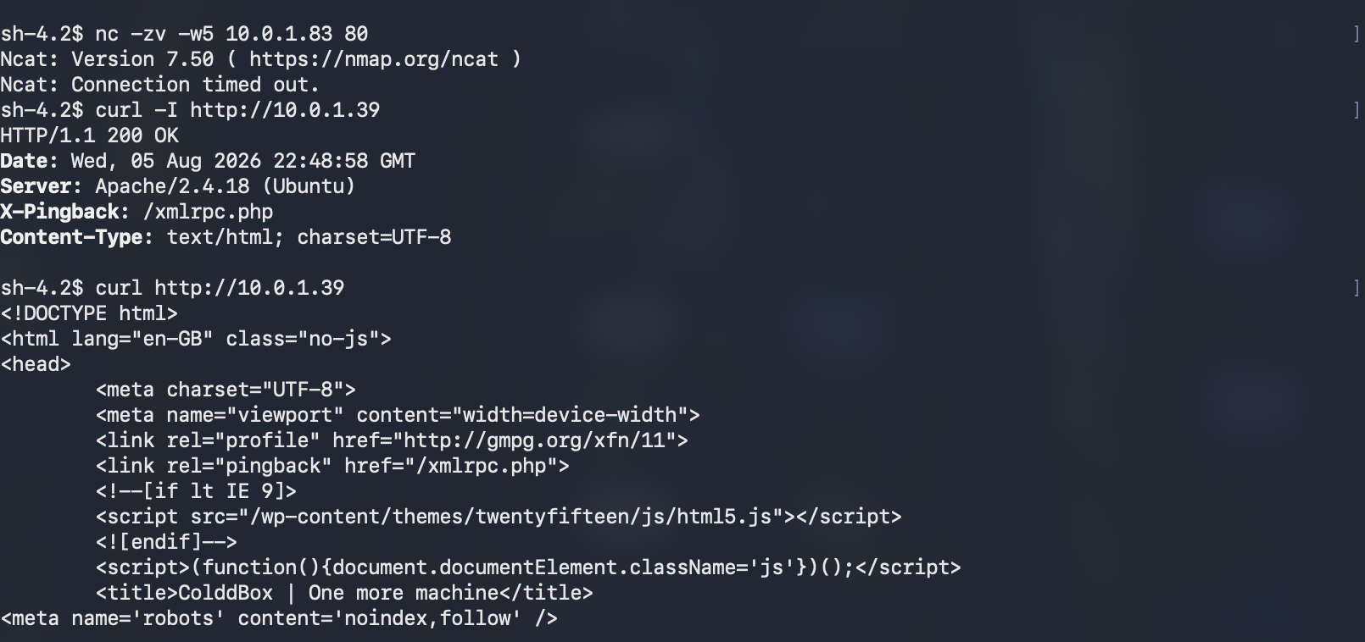
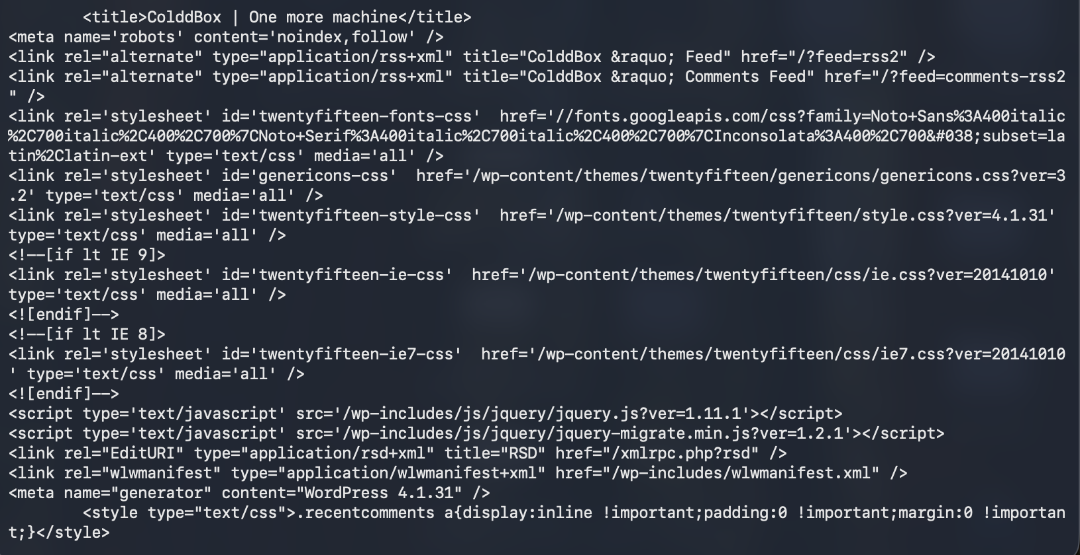
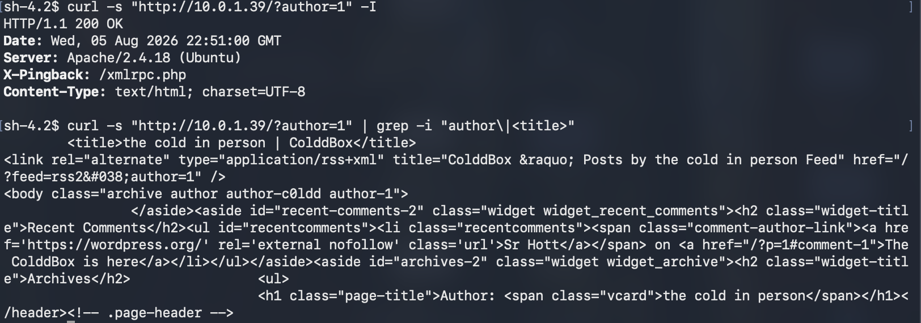
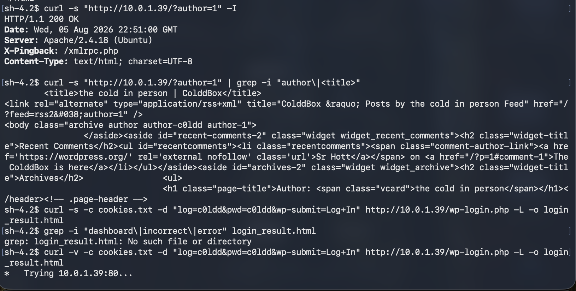
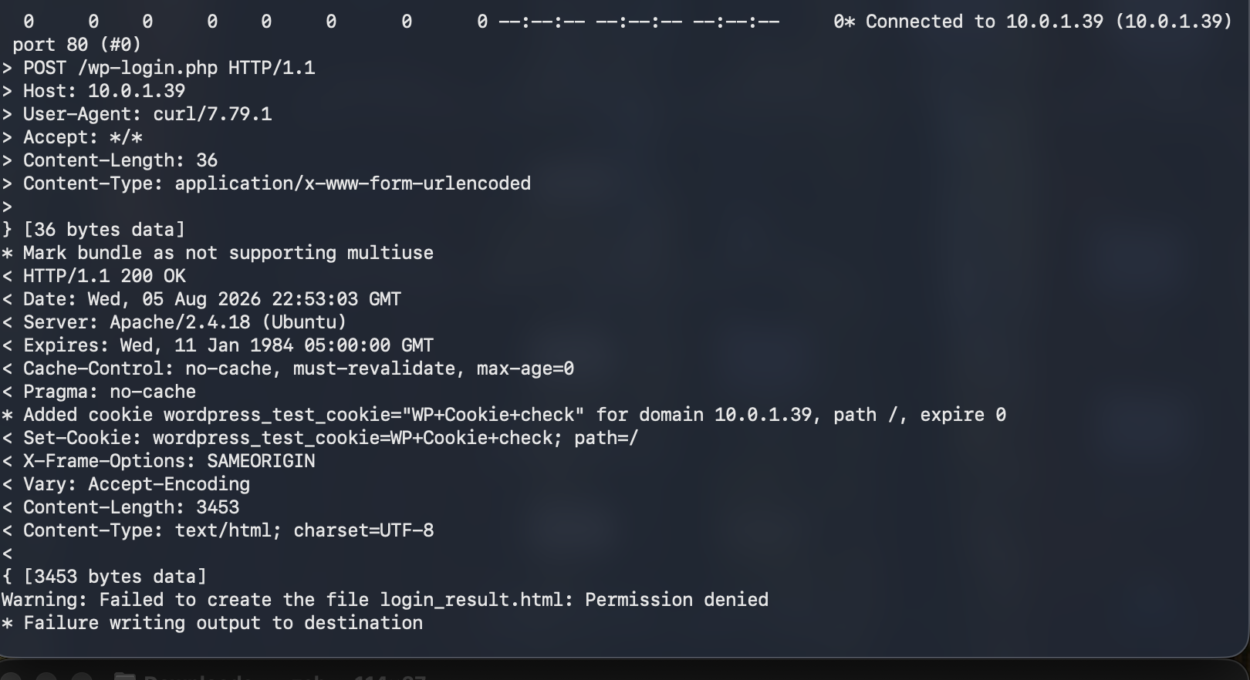
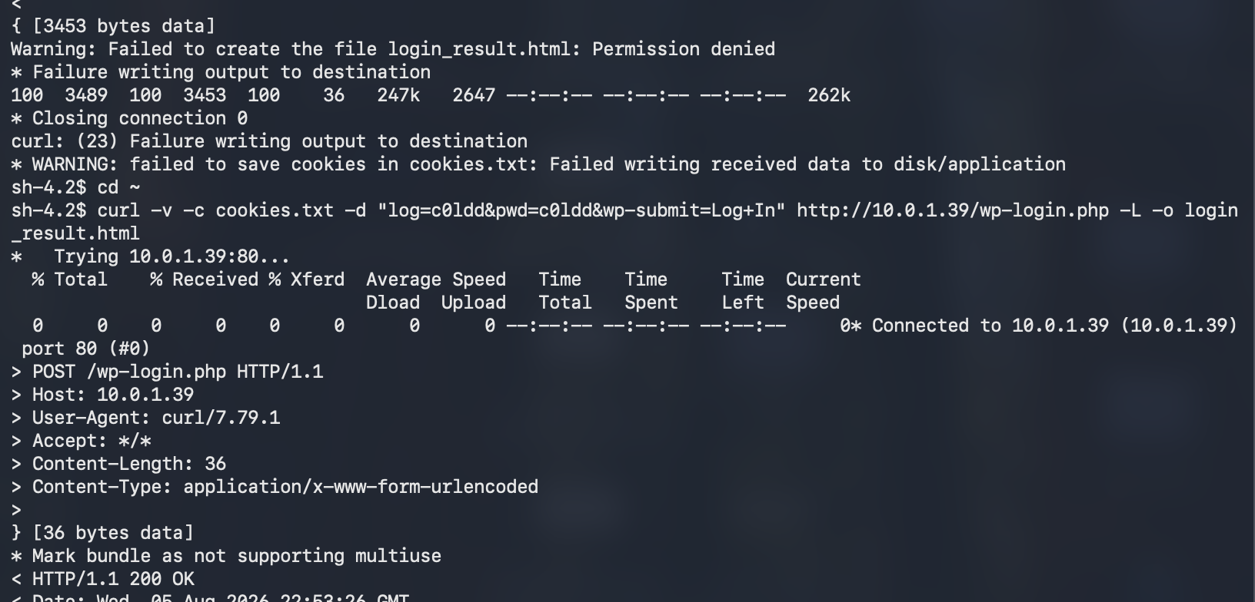
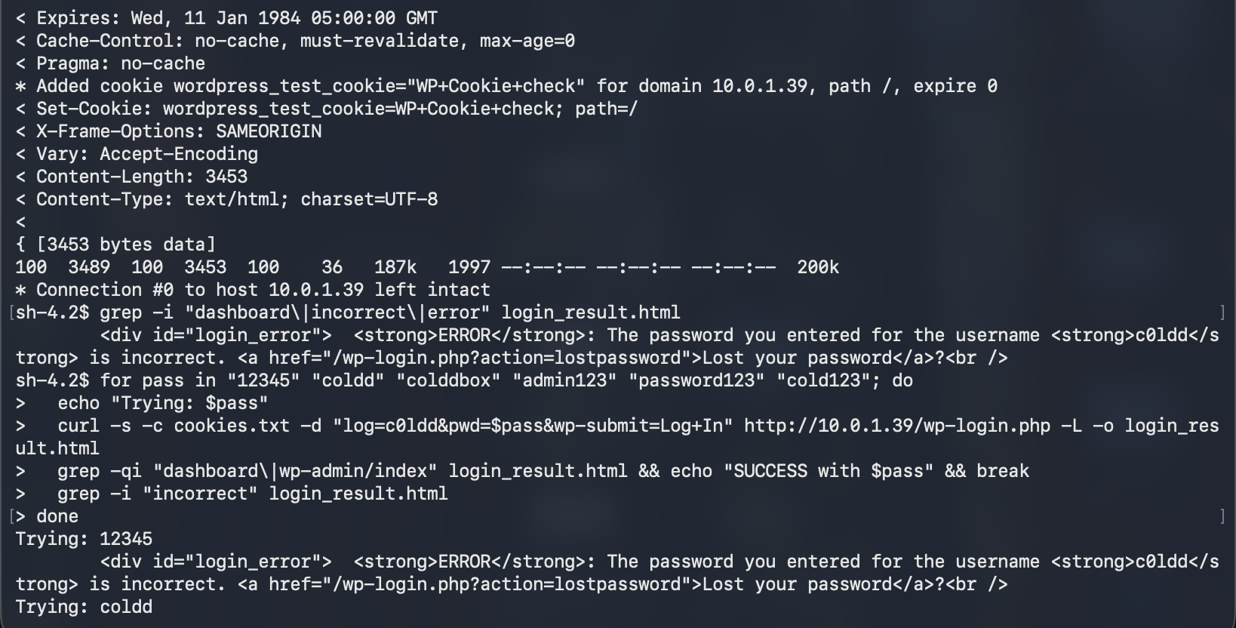
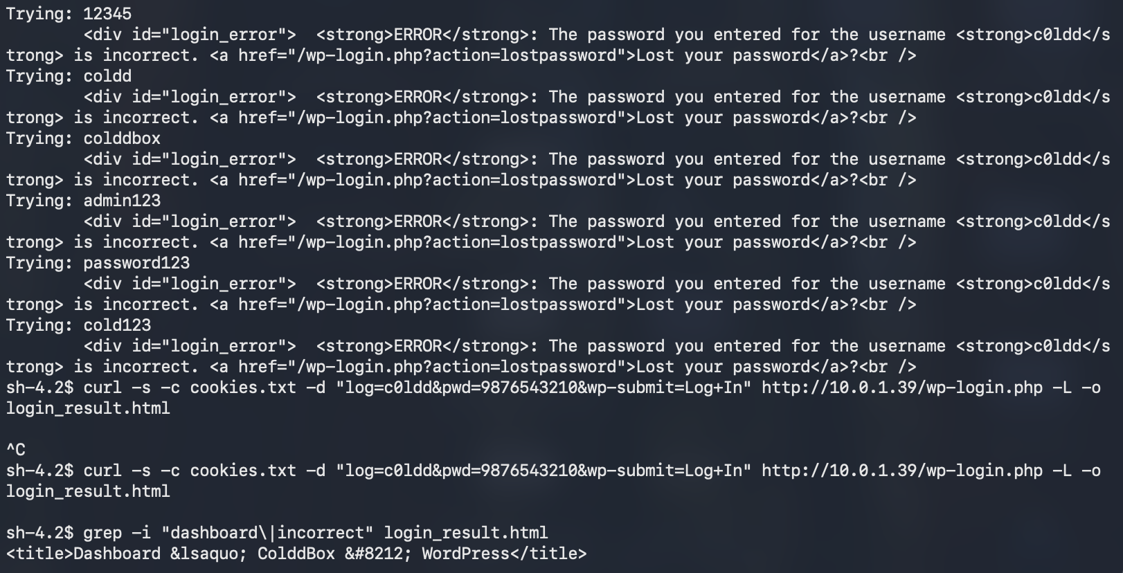
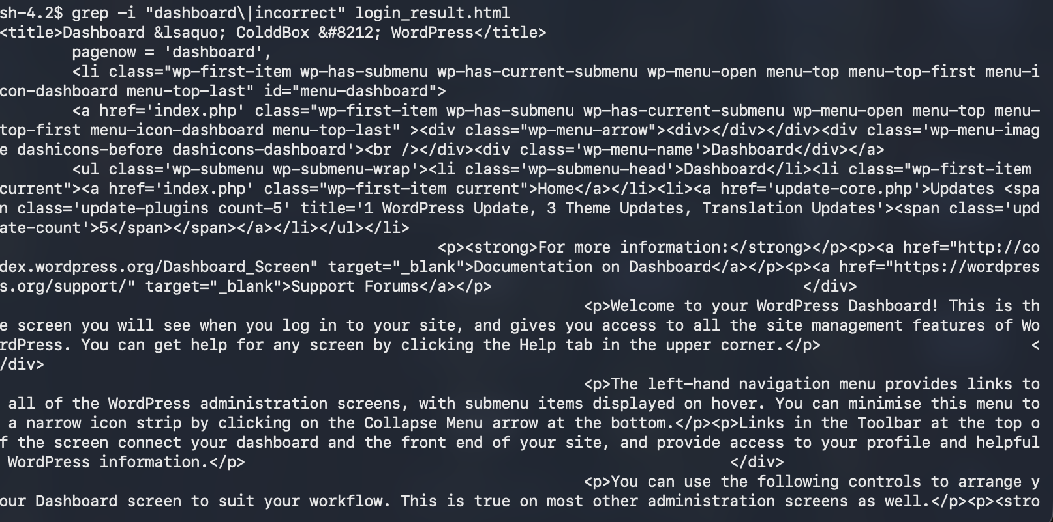
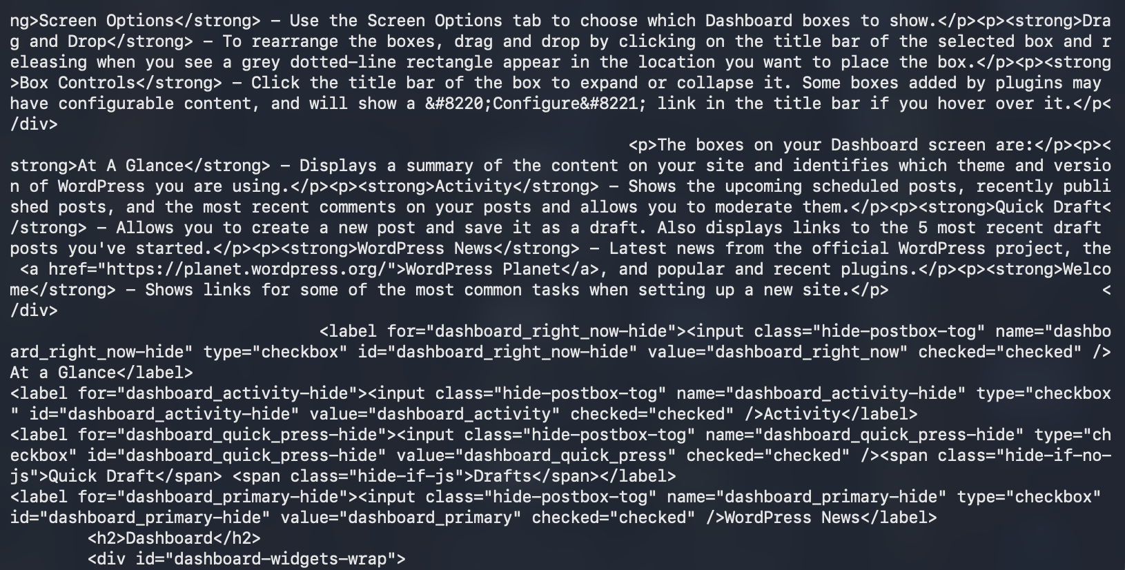
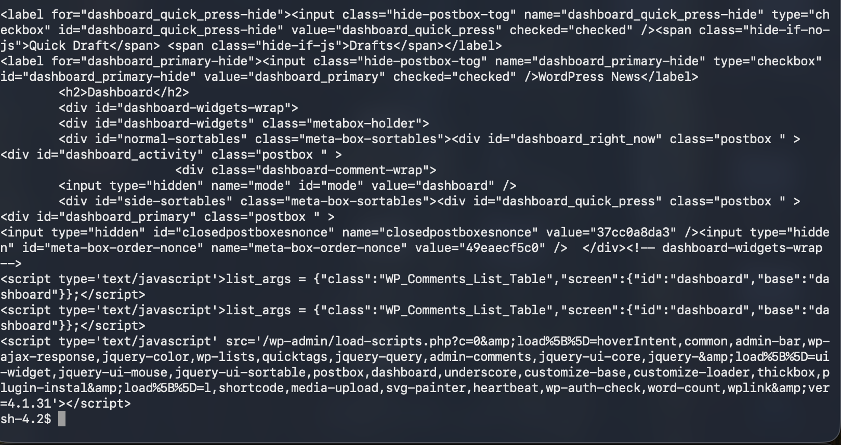
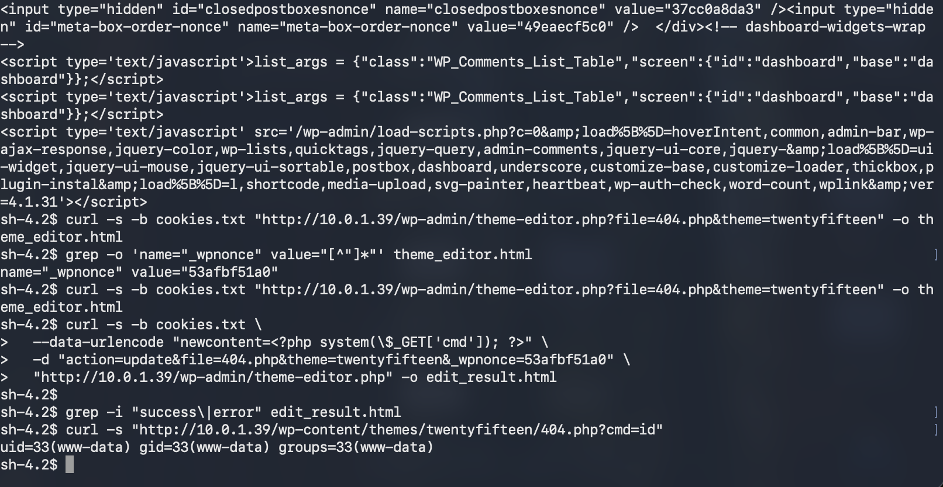
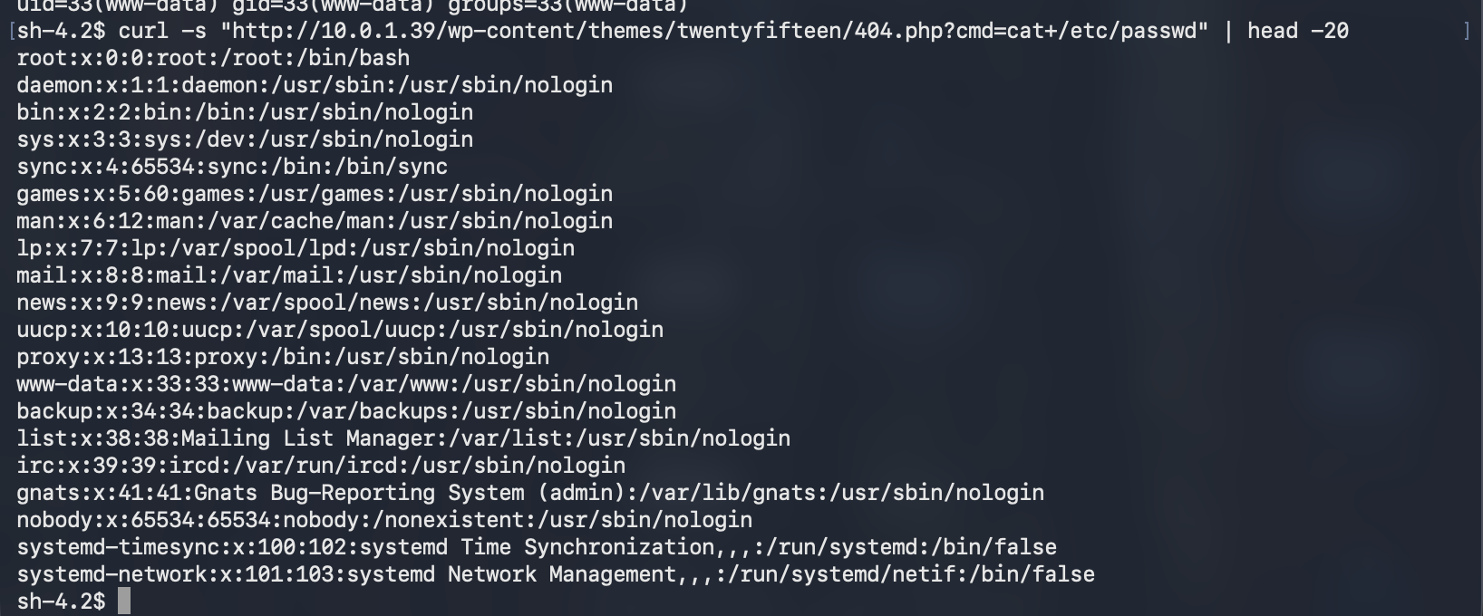

Figure of Exploit A (Self-developed)
The initial attack was made against the compromised application, which was the WordPress app, which was on the operational Coldd-Box virtual machine since the planned VM-2 could not be used because boot failures related to import were documented. The exploitation could only be possible when the public web application was successfully enumerated and a valid administrative user account found. Using a reconnaissance I found the WordPress author page, it showed the username c0ldd, which testing the password revealed was the valid administrative credential. After authenticated access to the WordPress dashboard, a built-in Theme Editor was used to modify an authorized theme file and place a small PHP command-execution script. By using a valid administrative function instead of a memory corruption bug or a weaponised payload, remote code execution can be demonstrated. The activities performed at a high level were web enumeration, authenticated login, theme change, and command execution validation.
Successful execution indicated that random OS commands can be input from the webserver, thus compromising the application layer [41]. The activity demonstrates the weaknesses in the handling of web applications that get used to affect an initial compromise of the system. The activity maps to ATT&CK T1190 (Exploit Public-Facing Application), T1059.004 and T1505.003 (Web Shell).

5.2 Exploit B: Privilege escalation or lateral movement inside the Windows domain
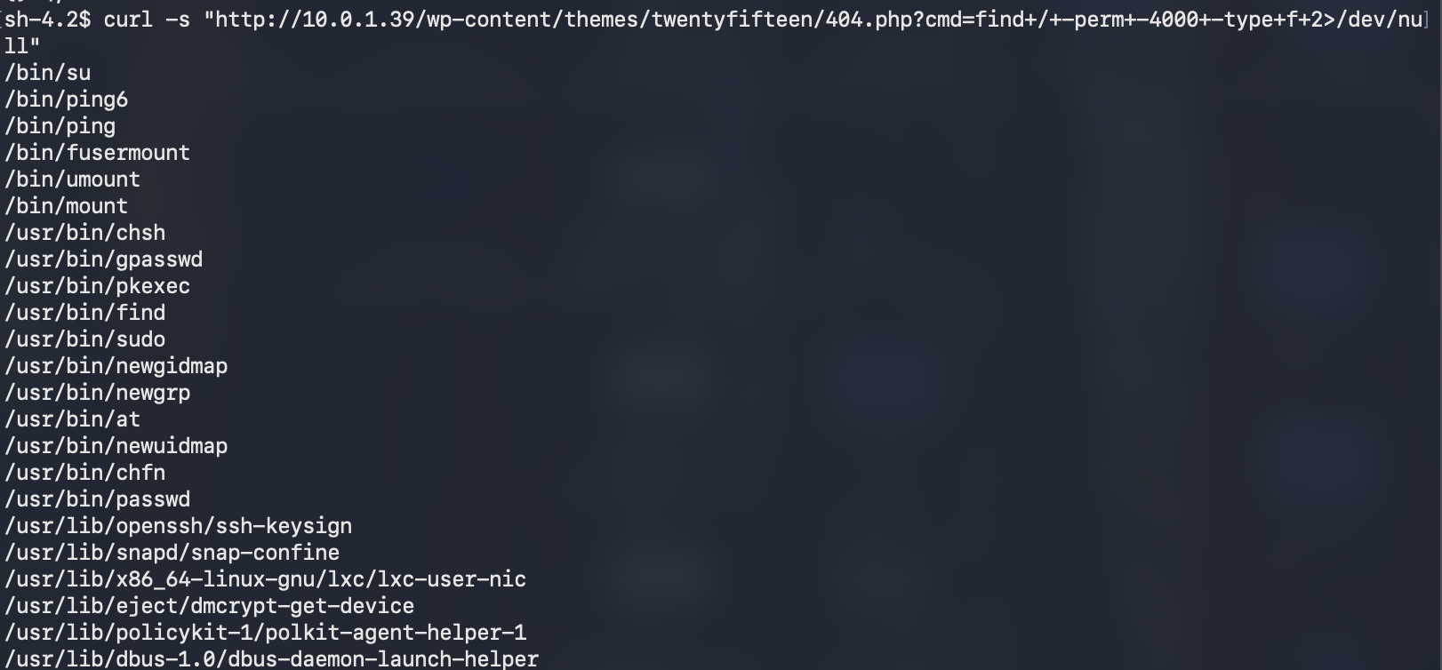
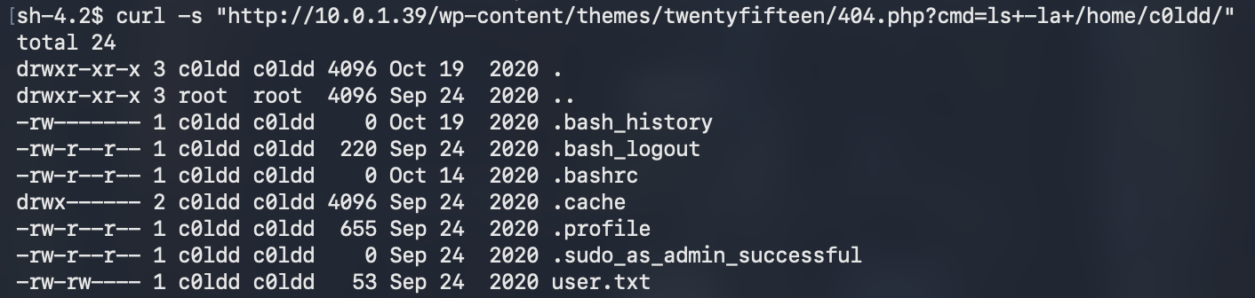
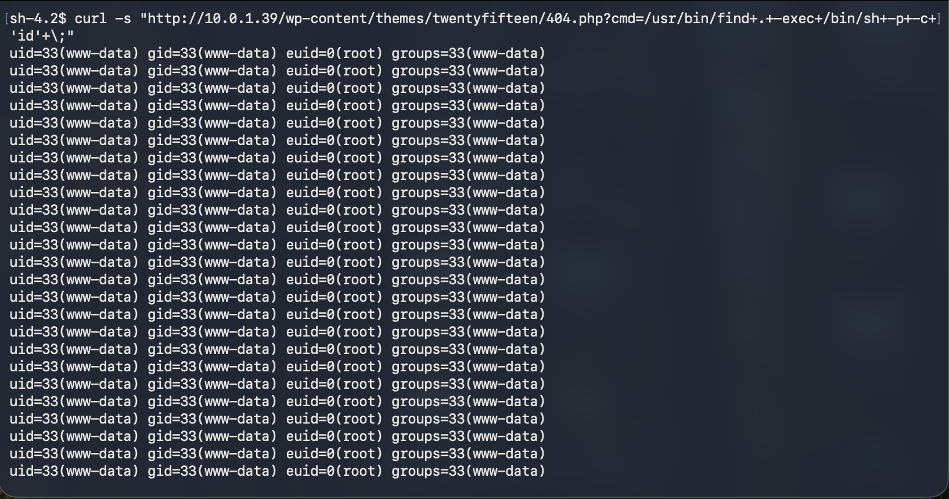
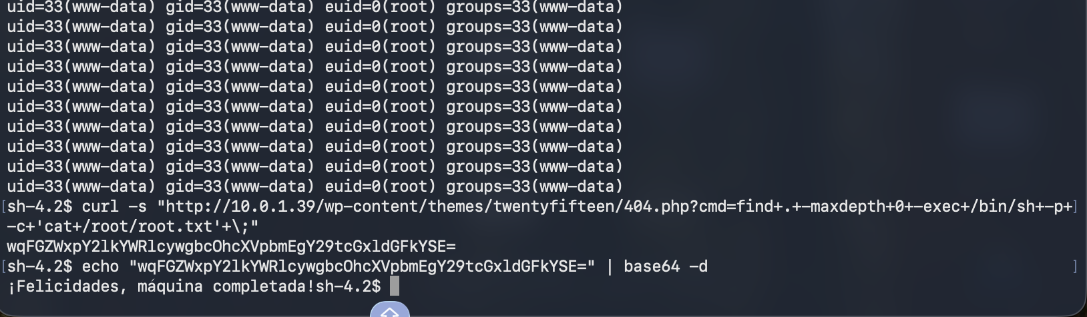

Figure of Exploit B (Self-developed)

The exploit 2 shows the privilege escalation after getting a low-privileged shell at an initial breach. The initial design of the engagement foresaw a privilege escalation scenario targeting a Windows Active Directory environment. However, the limitations of the documented infrastructure meant execution on the live Coldd-Box Linux system. After the exploitation, enumeration determined the /usr/bin/find binary has the wrong SUID root permission. It is a local privilege escalation.
Successful implementation of not available normal user highlights the exploitation which lead to indigate the protected root flag [42]. The terminal screenshots command outputs highlight its primary forensic artefacts indigate the exploitation process relied heavily on this factor [43].
Addressing
- MITRE ATT&CK T1548.001
- T1068 (Exploitation for Privilege Escalation)

5.3 Exploit C: Client-side or service-side exploit to access sensitive files on VM-3.
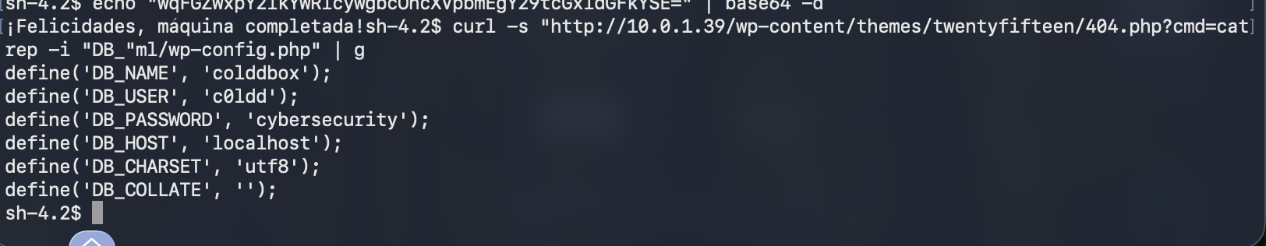

Figure of Exploit C (Self-developed)
Due to the planned file server virtual machine failing during AWS import phase, the engagement repurposed to look at service-side credential disclosure attacks against the operational Coldd-Box system. After privilege escalation, authorized post-exploitation activity involved reviewing WordPress config files (wp-config.php). Checking its contents through an authorised shell which highlight configuration files taking a note of the exposed credentials highlights the actions taken at high levels [44]. Moreover, the application data or db record was not changed or altered. The artifacts show terminal output confirming the file access, as well as screenshots showing the username and password of the database. The compromised host notwithstanding, it was shown that application credentials can practically be extracted from it and pose the same threat as business email compromise. There was no damage-causing activity or unauthorized database alteration that violated the Rules of Engagement. The vulnerability is associated with MITRE ATT&CK T1552.001 (Credentials in Files) and T1005 (Data from Local System). This shows how insecure configuration management can expose critical credentials to enable the subsequent compromise of enterprise services.

6. Tools & Techniques

AWS EC2
The cloud environment provided a secure network segmentation and controlled routing along with speedily deploying VMs. The use of real infrastructure closely resembles enterprise cloud environments while ensuring containment of the tests within a sanctioned infrastructure.

Linux
The Red Team attack platform was Kali Linux which provides a comprehensive suite of tools for penetration testing and forensics. The entire engagement utilized this for reconnaissance, vulnerability assessment, exploitation and post-exploitation. The use of genuine software was necessary since it is essentially the industry-standard OS for authorized offensive security assessments.
By using trusted Linux tools like find, cat, id, whoami, ls, and pwd instead of external malware, LOLBin Techniques can be executed. Employing binaries from the native operating system minimized the area of attack, mixed the malicious activity with administrative behaviour, and revealed that adversaries can utilize the built-in functionality of the operating system. This helps in evading security monitoring.

Nmap
Nmap was used to determine active hosts, discover open ports, identify running services, and characterize an operating system.

Gobuster
We used Gobuster to enumerate the hidden folders, admin pages, and web resources of the application. The process of directory discovery revealed potential attacks which were not normally accessible. The use of actual software is important because content enumeration is critical during the reconnaissance stage of web apps.

WordPress
To enumerate users and discover the WordPress version as well as identify installed themes and plugins, we used WPScan. The tool additionally supported user enumeration in reconnaissance. Real software was chosen as it specializes in WordPress Security Assessments and offers accurate Vulnerability Intelligence to conduct authorized testing.

Linux Bash Shell
The Linux Bash shell allowed for post-exploitation access and helped in the enumeration of the systems, privilege verification, review of the configuration, and collection of evidence. Only after authorized compromise of the system, administrative commands were executed. The actual characteristics of operating systems were utilized since Bash is the Linux operating system’s standard command-line environment for system administration and security assessments.

GTFO-Bins
GTFO-Bins was referenced to verify proper privilege escalation opportunities related to misconfigured Linux binaries as a well-known defensive and educational resource. It served as a reference resource rather than an exploitation tool. This ensured safe verification of the find binary with SUID identified during post exploit analysis.

7. Operational Execution
The Red Team operation was conducted in a reserved AWS VPC so that offensive activity was contained within the permitted laboratory domain. This operation followed a phase-wise methodology. First, the reconnaissance phase where Nmap was used to identify all the live hosts and exposed services. Then, WPScan was used to enumerate the WordPress installations and find valid user accounts. Following a successful authentication to the WordPress administrative interface the controlled modification of a theme file allowed remote command execution and provided an initial shell on the target system. Using native Linux utilities to enumerate the OS in the following post exploitation activities showed the presence of an insecure SUID-enabled find binary, which led to successful privilege escalation to the root account.
The wp-config.php configuration file contained sensitive application credentials which indicated controlled access to protected organisational data. During the engagement, I took steps to not raise any alarms by masking the intensity of scans and not using any destructive payloads. The engagement made use of techniques of Living-Off-the-Land, which essentially means making use of trusted operating system utilities, instead of external malware or persistent C2 [45]. Evidence for each phase of the attack was present in the terminal logs, screenshots of the WordPress administration, outputs of the privilege verification, capture of the root flag, and the screenshots of credential disclosure.

8. Containment & Safety
The AWS Virtual Private Cloud (VPC) is used for security testing purposes across the lab environment. However, the Vuln Hub virtual machines highlight the private network segments to live production systems. Ensuring that exploitation would remain in the environment across the Security Groups and NACLs (Network Access Control Lists) to enter and exit the controlled environment [46].
Amazon Machine Image (AMI) backups indicating the EBS volume snapshots to commencement of intrusive testing on virtual machines [47]. AWS networking configuration successful restoration of the laboratory led to highlight by architecture diagrams, which is the evidence for isolation.

References
1. Gómez Hernández, J.A., García Teodoro, P., Magán Carrión, R. and Rodríguez Gómez, R., 2023. Crypto-ransomware: A revision of the state of the art, advances and challenges. Electronics, 12(21), p.4494. https://www.mdpi.com/2079-9292/12/21/4494
2. Up Guard (2026) Biggest Data Breaches in the UK (Updated July 2026) Available form: https://www.upguard.com/blog/biggest-data-breaches-uk Accessed on 06.08.2026
3. Dev, N.R., The Influence of Multi-Factor Authentication in Enhancing Cloud Application Security. https://www.researchgate.net/profile/Prabhu-Prasad/publication/398425065_The_Influence_of_Multi-Factor_Authentication_in_Enhancing_Cloud_Application_Security/links/6935bf9727359023a009d180/The-Influence-of-Multi-Factor-Authentication-in-Enhancing-Cloud-Application-Security.pdf
4. Computer Weekly (2026) Co-op declares cyber attack damage cost £206m. Available form: https://www.computerweekly.com/news/366632018/Co-op-declares-cyber-attack-damage-cost-it-206m Accessed on 06.08.2026
5. Nagar, G., 2024. The evolution of ransomware: tactics, techniques, and mitigation strategies. International Journal of Scientific Research and Management (IJSRM), 12(06), pp.1282-1298. https://www.academia.edu/download/116771362/The_Evolution_of_Ransomware_Tactics_Techniques_and_Mitigation_Strategies.pdf
6. Neupane, S.R., Shrestha, N. and Sun, W., 2026. A Qualitative Synthesis of Cyberattack Trends in Managed Service Providers: Analyzing Multi-Tenant Vulnerabilities and Mitigation Strategies. Information, 17(4), p.378. https://www.mdpi.com/2078-2489/17/4/378
7. Johansen, G., 2022. Digital Forensics and Incident Response: Incident response tools and techniques for effective cyber threat response. Packt Publishing Ltd. https://books.google.com/books?hl=en&lr=&id=1N-fEAAAQBAJ&oi=fnd&pg=PP1&dq=Immediate+incident+response+and+forensic+investigation+were+initiated+while+stores+remained+operational.&ots=WIiu1irC11&sig=pTR9c3j25SEyWB9u0RpD1rbj9xs
8. Brown, W., Johnson, O. and Wilson, G., 2024. Influence of e-commerce technologies on supply chain management in retail. https://www.preprints.org/frontend/manuscript/fc45250718788c0c4449a3f55d4179ba/download_pub
10. Aliya, H. and Nicola, H., 2024. Enhancing Corporate Resilience: A Comprehensive Disaster Recovery Plan for Ensuring Business Continuity in the Age of IoT Security. https://www.researchgate.net/profile/Henrietta-Nicola/publication/387502238_Enhancing_Corporate_Resilience_A_Comprehensive_Disaster_Recovery_Plan_for_Ensuring_Business_Continuity_in_the_Age_of_IoT_Security/links/6771140ac1b0135465feda0c/Enhancing-Corporate-Resilience-A-Comprehensive-Disaster-Recovery-Plan-for-Ensuring-Business-Continuity-in-the-Age-of-IoT-Security.pdf
11. Cerutti, F., Giacomin, M., Loreggia, A. and Scala, E., 2026. Preliminary Insights in the Language of Extortion in Ransomware Dialogues. In ITASEC/SERICS. https://ceur-ws.org/Vol-4198/paper29.pdf
12. Jabid, T., Rashid, M.R.A., Ferdaus, M.H., Ali, M.S., Islam, M.M., Hasan, M. and Islam, M., 2024. Ransomware prevention strategies: Building robust cyber defenses. Ransomware Evolution, pp.144-171. https://www.researchgate.net/profile/Md-Hasanul-Ferdaus/publication/389816989_Pre-Print_Ransomware_Prevention_Strategies_Building_Robust_Cyber_Defenses/links/67d310707d56ad0a0f01cd3c/Pre-Print-Ransomware-Prevention-Strategies-Building-Robust-Cyber-Defenses.pdf
13. Sullivan, J. and Muir, J., 2022. Ransomware: A perfect storm. Australasian Policing, 14(2), pp.11-20. https://static.rusi.org/263_ei_ransomware_final_0_0.pdf
14. Jabid, T., Rashid, M.R.A., Ferdaus, M.H., Ali, M.S., Islam, M.M., Hasan, M. and Islam, M., 2024. Ransomware prevention strategies: Building robust cyber defenses. Ransomware Evolution, pp.144-171. https://www.researchgate.net/profile/Md-Hasanul-Ferdaus/publication/389816989_Pre-Print_Ransomware_Prevention_Strategies_Building_Robust_Cyber_Defenses/links/67d310707d56ad0a0f01cd3c/Pre-Print-Ransomware-Prevention-Strategies-Building-Robust-Cyber-Defenses.pdf
15. Aslan, Ö., Aktuğ, S.S., Ozkan-Okay, M., Yilmaz, A.A. and Akin, E., 2023. A comprehensive review of cyber security vulnerabilities, threats, attacks, and solutions. Electronics, 12(6), p.1333. https://www.mdpi.com/2079-9292/12/6/1333
16. Attaluri, V., 2022. Securing SSH access to EC2 instances with Privileged Access Management (PAM). Multidisciplinary international journal, 8, pp.252-260. https://www.themijournal.com/admin1/upload/28%20Vivekchowdary%20Attaluri%2001360.pdf
17. Blyth, A., 2024. PowerShell for Penetration Testing: Explore the capabilities of PowerShell for pentesters across multiple platforms. Packt Publishing Ltd. https://books.google.com/books?hl=en&lr=&id=XS8FEQAAQBAJ&oi=fnd&pg=PP1&dq=PowerShell+execution,+and+lateral+movement+are+all+commonplace+in+modern+cybercriminal+groups.+Various+reasons+lend+support+to+the+Scattered+Spider+attribution&ots=K8_IrV6jDZ&sig=FEpmHuFkHgjrH9gf9T2IAUGqgVI
18. Forshaw, J., 2024. Windows Security Internals: A Deep Dive into Windows Authentication, Authorization, and Auditing. No Starch Press. https://books.google.com/books?hl=en&lr=&id=RfLNEAAAQBAJ&oi=fnd&pg=PR19&dq=Security+configurations+are+Windows+Defender+Firewall,+group+policy+objects+(GPO),+Kerberos+authentication,+and+event+logging&ots=R4H5ee7BWd&sig=IuPhRGQdIyDcIk_0DienshqwB30
19. Singh, T., 2023. Cyber Security and Human Factors: Keeping Information Safe. Tarnveer Singh. https://books.google.com/books?hl=en&lr=&id=LT1AEQAAQBAJ&oi=fnd&pg=PA1&dq=Human+Factors+error+played+a+pivotal+role+in+both+cases+used+vishing+to+impersonate+legitimate+employees+and+manipulate+IT+helpdesk+personnel+to+reset+credentials&ots=tFQRhir25l&sig=OC399MaioN4xCoOZ0K6j9yGNfN0
20. Al Barwani, M.A.S., State-Sponsored Cyber-Attacks: Threats, Strategies, and Global Responses. https://www.researchgate.net/profile/Marya-Al-Barwani/publication/403702028_State-Sponsored_Cyber-Attacks_Threats_Strategies_and_Global_Responses/links/69d8fd925518257d60e96a92/State-Sponsored-Cyber-Attacks-Threats-Strategies-and-Global-Responses.pdf
21. Patsakis, C., Arroyo, D. and Casino, F., 2024. The malware as a service ecosystem. In Malware: Handbook of prevention and detection (pp. 371-394). Cham: Springer Nature Switzerland. https://arxiv.org/pdf/2405.04109
22. Malik, M.I., Ibrahim, A., Hannay, P. and Sikos, L.F., 2023. Developing resilient cyber-physical systems: a review of state-of-the-art malware detection approaches, gaps, and future directions. Computers, 12(4), p.79. https://www.mdpi.com/2073-431X/12/4/79
23. Mailewa, A. and Rozendaal, K., 2022. A Novel Method for Moving Laterally and Discovering Malicious Lateral Movements in Windows Operating Systems: A Case Study. Advances in Technology, pp.291-321. https://journals.sjp.ac.lk/index.php/ait/article/download/5584/4462
24. Dev, N.R., The Influence of Multi-Factor Authentication in Enhancing Cloud Application Security. https://www.researchgate.net/profile/Prabhu-Prasad/publication/398425065_The_Influence_of_Multi-Factor_Authentication_in_Enhancing_Cloud_Application_Security/links/6935bf9727359023a009d180/The-Influence-of-Multi-Factor-Authentication-in-Enhancing-Cloud-Application-Security.pdf
25. Ghadge, N., 2024. Enhancing identity management: Best practices for governance and administration. Available at SSRN 4877656. https://papers.ssrn.com/sol3/Delivery.cfm?abstractid=4877656
26. Areo, G., 2024. From Policy to Practice: Public–Private Partnerships as Catalysts in National Cybersecurity Strategies [online] https://www.authorea.com/doi/pdf/10.22541/au.176340972.25169415
27. Aslam, N. and Steltzer, H., 2025. Cybersecurity and network security: Strengthening defenses against emerging threats. Preprint]. ResearchGate. https://doi. org/10.13140/RG, 2(16350.96321). https://www.researchgate.net/profile/Heinz-Steltzer-2/publication/388848103_Cybersecurity_and_Network_Security_Strengthening_Defenses_Against_Emerging_Threats/links/67aa1c6d645ef274a479b09e/Cybersecurity-and-Network-Security-Strengthening-Defenses-Against-Emerging-Threats.pdf
28. Sania, N.S., Gigras, Y. and Mahajan, S., 2024. Gatividhi Guard: The Activity Guardian—Revolutionizing Security Information and Event Management (SIEM) Technology. Journal of Operating Systems Development & Trends, 11(1), pp.29-44p. https://research-reels.com/wp-content/uploads/2024/07/175d7718-29-44-gatividhi-guard_the-activity-guardian_revolutionizing-siem-technology.pdf
29. Ismail, Kurnia, R., Brata, Z.A., Nelistiani, G.A., Heo, S., Kim, H. and Kim, H., 2025. Toward robust security orchestration and automated response in security operations centers with a hyper-automation approach using agentic artificial intelligence. Information, 16(5), p.365. https://www.mdpi.com/2078-2489/16/5/365
30. Harrison, B., Dimarogonas, J., Catlin, J., Donohue, R.H., Goughnour, T., Hollywood, J.S., Mastbaum, J., Van Abel, K. and Balagna, J., 2022. BROADBAND COMMUNICATIONS PRIORITIZATION AND INTEROPERABILITY GUIDANCE FOR LAW ENFORCEMENT... NIELSEN BOOKDATA. https://read-me.org/s/BROADBAND-POLICING.pdf
31. Shah, Z., Ullah, I., Li, H., Levula, A. and Khurshid, K., 2022. Blockchain based solutions to mitigate distributed denial of service (DDoS) attacks in the Internet of Things (IoT): A survey. Sensors, 22(3), p.1094. https://www.mdpi.com/1424-8220/22/3/1094
32. Li, T., 2024. Improving Factory Acceptance Testing Process for Superior Customer Experience. https://www.theseus.fi/bitstream/handle/10024/877884/Li_Tianxin.pdf?sequence=2
33. Hattenhauer, R., 2024. ChatGPT & Co.: a workbook for writing, research, creating images, programming, and more. CRC Press. https://books.google.com/books?hl=en&lr=&id=xL4XEQAAQBAJ&oi=fnd&pg=PP12&dq=Routine+progress+updates+should+be+communicated+using+Microsoft+Teams+and+corporate+email+(Microsoft+Outlook),+while+urgently+emerging+critical+incidents+should+be+called-up+immediately+using+a+telephone+and+Microsoft+Teams+voice+call&ots=NW3PCdoPbR&sig=YnGGqlR05VmZgGqwML2SwF0FNro
34. Hon, W.K., 2024. Technology and security for lawyers and other professionals: The basics and beyond. Edward Elgar Publishing. https://books.google.com/books?hl=en&lr=&id=3QMOEQAAQBAJ&oi=fnd&pg=PR11&dq=the+Computer+Misuse+Act+1990,+the+Data+Protection+Act+2018,+the+UK+GDPR+and+the+NCSC+Cyber+Assessment+Framework+(CAF)&ots=znp_y85pnP&sig=I6x65PaYa6tAna_14HoehHT003A
35. Panigrahi, P.C.J.S.K. and Mishra, J.K., ETHICAL HACKING: SKILLS TO FIGHT CYBER SECURITY. https://www.journal-dogorangsang.in/no_1_may-august_20/62.pdf
36. Boyraz, G., 2024. Endpoint Detection and Response Essentials: Explore the landscape of hacking, defense, and deployment in EDR. Packt Publishing Ltd. https://books.google.com/books?hl=en&lr=&id=fy8FEQAAQBAJ&oi=fnd&pg=PP1&dq=Unrestricted+lateral+movement+occurred+due+to+limited+network+segmentation+and+insufficient+endpoint+detection+and+response+EDR+coverage+and+privilege+access+management&ots=ESqT3a6GXB&sig=mEprfMrItWq4pKdqDhgfTIHi0O8
37. Ailabouni, F., Román-Gallego, J.Á. and Pérez-Delgado, M.L., 2025. FG-RCA: Kernel-Anchored Post-Exploitation Containment for IoT with Policy Synthesis and Mitigation of Zero-Day Attacks. IoT, 7(1), p.3. https://www.mdpi.com/2624-831X/7/1/3
38. Gudepu, B.K. and Jaladi, D.S., 2022. Data discovery and security: Protecting sensitive information. International Journal of Acta Informatica, 1(1), pp.176-187. http://yuktabpublisher.com/index.php/IJAI/article/download/265/253
39. CNBC (2025) M&S cyberattack to wipe out nearly one-third of annual profits. Available form: https://www.cnbc.com/2025/05/21/ms-cyberattack-to-wipe-out-nearly-one-third-of-annual-profits.html Accessed on 06.08.2026
40. Forshaw, J., 2024. Windows Security Internals: A Deep Dive into Windows Authentication, Authorization, and Auditing. No Starch Press. https://books.google.com/books?hl=en&lr=&id=RfLNEAAAQBAJ&oi=fnd&pg=PR19&dq=+locating+the+configuration+file,+checking+its+contents+through+an+authorised+shell,+and+taking+a+note+of+the+exposed+credentials&ots=R4H5f5_uW8&sig=HHeooU2KDjZFZB-XjSuOiU3ydvk
41. Kaushik, K., Ouaissa, M. and Chaudhary, A. eds., 2024. Advanced techniques and applications of cybersecurity and forensics. CRC Press. https://books.google.com/books?hl=en&lr=&id=1N-fEAAAQBAJ&oi=fnd&pg=PP1&dq=The+documentation+of+all+attack+phases+must+include+terminal+outputs,+screenshots,+and+forensic+artefacts+and+is+conducted+within+the+agreed+Rules+of+Engagement&ots=WIiu1itC72&sig=T5XsdypZEJNzL4ZGB55mCNQG40k
42. Kavadias, N., 2024. Silent Intruders: Understanding Living-off-the-Land Techniques, Threats, Countermeasures and Emerging Solutions. Charles Sturt University. https://blog.kavadias.net/assets/pdf/lotl_paper_nkavadias.pdf
43. Kesavan, B., 2024. Mastering Amazon EC2: Unravel the complexities of EC2 to build robust and resilient applications. Packt Publishing Ltd. https://books.google.com/books?hl=en&lr=&id=A0ACEQAAQBAJ&oi=fnd&pg=PP1&dq=Amazon+Machine+Image+(AMI)+backups+and+EBS+volume+snapshots+were+created+as+a+recovery+point&ots=0dbBAsZLiZ&sig=wIzwWV_WYyjZiMGDhcINXoxsu4U
44. Mailewa, A. and Rozendaal, K., 2022. A Novel Method for Moving Laterally and Discovering Malicious Lateral Movements in Windows Operating Systems: A Case Study. Advances in Technology, pp.291-321. https://journals.sjp.ac.lk/index.php/ait/article/download/5584/4462
45. Mathieu, L., 2024. Mastering AWS Security: Strengthen your cloud environment using AWS security features coupled with proven strategies. Packt Publishing Ltd. https://books.google.com/books?hl=en&lr=&id=pxn-EAAAQBAJ&oi=fnd&pg=PP1&dq=The+Security+Groups+and+NACLs+(Network+Access+Control+Lists)+permitted+only+approved+management+services+to+enter+and+exit+the+controlled+environment,+ensuring+that+exploitation+would+remain+in+the+environment&ots=Zcv7O-vFeO&sig=gaK1vmgSjBvcpjCLSKbHEDFwRAU
46. Moallim, M., Lee, S., Alzahrani, I., Alfouzan, F.A. and Kim, K., 2026. AI-Amplification Indicator: An Actor-Level Scoring Framework for Ransomware Operations on the Dark Web. Journal of Cybersecurity and Privacy, 6(2), p.70. https://www.mdpi.com/2624-800X/6/2/70
47. NCC group (2026) Emergency Cyber Incident Response, Global threat expertise—on your side. Available form: https://www.nccgroup.com/cyber-incident-response/?utm_source=google&utm_medium=cpc&utm_campaign=18085215780&utm_content=141187309198&utm_term=cyber%20incident%20response&keyword=cyber%20incident%20response&adposition=&matchtype=b&sitelink=[name]&campaignid=18085215780&adgroupid=141187309198&adid=617140904373&gad_source=1&gad_campaignid=18085215780&gbraid=0AAAAADlK55VI5dfK0wJe-A5_c-PgGOwCG&gclid=CjwKCAjwvsvTBhBaEiwAmf-3noD8Ilqh5pIqGkeXqRNVkCICQuTDXwNHcEwKv8SiZi5SnQn7gAcj5RoCx54QAvD_BwE Accessed on 06.08.2026

Appendices

Appendix A: Linking Exploitation to Failed Security Controls
Observed Exploitation | Security Control That Failed
Voice phishing (vishing) against IT helpdesk | NIST SP 800-63B – Identity Verification; ISO 27001 Annex A 6.3 – Security Awareness
Password and MFA reset abuse | NIST SP 800-53 IA-2 – Identification and Authentication
Valid account abuse | NIST SP 800-53 AC-6 – Least Privilege
Lateral movement across enterprise systems | NIST SP 800-53 SC-7 – Network Segmentation; Zero Trust (NIST SP 800-207)
Delayed detection of attacker activity | ISO 27001 Annex A 8.15 & 8.16 – Logging and Monitoring; NIST SP 800-53 SI-4 – System Monitoring
Data exfiltration and ransomware deployment | NIST CSF 2.0 Detect & Respond Functions; CIS Controls v8 (Controls 13 & 17)

Appendix B: Prioritised Strategic Recommendations
Recommendation | Framework/Control | Estimated Effort | Estimated Cost | Expected Risk Reduction
Phishing-resistant MFA (FIDO2/Passkeys) | NCSC, NIST SP 800-63B | Medium | Medium | Very High
Zero Trust & Network Segmentation | NIST SP 800-207 | High | High | Very High
Privileged Access Management (PAM) | NIST SP 800-53 AC-6 | Medium | Medium | High
SIEM + XDR + UEBA | MITRE ATT&CK, NIST CSF 2.0 | Medium | Medium–High | High
Centralised Logging (Sysmon, AD, VPN, PowerShell) | ISO/IEC 27001:2022 Annex A 8.15 & 8.16 | Medium | Medium | High
Incident Response Testing & SOAR | NIST SP 800-61, ISO/IEC 27035 | Medium | Medium | High
Third-Party Security Assurance | ISO/IEC 27001 Annex A 5.19 | Medium | Low–Medium | High
Security Awareness & Helpdesk Verification | CIS Control 14, NCSC Guidance | Low | Low | Medium–High

Appendix C: Tools Used
Tool | Purpose
AWS EC2 / AWS VPC | Hosted the isolated penetration testing laboratory
Kali Linux | Red Team attacker operating system
Nmap | Network discovery, host identification, and service enumeration
Gobuster | Directory and web content enumeration
WPScan | WordPress vulnerability and user enumeration
Burp Suite Community Edition (if shown in your results; otherwise omit) | Web application request inspection and analysis
Firefox / Web Browser | Accessing and interacting with the target web application
WordPress Admin Dashboard | Administrative access and controlled theme modification
Linux Bash Shell | Post-exploitation command execution
GTFOBins Reference | Identification of SUID privilege escalation technique using the find binary
Linux Built-in Commands (find, cat, id, whoami, ls, pwd) | Local enumeration, privilege verification, and evidence collection
Screenshot / Terminal Logging | Evidence collection and reporting

Appendix D: Real vs Simulated Tools
Tool | Type | Justification
AWS EC2 / VPC | Real | Hosted the isolated cloud laboratory
Kali Linux | Real | Industry-standard penetration testing platform
Nmap | Real | Network reconnaissance and service discovery
Gobuster | Real | Web content enumeration
WPScan | Real | WordPress vulnerability assessment
Burp Suite CE (if used) | Real | Web request inspection
Firefox | Real | Browser interaction with target application
WordPress Admin | Real | Legitimate application administration interface
Bash Shell | Real | Native Linux command execution
GTFO-Bins | Reference | Educational privilege escalation knowledge base
Linux Commands | Real (LOLBin) | Trusted operating system utilities

Appendix E: Result Screen Short
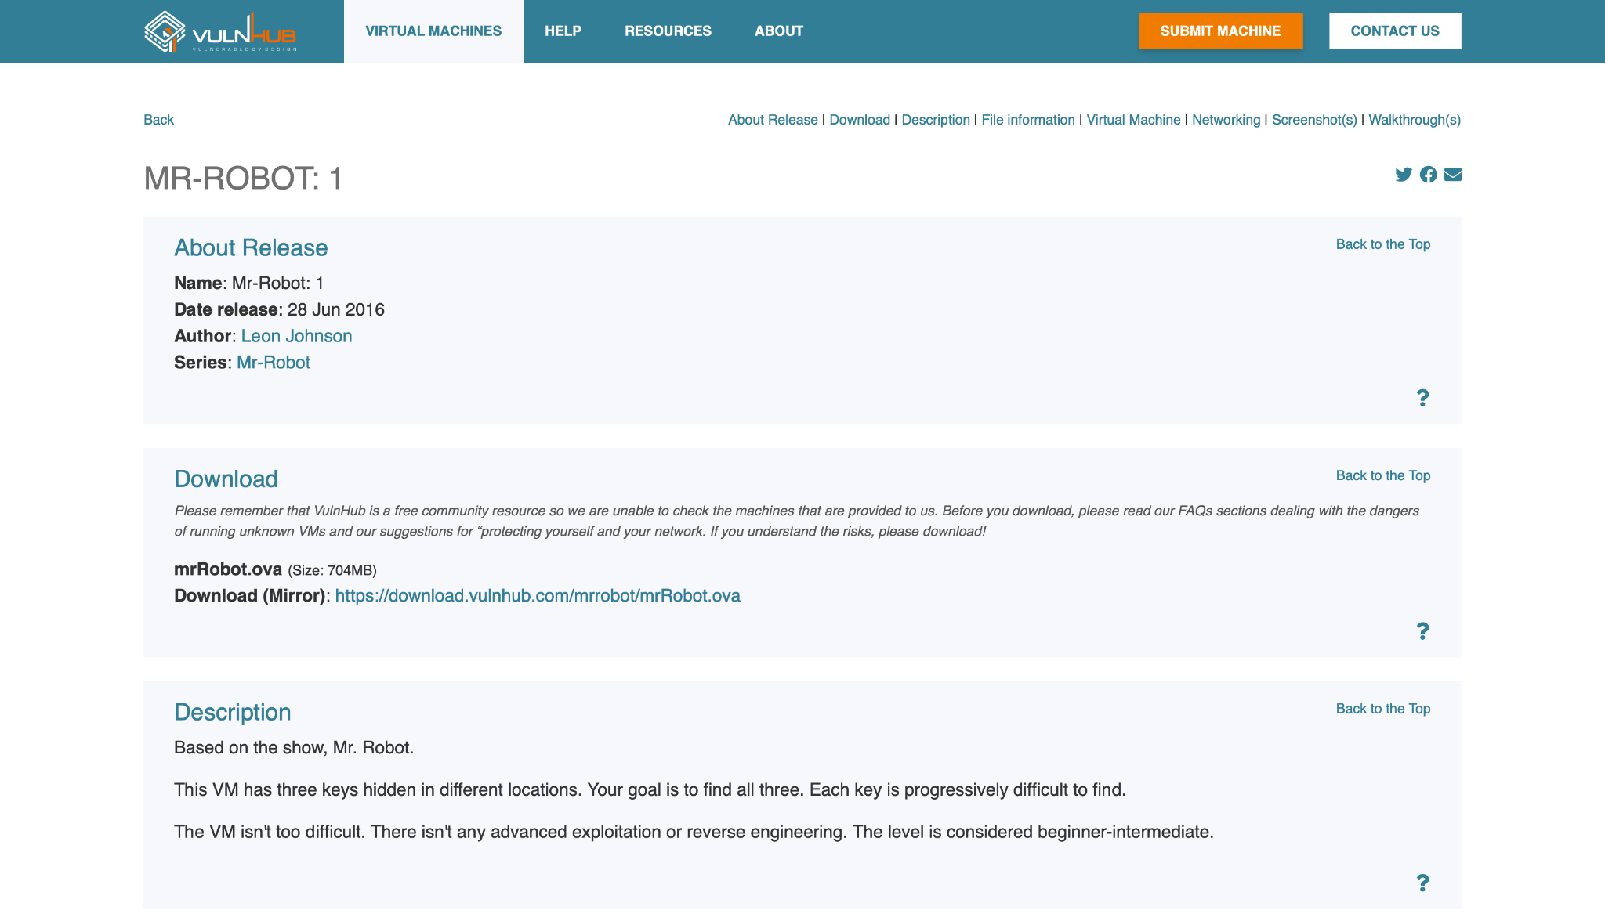
https://download.vulnhub.com/colddbox/ColddBoxEasy_EN.ova
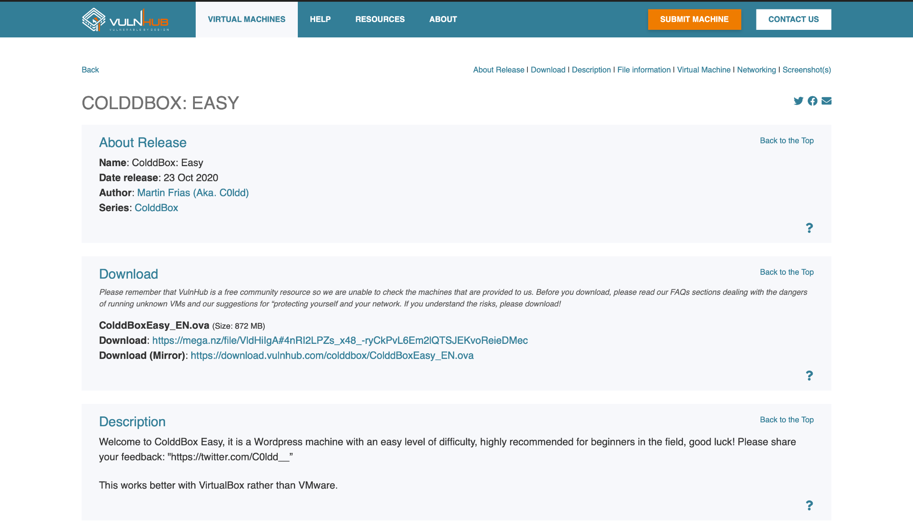
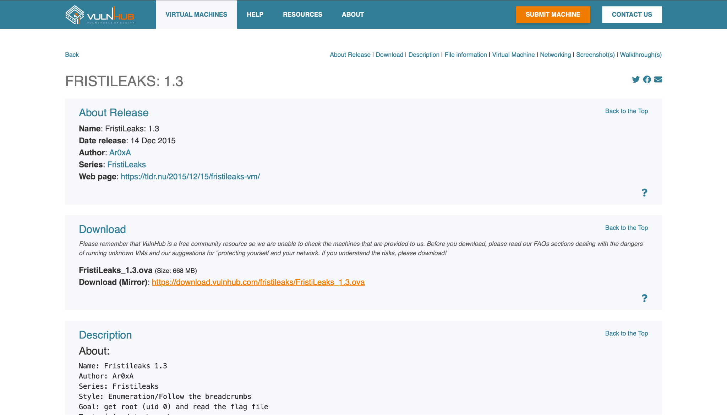
https://www.vulnhub.com/entry/fristileaks-13,133/



