Name:____________Vivien Tam_____________________

Student Number: _______2505794_________________
__________________________________________________________

WORKSHEET 1 – TESTING (Using Variables)

- Original code:
[Copy and paste your original code from Moodle into this box. Do not change it.]

Surname = str(input("Please enter your surname "))

NI = str(input("Please enter your national insurance number "))

flag = 0
while flag == 0:
try:
Age = int(input("Please enter your age "))
except ValueError:
print("This is not a number, try again")
else:
flag = 1

flag = 0
while flag == 0:
try:
WH= float(input("Please enter your number of working hours per week "))
except ValueError:
print("This is not a number, try again")
else:
flag = 1

- Code Testing

For each test below, run your code and enter the values provided. Present a screenshot of the programme running. Did the programme behave correctly or did it do something unexpected, and if so, why?

Surname:
- Enter JONES
- Leave blank
- Enter A
- Enter 123

National Insurance Number:
- Enter PE534121B
- Leave blank
- Enter AB11223344556677 (ie too long for National Insurance number format)
- Enter 22PE4088A (ie wrong format)

Age
- Enter 34
- Enter 150
- Enter -4
- Enter a letter

Number of working hours per week:
- Enter 37.5
- Enter 150
- Enter 0
- Enter -2

Fill in a box for each test above. You should present 16 separate boxes, 1 for each test. (Note: the first two boxes are provided as a template)

Test:
Surname i. Enter JONES

Screenshot(s) of output:
Result: Did the programme behave as expected ie syntactically and logically correct?
YES
If YES, comment on what happened:
The program worked fine and no error has come up

Test:
Surname ii Leave blank

Screenshot(s) of output:
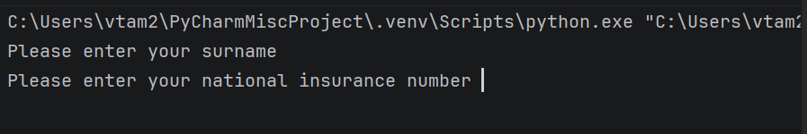
Result: Did the programme behave as expected ie syntactically and logically correct?
NO (delete as appropriate)
If NO, what went wrong?
No error came up when user left it blank

Continue the rest of the tests below. (Copy and paste a box for each one)

Test:

Screenshot(s) of output:
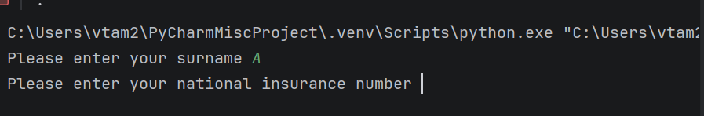
Result: Did the programme behave as expected ie syntactically and logically correct?
NO (delete as appropriate)
If NO, what went wrong?
The answer “A” was accepted but no name should be with just 1 letter

Test:

Screenshot(s) of output:
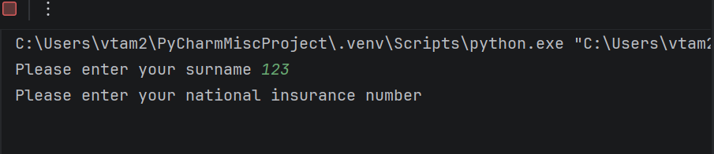
Result: Did the programme behave as expected ie syntactically and logically correct?
NO (delete as appropriate)
If NO, what went wrong?
Name should not have consist of numbers

Test:

Screenshot(s) of output:
Result: Did the programme behave as expected ie syntactically and logically correct?
YES(delete as appropriate)
If YES, comment on what happened

Test:

Screenshot(s) of output:
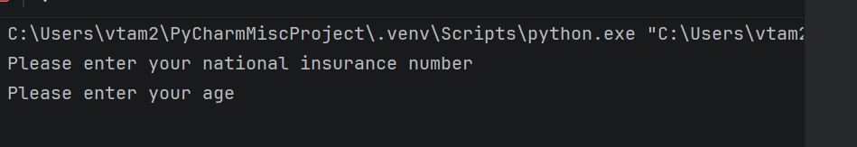
Result: Did the programme behave as expected ie syntactically and logically correct?
YES (delete as appropriate)
If YES, comment on what happened

The program worked fine and no error has come up

Test:

Screenshot(s) of output:
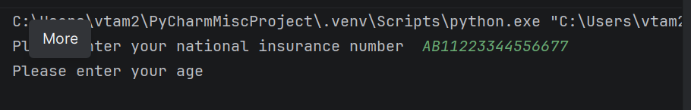
Result: Did the programme behave as expected ie syntactically and logically correct?
NO (delete as appropriate)
If NO, what went wrong?
The format/input value was too wrong and there was no error came up

Test:

Screenshot(s) of output:
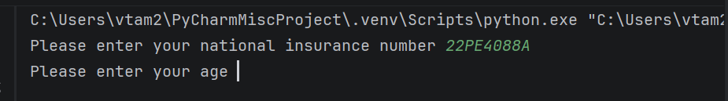
Result: Did the programme behave as expected ie syntactically and logically correct?
NO (delete as appropriate)
If NO, what went wrong?
The format was incorrect and there was no error came up

Test:

Screenshot(s) of output:
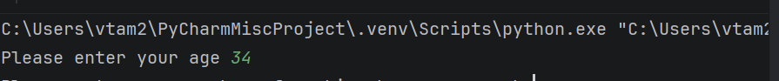
Result: Did the programme behave as expected ie syntactically and logically correct?
YES (delete as appropriate)
If YES, comment on what happened
The program worked fine and no error has come up

Test:

Screenshot(s) of output:
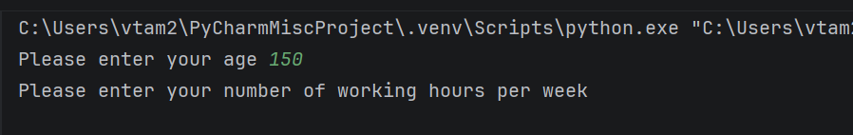
Result: Did the programme behave as expected ie syntactically and logically correct?
YES (delete as appropriate)
If YES, comment on what happened
The program worked fine and no error has come up

Test:

Screenshot(s) of output:
Result: Did the programme behave as expected ie syntactically and logically correct?
NO (delete as appropriate)
If NO, what went wrong?
There should not be negative number for age

Test:

Screenshot(s) of output:
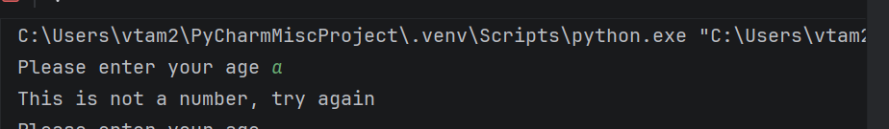
Result: Did the programme behave as expected ie syntactically and logically correct?
YES
If YES, comment on what happened
When a number is being input there is the error came up to advise user it is not a number

Test:

Screenshot(s) of output:
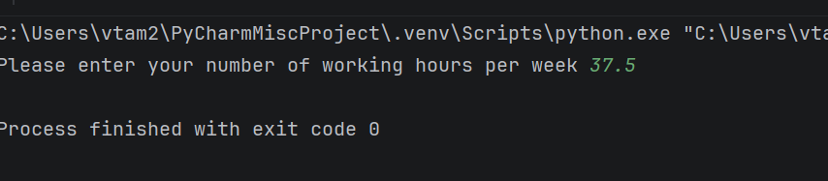
Result: Did the programme behave as expected ie syntactically and logically correct?
YES(delete as appropriate)
If YES, comment on what happened
The program worked fine and no error has come up

Test:

Screenshot(s) of output:
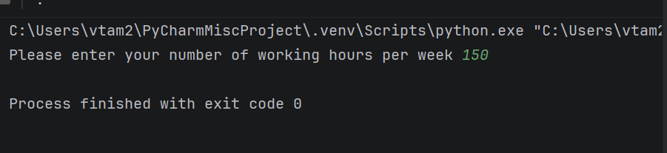
Result: Did the programme behave as expected ie syntactically and logically correct?
NO
If NO, what went wrong?
Technically 150 working hours is a correct output as there is over 150 hours in a week, logically it will be impossible as you could not work for over 21 hours per day for 7 days.

Test:

Screenshot(s) of output:
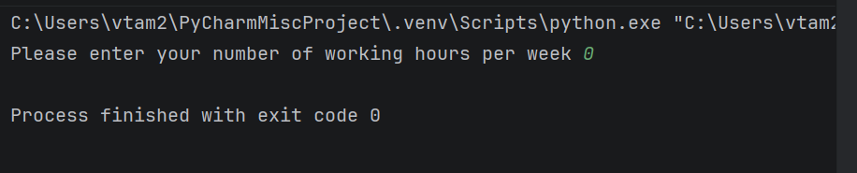
Result: Did the programme behave as expected ie syntactically and logically correct?
YES (delete as appropriate)
If YES, comment on what happened
The program worked fine and no error has come up

Test:

Screenshot(s) of output:
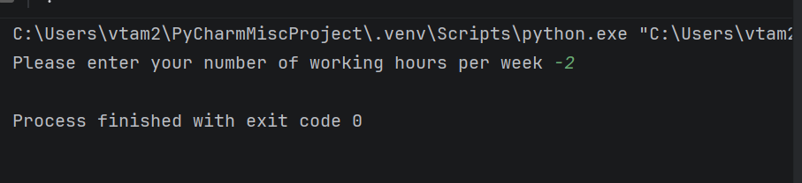
Result: Did the programme behave as expected ie syntactically and logically correct?
NO (delete as appropriate)
If NO, what went wrong?
There should not be negative hours

- Consider the results of the above tests and revisit your code in order to solve the problems. (Note: you may not be able to solve all of them, but solve as many as you can.)

Paste your revised code here:

[Copy and paste your revised code here – note, do not use a screenshot]
def is_invalid_name(name):
if name.isdigit() or name.startswith('-'):
print("Name must not contain numbers")
return True
if name == "":
print("Your name must not be empty")
return True
return False
flag = 0
while flag == 0:
try:
surname = str(input("Please enter your surname "))
if is_invalid_name(surname):
continue
except ValueError:
print("This is not a name, try again")
else:
flag = 1
def is_invalid_ni(insurance):
if len(insurance) != 9:
print("National Insurance must have 9 digits")
return True
if ni[0].isdigit() or ni[1].isdigit():
print("National Insurance Number must starts with letters")
return True
return False
flag = 0
while flag == 0:
try:
ni = str(input("Please enter your national insurance number "))
if is_invalid_ni(ni):
continue
except ValueError:
print("This is not a national insurance number, try again")
else:
flag = 1
def is_negative(number):
return number < 0
flag = 0
while flag == 0:
try:
age = int(input("Please enter your age "))
if is_negative(age):
print("Please enter a positive number")
continue
except ValueError:
print("This is not a number, try again")
else:
flag = 1
flag = 0
while flag == 0:
try:
WH= float(input("Please enter your number of working hours per week "))
if is_negative(WH):
print("Please enter a positive number")
continue
except ValueError:
print("This is not a number, try again")
else:
flag = 1

