FARZANA SHARMIN

Effective Team Working and Communication Skils.

TABLE OF CONTENTS:
- Introduction
- Definition of communication
- Importance of communication
- Effective communication at the workplace
- Methods of communication
- Shanon and Weaver model at workplace
- Berlor’s theory of communication
- Barriers of communication at work with team members
- How to improve communication at workplace
- Positive work relationships
- Conclusion
- Bibliography


INTRODUCTION:
Effective communication and teamwork is an essential aspect of any workplace such as nursery and preschool which is venerable practitioners. Throughout this assignment, I will be talking about a nursery’s value of communication and the effective teamwork and their importance on our daily life. A nursery is a place where children start their journey through education. Learning and correctly practice writing at a young age will form a crucial part in developing a child’s curricular.
In this assessment, I would add some HARVARD references and BERLO’S theory. I would also like to give some example from my workplace with my colleagues and other people.
This is an academically styled task and hence I will incorporate information that I have acquired from books, articles and newspapers.
DEFINITION of COMMUNICATION:
‘’Good communication skills are very important to one’s success as an administrator (Yate, 2009).’’
Communication means to collaborate with people, pass information and share ideas. Without communication, you will not be able to reach people as, throughout our lives, we need to communicate repetitively. Without the ability to communicate, you cannot share your ideas and an example would be at the workplace if you work in a school. There you need to communicate with children, teachers, parents and other pupils and you need to understand their problem and try to solve it. Sometimes SEN children do not understand with a common approach and thus you need to know how to communicate with them differently and one method could be using sign language (MAKTON) or show them pictures to break down information for them.
Communication is listening, understanding, discussing, exchanging and receiving information about others. “Communication is the transfer of information from one person to another, whether or not it elicits confidence, but the information transferred must be understandable to the receiver.”- (G.G. Brown)
IMPORTANCE OF COMMUNICATION:
Communication helps to spread knowledge and information among the people and is really important in our everyday life. It is also really important to develop relationships to others as usually there is a sender of the message and a receiver of the message. This exchange between people is labelled as communicating.
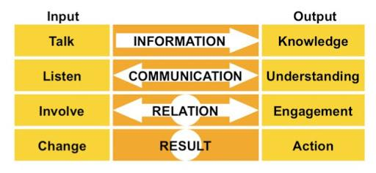
There are very different ways to communicate with people for example via email, direct messages, letters and video conversations. This verbal/non-verbal way to transmit information brings people together and closer to the person. Information is the most vital aspect of a conversation. The importance of communication for a parent /carer with the school to share information about their children is essential but most importantly, children also benefit as they improve with the communication between the home and school. as contact between the school and home helps the child to succeed by maintaining a better more focused mind. Most of the time, my colleagues and I write notes to their guardian about their children and tell them the activities/behaviour and the child’s improvement. We call parents to share information and thus it is important to maintain an open relationship between the teachers and the student. This is an important part of my job and to do my job better, I have to understand more about the child’s life outside of school and their home activity. To further increase communications between the guardian and the school, we arrange specific meetings to gather more information.

EFFECTIVE COMMUNICATION IN THE WORKPLACE:
Effective communication is more important in early years learning settings, as communication is a fundamental necessity of everyday life. It helps bring positive relations between children and practitioners. During work, it brings workers and co-workers together and ensuring the exchange of their ideas, about behaviour, and attitude. At work, communication misunderstandings may cause of loss of the job and hence further communicating until all parties have reached the same conclusion is necessary to avoid complications. While working in the workplace we have to communicate with others colleagues and create good bonds with each other, for example, if we miss any sort of conversations with the head of the department, colleagues will let us know and this is so that they can share the information and let us know what we have to do.
Examples at my workplace as a child care assistant is that I have to communicate with a wide variety of people, with my knowledge I have to develop my communication skills in order to work effectively with children, parents and carers, colleagues and other professionals. Good communication skills help with effective interaction which involves listening, understanding and responding to people and in order to improve my listening skills, I have to pay attention to what is being said and asking questions will show that I am engaged and interested.
Whilst working at my school, I had found some key features of effective communication such as:
- Listening carefully
- Seeing what effect my words and gestures have on others
- Demonstrating empathy
- Adjusting communication methods to the person or senior
- Being conscious and confidential
- Being friendly and showing respect to everyone
- No discrimination and honesty
- Consider people and children whose first language is not English.
As an early childhood teaching assistant, I should always be aware of my importance in the role, as my actions would have an impact on children as they will try to understand them.
METHODS OF COMMUNICATION:
Two common elements in every communication exchange are the sender and the receiver.
“Definition and identifies are the important elements of the communication process” (Mc Share & Von Glinow, 2003)
There are different methods of communicating in my workplace; verbal and non-verbal.
Verbal communication is the art of vocally expressing thoughts, feelings, ideas and emotions. It could be through phone calls, emails or a direct conversation to another person. while directly conversing with a person, it is really important to recognise their body language and easily understand what they trying to say. Storytelling is another way to verbally communicate to the young children and comprehend rapidly. Furthermore, it is also enjoyable as stories assist to clarify the key points and also demonstrate and emphasize the value of situations. On the other hand, in the workplace, if your speech is not delivered in a professional manner, it may be misunderstood. An example is at a work environment where someone can misbehave with you and you approach your line manager to complain about the behaviour that you have received implies that you have failed to reach and communicate with the other party.
Non-verbal communication is based around your body language and facial expression. It could be written with words as well or through showing symbols and using sign language for those who are unable to communicate verbally.
‘’communication other than written or spoken language that creates meaning for someone’’ (IVY &Wahl, 2014, p.5)
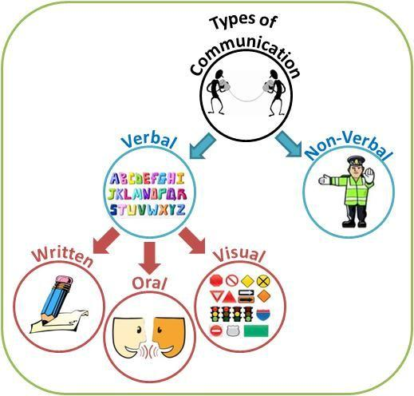

In the 20th century, mobile apps were becoming a very popular method for schools to communicate. A mobile app can make it efficient to access common information like alerts, calendars, directories, news and lunch menus. Additionally, it can make it simple to integrate the phone, email and texting features into the app, making it even more useful.
‘’Non-verbal cues not only help members interpret verbal messages; they also help regulate the flow of conversation” (Goleman, 2006 (CERTH H SKILLS BOOKS PAGE 50)).
SHANNON AND WEAVER MODEL AT A WORKPLACE:
The most famous and influential model of communication which was developed in 1949 by Claude Shannon and Warren Weaver. This is a transmission model consisting of five elements: an information source- which produces a message, a transmitter- which encodes the message into signals, a channel to which signals are adapted for transmission, a receiver- which decodes (reconstructs) the message from the signal, a destination-where the message arrives. A sixth element is noise- a dysfunctional factor: any interference with the message travelling along the channel.
Every moment at my workplace is challenging. Communication is a big factor as I have to communicate with children and my colleagues. At school, we have many more common rooms such as the soft room, the sensory room, the technology room and many more. The interactions between these rooms is also another form of communicating.
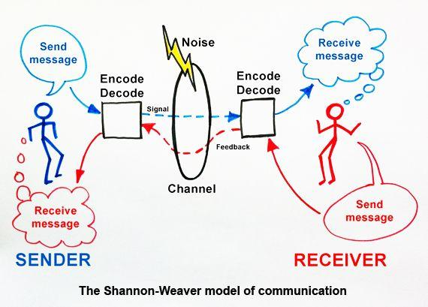
In my school, we meet parents in many ways. If a parent or carer has any suggestion or any messages, they can easily communicate and so then we can be alerted. Home school communication is used to support communication between home and school, and parents can write notes to the staff. Another way to communicate to parents is via email, by telephone or website, parent mail, letters and newsletters.
BERLOR’S THEORY OF COMMUNICATION AT A WORK ENVIRONMENT:
Berlor's SMCR Model of Communication represents the process of communication in the simplest form. The SMCR stands for Sender, Message, Channel, and Receiver. Berlor’s SMCR Model of Communication describes the different elements that form the basic process of communicating. This communication tool also emphasises the coding and decoding of the message, it can be used for more efficient communication.


The SMCR model represents the process of the phenomenal art of communication and this theory lays out the different components that form the net effect of communication.
BARRIERS OF COMMUNICATION AT WORK WITH TEAM MEMBERS
There were barriers to communication with team members if we do not converse with each other. Every step in the communication process is necessary for effective and good communication and blocked steps become barriers. Consider the following situations:
- Sender Barrier. A new manager with an ground-breaking idea fails to speak up at a meeting due to the fear of criticism.
- Encoder barrier. A Spanish speaking staff cannot get an English-speaking administrator to understand an issue about working conditions.
- Medium Barrier. An upset staff member sends an emotionally charged letter to the leader instead of talking about her emotions in person.
- Receiver barriers. A school administrator who is responsibilities to make a plan or budget and ask staff members, because he /she doesn’t listen properly, to the conversation.
- Lack of confident. It is a major problem faced by many in the workplace, and being uncertain and misunderstanding.
Most communication barriers occur due to misconceptions and misunderstanding, some happen to hinge on on to the tense work environment, usually, every employee come from different personalities and background and it is become hard to understand each other.
‘’An administrator has no greater responsibility than to develop effective communication’’ (Pauley, 2010).
Lack of time enables the sender to not carefully think thoroughly about the structure of his/her message accordingly, and limits the receiver’s ability to decrypt the message and understand its meaning. Other barriers include the organisation’s managerial philosophy, multiple levels of hierarchy, “power or status relationships between senders and receivers (Sanchez & Guo, 2005)”.
Additionally, a personal barrier is the lack of empathy meaning insensitivity to the emotions of senders and receivers. Empathy is the ability to put one's self into another's shoes. The empathetic person is able to see the world through the eyes of the other person. “Research shows that lack of empathy is one of the major obstacles to effective communication’’ (Eisenberg, 2010).
HOW TO IMPROVE COMMUNICATION:
As soon as the barriers are dealt with, a way is made for improving communication in the organisation. Effective communication which is a two-way process requires effort and skill by both sender and receiver.
Administrators will at times assume each of these roles in the communication process. In view of this, guidelines for improving communication effectiveness, sender responsibilities, receiver responsibility, all of this can make communication better, every organisation have made a group discussion and arrange a meeting with staff, this requires good communication, of course, Cory Efrem Doctorow is a Canadian-British blogger, journalist, he quoted that
“communication sometimes is not what you first hear, listen not just to the words, but listen for the reason.’’
POSITIVE WORK RELATIONSHIPS
These communication skills create trust between teammates, and this creates a place for positive professional relationships. When teammates know each other well, they become understanding with each other’s' strengths, weaknesses, tendencies and thought processes, which makes it easier to work together toward a common goal and plan for future projects. Positive work relationships add a sense of fulfilment and satisfaction to the job, which can aid in employee retention and a stable work environment.
Johnny Tan said that ‘’To have good communication skills means you are able to make your point without a lot of fillers and stumbling ‘’ (Johnny Tan is a professional keynote speaker, talk show host, author, and founder of From My Mama's Kitchen).
An example where I have experienced positive work relations is at work. This was seen where we had an inspection, and this opportunity allowed us to show our full potential as a school. A letter was received from the head of the deputy at our school for each staff member alerting us of the inspection and this has made our staff more conscious. We use this time to come together and collaborate to help each other be presented at our finest and this shows a good positive work relation as the communication between the head of department/head of school and the staff members are good.
CONCLUSION:
Communication in the workplace is critical to establish and maintain the quality of working relationships in an organisation. The process of transmitting information and common understanding from one person to another, effective communication in the workplace is important because every administrative function and activity involves some form of direct or indirect communication. Consequently, to improve the efficiency of communications, managers must develop an awareness of the importance of the sender and receiver’s responsibilities and understand active listening skills. Effective communication skills in the workplace will improve an administrator’s ability to be a strong leader. Administrators should, therefore, create an environment wherein problems, plans, issues, opinions, thoughts and ideas pertaining to work, are discussed and handled in a professional, proficient manner through positive and effective communication.
To conclude, throughout this assignment, I have talked about the importance of communication and have used examples that are incorporated into our daily life and work environment where communication was successful.
BIBLIOGRAPHY:
- Pauley, J. A. (2010). Communication: The key to effective leadership. Milwaukee, WI: ASQ Quality Press.
- Sanchez, Y. & Guo, K.L. (2005). Workplace Communication. Boston, MA: Pearson.
- Eisenberg, E. M. (2010). Organizational communication: Balancing creativity and constraint. New York, NY: Saint Martin’s.
- McShane, S. L., & Von Glinow, M. A. (2003). Organizational behaviour: Emerging realities for the workplace revolution (2nd ed.). Boston: McGraw-Hill.
- Yate, M. (2009). Hiring the best: A manager’s guide to effective interviewing and recruiting. Cincinnati, OH: F & W Media.

