  Evaluating the Effectiveness of Chosen Maintenance Strategies for Dedicated Equipment | Abstract  This report evaluates FSG Tool & Die’s current CNC machine maintenance strategy, identifying gaps in its largely reactive, time-based approach. With equipment approaching mid-life, the need for predictive, data-driven maintenance is critical. Drawing on industry best practices, including Siemens’ AI-powered monitoring system (Siemens, 2023), the report recommends transitioning to condition-based maintenance supported by clear responsibilities, digital tools, and staff training. Although the proposed changes may marginally increase short-term costs, they offer significant long-term savings through reduced downtime, fewer breakdowns, and improved machine lifespan—ensuring FSG maintains its standards in high-precision manufacturing  William Holmes (2015755)  Plant & Asset engineering

Table of Contents
Introduction 2
Business and equipment background 2
Critical Review of Current Maintenance Practices 2
Evaluation of Improvements to Current Maintenance Approaches 4
Evaluation of Process Improvement Opportunities 4
Maintenance strategy improvements 5
Strategic Value of Predictive and Diagnostic Maintenance 6
Calibration and Alignment: A Quality Assurance Essential 7
Technology Integration and Condition Monitoring 8
Maintenance Strategy Development 8
Example 9
Change Management Considerations 9
Costs and Resources Required to Implement the Proposed Changes 10
Conclusions and Recommendations 12
Conclusions: 12
Recommendations: 12
Works Cited 14

Figure 1-Current Maintenance 3
Figure 2 Machine degradation 3
Figure 3 Revised maintenance regime 6
Figure 4 Filters Figure 5 Grease pump Figure 6 Oil levels 7
Figure 7 Maintenance risk assessment 8
Figure 8 CMM calibration probe 9
Figure 9 Condition monitoring 9
Figure 10 Maintenance costs 11
Figure 11 Total equipment costs 11
Figure 12 Direct cost of improvement 12
Figure 13 cost comparison 12
Figure 14 Category distribution 13
Figure 15 Gantt chart for strategy rollout 14

Introduction
This report evaluates the maintenance strategies applied to CNC (Computer Numerical Control) machines at FSG Tool & Die to identify how current practices support or hinder production efficiency. CNC machines are fundamental to precision manufacturing, offering unmatched accuracy, speed, and repeatability. This analysis aims to critically assess existing maintenance regimes and propose improvements that align with industry best practices and the company’s operational goals.
The report will begin with an overview of the company and the role of CNC machines in its operations, followed by a critical review of current maintenance methods. It will then explore potential improvements to maintenance planning and strategy, consider the resources and costs required to implement these changes, and conclude with evidence-based recommendations to guide future decision-making.

Business and equipment background
FSG Tool & Die, founded in the 1960s in South Wales, is Europe’s largest private toolmaker, serving industries like automotive, packaging, and consumer goods. Its operations rely heavily on CNC machines, which perform high-precision cutting and shaping tasks for clients such as Tesla, Muller, and Monster Energy. These machines run continuously and are vital to maintaining quality and efficiency, making effective maintenance essential to minimise downtime and extend their lifespan (FSG 2025).

Critical Review of Current Maintenance Practices
The current maintenance regime at FSG Tool & Die comprises a hybrid approach combining corrective, run-to-failure, and time-based maintenance. Corrective maintenance is performed reactively—only after breakdowns occur. The run-to-failure method is primarily applied to non-critical components, where equipment is deliberately operated until failure; at this point, repairs or replacements are carried out. Additionally, time-based maintenance occurs annually and is carried out by the machine manufacturer to ensure major components function as intended.
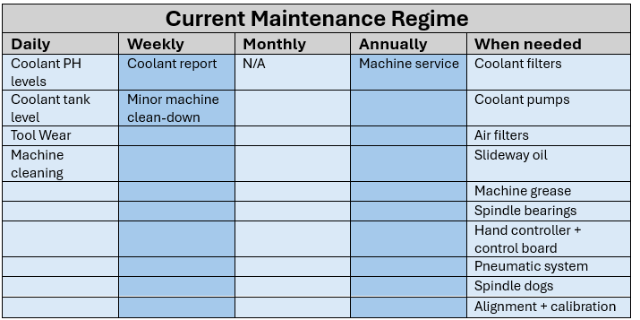
Figure 1-Current Maintenance

This regime has been shaped by the perceived durability of CNC machines, which typically have a service life of 10 to 20 years (Liu et al., 2020). FSG’s machines, 80% of which are less than eight years old, have experienced minimal breakdowns, justifying the minimalistic maintenance strategy. However, this approach overlooks the risks associated with aging machinery, where wear and tear may not be visible until serious failures occur.
The current strategy fails to consider the importance of condition-based monitoring, predictive maintenance, and the proactive identification of early-stage component degradation. This leaves the business vulnerable to unplanned downtime, which can have cascading effects on other machine parts and the overall production schedule (Mobley, 2002), as shown below through machine degradation data collected by FSG tool & die since purchasing the machines between 2015 and 2018.
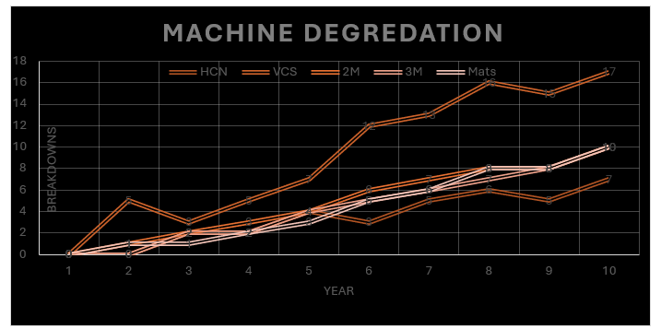
Figure 2 Machine degradation

For instance, the limited frequency of daily checks and the lack of monthly inspections highlight a reactive culture where machines are expected to perform without regular assessments. This not only jeopardises machine health but also reduces long-term reliability. Moreover, a lack of standardised procedures and proper documentation impedes trend analysis and informed decision-making (Mourtzis et al., 2016).
An additional challenge lies in the organisational culture. Many staff members, including those in operational and supervisory roles, are not adequately briefed on the importance of machine maintenance. This creates a nonchalant attitude toward regular checks, undermining the effectiveness of the maintenance strategy. To address this, targeted training programs and maintenance responsibility delegation should be introduced to upskill the workforce and instil ownership of equipment upkeep (Yam et al., 2000).
Introducing digital tools such as maintenance logs, condition monitoring sensors, and trend analysis software can significantly enhance decision-making capabilities. Line managers can identify patterns and make evidence-based decisions by tracking data over time, such as scheduling preventative repairs or replacing components before failure occurs.

Evaluation of Improvements to Current Maintenance Approaches
A review of FSG Tool & Die’s maintenance strategy reveals the need for significant improvements to meet expectations for a company of its size. Although most CNC machines are relatively new, they are approaching a stage where proactive maintenance is critical. Machine life could drop to 10 years below industry standards without early intervention.
Currently, apprentices handle daily maintenance, with checks often being superficial. While this may encourage participation, it also reflects resistance to change—driven by concerns over disrupting workflows or adapting to new systems (Kotter, 1996). To address this, change must be introduced gradually, with clear communication on benefits and alignment with business goals like reducing downtime and improving reliability.
The current reactive approach uncovers critical components until failure, leading to unnecessary risks such as costly repairs and unplanned downtime. A structured, tiered maintenance plan involving all staff levels is essential to foster engagement and long-term cultural change.
Effective change management also requires allocating resources—skilled personnel, diagnostic tools, and modern monitoring technologies. While often seen as a cost, maintenance, when strategically planned, extends equipment life and lowers total ownership costs (Campbell & Reyes-Picknell, 2015).

Evaluation of Process Improvement Opportunities
Following a detailed assessment of the current maintenance practices, several strategic modifications are necessary to elevate equipment care to the standards expected by FSG Tool & Die. While the CNC machines remain relatively new, they are entering their serviceable lifespan—an operational phase that requires increased attention to avoid premature failures. Without adequate planning, the potential lifespan of 15–20 years could be reduced to as little as 10 years due to inadequate maintenance practices.
Currently, daily maintenance is assigned to apprentices, whose tasks focus mainly on basic visual checks. While this promotes hands-on learning, it also highlights a broader issue: a resistance to adopting more systematic and advanced maintenance practices. This resistance is commonly rooted in apprehension towards change, fear of disrupting established routines, and lack of clarity on the long-term benefits of transformation (Kotter, 1996).
Change must be managed and integrated strategically to overcome barriers. Utilising effective communication, involving managerial staff early in the process, and linking maintenance enhancements to overreaching business goals, such as reducing unplanned downtime, improving machine liability, and lowering operating costs. Without such alignment, efforts can appear disconnected from strategic objectives, leading to poor engagement and regressing to old habits. In this context, Mckinsey’s 7S framework provides valuable insights for evaluating the alignment between strategies, structure, systems, and staff. Misalignment across these internal elements can significantly hinder the implementation of advanced maintenance practices (Waterman, Peters and Phillips, 1980).

Maintenance strategy improvements
While the current maintenance system at FSG Tool & Die has served a foundational role, it lacks the structure, frequency, and strategic alignment needed to support an evolving production environment. A revised maintenance regime is essential to extend equipment lifespan, ensure consistency in machining quality, and support future growth.
The following improvements are recommended to transition from reactive to predictive and preventative maintenance strategies:
- Clear, Updated Daily Maintenance Responsibilities
– Establishing routine and specific operator tasks creates structure, reduces oversight gaps, and promotes ownership at the ground level.
- Localised Accountability for Team Members
– Assigning responsibility to individuals encourages proactive engagement, improves task follow-through, and fosters a culture of accountability.
- Shift to Condition-Based and Predictive Maintenance
– Moving away from time-based or reactive approaches toward data-driven methods reduces unnecessary interventions and prevents unexpected failures.
- Integration of Machine Usage Data
– Using real-time machine data allows for tailored maintenance scheduling, optimising resources and reducing unnecessary downtime.
- Management Support and Resource Allocation
– Ensuring leadership buy-in and providing the necessary tools and training is crucial for sustaining long-term cultural and operational change.
These adjustments will foster a proactive maintenance culture and help embed ownership of machinery upkeep within day-to-day operations. Most importantly, they will reduce downtime, enhance machine availability, and improve output quality.
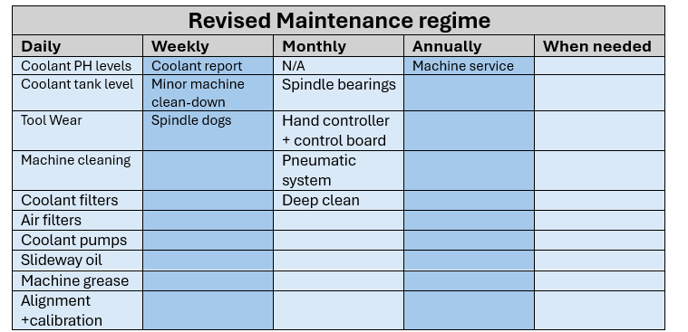
Figure 3 Revised maintenance regime

Failure to implement or adhere to this structured schedule may compromise the machine’s
ability to operate efficiently. Over time, the degradation of core internal components may lead to serious breakdowns, which would have been avoidable through consistent preventative checks.
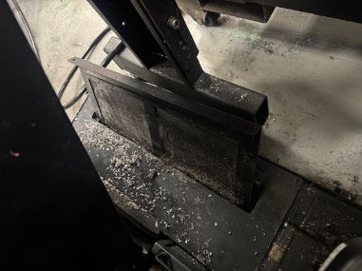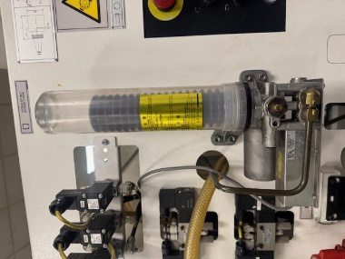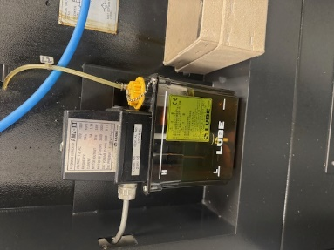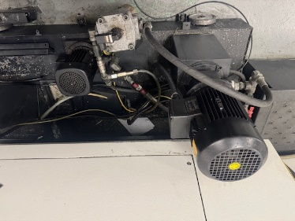
Figure 4 Filters Figure 5 Grease pump Figure 6 Oil levels

Strategic Value of Predictive and Diagnostic Maintenance
Increasing the frequency and scope of inspections for wear-sensitive components—such as filters, pumps, oil reservoirs, and spindle bearings—allows early detection of abnormalities before they result in significant disruptions. According to Mobley (2002), predictive maintenance can reduce equipment breakdowns by 70% and maintenance costs by up to 30%.
Although the revised regime may marginally increase labour time (estimated at £22/hour per operator) and affect machine availability during inspections (costed at £65/hour), unplanned downtime and scrap rate reductions offset these costs. For twelve CNC machines, the net impact will be a minor operational investment compared to the long-term benefits.
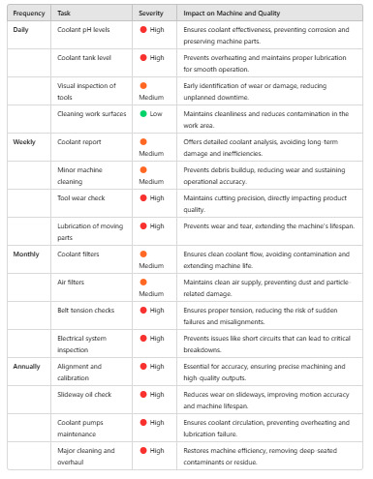
Figure 7 Maintenance risk assessment

Calibration and Alignment: A Quality Assurance Essential
Introducing daily machine calibration and alignment offers significant benefits in quality control. These activities provide machine operators with real-time accuracy data on the X, Y, and Z axes and detect minor misalignments early. FSG already applies these principles in other departments using ceramic datum spheres and ISO 9001-compliant standards. Extending the process to CNC machinery would be a logical and scalable enhancement.
This practice requires a modest investment in time and training but delivers substantial benefits by consistently meeting product tolerances. Operators would also benefit from performance visibility, enabling them to self-correct issues before they escalate.

Figure 8 CMM calibration probe

Technology Integration and Condition Monitoring
Modern CNC equipment, including the Mazak models used at FSG, are equipped with software capable of real-time condition monitoring. These systems track machine states such as Idle, Setup, Auto-Run, and Alarm while detecting vibration, temperature, tool wear, and noise levels.
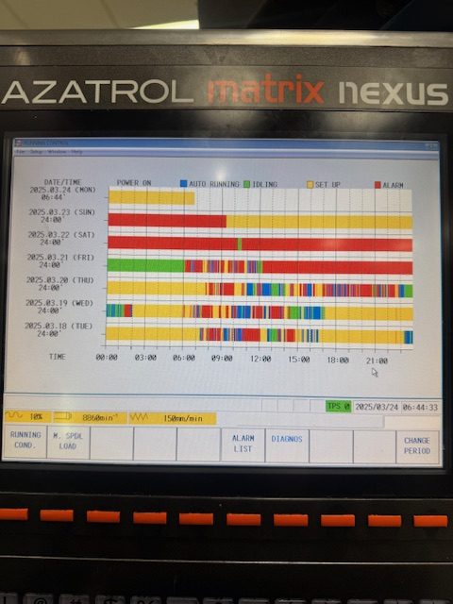
Figure 9 Condition monitoring

To capitalise on this, the following should be implemented:
- Standardise usage of monitoring software across all machines.
- Customise alert thresholds to suit specific machines or workloads.
- Train operators to respond appropriately to triggered alerts.
- Log all warning data for predictive trend analysis and future planning.
This move toward digitised maintenance supports the development of a more intelligent, adaptive maintenance strategy, which is essential for sustained competitiveness in high-precision manufacturing.

Maintenance Strategy Development
The current maintenance strategy at FSG Tool & Die relies heavily on run-to-failure, time-based, and corrective approaches. While these methods may have been adequate during the CNC machines' early operational life, they are no longer sustainable as equipment ages and production demands increase. The maintenance methodology must evolve to maximise asset reliability and operational efficiency.
The proposed strategy involves the integration of two advanced maintenance approaches:
Condition-Based Maintenance (CBM): This is implemented for high-frequency components such as filters, coolant, oil levels, and grease systems. CBM allows maintenance actions to be scheduled based on actual wear conditions rather than arbitrary time intervals, reducing unnecessary servicing and focusing on developing issues (Mobley, 2002). This maintenance strategy can be utilised to evaluate equipment and machinery's current and future states.

- Current operating conditions from real-time data
- Thresholds and limits ( when vibration exceeds safe tolerances)
- Wear and tear indicators (lubrication levels, corrosion)
- Visual/auditory inspections and manual checks

Predictive Maintenance (PdM): CNC machines have internal software automatically flag issues such as low lubrication or filter status. This data should be interpreted as alerts and trend indicators, allowing the evaluation of many data trends such as:
- Historical data trends (past failures, usage patterns)
- Real-time sensor data (noise, vibration, temperature, pressure)
- Machine learning models or algorithms that forecast failure patterns
- Remaining Useful Life (RUL) of components
Integrating these strategies will allow for an accurate understanding of current conditions and a more responsive and resilient maintenance framework that assists in detecting potential failures, reducing reactive repairs, and extending the overall machine lifespan. This shift significantly facilitates better resource allocation and shows clear maintenance prioritisation, as maintenance becomes targeted and measurable, whilst monitoring past, present, and future patterns within the process transforms from a necessity to a strategic value-adding function.

Example
Siemens applies predictive maintenance in its advanced manufacturing facilities, notably at the Amberg Electronics Plant in Germany. The company monitors variables such as vibration, motor temperature, spindle wear, and cycle irregularities by embedding sensors in CNC machines and robotics. These data points are processed through AI and machine learning within the MindSphere industrial IoT platform to detect anomalies and forecast potential failures. For instance, unusual spindle vibrations can trigger alerts days before breakdowns occur, enabling proactive maintenance without disrupting production (Siemens, 2023).

Change Management Considerations
Despite the technical benefits, transitioning to a new maintenance strategy involves a cultural shift. Operators—many of whom are accustomed to existing routines—may find new responsibilities and procedures disruptive. Change in daily practices can lead to resistance if not managed appropriately.
To mitigate this, the strategy should be introduced incrementally:
- Pilot Testing: Begin with one machine or section to trial the new strategy, collecting performance data and addressing workflow concerns.
- Phased Rollout: Expand implementation gradually across departments based on pilot outcomes.
- Staff Involvement: Engage operators early in the process, offer hands-on training, and explain how new processes benefit machine performance and job efficiency.
- Feedback Loops: Create regular review meetings to evaluate system performance, gather feedback, and continuously refine the strategy.
This staged approach will allow FSG Tool & Die to transition confidently to a more advanced maintenance culture, ensuring improvements are adopted, refined, and embedded.

Costs and Resources Required to Implement the Proposed Changes
Implementing a revised maintenance strategy requires a thorough understanding of the associated costs, their impact on productivity, and the allocation of necessary resources. These considerations must factor in direct and indirect expenses, including labour time, material costs, equipment investments, training, and potential downtime during transitions.
The table below outlines the primary maintenance activities affected by the proposed improvements, along with estimated costs and required resources:
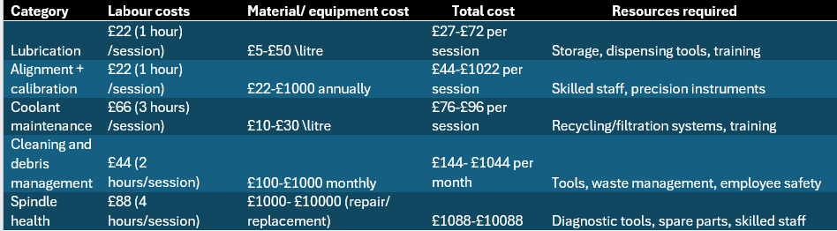
Figure 10 Maintenance costs

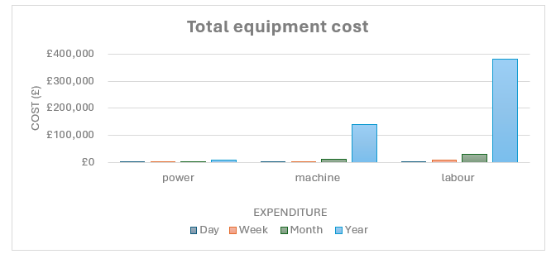
Figure 11 Total equipment costs

Figure 12 Direct cost of improvement

Figure 13 cost comparison

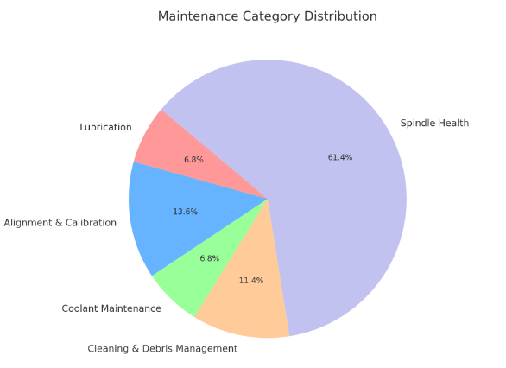
Figure 14 Category distribution

This cost structure provides a practical foundation for informed decision-making and helps ensure maintenance investments are proportionate to the value of the machinery and overall productivity.
A further analysis of operational costs for power consumption (kWh), machine time (Mazak CNCs), and labour inputs reveals that the proposed changes represent just 2.5% to 3% of the department’s total cost profile. This figure rises significantly to 6% if maintenance continues to be unplanned and reactive. Therefore, adopting a preventative and predictive maintenance approach is operationally beneficial and cost-effective in the long term (Mobley, 2002).

Conclusions and Recommendations
Based on the assessment of current practices and cost analysis, several conclusions and actionable recommendations can be drawn:

Conclusions:
- The existing strategy, which relies on reactive and time-based maintenance, is no longer appropriate as equipment ages.
- Delays in maintenance tasks can lead to costly repairs, reduced machine life, and production downtime.
- Transitioning to a more proactive, data-driven maintenance regime will ensure sustainable operations and support FSG’s commitment to precision and quality.

Recommendations:
Short-Term (0–6 months):
- Begin pilot testing of the new maintenance schedule on selected machines.
- Assign maintenance responsibilities to specific team members to increase accountability.
- Initiate basic training on condition-based and predictive maintenance tools.
Medium-Term (6–18 months):
- Implement a full-scale rollout of the revised maintenance plan across all departments.
- Standardise condition monitoring systems and integrate them with maintenance logs.
- Analyse machine usage data to tailor maintenance frequency and reduce unnecessary interventions.
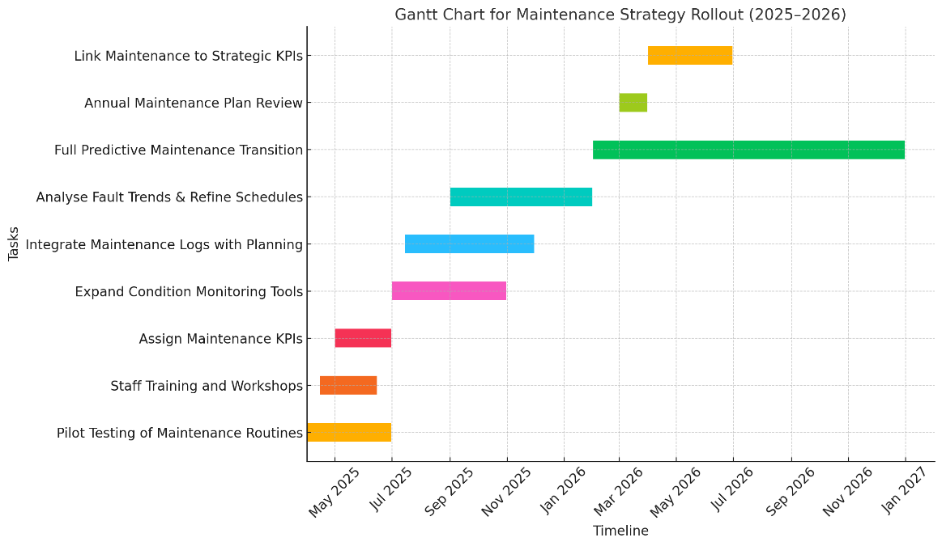
Figure 15 Gantt chart for strategy rollout

Long-Term (18+ months):
- Fully transition to a predictive maintenance model by leveraging machine learning and real-time sensor data.
- Develop internal KPIs for maintenance efficiency and tie them to team performance evaluations.
- Continually review and update procedures based on machine condition trends and feedback.
These recommendations are intended to reduce downtime, lower repair costs, and prolong equipment life, thus ensuring that FSG Tool & Die maintains its reputation for high-precision engineering.

Works Cited
There are no sources in the current document.
- Mobley, R.K. (2002). An Introduction to Predictive Maintenance. 2nd ed. Butterworth-Heinemann.
- Campbell, J.D. & Reyes-Picknell, J.V. (2015). Uptime: Strategies for Excellence in Maintenance Management. 3rd ed. CRC Press.
- Yam, R.C.M. et al.. (2000). Intelligent predictive decision support system for condition-based maintenance. International Journal of Advanced Manufacturing Technology, 17(5), pp.383–391.
- Wireman, T. (2010). Total Productive Maintenance. 2nd ed. Industrial Press Inc.
- Kotter, J. P. (1996). Leading Change. Boston: Harvard Business School Press.
- Cameron, E. and Green, M. (2019). Making Sense of Change Management. 5th ed. Kogan Page.
- Siemens (2023) Smart manufacturing with predictive maintenance at the Amberg Electronics Plant. Available at: https://new.siemens.com/global/en/company/stories/industry/amberg.html
- FSG (2025) Home - FSG Tool and Die | A total toolmaking service provider
- Waterman, R.H., Peters, T.J. and Phillips, J.R., 1980. Structure is not organisation. McKinsey Quarterly, 1980(3), pp.2-20.

