A marketing plan for the Ritz Carlton hotel brand

Student name: Mihai Valentin Ganea
Student id:2022142
Module name:Marketing Essentials(BMIH4005)

A marketing plan for the Ritz Carlton hotel brand
Part 1 Presentation
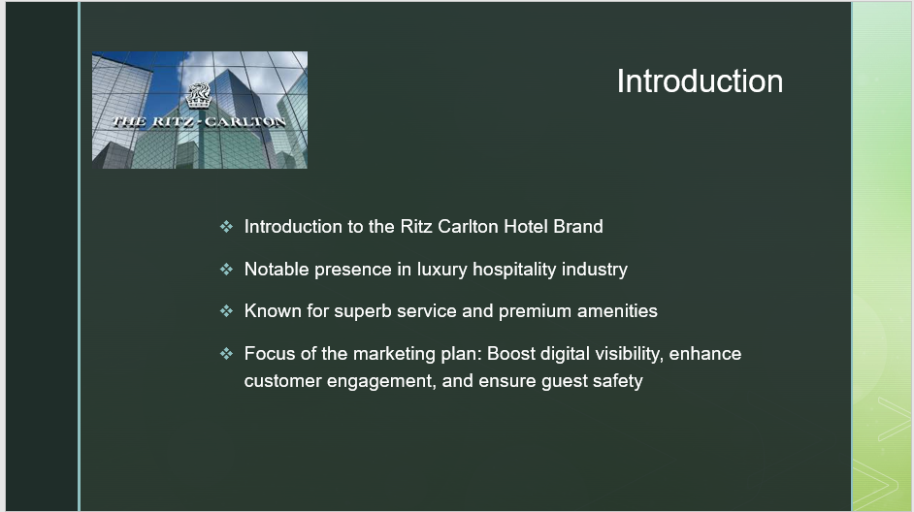
Script: The Ritz Carlton Hotel Brand is a name that reverberates with high-end, elegant, and remarkable solutions in the friendliness market. Its meaningful existence in the luxury sector has become a recommended choice for discerning vacationers worldwide. Renowned for its excellent solution and dedication to offering an exquisite experience, the Ritz Carlton has come to be identified with quality and interest in detail. This advertising and marketing strategy is designed to boost the brand's credibility and guarantee its ongoing success by focusing on three vital locations: improving digital visibility, customer engagement, and ensuring visitor security. A strong online presence is important for any company in today's digital age. Our strategy aims to utilize digital systems, advertising, and marketing approaches to boost the brand's exposure, bring in a larger target market, and meaningfully involve customers. Our strategy integrates steps to reassure guests and emphasize the resort's commitment to supplying a safe and safe and secure environment. By integrating these aspects, our advertising and marketing strategy intends to push the Ritz Carlton Hotel Brand to new heights, strengthening its setting as a leader in the deluxe friendliness sector and ensuring that every guest experience is outstanding.
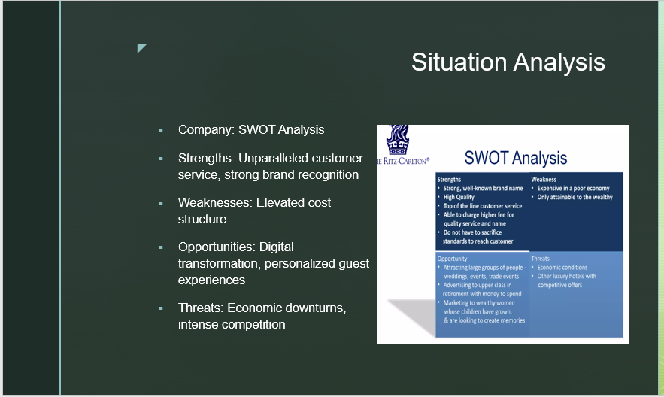
SWOT Analysis
Strengths: The Ritz Carlton is renowned for its exceptional customer support, setting luxury friendliness standards. This commitment to excellence has garnered a faithful client base and a favourable brand name online reputation. In addition, the brand enjoys solid recognition and depends on consumers, boosting its competitive advantage in the marketplace.
Weaknesses: The Ritz Carlton's raised price structure, required to preserve its high requirements, can present difficulties throughout financially unclear durations. The high-end experience comes at a premium cost, which might restrict the brand name's accessibility to a wider client base.
Opportunities: In the era of electronic makeovers, there are adequate possibilities for the Ritz Carlton to leverage innovation to enhance guest experiences. Through tailored guest experiences and leveraging electronic platforms for bookings and interaction, the brand can reinforce its setting and draw in a larger range of consumers.
Threat: Economic declines can affect consumer investing in high-end hotels, posturing a threat to the Ritz Carlton's profits. Furthermore, the deluxe hospitality market is extremely competitive, with competing brand names also vying for a share of the upscale client sector. Intense competitors require continuous technology and distinction to maintain a competitive edge.
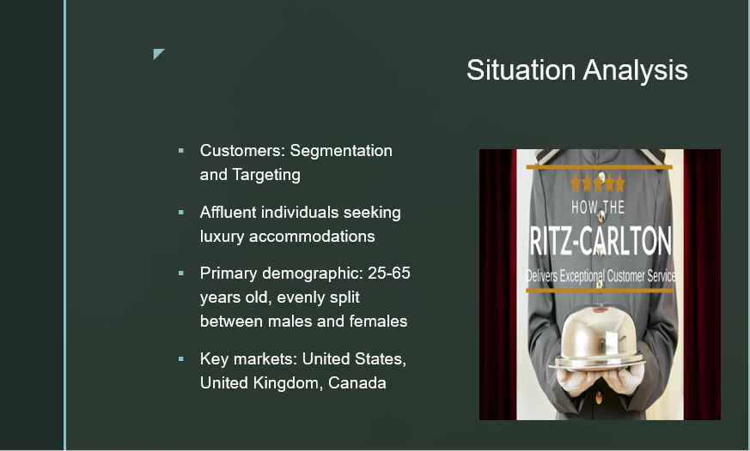
Consumers: Segmentation and Targeting
Comprehending the consumer base is vital for efficient marketing techniques. The Ritz Carlton Resort Brand targets affluent people seeking glamorous lodgings and phenomenal experiences.
The main demographic of Ritz Carlton's consumers falls within the age series of 25-65 years old, with an even circulation between men and ladies. This age generally consists of successful professionals, business tourists, and high-net-worth individuals who value and can afford the brand's premium offerings.
Geographically, the vital markets for the Ritz Carlton are the United States, the UK, and Canada. These areas strongly need high-end accommodations and bring in a substantial variety of upscale vacationers.
The marketing plan will use electronic channels, personalized interaction, and experiences tailored to their preferences and wishes to properly get to and involve this target market. Via targeted marketing projects and tactical collaborations, the Ritz Carlton will seek to record the interest and loyalty of this critical consumer sector.
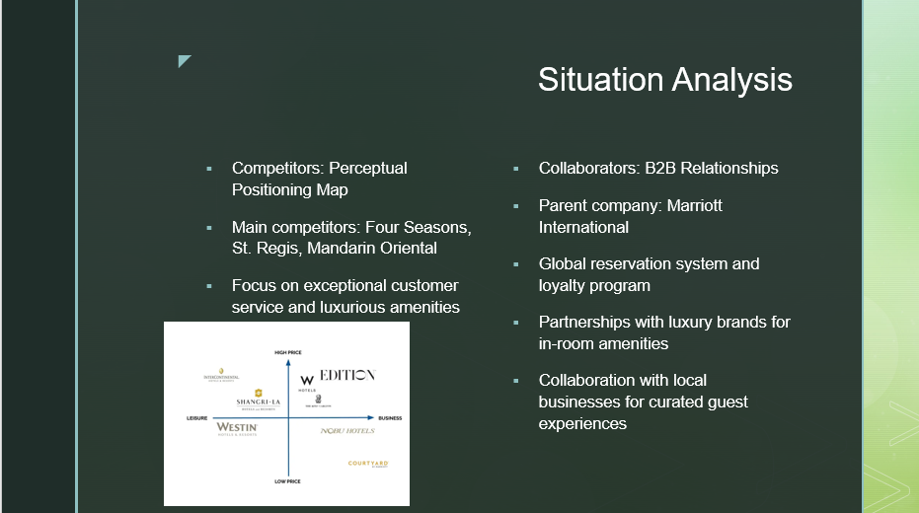
Competitors and Partners
Competitors:
The major rivals of the Ritz Carlton Resort Brand name in the high-end friendliness sector include Four Seasons, St. Regis, and Chinese Oriental. These brand names are recognized for their outstanding customer service and extravagant services. To differentiate itself from the competitors, the Ritz Carlton will certainly focus on supplying a superior visitor experience and personalized solution, offering special services and tailored experiences that surpass client assumptions.
Partners:
The Ritz Carlton takes advantage of its collaboration with its moms and dad company, Marriott International. This collaboration offers access to a global reservation system and a durable commitment program, enabling visitors to enjoy seamless reservations and gratifying experiences. Along with the partnership with Marriott International, the Ritz Carlton likewise forms partnerships with high-end brands to provide high-end in-room amenities, boosting the deluxe experience for guests. The resort collaborates with regional services to curate exceptional guest experiences, supplying exclusive access to regional destinations, eating, and entertainment alternatives.
By leveraging these collaborations and stressing its one-of-a-kind value recommendation, the Ritz Carlton intends to enhance its affordable setting in the deluxe hospitality market and offer guests extraordinary and unrivalled experiences.
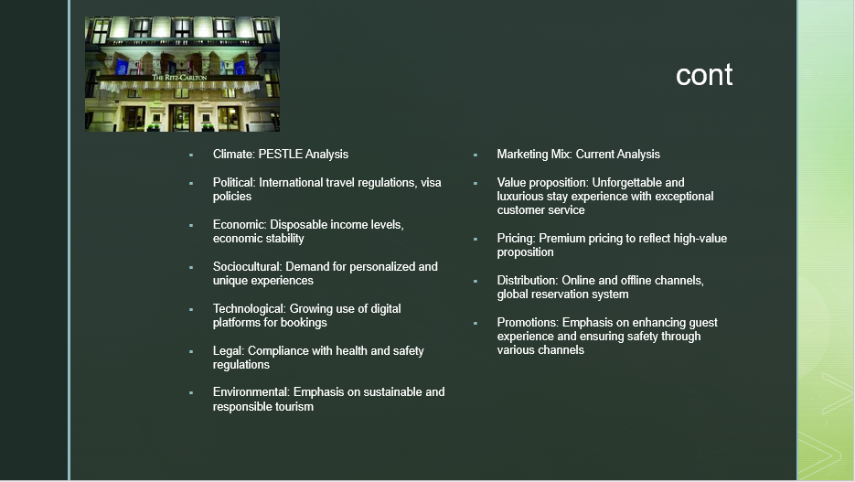

PESTLE Evaluation
Political: The Ritz Carlton is affected by international travel regulations and visa plans, which can influence the hotel's ability to bring in worldwide visitors.
Economic: The hotel's success is connected to non-reusable earnings levels and economic stability, as they impact consumer investing in luxury lodgings.
Sociocultural: There is a growing need for personalized and unique experiences among guests, highlighting the importance of delivering outstanding service and tailored offerings.
Technological: The resort sector is experiencing a change towards electronic platforms for reservations, highlighting the need for a strong online presence and seamless booking experiences.
Legal: Compliance with health and wellness guidelines is vital to ensure guests' health and preserve a favourable online reputation, particularly in the post-pandemic era.
Environmental: There is an enhancing emphasis on lasting and accountable tourism, triggering the Ritz Carlton to embrace environmentally friendly methods and efforts.
Marketing Mix analysis
Value proposal: The Ritz Carlton offers a memorable and elegant remaining experience with remarkable customer care as its core worth suggestion.
Prices: The resort adopts a premium pricing approach to mirror the high-value proposition and special features supplied to guests.
Distribution: The resort uses a combination of online and offline channels, consisting of a worldwide booking system, to guarantee easy access for guests and facilitate seamless bookings.
Promotions: The Ritz Carlton concentrates on improving the guest experience and ensuring security via different channels such as social media, email marketing, and the resort's website.
By considering the outside factors recognized in the PESTLE evaluation and evaluating the efficiency of the current advertising mix, Ritz Carlton can tactically align its offerings and advertising efforts to fulfil the progressing requirements and preferences of its target audience.
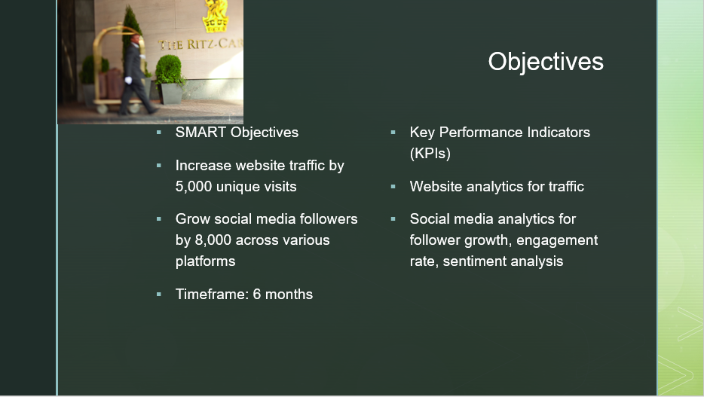
SMART Goals
Rise website web traffic by 5,000 special checkouts within 6 months.
Expand social media followers by 8,000 across various systems within 6 months.
Key Efficiency Indicators (KPIs).
Internet site analytics will track the rise in website traffic, determining the number of special checkouts over the duration.
Social media analytics will monitor follower development, engagement price, and sentiment evaluation across various platforms.
These SMART objectives supply clear and specific targets for the advertising strategy. By executing strategies and techniques focused on boosting site traffic and social network followers, Ritz Carlton aims to boost its digital presence, expand its reach, and engage with a wider audience. The chosen KPIs will act as measurable metrics to analyze the success of the advertising initiatives and identify the efficiency of the techniques utilized. Normal monitoring and analysis of internet site analytics and social media site metrics will supply beneficial understandings of the performance of the advertising strategy and guide future decision-making.
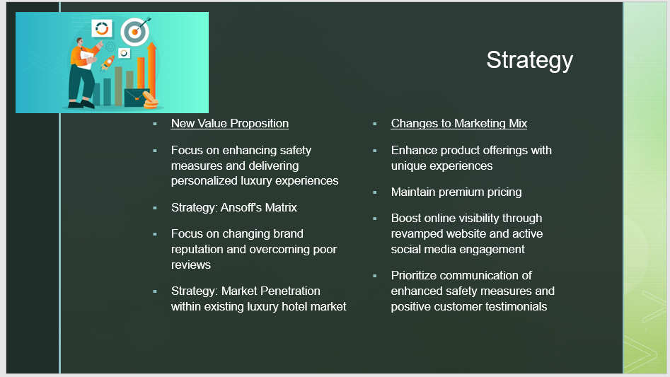
New Value Proposition
The Ritz Carlton aims to boost precaution and supply customized luxury experiences to its visitors. By focusing on the security of visitors and providing tailored, phenomenal solutions, the brand aims to separate itself and produce a positive brand picture.
Method: Ansoff's Matrix.
The advertising and marketing strategy will concentrate on changing the brand name's track record and overcoming bad testimonials. By addressing customer issues and boosting the overall perception of the brand name, Ritz Carlton intends to restore trust and commitment.
Strategy: Market Penetration
The chosen method from Ansoff's Matrix is market infiltration, which involves increasing the brand's market share within the existing deluxe hotel market. This method permits Ritz Carlton to leverage its existing toughness and resources to attract more consumers and boost market supremacy.
Adjustments to marketing Mix.
The advertising mix will undergo particular changes to align with the brand-new method. This includes improving product offerings with distinct experiences emphasising safety and deluxe, keeping superior rates to show the brand name's high-value proposal, enhancing the internet visibility with a revamped internet site and energetic social network involvement, and focusing on the interaction of enhanced precaution and favourable client reviews. These tactical campaigns and modifications to the advertising mix will contribute to Ritz Carlton's objective of strengthening its market position, drawing in more consumers, and strengthening its dedication to providing exceptional deluxe experiences.
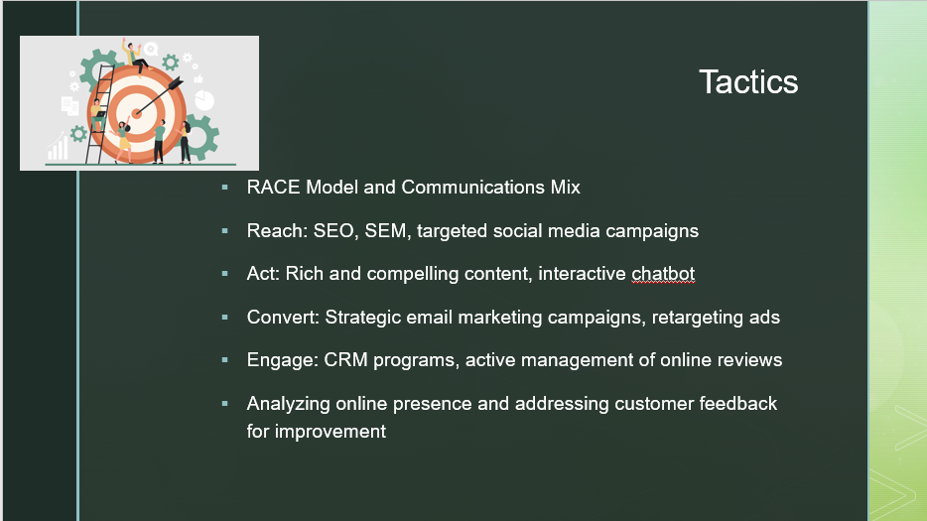
RACE Version and Communications Mix.
Reach to: To reach a wider target market, the Ritz Carlton will use Seo (SEARCH ENGINE OPTIMIZATION) and Online Search Engine Advertising and Marketing (SEM) approaches to enhance its online presence and increase natural and paid traffic.
Targeted social media site campaigns will be applied on platforms such as Instagram and Facebook to involve the preferred market and advertise the brand's one-of-a-kind offerings.
Act: Engaging and rich content will be produced and released on the site and social media platforms to capture the target market's attention and create a positive brand picture. An interactive Chabot will be presented on the site to supply instantaneous customer care and assist with queries, boosting the total individual experience.
Transform: Strategic email advertising and marketing campaigns will be applied to transform online web traffic into actual clients. Individualized offers, updates about brand-new safety and security procedures, and info about distinct experiences readily available at Ritz Carlton residential properties will be included to encourage bookings. Retargeting advertisements will certainly be used to remain top-of-mind for prospective clients who have shown a passion for the brand's offerings.
Engage: A detailed Customer Relationship Administration (CRM) program will certainly be executed to foster customer loyalty and interaction. This consists of customized emails, consumer feedback studies, and exclusive deals. Active monitoring and response to online reviews will be carried out to demonstrate the brand name's dedication to customer fulfilment and constant renovation. Furthermore, continual tracking and evaluation of the Ritz Carlton's online visibility and customer responses will certainly be performed to recognize areas for renovation and make certain a customer-centric technique in all interaction initiatives.
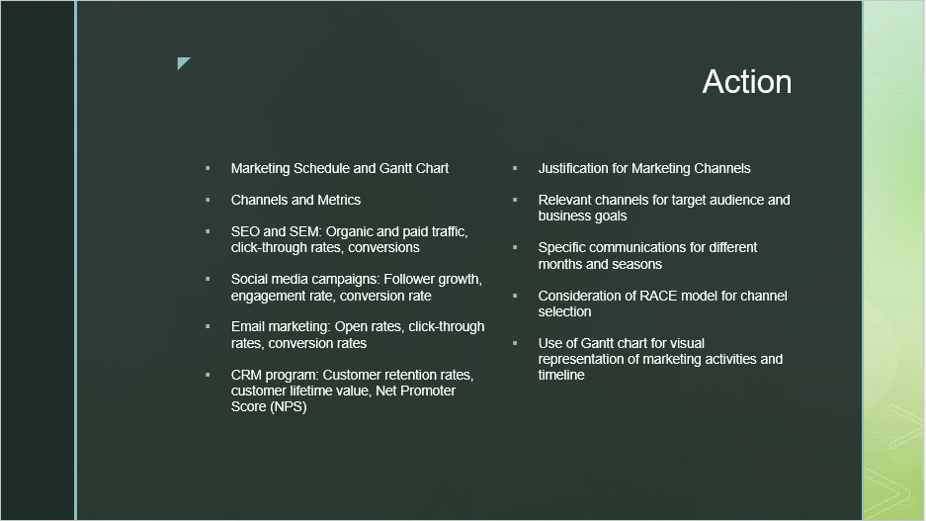

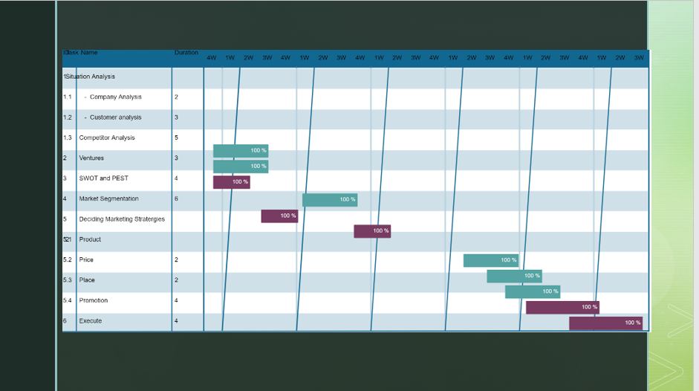
Advertising Schedule and Gantt Graph.
The advertising plan will certainly be performed according to a carefully created timetable and stood for in a Gantt graph to visualize the timeline and activities.
Channels and Metrics.
The advertising efforts will use various networks, each with detailed metrics to measure their efficiency and influence.
Search engine optimization and SEM: The success of organic and paid website traffic will be gauged using metrics such as click-through rates and conversions.
Social media site projects: Follower development, interaction rate, and conversion price will certainly be kept an eye on to assess the influence of social network initiatives.
Email advertising: Open-up, click-through, and conversion rates will be tracked to examine the efficiency of email projects.
CRM program: Customer retention rates, customer lifetime value, and Net Marketer Score (NPS) will certainly be used to evaluate the success of customer partnership administration efforts.
Reason for Marketing Channels.
The picked advertising channels are carefully selected based on their relevance to the target audience and placement with business objectives.
Particular interactions will certainly be created for various months and seasons to guarantee the message is customized to the needs and choices of clients during specific periods.
The network choice process considers the RACE model, ensuring that the chosen channels can get to, act, transform, and involve the target audience properly.
The Gantt chart visually represents the advertising activities and their timeline, enabling far better preparation and coordination of the advertising and marketing efforts.
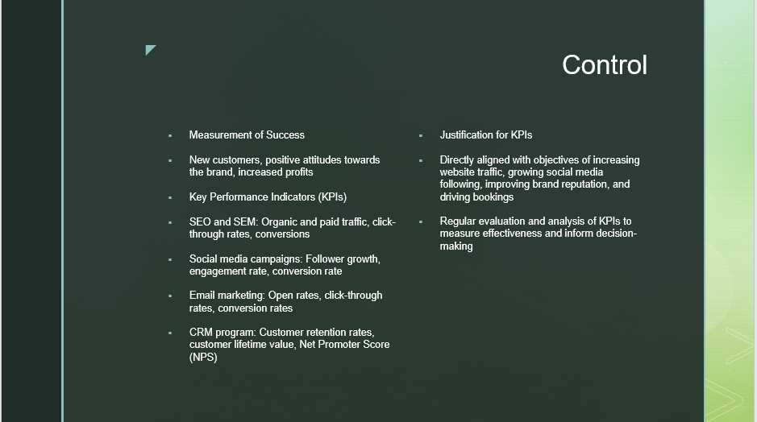
Measurement of Success.
The advertising strategy's success will certainly be determined by key elements such as obtaining brand-new consumers, cultivating favourable attitudes in the direction of the brand name, and raising revenues.
Key Performance Indicators (KPIs).
SEO and SEM: Organic and paid website traffic, click-through prices, and conversions will be tracked to review search engine optimisation performance and advertising and marketing initiatives.
Social media site projects: Follower growth, involvement rate, and conversion rate will certainly be kept an eye on to examine the influence of social network approaches.
Email advertising: Open-up rates, click-through rates, and conversion prices will certainly be examined to gauge the success of email advertising projects.
CRM program: Client retention rates, customer lifetime worth, and Internet Promoter Score (NPS) will be used as signs of customer complete satisfaction and loyalty.
Reason for KPIs.
The selected KPIs are directly lined up to raise website traffic, expand social media site following, enhance brand name reputation, and drive reservations.
Routine analysis and analysis of these KPIs will provide useful insights to gauge the efficiency of the marketing efforts, recognize areas of improvement, and make data-driven choices to optimize the method.
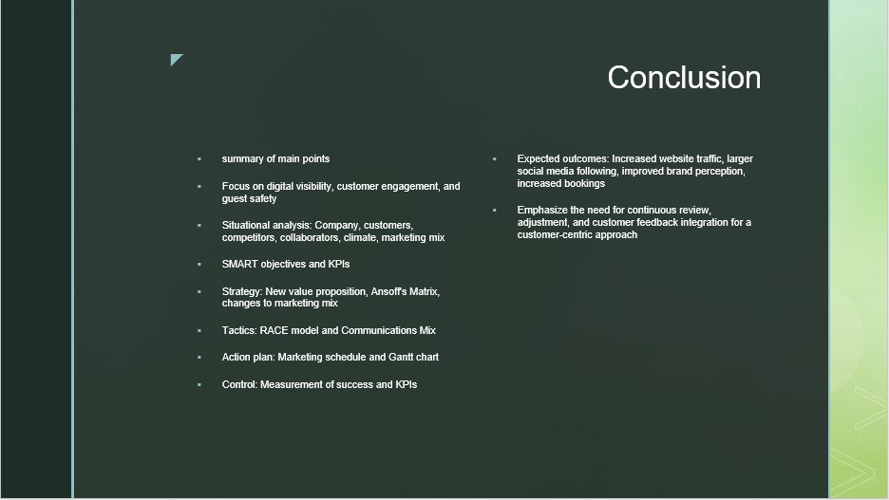
Conclusion.
Summary of Key Information.
The marketing plan concentrates on boosting digital visibility, customer interaction, and visitor safety for the Ritz Carlton Resort Brand.
The situational analysis covered different facets, including business, clients, rivals, collaborators, environment, and marketing mix.
Wise objectives and vital efficiency indicators (KPIs) were readied to measure the plan's success.
The technique entails a brand-new worth recommendation, Ansoff's Matrix for market infiltration, and changes to the advertising mix.
Techniques applied include the RACE version and Communications Mix for effective reach, interaction, conversion, and consumer engagement.
An activity strategy with an advertising and marketing timetable and a Gantt graph was established to guide the application of activities.
Control measures include the measurement of success and KPIs aligned with the goals.
Expected results include enhanced website traffic, larger social media complying with, improved brand perception, and raised bookings.
Continual evaluation, adjustment, and integration of client responses are stressed for a customer-centric strategy and to ensure the marketing plan's performance.

Part 2:
Introduction
This marketing plan has been developed for the well-regarded Ritz Carlton Hotel Brand name. It has remarkable visibility in the deluxe hospitality industry, celebrated for its excellent solution and cost of services. The core purpose of this strategy is to boost the brand's electronic presence and customer involvement while preserving visitor security following the global pandemic. The strategy aspires to improve internet traffic, expand the brand's social media sites, and raise scheduling conversions. The SOSTAC planning model structures this plan, integrating elements such as Scenario evaluation, Purposes, Technique, Strategies, Activities, and Control. The marketing mix's 4Ps (Item, Price, Place, and Promo) will certainly be leveraged to inspect and evolve the hotel's market technique, enabling us to assess and modify the resort's product variety, rates technique, circulation channels, and marketing tasks. Bowman's Approach Clock will certainly be used to examine the Ritz Carlton's competitive standing versus rival brands, assisting in strategizing the resort's value suggestion and rates strategy. The plan also performs a SWOT analysis to review the company's inner strengths and weak points and outside opportunities and hazards. Ultimately, PESTLE analysis will be executed to consider the macro-environmental aspects (Political, Economic, Sociocultural, Technological, Legal, and Environmental) that could affect the hotel. This marketing blueprint presents a unique path for boosting the Ritz Carlton's market position and client engagement while supporting the brand name's dedication to guest safety and security.
Situation Analysis
Company (SWOT Analysis): The Ritz-Carlton Resort masters supplying exceptional customer care and a glamorous keep experience, capitalizing on its robust brand acknowledgement in the luxury friendliness sector (Stamina) (Han & Hyun, 2015). Nevertheless, the elevated price structure associated with promoting such high requirements can be a drawback, especially in a financially volatile period (Weak point). Opportunities exist in electronic makeovers and individualized visitor experiences, while dangers emerge from financial downturns and extreme competition in the luxury resort market (Chen & Chen, 2010).
Customers: Using Similar Web, Ritz-Carlton's key customers are affluent people looking for high-end holiday accommodations, typically aged 25-65, and uniformly divided between men and ladies. Most internet website traffic originates from the USA, which is adhered to by the UK and Canada (Wang et al., 2013).
Competitors: The perceptual positioning map and Bowman's method clock expose that Ritz-Carlton's primary rivals in the high-end hotel sector are brands like 4 Seasons, St. Regis, and Chinese Asian. These brands likewise focus on remarkable customer support and extravagant amenities (Tseng et al., 2015).
Collaborators: The Ritz-Carlton teams up with different entities, including its moms and dad company Marriott International, which gives a robust global reservation system and loyalty program. Other B2B connections include deluxe brand names for in-room services and regional businesses for curated guest experiences (Kim et al., 2015).
Climate (PESTLE Analysis): Political aspects such as international travelling policies and visa plans can impact the Ritz-Carlton. Economically, non-reusable revenue levels and financial security impact consumer spending on deluxe resorts. Sociocultural trends highlight the demand for individualized and distinct experiences. Technically, the growing use of digital platforms for hotel bookings is significant. Lawful aspects include conformity with health and wellness laws, specifically in the post-pandemic era. Environmental factors include emphasising lasting and responsible tourism (Zhang et al., 2018).
Marketing Mix: The Ritz-Carlton's worth recommendation focuses on giving a memorable and luxurious stay experience with exceptional customer service. The pricing is evaluated at a cost level to show the high-value recommendation supplied by the brand name. Circulation is helped with online and offline channels, consisting of the robust global booking system provided by Marriott International. Present promotional efforts concentrate on improving the visitor experience and ensuring visitor safety, utilizing different communication channels such as social media sites, email marketing, and the hotel's website (Narangajavana & Hu, 2019).
Objectives
The key objective of this marketing strategy is to enhance Ritz-Carlton's electronic presence and reputation by bringing in an extra 5,000 unique site visitors and increasing the social networks complying by 8,000 across different systems within a six-month timeframe. The strategy's performance will be measured using essential performance indicators (KPIs) such as site analytics to monitor traffic and social media site analytics to track follower development, interaction rate, and belief analysis (Zhang et al., 2014).
Strategy
Offered the existing company setting and consumer feedback, there is an acknowledgement of the requirement to rearrange Ritz-Carlton's brand picture. The restored value suggestion will undoubtedly emphasize the brand's dedication to providing outstanding and risk-free high-end experiences, highlighting stringent health methods and individualized customer support in the post-pandemic globe.
A Market Infiltration method will certainly be used to attain this, based on Ansoff's matrix, aiming to enhance market share within the existing high-end resort market. This strategy entails refining the current marketing mix:
Product: Enhancing offerings with unique, personalized experiences emphasising safety and luxury.
Price: Enhancing offerings with special, individualized experiences emphasising safety, security, and luxury.
Price: Keeping a costs rates strategy that reinforces the worth and exclusivity of the Ritz-Carlton experience.
Promotion: Improving online presence through a revamped website and active involvement in social network systems.
Focusing on the interaction of enhanced precaution, bespoke experiences, and favourable client reviews to restore and strengthen the online track record (Xiang et al., 2017).
With these alterations to the marketing and marketing mix, the objective is to impart confidence in guests regarding their safety, stress the brand name's resilience and flexibility, and proceed to deliver the unequalled deluxe experience for which the Ritz-Carlton is prominent (Zhang et al., 2018).
Tactics
In line with the tactical purposes, a comprehensive set of strategies will be implemented based on the RACE version and a durable Communications Mix.
Reach: The goal is to boost brand name recognition and reach by leveraging Search Engine Optimization (SEARCH ENGINE OPTIMIZATION) and Online Search Engine Marketing (SEM) strategies to drive an extra 5,000 visitors to the site. Targeted social media campaigns will certainly be deployed on systems such as Instagram and Facebook, prominent amongst the target demographic, highlighting the brand's renewed commitment to safety and security, high-end, and individualized experiences.
Act: Involving and capturing the target market's attention through rich, engaging content released on the site and social media systems. This consists of virtual scenic tours of residential properties, client testimonies, and stories that display the special worth proposition. An interactive Chabot will be introduced on the website to provide immediate client service.
Convert: Carrying out a strategic email marketing campaign to convert the internet web traffic into actual consumers. Personalized deals, updates about brand-new safety and security procedures, and details regarding special experiences readily available at Ritz-Carlton properties will certainly be included. Retargeting advertisements will certainly likewise be used to remain top-of-mind for possible customers who have shown a passion for the offerings.
Engage: Fostering customer loyalty via a robust consumer partnership management (CRM) program. This will include customized emails; customer comments studies, and special deals. Furthermore, energetic administration and action to online evaluations will certainly be conducted to demonstrate the brand's dedication to complete customer satisfaction and continual improvement (Han & Hyun, 2015).
Considering the existing internet track record of the Ritz-Carlton, the emphasis will certainly get on promoting the brand's favourable elements while addressing any issues raised by customers. For example, the price method has been a factor of opinion for some customers. While maintaining the costs and prices, efforts will certainly be made to efficiently communicate the worth and exclusive experiences that validate this rate point. Similarly, enhancing the online booking process has been recognized as a demand. Consequently, a simple, secure Internet reservation system will be presented on the Internet site to enhance the general customer experience (Li et al., 2020). Through these methods, the objective is to redefine the Ritz-Carlton brand name experience, ensuring that every communication successfully connects the brand's dedication to luxury, security, and client satisfaction (Zhang et al., 2018).
Action
Based upon the tactical goals and recognized tactics, an advertisement and marketing timetable has been developed, optimizing each marketing network for the target market and business objectives. The thorough plan is described in the affixed Gantt graph. The selected channels are those primarily utilized by the target audience to ensure efficient reach. Material kind and messaging ideal for every channel have been considered, in addition to the optimal involvement times.
For example, ongoing SEO and SEM methods will be applied, requiring normal optimization. Social media campaigns will be most noticeable during the holiday season when potential clients will likely book trips. Email marketing and marketing efforts will certainly be continuous yet heightened leading up to peak seasons. The CRM program will be an ongoing initiative to develop long-lasting client connections (Wang et al., 2013).
Control
The marketing strategy's success will be examined by utilizing a range of KPIs customized to each channel and aligned with clever targets. For search engine optimization and SEM, natural and paid web traffic, click-through rates, and conversions will be tracked. Social media site campaign metrics will certainly include fan development, interaction, and conversion rates. Email marketing success will be evaluated based on open prices, click-through rates, and conversion prices. Lastly, the success of the CRM program will be evaluated via client retention rates, customer lifetime worth, and Web Marketer Score (NPS) (Narangajavana & Hu, 2019).
These selected KPIs will allow monitoring of the plan's efficiency and promote data-driven decision-making. They align with the objectives of raising internet site traffic, expanding social media sites complying, enhancing brand track record, and driving more reservations at Ritz-Carlton buildings (Kim et al., 2015).
Conclusion
Finally, this marketing plan offers a critical roadmap for enhancing the positioning of the Ritz-Carlton brand, boosting its online exposure, and broadening its client base. Through a thorough situation analysis, vital possibilities and difficulties have been recognized, establishing certain measurable, attainable, appropriate, and time-bound purposes. The techniques focus on Ansoff's matrix, permeating brand-new markets with existing products and improving brand credibility. The strategy suggests targeted interaction techniques and an extensive activity plan to implement these approaches, measured by appropriate KPIs. By implementing this strategy, it is anticipated that there will be boosted website web traffic, a bigger social network following, enhanced brand name perception, and raised bookings. It is necessary to consistently evaluate and adjust the plan based on developing market conditions and organization objectives. Continual collection and analysis of customer comments should also be integrated into the marketing approach to make certain a customer-centric approach.

References
Berezina, K., Bilgihan, A., Cobanoglu, C., & Okumus, F. (2016). Understanding satisfied and dissatisfied hotel customers: Text mining of online hotel reviews. Journal of Hospitality Marketing & Management, 25(1), 1-24.
Chen, C. F., & Chen, F. S. (2010). Experience quality, perceived value, satisfaction and behavioural intentions for heritage tourists. Tourism Management, 31(1), 29-35.
Han, H., & Hyun, S. S. (2015). Customer retention in the medical tourism industry: Impact of quality, satisfaction, trust, and price reasonableness. Tourism Management, 46, 20-29.
Kim, W. G., Lim, H., & Brymer, R. A. (2015). The effectiveness of managing social media on hotel performance. International Journal of Hospitality Management, 44, 165-171.
Li, X., Wang, D., Zhao, X. R., Huang, X., & Liang, L. J. (2020). China's outbound medical tourism for cosmetic surgery: A 10-year analysis of Baidu Index data. Current Issues in Tourism, 23(5), 564-570.
Narangajavana, Y., & Hu, B. (2019). The influence of social media on corporate reputation and firm performance in the hotel industry. International Journal of Hospitality Management, 80, 77-87.
Neuhofer, B., Buhalis, D., & Ladkin, A. (2014). A typology of technology‐enhanced tourism experiences. International Journal of Tourism Research, 16(4), 340-350.
Prayag, G., Hosany, S., Muskat, B., & Del Chiappa, G. (2017). Understanding the relationships between tourists' emotional experiences, perceived overall image, satisfaction, and intention to recommend. Journal of Travel Research, 56(1), 41-54.
Sigala, M. (2018). New technologies in tourism: From multi-disciplinary to anti-disciplinary advances. Tourism Management Perspectives, 25, 151-153.
Sigala, M. (2020). Tourism and COVID-19: Impacts and implications for advancing and resetting industry and research. Journal of Business Research, 117, 312-321.
Tseng, C., Wu, B., Morrison, A. M., Zhang, J., & Chen, Y. C. (2015). Travel blogs on China as a destination image formation agent: A qualitative analysis using Leximancer. Tourism Management, 46, 347-358.
Wang, D., Li, X., & Li, Y. (2013). China's online tourism market: A path analysis of the impact of travel website quality. Current Issues in Tourism, 16(7), 620-641.
Xiang, Z., Du, Q., Ma, Y., & Fan, W. (2017). A comparative analysis of major online review platforms: Implications for social media analytics in hospitality and tourism. Tourism Management, 58, 51-65.
Zhang, H., Gordon, S., Buhalis, D., & Ding, X. (2018). Experience value cocreation on online destination platforms. Journal of Travel Research, 57(8), 1093-1107.
Zhang, Z., Zhang, Z., & Law, R. (2014). Positive and negative word of mouth about

Appendix 1: SWOT Analysis:
Strengths | Weaknesses
Exceptional customer service | Higher cost structure
Strong brand recognition | Economic volatility
Luxurious amenities
Robust global reservation system provided by Marriott International

Opportunities | Threats
Digital transformation | Economic downturns
Personalized guest experiences | Intense competition in the luxury hotel market

Appendix 2: Bowman's Strategy Clock: Clock diagram Ritz Carlton and its competitors
Positioning Strategy | Ritz Carlton | Competitors
High Price/Low Value | Not positioned here | Some lower-priced luxury hotel brands
Differentiation | Positioned here | Other luxury hotel brands (Four Seasons, St. Regis)
Hybrid | Potentially positioned | Some competitors in the luxury segment
Focused Differentiation | Potentially positioned | Other luxury hotel brands targeting specific segments
Increased Price/Low Value | Not positioned here | Some luxury brands charge high prices without the value
Low Price | Not positioned here | Some lower-priced hotel brands
Low Price/Low Value | Not positioned here | Budget or economy hotel chains
Standardization | Not positioned here | Mid-range hotel brands offering standardized experiences

Appendix 3: Customer Segmentation:
Segment | Demographics | Preferences | Behaviour
Business Travelers | Age: 30-55 | Preferences: Convenience, amenities, productivity | Behaviour: Frequent travellers seeking efficiency and comfort
Luxury Vacationers | Age: 35-65 | Preferences: Luxury, exclusivity, relaxation | Behaviour: High spenders seeking exceptional experiences
Event Planners | Age: 25-45 | Preferences: Event facilities, customizable services | Behaviour: Organizing conferences, weddings, and special events
Wellness Enthusiasts | Age: 25-55 | Preferences: Fitness facilities, spa services, healthy dining options | Behaviour: Prioritizing self-care, seeking rejuvenation
Appendix4: Marketing Channel Schedule:
  - Gantt chart depicting the timeline and allocation of marketing activities across different channels
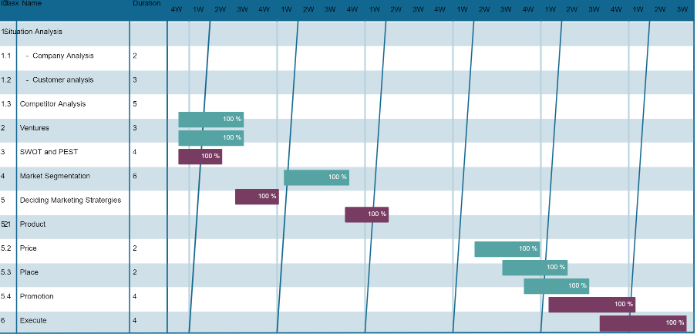
Appendix 5:KPIs and Metrics

KPIs | Metrics
Website Traffic | - Total number of website visits
 | - Unique website visitors
 | - Page views per visit
 | - Average session duration
Social Media Followers | - Total number of followers on each platform
 | - A growth rate of followers
 | - Engagement rate (likes, comments, shares)
Engagement Rate | - Social media engagement rate
 | - Email open rates
 | - Click-through rates on email campaigns
Conversion Rate | - Conversion rate on the website
 | - Click-through rate on promotional campaigns
 | - A booking completion rate
Customer Satisfaction | - Net Promoter Score (NPS)
 | - Customer feedback and reviews
Return on Investment | - Revenue generated from marketing efforts
 | - Cost per acquisition (CPA)
 | - Return on Ad Spend (ROAS)

