Task 1:

a) Fundamental Electrical Quantities:

- Charge (Q):
- The fundamental unit of electrical charge, the electron's charge (represented by the letter e), is the quantity of electricity that is transported across a circuit. The unit of charge is the Coulomb (C).

- Current (I):
- The flow of electric charge, or the speed at which charge passes through a conductor, is measured in amperes (A).

- Electric Field (E):
- The electric field, which defines the area around charged particles where forces operate on other charged things, is measured in volts per meter (V/m).

- Potential Difference (Voltage - V):
- The electric potential energy per unit charge, or voltage, is expressed in volts (V) and drives the flow of electric charge.

- Resistance (R):
- Resistance, measured in ohms (Ω), opposes current flow and impedes the smooth passage of electric current.

- Capacitance (C):
- Capacitance, which is expressed in farads (F), is a measurement of a system's capacity to hold electrical charge.

- Electromotive Force (EMF):
- EMF is a unit of measurement for voltage generated by any electrical energy source, including batteries, and is expressed in volts.

- Conductors:
- materials that make it simple for electric current to flow.

- Insulators:
- materials that impede the flow of electric current.

b) Energy Transfer into and out of Circuits:
Within electrical circuits, energy transfer entails transforming one type of energy into another.

Ex:

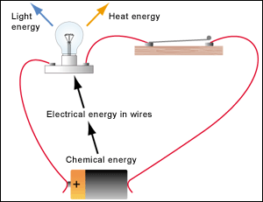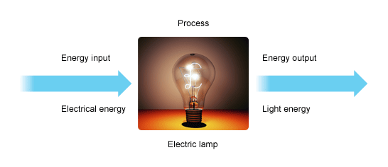

1. Energy Input into Circuits:
- Voltage Source:
A voltage source, such a battery or generator, is the main energy source that enters a circuit. The potential difference produced by the voltage source is what propels the flow of electric charge.

- Chemical Reactions (in Batteries):
Batteries work by releasing energy through chemical processes inside the cells, which create an electromotive force (EMF) that drives electrons across the circuit.

- Mechanical Energy (in Generators):
Generators convert mechanical energy, often from turbines or engines, into electrical energy through electromagnetic induction. The relative motion between magnets and conductors induces an electromotive force.

- Photovoltaic Effect (in Solar Cells):
Through the photovoltaic effect, solar cells directly transform light from the sun into electrical energy. A semiconductor material's electrons are freed by photons from sunshine, creating a current flow.
2. Energy Transfer within Circuits:
- Power Dissipation:
Electrical energy is transformed into heat when it passes through resistive components in the circuit, such as resistors or other components having resistance. Joule's Law (P = I²R) describes this process, in which heat is released from the power in the resistive components.

- Work Done by Electrical Components:
In some cases, electrical energy is converted into other forms of energy within specific components. For example, in electric motors, electrical energy is converted into mechanical energy.

3. Energy Output from Circuits:
- Power Consuming Devices:
Electrical energy is used by circuit-connected devices, such lightbulbs, motors, and electronic devices, to carry out operations or offer services.

- Radiation (in Antennas):
Electromagnetic waves are the energy that circuits emit in some applications. This is typical of antennas, which convert electrical energy into radiofrequency waves for transmission.

- In summary, voltage sources allow energy to enter electrical circuits. Once inside, the energy changes and moves among circuit components before being either consumed by the devices or released as heat, light, or other energy. It is essential to comprehend these energy transfer mechanisms to develop dependable and effective electrical systems.

C) Types of DC Voltage Sources and Their Working Operations:
- Battery:

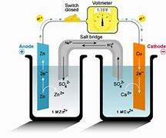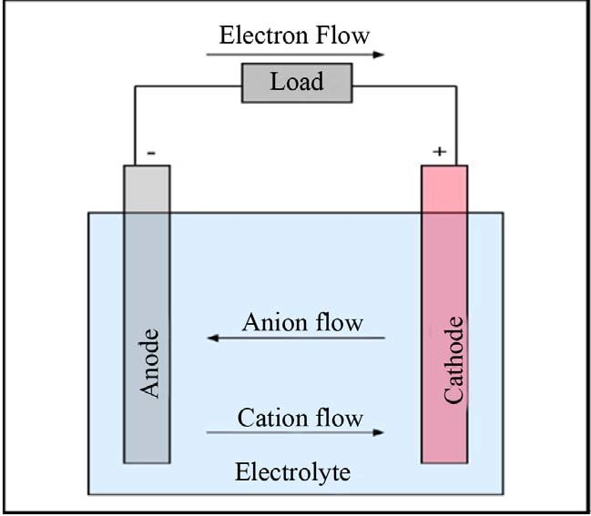

Working Operation:
Batteries consist of one or more electrochemical cells. Each cell contains two electrodes (anode and cathode) and an electrolyte. During a chemical reaction, electrons are released at the anode and absorbed at the cathode, creating a potential difference (voltage) between the terminals. This potential difference, or electromotive force (EMF), drives the flow of electrons in an external circuit.
- Generator:

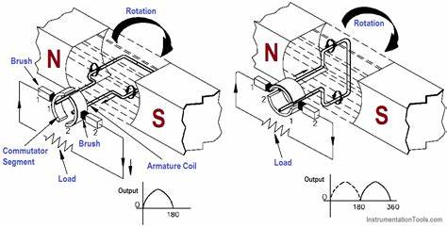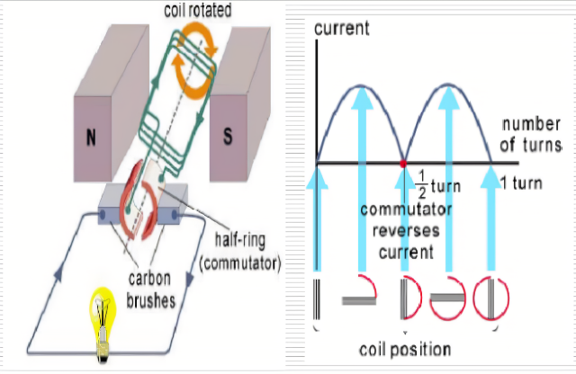
Working Operation:
Generators convert mechanical energy into electrical energy through electromagnetic induction. A coil of wire is rotated within a magnetic field. The changing magnetic flux induces an electromotive force (EMF) in the coil according to Faraday's law of electromagnetic induction. This induced EMF creates a potential difference that drives the flow of electrons in a connected circuit.
- Solar Cell (Photovoltaic Cell):

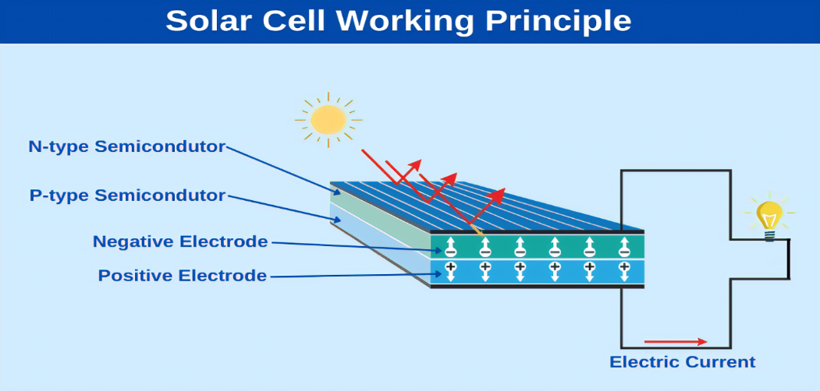
Working Operation:
Solar cells convert sunlight directly into electrical energy through the photovoltaic effect. The cell is made of semiconductor materials such as silicon. When photons from sunlight strike the semiconductor, they release electrons, creating a potential difference across the cell. This potential difference drives the flow of electrons, generating electrical current.

- Fuel Cell:
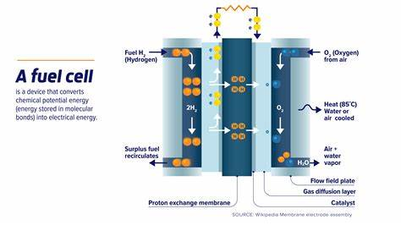

Working Operation:
Fuel cells generate electricity through an electrochemical reaction between hydrogen and oxygen. Hydrogen gas reacts with oxygen in the presence of an electrolyte, releasing electrons and forming water. The released electrons create an electromotive force (EMF) that drives the flow of electrons in an external circuit, producing electrical energy.

Task 2:
- Measure Voltage Across Resistors:

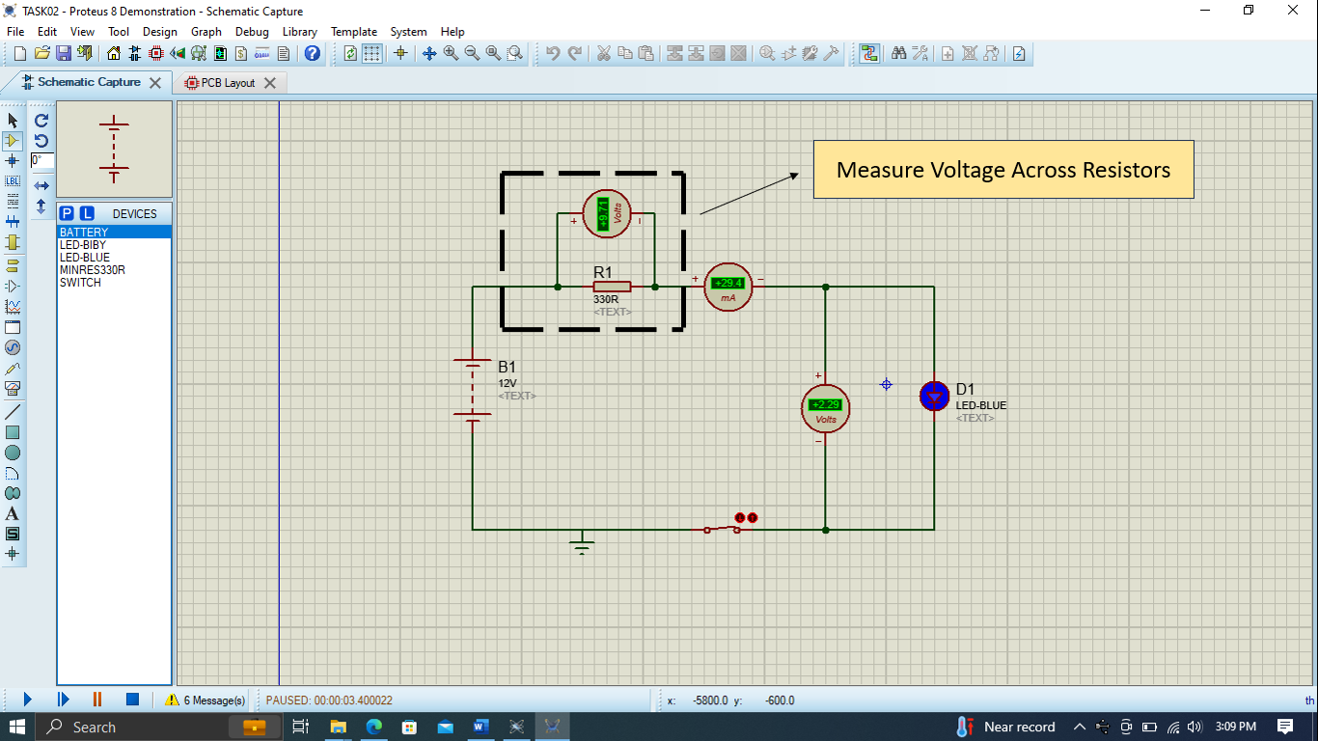

Explanation:
1.Voltage Source (V): Represents the voltage across the resistor.
2. Resistor (R): The resistor whose voltage is to be measured.
3.Voltmeter (V): Connect the voltmeter in parallel with the resistor to measure the voltage across it.
Function:
The voltmeter measures the potential difference across the resistor, providing the voltage value.

- Measure Current Across an Electronic Component:

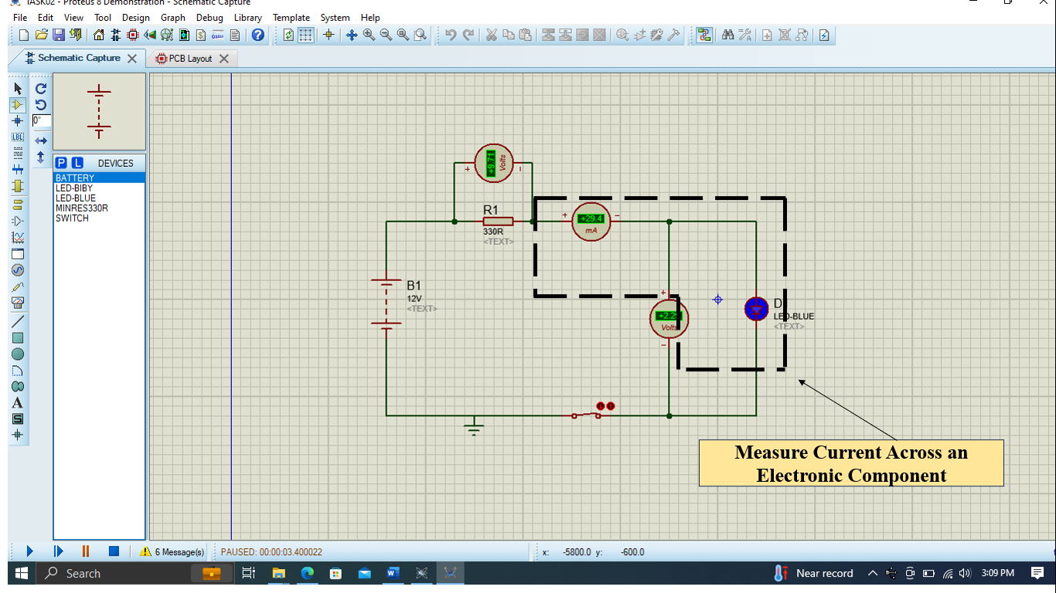
Explanation:
1.Current Source (I): Represents the current flowing through the electronic component.
2.Electronic Component: The component (e.g., a resistor) through which the current is flowing.
3. Ammeter (A): Connect the ammeter in series with the electronic component to measure the current flowing through it.

Function:
The ammeter measures the current flowing through the electronic component, providing the current value.

- Measure Total Resistance:

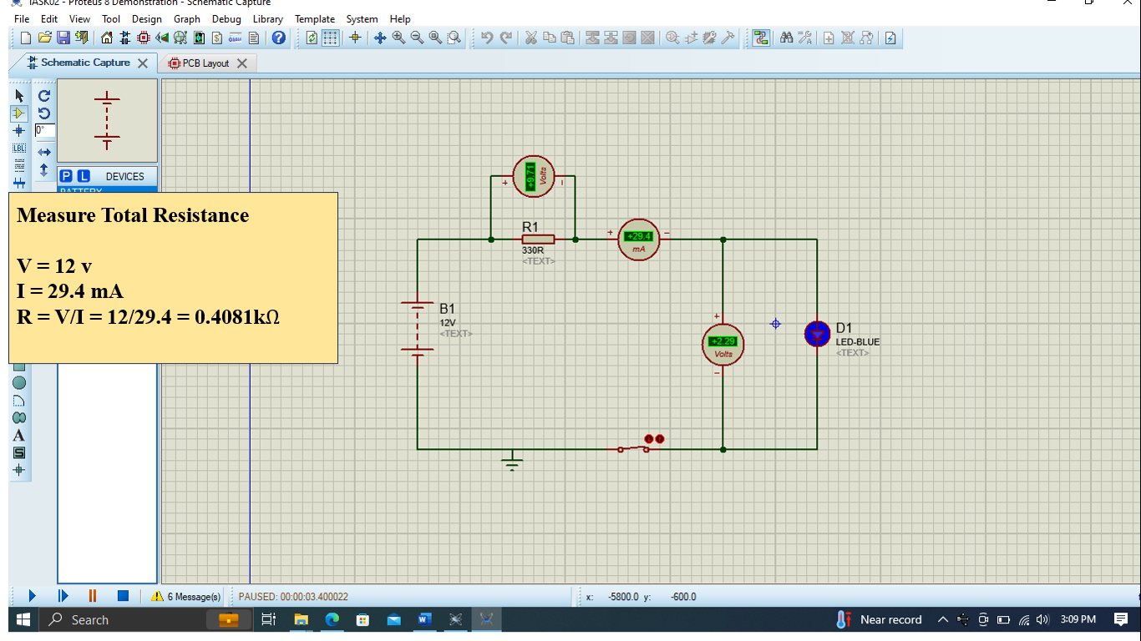

Explanation:
1. Voltage Source (V): Represents the voltage applied across the circuit.
2. Resistors (R1, R2, R3, ...): The resistors in the circuit whose total resistance is to be measured.
3. Ammeter (A): Connect the ammeter in series with the resistors to measure the total current flowing through the circuit.
4. Voltmeter (V): Connect the voltmeter across the entire circuit (from one end to the other) to measure the total voltage across the circuit
Function:
The ammeter measures the total current flowing through the resistors, and the voltmeter measures the total voltage across the circuit.
The total resistance (R total) can be calculated using Ohm's Law:
R = V \ I (V is the total voltage and I is the total current.)

Task 3:
Student ID - 2230692
$R_{1}- 2Ω$ (the first digit of the student ID)
$R_{2}- 2Ω$ (Second digit of the student ID)
$R_{3}-$ $2Ω$ (the last digit of the student ID)
- by Ohm’s law, potential divider, current divider.
Calculation:
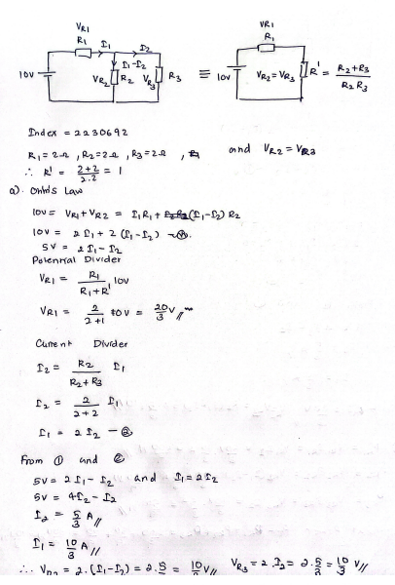
Answer: VR1 = 6.6667 V
VR2 = 3.3333 V
VR3 = 3.3333 V
- by Kirchhoff’s current law.
Calculation:
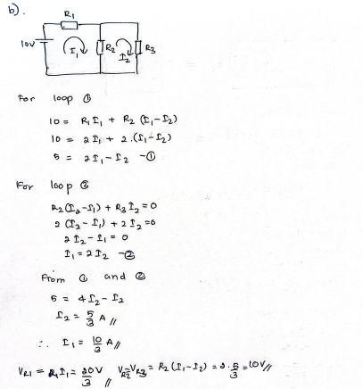

Answer: IR1 = 3.3333A
IR2 = 1.6667A
IR3 = 1.6667A

- Determine the power in each resistor and the total power of the circuit.

Calculation: P = VI
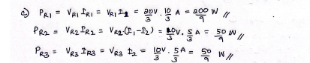
Answer: p1 = 22.2222W
P2 = 5.5556W
P3 = 5.5556W

Design the circuits using appropriate simulation software (Proteus)

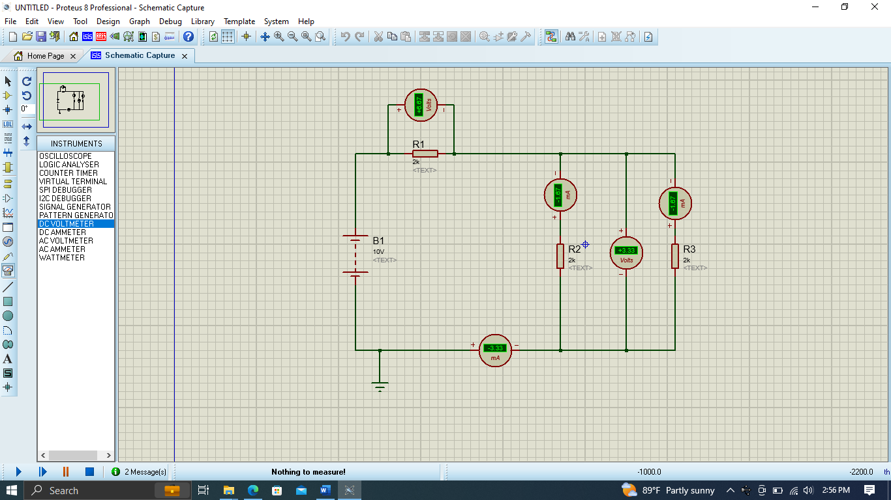

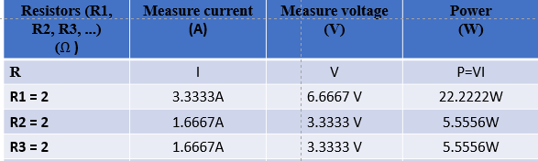

total power of the circuit = (22.2222+5.5556+5.5556) W
= 33.3333W

Task 4:
The circuit elements in the power supply unit:

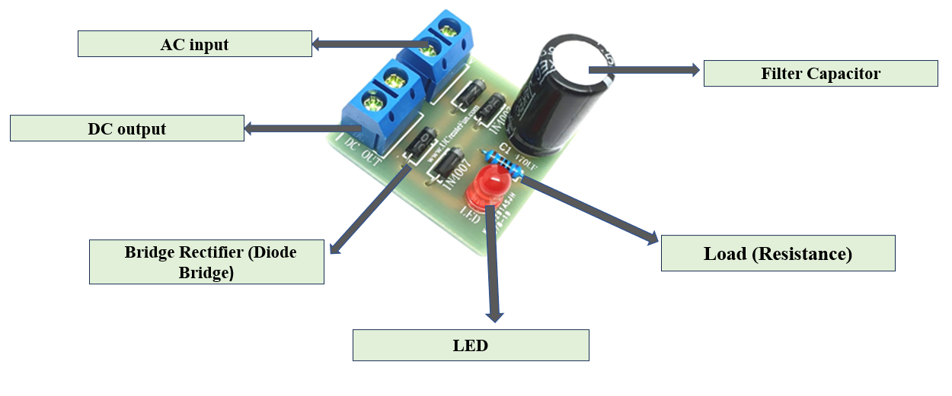
to change an AC (alternating current) into a DC (direct current). It makes use of four arranged diodes. In power supply applications, a circuit arrangement frequently utilized in a bridge topology is a bridge rectifier. The parts of a bridge rectifier circuit and their respective purposes are listed below.:

1. Transformer:
Function/Role:
The input AC voltage is changed by the transformer to the appropriate level. Before the voltage is delivered into the bridge rectifier, it steps it up or down.

2. Bridge Rectifier (Diode Bridge):
Function/Role:
The circuit's primary element is the bridge rectifier. It can correct AC voltage since it is made up of four diodes placed in a bridge arrangement. The diodes operate in pairs, allowing electricity to flow continuously in one direction.
3. Filter Capacitor:
Function/Role:
The filter capacitor is positioned after the bridge rectifier and soothes ssthe rectified output by releasing electrical energy during troughs and holding it during peaks. This aids in lessening the DC voltage's ripple and oscillations.

4.Load (Resistance or Electronic Device):
Function/Role:
The part or appliance that rectified DC output powers is known as the load. It may be a resistor, an electronic circuit, or any other gadget that needs a steady source of DC power.

