University of Wales Trinity Saint David
Wales Institute of Science & Art



Investigation of the characteristics of a Van Diemen Single Seater Front Suspension System
Motorsport Technology (ACHA4012)

Ben Slade
2104137
December 2021
Table of Contents
1. Introduction 2
2. Laboratory Sessions 3
3. WinGeo Kinematic Simulation 7
4. Suspension Calculations 14
5. Validation 15
6. Conclusion 17
7. Reference List 18

Introduction
This report will discuss how the front suspension system of a Van Diemen Single Seater. This vehicle is used within the racing series Formula Ford, and it is an foundation division to Formula One. The aim of this report is to gain an understanding of how the suspension operates under differing conditions such as wheel displacement and roll, and how these factors influence Camber, Toe and the Motion Ratio of the vehicle. The Suspension System that is found on this vehicle is Independent Dual wishbones.

Laboratory Sessions
  - Equipment
In this session we used multiple pieces of equipment to gather our readings. These were:
- Formula Ford Test chassis.
- A Vernier Calliper to measure our damper length which is used to determine the spring compression. This tool was used as it is an accurate piece of equipment which can measure readings to a hundredth of a cm reliably.
- A Height gauge to measure the height of the wheel as the damper is compressed. This tool was used as it can reliably measure the height to 0.01 cm.
- A Camber Gauge to read the camber of the wheel.
- DTI gauges which are pressed against each side of the wheel to measure how the toe of the vehicle changes.
- Corner weight scale connected to a laptop to measure the unsprung mass.
- Spring compression tester to test the compression rate of the spring.
- Tyre stiffness rig which is a Hydraulic press which presses the tyre against a corner weight scale.

  - Methodology
The laboratory session consisted of four tasks, with each one being:
A suspension Kinematics test where a height gauge is fitted to the wheel of the test chassis with the spring and damper removed and with an adjustable linkage in place of it, along with a camber gauge and two DTI gauges on the face of the wheel to measure the toe. The readings of the camber and the linkage length should be taken, and the height gauge and DTI’s should be Zeroed. The adjustable linkage should be rotated twice and then all the readings should be taken. This task should then be repeated until the wheel position is approximately 50mm higher than where it originated.
An Unsprung Mass test, where a corner weight scale is connected to a computer, zeroed and then placed under the wheel of the test rig. This measures the weight of the wheel and suspension linkage when connected to the chassis. A reading should then be taken as the ‘Unsprung Mass on car’, and then the scale should be taken from under the wheel. The suspension linkage should then be disconnected from the chassis and then the scale be repositioned under the wheel again to measure the ‘unsprung mass off car’.
A spring stiffness test: where a spring is placed in a spring compression tester and then the scale of tester is zeroed. Then a DTI is fixed to the rig and zeroed when it is touching the scale. The rig then compresses the spring until the DTI has measured one revolution at which a reading on the scale is taken. This is repeated until the spring has been compressed by an inch.
A Tyre Stiffness test: in which a tyre is placed upon a tyre stiffness rig which has a DTI attached to the tester to measure how much it has been compressed. Then the scale and the DTI are both zeroed after the tyre pressure has been set to 20PSI. The rig then compresses the tyre by two millimetres (Two DTI rotations) and the reading on the scale is then recorded. This is repeated until the tyre has been deflected by 14mm.
  - Results
The Results of the Workshop Session are shown in the Below Tables and Graphs. The sessions provided data which can be used to calculate the spring stiffness, tyre stiffness and the Motion Ratio.
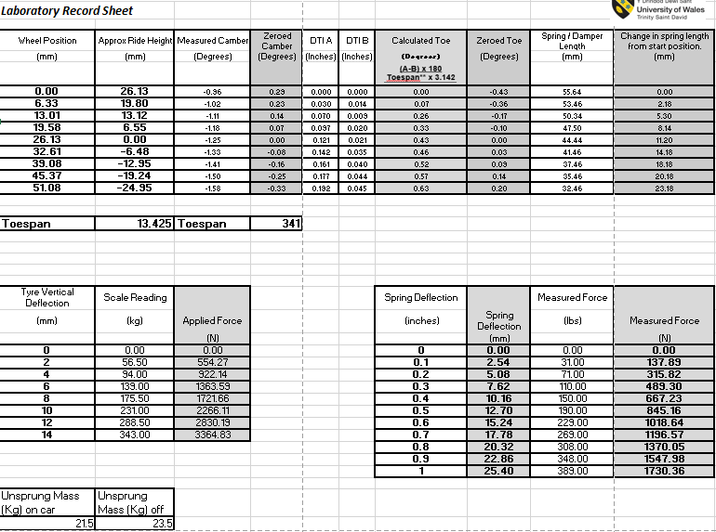 (Figure 2.3.1. Workshop session results)

(Figure 2.3.2 A Graph to show the Camber change with Ride Height)
This Graph shows that the camber of the wheel changes with the ride height in a consistent manor with the negative camber increasing the lower the vehicles is. This means the top of the wheel is closer into the center of the vehicle in relation to the bottom of the tyre. This means the camber increases over bumps or compression of the suspension, for example, cornering forces.

(Figure 2.3.3 A Graph to show Toe change with Ride Height)
This Graph shows that the toe of the wheels increases under compression in a generally linear manor above 0mm ride height. Under 0mm, the trajectory isn’t linear but continues the trend of less negative toe the lower it gets. This decreases cornering stability.

(Figure 2.3.4 A Graph to show the Spring Compression versus the wheel Deflection)
This Graph shows that as the wheel position rises, the spring compresses more in a linear pattern. This graph allows us to work out the Motion Ratio, which is the amount of spring compression in relation to the wheel movement, which in this case is 0.4617.

(Figure 2.3.5 A Graph to show the Spring Deflection versus the Applied Force)
This graph shows that the spring deflects as more force is applied to it, and that it deflects in a linear pattern. This graph also shows us the Spring rate in N/mm as 68.793, or 68793 N/m

(Figure 2.3.6 A Graph to show the Tyre Deflection Versus the Applied Force)
This graph shows that the Tyre deflects as more force is applied to it, and that it deflects in a linear pattern. This graph also shows us the tyre stiffness in N/mm as 234.07, or 23407 N/m

WinGeo Kinematic Simulation
  - Methodology
The WinGeo Kinematic simulation was carried out by loading in a vehicle model which has the exact same dimensions and suspension layout as the Formula Ford car. This is done so that it can be manipulated the same way as the real-world vehicle to show the theoretical results. Once the Formula Ford suspension model is opened in WinGeo, the ride height was manipulated from +/- 25mm in 5mm increments with the roll at 0 degrees. The results from this should be recorded into a table. The ride should be reset back to 0 and then the roll should be manipulated from 0 to 1.5 degrees of roll in 0.1 degrees increments. The results should then be recorded into a table.
  - Kinematics Results and Discussion
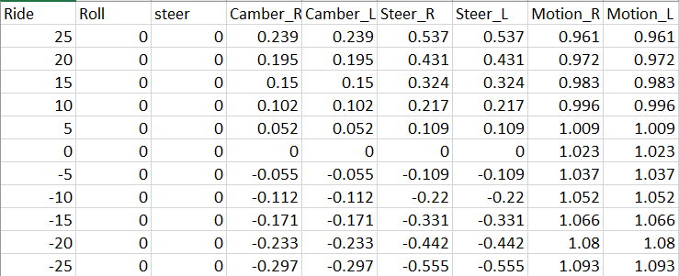
(Figure 3.2.1 WinGeo Ride height Results)
The raw results data from the WinGeo Kinematics simulation which outputs how the camber, toe steer and motion ratio change when the ride height is manipulated. This can be used to be made into graphs to gain a better understanding of the results

(Figure 3.2.2 WinGeo Graph of Ride height Versus Camber, Toe steer and the Motion Ratio)
This graph shows the relationship between camber, toe steer and the motion ratio. As the ride height increases, the camber and toe steer also increase. The opposite happens with the motion ratio. Although only three lines are visible on the graph, there are 6 data sets present as mentioned in the legend. This is because both the right and the left sets of data are identical for camber, toe steer and the motion ratio.

(Figure 3.2.3 WinGeo Graph of Camber versus Ride Height)
The graph shows an upwards trajectory between the relationship of camber and ride height. As ride height increases, so does the positive camber, however it isn’t linear.

(Figure 3.2.4 WinGeo Graph of Toe steer versus Ride Height)
The graph shows the linear relationship between ride height and Toe steer, as ride height increases so does toe steer.
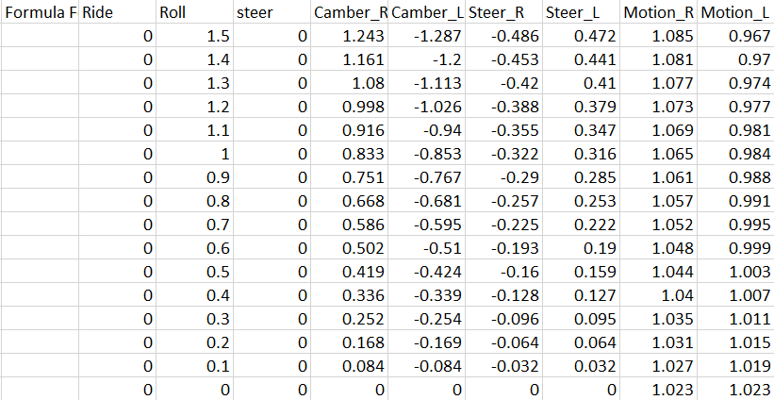
(Figure 3.2.5 WinGeo Roll Simulation Results)
The WinGeo results of how camber, toe steer and the motion ratio is influenced by the Roll.

(Figure 3.2.6 WinGeo Graph of cambers versus Roll)
The graph shows how a change in the roll of the vehicle influences the camber of the wheels. As one wheel increases in camber, the other decreases. This would be expected because as one wheel increases load due to cornering, its height to the ground decreases, and the other side raises up due to the weight being transferred to the other wheel.

(Figure 3.2.7 WinGeo Graph of Toe steers versus Roll)
This graph shows the relationship between the toe steer of the wheels under roll. This is similar to Figure 3.2.6 as the roll effectively lowers one side of the vehicle and raises the other. This results in the side that is lowered to increase in negative toe steer and the other to decrease in negative toe steer.

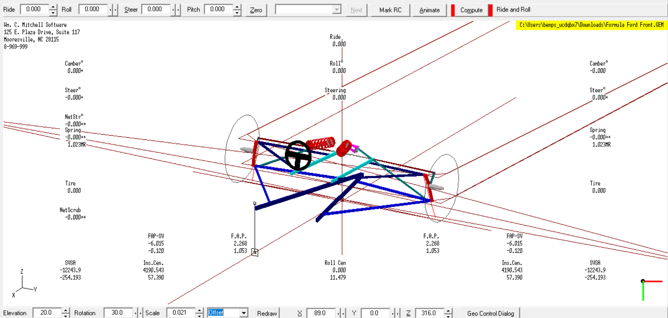
(Figure 3.2.8 WinGeo Model Offset View)
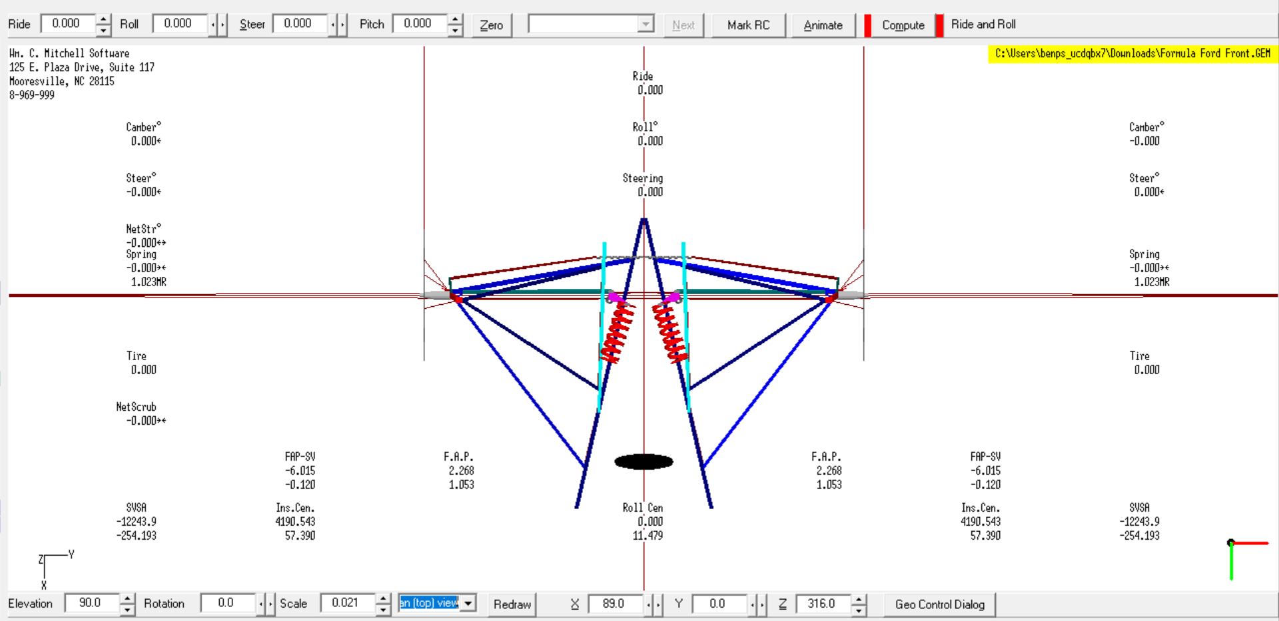
(Figure 3.2.9 WinGeo Plan View)
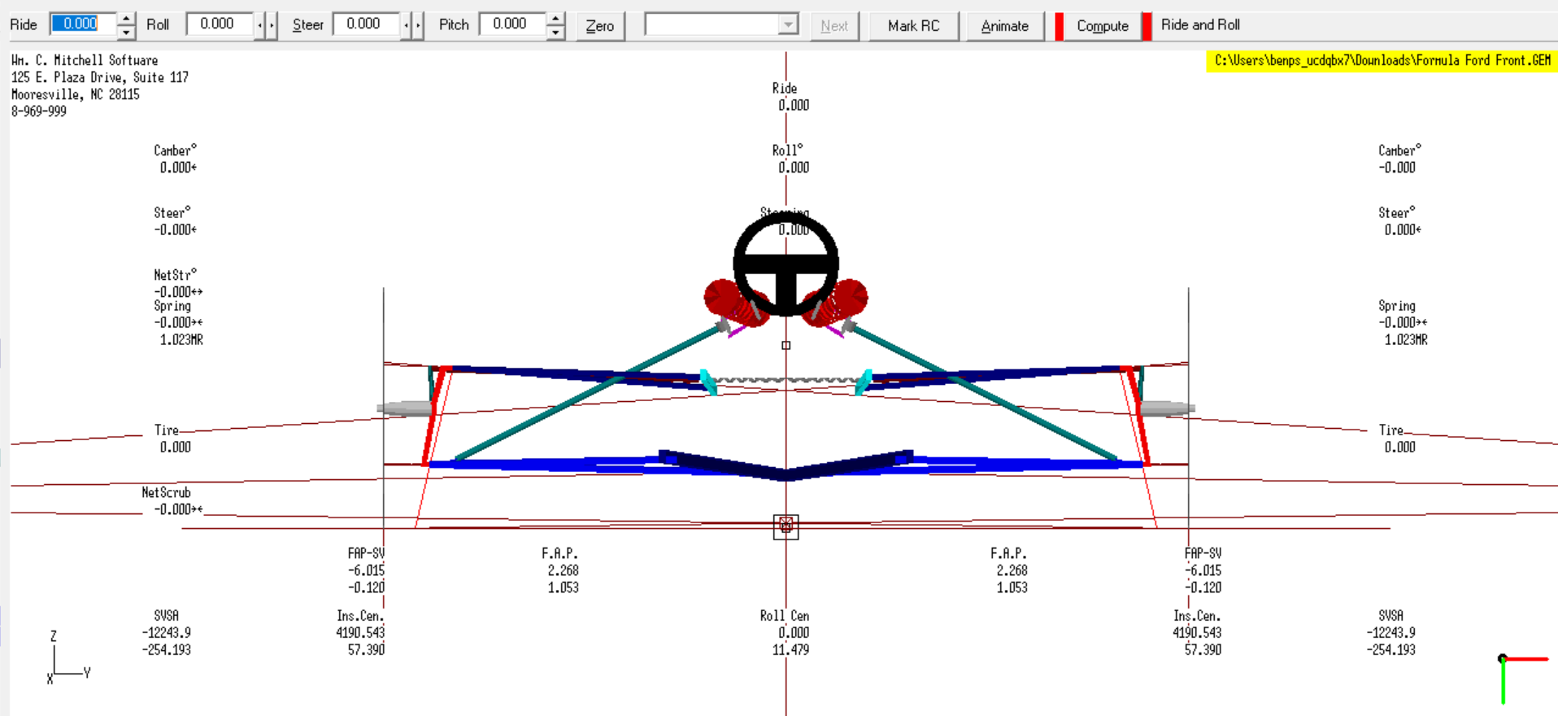
(Figure 3.2.10 WinGeo Standard View)
From the above screenshots of the WinGeo Model and results tables, the Roll Centre, Instant centre and Motion Ratio at 0 Roll and 0 Ride can be determined as:
RC Height: 11.479mm
RC Lateral: 0mm
Instant Centre height: 57.39mm
Instant Centre Lateral: 4190.543mm
Motion Ratio: 1.023
  - RC Migration
The Roll centre (RC) will change from being purely in the centre laterally due to it experiencing both bump and roll the same time, which results in its migration away from the middle. As Spender, J (2019) states in their article for Whiteline Performance UK, “The RC is a virtual point at which the chassis interacts with the centre of gravity to create weight transfer and roll”.
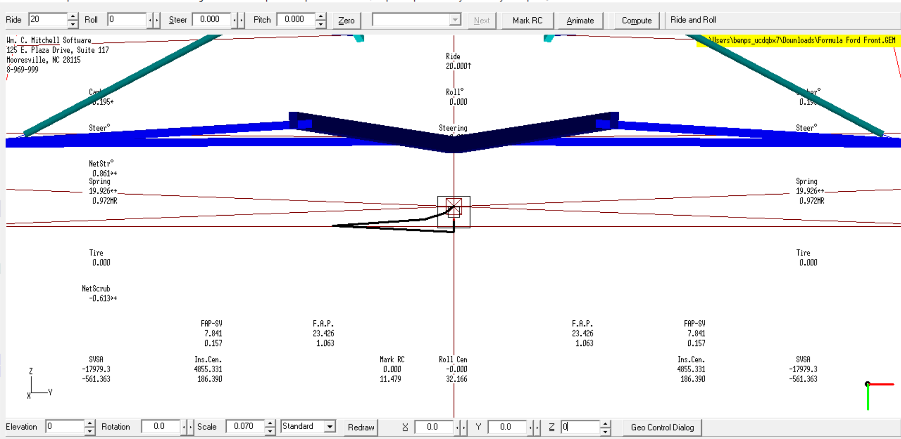
(Figure 3.3.1 WinGeo RC Migration)
The above diagram shows how the RC migrates under braking and cornering as the front of the car sinks under braking which sends the RC into the floor. When steering is added and the body rolls, the RC also shifts sidewards. When the braking is let off and the RC rises out of the floor while still at full roll, it migrates to a more central position. This is because when the RC is under the ground, more weight is transferred through the springs instead of the sprung mass which makes body roll more pronounced.

Suspension Calculations
  - Calculations
With the data produced from the Workshop sessions and the WinGeo Simulation, Calculations can be made to determine other information. This other information is the Wheel rate, sprung mass natural frequencies and unsprung mass natural frequencies.
The Sprung corner mass (Ms) is equal to the total corner mass – Unsprung corner mass (Mus)
The wheel rate (Kw) is calculated with the following formula:
Kw = Spring rate * Motion Ratio ² = 68793 X 0.4617 ² = 14664.39 N/m
The Sprung Mass Natural Frequency is calculated with the following formula:
$f=\frac{1}{2π}\sqrt{\frac{Kw}{Ms}}$ $=\frac{1}{2π}\sqrt{\frac{14664.39}{150}}$ = 1.573644 Hz
The Unsprung Mass Natural Frequency is calculated with the following formula:
$fus=\frac{1}{2π}\sqrt{\frac{Kw+Kt}{Mus}}$ $=\frac{1}{2π}\sqrt{\frac{14664.39+234070}{21.5}}$ = 25.44059

  - Discussion
In their article for DR Tuned, Routley, D (2017) describes the sprung mass natural frequencies for different types of vehicles. The Formula ford car is a formula vehicle with moderate to low downforce, and our calculated $f$ is 1.573644 Hz which fits within Routley’s table.

0.5-1.0Hz | Passenger cars, typical OEM
1.0-1.5Hz | Typical lowering springs
1.5-2.0Hz | Rally Cars
1.5-2.5Hz | Non-Aero racecars, moderate downforce Formula cars
2.5-3.5Hz | Moderate downforce racecars with up to 50% total weight in max downforce capability
3.5-5.0+ | Hz High downforce racecars with more than 50% of their weight in max downforce

Validation

(Figure 5.1 A graph of WinGeo versus Measured Camber)
This graph compares the camber recorded from the WinGeo and workshop sessions results. Both results show the same relationship of a lower ride height also increasing the negative camber. The workshop readings show a steeper trajectory than that found in the WinGeo’s results. This could be from many factors such as the equipment being faulty or inaccurate, or from other suspension components being faulty, not entirely rigid or the same length as the WinGeo models. I think that it will be a mixture of user error with measuring as the accuracy of adjustments made and/or the measuring could be slightly out due to human error. The model could also be slightly different to the chassis rig due to the rig being used and worn.

(Figure 5.1 A graph of WinGeo versus Measured toe)
This graph compares the readings of Toe from WinGeo and the workshop sessions. The results from there are contradictory as the WinGeo results show that the higher the ride, the more positive toe, but the workshop results show that the higher the ride, the less positive toe there is. This is likely due to human error when recording the results such as mixing up the DTI readings in the calculation or an error when carrying out the WinGeo simulations. Aside from the opposite trajectories, the WinGeo results create a smooth linear line whereas the workshop results show the toe isn’t linear through its stroke. This is likely due to a measuring mistake as the readings must be extremely accurate.

Conclusion
In Conclusion, the WinGeo model can produce near to real readings for a suspension systems’ kinematics when used correctly. However, there can be discrepancies between it and the real-world vehicle due to the model not being 100% accurate as factors like wear and slight manufacturing defects can make the real-world suspension slightly different to the model. The WinGeo model also doesn’t consider the material elasticity and how different temperatures can affect the length and geometry of the suspension components. These factors can lead to slight differences. Both methods show the same trend between ride height and camber but due to possible user error, the reading for toe is different.

Reference List
Routley, D. (2017). DRTuned Racing. [online] DRTuned Racing. Available at: https://www.drtuned.com/tech-ramblings/2017/10/2/spring-rates-suspension-frequencies
Suspension Secrets. (2017). Toe - How to Adjust and Tune - Suspension Secrets. [online] Available at: https://suspensionsecrets.co.uk/adjust-tune-toe/#:~:text=Rear%20Wheel%20Drive%201%20Front%20Wheels%202%20Toe,the%20car%20due%20to%20the%20tyre%20rolling%20
Spender, J. (2019). What is roll centre? And how does ride height affect it? [online] Whiteline Performance UK. Available at: https://ukwhitelineperformance.com/blogs/whiteline-blog/what-is-roll-centre-and-how-does-ride-height-affect-it
‌

‌

