

Reflective report in promoting further community engagement in recyclable

Course work

Models and Principles of Community Engagement

Name: Georgina Loredana Nedelcu
Student ID: 2018584.

Table of Contents
Reflective Introduction 3
Background to community engagement in recyclable reflection 3
Reflection on the practice to community engagement in recyclable 4
Reflectiveness of relationship and networking with community engagement in recyclable 6
Reflecting on recycling targets………………………………………………………………………………………………………8

Conclusion………………………………………………………………………………………………………………………………………..9_Toc70882491

Reflective Introduction
Looking into the course work of community engagement in recyclable attentively, using the 3R’s (Reduce, Reuse & Recycle) of waste management deployed in the course work as a methodology to recyclable improvement of overall waste management processes with the help of community engagement terminologies and these terminologies are communication, informing, consultation, involvement, collaboration, intervention, top down engagement and ground up engagement. These techniques will sustain community engagement in recyclable and protect people from environmental pollution and the planet as well.
Applying the 3R’s of waste management with community engagement principles shows how recycling can be done and communicated effectively in our communities by reducing waste to landfill. One of the highest pollution to our planet is packaging consumption because this packaging’s are found all over the place, such as retails, manufacturing, pharmaceutical, household, food and day to day provisions. These uncontrolled packaging have increased our pollution in our communities, and we need good waste controlling policies and community engagement activeness.
This coursework reflects on community engagement in recyclable, which is a reflection on a course work for community engagement using recyclable as the drive to community engagement. The course work also focusses on the 3R’s (Reduce, Reuse & Recycle) of waste management and community engagement models that leads to sustainable environment. The reflection also captures the use SMART GOALS Tool that was incorporated with the community engagement in recyclable and the 3R’s, as a SMART RECYCLABLE GOALS.

Background to community engagement in recyclable reflection
Community engagement in recyclable effects would definitely reduce green gas due to the knowledge the community have acquired through community engagement relationships and implementation of the 3R’s (Reduce, Reuse & Recycle) of integrated waste management.
Actually, the project of the community engagement in recyclable has clearly formed the determination to simplify each stage of the recycling objectives to the community about the recyclable outcomes through communication, informing, consultation, involvement, collaboration, intervention. In addition to this, the SMART GOALS tool will be incorporated with the community engagement in recyclable and the 3R’s, as a SMART RECYCLABLE GOALS – the aim and goals Community engagement in recyclable will be defined clearly, as stated in the above introduction area, the engagement plan(s) will be establish according with the models of community engagement, as well as those participating and benefits will be realistic and achievable within the time scale of each phase of the community engagement in the recyclable project.
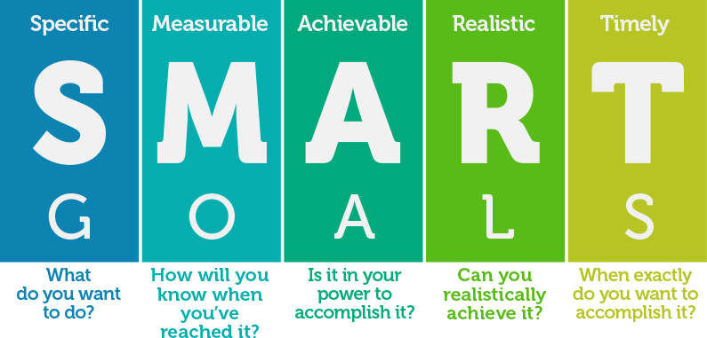
Source: Class presentation / https://eprints.qut.edu.au/10582/1/10582.pdf
Everyone that is involved in the recyclable project to promote clean environment will understand the targets that are set in each phase of the community engagement in the recyclable project. The targets of the community engagement in recyclable applying the 3R’s of waste management will be measured and this approach will ensure that the people in the community understood the whole thing involved in the recycling and waste reduction. Then, we will confident about the project of community engagement in recyclable that those targets set out will be encountered.
Reflection on the practice to community engagement in recyclable
To multiply our social relationship, we need to deeply understand the human needs. Applying SMART technique, define the Principles and Values of our communities, establishing some Standards, create Community Mapping, using Forum technique, create social media as: Facebook, Twitter, Instagram, Messenger, WhatsApp, Pinterest and implement Community Surveys by getting feedback from the people to engage with the Society in their surroundings, we are creating an Ecosystem. Also defining the type of Engagement matters about to the people needs by creating and a Timeline Plan and examine the Community Assets. This means that We are the EMPOWERING the people to succeed in recycling and help our Environment at the same time.

The greatest concepts about the practice to community engagement in recyclable is that it improves waste management in the community and to solve problems of non-recyclable items as well. These effects are linked to economic, social and environmental sustainability. For example, if we recycle more household items, like paper, cans or plastic bottles, we will reduce the energy and water consumption used to produce plastic bottles or paper. This will help to decrease the amount of household waste in our community that is going into landfill or even incineration process – meaning, CO2 produced in community will decrease a lot (Miller, 2012, p 410 – 411).
In addition, the community engagement in recyclable project is based on economic movement that is essential of human development when the environment changes by social expansion or even communal growth in the community. Then, there is a range of change to the community and human social economy growth will unavoidable cause massive change to the environment. This indicate the link between our economy, community engagement in recyclable and the environment we lived in. Consequently, it is vital for this subject matter to be promoted, supported by governments, private industries and everyone in our community because it leads to the sustainability of our social economy growth and the environment (Liu, 2009, p 41 – 46).

Therefore, this is now associated with social connectedness and empowerment to people in the community of community engagement in recyclable project, due to the compassion that the people have for their environment, as a social linkage as well.

Community engagement in recyclable influence
- Will overcome social isolation
- Will creating access to opportunity
- Will encourage learning and talent upskills
- Will encourage positive thinking
- Will promote their moral standards
- It lookout for the growth in the community
- Brings community integrity
The above points were taken from class presentation - university of wales, models of community engagement

Source: https://geo300summer.files.wordpress.com/2012/08/5.jpg

Community Engagement approach, community planning, teamwork, collaboration, feedbacks, smart goals, participation, culture quality and quantitative approach, and without community engagement principles, a project in a community will not be fair, even if when it is called a successfully project.

Reflectiveness of relationship and networking with community engagement in recyclable
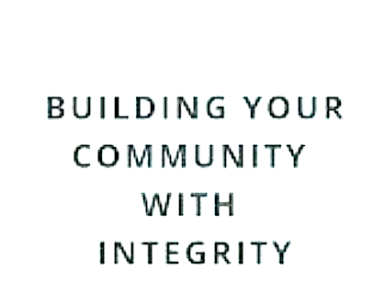
In order to launch operational relationship and networking with community engagement in recyclable with the people in our communities, we must be creative with ideas that can attract the people to come and engage in the platforms we are promoting. This can be done with an incentive to motivate the people or a raffle with a chance to win a voucher, price or any items relating to the community through an online campaign and social medial engagement. Informal interview or events can aid the sharing of ideas and any concerns as well. The informal interviews deliver the chances for community engagement in recyclable workforce to discuss and network with the people in the community. By so doing, the workforce will learn some history the people, the community as a whole and include these findings along with the smart goal objectives and community engagement principles in this project. In addition, they will advance their awareness about waste reduction problems and involve the community people about the 3R’s of waste management and the future plan for the community.
The relationship and networking will focus on reaching out to the community in an operational routine broadcasting, social medial, visiting particular areas and find out how the recyclable project will work in the community with aim of community integrity, climate change programs and economic benefits to the society. Source: https://carolineleon.com/building-your-community-with-integrity
Also, during the process of building the community with integrity and interacting with the people, about community engagement in recyclable. The project owners and drives, will create a practicable framework that aligns with different method of community engagement standard and activities to stimulate the recyclable project. They must understand that the information provided to the people should be transparent and reviewed with them from time to time, as this will serve as a guide to them. The project owners and drives will be aware that there’s no role for any form of discriminatory within the community engagement in recyclable project and they have to pay attention to time because it is valuable to everyone. The guide should also include the benchmark of other communities as a learning practise, comparison and improvement processes through discussions. As we may already know from our presentation class, the community engagement process needs to reflect on fairness and equality for the people in the community to engage fully.
Sustainability and social inclusion. The social inclusion with the community involve all age, sex and race to participate in recycling and promote free speech about the project. This means that the recyclable project is connecting to the quality of life with everyone in the community by reducing waste and pollution. As a result of the implementation of the recyclable project comprehensively with the contribution of the 3R’s of waste management will lead to clean environment and good health to the people in the community. This good practices of the 3R’s of waste management results will be recorded and shared with lessons learned.
Reflecting on recycling targets
UK together with EC Member States, they have the target to recycle 50% of household waste by 2020. The UK analysis, for example we see a slow growth in recyclable by every year. This is due to lack of Community Engagement because the people are not informed about the theories of 3 R’ of waste management. Applying the 3 R’s will make a better recycling either in the UK or in the EC Member States.
Looking forward to the future and the way recycling rate is growing in our communities using the 3R’s of recyclable waste management ideas, this shows that more people are recycling their household waste. The community engagement in recyclable networking will grow and the people in the community and people will be attentive to recyclable matters and they will be promoting waste management programs and implement the 3R’s of recyclable as part of their daily activities. Comprehensively, community engagement rises the encouragement and ability to reach desired changes for the community in almost any scenario, together with the implementation of waste management programs that will contribute to recycling behaviour in the communities.
Table 1. Waste from Household (WfH), UK and country split, 2015-2018. The figure includes IBA metal.
Year | Measures | UK Total | England | Northern Ireland | Scotland | Wales
2015 | Arising  Of which Recycled  Recycling rates | 26.675  11.865  44.5% | 22.225  9.849  44.3% | 818  344  42.1% | 2.354  991  42.1% | 1.278  681  53.3%
2016 | Arising  Of which Recycled  Recycling rates | 27.300  12.318  45.1% | 22.770  10.217  44.9% | 845  366  43.3% | 2.378  1.018  42.8% | 1.307  716  54.8%
2017 | Arising  Of which Recycled  Recycling rates | 26.897  12.250  45.5% | 22.437  10.139  45.2% | 843  390  46.3% | 2.345  1.019  43.5% | 1.271  702  55.2%
2018 | Arising  Of which Recycled  Recycling rates | 26.411  11.896  45.0% | 22.033  9.840  44.7% | 841  401  47.7% | 2.292  981  42.8% | 1.244  673  54.1%
Source: https://assets.publishing.service.gov.uk

Conclusion
Overall, this report of community engagement in recyclable is down to individuals to reduce the waste and learn how recycle their household waste by Reducing, Reusing and Recycling their cans, reusing the plastic bags, bottles and papers. We should all encourage everyone around us to do the same and this will create a good impact to our environment. All we need to do is to educate others and share helpful information or tools on how to reduce waste and to use the 3R’s to recycle. Especially, using social network platforms to promote this subject and applying community engagement models.
Community engagement in recyclable helps to reach out to the people in community through the opportunity to provide public meetings for consultations to groups in the community and to concentrate to their stakeholders. This type of consultations permits direct communication, that allows data collecting, analysing and to be clear about the community engagement objectives, with the data of the feedback received. It also identifies the number of stakeholders that are willing to engage fully. However, when planning community engagement meetings, there are certain things to consider the people in the community. These considerations should reflect and capture the location, number of people, duration of the meeting, childcare, community input and appropriate information etc. The community engagement method should also consider focussing on smaller groups meetings, so that the recyclable goal can be communicated effectively to the people, and they will have the opportunity to feel comfortable to ask questions about 3R’s of waste management as well.
The benefits relating to community engagement in recyclable is massive to people, community, and our planet. This include ecology improvement, natural resources, climate change, reduction of carbon, collaboration between stakeholders and shareholders, identifying risks in recyclable and mitigating the risks in waste management as a whole. At the moment, the community engagement in recyclable coursework has expanded my knowledge on community engagement planning and on environmental awareness, such as emission.

Reference
Class presentation / https://eprints.qut.edu.au/10582/1/10582.pdf
Table 1/: https://assets.publishing.service.gov.uk accessed on 04.05.2021.
Miller, T. G., & Spoolman, S. (2012). Environmental science (14 ed.). Belmont, CA: Brooks/Cole.
Liu, H. (2009, May 1). Investigation of Relationship between Economy and Environment. Journal of geography and geology p. 42-46, accessed on 01/05/2021
https://geo300summer.files.wordpress.com/2012/08/5.jpg, accessed on 02/05/2021
https://carolineleon.com/building-your-community-with-integrity/, accessed on 02/05/2021

