Name- OLUMIDE OGUNYOYE
Lecturer- Dr AISHAT BAKRE
Student ID: 2507369
Module Code - LCHS4003_BIRM
Tittle- Task 1: Residential Care Home.
Task 2: Ambulance Services.
Submittion Date: MONDAY 23RD FEBRUARY 2026.

Staff are available 24/7, but doct
HISTORY
HISTORY
Residential care homes focused more on individual needs, independence, and choice, while governments introduced regulations and inspections to improve standards and protect residents. Today, residential care homes are part of wider health. When the monarch, King Aethelstan of England, saw some religious leaders using their money to care for the elderly, he helped fund the establishment of the UK's first care home in York. The religious group also used Bebehouses, a house of prayer that is also funded by wealthy members of society, who believed that providing care would make them accepted in heaven. .Bedesman and Bedeswomen live strictly by praying and worship, this is part of the care activities. The disabled patient and old vulnerable were also accepted in the home and later changed to First hospital. The elderly volunteer and disabled patient were also welcomed in the house before being transferred to First Hospital. Long-term and short-term treatment were always provided to patients at the first hospital, such as St. John's Hospital in Canterbury, which was established in 1087. For instance, patients with leprosy who wanted temporary admittance were treated there. Act 1601, sometimes referred to the Old People's Law, was created for the impoverished during Queen Elizabeth's reign. People who are unable to work are housed there. During the conservative administration of the 1980s, residential care homes became a large enterprise. Prior to the local authority, they dominated the market, but self-funded care homes later grew and tripled over the course of ten years in 1990 (Carehome.Co.Uk 2026).
INTRODUTION

A residential care home is an institute that provides residential care for old people with dementia and nursing services. A residential care home provides accommodation, meals, and personal care (like washing, dressing, and supervision) for people who cannot live independently but do not need constant medical care. Staff are available 24/7, but doctors and nurses usually visit rather than being on-site. Residential care homes play a significant role in long term care by providing essential services and support for older adults and individuals living with disabilities. Many residents with underlying medical conditions and reduced ability to function independently, they bank vividly on both their surroundings and the assistance available to them (Lawton and Nahemow ,1973)
CURRENT FUNTION OF RESIDENTIAL CARE HOME
INTRODUTION
CURRENT FUNCTION OF RESIDENTIAL CARE HOME
Residential homes focus on providing safe person-centered support for individuals who need help with daily living. Daily care includes assistance with personal hygiene, dressing, mobility, eating, and taking prescribed medication. Staff work closely with each resident to promote independence wherever possible, respecting personal preferences, routines, culture, and dignity. Care plans are regularly reviewed and updated to reflect changing needs. Care homes offer a variety of services for older people, including short-term respite care, nursing care and end-of-life care, as well as specialist support for those living with Alzheimer’s disease and other forms of dementia. 24 hours support also given, assisting them in the daily activities also making sure their safety is paramount. Moreso (Beaumont Manor Care Home in Front On -Sea 2025)
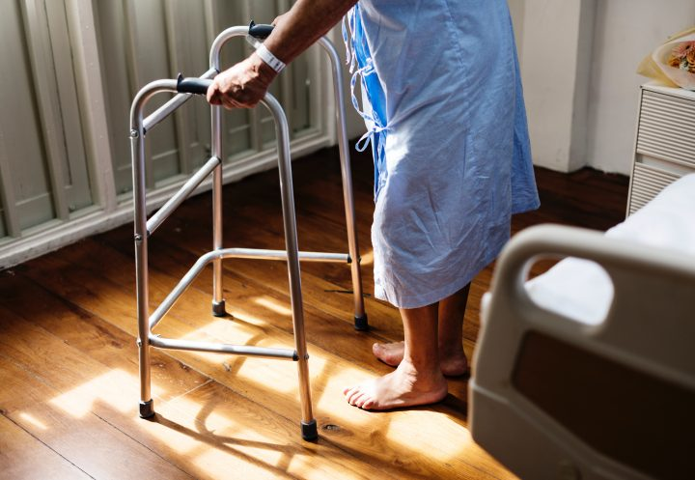
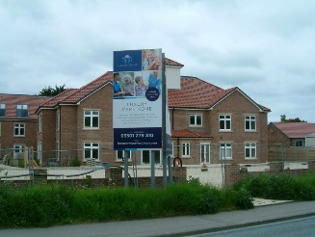
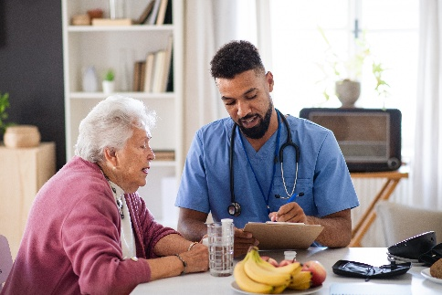
HH
REFERENCES

Beaumont Manor Care Home in Front On -Sea (2025) What Services Do Residential Care Homes Provide. Available at: https://www.beaumontmanorcare.co.uk/news-events/services-residential-care-homes/?(Accessed:12 February 2026
Carehome.Co. Uk .A history of care homes: Available at: https://www.carehome.co.uk/advice/a-history-of-care-homes/(Accessed:12 Februrary 2026)
Davies, M. (2021). "Practice Plus Group announces first set of results as standalone business". LaingBuisson News. Accessed 22nd January 2026.
Paper Clip (2021.The serious challenges facing residential care and nursing homes: Available at: https://www.paperclip.co.uk/care-homes/(Accessed:12 February 2026)
Peart, L. (2017). "Care UK and Suffolk County Council Scoop award" Accessed 22nd January 2026.
Scott, E. (2020). "85-year-old woman's wish to meet a penguin comes true thanks to care home" Care UK - Wikipedia Accessed 22nd Januar2026.
Smulian, M. (2015). "Care UK sells domiciliary services" Accessed 22nd January 2026.
CHALLENGES
CHALLENGES
One major challenge the residential care homes undergo is the issue of staffing shortages and retention. Residential homes often struggle to recruit and keep competent workers because the work can be emotionally and physically demanding while pay may not be good enough. Staff shortage can lead to overload of work and stress and reduced continuity of care.
Another challenge is the rising cost and funding. Residential care homes face the issue of increasing expenses such as staff wages, training, utilities, and feeding. At the same time funding may not be keeping pace with the costs. This can limit resources, affect service quality, and make it difficult to invest in improvements or new services. Meanwhile the cost incurred in running residential care home and adult social care in Uk is huge amount of money. Governments are under serious pressure as occupancy rate struggled to get over the low point of 79% in 2021. (Paper Clip 2021

HISTORY: A residential care home is an institute that provides residential care for old people with dementia and nursing services. A residential care home provides accommodation, meals, and personal care (like washing, dressing, and supervision) for people who cannot live independently but do not need constant medical care. Staff are available 24/7, but doctors and nurses usually visit rather than being on-site. Residential care homes play a significant role in long term care by providing essential services and support for older adults and individuals living with disabilities. Many residents with underlying medical conditions and reduced ability to function independently, they bank vividly on both their surroundings and the assistance available to them (Lawton and Nahemow ,1973)
AMBULANCE SERVICE
ORIGIN
The Greek word πᾰρά, which means alongside, besides, or nearby, is the source of the English prefix para, which is also used to refer to the "paramedics" (Aronson, 2017). The idea of collaborating with medicine is established in the professional title. It is a parallel and independent profession rather than an auxiliary, assistant, or associate. This is indicative of a field that functions without direct medical supervision and whose main goal is to provide urgent and emergency care outside of hospitals.
Paramedicine is also among the fastest evolving professions in the United Kingdom. Since 2000, paramedics have been required to obtain.
HISTORY, EVOLUTION OF AMBULANCE SERVICE
In the United Kingdom, the concept of the paramedic as a registered profession with a legally protected title has existed for just over two decades. However, the historical roots of paramedicine extend far earlier. As the title implies, subsequent conflicts worldwide and eventually transitioned into civilian healthcare, emerging in southern England in the early 1970s.
Significant shifts in demand patterns have generally led to the need to expand ambulance services and the paramedic staff within them. According to NHS England (2014), only about 8% of 999 emergency calls today include life-threatening conditions or injuries. Rather, in addition to calls related to managing chronic diseases, mental health emergencies, and unmet social care needs, ambulance services are increasingly responding to situations involving minor illness and injury (Eaton et al., 2021)
Other healthcare providers like primary care, community nursing, or specialty medical services which typically handle patient management might be able to handle a large portion of this demand. These options are frequently unavailable around the clock. When such services are available, they might not have the means or promptness necessary to satisfy the public's demand for prompt action. This makes many people believe that the 999 system's accessibility and ambulance services' responsiveness serve as a safety net for the National Health Service's deficiencies and structural stresses (Newton A. et L., 2020).

Functions of Ambulance Services Today
Ambulance services are now qualified to perform the duties of Surgical Care Practitioners and have been observed working in hospice environments in recent years (Singer 2021). They also participate in the detection of modern slavery instances (Wilson S 2019), support health promotion programs (Wilson T 2021), and work in highly specialised roles such neonatal transfer services (College of paramedics 2016). paramedics have long functioned alongside physicians, with their earliest widely acknowledged presence dating back to the Crusades of the eleventh century (Porter.1997). During this period, members of the Order of the Knights Hospitaller were trained by physicians to deliver remote emergency care, treating wounded soldiers on the battlefield as well as providing medical assistance to ill pilgrims. This model of delegated medical practice persisted through

Significant In Enhancing the Quality of Life Of Service Users
Reduction in GP workload
All reviewed studies indicate that paramedics contribute to the primary care workforce by operating within multidisciplinary teams. In many ways, paramedics working in primary care were helping to reduce general practitioner (GP) workload by assessing and managing urgent, non-complex cases (NHS England 2019).
Clinical work environment
In addition to differences in job titles, there was also considerable variation in the clinical settings in which paramedics were deployed. The studies documented paramedics working across a range of environments, including commissioned home visiting (Turner J 2020) services, minor units (such as first aid units, minor injury units, hospital minor departments, and walk-in centers), general practice, and out of hours services (Eaton G 2017).

REFERENCES

Aronson, J. (2017) When I use a word … paramedics, BMJ Opinion. Available at: https://blogs.bmj.com/bmj/2017/12/01/jeffrey-aronson-when-i-use-a-word-paramedics/ (Accessed: 09 February 2026).
College of Paramedics (2019) Paramedic Curriculum Guidance. 5th edn. Bridgwater: College of Paramedics, pp. 1–33. Available at: https://collegeofparamedics.co.uk/COP/ProfessionalDevelopment/Paramedic_Curriculum_Guidance.aspx (Accessed: 11 February 2026).
Eaton, G. Wong, G. Tierney, S. et al. (2021) ‘Understanding the role of the paramedic in primary care: a realist review’, BMC Medicine, 19, p. 145. (Accessed: 13 February 2026).
Health and Care Professions Council (2021) HCPC increases the education threshold for paramedics. [Online] Available at: https://www.hcpc-uk.org/news-and-events/news/2021/hcpc-increases-the-education-threshold-for-paramedics/ (Accessed: 09 February 2026).
Henderson, T. Endacott, R. Marsden, J. et al. (2019) ‘Examining the type and frequency of incidents attended by UK paramedics’, Journal of Paramedic Practice, 11, pp. 396–402. (Accessed: 13 February 2026).
NHS England (2014) The Keogh Urgent and Emergency Care Review.Available at: https://www.nhs.uk/NHSEngland/keogh- (Accessed: 11 February 2026).
Singer, M. (2021) ‘P-123: The role of a paramedic in a community hospice/palliative/end-of-life care team’, BMJ Supportive & Palliative Care, 11, pp. A53–A53. (Accessed: 15 February 2026).
Turner, J., Coster, J., Chambers, D., et al. (2015) What evidence is there on the effectiveness of different models of delivering urgent care? A rapid review’, Health Services and Delivery Research, 3(43), pp. 1–160. (Accessed: 15 February 2026).
Wilson, S. and Hill, L. (2019) ‘What is the paramedic’s role in smoking cessation?’, Journal of Paramedic Practice, 11, pp. 100–105. (Accessed: 15 February 2026).
Wilson, T. and Hill, L. (2021) ‘The role of the paramedic in identifying modern slavery’, International Paramedic Practice, 13, pp. 1–11. (Accessed: 15 February 2026).



