
Marketing in Practice
Assignment Two

2003955
Tom Pendlebery

Executive Summary

The purpose of this report is to complete a campaign proposal with the aim being to sign up 5000 new members at a £10 monthly payment from an advertising budget of £500,000 to the new online library of E-Films. The main sections of the report are as follows; the communication channels which will be used in order to advertise/ promote the new online library, the ones chosen specifically picked to line in with the organisation’s values and in conjunction target audience.

The campaign consists of the main message the business wants to send out along with the values of the business and how these will be communicated to potential new customers; furthermore, the specific strategies are discussed as to how these new customers will be inclined to join through various offers and promotional codes enticing them to join. In addition, the use of influencer marketing to focus on the human element of promotion is a large part of the strategy as there is already a high level of trust between consumer and the influencer they follow. This bond of trust is what the business is buying into as business to consumer relationships often lack trust creating distance between the buyer and the seller. In the modern world, a personalised experience is expected from consumers and the expectation follows into any purchase as society moves into an age of the consumer.

The proposed split of the budget is also discussed in detail determining in percentages how much will be spend on each strategy to gain new members, whether that be through social media channels or more traditional marketing strategy. The budget is one of the most important parts of the campaign because without an accurate budget plan it could result in failure or huge monetary loss for the organisation. Equally, to be able to measure the campaign’s performance is crucial to success as the amount spent on advertisement may not be recouped from the benefits of it. On the other hand, if the campaign is really successful then the businesses will not know how to adjust the original budget accordingly to achieve a higher success rate in the future. Moreover, particular marketing strategies will prove more effective than others making them more appealing to invest larger volumes of money into the future and similarly some not so effective to use less funding or none at all.

1.
Contents:

Executive Summary……………………………… Page 1

Introduction……………………………………….. Page 3

Communication Channels………………………..Page 4/5

The Campaign…………………………………….Page 5/6

Budget Splits………………………………………Page 7

Measuring campaign performance……………...Page 7

Conclusion…………………….………………….. Page 8

References…………………….…………………Page 9/10

Appendix………………………………………….. Page 11

Introduction –

Environmental Films (E-Film) is launching a new service within the existing company to provide its users with new content and to expand its overall user base by initiating a new focus to an online library where users can consume various E-books and audiobooks. The main objective of this campaign is to sign up 5000 new members to the online library launching in six months’ time. This objective is key to the success of the new service as the monthly subscription base will generate a steady income into the business, allowing for a larger range of content to be provided improving user experience. As suggested by Kotler (2000), the role of marketing has changed dramatically in organisations and as a result there is a much wider focus on marketing strategies regarding achieving the corporate objective within the business. The E-Books and audio books will follow the absolute value of the company, sharing a strong focus of the environment and educating consumers on the important Eco-friendly message.

3.

Communication channels

The target audience of the new online library follows in conjunction with the original segment of the business, however, there will be a stronger emphasis on younger people and as a result, the communication channels used will reflect this. Social media marketing is defined by Bansal, (2014) as a process to grow attention around a specific product/service or organisation itself; this could also be used to increase website traffic and general footfall with a company. The use of social media will be one of the main channels used to direct the messages to the target audience; in particular Instagram, through affiliation marketing, because of the profound growth of the platform and potential exposure to the younger demographics upon which we are aiming our new online library at. According to Statista, (2021) Instagram had a worldwide userbase in 2021 of two billion, as seen on figure A, of which the second largest user group of the platform consisted of 18–24-year-olds. Justifying the use of Instagram, the platform offers exposure to the target audience of the business venture in question; furthermore, allows for a low-cost advertisement to be run. The accessibility of new resources at the hands of social media marketing has given organisations the ability to advertise only to the target audience relevant, making advertising through social media largely cost-effective (Jagongo, 2013); where certain direct marketing strategies on the other hand can result in failure because of the volumes of people exposed to it who would be deemed irrelevant to the product/service.

Influencer marketing is described by Martinez-Lopez, et al (2020), as using the influence and influential opinions of people in power, celebrities and non-celebrities who have large followings to adopt these values and sentiments onto their own following. For the most part, organisations will choose to partner with influencers who share common interests/values as this will strengthen publicity on both sides. Furthermore, the reputation of businesses has become one of the most important factors determining their long-term success; the idea of a corporate reputation is defined as a representation of business actions in the past and its future ambitions to compete with top rivals with the businesses overall appeal (Fombrun, 1996). Partnering up and sponsoring an influencer provides an effective communication channel for the E-books and audiobooks as the product is being advertised by a trusted and respected individual. This channel will be used to expand our message and values through a well-established individual who reflects similar environmentally friendly credentials; Sustainably Vegan is a YouTube influencer with a large following focusing on sustainable alternatives to everyday activities. This would act as a prime target for the business and provide the most effective approach to communicate our message as consumers don’t have to take the organisations claims as fact (due to potential bias), instead an already established influencer promoting the online library instantly hones in on a trust level.

4.
A further communication channel, which will be utilised in order to promote our message/products is an advertising partnership with Starbucks. Brand awareness has proven to be one of the most important factors in the growth of a business and is also recognised by the majority that businesses with strong brand awareness gain a substantial competitive advantage (Latif, 2014). Moreover, the use of advertising on the Starbucks cups, exposes the brand to high levels of potential future members; in addition to this, Starbucks have been leading the fight on climate change from as early as 2013, (Starbucks, 2022), ensuring they share the same environmentally friendly values of E-Film. To further the idea of the huge success potential from using Starbucks as a communication channel, the coffee shop market aligns perfectly with the promotion of the E-books and audiobooks as it is common for people to consume information either for enjoyment or education while drinking a coffee. The branding will not be connotated as distant from the coffee shop chain, instead by entering a content partnership both brands are able to create the content in question, however the most valuable benefit is that this will align the two organisations together, advancing the exposure of both businesses to their unique audiences; in turn improving their userbase and contributing to E-Films online library sign ups.

The Campaign

The objective of attaining 5000 new members will be achieved through multiple marketing strategies across varied communication channels. According to Jobber (2009), marketing strategies maintain a focus on activities consisting off market research, planning and executing effective strategies; alongside this, the implementation of the marketing mix is crucial in particular the 4Ps (Price, product, promotion and place) to a successful marketing strategy for any business (Armstrong et al, 2008). To ensure a successful campaign, E-Film will be launching various strategies, beginning with a promotional offer on Instagram. The most important factor considered when launching a promotion is the promotion mix for the targeted demographic to guarantee that the offer will be suitable and worth-while to the consumer. The promotional offer displayed on Instagram will be targeting those of the 16-25 demographic where users may not have disposable income. As a result of this, the offer will consist of the first month free, when an account is created and there is an agreement for promotional material to be communicated; the continued offer after this will consist of, if users read a certain number of E-books/audiobooks then there is a further 10% off the following months if the condition is fulfilled. A big issue businesses face is customer retention; initial offers will intrigue people to sign up but after the first month are likely to cancel (Al-Rabayah, 2017). To counter this, as suggested, by offering a further 10% off every month the reading list target has been met, users will be inclined to spend time on the online library because they know it will benefit them in a secondary regard along with the exciting content provided. The offer therefore incentivises repeat purchase.

5.
In line with the promotional offer through Instagram, Influencer marketing will be used as a strategy allowing for the main environmental messages of the new sector to be communicated with the audience. E-Film will associate themselves with Sustainably Vegan’s YouTube channel, paying for them to promote the new online library and the benefits consumers experience by joining over other audiobook/E-book subscriptions. According to Almousa (2013), one of the biggest factors affecting consumer to business is the element of trust, particularly in a modern data farm where organisations do everything in their power to gain information on consumers. Therefore, the trusted voice of the influencer breaks down that initial barrier between businesses and consumers making sign ups a lot more likely. Furthermore, to incentivise listeners to join quickly a time bound offer will be communicated by the influencer stating that if the certain code is entered within three days, they will gain exclusive early access to new releases into the online library in the future. This offer will draw large numbers of new members in because of fear of missing out and the fact that the audience of Sustainably Vegans YouTube channel will know that the offer will never exist again after the short time period is available. According to (Salvi, 2013) having a bonus creates incentive to buy and shorter time periods mean a large number of members will be signed up in a short space of time which may even exceed the 5000 members target as the Sustainably Vegan YouTube channel has a large following of over 200 thousand.

The main message of E-Film is to be able to make a serious positive difference to the environmental issues the world faces. This message alone if communicated correctly will entice new consumers to sign up following our environmental credentials. To push this new venture of environmental E-Books and audiobooks into the mainstream the majority of the budget split will be spent on a national traditional advertising collaboration with Starbucks. According to Corporate finance institute (2022) the Boston Matrix grid suggests Starbucks falls under the star category as it holds a large amount of the market share with continuous growth. This is partly down to its continued support and investments into environment benefitting projects and by making sure their products are made dealing as little harm as possible to the planet. E-Film will not be advertising anything on plastic packaging within Starbucks as this directly violates the message the business is sending out to consumers. Instead, advertisements of the environment themed E-Books and audiobooks will be plastered onto recyclable and reusable packaging with a QR code to take potential members straight to the sign-up sheet. By partnering with an already established environmentally sustainable business, customers will be able to align values they hold within Starbucks to E-Films online library increasing the chances of sign-ups. As suggested by Liao, (2008) and by Mullins, (2014) customer orientated values must be represented and exemplified to encourage purchases and sign ups within the organisation. Furthermore, the message that E-Film wants to establish, reaches national level by advertising with Starbucks. Concerning the E-Books/audiobooks accessibility by many nationally, there is no fear of stock or capacity therefore pushing the offers and messages stood for in front of as many people within the target audience as possible only increases the chances of achieving the 5000 new members targeted for the online library.

6.

Budget splits

The budget of £500,000 thousand will be spent in its entirety in an attempt to exceed the 5000 new members targeted by the business. The advertisements with Starbucks coffee cups accounts for 70% of the total budget spent and the reason for this was because of the national scale that the E-Books and audiobooks could be advertised at. Due to the high exposure Starbucks as a coffee shop acquires, the costs to advertise in every store across Britain was out of the allocated budget therefore the decision was made to hold 30% of the budget back for social media advertising. Moving onto the costs for the various Instagram adverts, 10% of the overall budget is assigned. Instagram adverts are not expensive for the most part and run of cost per click at a rate of £0.01-£0.05 per click (DeFazio, 2022), therefore it was established that £50,000 would be ample for the majority of the target audience to see the offer. The final 20% of the budget will be used on influencer marketing where for the money put forward (£100,000), the continued advertisements and support from the established individual will prove a good investment. The most important element to budgeting is detailed preparation as without an elaborate plan the chances of reaching overall aims become lower (Sulaymonov, 2018).

Measuring Campaign Performance

The campaign performance will be measured through financial measurement and through the number of new customers/members acquired from the start of the campaign. Brown (2012) suggests that results have to be measurable to a certain degree in order to gain knowledge on the success of the campaign. Financial measurement will be used to determine whether the £500,000 was cost effective against the number of sign-ups by comparing the invested money with the predicted monthly income from the new influx of members. From this information the price point of £10 a month can be adjusted accordingly to maintain success and plan for a larger return in the future. The number of new customers gained will be the best indication to the success of the campaign as if the target of 5000 members is met with the allowanced budget, then the campaigns aim would have been achieved. However, the offers and discounts would have to be factored into the financial side but with the aim met of the new member count the monetary loss will be recouped in the near future Bendixon. (1993).

7.

Closing statement

The campaign put in place will achieve the 5000 new members target within the budget of £500,000 simply from the fact that only 2.5% of Sustainably Vegans subscriber base would have to sign up to gain the 5000 new members alone. With all the other advertisements put in place the chances of achieving more than 5000 members are positive and the campaign will be a success based on the extensive advertising research and application.

8.
References –

Almousa. (2013). Barriers to E-Commerce Adoption: Consumers’ Perspectives from a Developing Country. Available: https://www.researchgate.net/publication/276493279_Barriers_to_E-Commerce_Adoption_Consumers'_Perspectives_from_a_Developing_Country. Last accessed 07/05/2022.
Al-Rabayah. (2017). Sentiment Analysis of social media as Tool to Improve Customer Retention. In: . Strategic uses of social media for improved customer retention. Jordan: IGI GLobal. 207/220.
Armstrong, Kotler, Saunders, Wong (2008). Principles of marketing. 12th ed. London: Pearson/Prentice Hall.
Bansal, Masood, Dadhich. (2014). Social Media Marketing-A Tool of Innovative Marketing. Journal of Organizational Management. 3 (1), 01-07.
Bendixon. (1993). Advertising Effects and Effectiveness. Available: https://www.researchgate.net/publication/235288078_Advertising_Effects_and_Effectiveness. Last accessed 04/05/2022
Brown (2012). Working the crowd: social media marketing for business. London: BCS. 16-17.
Corporate finance institute. (2022). Boston Consulting Group (BCG) Matrix. Available: https://corporatefinanceinstitute.com/resources/knowledge/strategy/boston-consulting-group-bcg-matrix/. Last accessed 08/05/2022.
DeFazio. (2022). How Much Do Instagram Ads Cost? (+How to Make the Most of Your Budget). Available: https://www.wordstream.com/blog/ws/2021/02/08/instagram-ads-cost. Last accessed 09/05/2022.
Fombrun, C.J.,1996. Reputation: Realising Value from the Corporate Image. Boston: Harvard Business School Press.
Jagongo. (2013). The social media and Entrepreneurship Growth. International Journal of Humanities and Social Science. 3 (10)
Jobber (2009). Principles and Practice of Marketing. 7th ed. London: McGraw-Hill.
Kotler, Philip (2000), Marketing Management, Tenth Edition, Prentice Hall: Upper Saddle River (NJ).
Liao, Hui, and Mahesh Subramony. 2008. “Employee Customer Orientation in Manufacturing Organizations: Joint Influences of Customer Proximity and the Senior Leadership Team.” Journal of Applied Psychology 93 (2): 317–328.

9.
Latif. (2014). Building Brand Awareness in the Modern Marketing Environment: A Conceptual Model. Available: https://www.researchgate.net/publication/272161898_Building_Brand_Awareness_in_the_Modern_Marketing_Environment_A_Conceptual_Model. Last accessed 6th May 2022.
Martínez-López, Francisco J.; Anaya-Sánchez, Rafael; Fernández Giordano, Marisel ; Lopez-Lopez, David. (2020). Behind influencer marketing: key marketing decisions and their effects on followers' responses. Journal of marketing management. 36 (7/8), 579.
Mullins, Syam. (2014). Manager–salesperson congruence in customer orientation and job outcomes: The bright and dark sides of leadership in aligning values. Journal of Personal Selling & Sales Management. 34 (3), 188-189.
Starbucks. (2022). Coffee sustainability. Available: https://www.starbucksathome.com/gb/story/coffee-sustainability. Last accessed 6th May 2022.
Statista. (2021). Number of monthly active Instagram users from January 2013 to December 2021. Available: https://www.statista.com/statistics/253577/number-of-monthly-active-instagram-users/. Last accessed 04/05/2022.
Salvi. (2013). EFFECTIVENESS OF SALES PROMOTIONAL TOOLS: A STUDY ON DISCOUNT, PRICE OFFAND BUY ONE GET ONE FREE OFFERS IN BRANDED APPAREL RETAIL INDUSTRY INGUJARAT. ELK ASIA PACIFIC JOURNAL OF MARKETING AND RETAIL MANAGEMENT. 4 (4), 1-10..
Sulaymonov. (2018). Importance of budgeting and its role in strategic management accounting. Available: https://www.researchgate.net/publication/338984565_Importance_of_budgeting_and_its_role_in_strategic_management_accounting. Last accessed 09/05/2022.

10.
Appendix –
Figure A –
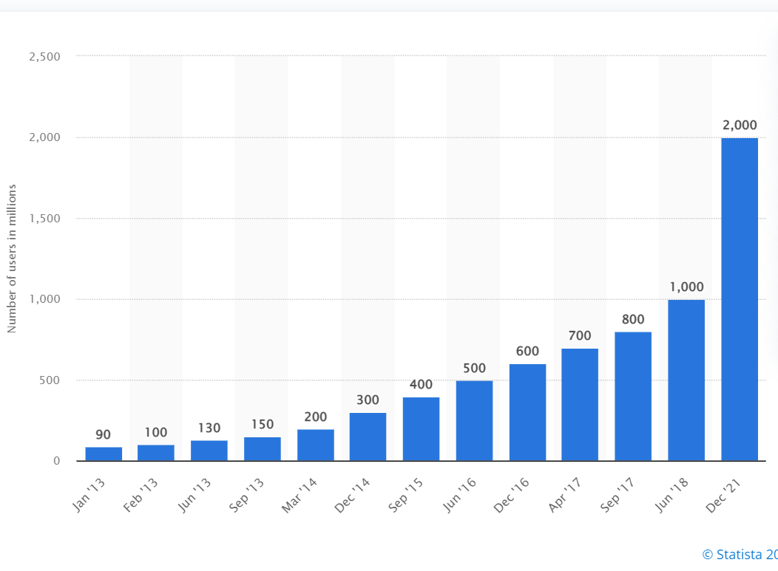

11.

