Module Title: Introduction to Web and Database Concepts
Module Code: ACCA4023
Student Name: Edoard Buzga
Student ID: 2439674
Table of Contents
1. Introduction 3
2. Requirement Analysis 4
3. System Design and Decisions 6
4. Normalisation 7
5. ERD and Implementation 8
6. Sample Data 11
7. Queries 12
8. Testing and Validation 15
9. Reflection 16
10. Conclusion 17
References 18

1. Introduction
The report will demonstrate the design and development of a database system for a chosen scenario. The report aims to understand the needs of the system and transform them into a structured relational database management system. The development work will start with a requirement analysis to recognise the key entities and their core relationship [7]. After that, it will demonstrate the design decisions and represent the ERD design that will be applied for implementation. Additionally the report will include sample data and queries to represent how the system works in practice. The last part of the report will provide a conclusion with testing, validations and reflection to make sure that the complete database will be reliable, accurate and suitable for practical use.

2. Requirement Analysis
The EcoRide system needs a structured database that can help to support regular operations, monitor transactions as well as maintain appropriate records. The system aims to make sure that all information related to maintenance, rentals, system activities and staff is collected reliably and consistently [8]. The major system requirements are described in the table below:
i) Functional Requirements
Requirement | Description
User Management | The system needs to store, retrieve, and update the rider and employee information at the time needed.
Rental Processing | It should allow recording of rental start time, duration, return time and cost.
Bike Availability Tracking | This system requires recording the current condition, status and location of each bike.
Reporting | It must generate valuable reports such as active rentals, available bikes, overdue returns and revenue.
Maintenance Logging | The system should support logging of the activities of maintenance, including staff involved and service type.

ii) Data Requirements
Requirement | Description
Data Consistency | Relationships between records need to be maintained using foreign keys of the system.
Unique Identification | Each record of the system requires a unique ID to avoid duplication.
Status Tracking | The system should store the real-time status of bikes, such as in use, available, or under repair.
Secure Contact Information | Personal contact details need to be stored clearly and securely in this developed system.
Accurate Time Records | Dates and times for rentals and maintenance should be stored in precise formats.

iii) Non-Functional Requirements
Requirement | Description
Performance | Queries require execution quickly, even as data grows.
Reliability | The system should store data accurately and function without interruptions.
Scalability | The database requires support for more users, bikes, and maintenance entries in the future.
Data Integrity | Constraints need to ensure valid, consistent, and error-free data.
Usability | The structure must be simple to understand for staff who interact with the system.

3. System Design and Decisions
This system design focuses on fulfilling the requirements of the EcoRide stated in the previous section. This EcoRide database uses a relational database to ensure data integrity, clear relationships and enhance performance. A relational database allows organising data in various tables, handling a specific category of information [1]. This prevents data redundancy and helps in efficient data retrieval. Primary keys help to identify a row uniquely and foreign key enforces referential integrity.
The separate table for each category of information ensures better usability. Staff can update information without affecting other unrelated tables of the database, ensuring better data consistency. This feature supports modular growth for the future without the necessity to restructure the system.
Data types are selected based on the nature of stored information. Variable-length text fields are used for textual information. On the other hand, date and datetime are used for the appropriate storage of date and time. Numeric data types are used for costs and duration to support calculations.
Constraints play an important role in the design. UNIQUE constraints ensure that the tables do not contain any duplicate entries [2]. A NOT NULL constraint ensures no row in the table is left NULL, enforcing the requirement to provide all details during data insertion.
This design ensures that the design focuses on useful system outputs. The structure supports a report on available bikes, maintenance history, rental activity and revenue. This allows EcoRide to effectively manage service and make better decisions.
This design is scalable, structured and simple, ensuring efficient data handling, easy maintenance and streamlined operations.

4. Normalisation
This database of EcoRide applied normalisation to ensure the database design is efficient, consistent and free from data redundancy. This database has been normalised to the 3rd Normal Form (3NF), that is appropriate for transactional systems. First Normal Form ensures that all the attributes of the tables hold atomic values and each table has one primary key. The Second Normal Form ensured the database design is free from any partial dependencies. It requires ensuring that no non-key attribute depends on only part of a composite key [3]. As the tables have single-attribute primary keys, achieving second normal form is easy. Third Normal Form ensured that all non-key attributes depend on the primary key rather than depending on each other, eliminating transitive dependency [4]. These normalisations ensured that the database has no redundancy, anomalies and supports reliable data updates across the system.

5. ERD and Implementation
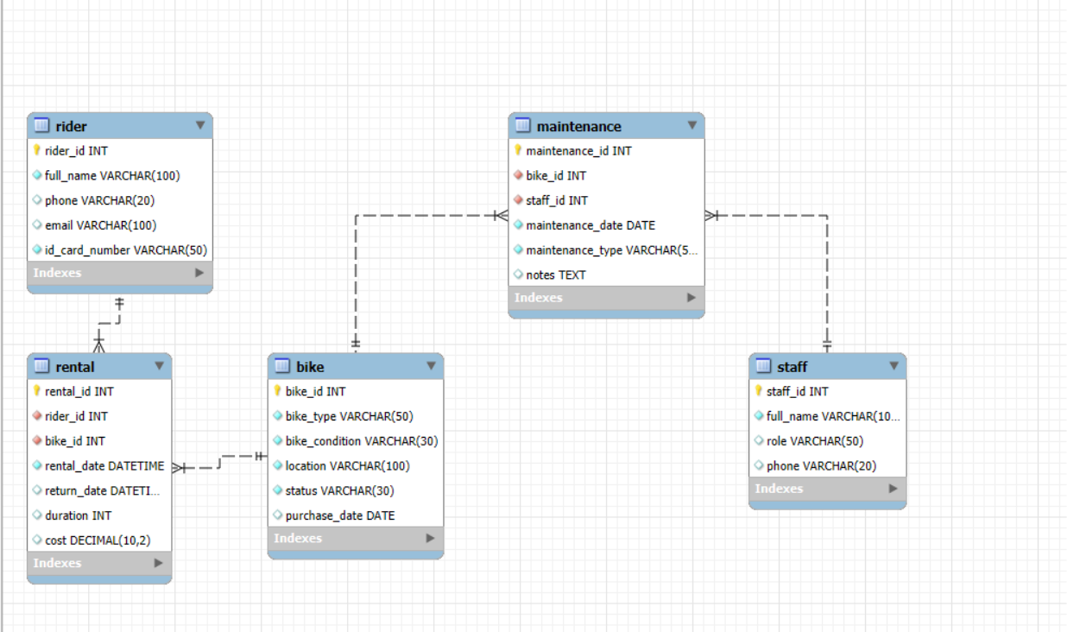
(Source: MySQL Workbench; Self-created)
An Entity-Relationship Diagram (ERD) provides a visual representation of the entire EcoRide database system [5]. It underlines key entities with their respective attributes and their internal connections. ERD acts as a blueprint for implementing the database and ensures that the final structure is logical, efficient and meets all the requirements.
The ERD of EcoRide includes five distinct entities: Rider, Staff, Bike, Rental and Maintenance. All of the entities contain a primary key that helps to uniquely identify each record of a table [6]. The rider_id in the Rider table, bike_id in the bike table and staff_id in the Staff table act as a primary key.
Foreign keys assisted in developing the relationships between different relations. The rider table contains rider_id and bike_id as foreign keys, helping to identify which biker rented which bike. Similarly, the Maintenance table stores information for a specific staff member and a specific bike through staff_id and bike_id foreign keys. These help to track information effectively and ensure the stored data is consistent and meaningful.
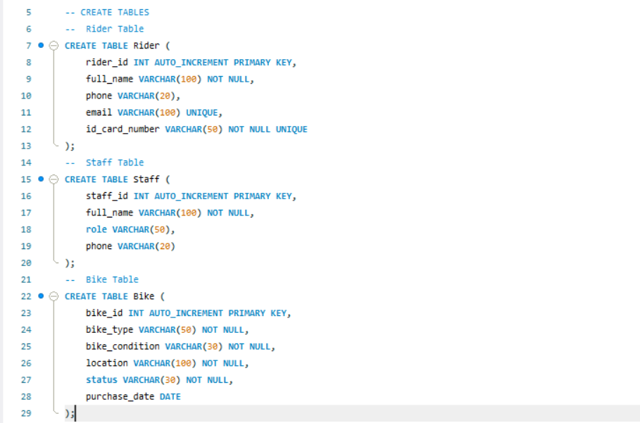
(Source: MySQL Workbench; Self-created)
The implementation aligns with the ERD. SQL commands such as FOREIGN KEY, NOT NULL, PRIMARY KEY and UNIQUE are applied to maintain data integrity. The structure is scalable and allows future additions. These constraints prevent duplicate entries, orphan records and incomplete information. Various datatypes such as VARCHAR, DATE, DATETIME and DECIMAL ensure accurate data storage. The ERD and implementation form the foundation of the EcoRide database.
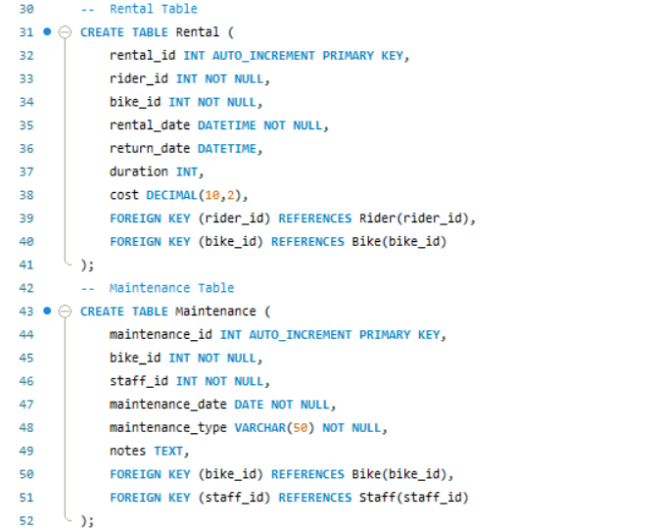
(Source: MySQL Workbench; Self-created)

6. Sample Data
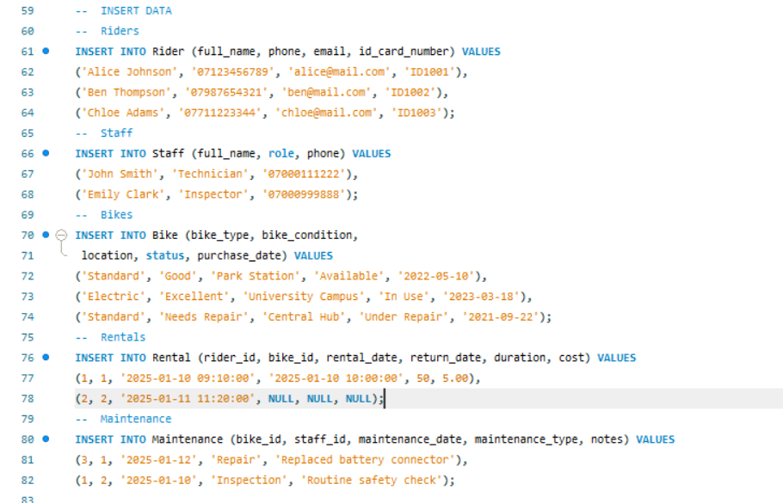
(Source: MySQL Workbench; Self-created)
To test the efficiency and whether the design meets the requirements effectively, sample data are inserted in each table of the EcoRide system. The dataset includes records of riders, staff members, bikes, rental transactions and maintenance activities. These data assist in testing the structure, relationships and run meaningful queries.
- Rider table includes contact details and the unique identification number of each rider.
- Staff table stores the details of employees responsible for inspection and repairs.
- Bike table holds bikes' condition, type, purchase date, status and location.
- Rental table holds the information of the completed and ongoing rentals.
- Maintenance table stores various service activities such as inspections and repairs, performed by specific staff.

7. Queries
A series of SQL queries is designed to evaluate whether the EcoRide database meets the actual day-to-day operational requirements [10]. These queries not only exemplify the system's capability to access pertinent data also to produce overviews and thus be able to make decisions more easily. Each query portrays a practical scenario that the management team might face in everyday operations.
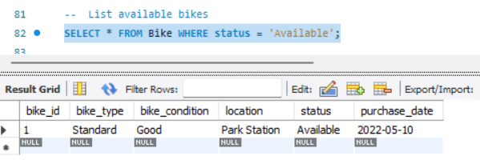
Available Bikes Query
(Source: MySQL Workbench; Self-created)
Explanation: One of the main query points out the bikes that are ready to be used. This query identifies the status field in the Bike table and gives back all the bikes with the "Available" label [11]. It saves the staff time in finding out which bikes are available for rent by doing the checking at every station.
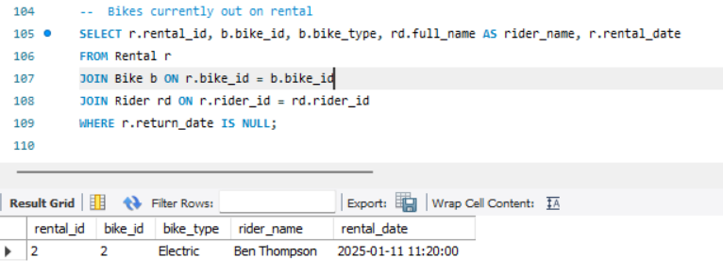
Bikes on Rental Query
(Source: MySQL Workbench; Self-created)
Explanation: The other significant query gets the bikes that are not yet returned and are still rented [12]. This query looks for records in the Rental table where the return_date is NULL. It enables the staff to keep track of active rentals and to spot late returns.
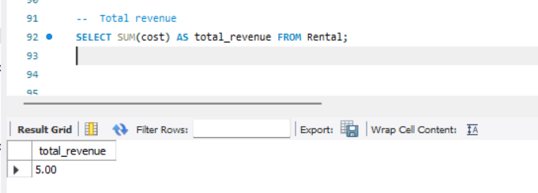
Total Revenue Query
(Source: MySQL Workbench; Self-created)
Explanation: The query based on revenue computes the total sum of money that has been earned from rentals that have been completed. It employs the SUM function on the cost field to arrive at the total income. This procedure underpins financial reporting and aids the team in assessing the service quality over time.
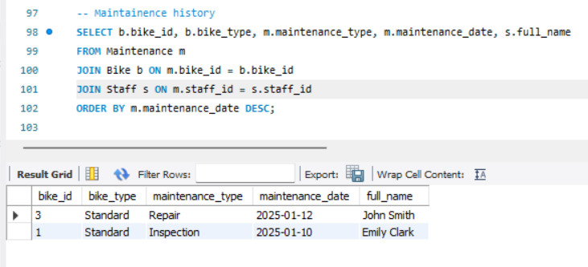
Maintenance Query
(Source: MySQL Workbench; Self-created)
Explanation: Queries related to maintenance constitute the main part of the work as well. One query fetches the complete maintenance history of each bike. It links the Bike, Maintenance, and Staff tables to reveal who did the service, what kind of maintenance was performed, and when it occurred. The output of this activity will be very useful for the staff in terms of scheduling inspections and repairs in the future.
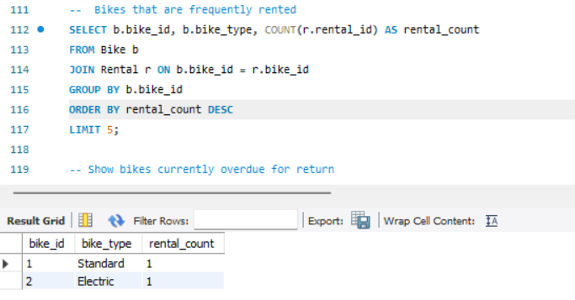
Most Rented Query
(Source: MySQL Workbench; Self-created)
Explanation: A query based on usage makes a list of the most rented bikes. The total number of rental transactions for each bike is counted and then they are arranged in descending order. This data will be used to recognise bikes that are in high demand and thus may need to be serviced more often.
At last, a query was set up to bring to attention the bikes that could be overdue. By looking at the rental duration against the present time.

8. Testing and Validation
Testing and validation have been carried out to confirm that the EcoRide database meets all functional requirements and operates as expected [9]. The process implemented running sample queries, checking table relations and verifying the data store as well as retrieving it in an appropriate way. Every table was initially tested to make sure that constraints such as foreign keys, primary keys and unique fields were functioning. Queries were then tested to ensure they produced accurate and meaningful results. For example, the query for available bikes returned only those marked as “Available,” as well as the query for ongoing rentals correctly identified entries with no return date. Additionally maintenance and revenue queries produced expected outcomes based on the sample data.

9. Reflection
This database design for EcoRide has helped to apply the database design principles in a practical scenario. I started understanding the functional and non-functional requirements of the Ecoride system. I identified the challenges that EcoRide was facing with manual record-keeping. This step highlighted the importance of accurate tracking, improved visibility and structured data management. Implementing the database according to the requirements of EcoRide requires an understanding of MySQL and relational database models.
I applied normalisation to the database schemas up to the 3rd Normal Form. This helped me to ensure that the database does not have any transitive or particle dependency and each attribute contains atomic values. I efficiently utilised the primary keys and foreign keys to enforce referential integrity and maintained connections between various tables.
During the implementation of SQL, I was required to select an appropriate data type for each attribute to ensure efficient data storage. I used DATETIME for rental records and a UNIQUE constraint to prevent any data repetition. I added sample data to the tables to simulate a real-world scenario. The testing phase of the system helped to assess whether the queries ran properly and returned expected results. It ensured that the system can address the operational requirements, such as tracking available bikes, monitoring rentals and viewing maintenance history.
It has been challenging to meet all the requirements of EcoRide along with keeping the database structure simple. In future, multiple features such as predictive maintenance alerts, overdue bike reminders can be added to improve the system’s functionality.

10. Conclusion
The EcoRide database system was developed to eliminate the manual operations which were the root causes of errors, delays, and inefficiencies in the electric bike rental scheme. The project has highlighted the benefits of a structured relational database for data storage, tracking, and decision-making with fewer errors. After going through a process of requirement analysis, system design, ER modelling, and SQL implementation, the final system can fully satisfy the operational needs of the service. Apart from rider registration, rental recording, maintenance activity tracking, and bike availability monitoring, it supports many other functions that are vital for the operation of the service.
The database's performance was evaluated through sample data and queries, and the results proved that the database not only performs as expected also is capable of providing useful outputs for the management. During testing and validation, integrity constraints, relationships, and queries were all confirmed to be functioning correctly. Although the present system covers the basic requirements, there is room for future improvement, such as automated notifications or extended reporting capabilities.
In conclusion, the project sets a strong and scalable platform for the efficient management of the EcoRide service.

References
[1] B. Lutkevich, “What is a Relational Database?,” TechTarget, Jun. 01, 2021. https://www.techtarget.com/searchdatamanagement/definition/relational-database
[2] Hightouch, “SQL UNIQUE - Syntax, Use Cases, and Examples,” Hightouch.com, Dec. 29, 2023. https://hightouch.com/sql-dictionary/sql-unique
[3] M. Fayard, “What is Second Normal Form (2NF)?,” Datacamp.com, Jan. 06, 2025. https://www.datacamp.com/tutorial/second-normal-form
[4] J. Garside “How to normalize data,” New Relic, Jun. 10, 2025. https://newrelic.com/blog/best-practices/data-normalization
[5] I. Belcic and C. Stryker, “What is an Entity Relationship Diagram? | IBM,” www.ibm.com, 2024. https://www.ibm.com/think/topics/entity-relationship-diagram
[6] Secoda, “In the context of a database, a primary key is simply a unique identifier for a row. Learn more about a primary key and how to use it in a table here.,” www.secoda.co, Nov. 20, 2024. https://www.secoda.co/glossary/primary-key
[7] A. Christian, “Requirements Analysis Process and Techniques,” Requiment, Apr. 10, 2024. https://www.requiment.com/requirements-analysis-process-and-techniques/
[8] P. A. Laplante and M. Kassab, “Requirements Engineering for Software and Systems,” Requirements Engineering for Software and Systems, Mar. 2022, doi: https://doi.org/10.1201/9781003129509.
[9] “What’s the Difference Between Data Validation and Testing? (Author: Dana Neis),” Definian.com, 2025. https://www.definian.com/articles/data-validation-vs-testing (accessed Nov. 21, 2025).
[10] B. Zaragozí, S. Trilles, A. Gutiérrez, and D. Miravet, “Development of a Common Framework for Analysing Public Transport Smart Card Data,” Energies, vol. 14, no. 19, p. 6083, Jan. 2021, doi: https://doi.org/10.3390/en14196083.
[11] A. Cortez and P.-P. Vázquez, “Advanced Visual Interaction with Public Bicycle Sharing Systems,” CSRN, 2021, doi: https://doi.org/10.24132/csrn.2021.3101.23.
[12] N. Meyers et al., “Value for money: a cost-effectiveness analysis of microplastic analytics in seawater,” Microplastics and Nanoplastics, vol. 4, no. 1, Feb. 2024, doi: https://doi.org/10.1186/s43591-024-00081-x.

‌

