Effective Team Work and Communication

Table of content

Introduction: 3
Application of the main theories, which relates group dynamics, team working and communication: 3
Group dynamics theories: 3
Team working theories: 6
Communication theories: 9
Conclusion: 10
References: 11
Appendix: 13

Introduction:
The report aims to critically demonstrate the importance of communication in the workplace, which helps one to create a good understanding among the team. this skill helps to elaborate on a project or an initiative in a proper manner, through which miscommunication can be avoidable. The report will describe the significance of group dynamics and team working theories to run the work process effectively. The mentioned implementation helps to handle the team, through which an effective performance can be insured. The relevant theories will help to understand the way of implementations of these mentioned practices, which the management of Bookish do, through which the company ensures profitability.

Application of the main theories, which relates group dynamics, team working and communication:

Group dynamics theories:
There are three theories, which will elaborate on the importance of group dynamics.
Social exchange theory:
The above-mentioned theory is helpful for group dynamics, which management of Bookish implement (Book-ish, 2020). According to the theory, people have a few expectations from an organization and the other team members. Making these expectations fulfilled help the management in group dynamics, through which teamwork becomes possible (Waskito et al. 2020). People want to have a few better experiences than the previous company. The management of Bookish focuses on this expectation and takes initiative to meet individual’s requirements such as a better salary package, good working environment and so on (Book-ish, 2020). Therefore the team leaders maintain a friendly attitude with the employees, through which the leaders can easily know about the requirements or the issues that the employees are facing. This thing helps the management to avoid conflicts and satisfy the employees, through which the employees work with motivation and productivity enhances (Waskito et al. 2020). This implementation helps both employees and the company to maintain a good relationship with each other by meeting the requirements of both sides. Meeting the requirements of both side helps the employees to work dedicatedly, through which the efficiency level of the individuals enhances, through which a better career opportunity insures. On the other hand, the company also expands business, through which the organization ensures an enhancement in profitability. The mentioned theory helped me to understand the importance of giving value to the opposite person in the workplace, through which I shall be able to work with the team effectively.
Social identify theory:
People want value, respect and independence from others and therefore the management of Bookish trains the employees to show respect and value to the team members, through which a good working environment can be maintained (Book-ish, 2020). This implementation helps the management of Bookish to avoid conflicts. The employees of the company follow the instructions of the seniors while taking an initiative, which helps the employees to avoid mistakes. This behaviour of people allows the management to get the best productivity in less time. The leaders are focused on the enhancement of an individual's efficiency. Therefore the leaders keep the performance records of the individuals and evaluate the efficiency level of all employees (Perry et al. 2020). The leaders arrange a training season for below-performing employees. This thing helps the employees to enhance the efficiency level, through which the employees can take responsibility for an individual project. This implementation helps the employees to create a self-identity in the organization. The leaders show respect to the employees, which makes the employees feel valued, through which the employees get motivation while working for the company. This thing helps the company to enhance productivity, through which the profitability enhances. The mentioned theory helped me to understand the importance of social identification, which is also important in the workplace.
Tuckman’s team model:
People come for different backgrounds and efficiency levels of the individuals are not the same, which creates difficulties to generate productivity. Therefore, the management of Bookish implements thin five-stage model to ensure the team dynamics and to generate profit. The five stages are being mentioned below.
The forming Stage allows the leaders to make the employees introduced with each other, through which the employees become familiar with the team. This thing helps the employees to work in a project together (Pfutzenreuter et al. 2020). The leaders of Bookish implement this thing to create good team bonding, through which the productivity of the company enhances (Book-ish, 2020).
The next stage is storming, which helps the leaders to give value to the employees to avoid conflict. In this stage, the leaders take individuals’ opinions regarding an initiative (Pfutzenreuter et al. 2020). This thing helps the leaders to get the best solution for the problems and it is also helpful to make the employees feel valued, through which the employees get motivation in work.
On the norming stage, the leaders of Bookish distribute responsibilities among the employees by evaluating the efficiency level (Pfutzenreuter et al. 2020). The leaders allow the employees to work on a project indecently as per the efficiency of the employees.
Performing is the last stage, where the employees successfully play roles of the individuals, through which the company generates revenue by enhancing the sale. This stage also helps the leaders to evaluate the efficiency level of the employees, through which the leaders can arrange training for the low-skilled employees (Pfutzenreuter et al. 2020). The theory helped me to understand the importance of the above-mentioned four stages, which will allow me to ensure an effective performance on the work floor.
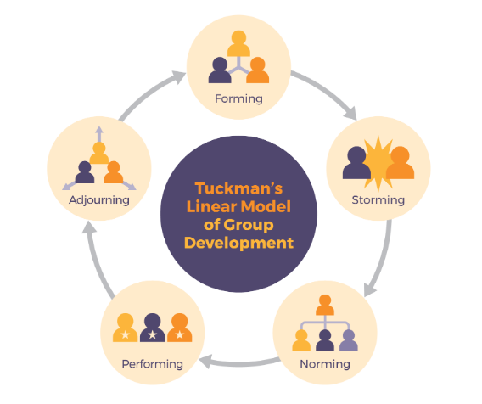
Figure 1: Tuckman’s team model
(Source: Pressbooks, 2020)

Team working theories:
The mentioned theory helps the leaders to handle the team effectively, through which the team members can ensure betterment in performance (Pfutzenreuter et al. 2020). Learning of the below-mentioned theories helped me to understand the effective ways to collaborate with a professional team, through which I shall be able to work efficiently in my organization.
Belbin’s Theory of team roles:
The mentioned theory has three stages, which are being mentioned below.
The first stage is achieving the task, where the managers of the mentioned company take responsibility to set a goal, vision and mission, through which the employees become motivated to work. This thing helps the company to enhance productivity. The managers ensure manpower and other important resources to achieve the target (Nair, 2020). After that, the management creates a plan, which the employees follow and also distributes job roles among the employees. The leaders set the deadlines for each activity to meet the target on time and also monitor the individuals’ performances, which helps the leader to evaluate the efficiency level of the employees.
The second stage is group-management, where the leaders focus on giving training to the employees regarding communication and behaviourism, through which the employees of the company can maintain a professional behaviour on the work floor (Nair, 2020). This thing helps the leaders to avoid conflicts. The leaders of Bookish focus on maintaining discipline and punctuality to run the work process in an organized way (Book-ish, 2020).
Managing individuals is the third stage, where the leaders maintain a friendly relationship with the individuals, through which the employees feel free to discuss the problems that the employees are facing (Nair, 2020). This thing helps the employees of Bookish to avoid mistakes and enhance efficiency level, through which betterment in performance insures (Book-ish, 2020). The leaders treat equal with the individuals, through with favouritism can be avoidable. This implementation of the leaders helps the management to avoid conflict. The theory helped me to learn about the possible way to deal with the employees in the workplace, which will help me in team handling.
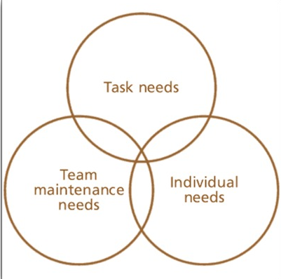
Figure 2: Belbin’s Theory of team roles
(Source: practical-management-skills, 2020)

Hierarchy of Needs Theory by Abraham Maslow:
Maslow's hierarchy of needs theory is one of the best practices that the management of Bookish do to ensure an effective teamwork process (Book-ish, 2020). According to Maslow, there are five needs that an employee has, which are being mentioned below.
The first need is a physical need, which includes food, clothes, shelter and so on. The management of the company gives sufficient salary to the employees and other facilities such as incentive and so on, through which the employees can fulfil these needs (McCleskey and Ruddell, 2020).
The second one is a safety need Such as job security and so on. The company ensures job security of the employees by giving joining letter and so on (McCleskey and Ruddell, 2020). The management of Bookish focuses on the security system such as fire alarm and so on to ensure the employees' safety (Book-ish, 2020).
The third need is belongingness. The management of Bookish maintains a good relationship with the employees by showing respect and love, through which the employees feel valued, through which the individuals become motivated in work (McCleskey and Ruddell, 2020).
The management appreciates the positive initiatives of the employees to meet the esteem needs of the individuals. This thing helps the employees to be motivated.
According to Maslow, the ultimate need for an employee is self-actualization. The management of Bookish gives award, reward and promotion to the efficient employees and also gives training to the employees, who are not enough skilled (Book-ish, 2020). This thing helps the employees to meet the need of self-actualization and also helps the other employees to develop skill, through these employees will also be able to meet the mentioned need (McCleskey and Ruddell, 2020).
The learning of the above-mentioned theory helped me to understand the category of needs of an employee. I shall implement this theory in my workplace to understand peoples' needs and shall take initiatives to fulfil the needs of the individuals, through which people will be motivated to work.
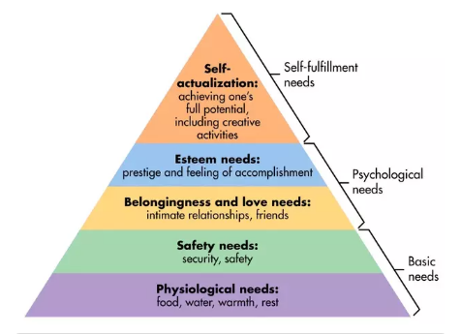
Figure 3: Abraham Maslow’s Hierarchy of Needs theory
(Source: Simplypsychology, 2020)
Y theory development:
There are two developed by McGregor, that is X and Y theory. The X theory includes the responsibilities of the leaders to observe the inefficiency of the employees and take initiatives to pull the productivities from the individuals, such as supervision, giving work pressure and so on. On the other hand, the Y theory includes the opposite things (Harari et al. 2020). The management of Bookish implements the Y theory to ensure a better team working process (Book-ish, 2020). The mentioned process includes motivating people, appreciating the effective initiatives of the employees, giving increment, incentive and promotion to the efficient people and so on. This implementation helps the management to motivate people and get the best productivity. The management of the company gives training to the inefficient people, through which the employees can enhance the performance level. This thing makes the employees of Bookish interested to work, through which the company generates profit (Book-ish, 2020). I shall apply the Y theory among these two theories to enhance the efficiency level of the team members, through which the profitability of my company will be enhanced.

Communication theories:
The management of Bookish implements several communication theories to ensure better communication skill, through which the employees and the leaders will be able to collaborate in a project and work effectively (Book-ish, 2020). The implementation helps the management of the organization to avoid miscommunication, through the organizational conflict can be avoidable. The theories that management applications are being mentioned below.
Communication Accommodation Theory:
The mentioned theory is being applied by the management to ensure a sustainable communication system. The management of the company gives training to the employees to understand the designation, experience, age and so on while communicating to the opposite person (Morgan et al. 2020). The management and the leaders also focus on these things while communicating with a junior employee. This implementation allows individuals of the company to give value to each other, through which a good working environment is possible to be maintained. This implementation ensures a good understanding among the employees and the employees and the management. This learning helped me to understand the possible and effective way of communication, which I shall apply in my professional field.
Cultivation Analysis:
The mentioned theory refers to a communication system through email, social media, television, through which the management of Bookish communicates with the employees and the customers (Book-ish, 2020). The management of the company instructs the employees through email, which helps individuals to keep the records safe (Bernhold and Giles, 2020). The organization also communicates with customers through email marketing. Implementation of the mentioned communication theory allows the company to let the people know about the products of the company, through which the possibility of sales enhances. Learning of this theory helped me to develop my communication skill, through which I shall be able to communicate with my co-workers and the customers in my company.

Conclusion:
The report has critically demonstrated the importance of group dynamics, team working and communication in an organization to ensure the effective performance of the individuals. The mentioned three things help an organization to expand the business by enhancing business. The relevant theories for the individual practices help to understand the significance of its implementation, which can help an organization to run the work process smoothly.

References:
Bernhold, Q.S. and Giles, H., 2020. Vocal accommodation and mimicry. Journal of Nonverbal Behavior, 44(1), pp.41-62.
Book-ish.co.uk. 2020. Book-Ish.Co.Uk – Books, Conversation & More. Available at: <https://www.book-ish.co.uk/>.
Harari, G.M., Vaid, S.S., Müller, S.R., Stachl, C., Marrero, Z., Schoedel, R., Bühner, M. and Gosling, S.D., 2020. Personality Sensing for Theory Development and Assessment in the Digital Age. European Journal of Personality, 34(5), pp.649-669.
Last, S., 2020. 4.2 Five Models For Understanding Team Dynamics. Pressbooks.bccampus.ca. Available at: <https://pressbooks.bccampus.ca/technicalwriting/chapter/understandingteamdynamics/#:~:text=%E2%80%9CTuckman's%20Stages%20of%20Group%20Development,was%20added%20later%3A%20adjourning).>.
McCleskey, J.A. and Ruddell, L., 2020. Taking a Step Back—Maslow’s Theory of Motivation: A Christian Critical Perspective. Journal of Biblical Integration in Business, 23(1).
Morgan, T., Soliz, J., Minniear, M. and Bergquist, G., 2020. Communication accommodation and identity gaps as predictors of relational solidarity in interfaith family relationships. Communication Reports, 33(1), pp.41-54.
Nair, D., 2020. A Review of Prominent Models of Team Roles and Conceptualizing a New Model. Nair, D., & Rani, NM (2020). A REVIEW OF PROMINENT MODELS OF TEAM ROLES AND CONCEPTUALIZING A NEW MODEL. Humanities & Social Sciences Reviews, 8(3), pp.1341-1349.
Perry, E., Hull, L., Mandy, W. and Cage, E., 2020. Understanding camouflaging as a response to autism-related stigma: A Social Identity Theory approach.
Pfutzenreuter, T.C., de Lima, E.P. and Frega, J.R., 2020. Building High Performance Teams (No. 4712). EasyChair.
Practical Management Skills. 2020. Leadership Theories, Theories Of Leadership. Available at: <http://www.practical-management-skills.com/leadership-theories.html>.
Simplypsychology.org. 2020. Available at: <https://www.simplypsychology.org/maslow.html#:~:text=Maslow's%20hierarchy%20of%20needs%20is,esteem%2C%20and%20self%2Dactualization.> .
Waskito, J., Riani, A.L., Suyono, J. and Setiawan, A.I., 2020. Does the Social Exchange Theory (SET) Work Effectively for New Employees? An Empirical Study of Contingent Worker in Indonesia. Pertanika Journal of Social Sciences & Humanities, 28(2).

Appendix:
Appendix 1:
Figure 1: Tuckman’s team model
(Source: Pressbooks, 2020)
Appendix 2:
Figure 2: Belbin’s Theory of team roles
(Source: practical-management-skills, 2020)
Appendix 3:
(Source: Simplypsychology, 2020)

