Operational excellence and guest satisfaction for Grand Beach Mykonos Hotel

Client: Grand Beach Mykonos Hotel
Location: Mykonos, Greece
Student name: Maricel-Avram Dobre
Student ID: 2108419
Email: 2108419@student.uwtsd.ac.uk
Name of the consultant: Maricel Dobre Consultant
Tutor’s Name: Dr Huw Thomas
Module name: Organisational Consultancy (BMIH6005)

Executive summary
Consulting reports play a vital role in building effective change management plans for international businesses that lack adequate time and expertise in problem-solving. However, it is essential for consulting companies to communicate with agents of client companies in order to learn their potential issues (Ooijen, 2023). In addition to this, the consulting report places an in-depth analysis of the micro-environmental factors of the business and the macro environment of its particular location. However, the Maricel Dobre Organisational Consultant has been approached by an internationally-renowned hotel called Grand Beach Mykonos Hotel to resolve its potential issues.
The hotel has clarified a few challenges that are constantly reducing the quality of its customer operations. It has further mentioned the major issues regarding its market scope, income, market reputation and sustainability practices in front of Maricel Dobre Organisational Consultant. The consultancy firm has identified a few problems regarding guest operation, environmental impacts, sustainability practices and income-related issues. The consultancy firm has further identified the way Grand Beach Mykonos Hotel has received a negative market reputation, negative feedback and poor economic outputs due to several reasons.
Issues regarding guest operation: Maricel Dobre Organisational Consultant firm has identified issues regarding guest operation and customer service along with the market reputation of Grand Beach Mykonos Hotel. The consultancy firm has also analysed that the poor coordination among hotel attendants and lack of expert employees led Grand Beach Mykonos Hotel to achieve negative remarks. The professional organisation consultant has detected that the hotel has limited availability of car parking space due to its beachfront location in Mykonos.
Income-related issues: As per evidence-based studies, there are almost 193 high-rated accommodation businesses in Mykonos including 6.590 rooms according to the preferences of clients (Kousounis, 2021). Additionally, the construction approval of 50 new hotel organisations in Mykonos by the local governing authority has pressured Grand Beach Mykonos Hotel in terms of economic outcomes (Kousounis, 2021).
Sustainability issues: Maricel Dobre Organisational Consultant has further identified several issues of Grand Beach Mykonos Hotel in terms of sustainability practices. The hotel has faced issues while conserving water and reducing natural energy consumption along with plastic waste. Furthermore, marine water pollution has restricted the hotel in maintaining the cleanliness of its seawater swimming pools. As a result of this, the organisation has received several negative feedbacks from its existing clientele along with complaints.
Environmental impacts: The environmental impacts in Mykonos include water scarcity, plastic pollution, climate change, air pollution and rising temperature. It has been observed by Maricel Dobre Organisational Consultant that rising climate change issues with more than 70 degrees temperature caused irritation for guests in Grand Beach Mykonos Hotel (Weather Spark, 2023). Besides this, 75 to 199 million tonnes of plastic waste in Mediterranean coastal areas have further demotivated tourists to book rooms at Grand Beach Mykonos Hotel (RTS, 2022). Additionally, 66 AQI with a high concentration of GHG levels in the air is another issue for Grand Beach Mykonos Hotel which affected its operational excellence (AccuWeather, 2023).

As per environmental factor analysis accompanied by TOWS analysis, Maricel Dobre Organisational Consultant has analysed several causes associated with challenges faced by Grand Beach Mykonos Hotel. A series of Panhellenic Strikes, the debt crisis in Greece, lack of sustainable practices, lack of maintenance of Marine Pollution Legislation and water shortage issues are responsible for these issues. Additionally, a lack of expert employee collaboration, limited guest facilities, huge market rivalry and environmental issues created huge issues for Grand Beach Mykonos Hotel.
Increasing workplace coordination: Maricel Dobre Organisational Consultant has offered a few effective solutions for addressing major issues faced by Grand Beach Mykonos Hotel. It has been suggested to Grand Beach Mykonos Hotel to increase workplace collaboration among hotel staff by sharing operational responsibility. The registered consultation agency has suggested maximising workplace communication to maintain proper synchronisation to avoid mismanagement.
Additional services: Grand Beach Mykonos Hotel is further recommended to enhance its competitive advantage in Mykonos by implementing additional guest services. Maricel Dobre Organisational Consultant has also suggested the hotel to reduce excess operational costs by maximising the usage of AI during guest check-in. Additionally, the hotel can improve its brand image by developing car parking areas and special facilities for physically challenged visitors. Besides this, the consultancy firm has recommended the hotel develop proper CSR techniques to improve its brand image along with economic outcomes.
Kottler’s 8-step change management plan has been outlined by Maricel Dobre Organisational Consultant in order to assist Grand Beach Mykonos Hotel. The Report has further shown the way its change management plan can offer potential benefits in the future along with a success rate measurement. Additionally, a cost-efficient plan has been outlined by Maricel Dobre Organisational Consultant in a tabular format along with a summarised action plan for the hotel. However, it can be assumed that the change management model along with the action plan can address potential issues of Grand Beach Mykonos Hotel within a short span.

Table of Contents
1. Introduction 6
2. Analysis 8
2.1 Identification of major issues faced by Grand Beach Mykonos Hotel 8
2.2 PESTLE Analysis 12
2.3 SWOT Analysis 15
2.4 TOWS Matrix for Grand Beach Mykonos Hotel 17
3. Recommendation and change management 19
3.1 Recommendations 19
3.2 Change Management 22
4. Action Plan 26
5. Conclusion 28
Reference List 30

1. Introduction
A consulting report is a type of summarised document that includes findings of potential issues faced by a business organisation along with actionable recommendations. The primary purpose of the consulting report is to share necessary research content on the areas of concern of the business organisation (Ooijen, 2023). It is evident that the business venture lacks the proper time or knowledge to conduct the necessary research on its potential challenges. As a result, the business organisation approaches a professional consultancy firm to assist it with an actionable change management plan for the elimination of its current barriers (Ooijen, 2023). It has been observed that a lack of expertise in resolving challenge areas creates huge issues regarding production, supply management and distribution.
Furthermore, the impacts of external environmental factors further induce several issues regarding customer service by downgrading business reputation in the market. Henceforth, consulting report with key findings, expert knowledge and solution with technical methods supports companies while overcoming their major barriers (Kienapple, 2023). A consulting report includes a detailed documentary on external and internal environmental factors along with critical data analysis. Additionally, the main goal of this report is to offer high-level relevant recommendations by considering all the possible market scopes for business organisations (Kienapple, 2023). The consulting report further offers expert judgements on all those fields in which the client organisations lack proper expertise. The costings and budgetary planning are crucial parts of this report that convey the relevance of this report to the client organisation.
This consulting report primarily aims to offer expert guidance to an international hospitality business organisation named Grand Beach Mykonos Hotel which is located in Mykonos Greece (Grand Beach Mykonos Hotel, 2023). Grand Beach Mykonos Hotel is located near the edge of Megali Ammos Beach with a beachfront luxurious setting. The prestigious international hotel was built in 2006 with Cycladic architectural features in Mykonos town in Greece (Grand Beach Mykonos Hotel, 2023). However, the hospitality business offers a range of accommodation options to its guests based on budget and family size. Standard double rooms deluxe double rooms, grand deluxe rooms and suite room options are available for the guests in Mykonos (Grand Beach Mykonos Hotel, 2023).
This international hotel business firm has consulted with Maricel Dobre Organisational Consultant in order to get advisory recommendations for eliminating its major issues. It has been observed that Grand Beach Mykonos Hotel is dealing with several issues regarding its sustainability practices and environmental impacts during peak tourist season. As a result of this, the internationally renowned hospitality business is facing major concerns while maintaining its customer service and operational function. Grand Beach Mykonos Hotel is also facing issues in guest satisfaction due to environmental impacts in Mykonos which is reducing its market reputation as well. Therefore, Grand Beach Mykonos Hotel has consulted with the consultancy firm in order to identify the background of its potential issues with effective solutions for the future.
Besides this, Maricel Dobre Organisational Consultant holds expertise in developing consulting reports for international business clients like Grand Beach Mykonos Hotel. Maricel Dobre Organisational Consultant has prominent experience with efficient employees who have assisted several multinational companies in overcoming major environmental barriers with cost-efficient plans. However, the professional consultant of this consultancy firm has been approached by Grand Beach Mykonos Hotel in order to develop a data analysis on its potential issues and outline effective solutions. Henceforth, this consulting report will include SWOT and TOWS analysis frameworks in order to analyse the depth of issues. Besides this, the study will develop a macro-environmental analysis to evaluate the way the external environment is responsible for the issues of Grand Beach Mykonos Hotel. The paper will further develop a change management plan for addressing the problematic areas of Grand Beach Mykonos Hotel along with an action plan.

2. Analysis

2.1 Identification of major issues faced by Grand Beach Mykonos Hotel
Issues regarding guest operation and customer service along with market reputation
As per personal analysis, Grand Beach Mykonos Hotel has identified a few issues regarding its operational and distribution function. Poor coordination among hotel attendants has led Grand Beach Mykonos Hotel to achieve negative remarks during guest services (Grand Beach Mykonos Hotel, 2023). As a result of this, the internationally renowned hotel has received negative feedback from some of its visitors during the peak tourist season in Mykonos town. In addition to this, the limited availability of car parking space due to a beachfront setting has made several guests face trouble while staying at Grand Beach Mykonos Hotel.
Issues regarding income during peak seasons
A valid web-based channel has stated that there are almost 193 top-rated hotels in Mykonos Island that possess more than 6,590 rooms based on clients’ preferences (Kousounis, 2021). Besides this, the local authority in Mykonos Island has approved the construction plan for at least 50 new hospitality businesses in Mykonos town in 2021 (Kousounis, 2021). However, Porto Mykonos Hotel, The Summit of Mykonos and OSOM Resorts are potential market rivals of Grand Beach Mykonos Hotel (Kousounis, 2021). It has been observed that the huge market rivalry in the Greek hospitality industry has further attracted a large group of its existing clients. As a result, the organisation has experienced a serious downturn in terms of economic outcomes during tourist seasons.
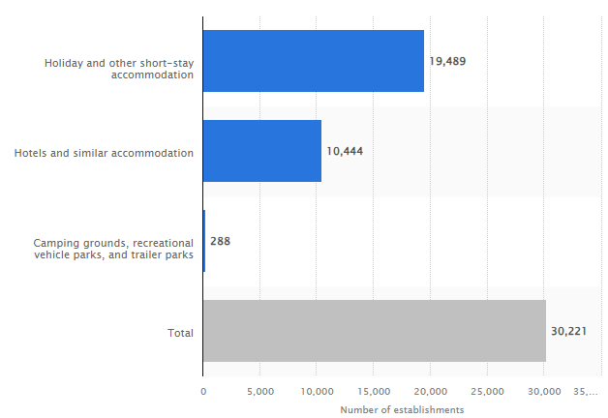
Figure 1: Number of travel accommodation in Greece in 2022
(Source: Statista, 2023)
Issues regarding sustainability practices
Grand Beach Mykonos Hotel is currently facing issues regarding its sustainability practices such as water consumption, natural energy conservation and reducing plastic waste. It is currently experiencing a few barriers regarding carbon emissions which in turn affected its operational functions as well. Failure to control carbon footprint during hospitality operations has further caused the international hospitality business to perceive complaints from environmentally-conscious visitors. In addition to this, Grand Beach Mykonos Hotel has identified that it showed a lack of expertise while tidying its seawater swimming pools (Grand Beach Mykonos Hotel, 2023). As a result, the hotel has gained serious criticism from a large number of its potential clientele.
Issues regarding environmental impact in Mykonos
Water scarcity: Climate change and water scarcity issues in Mykonos have further created a huge issue for the Grand Beach Mykonos Hotel during the peak tourist seasons. The accessibility and quality of drinking water are becoming a huge problem for the visitors in Mykonos along with Santorini (Atay and Saladié, 2022). The nominal capacity to mitigate water scarcity in Mykonos has become a noticeable issue in Greece. A statistical survey report has shown that the demand for water has risen by 15,000 cubic metres from July to October on a daily basis (Kousounis, 2023).
Plastic pollution: Several statistical reports have shown that the desalination of water has become one of the major causes of death of sea creatures in Mykonos. The sewage system of Mykonos has been destroyed due to a lack of supervision and administrative measures by the Greek government. However, these environmental issues show the dangerous impacts of plastic pollution in Mykonos which is increasing year to year. As per statistical reports, almost 75 to 199 million tonnes of plastic waste has been recorded in Mediterranean Sea areas (RTS, 2022). As per several projection reports, plastic waste may grow 29 million tonnes more by 2040 near the coastal areas of Mykonos (RTS, 2022).
Rising temperature and air pollution issues: Besides the water shortage issues, Mykonos faces rising temperature issues during the summer which is as high as 70 degrees (Weather Spark, 2023). As a result of this, Grand Beach Mykonos Hotel faced enormous barriers during peak summer seasons that have restricted its market scope, income and market reputation. As per evidence-based statistical reports, Mykonos has recorded 66 AQI which is poor air quality with high levels of pollution and GHG gas concentration (AccuWeather, 2023).
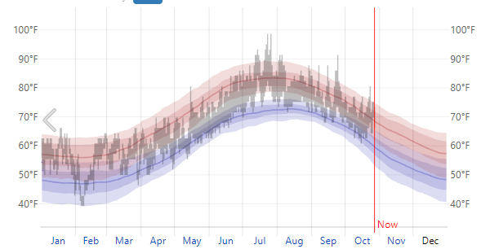
Figure 2: Temperature in Mykonos Greece
(Source: Weather Spark, 2023)
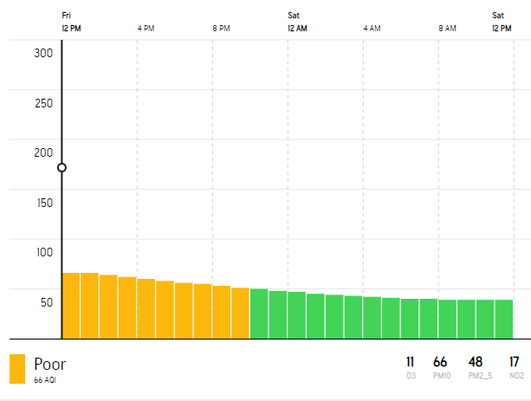
Figure 3: Poor air quality in Mykonos Island
(Source: AccuWeather, 2023)
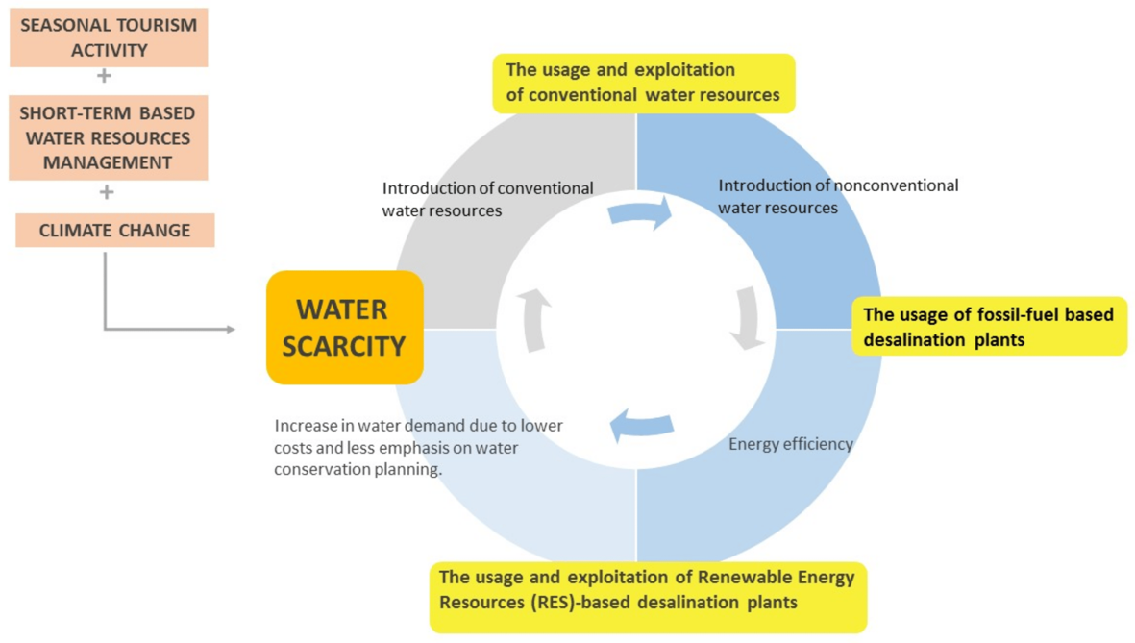
Figure 4: Water Scarcity and climate change impacts in Mykonos
(Source: Atay and Saladié, 2022)
As per the above analysis, it is clear that as an internationally-renowned hospitality business in Mykonos, Grand Beach Mykonos Hotel is currently experiencing several issues. As a professional organisation consultant, it is essential to critically analyse the micro and macro-environmental factors associated with these major issues to outline effective solutions.

2.2 PESTLE Analysis
Macro factors | Description | Impacts on Grand Beach Mykonos Hotel
1. Political factors | Political stability: As per statistical data, the Greek government has shown 39.15% political stability in 2021 (Trading Economics, 2023). Besides this, government intervention in terms of commercial support has grown the economic growth by 6.7% in 2021.  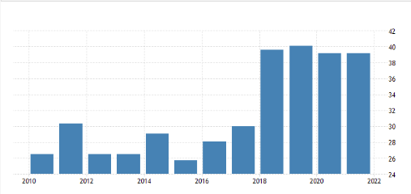  Figure 5: Political Stability Index in Greece  (Source: Trading Economics, 2023)  Strikes by civil servants: Several news articles have shown that millions of Greek civil workers conducted a series of strikes in September 2023 that has caused enormous mismanagement across the nation. Panhellenic Strikes in September have significantly created issues for the hospitality industry due to poor availability of transportation (US Embassy, 2023). | Positive and moderate  Negative and very high
2. Economic factors | Debt crisis: It has been observed that Mykonos in Greece is currently suffering from a huge debt crisis due to the limited availability of agricultural resources (Collavo and Katsikas, 2023). Financial stagnation issues in Mykonos have significantly affected the hospitality sector along with tourism businesses.  GDP growth: Economic projected reports have shown that the GDP in Greece may grow by 2.4% by the end of 2023 (European Commission, 2023). Besides this, inflation saturation may support the tourism and hospitality industry in Greece to recover from the debt crisis in the future.  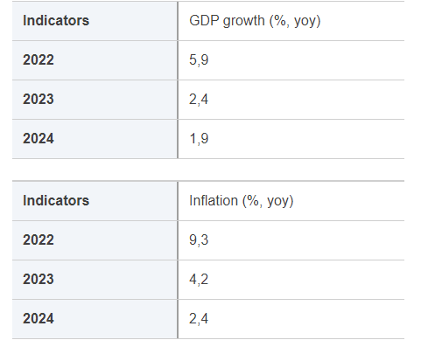  Figure 6: Forecasted GDP growth in Greece  (Source: European Commission, 2023) | Negative and very high  Positive and high
3. Social factors | International tourist arrivals: As per news articles, the post-pandemic tourism rush has triggered almost 7.6 million international tourists to famous tourist destinations in Greece including Mykonos (Krinis, 2023). Therefore, the hospitality industry has experienced a prominent growth in tourist arrival rate.  Sustainable tourism trends: The current state of tourism sustainability in Greece requires proper supervision and political commitment as eco-friendliness is growing among visitors (Deloitte, 2023). Therefore, the lack of sustainability commitment in Greece has created enormous pressure on its hospitality sectors. | Positive and moderate  Negative and very high
4. Technological factors | Digital booking process: The Greek hospitality sector including Mykonos has significantly invested capital in order to strengthen the digital booking process for facilitating guests. As a result of this, the hotel industry in Greece is expected to reach £1.00 billion by the end of 2023 (Statista, 2023). | Positive and moderate
5. Legal factors | Marine Pollution Legislation: The Law No. 3022 and Law 743/1977 by the Greek government have mentioned the protection of marine species and the marine environment (Kalimbassieris Maritime, 2020). However, the hospitality sector in Mykonos has shown mismanagement while maintaining the guidance of these legislations. | Negative and very high
6. Environmental factors | Water shortages: As per statistical survey reports, the shortage of water has increased by 15,000 cubic metres from July to October on a daily basis (Kousounis, 2023). As a result of this, the hotel and hospitality sector in Mykonos Island is facing enormous issues regarding guest service. | Negative and very high
Table 1: PESTLE analysis for Grand Beach Mykonos Hotel
(Source: Author)

2.3 SWOT Analysis
Strengths | Weaknesses
Location: Grand Beach Myokonos Hotel is located in Megali Ammos Beach in Mykonos Island with a beachfront setting (Grand Beach Mykonos Hotel, 2023). Additionally, the hotel is located near the most popular landmarks of Mykonos including Little Venice, the Archeological Museum and the famous Windmill.  Connectivity: Grand Beach Myokonos Hotel is located 400 metres away from the cosmopolitan Mykonos town which is favourable to international guests (Grand Beach Mykonos Hotel, 2023). Furthermore, its connectivity to Mykonos Port and the airport further facilitates its guests.  Range of room options: There is a range of room options available in Grand Beach Mykonos Hotel based on preference, budget and family sizes of guests.  Guest services: Besides restaurant and bar services, Grand Beach Mykonos Hotel offers a high-connectivity Wi-Fi facility, luggage transportation, airport pickup-drop facility and laundry services for its customers (Grand Beach Mykonos Hotel, 2023). | Employee base: the 4-star hotel has received poor feedback from international clients due to a lack of efficient workforce in guest service (Grand Beach Mykonos Hotel, 2023).  Scarcity of water: Scarcity of water has become another major issue for Grand Beach Myokonos Hotel due to environmental impacts.  Lack of guest facilities: The beachfront location of Grand Beach Myokonos Hotel offers a limited capacity of car parking and a lack of special facilities for physically challenged visitors (Grand Beach Mykonos Hotel, 2023). Additionally, poor maintenance of sea water swimming pools resulted in negative remarks from its clients.
Opportunities | Threats
Tourist arrivals: As per evidence-based studies, the post-pandemic tourism rush has triggered almost 1.2 million international tourists to visit Mykonos in 2022 which can facilitate Grand Beach Mykonos Hotel in the future (Krinis, 2023).  Connectivity: Well connectivity with the airport and cruise port can facilitate Grand Beach Mykonos Hotel in achieving a large number of guest arrivals in the next peak tourist season. | Competition: Huge market rivalry can disrupt economic growth and market potential of Grand Beach Mykonos Hotel in the future (Kousounis, 2021).  Environmental impacts: beac water pollution, poor sewage system and plastic pollution can restrict millions of tourists from booking rooms in the Grand Beach Mykonos Hotel.
Table 2: SWOT analysis of Grand Beach Mykonos Hotel
(Source: Author)

2.4 TOWS Matrix for Grand Beach Mykonos Hotel
TOWS MATRIX | Opportunities | Threats
Strengths | - The hotel provides excellent customer service with a range of accommodation options which would attract a lot of guests from the luxury travel market.  - According to Caldera et al. (2019), the beachfront idyllic location offers a memorable and unique experience to the guests through sunset cruises and boat tours.  - Prime location, well connectivity and the availability of restaurants and bars could attract a lot of customers even from distant locations as well as other continents. | - The luxurious accommodations and strong brand reputation could help the hotel organisation to stay ahead of the competition.  - The hotel could focus more on developing sustainable tourism options to reduce beach water pollution as well.  - The hotel organisation could develop a loyalty program to reward the customers as well. It could also help the hotel organisation to stay ahead of the competition as well.
Weaknesses | - A limited number of employees could impact the customer service of the hotel.  - The hotel could partner with other businesses to offer exclusive deals for physically challenged guests after the pandemic error (Grand Beach Mykonos, 2023).  - A limited number of staff might be unable to handle the tourist rush during the post-pandemic era. | - According to Shakeel et al. (2020), limited car parking facilities could increase beach water pollution.  - Limited staff could not address sustainability issues on behalf of the hotel organisation.  - Lack of customer service facilities for physically challenged customers could impact Corporate Social Responsibility for the hotel organisation.
Table 3: TOWS Matrix for Grand Beach Mykonos Hotel
(Source: Author)
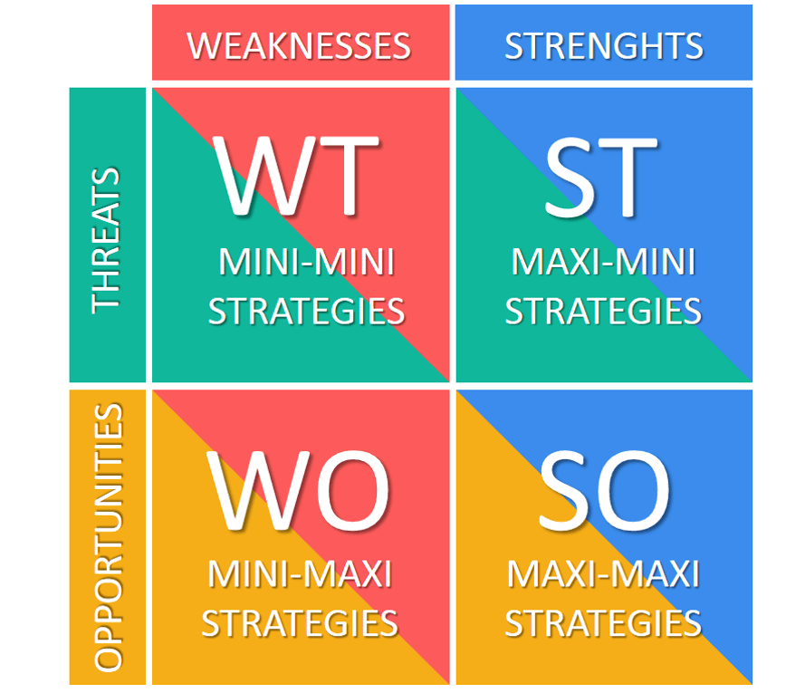
Figure 7: TOWS Matrix
(Source: Shakeel et al., 2020)

3. Recommendation and change management

3.1 Recommendations
Recommendation 1: Increase collaboration among the staff to share responsibility
The senior management of Grand Beach Mykonos Hotel is required to share information, resources and ideas with their staff. They could also collect feedback from the employees about various decision-making processes. According to Caldera et al. (2019), the staff of the hotel is also required to provide opportunities for working together to increase collaboration. The hotel could also use new technology to facilitate communication between the employees which will help to develop a good bond between them. Thus, the employees will maintain communication about their work as well and no misunderstanding will happen with the customers. This will also allow the hotel organisation to maintain work synchronisation. Furthermore, the problems of getting negative feedback from the customers could also be mitigated as well.
Implementation: Grand Beach Mykonos Hotel could create a shared workspace through a messaging application or online portal. It will allow the employees to communicate and share work information with others. According to Shakeel et al. (2020), holding regular team meetings is another great way to enhance collaboration between the staff of this hotel organisation. The staff of different departments will come together for discussion of their work and get more opportunities for collaboration with each other. The hotel organisation could also provide an opportunity for its staff to work on the same project together; when they face a problem while working on the project other team members will help them to solve the problem with their knowledge and skills. Furthermore, creating a loyalty program and video conferencing to other methods of promoting collaboration at the organisation. Thus, the staff will get public recognition and community with other stakeholders properly.
Recommendation 2: Enhancing competitive advantage through the implementation of new services
A hotel could increase its comparative advantage by improving customer service in a number of ways. Grand Beach Mykonos Hotel could provide a range of customer services digitally to attract a greater number of customers. They could also implement Artificial Intelligence to provide a personalised guest experience. According to Nosratabadi et al. (2019), it will help the hotel organisation enhance their productivity and efficiency as well. Implementation of new technology to provide customer service will also help the hotel organisation to reduce their operational cost.
Implementation: The hotel could provide 24*7 customer support by using chatbots. They could use a mobile application to handle the check-in and check-out process of the guests. It will not require the guests to be physically present at the reception of the hotel. According to Raut et al. (2019), AI could be used by the hotel organisation to track and analyse customer data in order to provide a more personalised experience to the guests. Some guests might want sea-facing rooms and some might prefer to go on boat tours. All these could be handled through the application. This would also help the hotel organisation to deal with the issue of limited staff as well. AI could also be used for revenue management, scheduling of work and forecasting of customer arrival for a particular season as well. They could also improve their service as well as their brand image by an efficient energy management system. The guests and the hotel could enjoy a seamless experience through mobile applications (Grand Beach Mykonos, 2023). Additionally, the hotel could also implement voice-activated rooms like Alexa to control temperature, TV, and lights just using their voice.
Recommendation 3: Development of proper CSR policies
Grand Beach Mykonos Hotel is one of the renowned hotels that could establish a CSR committee that will be responsible for developing and implementing the policies successfully. According to Nosratabadi et al. (2019), conducting a CSR assessment from time to time is also important for the hotel organisation to identify both the strengths and weaknesses of the hotel organisation. The committee will also develop proper social, ethical and environmental policies for CSR initiatives. They could also set a goal and SMART CSR objectives to make it more effective.
Implementation: The development of the policies is not only sufficient but it needs to be communicated with all the employees at Grand Beach Mykonos Hotel. Thus, the employees will also be connected with the organisational vision and mission. Furthermore, the CSR committee needs to continuously check the progress towards the CSR objectives at goals. According to Lu et al. (2019), they will also make a report on CSR performance and address the report to all its stakeholders. The hotel is required to make policies on energy consumption, using sustainable materials and conserving water. It will help them to enhance their brand image also. They could also encourage the guests to use public transportation to reach the hotel. It could include ride-sharing services or other public transportation modes which are easily available for this hotel. Proper energy management by using solar power could also help the hotel to address its carbon footprint issues.
Recommendation 4: Recommendations for several other environmental issues
Water scarcity, plastic pollution, air pollution and rising temperature are some of the major environmental issues faced by Grand Beach Mykonos Hotel currently. The hotel organisation is required to conserve water to address water scarcity issues. Additionally, they could focus on reducing waste, and protecting biodiversity in order to address various environmental problem
Implementation: According to Lu et al. (2019), the hotel could install water-efficient shower heads, faucets and toilets to reduce the use of water. They could also collect rainwater and use it in the bathrooms of the hotel to meet water demand. The hotel could also provide options to their guests for declining linen and towel services when they are checked in. The hotel could also provide reusable water bottles and encourage the guests to refill those bottles from water filters in their rooms. Thus, the problem of plastic use and water scarcity could be addressed. The hotel could also focus on implementing a waste reduction program and recycling different kinds of products used by the guests. According to Siregar (2021), digital boards could be installed at various places at the hotel to generate awareness for protecting sensitive habitats of coastal areas. The guests who opt for laundry services could be charged and the hotel organisation is required to reuse the water and not throw them directly into the sea. Thus, impacts on the coastal habitats could also be reduced along with protecting the biodiversity of the region. They could also promote the use of single-use plastics and disposable items. As the hotel is situated just beside the beach, the area needs to be declared as a plastic-free zone (Grand Beach Mykonos, 2023). They could also serve local food at their restaurants and bars. Furthermore, planting indoor plants will help the hotel deal with the issue of environmental air quality as well.

3.2 Change Management
Selecting a model for change management and implementation
According to Laig and Abocejo (2021), Kotter's 8-Step Change Management Model could be implemented for the hotel as it is effective for business sizes as well.
Creating a sense of urgency: The leadership team of the hotel is required to communicate with the employees about necessary changes. Both the organisational and environmental challenges need to be addressed in front of the employees to implement successful sustainable practices.
Forming a powerful coalition: According to Tang and Tang (2019), a successful assembly of employees from different departments is required at this stage. The employees are required to be committed to implementing sustainable practices for the entire hotel organisation.
Creating a vision for change: The leaders of the organisation will provide a vision to the employees for enhancing their sustainability practices as well as profit. Creating a vision will give them some specific goals for reducing problems like water scarcity, energy consumption, protection of biodiversity and waste management (Bedard, 2023).
Communicating with the vision: According to Laig and Abocejo (2021), after creating the vision, the leaders will communicate this with the employees through emails, meetings and other channels of communication. the leaders could also create posters to promote collaboration among the employees and sustainable business practices as well.
Removing barriers: According to Tang and Tang (2019), the higher authority will arrange training programs and workshops to empower the employees to achieve their vision. This will also create opportunities for the employees to share their feedback and ideas on change management.
Creating short-term wins: According to Small et al. (2016), increasing collaboration and enhanced hotel reviews will be to short-term success to achieve the vision in order to implement sustainable hotel business. Thus, momentum will be created to achieve long-term success as well.
Change building: Necessary CSR policies will be developed at this stage to implement changes. The hotel organisation could also develop and implement various other sustainability initiatives.
Anchoring change: According to Small et al. (2016), the change management will be embedded within the hotel’s values and culture which could be reflected through its mission statement, training programmes and core values.
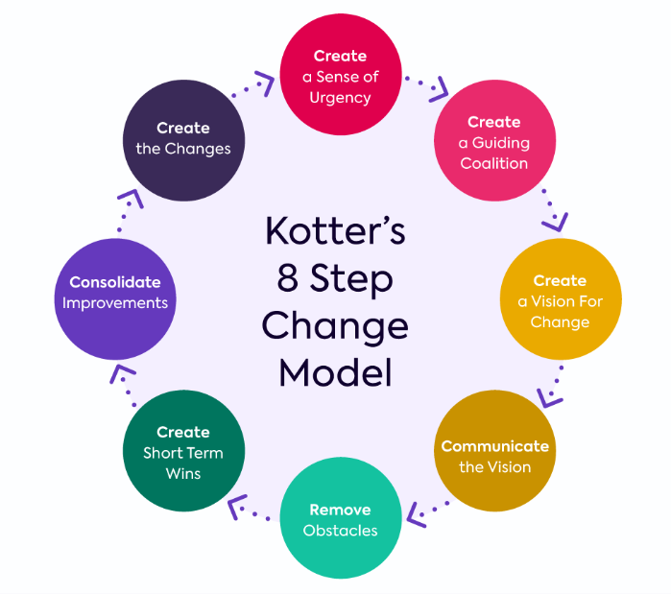
Figure 8: Kotter's 8-Step Change Management Model
(Source: Bedard, 2023)
Potential benefits
Reduction in environmental impact: Using energy-efficient lights, recycling water and promoting no use of plastics could help the hotel to reduce its environmental impact. Therefore, the impact on the local community as well as the coastal habitats will also be reduced effectively. According to Siregar (2021), reducing environmental impact will make the hotel business more sustainable and ethical.
Improved guest satisfaction: Generally, guest who looks for hotels committed towards sustainability could visit Grand Beach Mykonos Hotel more. The implementation of various sustainable practices could also attract and retain guests from different parts of the world. The application of chatbots along with other new technology could also enhance guest satisfaction at Grand Beach Mykonos Hotel.
Increasing employee engagement: According to De Giacomo and Bleischwitz (2020), the change management model could provide a sense of ownership and purpose to the employees. Additionally, the implementation of various communication methods will increase employee engagement as well. Holding meetings from time to time between the employees will also enhance their work efficiency because the employees will have the necessary information to welcome guests.
Enhanced brand image: A hotel organisation that is devoted towards waste management, no use of plastics and protecting biodiversity in order to protect the natural environment, its brand image will be enhanced to its stakeholders.
Measuring success rates
- Enhance the hotel rating as well as revenue of the hotel by 2 points within 6 months.
- Reduction in plastic use by 10% within 3 months
- Reduction in carbon emission by at least 5% within a year.
- Reduction in water use by 15% within 4 months.
- Reduction in average temperature by 2 degrees celsius within 12 months locally.
Table 4: Ways to measure success rates
(Source: Author)
Costs associated with recommendations
Bases | Costs (in £)
Creating a loyalty program for the employees | 500
A new type of customer service | 1,500
Establishing a CSR team | 700
Rainwater harvesting | 600
Planting indoor plants | 200
Recycling of water and other products | 1,200
Waste management | 800
Total | 55,000
Table 5: Costs associated with recommendations
(Source: Author)

4. Action Plan
Sl no. | Problem | Solution | Desired outcomes | Time scale | Date of completion | Planned budget
1 | Guest satisfaction issues | Enhance collaboration between the employees to have the necessary information for serving guests. According to Raut et al. (2019), the use of mobile applications for check-in and check-out, using chatbots to solve customers' queries and the use of AI to provide personalised services to customers could be probable solutions to this problem. | Customers engagement with this hotel will be enhanced and they will prefer to stay at this hotel for a long time. Furthermore, the rating of the hotel will also be increased on social media sites. | 6 months | 25/04/2024 | 1,500
2 | Limited sustainability practices | The hotel could establish a CSR committee that will be responsible for creating and implementing CSR policies. They will also review the policy from time to time and check the progress of the hotel towards CSR objectives. | According to De Giacomo and Bleischwitz (2020), the sustainability practices including waste management, water recycling, no use of plastics and protecting biodiversity will be enhanced. the mission statement of the hotel will also include practices to address these issues. | 12 months | 29/10/2024 | 3,500
3 | Income issues | Maintaining a competitive advantage could be the potential solution to the income issue for Grand Beach Mykonos Hotel (Lawrence and Weber, 2020). Providing top-notch customer service with 24/7 customer support could help them to address income issues. | The customer Lifetime Value of the organisation will be enhanced along with the employee retention rate. The hotel organisation could successfully implement AI to track customer data as well. | 6 months | 12/04/2022,0004
4 | Various environmental issues | They could develop smart CSR objectives which will contain proper social, ethical and environmental policies. The hotel organisation is also required to identify its strengths and weaknesses to implement necessary changes in its CSR policies. | The guests of Grand Beach Mykonos Hotel will use ride-sharing and public transportation options to reach the hotels. The carbon emission of the hotel would reduced within a short period with a greater contribution of all their stakeholders. | 14 months | 25/12/2024 | 3,500
Table 6: Action plan for the hotel
(Source: Author)

5. Conclusion
Grand Beach Mykonos Hotel is one of the most famous hospitality companies in Greece. It is a luxury hotel and it is just 450 metres away from Mykonos Town. This organisation has been facing a few challenges over the years. As a professional organisational consultant, the author has identified the faced issues by this organisation. This hotel has stated that the challenges are reducing the quality of customer operations significantly. The main identified issue is poor guest operations. The lack of expert employees and poor numbers of experienced employees are making this situation more critical. However, shortages of car parking areas are also making the guest service poor. A large number of similar businesses in the surrounding areas of Grand Beach Mykonos Hotel are reducing customer counts and negatively affecting income. The creation of plastic waste, poor conservation of water and high consumption of energy are also developing sustainability challenges for this hotel. All the above-identified issues are impacting the reputation of this hospitality organisation negatively. Hence, the number of customers of this business is also getting reduced in Grand Beach Mykonos Hotel. Eventually, this report has identified potential issues and discussed them in detail. All the discussions in this part are supported by statistical information and suitable examples. The environmental impacts of this organisation have been explained to identify the lack of its sustainability approaches intensely. The external factors can also affect any hospitality organisation both positively and negatively. Hence, this report has presented a PESTLE analysis on Greece to analyse the impacts of those factors on the Grand Beach Mykonos Hotel. A detailed analysis of political stability and strikes has been presented to assess the impacts of those factors on this business. Currently, Mykonos is suffering from a debt crisis and it will impact this hotel negatively in the coming years. Greece counted about 30 million international travellers in the accounting year 2022 (Statista, 2023). This high number of travellers can assist Grand Beach Mykonos Hotel in acquiring a large number of guests in the coming times. However, this organisation has strong and weak areas which can create opportunities as well as threats respectively. Location, connectivity, guest services and range of room options are strengths of this hotel (Kousounis, 2023). Alternatively, lack of guest facilities, scarcity of water and poor employee base are the major weak areas of this business. A detailed TOWS analysis has also been executed with special references from the Grand Beach Mykonos Hotel. A few recommendations also have been provided to this organisation for combating the identified issues easily. Kotter's 8-Step Change Management Model also has been explained to implement the changes in this business to resolve the identified challenges quickly. This company can reduce the environmental impacts, increase brand image, boost guest satisfaction and improve employee engagement by applying the above model properly. Possible costs associated with the recommendation have also been assessed. Finally, an action plan has been presented to resolve all the issues within a specific timeline at Grand Beach Mykonos Hotel smoothly.

Reference List
- Atay, I. & Saladié, Ò., (2022). Water Scarcity and Climate Change in Mykonos (Greece): The Perceptions of the Hospitality Stakeholders. Available at: https://www.mdpi.com/2673-5768/3/3/47 [Accessed: 25th October, 2023]
- Bedard, A., (2023). The 8-Step Process for Leading Change. Available at: https://www.kotterinc.com/methodology/8-steps/ [Accessed 27 October 2023]
- Caldera, H.T.S., Desha, C. and Dawes, L., (2019). Evaluating the enablers and barriers for successful implementation of sustainable business practice in ‘lean’SMEs. Journal of cleaner production, 218, pp.575-590.
- Collavo, A. C. and Katsikas, D., (2023). Will Greece Recover From Its Debt Crisis by the End of 2023?. Available at: https://www.fairobserver.com/economics/will-greece-recover-from-its-debt-crisis-by-the-end-of-2023/ [Accessed: 25th October, 2023]
- De Giacomo, M.R. and Bleischwitz, R., (2020). Business models for environmental sustainability: Contemporary shortcomings and some perspectives. Business Strategy and the Environment, 29(8), pp.3352-3369.
- Deloitte, (2023). Sustainability in the Greek tourism market Paving the way for sustainable tourism growth. Available at:https://www2.deloitte.com/content/dam/Deloitte/gr/Documents/consumer-business/gr_deloitte_insete_sustainability_report_noexp.pdf [Accessed: 27th October, 2023]
- Europan Commission, (2023). Economic forecast for Greece. Available at:https://economy-finance.ec.europa.eu/economic-surveillance-eu-economies/greece/economic-forecast-greece_en [Accessed: 26th October, 2023]
- Grand Beach Mykonos Hotel, (2023). Accommodation. Available at: https://www.grandbeachmykonos.com/mykonos-beach-hotel-luxury-stay/ [Accessed: 25th October, 2023]
- Grand Beach Mykonos Hotel, (2023). Guest Services. Available at: https://www.grandbeachmykonos.com/services/ [Accessed: 25th October, 2023]
- Grand Beach Mykonos Hotel, (2023). Location. Available at: https://www.grandbeachmykonos.com/mykonos-town-hotel-location/ [Accessed: 25th October, 2023]
- Grand Beach Mykonos Hotel, (2023). The Hotel. Available at: https://www.grandbeachmykonos.com/mykonos-town-hotel/ [Accessed: 26th October, 2023]
- ‌Grand Beach Mykonos, (2023). Explore Mykonos. Available at: https://www.grandbeachmykonos.com/explore-mykonos/ [Accessed 27 October 2023]
- Grand Beach Mykonos, (2023). Facilities & Services - Grand Beach Mykonos. Available at: https://www.grandbeachmykonos.com/services/ [Accessed 27 October 2023]
- Grand Beach Mykonos, (2023). Mykonos Town Hotel Grand Beach. Available at: https://www.grandbeachmykonos.com/ [Accessed 27 October 2023]
- Kalimbassieris Maritime, (2020). Pollution of Marine environment in Greece. Available at: https://www.swedishclub.com/media_upload/files/Member%20Alerts/pollution_of_marine_rnvironment_Greece_February2020.pdf [Accessed: 25th October, 2023]
- Kienapple, B., (2023). 25+ Consulting Report Templates Every Consultant Needs. Available at:https://venngage.com/blog/consulting-report-template/ [Accessed: 24th October, 2023]
- Kousounis, (2023). How Mykonos Found Itself Parched and Thirsty. Available at: https://www.travel.gr/en/how-to-travel-en/travel-news-en/how-mykonos-found-itself-parched-and-thirsty/ [Accessed: 27th October, 2023]
- Kousounis, S., (2021). Mykonos’ tourism figures: new hotel investments, aspirations for improved season. Available at: https://www.travel.gr/en/how-to-travel-en/mykonos-tourism-figures-new-hotel-investments-aspirations-for-improved-season/ [Accessed: 26th October, 2023]
- Krinis, N., (2023). Greece Welcomes 1.2 Million More Air Arrivals During January-May. Available at: https://news.gtp.gr/2023/06/30/greece-welcomes-1-2-million-more-air-arrivals-during-january-may/ [Accessed: 25th October, 2023]
- Laig, R.B.D. and Abocejo, F.T., (2021). Change management process in a mining company: Kotter’s 8-Step change model. Journal of Management, Economics, and Industrial Organization, 5(3), pp.31-50.
- Lawrence, A.T. and Weber, J., (2020). Business and society: Stakeholders, ethics, public policy. McGraw-Hill.
- Lu, J., Ren, L., Lin, W., He, Y. and Streimikis, J., (2019). Policies to promote corporate social responsibility (CSR) and assessment of CSR impacts.
- Nosratabadi, S., Mosavi, A., Shamshirband, S., Zavadskas, E.K., Rakotonirainy, A. and Chau, K.W., (2019). Sustainable business models: A review. Sustainability, 11(6), p.1663.
- Ooijen, G., (2023). How to Write an Expert Business Consulting Report: Best Practices & Templates. Available at: https://visme.co/blog/consulting-report/ [Accessed: 25th October, 2023]
- Raut, R.D., Mangla, S.K., Narwane, V.S., Gardas, B.B., Priyadarshinee, P. and Narkhede, B.E., (2019). Linking big data analytics and operational sustainability practices for sustainable business management. Journal of cleaner production, 224, pp.10-24.
- RTS, (2022). Plastic Pollution in The Ocean 0 2023 Facts and Statistics. Available at: https://www.rts.com/blog/plastic-pollution-in-the-ocean-2023-facts-and-statistics/ [Accessed: 24th October, 2023]
- Shakeel, J., Mardani, A., Chofreh, A.G., Goni, F.A. and Klemeš, J.J., (2020). Anatomy of sustainable business model innovation. Journal of cleaner production, 261, p.121201.
- Siregar, I., (2021). CSR-based corporate environmental policy implementation. British Journal of Environmental Studies, 1(1), pp.51-57.
- Small, A., Gist, D., Souza, D., Dalton, J., Magny-Normilus, C. and David, D., (2016). Using Kotter's change model for implementing bedside handoff: a quality improvement project. Journal of nursing care quality, 31(4), pp.304-309.
- Statista, (2023). Hotels - Greece. Available at: https://www.statista.com/outlook/mmo/travel-tourism/hotels/greece [Accessed: 27th October, 2023]
- Statista, (2023). Number of international tourists in Greece from 2005 to 2022. Available at https://www.statista.com/statistics/444847/total-number-of-inbound-visitors-in-greece/#:~:text=How%20many%20tourists%20visited%20Greece%20in%202022?,tourists%20in%20Greece%20reached%20nearly%2030%20million. [Accessed 27 October 2023]
- Statista, (2023). Number of travel accommodation establishments in Greece in 2022, by type. Available at: https://www.statista.com/statistics/413417/number-of-travel-accommodation-establishments-in-greece/ [Accessed: 25th October, 2023]
- Tang, K.N. and Tang, K.N., (2019). Change management. Leadership and change management, pp.47-55.
- Trading Economics, (2023). Greece - Political Stability And Absence Of Violence/Terrorism: Percentile Rank, Lower Bound Of 90% Confidence Interval. Available at: https://tradingeconomics.com/greece/political-stability-and-absence-of-violence-terrorism-percentile-rank-lower-bound-of-90percent-confidence-interval-wb-data.html [Accessed: 26th October, 2023]
- US Embassy, (2023). Demonstration Alert: Panhellenic General Strike on 21 September 2023. Available at: https://gr.usembassy.gov/demonstration-alert-panhellenic-general-strike/#:~:text=Demonstration%20Alert%3A%20Panhellenic%20General%20Strike%20on%2021%20September%202023,-Home%20%7C%20News%20%26%20Events&text=Public%20sector%20employees%20have%20announced,Greece%20for%20September%2021%2C%202023. [Accessed: 25th October, 2023]
- Weather Spark, (2023). 2023 Weather History in Mykonos. Available at: https://weatherspark.com/h/y/91788/2023/Historical-Weather-during-2023-in-Mykonos-Greece#Figures-Summary [Accessed: 27th October, 2023]

