Financial Management for the Hotel Industry
Assignment 1
PETRU VARGA:2022595

Table of Content
Introduction 1
Total Revenue 2
Market Position 2
Growth Potential 2
Financial Commitment to CSR 3
Recommendations 5
Opportunities for Growth 5
Potential for Outsourcing 6
Conclusion 7
Reference 8

Introduction
Marriot International Hotel and Hilton hotels are two of the most renowned hotel companies in the UK. The Marriot International hotel is an American hotel chain that has over 8 thousand properties operating in 139 countries. The multinational hotel company had been found in 1927 by Alice Marriott and J. Willard Marriott. The company generates over USD 13.86 billion as sales revenues and has assets over USD 25.55 billion as of 2021. The Hilton Hotels and Resorts is known as a global full-service hotel brand that is also an American hospitality company. The company had been found in 1919 by Conrad Nicholson Hilton. The multinational company holds over 61 properties worldwide. The following report shall provide a financial overview of the two hospitality companies in terms of growth and market position.

Total Revenue
Marriot International Hotel – the total revenue generated by the hotel had been over USD 20.773 billion as of 2022. The company’s revenue had increased by 49.91% since 2021 when the revenue had been USD 13.85 billion (Janjusevic, 2022). Since the pandemic had subsided, the company has been able to increase its revenue due to better marketing and customer satisfaction.
Hilton Hotels and Resorts – the company had generated over USD 8.773 billion as of 2022. The revenue had been an increase of 51.57% since 2021 which was merely USD 5.788 billion (Avasiloaei, 2022). Since the pandemic had subsided, the company has been able to increase its revenue due to better marketing and customer satisfaction.
However, the higher revenue generated can be observed to be of Marriot International Hotel, as it had generated an additional USD 12 billion as revenue relative to Hilton Hotels and Resorts. So, in terms of revenues, the Marriot International Hotel is in a better position.

Market Position
Marriott International Hotel, with an estimated market capitalization value of GBP 53.42 billion, stands as a prominent player in the global market. Its impressive market valuation secures the company's position at 297th among the world's most valuable enterprises. This achievement speaks volumes about Marriott's strong brand reputation, extensive hospitality portfolio, and ability to cater to diverse customer needs.
Similarly, Hilton Hotels and Resorts, boasting a market capitalization value of GBP 37.91 billion, holds its ground as a significant player in the industry. Ranked 450th in the global hierarchy of valuable companies, Hilton's market value underscores its enduring appeal and success in the competitive hotel and resort sector. Both Marriott and Hilton's remarkable market positions reflect their ability to consistently deliver exceptional services and capture the trust and loyalty of customers worldwide.

So, in terms of the market position, Marriot International Hotel is leading as the market capitalisation value of the company is much higher than that of Hilton Hotels and Resorts’ market capitalisation value. Also, Marriot International Hotel is higher in the most valuable companies in the world. So, it can be observed that Marriot International Hotel is the leading in market position.
The comparison chart is given below-
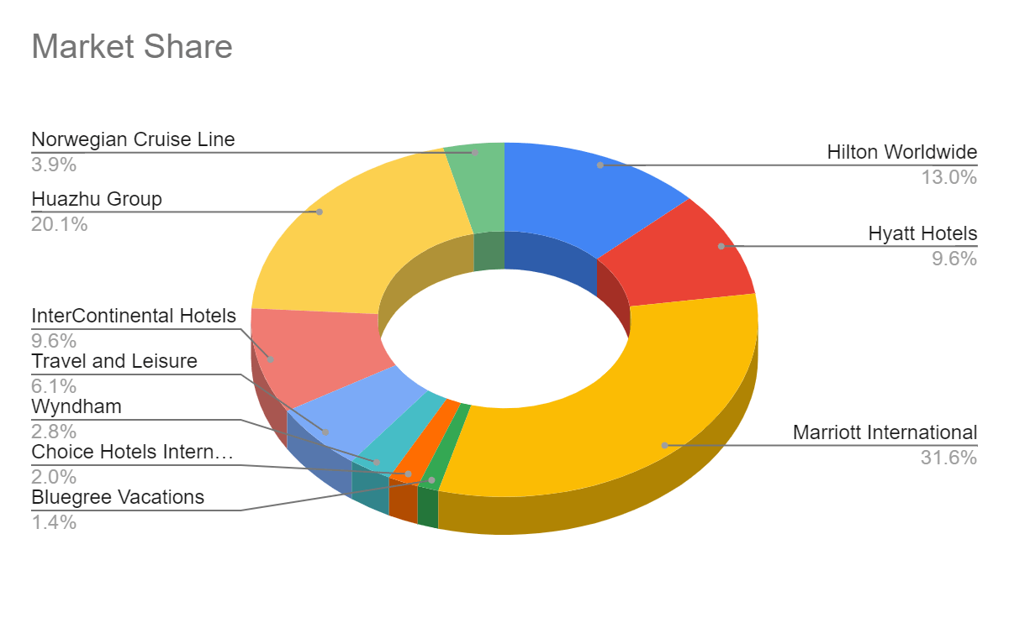
Source: rooms (Ertuna, Gu and Yu, 2022)

Growth Potential
The growth potential refers to the growth of the company in terms of profitability and business size. As both of the hospitality companies are so large in nature, the growth rate is considerably slower for the both the companies.
Marriot International Hotel – the multinational hospitality company has a growth rate of 4% to 4.50% increase. This involved the expansion of locations and the number of rooms. The company had added over 65 thousand rooms within its 394 locations all around the world, which consisted of 40 thousand rooms in the international markets and over 17 thousand conversion rooms (Ertuna, Gu and Yu, 2022).
Hilton Hotels and Resorts – the multinational hospitality company has a growth rate of 5% to 5.50% increase. This involves the expansion of the hotel by one room every day, which equivalents to over 58 thousand rooms (Zutshi et al., 2022). The hotel management plans to increase their number of rooms in the future as the previous years as the demand for their hospitality has been increasing.
Thus, in terms of growth rate, the Hilton Hotels and Resorts have a higher growth rate than Marriot International Hotel. This is mainly because the Hilton Hotels and Resorts has less properties and rooms compared to the rival company and still has scope to increase in size.

Financial Commitment to CSR
The financial commitment to CSR refers to the amount of funds the hospitality company spends on CSR activities and practices.
Marriot International Hotel – the multinational company believes in developing the communities around them. This involves providing training and development programs to build skills and expertise of the local people (Mani and Mishra, 2022). It also involves providing education for the children, utilising natural resources, and preservation of the nature. The company also aims to operate responsibly to minimising their plastic, water, and paper usage. It also involves the reduction of environmental impacts such as water pollution and sound and air pollution. The company also promotes and invests into non-profitable organisations to increase the skills and employability of the local people. It helps the company to enhance the scope for career development, diverse population, And workplace readiness for the local people (Baxter and Srisaeng, 2022). The Marriot International Hotel also engages in sustainability and social impact goals that involves a number of goals consisting of sustainability for employment, business operations, environmental wellbeing, etc. It also involves reducing the environmental footprint by 50.0% by the end of 2025, that includes reduction of water wastes by 15.0%, carbon emissions by 30.0%, reduction of wastes by 45.0%, and investment in renewable energy by a minimum 30.0% (Adalja and Varney, 2022). The company also aims to have sustainability certificates for all its locations and LEED certification. The company also aims to conduct sustainable sourcing of resources by 95.0% by sourcing free-range eggs, top priority sourcing of protein food, etc.
Hilton Hotels and Resorts – the multinational company had planned to double their investment in the CSR activities. The hotel has been already involved in workplace diversity and inclusivity of gender, race, and culture (Avasiloaei, 2022). It can be observed from the chart below that the company’s workforce consists of 53.0% women and 47.0% men, giving the females an opportunity for career growth. Also, the diversity of cultures, race, and ethnicities can be observed to be 69.0% with age range of the employees belonging from different generations (Adalja and Varney, 2022).
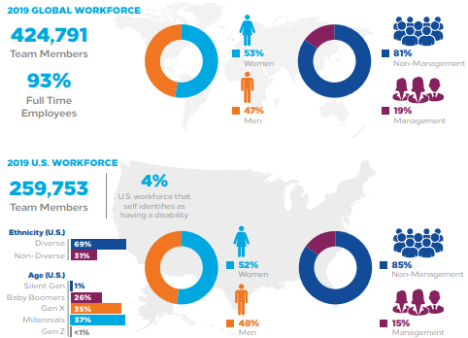
So, overall, Marriot International Hotel has contributed to more financial commitments to CSR in multiple forms relative to the rival multinational hospitality company - Hilton Hotels and Resorts. So, overall, it can be said that aside from the growth rate, Marriot International Hotel has been leading in terms of finances, financial commitment to CSR practices, and market share. It is one of the leading hospitality companies in the world with numerous locations and potential for further growth in the future.

Recommendations
From the comparison analysis between Marriot International Hotel and Hilton Hotels and Resorts, it was observed that Marriot International Hotel had the higher revenue relative to Hilton Hotels and Resorts; as it had an additional revenue of USD 12 billion as revenue. So, in terms of revenues, the Marriot International Hotel is in a better position. Also, in terms of the market position, Marriot International Hotel is leading as the market capitalisation value of the company is much higher than that of Hilton Hotels and Resorts’ market capitalisation value. Also, Marriot International Hotel is higher in the most valuable companies in the world. But in terms of growth rate, the Hilton Hotels and Resorts have a higher growth rate than Marriot International Hotel. This is mainly because the Hilton Hotels and Resorts has less properties and rooms compared to the rival company and still has scope to increase in size. However, in terms of financial commitment to the CSR practices, Marriot International Hotel has contributed to more financial commitments to CSR in multiple forms relative to the rival multinational hospitality company - Hilton Hotels and Resorts.

Opportunities for Growth
Marriot International Hotel – the company may opt to open its hospitality services in locations in the middle eastern countries as well as the Asian countries. It may want to enter into new markets which have the potential for growth in its tourism sector. It shall help the Marriot International Hotel to expand into new markets and take advantage of opportunities for growth. It may also opt to provide hospitality for single guests similar to capsule hotels. This shall help the hotel to attract single travellers and increase market share in new markets.
Hilton Hotels and Resorts – the Hilton Hotels and Resorts may opt to open in areas which has potential growth rate for tourism for wealthy travelers. Such locations may involve the rapidly developing countries such as India, Saudi Arabia, etc. Moreover, the company may opt to come up with unique hospitality concepts for travelers and form strategic alliances with travel agencies to increase sales and eventually the market share.

Potential for Outsourcing
The hospitality companies have adequate opportunities for outsourcing. This may be in forms of franchises, trademarking, etc. However, adequate attention to service quality must be ensured for the companies respectively.
Marriot International Hotel – this multinational hotel may want to outsource its customer care services to developing countries to opt for low-cost yet effective customer services. This shall involve the company to hire low cost call centres which are trained in lesser developed countries. This would provide employability for the lesser developed countries and also provide a low cost service for its customers. This would also help Marriot International Hotel to cut down on overhead costs greatly and improve customer relations and profitability. The company may also opt to provide franchise to other companies in new locations. But it must set standards and perform regular checks to ensure the service quality is maintained.
Hilton Hotels and Resorts – this multinational hospitality company also may opt to outsource it services by franchising to new locations. However, the company must set standards and perform regular checks to ensure the service quality is maintained. This would allow the parent company to cut down on overhead costs. The company may also opt to outsource its digital marketing operations and information technologies to countries with IT expertise and low cost employees. This shall help to provide employability for the hosting countries and also provide a low cost operations for company. This would also help Hilton Hotels and Resorts to cut down on overhead costs greatly and improve customer relations and profitability.

Conclusion
The report has successfully compared the two hospitality companies of Hilton Hotels and Resorts and Marriot International Hotel. It was observed that the Marriot International Hotel had been performing better in terms of market position and revenues. However, the Hilton Hotels and Resorts had a higher growth rate. Nonetheless, Marriot International Hotel had more commitment to CSR activities. But both share opportunities for growth and outsourcing.

Reference
Adalja, A. and Varney, J. (2022) ‘12th Annual Sustainability Roundtable Highlights’.
Avasiloaei, D. (2022) ‘Reinventing the Business Model in the Tourism Industry based on Sustainable Circular Economy and Innovation’, ENTRENOVA-ENTerprise REsearch InNOVAtion, 8(1).
Baxter, G. and Srisaeng, P. (2022) ‘An Examination of Hotel’s Use of Carbon Offset Programs as an Environmental Sustainability Measure’, วารสาร เพื่อ การ พัฒนาการ ท่องเที่ยว สู่ ความ ยั่งยืน, 4(1).
Ertuna, B., Gu, H. and Yu, L. (2022) ‘“A thread connects all beads”: Aligning global CSR strategy by hotel MNCs’, Tourism Management, 91, p. 104520.
Janjusevic, L. (2022) ‘SUSTAINABLE TOURISM DEVELOPMENT, EVIDENCE BASED APPROACH’, Economic and Social Development: Book of Proceedings, pp. 121–133.
Zutshi, A. et al. (2022) ‘Sustainability during the COVID pandemic: analysis of hotel association communication’, Current Issues in Tourism, 25(23), pp. 3840–3853.

