

BMSW4011 – Managing Enterprise
Certificate of Higher Education in Employability Skills
LEVEL 4
Module Lead: Mel Squire

Student Name: Michaela Stoean-Cristea
Student ID:2325709
Table of Contents
Introduction 3
Task 1: Business Plan 3
1. Product/Service Proposition 3
2. Business Name and Form of Ownership 3
3. Mission Statement, Purpose, and Goals 4
4. USP 4
5. Location 4
6. Human Resources 5
7. Marketing Activities 5
8. Market Research 6
9. Financial Resources 6
10. 12-Month Cash Flow Forecast 6
11. the biggest threat to the success of this business plan and how to propose to overcome this 7
Individual Reflection 8
1. What new business skills and knowledge have you acquired during the process of formulating and developing your business plan? 8
2. Evaluation of Entrepreneurial Strengths 8
3. Challenges in Implementing the Business Plan 9
Task 2: Presentation 10
GreenBrew Café: Business Plan 10
Marketing Strategy and Branding for GreenBrew Café 11
SWOT Analysis of GreenBrew Café 12
Conclusion 13
Reference List 15

Introduction
This business proposal identifies the unique aspects that shall be offered through GreenBrew Café, an eco-friendly coffee shop situated in Liverpool. It goes on to look at the marketing strategy, the operational structure, financial viability, and all other aspects that will determine if the venture survives and thrives in a highly competitive market dominated by sustainability and quality.

Task 1: Business Plan

1. Product/Service Proposition
The business is an eco-friendly café referred to as GreenBrew Café that offers a unique blend of organic and sustainable coffee, teas, and healthy snacks. High-quality beverages and food from locally sourced ingredients will be encouraged for environmentally conscious consumers (Smith, 2008). Additionally, it will offer takeaways that embrace zero-waste packaging using biodegradable containers, and it encourages customers to bring their reusable cups to the café for the provided beverage.
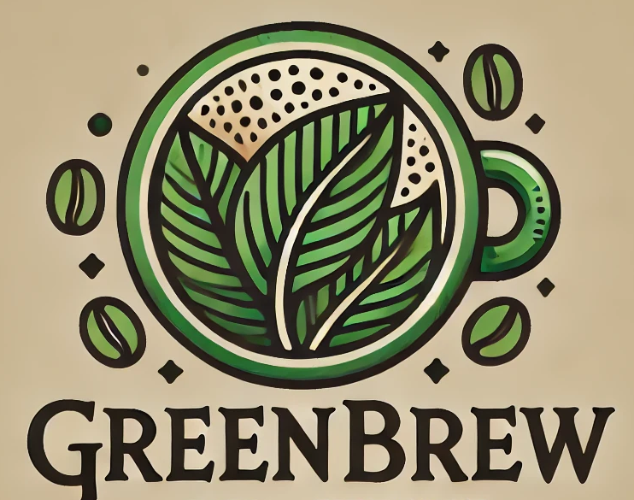

2. Business Name and Form of Ownership
GreenBrew Café shall be a partnership. The reason for selecting a partnership is the ability to pool resources, skills, and capital between two complementary business experts. One on sustainable food sources and the other on marketing and operations.
- Advantages: Shared financial burden, diverse skills, and less personal liability in comparison to a sole proprietorship (Hansmann, 2000).
- Downsides: Profits are shared, and the decision-making time may be slower because of the consensus needed by the partners (Straus, 2002).

3. Mission Statement, Purpose, and Goals
Mission Statement: To provide the community with eco-friendly, sustainable coffee and food along with raising awareness about the environment and stewardship.
Purpose: To be the first year's eco-friendly café leader in our region where quality can be made to last through sustainability and community engagement.
Goals
- Enjoy a 25% market share of local coffee shops in the first 12 months.
- Strategic partnerships with local suppliers to promote and ensure sustainable sourcing
- 50% waste reduction in the first year by living a life zero-waste

4. USP
The USP at GreenBrew Café would be a focus on sustainability from source to packaging, thus offering a 360-degree eco-friendly experience to the market.

5. Location
The GreenBrew Café is located on Bold Street, Liverpool. Bold Street represents one of the busiest areas in Liverpool and includes independent shops, cafes, and restaurants, with the street focusing on a very diverse set of professionals, students, and tourists (Parsons, 2013).
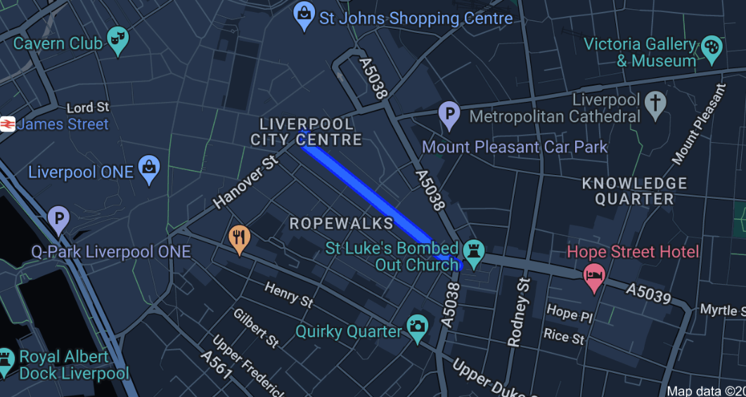

6. Human Resources
The business will recruit 10 employees, including baristas, kitchens, and customer services. The company will source staffing locally through employment agencies and job advertisements where an individual is of interest as long as he has a passion for sustainability (Gershon, 2024).

7. Marketing Activities
GreenBrew Café will make use of a mix of mainstream and digital marketing methods of advertising eco-friendly products and services with a high emphasis on creating a brand around sustainability and environmental consciousness.
The first launch post of the marketing campaign for the café will be executed through Facebook and Instagram launch posts as a means of targeting the environment-conscious consumer in Liverpool and more precisely the area around Bold Street. Flyer and poster circulation in strategic points that include universities, co-working spaces, and local green stores with special promotions that offer a special discount once the first month of operations is completed (Agboke and Effiong, 2020). PR buzz to be generated among local influencers and environmental bloggers who write free coffee for honest reviews on social media platforms. On its website, GreenBrew Café would host a blog on issues of sustainability, further enhancing its reputation as the pre-eminent place for living green. GreenBrew Café would additionally partner with environment-focused non-profits and donate percentage amounts of profits towards local green initiatives (Sigala, 2014).

8. Market Research
Market research by GreenBrew Café has included conducting market surveys and gathering information from focus groups targeted towards local customers, as well as competitor analysis in the Liverpool region (Krueger, 2014). To solicit feedback on what consumers want to see in an eco-friendly café, the surveys were put out online on Facebook and student forums (Kumar, 2024).
Focus groups also spoke to a perceived need in the marketplace for locally sourced, zero-waste products sold in cafés, with many respondents stating that they are willing to pay more to use such a service (Huang, 2024). This research was directly used in GreenBrew Café's business proposition, informing the central focus on sustainability as part of the brand identity. Graphs and data were showing increased behaviour in which consumers were becoming more environmentally friendly, meaning further defining the niche was something worth pursuing (Reddy et al., 2023).

9. Financial Resources
GreenBrew Café's running costs include rent, utilities, staff wages, raw materials, and marketing expenses, estimated at £8,000 monthly. Initial funding will come from a £50,000 bank loan and £10,000 personal savings. These sources are realistic and feasible, considering projected sales and market demand, which indicate the café can break even within 12 months.

10. 12-Month Cash Flow Forecast
Month | Revenue (£) | Expenses (£) | Net Cash Flow (£)
January | 10,000 | 8,000 | 2,000
February | 11,000 | 8,000 | 3,000
March | 12,000 | 8,500 | 3,500
April | 13,000 | 8,500 | 4,500
May | 14,000 | 8,500 | 5,500
June | 15,000 | 9,000 | 6,000
July | 16,000 | 9,000 | 7,000
August | 17,000 | 9,500 | 7,500
September | 18,000 | 9,500 | 8,500
October | 19,000 | 10,000 | 9,000
November | 20,000 | 10,000 | 10,000
December | 21,000 | 10,500 | 10,500
Cash Flow Summary and Narrative
Sales of GreenBrew Café are likely to increase steadily. The sales are forecasted to start at £10,000 in January and to increase to £21,000 by December. The cost will be £8,000 for the first month and increase to £10,500 by the end of the year. All these costs include staffing rent and materials. A positive net cash flow is going to arise from the first month and this flow will continue upwards till it reaches £10,500 by December. On this steady growth curve, GreenBrew Café is poised to enjoy healthy cash flow, reinvest in the business, and be financially sustainable throughout its first year.

11. the biggest threat to the success of this business plan and how to propose to overcome this
Main Risks Certainly, significant competition in the market from other commercially established cafés in Liverpool, including Starbucks (Starbucks, 2019) and Costa (Costa coffee. 2013), with well-known brands and low prices, would undermine GreenBrew Café's prosperity.
In that case, GreenBrew Café will emphasize sustainability and environmental-friendliness, addressing a growing marketplace demand, particularly among environmentally conscious consumers (Chen et al., 2023). The whole idea is to enhance strong community relationships by hosting events, hence taking advantage of and promoting local suppliers for a loyal customer base. Targeted digital marketing and personalized customer experiences will make GreenBrew Café stand out from its big competitors (Cannon and Homburg, 2001).

Individual Reflection

1. What new business skills and knowledge have you acquired during the process of formulating and developing your business plan?
Working out and developing the business plan for GreenBrew Café really enhanced my business knowledge and skillset to several notches. Among some of the greatest skills acquired was financial forecasting, which gives one good knowledge on how to project revenues, manage expenses, as well as maintain cash flow for a new business.
Other important learning areas include market research. Through surveys and focus groups, I discovered consumer preferences, particularly concerning sustainability and eco-friendliness. This enabled me to gain experience in how to collect and analyze data and use it to inform key business decisions in order to fine-tune GreenBrew Café's value proposition. Above all, I learned more about marketing strategies, from digital campaigns to community engagement, which will be important in promoting a new business within a competitive market. I also learned the importance of branding and how a business's unique selling proposition could be communicated during this process.

2. Evaluation of Entrepreneurial Strengths
In this process, I identified a number of entrepreneurial strengths that would aid in the launching and managing of GreenBrew Café. One of the key strengths which I possess involves creativity. I can come up with a business idea nobody else has thought of and combine it with a unique feature related to sustainability, not only timely but also relevant in today's market. It ranges from innovative ways the café could reach out to the community, like sustainability workshops or working with a local supplier, to developing new product lines that inform customers' values they want it to promote.
Another of my strengths lies in my strategic thinking. For example, I understood that a niche market of environmentally conscious consumers would tend to differentiate GreenBrew Café from close competitors. I further presented good problem-solving ability, mainly when I estimated possible threats associated with the business such as competition of already established brands. Good community relations and concentrated efforts on purely digital marketing stand as a great testament to my ability to see ahead with the challenges that would arise and develop solutions for them, navigating a competitive market.

3. Challenges in Implementing the Business Plan
While the business plan provides a solid foundation for GreenBrew Café, I think several things will occur during implementation. The biggest headache in the short run will be how to manage cash flow. It is another challenge: people. At least the level of those who are not only qualified but enthusiastic about issues concerning sustainability. Undeniably, this is where the core of the identity of the café is connected with its cause and values, thus making the selection of proper staff quite crucial. I will tackle this by designing very precise job descriptions and specifying how important the adoption of eco-friendly behavior and sustainability is, as well as by cooperating with socially responsible recruitment agencies. The last one is to create brand awareness in a very competitive marketplace, saturated with coffee shops. In this case, the threat to small, independent businesses like GreenBrew Café is fairly considerable.

Task 2: Presentation

GreenBrew Café: Business Plan
Product/Service Description
GreenBrew Café is a unique experience of an environmentally friendly coffee house focusing on sustainably sourced, quality products. The café will offer several kinds of ethically sourced, organic coffees, teas, and plant-based food options that are packaged entirely in zero-waste materials. Most of the used materials will be sourced locally to cause as much of an environmental impact and boost local economies as possible.
Mission Statement
"To offer a sustainable, high-quality coffee and food service that supports green lifestyles and community connections."
Business Aims and Objectives
GreenBrew Café will be the number one green coffee shop in the Liverpool region. Utilizing a loyal customer base that values sustainability, our goals are outlined below.
- Be profitable 18 months from opening.
- Reduce single-use packaging waste by 80 per cent over the first year.
- Partner with local suppliers to ensure quality, environment-friendly products.
Unique Selling Proposition (USP)
The USP of GreenBrew Café lies in the zero-waste, eco-friendly packaging, sourcing locally from the marketplaces, and encouraging sustainable living practices. For a customer, this means working hand-in-hand with a business that is attentive to its environmental impact. Our 'green' practices make us unique in a fast-growing market that wants to be sustainable.
Legal Structure
GreenBrew Café will be incorporated as a sole proprietorship (Darmansyah, 2018) because it can afford the owner of the business maximum control over its operations and decision-making. Ideally, this is suitable for the establishment of a small-scale business because its starting point is local. Being risky, it is more convenient at the same time due to flexibility in the initial development of the business.
Proposed Location
GreenBrew Café will be located on Bold Street, right in the heart of Liverpool's energetic and vibrant hub with lots of foot traffic from students, professionals, and tourists. It is most famous for independent shops and cafes, which appeals to our target market of eco-friendly users.
HRM Strategy
There will be five employees working in the café, including a manager, two baristas, and two kitchen workers. Hiring is going to be based on a passion for sustainability and being knowledgeable about living an eco-friendly lifestyle (Llewellyn and Hendrix, 2008). All employees are going to be properly trained in customer service, sustainable practices, and products to maintain the consistency of the GreenBrew values shared by all employees.
Financial Overview
The initial capital will be obtained by borrowing £50,000 from the bank and £10,000 from personal equity. The monthly running cost concerning rent, wages, and stock is seen to be around £8,000, as the projected monthly income is believed to increase from £10,000 in the first month up to £21,000 in the twelfth month. GreenBrew Café anticipates recovering its costs within a year; this is from the low-cost, high-margin products GreenBrew offers and also acquiring the right market targeting.

Marketing Strategy and Branding for GreenBrew Café
GreenBrew Café's marketing strategy focuses on eco-conscious consumers through digital marketing, community outreach, and visual branding. All that makes up the brand of the café are sustainability, local sourcing, and community, which are included in the marketing strategy (Almestarihi, 2024). The primary goal is to build a loyal customer base by positioning the café as an eco-friendly place with quality, locally sourced products.
Social Media Campaigns
GreenBrew Café will use Facebook, Instagram, and TikTok to target large audiences, targeting young, environmentally-conscious consumers (Evgenevna, 2024). A series of TikTok ads will drive home the fact that GreenBrew Café ensures zero waste; an example is through the use of reusable packs and local suppliers in a series of activities that it undertakes in its operations and all this under the utilisation of hashtags #EcoFriendlyCafe and #GreenLiving. Posts on Instagram about the plant-based foods served in the café and special coffee blends used will be done. Those will be completed with high-quality images and exciting captions that attract more customer engagement. Launch posts on Facebook would announce the launch of the café with offers for free use, such as free coffee on any purchase by the first 100 customers.
Community Engagement and Events
For GreenBrew Café, this would entail hosting sustainability workshops and collaborating with the local environmental groups. Such events would be advertised through posting flyers on Bold Street and its surroundings as well as on various university campuses (Kutter, Wolf and Rothbarth, 2023). Eco-friendly flyers made of recycled paper will be used to advertise the workshops. The flyers advertising the workshops shall carry incentives such as discounts for the attendants.
Branding Elements
The branding at GreenBrew is very simple and minimalist in design but corresponds to its green mission. Business cards and flyers feature green tones with natural ingredients and give off a sustainability message. A coffee cup with a leaf further enhances the eco-friendly positioning of the logo for the café.

SWOT Analysis of GreenBrew Café
Strengths
Sustainability focus: The policy on zero-waste packaging and GreenBrew Café using eco-friendly products would appeal to the growing customer population that is concerned about the environment.
Location: Bold Street, Liverpool is a location of high foot traffic with characteristics being dominantly independent shops. This will most likely attract many footpassers who are the target customers.
Community involvement: Contracts with the local suppliers that GreenBrew has fostered will enhance its loyalty brand but hosting sustainability events demonstrates the company's uniqueness compared to most other competitors.
Weaknesses
Limited Brand recognition: A new, independent business like GreenBrew Café lacks the brand name and customer base of established coffee chains.
Higher Cost: Green products made from sources that are available in the local community will cost more; hence, the business might incur higher costs than its competitors who make use of cheaper, mass-produced goods (Iannuzzi, 2024).
Opportunities
Eco-friendly trends: The present and growing trends of consumer behaviour demanding sustainability create an upward market for GreenBrew's products (Ray and Nayak, 2023).
Digital marketing: Leverage the usage of TikTok and Instagram to expand in-store visibility and attract more young customers.
Threats
Competitive threat: Giant coffee chains compete based on price cuts and sizable marketing budgets (de Souza Santos and Carrino, 2023).
Economic factors: They are vulnerable to sharp rises in ingredients used for their menu items and a very volatile market, which may dent profitability (Clapp, 2023; Matthews, 2023).
Appraisal
Such is the business proposition for GreenBrew Café, which can easily enhance sustainability trends and a significant location. It faces difficulties like competition and cost management. However, with a strong marketing strategy focusing on locality, the café shall surely excel in this competitive market of Liverpool.

Conclusion
A promising business proposition is GreenBrew Café, based on the growing demand for sustainable products located at a prime location. With such a strong marketing plan and engagement in the local community, it stands a good chance of increasing the customers' loyal base, provided that it can obtain favourable prices by avoiding competition and reducing operational costs.

Reference List
Task 1
Agboke, A.L. and Effiong, A.E., 2020. Promotional techniques used as marketing strategies for library resources and services. Research Journal of Library and Information Science, 4(2), pp.29-34.
Cannon, J.P. and Homburg, C., 2001. Buyer–supplier relationships and customer firm costs. Journal of marketing, 65(1), pp.29-43.
Chen, L., Matloob, S., Sunlei, Y., Qalati, S.A., Raza, A. and Limón, M.L.S., 2023. A moderated–mediated model for eco-conscious consumer behavior. Sustainability, 15(2), p.897.
Costacoffee.in. 2013. Available at: https://www.costacoffee.in/. [Accessed Date: 19th Oct, 2024]
Gershon, I., 2024. Down and out in the new economy: How people find (or don’t find) work today. University of Chicago Press.
Hansmann, H., 2000. The ownership of enterprise. Harvard University Press.
Huang, K.E., 2024. Rethinking Food Waste to Mitigate Climate Change: Actions and Conversations on Zero Waste.
Krueger, R.A., 2014. Focus groups: A practical guide for applied research. Sage publications.
Kumar, V., 2024. International Marketing Research: A Transformative Approach. Springer Nature.
Parsons, K., 2013. Heritage and the High Street: conference report.
Reddy, K.P., Chandu, V., Srilakshmi, S., Thagaram, E., Sahyaja, C. and Osei, B., 2023. Consumers perception on green marketing towards eco-friendly fast moving consumer goods. International Journal of Engineering Business Management, 15, p.18479790231170962.
Sigala, M., 2014. Customer involvement in sustainable supply chain management: A research framework and implications in tourism. Cornell Hospitality Quarterly, 55(1), pp.76-88.
Smith, B.G., 2008. Developing sustainable food supply chains. Philosophical Transactions of the Royal Society B: Biological Sciences, 363(1492), pp.849-861.
Starbucks, 2019. Starbucks. [online] Starbucks Coffee Company. Available at: https://www.starbucks.in/. [Accessed Date: 19th Oct, 2024]
Straus, D., 2002. How to make collaboration work: Powerful ways to build consensus, solve problems, and make decisions. Berrett-Koehler Publishers.
Task 2

Almestarihi, R., 2024. Eco friendly branding and digital marketing strategies in Jordanian assessment. Journal of Infrastructure, Policy and Development, 8(7), p.4843.
Clapp, J., 2023. Concentration and crises: exploring the deep roots of vulnerability in the global industrial food system. The Journal of Peasant Studies, 50(1), pp.1-25.
Darmansyah, A., 2018. Comparative analysis of bookkeeping at sole proprietorship and partnership small and medium enterprises: Study on culinary sector in Greenville, Jakarta. Scientific Research Journal (SCIRJ), 6(6), pp.1-10.
de Souza Santos, V.C. and Carrino, A.L., 2023. Competition in the metallurgical area of the production of equipment for coffee roasting. Seven Editora.
Evgenevna, P.V., 2024. Modern Marketing Technologies as a Factor of Attracting and Retaining Attention of Generation Z.
Iannuzzi, A., 2024. Greener products: The making and marketing of sustainable brands. CRC press.
Kutter, L., Wolf, P. and Rothbarth, C.S., 2023. Shall we dance? How systemic intermediaries coordinate interaction within local sustainability initiatives over time. Creativity and Innovation Management, 32(2), pp.340-356.
Llewellyn, A.B. and Hendrix, J.P., 2008. Green jobs: A guide to eco-friendly employment. Simon and Schuster.
Matthews, A., 2023. Food price situation in Europe. Studies in Agricultural Economics, 125(1), pp.60-68.
Ray, S. and Nayak, L., 2023. Marketing sustainable fashion: trends and future directions. Sustainability, 15(7), p.6202.

