Supporting pupil progress: a detailed analysis of one child’s holistic development, with justification for the next steps in learning.

The aim of this essay is to give a detailed analysis of one child’s holistic development, giving justification for the next steps in their learning. The child used for this research has been chosen in discussion with the class teacher and parental permission was sought (Appendix 1). For the purpose of this essay and to keep the identity of the child confidential, the child discussed within this essay will be referred to as Child A. The school that Child A attends, is a small school in the local authority of Rhondda Cynon Taff, with approximately 150 pupils from ages three to 11. Child A is in a Year one class of 15 pupils. The class is shared with a year two class of 16 pupils. Child A could be considered a ‘middle ability’ learner, who with extra support could reach her full potential. This essay will give a detailed analysis of the target learner, discussion of development and next steps that could be implemented to continue development and learning.

In order to gain a detailed analysis of one child’s holistic development, the ‘Mosaic Approach’ was adopted. “The Mosaic Approach is a way of researching that is participatory, adaptable and focused on children’s lived experience.” (Greenfield, 2011). It occurs in the setting where the children are, and it provides a valid framework for listening to learners (Greenfield, 2011). Clark (2007) states that the Mosaic Approach combines the traditional adult-directed research tool of observation and interviews, with participatory tools for children. Clark (2007) goes on to state that the term “Mosaic refers to drawing together pieces from different sources to create a complete picture of children’s perspectives.” This was the approach used during this research.
The Mosaic Approach is comprised of three stages. Stage one involves both children and adults gathering information and then beginning to assess it together. The tools involved in Stage one allow children to demonstrate their perspectives in a variety of ways; each tool provides a piece of the overall picture of the child (Clark and Moss, 2005). During Stage two, adults and children discuss and interpret the meaning of the information that was gathered during Stage one. Stage two involves the children, the researcher and the practitioner. Stage three, the adults and children discuss what is going to change or remain the same as a result of the process (Clark, 2007). During the data collection on the learner, several tiles were used to gain a holistic view of the child. The first of these tiles was observation. Butler (2015) states that observation allows practitioners to better understand individuals, their lived experiences and the interactions they have with others. This is echoed by Chesterfield (1997) who stated that observations within the classroom allow practitioners to capture the naturally occurring events of the educational setting. Practitioners need to be aware of the children’s individual needs in order to provide the appropriate environment for the learners and to also ensure pupils are engaged in play opportunities (Palaiologou, 2010). In order to gain a holistic view of Child A, several written observations were carried out at different times and during different activities, as Papathodorou, Luff and Gill (2013) suggest that if practitioners wish to observe a child’s holistic development over a period of time, they should observe the learner in different situations. They go to state that this allows the practitioner to notice how the different environments affect the child. There are several advantages and limitations to using observation. Burton and Barlett (2005) state that observation allows practitioners to gather large amounts of data on a learner in a short time frame. They go to state that observation may highlight certain behaviours or practices that the learner exhibits, that the practitioner was previously unaware of. This allows practitioners to find out new information on the learner they are observing and create a better holistic picture of the child. Bruce, Louis, and Mcall (2014) state that “an assessment of the whole child becomes possible when a child is observed”. Observations take time (Szarkowicz, 2006). In order to overcome the time limitations that come with observations is it crucial to remember that observations are flexible (Szarkowicz, 2006). The observations carried out on the learner, where done over a period of four weeks, during different stages, places and times of learning.
Another tile of the Mosaic Approach that was used to collect data on Child A was Child Conferencing/conversations. Clark (2007) states that all practitioners need to take the time to listen to young children, in order to understand the many meanings, they bring to an environment they know well. “Child conferencing provides the opportunity for formal conversations with children about their present early childhood institution” (Clark and Moss, 2005). The questions used during the child conferencing can be found in Appendix 2. Photography was a tile of the Mosaic Approach that was also used. The child was asked to take photographs of the places within the classroom that she enjoyed using. These can be found in Appendix 3.
The analysis of the learner throughout this essay will not only be through The Mosaic Approach but with also encompass the A.S.K model. Nottingham (2013) states that when looking at the learning process, it is key to recognise the value and role of Attitudes, Skills and Knowledge. Nottingham (2013) goes on to state that practitioners need to ensure that children’s education involves the development of each of these things.
Blackburn (2015) states that “researchers need to develop ways of engaging children in a wide range of different circumstances, in order to obtain high-quality information but they must also ensure that children’s rights are safeguarded. In order to ensure that Child A’s rights were safeguarded for this research project, parental consent was gained. Alongside this both the Child and the parent were made aware that the pupil would be anonymised throughout the project. The pupil and the parents were also made aware that the child had the right to withdraw from the project at any time (BERA, 2018).

During this section an analysis of the target learner will be discuss based on the Foundation Phase Framework and supporting literature. The analysis will also look at the A.S.K model. At the end of the Foundation Phase in Wales, Year two pupils should reach an outcome 5 based on the Foundation Phase profile (Welsh Government, 2015). Following conversations with the class teacher, Child A was selected as the target learner to be the focus of this detailed analysis of a pupil’s progress (notes made from this discussion can be found in Appendix 4). It could be argued from observations made on Child A that she is a pleasant, well-mannered individual, who generally gets on well in school. Discussions with the class teacher highlighted that Child A, with some extra support in place could reach a higher potential. This is something that will be discussed further in the essay.

After analysis of work collected during the period of Professional Teaching Experience, Child A presents as an Outcome 4 for the Language, Literacy and Communication Area of Development. Appendix 5 shows a piece of literacy work completed by Child A. Child A was asked to reorder images from the story of Hansel and Gretel, writing sentences to accompany the images, using adverbial phrases. As highlighted in the work in Appendix 5, Child A is able to “use spelling strategies to spell high frequency words” (Welsh Government, 2015). Child A used her knowledge of high frequency and Consonant-Vowel-Consonant words to sound out words that she found tricky in order to complete the task. Highlighted in the work in Appendix 5 the word “crums” was written. Child A used her knowledge of initial sounds to attempt to spell a word she found tricky. In both Appendix 5 and Appendix 6 Child A uses ordering words. This is another element of Outcome 4 that is evident in Child A’s writing. Child A uses ordering words to write sentences to support images in both pieces of work. In an observation in Appendix 7 Child A was also able to recall some ordering during a discussion and recap session. Appendix 6 also highlights Child A’s inconsistent use of capital letters. Outcome 4 of the Foundation Phase Framework states “use capital letters and full stops with some degree of consistency” (2015). Although Appendix 6 shows that Child A does not always use capital letters in her writing, Appendix 5 shows that she is able to use capital letters with a degree of consistency in her writing.
Following a semi-structured interview (Appendix 9) with Child A, it could be argued that Child A enjoys Literacy activities. Her attitudes towards the area of learning could be attributed to her success in this area. A positive attitude towards learning is one of the elements of the A.S.K model (Nottingham, 2013). It could be argued that the positive attitude Child A shows towards her writing, has a positive impact on the written work she produces. This was also highlighted during several observations made of the learner. On various occasions where pupils were given “free-choice”, Child A chose to use scrap paper to write. The writing area was also one of the areas she chose to take a photograph of, as one of the areas of the classroom she enjoyed spending time in (Appendix 3).
Marzano and Pickering (2010) state that when pupils are engaged, they tend to experience enthusiasm and enjoyment in the activity they are carrying out. It could be argued that Child A is engaged during literacy sessions, particularly those that involve writing as it is something she enjoys doing. This in turn has a positive effect on the work that is produced. In a semi-structured interview with the learner (Appendix 9), Child A expressed her slight dislike for reading. It was observed that on several occasions on her reading day that the learner would not bring her reading book to school; following a conversation with the LSA it was noted that this was a regular occurrence. The interview also highlighted that Child A does not often read at home. It could be argued that the learners’ attitudes to reading are not as positive as that to writing. McGeown et al (2015) state that on average, children’s attitudes towards reading become increasingly negative with age. It could be argued that Child A has developed negative feelings towards reading. In work relating to the A.S.K model, Nottingham (2013) suggests that children adopt many adults’ attitudes and values. As Child A does not often bring in her reading book and does not always read at home, it could be suggested that her attitudes towards reading have been picked up from home.

The year one class use the Singapore Maths Mastery approach to numeracy. “Based on recommendations from notable experts such as Jerome Bruner, Richard Skemp, Jean Piaget, Lev Vygotsky, and Zoltan Deines, Singapore maths is an amalgamation of global ideas delivered as a highly-effective programme of teaching methods and resources” (Maths No Problem, 2019). The numeracy work in Appendix 8 highlights many of the skills needed to gain an Outcome 4 in the Mathematical Development Area of Learning of the Foundation Phase Framework (2015). Work completed by Child A in numeracy shows that she is able to partition numbers into tens and units (ones in the Singapore Maths approach). Child A is also able to complete number patterns and calculate one more and one less of a number. The Knowledge for Learning aspect of the A.S.K model encourages practitioners to take the opportunity when teaching pupils something to help them learn how to learn (Nottingham, 2013). This is something that is used within the Singapore Maths Approach. The pupils are shown through a ‘Guided Practice’ session the skills that will be required to work out the problems they are given. This gives them the opportunity to learn how they will be learning. This is something that could be argued that Child A benefits from. Most of the numeracy work that Child A completes is done independently. It could be argued that this confidence to work independently comes from the learning to learn approach. Child A is shown the skills needed to complete the task, and then goes away and attempts to use them independently. Although her answers are not always correct, she feels confident enough to attempt the problems herself, before coming to an adult for support. The learner is able to transfer the skills modelled by the practitioner into her numeracy work.

In order to assess an outcome for Personal and Social Development, Well-Being and Cultural Diversity, observations were carried out on Child A over a period of four weeks. Alongside these observations were discussions with the class teacher and a child conference with the child (Appendix 9). Taking all of these into consideration it could be argued that Child A presents as an Outcome 4 for the PSD Area of Learning. Child A is able to communicate and cooperate with her peers, both in play and in learning experiences. Child A stated that she enjoys playing with several pupils and added at the end that she enjoys playing with everyone. This was observed during break times. Child A would regularly mix with different pupils on the playground, and also interacted with pupils from the younger classes. Child A regularly seeks help from an adult within the classroom if she feels that it is needed. Particularly during numeracy tasks, the learner would independently complete work and then ask an adult for support if she found a question she could not answer. On several occasions the learner would attempt the difficult question before asking for help. Child A is able to take responsibility for her actions and knows that there are consequences for the actions she makes. Child A also values their achievements. During an achievement assembly, the learner won a class dojo award for the most Dojo points earned that week. As stated in the observation made during this time (Appendix 7), Child A was notably pleased and proud of this achievement. Tadic et al (2014) children’s school related well-being as ‘the degree to which pupils feel positive effects and have positive attitudes to experiences in school’. The semi-structured interview (Appendix 9) with the learner highlighted that Child A enjoys school and enjoys learning. Child A also stated that there was nothing about school she disliked. It could be argued from observations of the learner that her school-based well-being is high, and this is something that positively affects the work that she produces. It could also be argued that her attitudes towards learning and school positively impact her well-being.

Lu and Buchanan (2014) state that “physical education is a key setting in which students develop all aspects of their physical health in tandem with their cognitive, social, and emotional development in a school environment”. Observations in Appendix 7 highlight the elements of Outcome 4 for the Physical Development Area of Learning that Child A has presented. During several exercise sessions it was observed that Child A had “awareness of the space away from others in which to work safely in different environments” (Welsh Government, 2015). Child A was able to stand in a space away from others, with the understanding that this was necessary in order to carry out exercise activities safely. Observations made during weekly Physical Education sessions (Appendix 7), show that Child A is able to do various elements mentioned in the Outcome 4 strand such as “jump backwards and hop forwards”, “walk to or run to kick a ball”, “jump and land” (Welsh Government, 2015). Child A was also observed on various occasions during free choice (Appendix 7) cutting out basic shapes. This can also be seen in Appendix 5 and Appendix 6, where Child A cut out square images for literacy activities. It could be said that Chid A has elements of Outcome 5 for Physical Development, however this is more difficult to assess as many elements within the Outcome 5 strand were not observed. Many skills children use and learn overlap (Nottingham, 2013). It could be argued that the skills a learner develops during Physical Education sessions can be transferred into other areas of their learning.

In order to further support the learning and development of Child A, there are several strategies that could be put in place in order to push the development of the learner further. Within the next section of the essay, the next steps for the learner will be discussed.
It is evident from the data collected using the tiles of the Mosaic Approach that the learner is somewhat disinterested in reading and could potentially develop a negative attitude towards it. Fletcher et al (2012) state that as pupils become more engaged in literature the more likely they are to use their imaginations and extend their social and personal development. It could be argued that the more the learner is exposed to literature within the classroom, the more curious of reading she may become. Reading more books as a class could improve the learner’s exposure to a wider range of literature and also model good reading. The A.S.K model encourages practitioners to model, as Nottingham (2013) states that children mimic those around them. If the learner sees ‘good reading’ and a positive attitude to reading, this could support, encourage and foster a positive attitude.
It has been argued that high motivation and positive attitudes are related to higher reading achievement and more frequent reading from pupils (Sainsbury and Schagen, 2004). It could be argued that in order to encourage more reading from the learner, that a more positive attitude towards reading needs to be fostered. This is something that could be targeted to the whole class. It could be beneficial to create a class challenge of who can bring in their reading book for the most consecutive weeks or encouraging pupils to use the book corner. It is slightly surprising that the learner expressed her dislike for reading as the reading corner was one of the areas within the classroom she took a photograph of, as being an area of the classroom, she enjoys spending time in (Appendix 3). It could be concluded that the learner enjoys reading, however only on her terms. It could be that she will read and enjoy reading, when she chooses a book for pleasure and is able to read at leisure. It may be beneficial to encourage the learner to use more of the book corner within the class when pupils have “free-choice”. As discussed above, it could be argued that reading at home is something that does not seem to happen often with the learner. David (2014) states that there are several reasons why children’s reading is struggling; it has become challenged by hectic family lives and a lack of time. Nottingham (2013) states within the A.S.K model that it is beneficial to help parents support their child’s learning. It could be beneficial for a conversation to be had with the learner’s parents to emphasise the importance of reading at home, and the importance of the learner bringing her reading book to school. Although the parents could take this conversation in a negative way, this could be overcome by involving all parents in this conversation to ensure the parents do not feel singled out or confronted.

As discussed within the learner analysis, Child A is fairly independent when it comes to her numeracy work. This is something that could benefit from further development. The Singapore Maths Approach is scaffolded so that students learn to visually represent math concepts before applying abstract symbols such as numbers and equations (Jaciw et al 2016). In order to further encourage this, the use of resources could encourage the learner to visually represent the math concepts before moving on to the numbers. If the learner is aware of the resources available to her and she is shown how to use them correctly and independently, she may be able to use them to develop her numeracy skills. The learner could be encouraged to use the resources such as Numicon, Multilink and Base Tens to answer questions that she may find difficult before asking for help from a practitioner. This may limit the mistakes or misconceptions she may have and increase her confidence in her numeracy abilities. Riding and Rayner (2001) state that as self-esteem grows, and pupils develop the confidence to tackle new things, learning improves. If the learner is able to gain an understanding that a practitioner is not far away, however independence is encouraged, her self-esteem and confidence in numeracy could be developed. As discovered in the semi-structured interview with the learner, a positive attitude to numeracy is already held. It could be argued that it is important to continue to develop this positive attitude and to ensure it does not decline. This could also be developed through the learners increase in confidence towards her abilities in numeracy activities..
Donaldson (2015) states that with the new curriculum for Wales, children and young people should be ‘ambitious and capable learners, who set themselves high standards and seek and enjoy challenge’. Within her numeracy, Child A seems comfortable at the level she currently works. It could be argued that she needs to be challenged in order to reach her full potential. The learner needs to be aware that with a little extra challenge she could achieve more. Nottingham (2013) states that it is important to consider the benchmark practitioners set to expectancy from our learners. Nottingham goes on to state that in order to believe they can achieve, children need to feel they can have an influence on the outcome (2013). If Child A gains the skills to set herself higher targets, alongside challenges set by practitioners, her attitude and skill level in numeracy could significantly increase. Wallace et al (2009) state that challenge is about taking pupils out of their comfort zone. Child A seems content to work at the level she is, however discussions with the class teacher and observations during numeracy sessions suggest that with scaffolding and support, the learner could be taken out of her comfort zone and challenged in this area of learning. It may also be beneficial for the learner to work with or alongside pupils in the class who are considered higher ability. This again may push the learner to strive to improve and embrace challenge.
Within the new Curriculum for Wales, health and well-being will become an Area of Learning and Experience. In Successful Futures, Donaldson (2015) states that “children and young people need to experience social, emotional and physical well-being to thrive and engage successfully with their education”. As discussed within the learner analysis, observations and interviews with the learner, suggest that her school well-being is relatively high as she enjoys school. In order for this to continue, it could be considered important to ensure that this enjoyment and positive attitude towards school is not affected in any way. In order to do this the learners’ perspectives and ideas on lessons and school could be considered. Nottingham (2013) states that pupils tend to be more engaged in lessons when they are involved in the planning and decision making about their learning. In order to combat any issues that may arise that could diminish pupils’ positive attitudes towards school, their opinions, thoughts and ideas on topics being covered could be discussed and implemented. The practitioner could use these ideas and opinions to influence future planning, to ensure that the topics and lessons that are being taught are ones that pupils are interested in. KWL grids can be used for short- and long-term planning and allow pupils to become more aware of their learning and needs (Harrison and Howard, 2009). If the pupil feels her opinions and ideas are being taken into consideration and implemented, her motivated and attitude towards these lessons may improve.
Within the new Curriculum for Wales, Donaldson (2015) states that pupils need to be ‘healthy, confident individuals who are building their mental and emotional well-being by developing confidence, resilience and empathy”. In order to develop her well-being, Child A’s confidence in her abilities is something that could be developed. Although the learner is able to complete tasks independently, she often needs or wants approval from an adult within the classroom to check that how she is completing a task is correct. It could be considered an important next step in the learner’s development to build upon and develop her confidence in her abilities. Observations carried out highlighted that on several occasions during carpet time, Child A would not raise her hand to answer questions. During ‘think, pair, share’ activities however it was evident she was able to discuss the questions that had been raised, with her peers. It could be argued that the learner was afraid to raise her hand, for a lack of confidence in her responses. In order to overcome this, it could be important to create a classroom ethos, that it is acceptable to get things wrong, and to diminish the negative connotations that are associated with being wrong. Lawrence (2006) suggests that in order to increase confidence of learners, it is important to provide a positive ethos within the classroom. Lawrence (2006) goes on to state that practitioners can either positively or negatively affect pupil’s confidence and self-esteem depending on how they manage their classroom ethos. It could be argued that creating a positive ethos within the classroom would also positively impact the confidence and well-being of all the pupils within the class.
The skills that the learner could develop through the implementation of the next steps discussed, could be transferable to all aspects of her learning. The A.S.K model suggests that the skills children need in order to develop their learning will overlap (Nottingham, 2013). This could also be said for the attitudes a child has towards their learning. Many of the next steps discussed, if developed will impact other areas of the child’s learning. If the learner has a positive attitude to learning in one area of learning, it could be argued that this could be transferred to another. If Child A’s self-confidence and confidence in her abilities increases in one area this could also be developed for another area of learning. Although the discussion has focused on next steps for individual areas of learning, looking holistically at the learner’s whole development, suggests that once acquired these skills could be transferred and developed in other areas.
The Mosaic Approach allows a practitioner to piece together different sources to create a complete picture of a child (Clark, 2007). The Mosaic Approach has allowed for a holistic view of the target child, with a detailed analysis and discussion of the next steps for development. Using the different tiles of the approach has allowed for several perspectives to be considered when analysing the data that was collected. Analysing the data collected using the A.S.K model has allowed for a clear picture of the learner’s attitudes towards learning, skill set and knowledge base. The Mosaic Approach has allowed for identification of next steps for the child’s learning and development. Combing observation, child conferencing, practitioner discussions, photographs taken by the learner and examples of work have given a holistic view of the child. The process has highlighted the importance of looking at a learner from various perspectives and combining several elements of their learning in order to gain an understanding of the child’s development and learning needs. It has also allowed for a detailed analysis of the learner and revealed areas for development and next steps. Although the approach has allowed for a holistic view of the learner, it could be argued that the more tiles used the more information you would gain. Observation was one of the main tiles used to collect data on the learner. It could be argued that this was an effective tile to use as it allowed for identification of the progress, involvement and enjoyment experienced by the learner (Welsh Government, 2008). It is important to consider every aspect of a child’s learning and development when considering their next steps in, this is something that the Mosaic Approach has facilitated when analysing the target learner within this essay.

Appendix 1 – Permission Letter



Dear Parent/Guardian,
Your child’s school is a partner with Yr Athrofa at the University of Wales Trinity Saint David in Carmarthen and Swansea. This school offers placements to students who are learning to be teachers.
The student-teacher in your child’s class has been given the task of analysing children’s learning so that he/she can consider how he/she would support pupils in making progress. As part of this, student-teachers will be observing the children’s learning and asking about what things and places in the school help children learn. This is designed to inform students’ own practice and support children’s learning.
Any information collected would remain confidential, and both the school and the children would remain anonymous in work produced. The work undertaken would be in line with the University’s ethical guidelines. If, at any time, your child does not want to share ideas, they would not be required to do so.
If you are happy for your child to contribute to the project, please complete the parental consent form below and return directly to the school as soon as possible. If you are interested in the outcome of this project or if you have any questions, please contact the University Partnership Office - partnership@uwtsd.ac.uk.

Yours faithfully,

Mathew Jones
Module lead – School Development and Pupil Progress
___________________________________________________________________________
As Parent/Guardian of…………………………………………………………………….. (pupil name),
I do / do not give consent (please delete) for my child to take part in this project.

Signed…………………………………………………………………………….(Parent/Guardian).

Date………………………………………………………

Appendix 2 – Questions for Semi Structured interview

Questions –

- Why do you come to school?
- What is your favourite thing to do in school?
- What don’t you like about school?
- Who do you like playing with?
- What do your teachers do for you?
- What should your teachers do for you?
- What do you find hard?
- What has been your best day in school?
- How do you feel about maths?
- How do you feel about literacy (reading and writing)? Do you read in the house? Do you like writing?
- How do you feel about p.e?
- How do you feel about coming to school?

Appendix 3 – Photographs taken by the child
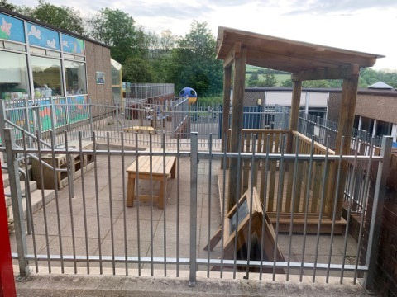
Outside Area

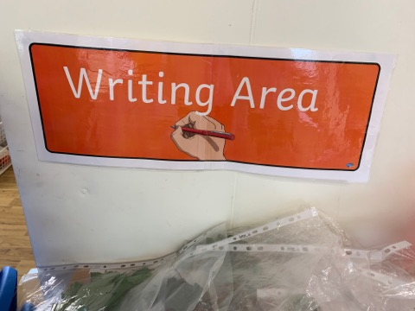
Writing Area

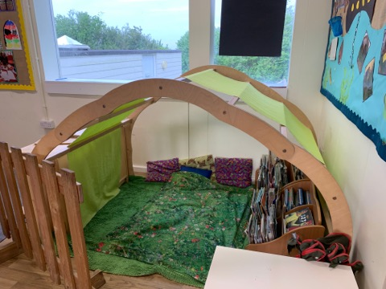
Book Corner

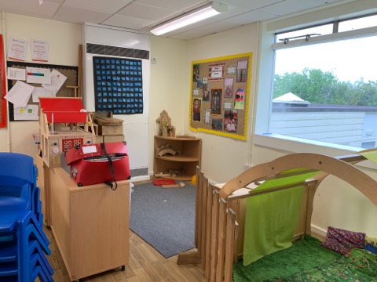
Construction Area

Appendix 4 – Notes from discussion with class teacher.

“Child A is a well-mannered, polite child. Comes in everyday no fuss, no problem and usually with a smile on her face.”
“She is in the higher ability group for maths, and the middle ability group for literacy and topic work. She has the potential to be at the top end of the class”.
“Child A can be independent, sometimes she needs reassurance that she is doing what has been asked, particularly in maths.”
“She gets on well with everyone in the class and plays with most of the other children”.
“She plays golf outside of school”.
“Doesn’t often put her hand up to answer questions on the carpet, I think this is a confidence issue rather than her not knowing the answers.”

Appendix 5 – Literacy work (Hansel and Gretel reordering).

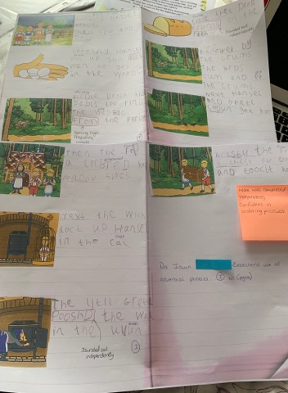

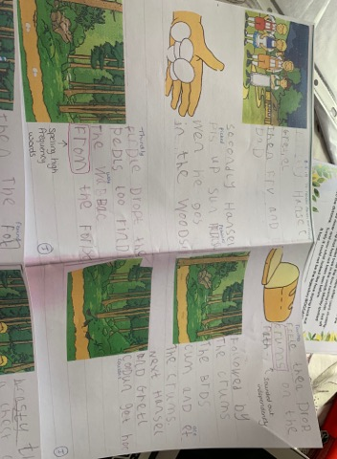

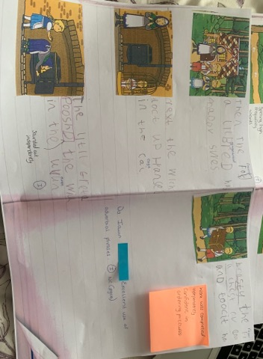

Appendix 6 – Literacy work (woodland pictures).

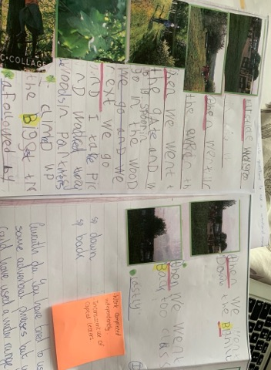

Appendix 7 – written observations.

Monday 29th April 2019
Registration (am)

Child A entered the classroom quietly and sat on the carpet cross legged with no fuss and quite little talking. Child A replied good morning to the LSA sat at the table. Child A did not speak after the class teacher started the register only to answer to her name and to give her dinner register response.

Tuesday 7th May 2019
Literacy (am)

Child A used the scissors in her right hand and was able to carefully cut out the pictures following the lines. She stuck them in her literacy book in the correct order and was able to write sentences to explain what was happening. This was done independently.

Wednesday 8th May 2019
Exercise (am)

Today’s exercise session involved a ball. Pupils were practising their throwing and catching. At the start of the session Child A seemed apprehensive and anxious when catching the ball from a peer. Child A seemed to be afraid of the ball. Child A had a few unsuccessful attempts at catching. Child A caught the ball. This seemed to give her a confidence boost and her expression changed to a more positive one. Child A was able to throw the ball to her peers and did catch the ball on two occasions during the session.

Tuesday 14th May 2019
Exercise (am)

Child A took part in the exercise session. Child A walked to the playground and found a space away from others without prompting. Child A swung her arms around in order to check she was far enough away from others not to touch them. Child A was able to run, skip, jog and jump with two feet. Child A was able to change direction both when stationary and in motion. Child A could hop on one foot; both the right and the left.

Friday 17th May 2019
P.E session (pm)

Child A brought P.E kit for the session and seemed enthusiastic to get ready for the lesson. Once ready the pupils walked to the field. Child A ran up the hill. Child A stood with others from her friendship group while waiting for the teams to be chosen for football. Child A seemed apprehensive to stay with her friends in teams. Child A was split from her friendship group. Child seemed fine once the activity started. Child A participated well in the football activities. She was able to take turns and wait patiently for her go with the football. Child A mixed well with the other pupils in her team and throughout the activity chatted with them while waiting for her turn with the ball. Child A was able to confidently kick the ball with her dominant foot (right) and also attempted to kick the ball with her left foot.

Friday 17th May
Assembly (pm)

Child A was unware that she was being spoken about by the class teacher. When her name was announced she smiled and walked up to the front of the hall. Child A smiled at the headteacher and continued to smile while standing at the front of the hall.

Friday 24th May 2019
P.E session (am)

Child A brought in P.E kit for todays lesson. Child A asked during registration if we were doing P.E today and was pleased to hear we were. Child A took part in team activities during the session and was able to wait patiently and turn take. The main body of today’s lesson focused on ball skills, primarily throwing and catching. Child A was able to successfully throw the ball using the chest pass to other members in her team. Child A was able to pass the ball over her head and between her legs with confidence during one activity. Child A dropped the ball on a few occasions when asked to catch.

Appendix 8 – numeracy work.

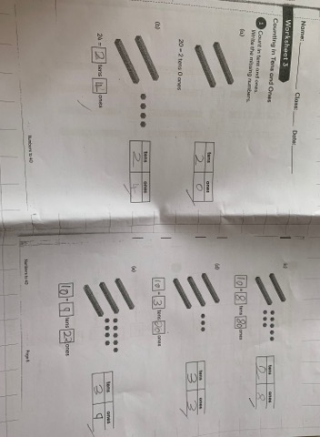

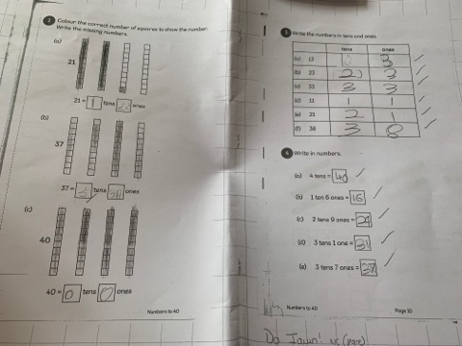

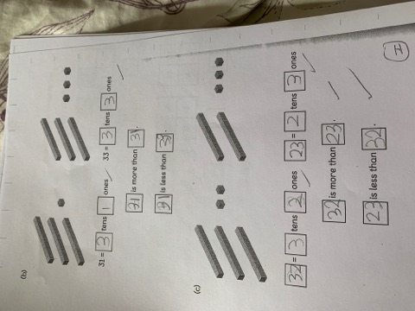

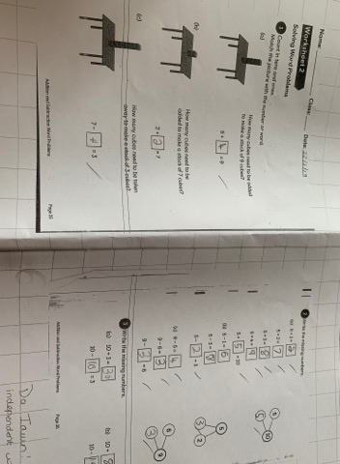

Appendix 9 – answers from semi-structured interview.

Questions –

- Why do you come to school? To learn new things.
- What is your favourite thing to do in school? Play with my friends and learn about things I didn’t know about before.
- What don’t you like about school? Nothing.
- Who do you like playing with? Ava, Alexia, Eleanor, Innes, Olivia, everyone.
- What do your teachers do for you? Help us learn and teach us.
- What should your teachers do for you? Teach us and look after us in school.
- What do you find hard? Maths but only sometimes.
- What has been your best day in school? When we went to Techniquest.
- How do you feel about maths? I like doing maths. I like answering the questions. Sometimes it’s hard to answer the question so you have to use the stuff or ask the teacher to help.
- How do you feel about literacy (reading and writing)? I don’t like reading very much. Do you read in the house? Umm sometimes with Mammy. Do you like writing? Yeah! But writing is hard if you don’t know the spelling, but you can sound it out. I like it when we get to do writing in our books.
- How do you feel about p.e? I like it.
- How do you feel about coming to school? Its good. Why? I see my friends and teachers. I can learn new things and play outside.

Bibliography

BERA (2018) Ethical Guidelines for Educational Research. Available at; https://www.bera.ac.uk/wp-content/uploads/2018/06/BERA-Ethical-Guidelines-for-Educational-Research_4thEdn_2018.pdf?noredirect=1 (Accessed on; 19th May 2019).
Blackburn, C. (2015) Researching with Young and Developmentally Young Children – Ethical Considerations, Dilemmas and Compromises. Available at; https://www.bera.ac.uk/blog/researching-with-young-and-developmentally-young-children-ethical-considerations-dilemmas-and-compromises (Accessed on; 19th May 2019).
Bruce, T., Louis, S. and Mcall, G. (2014) Observing Young Children. Sage Publications Ltd: United States.
Burton, D. and Barlett, S. (2005) Practitioner Research for Teachers. Paul Chapman Publishing: London.
Butler, G. (2015) Observing Children and Families: Beyond the Surface. Critical Publishing Ltd: Northwich.
Chestefield, R. (1997) Classroom Observation Tools. Institute for International Research: London.
Clark, A. (2007) ‘A Hundred Ways of Listening: Gathering Children’s Perspectives of their Early Childhood Education.’ Faculty of Wellbeing, Education and Language Studies. 62(3) pp. 76-81.
Clark, A. and Moss, P. (2005) Spaces to Play. National Children’s Bureau: London.
Greenfield, C. (2011) ‘ Effectiveness, Highlights, and Challenges in using the Mosaic Approach’. Manukau Institute of Technology. 36(3).
David, A. (2014) Help Your Child Love Reading; A Parents Guide. Egmont: United Kingdom.
Donaldson, G. (2015) Successful Futures. Available at: https://gweddill.gov.wales/docs/dcells/publications/150225-successful-futures-en.pdf (Accessed on: 29th May 2019).
Fletcher, J., Grimley, M., Greenwood, J., and Parkhill, F. (2012) ‘Motivating and Improving Attitudes to Reading in the Final Years of Primary Schooling in Five New Zealand Schools’. UKLA. 46(1).
Harrison, C. and Howard, S. (2009) Inside the Primary Black Box: Assessment for Learning in Primary and Early Years Classrooms. Granada Learning: Brentford.
Jaciw, A.P, Hegseth, W.M, Lin, L., Toby, M,. Newman, D., Ma, B., and Zacamy, J. (2016) ‘Assessing Impacts of Math in Focus, a “Singapore Math” Program.’ Journal of Research on Educational Effectiveness. 9(4). 473-502.
Lawrence, D. (2006) Enhancing Self-Esteem in the Classroom. Sage Publications Ltd: California.
Lu, C., and Buchanan, A., (2014) ‘Developing Students Emotional Well-Being in Physical Development’. Journal of Physical Education. 85(4). 28-33.
Maths No Problem (2019) What is Singapore Maths? Available at; https://mathsnoproblem.com/en/mastery/what-is-singapore-maths/ (Accessed: 28th May 2019).
McGeown, S.P, Johnston, R.S., Walker, J., Howatson, K., Stockburn, A., and Dufton P. (2015) ‘The relationship between young children’s enjoyment of learning to read, reading attitudes, confidence and attainment’. Educational Research, 57:4, 389-402,
Palaiologou, I. (2010) The Early Years Foundation Stage. Sage Publications Ltd: London.
Papatheodorou, T., Luff, P. and Gill, J. (2013) Child Observation for Learning and Research. Routledge: London.
Riding, R.J., and Rayner, S. (2001) Self Perception. International Perspectives on Individual Differences. Greenwood Publishing Group: Connecticut.
Sainsbury, M and Schagen, I. (2004) ‘Attitudes to Reading at Age Nine and Eleven.’ Journal of Reaearch in Reading. 27(4). 373-386.
Szarkowicz, D.L. (2006) Observations and Reflections in Childhood. Cengage Learning Australia: Australia.
Tadic,M. et al (2014) ‘Examining Well-Being in School Context: Weely Experinces of Pupils and Teachers.’ Journal od European Psychology Students.
Welsh Government (2015) Foundation Phase Framework. Crown Copyright: Wales.
Welsh Government (2008) Observing Children. Crown Copyright: Wales.

