Name: Lee Canning
Student Number: 2116294
Module: ACCA5023 Network Operating Systems and Services
Title: Build and deploy a type 2 hypervisor based virtualised network
Submission Date: 23rd February 2024
Table of Contents
Introduction 3
1. Hypervisor technologies 3
Types of hypervisors 3
Type 1: 3
Architecture 3
Features 4
Hardware Requirements 4
Type 2 5
Architecture 5
Features 5
Hardware requirements 6
Advantages 6
Use case and available solutions 8
Available solutions 8
3. Download and installation of hypervisor, server, and client OS 10
4. Implementation of network topology 10
5. IP Addressing 12
6. Network configuration 14
7. Testing 14
7.1 Network testing and troubleshooting techniques. 15
7.2 Testing and connectivity 15

Introduction
In the past, computers would run a single operating system and dedicate all available resources to it. If there were a requirement for multiple operating systems, multiple machines were needed. Virtualisation allows a single physical machine to host multiple virtual machines, which are then allocated resources from a host machine, such as CPU, memory, networking, and storage [1]. Virtual machines are essentially a digital replica of an actual machine.
As the industry becomes more reliant on virtualisation, it is becoming increasingly common for organisations to rent or purchase virtual machines, rather than physical ones [2]. Virtualisation is now considered a fundamental technology for data centre optimisation and cloud computing [3].

1. Hypervisor technologies
A hypervisor is also known as a Virtual Machine Monitor (VMM). It is used to create, run, and manage virtual machines (guests) on a physical machine (host). Hypervisors are typically software but can sometimes be embedded in firmware. The guest operates most instructions on the native hardware. How this is achieved depends on the type of hypervisor. Because a VM runs its own OS, it can run multiple resource intensive functions. The increased resources available to VMs allow them to abstract, split, duplicate, and emulate entire servers, operating systems, desktops, databases, and networks.

Types of hypervisors
Type 1 hypervisors are known as native, or bare metal. Type 2 hypervisors are known as hosted. Each have similarities and differences in their architecture and functionality, as discussed below.

Type 1: Native / bare metal
Architecture
A bare metal hypervisor is installed directly on a host machine’s hardware. This allows the VMs direct access to resources, which are negotiated, managed, and scheduled by the hypervisor. Because of this, a type 1 hypervisor is considered highly efficient and one of the main reasons they are more often used in enterprises and datacentres.

Features
There is no underlying OS, therefore VMs are fully isolated from each other. The hypervisor is powered on or off with the host machine. Unlike hosted hypervisors, they can offer High Availability (HA) via live migration, the ability to move a VM from one physical host to another while it is still running. This is particularly useful for load balancing and failovers [4]. The hosts can be clustered and appear as one to the VM, providing multiple options for a failover, which leads to improved business continuity and disaster recovery. These ensure that services remain available and minimises the negative impact on the organisation should hardware failure occur. Resource management: Hypervisors allocate the hosts resources to the virtual machines and manage them accordingly.

Hardware Requirements
Directly accesses resources like CPU, RAM, storage, and networking which are allocated and reallocated between existing and new VMs, depending on available physical resources. The more processing power, memory, and networking capabilities available, the more VMs can be deployed and the efficiency that they can run.
Requires hardware acceleration technology to aid in managing the machine’s resources. Without this the hypervisor would need to manage these itself, leading to a reduction in performance and the number of VMs deployed [5].

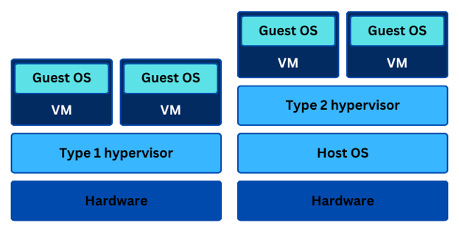
Figure 1: Comparison of hypervisor architecture.

Type 2: Hosted
Architecture
Hosted hypervisors run on top of an OS as a software layer or application [6]. A VM monitor runs as a process on the host and abstracts guest OSs from the host OS. So, while it has access to the host’s hardware, this access is indirect. Hosted hypervisors demand less resources than native ones, which makes them more suitable for personal use, testing, and development. They are considered less efficient than bare metal hypervisors because they sit on top of the host OS and share its resources. They are also less secure, because the OS is an additional layer which can increase the potential the attack surface. While the VMs are isolated from each other, if the OS or the hypervisor itself is compromised then potentially all VMs can be too.
Features
Function in a similar manner and offer many of the same features and benefits of a native hypervisor, however a type 2 typically demands less resources and offers a lower level of functionality. They are rarely used in server-based environments. Several of them are open source, can be installed on a variety of host OS, and can run a variety of guest OSs. Typically, Windows Server, Windows and Linux are popular hosts/guests. Type 2 hypervisors typically offer less complex workloads, security, and cannot support as many VMs as their type 1 counterparts.
Hardware requirements
Far less demanding than a type 1. A hosted hypervisor can run a VM on a single core machine with 1G of RAM, though these resources are shared with the host OS. The VM would perform poorly if it were to run a modern OS such as Windows Server 2022. The more resources available, the better the performance applies here too; however, it is important to consider that a hosted hypervisor also must share these resources with the host OS and any other applications and services it is running. Type 2 hypervisors will offer snapshots. When a snapshot is taken it records the state of the VM at that time, and allows users to roll back to this, should they make any future changes that have adverse effects.

Advantages, scalability, security, and compatibility
Hypervisors allow for quicker and simplified deployment of resources. If an organisation requires an additional VM, they need only create one and allocate resources to it. Compared to purchasing a physical machine, installing an OS, and of course deploying that machine to its desired location. This also reduces the dependent workload. An organisation’s resources can be vastly optimised and use of physical equipment far more efficient. This leads to an increase in server utilisation figures.
The key benefit of virtualisation is that one host machine running a certain operating system can run concurrent virtual machines with different operating systems. This is dependent on the exact hypervisor used, but it is realistic to assume that on a Windows machine, a hypervisor would allow you to run MacOS, Linux, and Windows Server operating systems. The hypervisor would then be responsible for allocating resources to the VMs. If you tried this on the same hardware it would cause conflicts. Multiple OSs can run concurrently and share hardware resources, which is a key benefit of virtualisation. They secure the operating environment from internal conflicts.
Hypervisors can employ full virtualisation, or para virtualisation. In full virtualisation, the guest OS is completely separated from the host’s hardware, and the hypervisor translates OS instructions during run-time and stores them for future reference. In para virtualisation the guest OS can interact with the hypervisor to improve performance. Para virtualisation in considered more efficient and secure, due the use of hypercalls to communicate. This is despite full virtualisation offering optimum isolation of VMs [7].
High availability and the ability to live migrate results in better uptime and availability of machines and resources. Combined with the rise of cloud computing and architecture, virtualisation facilitates remote working which can offer increased employee availability and performance.

Scalability
The number of guests that hardware can host depends mainly on the number of physical cores available. Over-allocating these cores will negatively affect all VMs, the hypervisor, and the host machine [3].

Security
A VM’s environment is isolated from the host system and other VMs so whatever runs inside it will not interfere with the host’s OS or hardware. If a VM is compromised, it is unlikely that other VMs or the host will be [8]. Although robust, the hypervisor itself could become an easy target, and vulnerability is increased because of the centralised system. If the hypervisor is compromised, every VM running inside it is potentially vulnerable. Type 1 hypervisors are more secure because there is no OS to compromise between them and the host CPU, where as a type to has a larger attack area due to the host OS. In a hosted hypervisor, security varies depending on the security configuration of the host OS.

Compatibility
Many hypervisors are considered cross-platform, which means they can run a variety of OSs on VMs [9]. However, it is important to reference any hypervisor’s compatibility matrix to ensure available hardware and guest OS are supported.
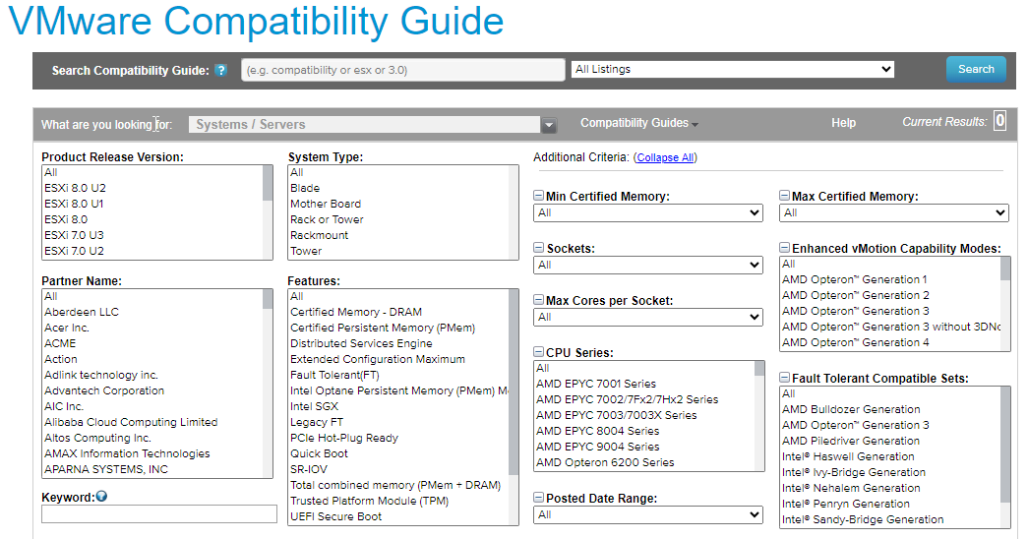
Figure 2: VMware compatibility guide, from www.vmware.com/resources/compatibility

The above figure is more usual of type 1 hypervisors when used in datacentres or enterprises. Type 2 tend to be less restrictive as they are often run on individual’s computers.

Use case and available solutions.
Type 1 are used in enterprise deployments and datacentres. Type 2 are more suitable for personal use, testing, and development.

Available solutions

Type 1: Microsoft Hyper-V, Citrix XenServer, KVM (Available as a Linux Kernel Module), Oracle VM Server for x86, VMware ESXi.
Type 2: QEMU, Oracle VirtualBox , VMware Workstation, VMware Player, VMWare Fusion.
2. Choice of hypervisor for virtual network implementation
The outstanding candidate was VMware ESXi, however cost proved prohibitive for an organisation of NOSS’s size. This resulted in a choice between the type 1 Microsoft Hyper-V, and Oracle’s open source VirtualBox. Whilst Hyper-V can be activated within Windows OSs, it is known to be complicated to set up.
Considering the limited financial and hardware resources available to the organisation and the requirement to run an on-premise hypervisor, the decision was made to install VirtualBox. VirtualBox supports hardware-assisted and software virtualisation, and it’s hosted VMs perform nearly as well as if they were natively installed. The host machine will need to support hardware virtualisation. One major benefit is that VirtualBox can deploy unlimited VMs, but of course this is resource dependent. Ideally, it would support live-migration, however the organisation will need to suffice with cold migration for the time being.

Figure 3: Comparison of popular hypervisors

The above comparison table shows general features of various type 1 and type 2 hypervisors. Considering the MNO is based in two locations, the option of either is viable, however with careful consideration, the ideal hypervisor would have been Microsoft’s Hyper V, as it is cost-efficient, secure, and supports live migration. Type 2 such as VirtualBox and VMware would have been adequate, but considering Hyper V is bundled with Windows OS’s, is easily setup and more to the point offers superior performance and security compared to type 2 hypervisors, it meets the needs of the organisation. It is also available free of charge. The organisation will however need to purchase the relevant operating systems depending on requirements.
Type 2 will struggle with a higher number of VMs due to the demand on system resources.
****Things to focus on in a virtualised environment.****

3. Download and installation of hypervisor, server, and client OS

Oracle VirtualBox was downloaded directly from the official website, Oracle VM VirtualBox.
Windows Server 2019 and Windows 10 are the chosen server and client OS, with evaluation versions downloaded directly from Windows’ official website. Although there are newer versions (Server 2022 and Windows 11) available, the choice was made to make more efficient use of resources and represent a more real-world situation, as several enterprises globally are still running these. In time, when NOSS provides more hardware resources, upgrades to the newer versions can be made.

4. Implementation of network topology
The host machine that runs the VirtualBox hypervisor and the 4 guest VMs has an i3 4 core processor and 16 GB of RAM. Each VM has been allocated 2GB of RAM and 1 CPU/core. This leaves 8GB of RAM remaining to share with the host OS.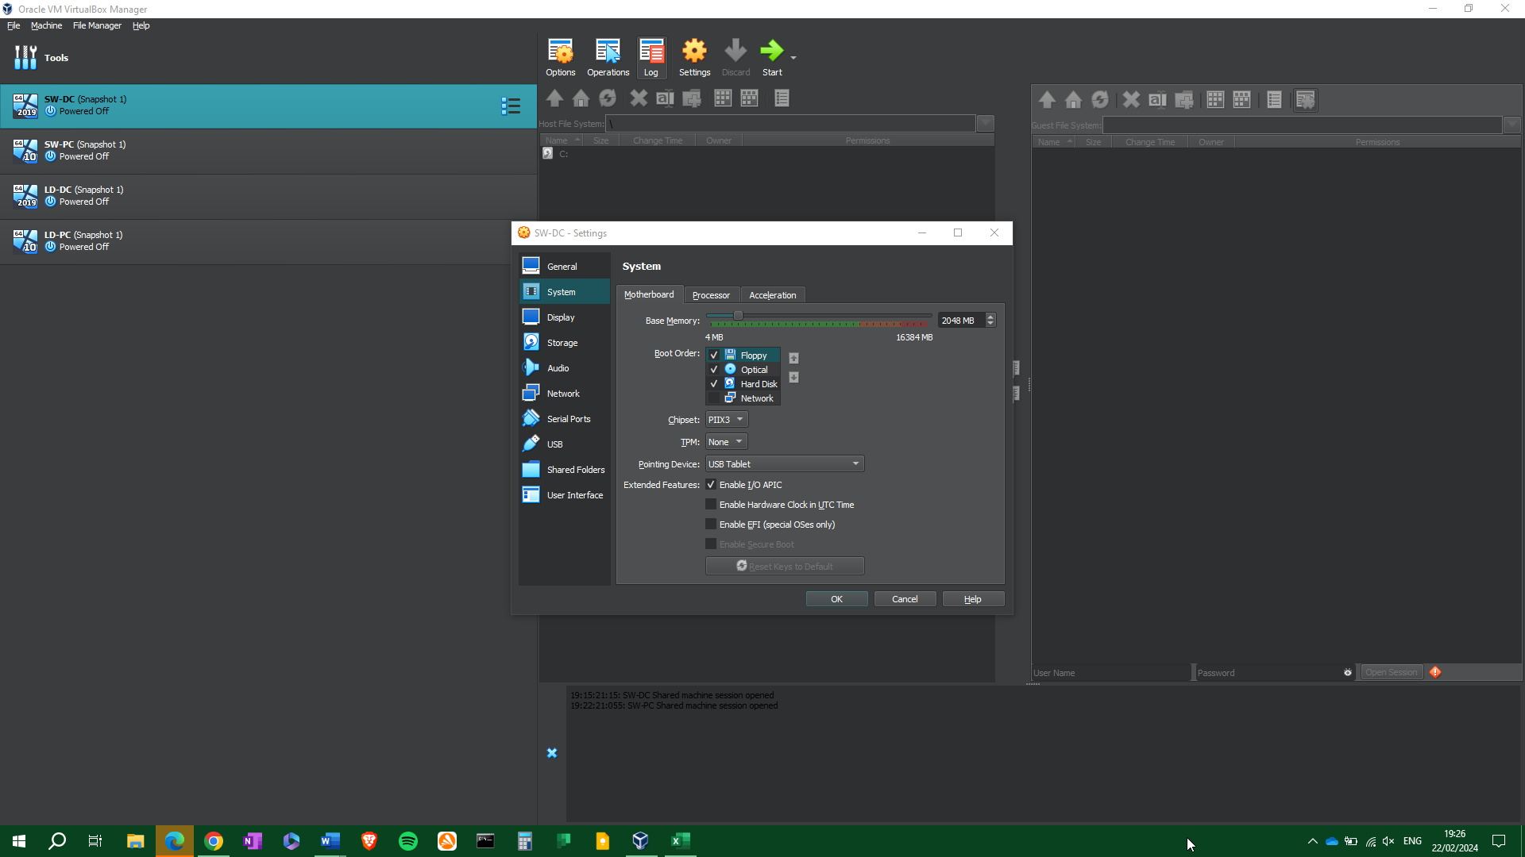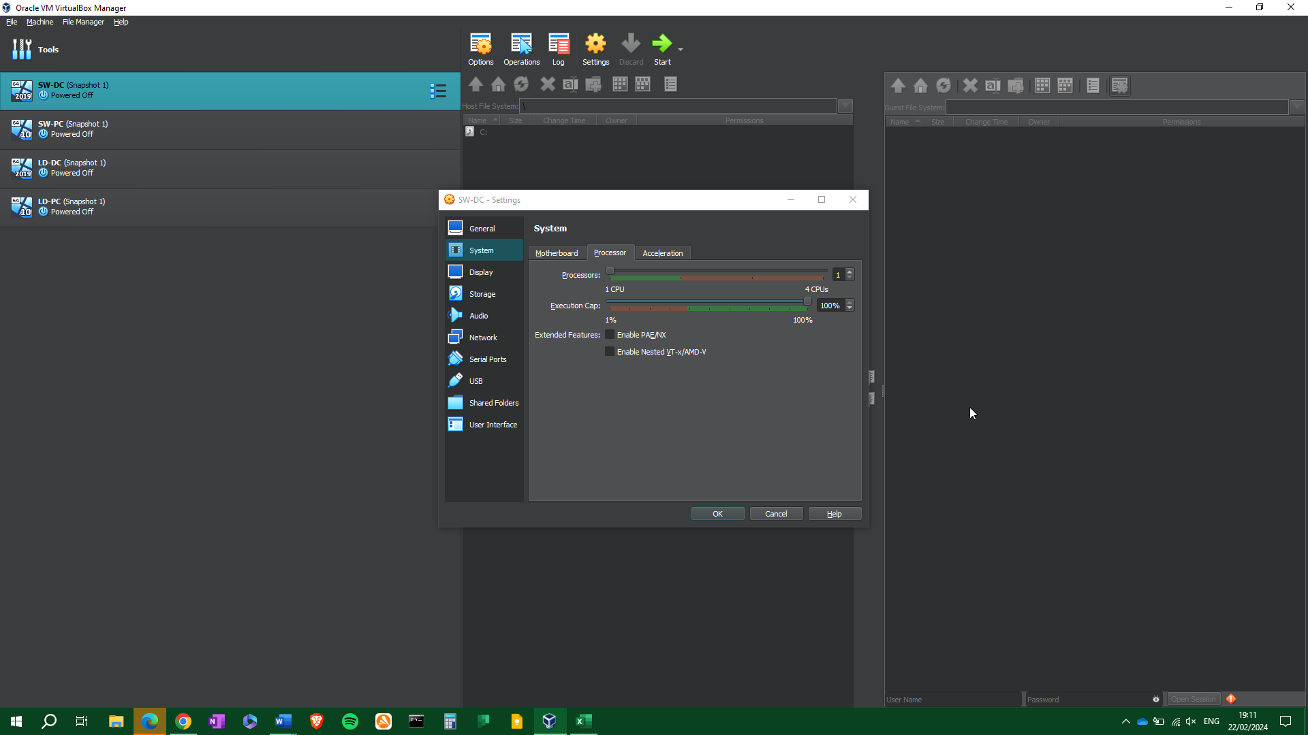
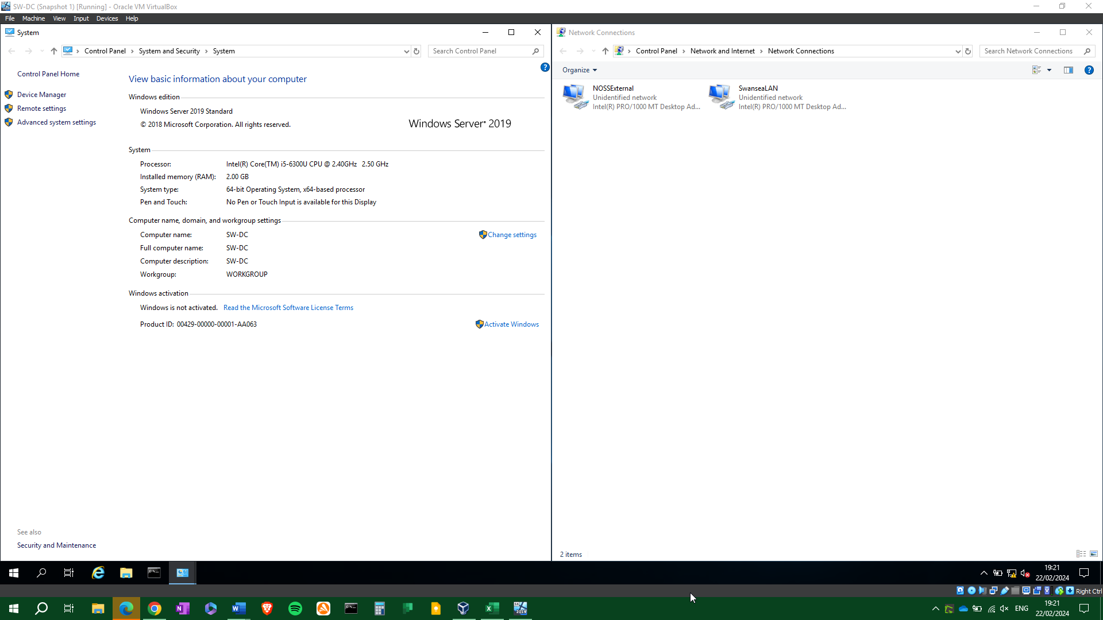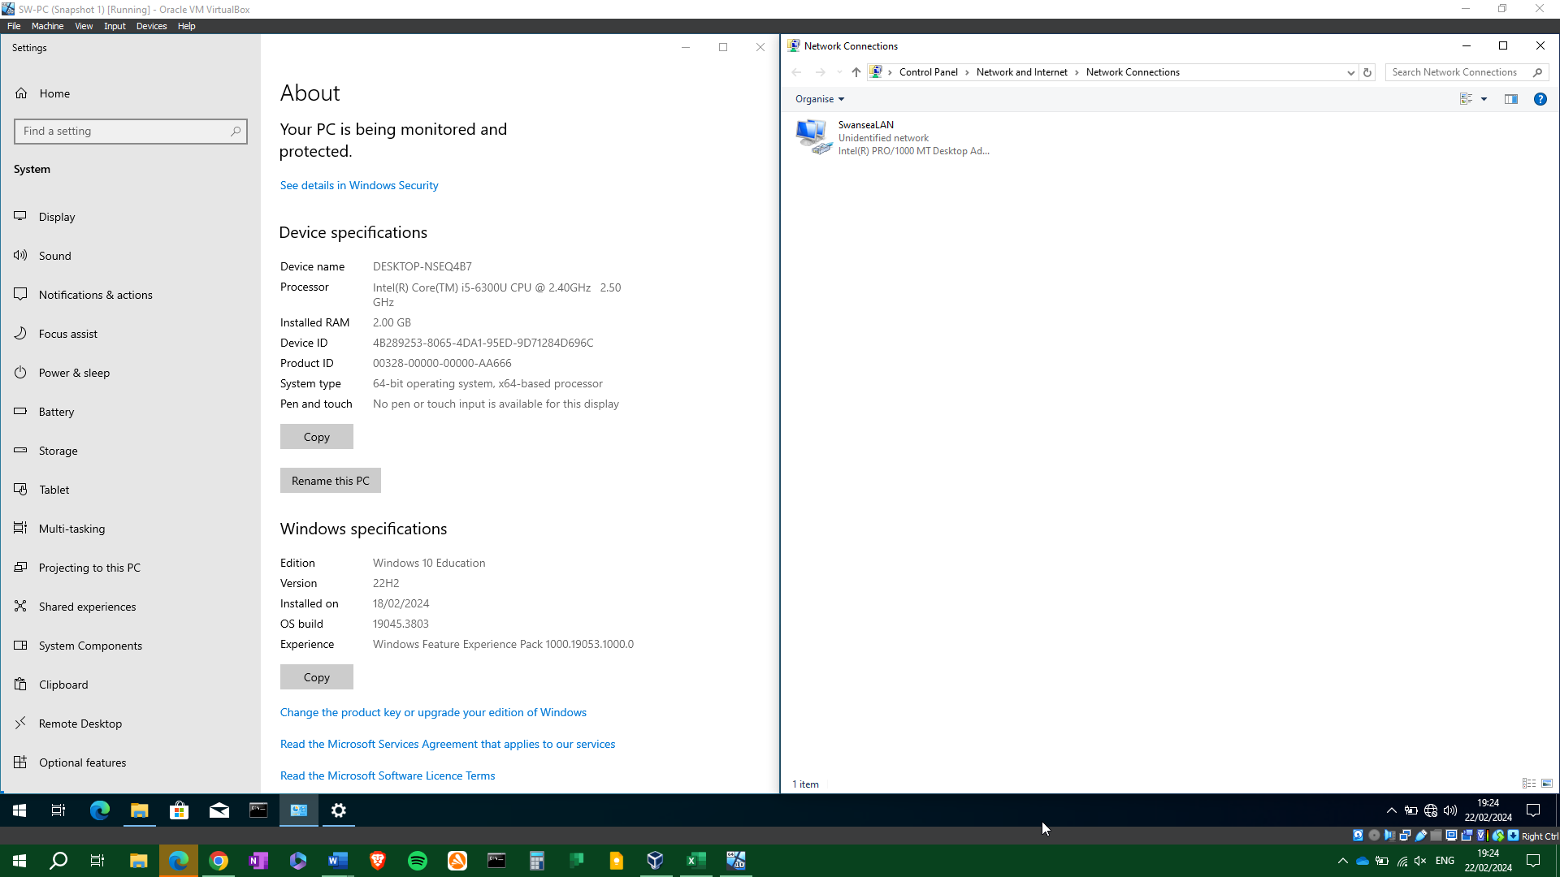
SW-DC and LD-DC have two network interfaces to connect to the LAN and external network, whilst SW-PC and LD-PC have one each, for the internal networks only.

5. IP Addressing
- How does data get from one computer to another on the Internet and what is the role of IP addresses in the transmission of data on the Internet?
Data is broken down into packets, which are then sent across one hosts’ network, to another. Packets are wrapped in a header which includes the source and destination IP address, and the order in which the packets should be reconstructed upon delivery. For example, if we wanted to send a single audio file this could be 100’s of mb in size. Attempting to send this in one go could work, but it’s more likely that the entire file cannot be sent successfully. Instead, it is broken down into packets (max packet size is 65535 bytes. This enables a more efficient and reliable delivery. If some packets are lost, then they can be resent (depending on the protocol), and because they are far smaller than the original file size, they do not congest the network. Once all have been delivered, they are reconstructed on the destination host.
Every device connected to a network has an IP address. Using this address, a router can determine if the target address is on the current network or not. If it’s on the same network, then delivery is straightforward. If it’s on a different network, the packets may travel via a series of routers and switches. If a router does not know where to send the packet, it will pass it to the next available router, and so on. Routers can use routing tables (either static or dynamic) which instruct them where the packet should go next. This is known as a next hop.

- How do you think routers and switches work on the Internet to facilitate the flow of data between different networks?
A switch connects network devices and forwards packets to and from those devices. This can be done by MAC address (layer 2 switch) or IP address (layer 3 switch). A MAC address is a unique address that belongs to a piece of networked hardware (or virtual hardware in some circumstances).
Routers differ from switches in that they can decide where the traffic is directed. A routing table holds this information and can be configured manually (better for small networks) or automatically (better for large networks). A router can connect multiple switches. The role of a router is to choose the most efficient route for data to travel. It can be configured to have preferred routes, to send data across multiple routes (known as load balancing) and decide if certain devices have a higher priority than others.

6. Network configuration
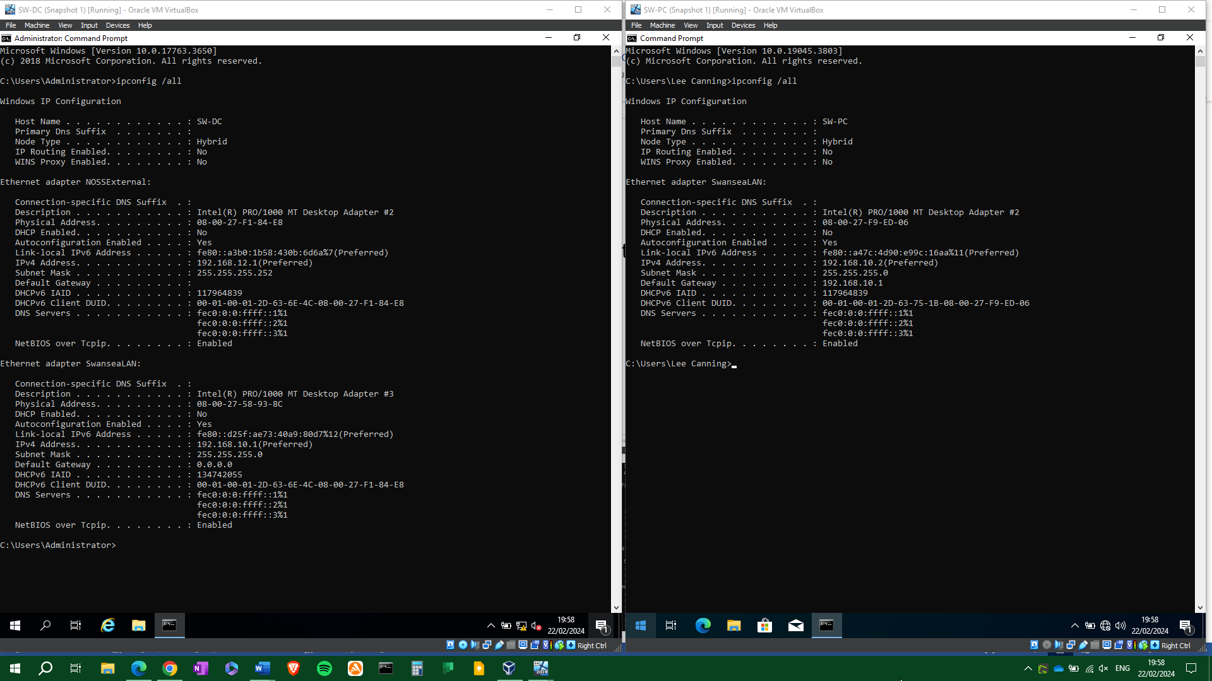Considering the above research the IP configuration will be set as the following:
Both locations have been assigned /24 subnets, which provide 254 usable hosts each. It would have been possible to assign Swansea with a /25 subnet of 126 hosts, however this would allow little room for expansion in the future. The Swansea – London external network has been assigned a /30 subnet, 2 usable hosts, which efficiently allows for both servers to connect.
The servers and PCs will be configured with the above IP addresses.

7. Testing

7.1 Network testing and troubleshooting techniques.

7.2 Testing and connectivity

Network connection troubleshooting.
Should a network lose connectivity, whether it is to the internet / gateway or between hosts and clients, it is important to take a rigorous and thorough approach to diagnose the exact issue.

To identify the problem, we must:
- Gather information about the network.
- Discover which errors occur, if any.
- Identify symptoms. Is the network just slow, total loss of connection, intermittent loss.
- Have any changes been made? (mention snapshots!?)
- Define if there are multiple issues.
Several tools are available.
- ping: sends an icmp message to a recipient and gets a reply to prove connectivity. Can ping 127.0.0.1 – loopback address – to prove tcp/ip stack is functioning correctly.
- tracert
- ipconfig /all
- netstat
- pathping – for latency and packet loss
- arp – shows the arp cache.

Latency
Firewall configuration.
IP conflicts
Ip config setup

References
[1] J. Savill, Mastering Windows Server 2016 Hyper-V, 1st, Newark, UNITED STATES: John Wiley & Sons, Incorporated, 2016Available: http://ebookcentral.proquest.com/lib/trinity/detail.action?docID=4751489.
[2] A. S. Tanenbaum and D. J. Wetherall, Computer Networks, Fifth Edition, .
[3] S. G. Soriga and M. Barbulescu, "A comparison of the performance and scalability of xen and KVM hypervisors," in 2013 RoEduNet International Conference 12th Edition: Networking in Education and Research, 2013, . DOI: 10.1109/RoEduNet.2013.6714189.
[4] Anonymous (). What are hypervisors? | IBM. Available: https://www.ibm.com/topics/hypervisors [Accessed Feb 10, 2024].
[5] Anonymous (). Type 1 and Type 2 Hypervisors: What Makes Them Different | by ResellerClub | ResellerClub | Medium. Available: https://medium.com/teamresellerclub/type-1-and-type-2-hypervisors-what-makes-them-different-6a1755d6ae2c [Accessed Feb 10, 2024].
[6] Anonymous (). What is a Hypervisor? | VMware Glossary. Available: https://www.vmware.com/topics/glossary/content/hypervisor.html [Accessed Feb 6, 2024].
[7] Anonymous (). Difference between Full Virtualization and Paravirtualization in Operating System - javatpoint. Available: https://www.javatpoint.com/full-virtualization-vs-paravirtualization-in-operating-system [Accessed Feb 22, 2024].
[8] (). What is a Hypervisor?. Available: https://www.redhat.com/en/topics/virtualization/what-is-a-hypervisor [Accessed 21 feb 2024].
[9] S. K. G. and A. Singh, "Hands-on guide to virtual box," in Design and use of Virtualization Technology in Cloud Computing, P. K. Das and G. C. Deka, Eds. 2018, pp. 194-207.

