PROFESSIONAL AND CAREER DEVELOPMENENT

Syeda Karima Akhtar
ID: 1814426
Module Code: BMSW4005
Lecturer: Dr. Buddhi Pathak

reflective portfolio
Table of Contents
Introduction: 2
What is a professional career development? 2
Reflection on self-awareness test 4
Self awareness: 4
What is self awareness? 4
How to become more self-aware version of you: 4
Johari Window 5
Career Motivation Test: 8
Mock Interview: 11
What is a CV? 12
Cover Letter 12
Preparing for interview: 13
References: 15

Professional and Career Development
Lecturer- Dr. Buddhi Pathak

Part 1 Discursive and reflective report

Introduction:

What is a professional career development?
A professional career development is the process of career planning and development, which involves thoughtful self-assessment, career exploration, planning and follow-through with preliminary employment strategies. It is the proactive planning and implementation of action steps towards one's career goals (Indiana.edu N.D)
To carry out a plan for career development, it is necessary to perform a self-assessment on where we are now in our career and where we would like to be.
In life we all have a career goal or career aspiration. It could be short term or long term. To have a successful career development, it is ideal to write our goals down. It is a critical component of success when creating career development plans. Writing something down helps us to expand our thinking.
My short term career goals that I have set for myself are below:
- Have to increase the speed of my work
- Finish my work in a timely manner
- Time management
- Learn new skills
- Stay away from negativity
- Stay away from stressful situations
- Avoid conflict
As for long term career goals, it is something that you want to accomplish in the future. It requires time and planning. Long term goals are usually a few years away and are important for a successful career. Below are some of the long term career goals that I have set for myself:

- Develop a career plan
- Achieve a promotion
- Improve communication skills
- Improve leadership skills
- Advance my career with education
Here are some common career aspirations:

• Enhance your professional skills in order to advance in your organization.
• Find stable job security.
• Become an expert in a field.
• Gain more autonomy at work.
• Better balance your home and work life.
• Network more on a professional level.
• Become better motivated to complete your job.
• Educate yourself more.

This report is divided into two parts. The first part discusses and reflection on the results that was obtained from utilisation of self-awareness test tools that I have learnt in-class and the insights gained from test conducted to my career aspiration. Self awareness is very important as it gives the people the ability to understand and see yourself from the outside. It is also very important to recognise one's emotions and feelings so that they can be aware of themselves and learn to adapt in the real world.Therefore, the first part focuses on the results obtained from the various tests.
The second part reflects on the recruitment activities conducted during the class. I will highlight the importance of a job advertisement, the description of the job and its person specification as well as mock interviews.

Reflection on self-awareness test

Self awareness:

What is self awareness?
Self-awareness is about focusing on yourself. It is the conscious knowledge of one's own character, feelings, motives, and desires (Oxford Dictionary,2018). It is when you have the ability to notice your own feelings, your physical sensations, your reactions, your habits, your behaviours, and your thoughts (Stephen Warley, N. D). You being another person observing yourself of all those different aspects of yourself. In other words, self-awareness is about focusing on the reality of your behaviour and not on the story you tell yourself about yourself. If you are self-aware, it is easier for you to ​​​​​understand other people and detect how they perceive you in return (AR Lifestyle, April 26,2019).
Self-awareness is one of the attributes of Emotional Intelligence and an important factor in achieving success. It is the first step in constructing what you want and accomplishing it.
Self-awareness is important in different fields. In leadership it is very important to be self-aware, as it gives leaders the opportunity to recognize any space that they might have in their management skills and uncover the things in which they are effective and where they might need additional work. It is not a simple process to learn to be self-aware, but it will help to improve one's leadership skills and be able to lead to a more supportive business culture. Having self-awareness as a social worker, is an important part to adapt the meetings of the clients in their particular situations. A social worker has to be aware of their own biased when dealing with clients, so that everyone is treated equally. Self-awareness is also an essential part of counselling or nursing. Counselling is a journey of self-discovery, because one is able to gain a greater understanding of themselves through the input of a therapist. In education self-awareness is also very important, as it helps students become focused on what they need to learn.

How to become more self-aware version of you:
There are many ways which you could improve your self-awareness:
(1) You should look at yourselves objectively by performing self-reflection. It can be a very difficult process to see your real self, but it can be very rewarding if you make the right efforts. Seeing yourself objectively helps you to learn how to accept yourself and find ways to improve in the future. The best ways to do that is to write all the things that you're good at, the things that you need to improve, and the things that you are proudest of.
(2) You can keep a journal. By putting thoughts down on paper, makes things look clearer in mind, which helps you have better information and ideas. Every night writing in the journal about your feelings, success, and failures will help you grow more forward in achieving your goals. While keeping a journal you can think of questions like: What are my values? What is most important to me right now? How can I help the people around me?
(3) You can write down your goals, plans, and priorities. Planning goals in a worksheet is ideal, as they can turn from ideas to step-by-step process.
(4) Practise meditation and other mindfulness habits. Meditation is a habitual process of training your mind to focus and redirect your thoughts. It is used to increase awareness of yourself and your surroundings (Mathew Thorpe, July 5, 2017).During your meditation, you may come up with questions like: What is your goal? What are you doing that is working? What are you doing that is holding you back? How can you change your process for the better?
(5) You can take personality and psychometric tests, which helps to understand what character you have. Myers-Briggs test and the Predictive index are quite popular and are aimed at increasing self-awareness.
(6) Ask for feedback at home or work. You will not be able to tell what other people think of you, therefore, you have to listen to the observations of your peers and mentors and tell friends to be open, honest, critical and objective. Ask trusted friends to describe you, allowing them to feel safe while they give you an informal and honest view.
Provided it is constructive and well done, having an option for formalized feedback allows us to self-reflect on our own strengths and weaknesses.

Johari Window
A Johari Window was developed by American psychologists Joseph Luft and Harry Ingham in 1955, hence the name Johari. It is a tool that we can use to understand our self. It is a useful tool for understanding our self and how therapy and self-awareness can help us live effective lives. The Johari Window has four "Panes", which represent four parts of our self. These are: (1) Open Self, (2) Hidden Self, (3) Blind Self, and (4) Unknown Self.
We all have these four parts of self, but they are different for each individual. A person who are fully aware of own self, has a large public self, comparing with the remaining three.
Below is a model of a Johari Window (Successful Culture, 2020):
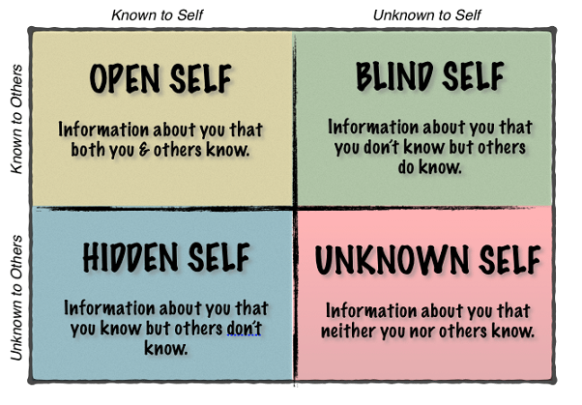
Each window in Johari window model signifies feelings, personal information, and motivation. Let's look at each of the windows in more details:
Open Self: This area is called the open area because the information in this box about a person's behaviour, feelings, emotions is known to that person itself as well as the other members in this group. They are like an open book, which anyone can read and understand.
Blind Self: This is the area in which others know certain information about your personality but the same information is not known by you. Your personality may be interpreted differently from what you have expected by other people. In order to reduce this area, it is ideal to get feedback from other member in the group.
Hidden Self: In this area it is when the information is hidden from others. The information is only known to you but others are not aware of this particular information. You may not want to share some of the things with others as they might be personal. It could be secrets, past experiences, feelings, etc. There are many people who wish to keep their information private and decide not to share with others.
Unknown Self: This is the area where neither you nor others are aware of certain information. It is unknown to yourself and others. It is usually, certain feelings, talents, information, etc. There may be a reason for this area. It could be like something that may have happened in the past which might be unknown to you forever. The person, as well as the group is unaware about this until it has been discovered. Having an open communication can reduce this area.

Below I have provided the results of my findings of Johari window which was carried out in class.

 | Things I know | Things I don’t know
Things others know | Quiet Helpful Observant Friendly Independent Caring Calm Adaptable Trustworthy Spontaneous | Accepting Cheerful Mature Modest Responsive Introvert Sensible Organized Idealistic
Things others don’t know | Shy Patient Nervous Brave | Extroverted Tense Self-Conscious Sentimental

Career Motivation Test:
Another test that we have completed in class is the career motivation test. After completing the test, I was given my personality type, which was Tycoon. With all the obstacles, people with Tycoon personality are destined to reach the top. The test results show the score that I have for each section. The graph section indicates how I scored on each of the motivators assessed on the test. I have shown the scores for each section below:
SUMMARY
INTRO
GRAPHS
DETAILS
CAREER MOTIVATORS
Achievement
  24
Structure and Order
  13
Balanced Lifestyle
  45
Change and Variety
  70
Creativity
  18
Financial Reward
  100
Identity and Purpose
  30
Altruism
  6
Contribution
  25
Independence
  80
Inspiration
  10
Responsibility
  50
Learning
  30
Mobility
  75
Power
  89
Recognition and Appreciation
  84
Social Fa  ctors
  52
Stability
  31
Status
  100
Fun and Enjoyment
  80
Customer Orientation
  12
Job-Hopping
  53
Active/High-pressure Work Environment
  22

Another test was carried out in class, which gave the personality type at the end. The test is the 16 personalities test. The results are as follows:
Personality type: Turbulent Consul- People with this personality type, are usually popular. It is a very common personality type. Consul's enjoy supporting their friends and loved ones, social gatherings are organized by them and always wants to make everyone happy (Deborah Day).
Code: ESFJ-T- This code refers to their five dominant traits:( E)-Extraverted,( S)-Observant, (F)-Feeling, (J)-Judging, and (T)-Turbulent.
Role: Sentinel- They are defined, not by individualism, but by character and competence. They are cooperative and practical. Sentinels look out for methods that have been proved. They are usually self-motivated and can be very productive without the need of external inspiration. These personality types are happiest without drama.
Strategy: Social Engagement strategy are an interesting group. In pursuing their goals, the people with these personality, are often restless, in order to make improvement. They work very hard at their personal and professional development to meet at their standard.
Below are my personality traits:
Mind- This trait determines how we interact with our environment. I am mostly Extraverted, as I was given 67% extraverted and 33% Introverted. A person who is more extraverted prefer working in groups and they get energized by social interaction. They are very enthusiastic.
Energy- This trait shows where we direct our mental energy. Looking at the score that I was given I can see that I am more observant, as I was given 56% for observant and 44% for Intuitive.
Nature- This trait determines how we make decisions and cope with emotions. Looking at the results I can see that I was given 40% for Thinking and 60% for Feeling. This shows I am mostly Feeling. An individual with feeling are more sensitive and emotionally expressive.
Tactics- This trait reflects our approach to work, planning and decision-making. I am mostly judging, as I was given 54% for judging and 46% for prospecting. Judging individuals are decisive, thorough and highly organized.
Identity- This trait underpins all others, showing how confident we are in our abilities and decisions. Looking at the scores that was given, I can see that I am mostly Turbulent. I was given 56% for Turbulent and 46% for Assertive. An individual with this personality, are always looking for being perfect and always eager to learn. They are self-conscious and are very sensitive to stress.

Part 2 Reflective report
For the in-class recruitment activities, we were to look for a job that suited us best and something that we intend to do in the future. As I already work at a school as a teaching assistant, I looked for job vacancy in that category. When I found a vacancy at a secondary school in Birmingham, I looked into it. The job advert stated for individual who have a good understanding and experience of how to support students with additional needs. They needed someone with an excellent interpersonal skill, good language and communication skills. The applicant must be able to demonstrate the ability to work within a team, be able to work under supervision and also take initiative when required. Will need to be able to relate to students effectively, in order to implement behaviour management strategies as agreed.
Looking at all of the above I start preparing for the job's application. I felt as though this was the perfect job match for me, as I already work in this field. Firstly, my CV needed updating. I added all the latest work experiences that I gained over the past years. I then wrote a cover letter stating as to why I feel that I am most suited for the job.

I had to get all the necessary documents ready for the mock interview that will take place in the class.

Mock Interview:
A mock interview is known as a practice interview. It gives the opportunity for job seekers to practice for an actual interview. They get feedback on their interviewing skills, which can be looked at and work on the things that they were weak at. A mock interview helps you to learn how to answer difficult questions, gain interview strategies, improve communication skills, and also it helps feeling less stressed before the actual job interview (Alison Doyle, October 31, 2019) Mock interview should be taken seriously, just as you would for an actual interview. You should get ready and be prepared with all the necessary documents, just as the way you would for an actual one.
Having a mock interview has many advantages. I have mentioned only a few below:
(1) Help reduce stress and anxiety. As attending an interview can be very stressful and makes you feel anxious. A mock interview makes you feel ready for all the challenge and helps you overcome anxiety (Krishna Reddy, N.D)
(2) Help boost your confidence. If you learn to overcome your anxiety, you tend to gain a little confidence. That way you will not forget the skills and experience that you have obtained over the years.
(3) Get constructive feedback. We are not perfect and mock interview really helps us response and clarify responses to a certain question and helps us to work on the area that we are weak in. In a real interview you're not always given feedback on how you performed.
Mock interviews are always best to conduct to find out more about the abilities you have for the interview, which gives a perfect opportunity to perform your best.
(4) Practice makes perfect: The more you practice the better you'll be. Therefore, taking advantage of mock interviews, will make you near perfect when it comes to holding yourself together in an interview. Even if you are highly skilled, you should think about how to improve your skills to make a great impression on a prospective employer.
(5) Nervousness: Before any interview, many people feel nervous and upset. It is very common for these nerve-wrecking events to occur. After attending many interviews many people still feel that way.
So having mock interviews and a lot of practice, it will be a slight increase in your confidence.

What is a CV?
When searching for any jobs, a CV becomes an essential part. It is a great way to show off all your skills, experience, and qualifications. In fact, a well written CV could be the difference between getting an interview and not being considered for the role. A CV (also known as a Curriculum Vitae, or resume), is a written overview of your skills, education, and work experience (by Amber Rolfe, N.D)
A CV is the first chance to impress a potential employer. If the CV is of top quality, the chance is more for getting a face-to-face interview. Therefore, spending quality time and putting in a lot of effort whilst working on the content and presentation of the CV, is worthwhile. It will make a huge difference in getting the position of own choice. It is therefore, essential to highlight all necessary skills, expertise and value (the institute of legal secretaries and PA’s, March,2007).
CV’s can be used for a variety of reasons, however, the most common of these is to send to prospective employers when looking for a new job.
CV’s should be clear and accurate, giving plenty of information, but making sure it’s not too long. Generally, it should be no more than two pages, making sure it’s tailored only for the job that is being applied for and including the skills, qualifications and experience which is suited for this job.

Cover Letter
A cover letter is very important for jobseekers. It’s an introduction that highlights all the things that have been accomplished and a good way for an opening of a job. It also gives an opportunity to add details about information that have been mentioned in the CV. Employers can also differentiate between two candidates with similar qualifications. The chance is greater to be shortlisted if we have a terrific cover letter, so it should definitely be included. In a resume we add only essential, bur very brief things and these are of limited values to an employer. With a cover letter, the employer can tell the type of position the applicant is seeking, and how they qualify for a particular job (Live Career Staff Writer, N.D).
A cover letter can explain things in more depths. For example, employment history, if there have been any gaps, returning to a job, changing careers, and why returning after a period of time etc.These can be all described in a positive way.
When writing cover letters one needs to be very careful. It needs to be of good quality, because if the quality of writing is of no good, the employers can and will discard it in a glance.

Preparing for interview:
As I got all the necessary documents for the application, I started preparing for my interview. I searched and researched on the school that I applied for, as I need to show that I know the school beyond the basics. Looked at all the challenging behaviours that are dealt with and how they are dealt. I read the job description a few times, so I can see how my skills and qualifications matches the role I applied for. I tried preparing how I will answer some common questions that are usually asked at an interview.
As the date was getting nearer to the interview I started feeling anxious and nervous. I felt a sense of panic when I was attending the interview, wondering what are the questioned that I will be asked and if I will be able to answer them properly. I tried practising questions at home to make it easier for me. I was feeling in doubt before the interview, thinking if I will be able to do a good job or not. I felt stressed out as well. At one point I felt very agitated, during the interview, because I thought I was running out of patience and didn’t like the questions that were being asked. Finally, when the interview was over, I felt a sense of relief. All the waiting has now come to an end and have nothing to stress over. But results yet to come. It was a matter of waiting for the results. After getting the feedbacks from the tutors, I examined my mock interview grades. I now know where I need to work on for my career development. I got two different feedbacks and two different scores from two different tutors. One of the report has given me a score of 56%, and the other 66%. There is a difference of 10% between the two interview results. On one of the report it says that I need to ensure that I greet all panel members, and be mindful about my hand movement. And on the other report it says that I could have provided more information about myself, related not only to work, but also my personal life. The second part of one report states that I should consider specific answers to questions. And the other report for the second part states that I could have demonstrated more knowledge about the school I have applied for, and be familiar with the STAR approach. Finally one of the report states that I need to be prepared with questions to ask the panel.
Looking over the interview results and analyzing it, I can see that I will need some improvement with interview skills for my career development. First impression is very important, therefore, I needed to ensure that I greet all panel members by shaking hands. When introducing myself I could have provided more information about myself. Need to be able to study and research more about the employer, gain more knowledge about the place. Familiarize myself with the STAR approach. When I was asked if there were any questions, I couldn’t think of any. I have learned that before any interview, I will need to prepare myself with some questions that I could ask the panel. Over all for preparation, the score that I was given was 3, which is Good/Average. This shows that I will need to fully prepare myself for any future interviews that I may be asked to attend for my career development. I will need to work on my communication skills, and show some confidence.

References:

Alina Reyzelman. (2019). 8 Ways to Become More Self Aware - Alina Reyzelman. [online] Available at: http://alinareyzelman.com/2019/04/8-ways-to-become-more-self-aware [Accessed 30 Jan. 2020].
Careers Advice Online. (2020). What Is Career Development | Careers Advice Online. [online] Available at: https://careers-advice-online.com/what-is-career-development.html [Accessed 30 Jan. 2020].
Healthline. (2020). 12 Science-Based Benefits of Meditation. [online] Available at: https://www.healthline.com/nutrition/12-benefits-of-meditation#section2 [Accessed 30 Jan. 2020].
Indiana.edu. (2019). Introduction to Professional Career Development. [online] Available at: http://www.indiana.edu/~jobtalk/Courses/PCD/PCD-Syllabus.htm [Accessed 25 Jan. 2020].
Legalsecretaryjournal.com. (2020). The Importance of a Good CV | DEDICATED. [online] Available at: https://www.legalsecretaryjournal.com/the_importance_of_a_good_cv [Accessed 30 Jan. 2020].
LiveCareer. (2018). What Is a Cover Letter - And Why Is It Important? | LiveCareer. [online] Available at: https://www.livecareer.com/resources/cover-letters/basics/cover-letter [Accessed 30 Jan. 2020].
Pathway to Happiness. (November 28,2019). Self Awareness | Pathway to Happiness. [online] Available at: https://pathwaytohappiness.com/blog/self-awareness/ [Accessed 30 Jan. 2020].
Prospects.ac.uk. (May,2019). How to get started in health informatics | Prospects.ac.uk. [online] Available at: https://www.prospects.ac.uk/jobs-and-work-experience/job-sectors/healthcare/how-to-get-started-in-health-informatics [Accessed 30 Jan. 2020].
reed.co.uk. (2020). What is a CV? | reed.co.uk. [online] Available at: https://www.reed.co.uk/career-advice/what-is-a-cv/ [Accessed 30 Jan. 2020].
Self Awareness. (2020). Self Awareness. [online] Available at: https://www.selfawareness.org.uk/news/understanding-the-johari-window-model [Accessed 30 Jan. 2020].
Started, G. (2020). What Is Self-Awareness?. [online] Life Skills That Matter. Available at: https://lifeskillsthatmatter.com/self-awareness/ [Accessed 30 Jan. 2020].
Successful Culture. (2020). How to Build More Self-Awareness & a Stronger Culture Using the Johari Window - Successful Culture. [online] Available at: https://www.successfulculture.com/build-more-self-awareness-stronger-culture-using-johari-window/ [Accessed 30 Jan. 2020].
The Balance Careers. (2020). An Overview of Mock Interviews. [online] Available at: https://www.thebalancecareers.com/how-to-use-mock-interviews-to-practice-interviewing-2061626 [Accessed 30 Jan. 2020].
Toppr-guides. (2020). Johari Window Model Explained: Definition and Examples. [online] Available at: https://www.toppr.com/guides/business-communication-and-ethics/intro-to-business-communication/johari-window/ [Accessed 30 Jan. 2020].
WiseStep. (2018). Mock Interview: Top 10 Advantages & Benefits You Must Know - WiseStep. [online] Available at: https://content.wisestep.com/mock-interview-advantages-benefits/ [Accessed 28 Jan. 2020].

Appendix:

Syeda Karima Aktar-1814426
Ann J Morgan- Looking at all the CV's that was given out in class, I chose Ann J Morgan's. As Ann is already in management role, I think that she will be best suited for this job.
There are a number of reasons as to why I think she is the best candidate for this job. She has various different experiences in this field. She is currently a senior area operation manager, and have gained many experiences, which could benefit for the company she applied for. Anne was also a customer service manager for two years.
Anne has had many managerial experience, therefore I think she is the right candidate for the job.

Here are the results for my 16 personality test which I completed in the class:

file:///C:/Users/Karima/OneDrive/Syeda%20-%20Turbulent%20Consul%20(ESFJ-T)%20_%2016Personalities.html
Syeda Akhtar

TYPE: Turbulent Consul

CODE: ESFJ-T

ROLE: Sentinel

STRATEGY: Social Engagement

Job Profile:
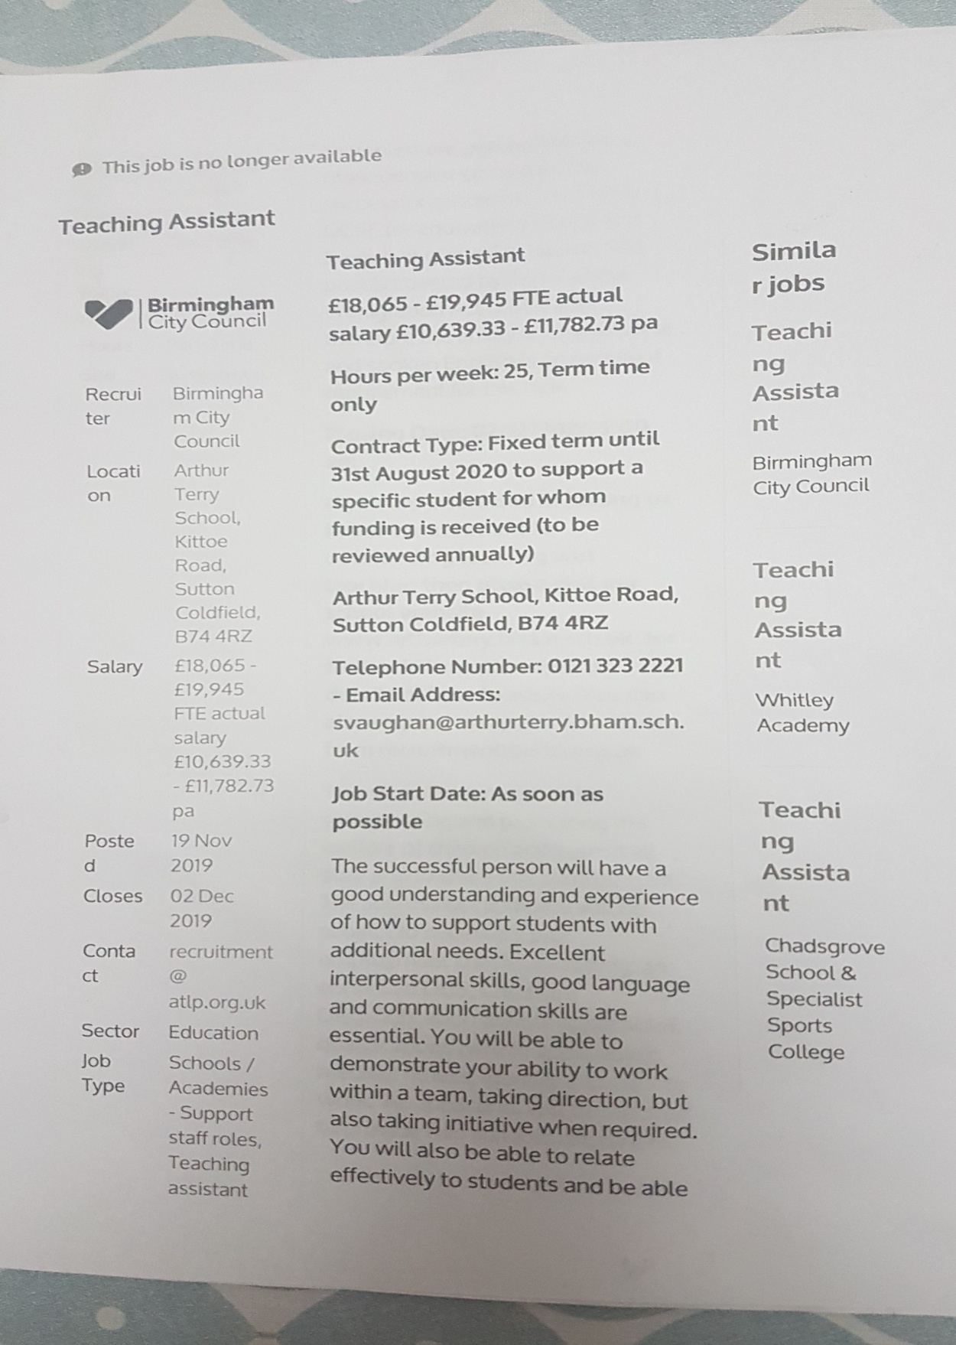

Cover Letter:
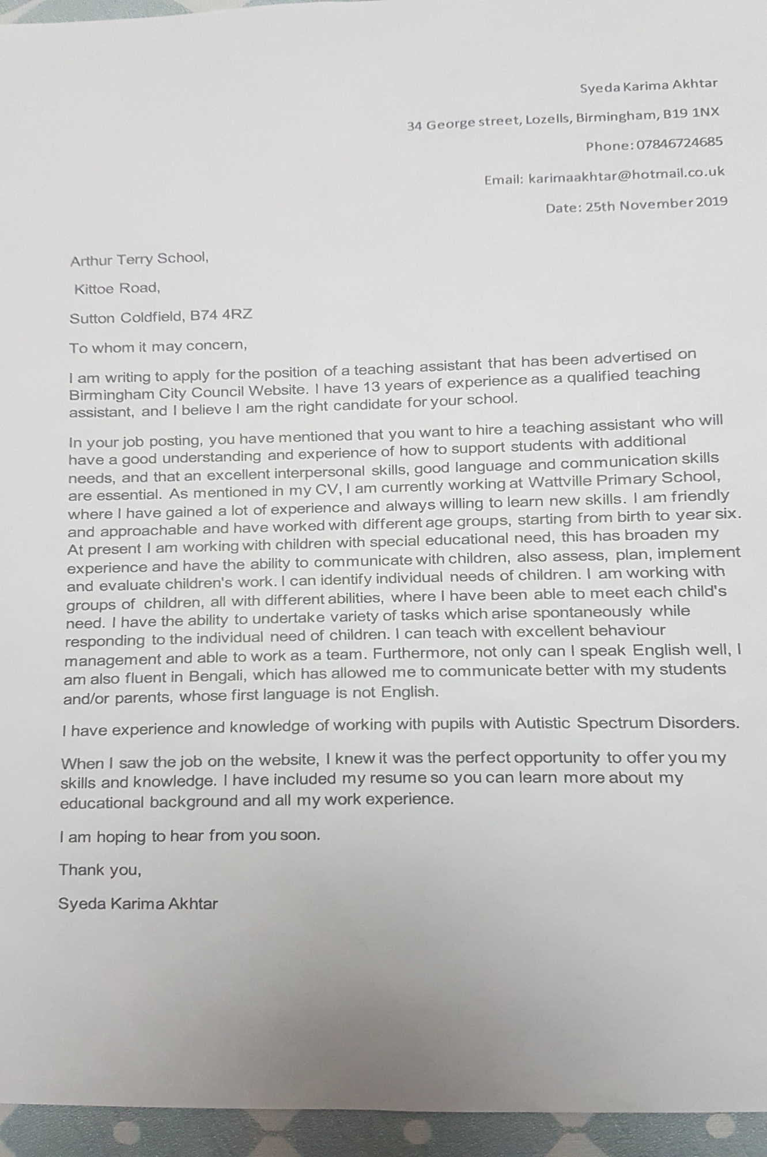
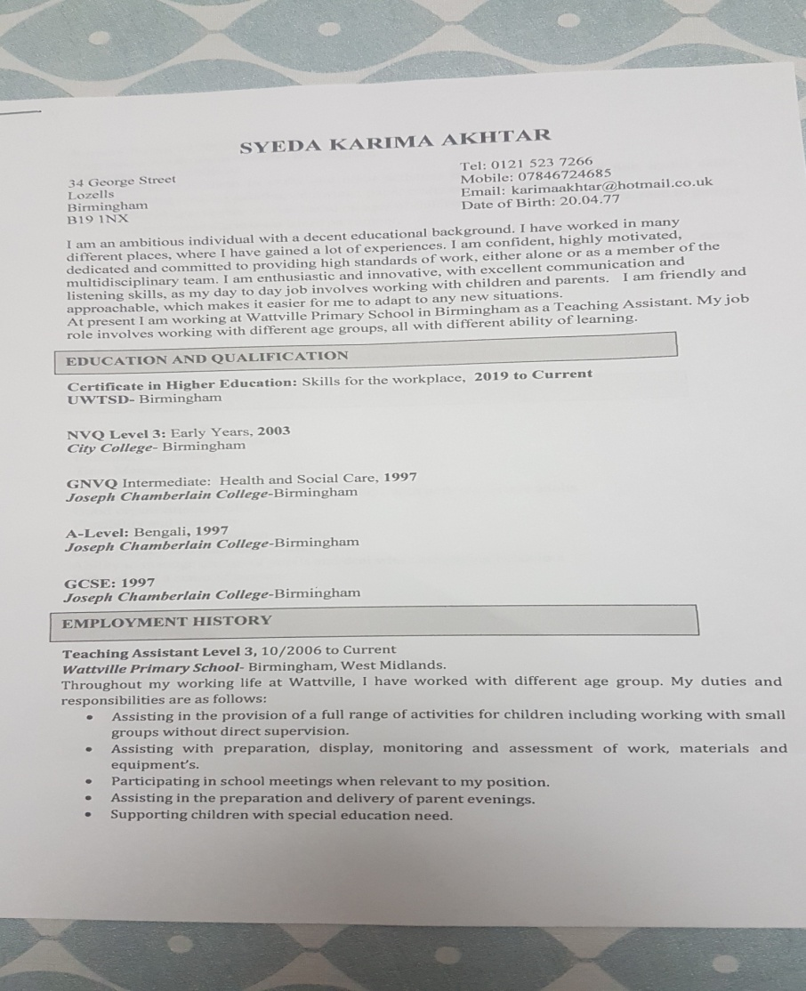
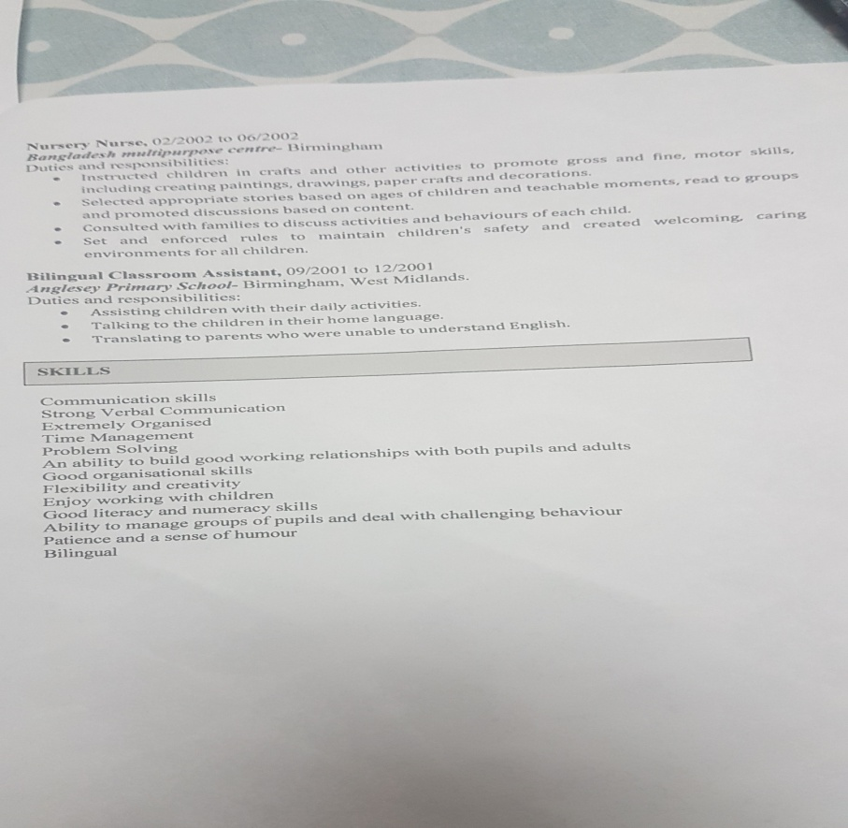

Mock Interview Grading Rubric:


