HSBC transfer
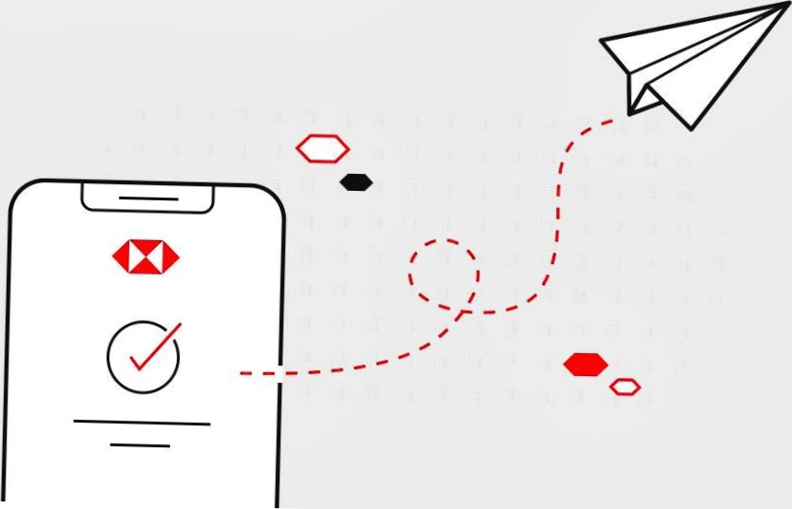
To Maricar Calma
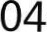— * * — * * * * * * * 65
Amount | €30.00
Reference | Friend
Date | 25 Jun 2026

DS 1 Template

My Screenshots/Photos
- Please add 4–6 screenshots or photos of your digital life.
- You can use your phone or laptop.
- For each screenshot, write one or two sentences explaining what it shows.

Screenshot/Photo 1
Mobile banking can do evrything with your everyday lives like paying bills

Screenshot/Photo 2

[Insert Photo/Screenshot below]
Pick-up in 1 min
Share your live trip
(0) Share
location
Trip details
Meet at your pick-up spot on Lancaster Road
L016NDV
White Toyota Prius
4.97
Binyam O Top-rated driver
Travel is easier

Screenshot/Photo 3

[Insert Photo/Screenshot below]
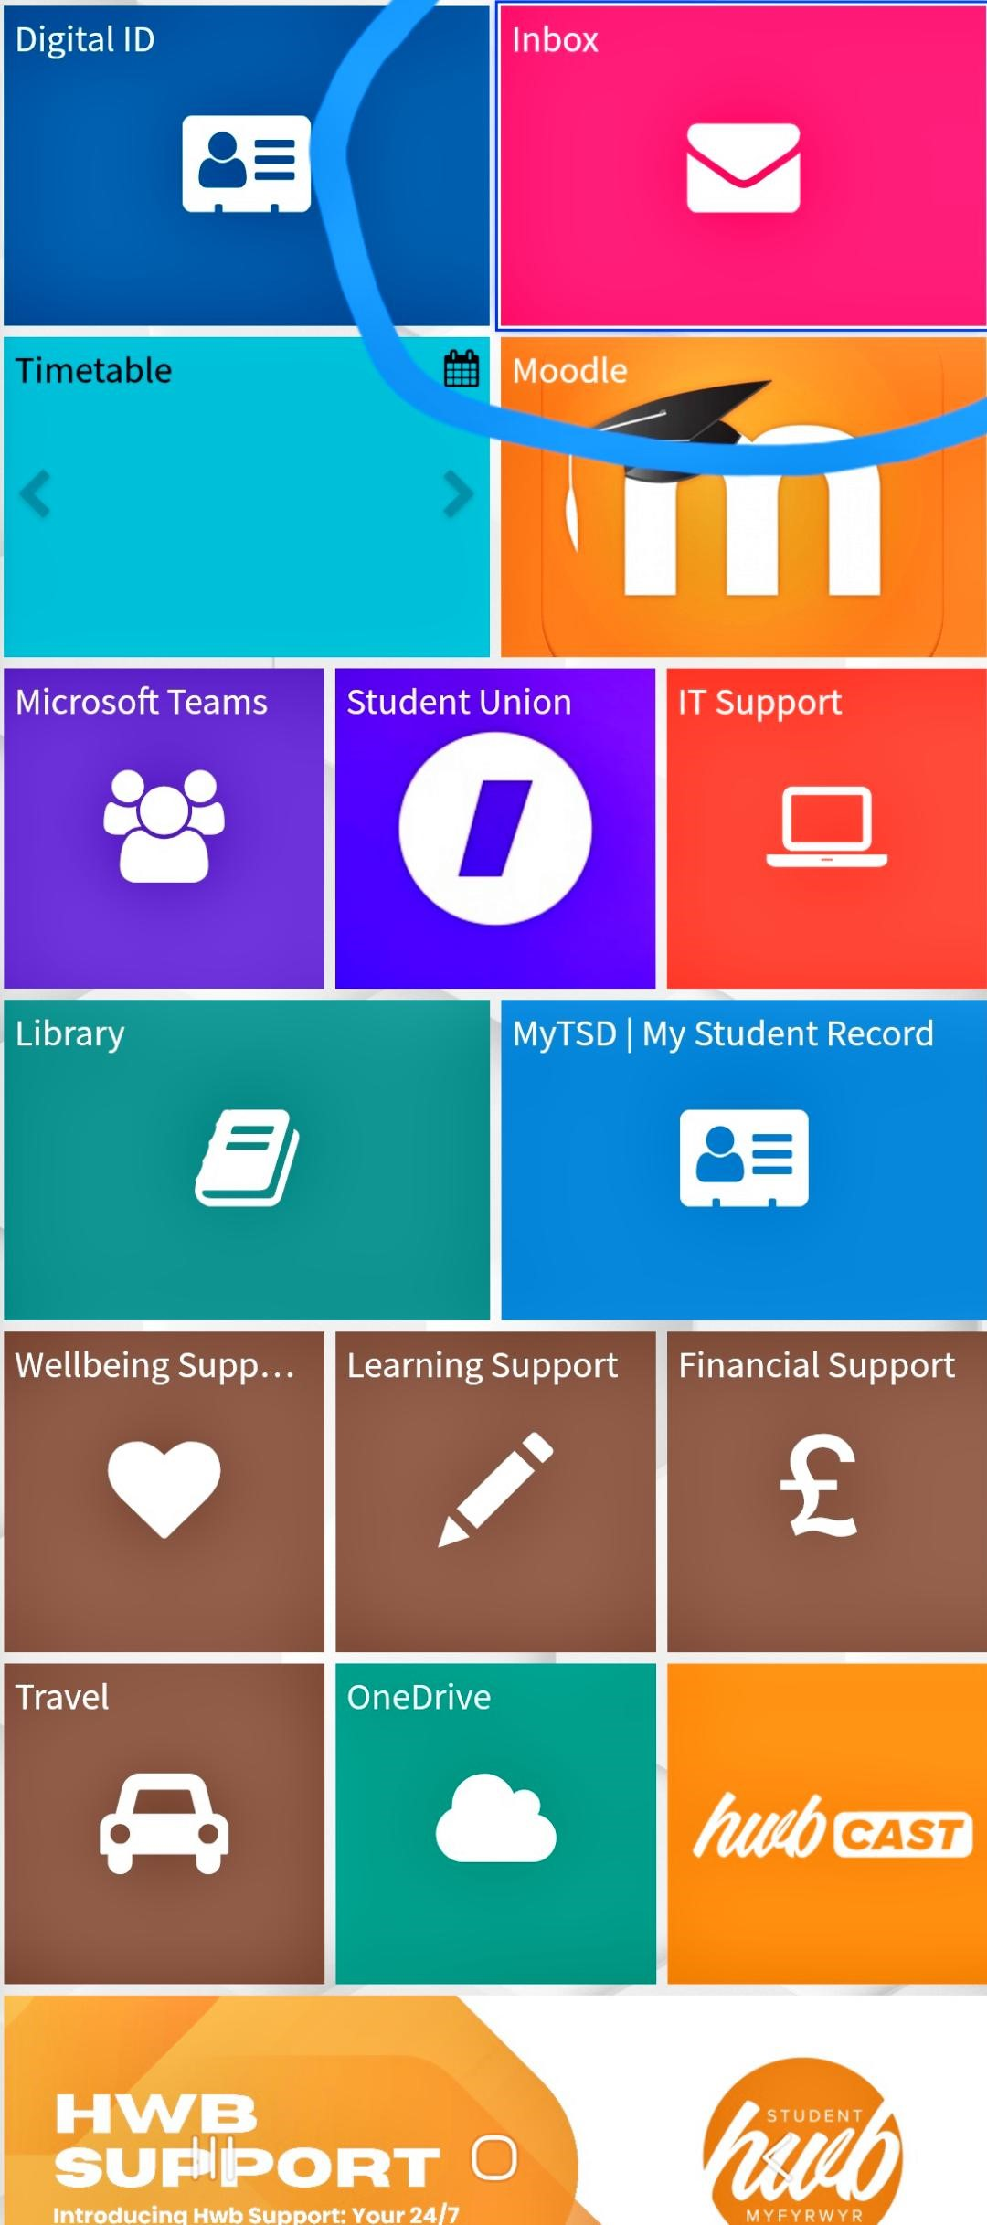

Screenshot/Photo 4
[Insert Photo/Screenshot below]
Screen profile you can easily access with your school work or information

Screenshot/Photo 5

[Insert Photo/Screenshot below]
Imperial College
London
APPLY NOW
www.opportunitiescircle.com #globalpassporttodreams

4,463 Q 204 121 5,154 R
opportunitiescircleofficial Imperial College... more
3 days ago
Social media like instagram, i can follow or search my family and friends

Screenshot/Photo 6

[Insert Photo/Screenshot below]
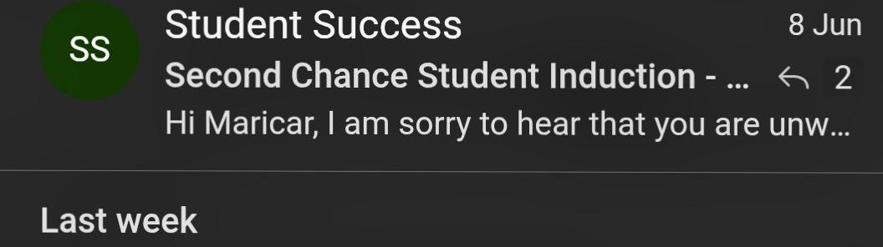
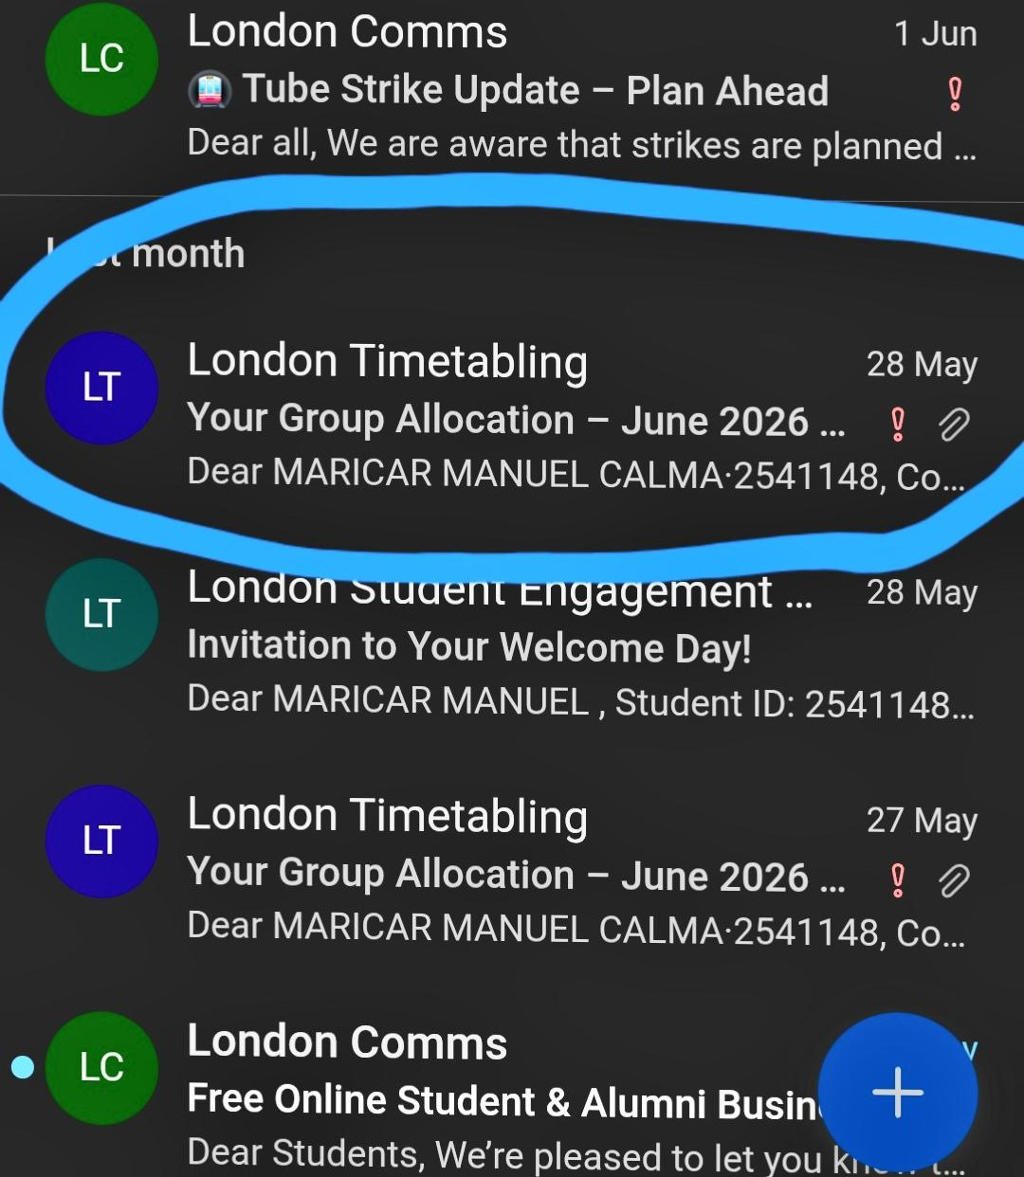
Inbox MC
Engagement Monitoring 7 Jun EM
Important Information After Induction
Important information for new UWTSD London...
Email makes my life convenient and easy to access for information and sending messages

My Short Reflection
- Write 5–8 simple sentences about your digital life.
- You can use the sentence starters below if helpful.
I used digitals to communicate
I am very confident when i used banking online as its easy and save your time
I want to improve my skills to use digital tools as thia is everyday needs
I sometimes feel nervous about digital skills because i know there is lot to learn
I hope this module will help me to build my confident using digital tools
Digital skills are important for me because this is now we need everyday for everything

Sentence starters
- I use digital tools to …
- I feel confident when I …
- I want to improve …
- I often use these tools: …
- I sometimes feel nervous about …
- I hope this module will help me …
- Digital skills are important for me because …
I need this everyday and also it’s a part of my everyday lives

Submission Checklist
Before you submit, please check:
​​​ ☐ I added 4–6 screenshots
☐ I wrote short sentences for each screenshot
☐ I wrote my short reflection
☐ My work is my own
☐ My file opens correctly
​​☐ My file opens correctly

