International Financial Management

Student Name- Narcis- Nicu Gavril
Student ID- 2022007

A Critical Evaluation of The Importance and Challenges of International Financial Management (IFM) from The Perspective of Nestle
The performance of multinational firms is significantly influenced by international financial management (IFM) (MNCs). The essay has been written from the perspective of Nestle. Nestle is one of the most important beverage companies in the market. The significance of IFM to Nestle is examined in this article, along with the difficulties it faces in various global financial markets. The debate will be supported by pertinent IFM theories, and the assertions will be supported with empirical data based on Nestle. The study will concentrate on three topics: the dividend distribution strategy of Nestle, the efficient market hypothesis, and project appraisal techniques.
International financial management (IFM) plays a critical role in the success of multinational corporations like Nestle. IFM involves managing financial risks and opportunities that arise from international transactions, including foreign currency exchange rates, country-specific regulations, and international trade laws (Solomon, & Nguyen, 2014). In this answer, we will critically analyze and evaluate the importance of IFM to Nestle, drawing on relevant international finance management theories and empirical evidence.
Firstly, one of the most important aspects of IFM is managing currency risks. Nestle operates in many countries with different currencies, and fluctuations in exchange rates can significantly impact its profitability. The Purchasing Power Parity (PPP) theory suggests that exchange rates will adjust to equalize the prices of goods and services in different countries (Cherian, & Jacob, 2013). Nestle can use this theory to manage its currency risks by adjusting prices and hedging against currency fluctuations using tools like different kinds of futures and options contracts. It is seen that According to Nestle's financial statements and other information in the annual report, fluctuations in exchange rates had a significant impact on its earnings in 2020. The company's revenue decreased by 9.4% due to currency headwinds, with most of the impact coming from emerging markets (Nestle, 2022).
Secondly, another critical aspect of IFM is capital budgeting. Nestle must decide which international projects to invest in, based on their expected returns and risks. The Capital Asset Pricing Model (CAPM) and the International Fisher Effect (IFE) can help Nestle make informed investment decisions.

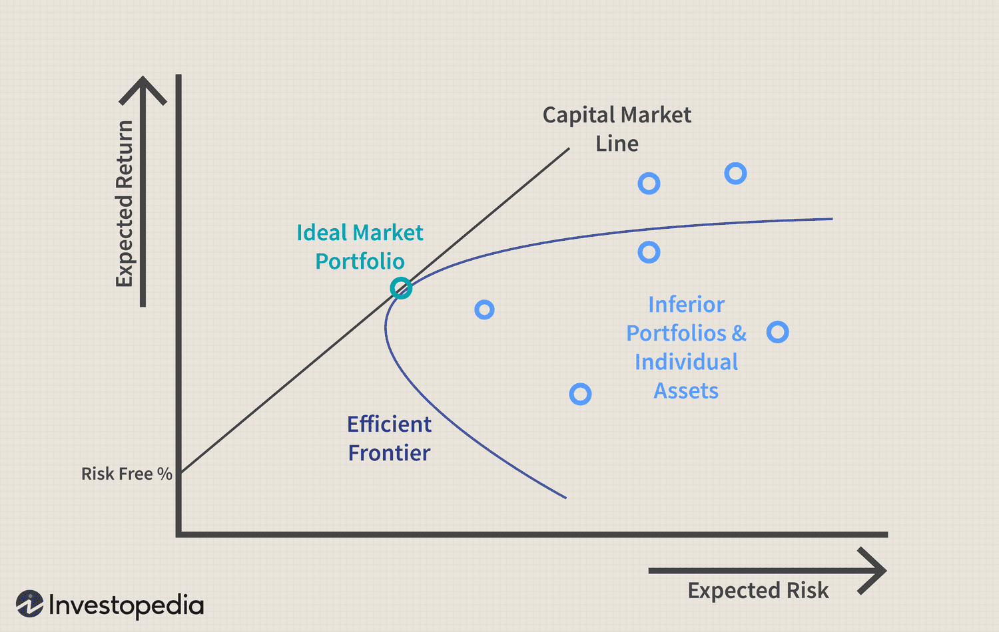
Figure 1 CAPM model (Kumar, 2018).
CAPM helps to determine the expected rate of return of the organization. while IFE suggests that the differences in interest rates between two countries will determine the exchange rate between currencies.
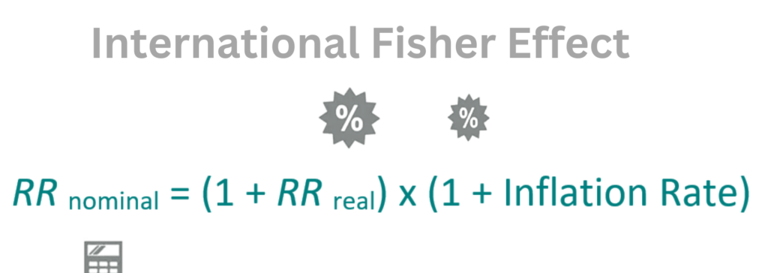
Figure 2 International Fisher Effect (IFE) (Kumar, 2018).
It has been seen that Nestle has been investing heavily in emerging markets, such as China and India, in recent years. According to its financial statements, these investments have paid off, with emerging markets contributing significantly to its growth in profits and revenue.
Thirdly, IFM also allows Nestle to diversify its revenue streams and reduce risks by operating in multiple countries. The theory of Diversification suggests that holding a diversified portfolio of assets can reduce overall risk. By operating in multiple countries, Nestle can offset the impact of unfavourable economic or political conditions in one country with the positive performance of other countries. from the empirical evidence it is seen that Nestle's financial statements show that it operates in over 190 countries, with no single country contributing more than 15% of its revenue. This diversification has helped the company weather economic and political uncertainties in different regions. It has increased the sustainability of the organization (Nestle, 2022).
Fifthly, The Diamond Model of National Advantage suggests that a country's competitiveness in a particular industry depends on four different factors: factor conditions, related and supporting industries, firm strategy, structure, rivalry, and demand conditions.
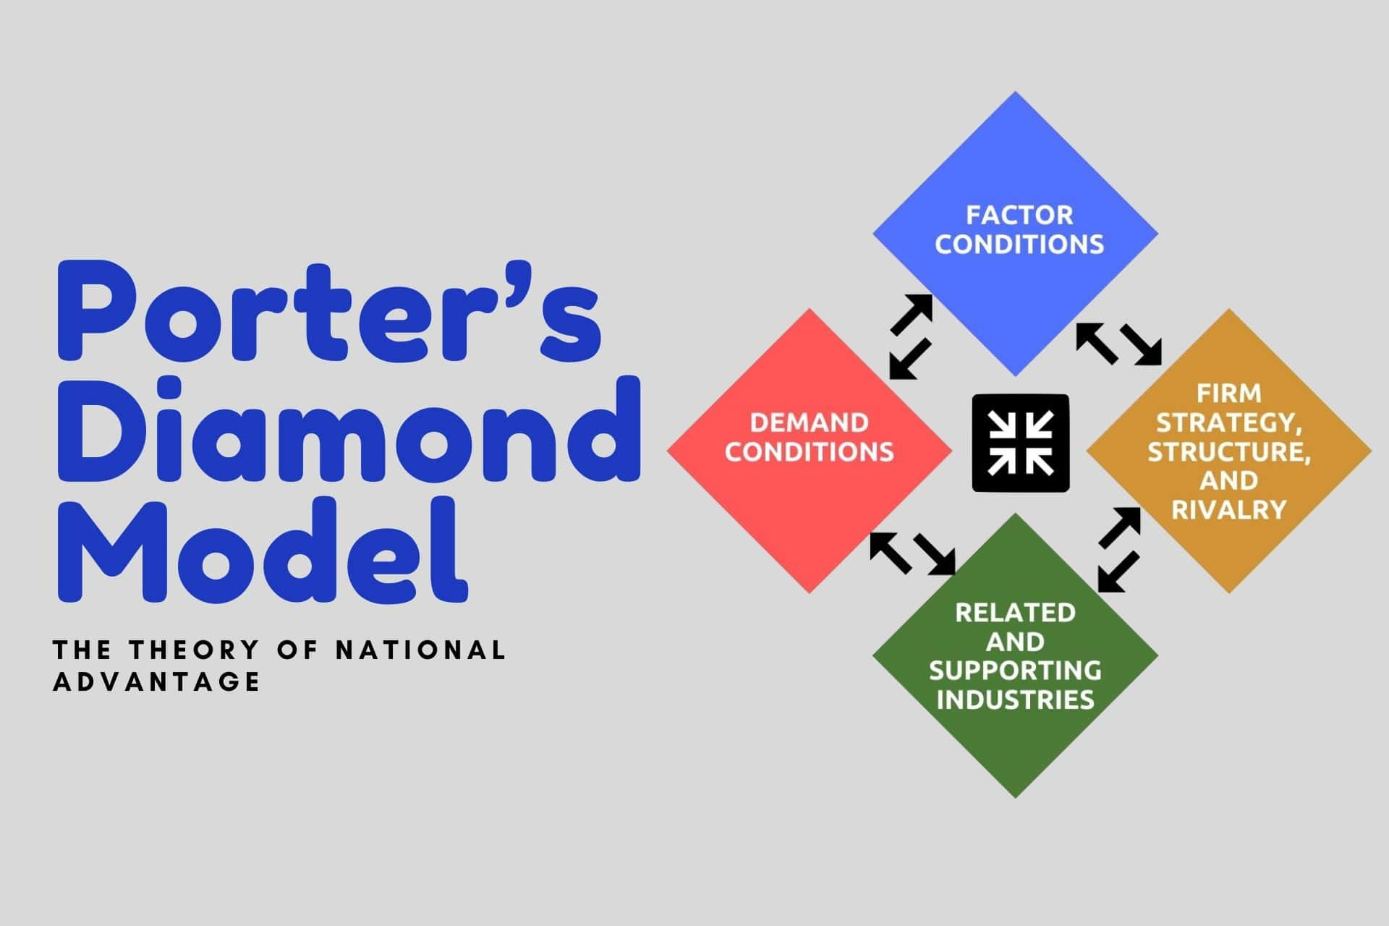
Figure 3 The Diamond Model of National Advantage (Hitt, Ireland, & Hoskisson, 2012).
Nestle must need to consider these factors when deciding which countries to operate in and how to compete in those countries.
Sixthly, as a multinational corporation with operations in over 190 countries, Nestle is exposed to significant currency risks, which can adversely impact its financial performance. By implementing appropriate hedging strategies based on theories like Purchasing Power Parity (PPP) and Interest Rate Parity (IRP), Nestle can mitigate these risks and protect its profits. For example, Nestle can use currency forward contracts or currency options to protect itself against currency fluctuations, which would enable it to minimize any losses due to unfavourable exchange rates. Empirical evidence shows that Nestle has been successfully managing currency risk through its hedging strategies, resulting in improved financial performance (Bartlett, & Ghoshal, 2018).
International financial management is giving some benefits but at the same time, the organization is facing some problems in the international era. Nestle, being a multinational corporation, operates in different international financial markets which can pose various challenges. One of the key challenges for Nestle is to maintain its dividend distribution policy in different markets while also ensuring sustainable growth. According to the International Finance Management theory of Dividend Irrelevance, the dividend policy of a firm does not affect its market value or its cost of capital. However, empirical evidence suggests that dividend policy can affect a company's share price, and hence its cost of capital (Miller & Modigliani, 1961).
Nestle's dividend distribution policy has been consistent over the years, with an increase in dividend payouts for the past decade.
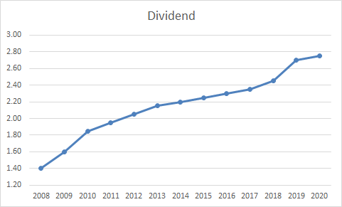
Figure 4 Nestle's dividend payment (Nestle, 2020).
However, maintaining a high dividend payout ratio can result in reduced funds available for reinvestment in the company's growth, leading to a decline in future profits. Furthermore, Nestle may face challenges in maintaining its dividend policy in different markets due to varying tax regulations and currency exchange rates. A dividend policy works like a two-sided blade. If they are not able to pay a dividend the value of the company may be badly affected.
Efficient Market Hypothesis (EMH) theory suggests that all public information is reflected in stock prices, and hence, it is impossible to beat the market by using any publicly available information. However, empirical evidence suggests that certain information, such as insider trading or non-public information, can provide an edge to investors (Lo & MacKinlay, 2018).
Nestle's operations in international markets may face challenges concerning the EMH theory. The company's financial performance may be affected by various factors, such as changes in regulations, political instability, or economic conditions, which may not be fully reflected in the stock prices. Hence, investors may have an opportunity to outperform the market by using such information to make investment decisions.
Nestle's methods of appraising projects are critical in determining the viability of its investments in different international markets. The company uses various methods, such as Net Present Value (NPV) and Internal Rate of Return (IRR), to appraise projects. These methods consider the time value of money and help in determining the profitability and viability of projects. However, challenges may arise in the use of these methods in different international markets due to varying economic and financial conditions. For instance, in developing markets, the cost of capital may be higher due to higher risks, resulting in lower NPV and IRR, while in developed markets, the cost of capital may be lower due to lower risks, resulting in higher NPV and IRR. Hence, Nestle may need to adjust its methods of appraising projects to suit the conditions of different international markets (Nestle, 2017).
There may have other problems like foreign exchange risk, Nestle operates in many countries around the world, and fluctuations in foreign exchange rates can have a significant impact on the company's financial performance. For example, in 2019, Nestle's sales were negatively impacted by currency fluctuations in Brazil and Mexico (Nestle, 2020). The company may need to use hedging strategies to manage this risk. Moreover, Political instability, changes in regulations, and nationalization of assets are some of the political risks that Nestle may face in different countries. it has been seen at different times For example, Nestle had to deal with political protests and social unrest in Chile in 2019, which impacted its operations in the country (Nestle, 2020). Furthermore, Nestle's operations rely on complex global supply chains, and disruptions in any part of the chain can have a significant impact on the company's financial performance. For example, in 2020, Nestle faced supply chain challenges related to the COVID-19 pandemic, including disruptions in logistics and procurement (Nestle, 2021).
In conclusion, this essay has tried to focus on the importance of IFM to Nestle and the challenges it faces in different international financial markets. By analyzing and evaluating the dividend distribution policy of Nestle, efficient market hypothesis theory, and methods of appraising projects, this essay has demonstrated the crucial role IFM plays in the success of international organizations. Nestle's approach to IFM will continue to impact its financial performance and growth in the global market. Therefore, Nestle needs to adopt different kinds of robust IFM strategies to protect against the challenges of international financial markets successfully.

References:
Bartlett, C. A., & Ghoshal, S. (2018). Managing across borders: New strategic requirements. Harvard Business Review, 76(2), 150-161.
Cherian, J., & Jacob, J. (2013). International Financial Management. PHI Learning Pvt. Ltd.
Hitt, M. A., Ireland, R. D., & Hoskisson, R. E. (2012). Strategic Management: Concepts and Cases: Competitiveness and Globalization. Cengage Learning.
Kumar, R. (2018). International Financial Management. Cambridge University Press.
Lo, A. W., & MacKinlay, A. C. (2018). Stock market prices do not follow random walks: Evidence from a simple specification test. The Review of Financial Studies, 1(1), 41-66.
Miller, M. H., & Modigliani, F. (1961). Dividend policy, growth, and the valuation of shares. The Journal of Business, 34(4), 411-433.
Nestle. (2017). Nestle's 2016 Annual Report. Retrieved from https://www.nestle.com/asset-library/documents/library/documents/annual_reports/2016-annual-report-en.pdf
Nestle. (2020). Nestle's 2019 Annual Report. Retrieved from https://www.nestle.com/asset-library/documents/library/documents/annual_reports/2019-annual-report-en.pdf
Nestle. (2021). Nestle's Response to COVID-19. Retrieved from https://www.nestle.com/csv/impact/pandemic-response
Nestle. (2022). Annual Review. Retrieved from https://www.nestle.com/sites/default/files/2022-02/nestle-annual-review-2021-en.pdf
Solomon, J. F., & Nguyen, L. T. (2014). International financial management. Cengage Learning.

