
-*


Student name: Ginalyn E. Leal

Student ID:2515491
Module name:Introduction to Health and Social Care
Module code:(LCHS4003_LON)
Lecturer name: Muhammad Aliyu

Content page

This Photo by Unknown Author is licensed under CC BY-SA-NC


Typical Services Offered Under Community Disability Services
-Personal care and daily living support
-Assistance with mobility and transportation
-Access to education and employment programmes
-Social and recreational activities
-Psychological and emotional support
-Rehabilitation and therapy services
^{. Explanation of} ^{Community Disability Services}
Community disability services offer necessary assistance to persons with disabilities of physical intellectual, sensory or developmental nature, so they could live independently in their societies. These service aim at enhancing the quality of life by providing personalized care, social inclusion, health education and job opportunities. Instead of encouraging institutionalisation, they seek to ensure that people can stay at home and be provided with the support the require to be able to go about in their day-to-day activities
. (World Health Organisation, 2024)

Community Disability Services
This Photo by Unknown Author is licensed under CC BY-SA

Current functioning of community Disability services
The community disability services are used to coordinate systems which cover the local authorities, healthcare services, voluntary organisations and community support agencies.The financing of it is primarily supported by government health and social care, and charities supplement this assistance. The major characteristics in the person – centred care model according to which people are evaluated to define their needs, strengths and goals.
(World Health Organization,2022).

Brief History of Community Disability Services
In the past, disabled individuals would tend to be concentrated in huge institutions the residential hospital and asylum facilities, where patients were treated more of a containment than independence and rehabilitation. The result of this was social isolation and impaired personal development. Nevertheless, in the middle of the 20th century, transforming attitudes and disability rights movements started to propagate equality, dignity and inclusion. These campaigns promoted the change of the institutional care of the community-based care (Slasberg,2022).

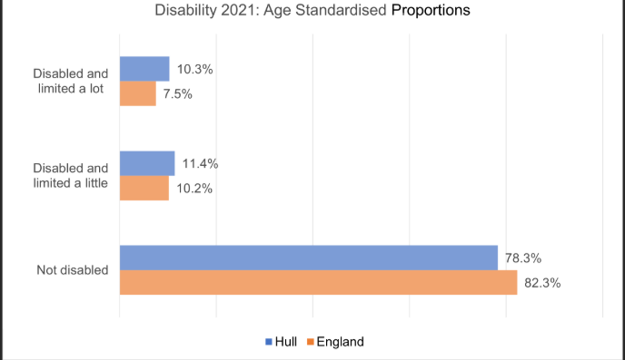
Glasby, J.O.N., Zhang, Y., Bennet, M.R. and Hall, P.,2021 A lost decade? A renewed case for adult social care reform in England. Journal of Social Policy,50(2), pp 406-437
(accessed March 7)
Slasberg, C,2022 Further lessons from the continuing failure of the national strategy to deliver personal budgets and personalization.
(accessed March 10)

Community Antenatal Midwifery Services

Introduction
Maternity services based on community antenatal midwifery services play the central role in maternity healthcare, especially in the United Kingdom where midwives initiate childbirth services. Antenatal care are entails observation, evaluation, and comprehensive care in protecting the well-being of the mother and the foetus. Maternal mortality is an issue worldwide, and according to a report by the World Health Organization, in 2020, it is estimated that 287,000 deaths are related to pregnancy; the skills of specialists are needed (World Health Organization,2023). The community midwives are concerned with the early detection of complication, health education and continuity of care. According to the study, early access to antenatal care is crucial for identifying risks and improving maternal and neonatal outcomes, particularly among women from disadvantaged or ethnically diverse communities. (Smith et al.,2023).
Historical development of maternity services in the United Kingdom
Mothers were used to giving birth at home and were assisted by traditional attendants, but the mortality rate was very high as an infection, haemorrhage, and lack of medical knowledge were the reasons (Reid,2020). In the United Kingdom, midwifery became profession with formal training and registration by the midwives Act 1902 (Renbarger,2020). With the establishment of the National Health Service in 1948, there was universal access to maternity care, and reinforcement of community services. Alternatives to the modernist approach to woman-centred care and continuity were advanced with reforms in the late twentieth century (England,2020). The Better Births (2016) also developed midwife-led continuity models, the evidence of which is associated with maternal satisfaction and decreased medical interventions (Bradford,2022).
Functioning of Community Antenatal Midwifery Services
The modern community antenatal midwifery services in the United Kingdom are under integrated system of midwives, GP’s obstetricians. Midwives are in charge of low risks pregnancies, observing regular routines of monitoring, screening, and ultrasound tests according to the National Institute of Health and Care Excellence. They offer nutrition, education, mental health, and birth preparation education, which contributes a better result. In case of complications, referrals allow the contribution of a specialist without discontinuities. Nevertheless, the problems of workforce shortages that Royal College of Midwives report about and ethnic disparities that MBRRACE-UK address are still a concern. Digital innovations such as telehealth and electronic maternity records are improving access and care coordination (Greenhalgh,2020).
Significance in Enhancing the Quality of Life of Service Users
Midwifery services in the community add value to the quality of life because it promotes safe childbirth and holistic wellbeing. This can be taken care of through frequent monitoring to help identify complications early as the world health organization (2023) notes. And key models of midwife led continuity models enhance the outcomes of the birth and minimize unwarranted interventions (Bradford,2022). In addition to clinical practice, midwives offer emotional assistance and teaching, which reinforces maternal confidence. Social services also enhanced access the less privileged women which will result in fair, long-term maternal and infant health. These services support both maternal and infant health, ensuring a safer and positive pregnancy experience. (National Health Service,2023).
Conclusion
The Community Antenatal Midwifery Services have developed into high complex and evidence-based health systems out of informal childbirth services. The Midwives Act and creation of the NHS are historical events that impacted the evolution of maternity care in contemporary times. Community midwives now provide health education and emotional support as well as clinical monitoring as part of a one stop shop of the antenatal service. Despite current issues, including the lack of work force and the problem of health disparities, such services are needed to enhance the maternal health outcomes and the overall quality of life of pregnant women and their families.

References
Bradford, B.F., Wilson, A.N., Portela, A., McConville, F, Fernandez Turienzo, C.S., 2022 Midwifery continuity of care; A scoping review of where, how, by whom and for whom? PLOS GLOBAL PUBLIC HEALTH,2(10), p.e0000935.

England NHS and NHS Improvement, 2020.Better births four years on: A review of progress. Available: NHS England.
Greenhalgh, T., Wherton, J., Shaw, S. and Morrison, C., 2020. Video consultations for COVID-19. BMJ, 368.
Reid, A., 2020.The geography of maternal mortality in early twentieth-century England and Wales. In: Annales de demographie historique, 139 (1), pp.111-140.Belin.
Renbarger, K. M., Moorman, M., Latham-Mintus, K., Shieh C. and Drauker, C., 2020. Factors associated with a trusting relationship between pregnant and postpartum women with substance use disorders and maternity nurses. International Journal of Childbirth, 10 (4).
Solnes Miltenburg, A., Kvernflaten, B., Mequid, T. and Sundby, J., 2023. Towards renewed commitment prevent maternal mortality and morbidity: Learning from 30 years of maternal health priorities. Sexual and Reproductive Health Matters, 31 (1), p 2174245.

