

Professional career development
Student Name : Kristian Pulhos
Student ID: 2314064
Submite date : 10/11/2023
Professional Career Development Using Kolb's Model
Executive summary:
Introduction: In today's competitive job market, individuals need to continuously develop their professional skills and knowledge to stay relevant and advance in their careers. One effective framework for career development is Kolb's Experiential Learning Model, which emphasizes the importance of learning from experience. By applying this model, individuals can enhance their professional growth and achieve their career goals. This essay will explore the application of Kolb's model in professional career development, supported by the Johari Window and SMART goals.
Concrete Experience: The first stage involves actively engaging in experiences that supply opportunities for learning. In this case, the individual could seek out leadership roles or projects that require them to lead a team. By immersing themselves in such experiences, they can gain firsthand knowledge of the challenges and responsibilities associated with leadership.
Reflective Observation: After the concrete experience, the individual needs to reflect on the experience and analyze what they have learned. This stage involves seeing and evaluating the outcomes, strengths, and areas for improvement.
The Johari Window a psychological model that divides self-awareness into four quadrants: open, blind, hidden, and unknown.
Johari Window: The open quadrant stands for the information known to both the individual and others. In the context of leadership development, this could include the individual's ability to communicate effectively, delegate tasks, and motivate team members. The blind quadrant stands for information known to others but unknown to the individual. Feedback from colleagues and superiors can help the individual uncover blind spots in their leadership skills, such as a tendency to micromanage or a lack of empathy.
The hidden quadrant stands for information known to the individual but not to others. This could include the individual's personal goals, aspirations, or fears related to leadership. By sharing this information with trusted colleagues or mentors, the individual can receive support and guidance in their career development. Finally, the unknown quadrant stands for information unknown to both the individual and others. This emphasizes the importance of continuous learning and exploration to uncover new skills and abilities.
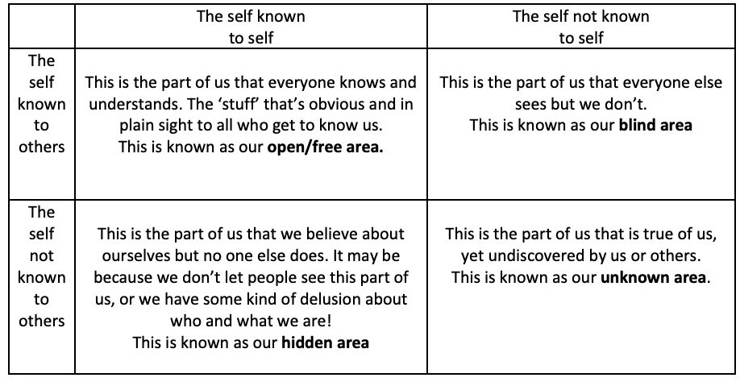

USING THE JOHARI WINDOW BY BEN HARPER
In 1955, American psychologists Joseph Luft and Harrington Ingham were researching group dynamics as part of their work at the University of California Los Angeles.

Abstract Conceptualization: In this stage, the individual reflects on their experiences and observations to develop abstract concepts and theories. They can draw upon existing knowledge, theories, and frameworks to make sense of their and frameworks to make sense of their experiences. For example, the individual could study leadership theories and models to gain a deeper understanding of effective leadership practices. By connecting their experiences to theoretical frameworks, they can develop a more comprehensive understanding of leadership and find areas for growth.
Active Experimentation: The final stage involves applying the knowledge gained from the earlier stages in new situations. The individual actively experiments with new approaches, strategies, and behaviors to refine their leadership skills. This could involve taking on new challenges, seeking feedback, and continuously reflecting on their experiences. By actively experimenting and adapting, the individual can refine their leadership skills and become more effective in their role.
SMART Goals: To ensure effective career development, it is essential to set SMART goals. SMART stands for Specific, Measurable, Achievable, Relevant, and Time-bound. By setting SMART goals, individuals can have a clear roadmap for their professional growth and measure their professional growth and measure their progress. Specific goals define the desired outcome in detail. For example, a specific goal for the individual seeking to enhance their leadership skills could be improve team collaboration and communication by implementing a monthly team-building activity."
Measurable goals allow individuals to track their progress. In the case of leadership development, a measurable goal could be "increase team satisfaction by 20% within six months, as measured by anonymous team surveys."
Achievable goals are realistic and reachable. For instance, an achievable goal for the individual could be "Attend a leadership training program within the next three months to gain new skills and knowledge."
Relevant goals align with the individual's career aspirations and the organization's aims. Relevant goal for the individual could be "Develop a mentoring
individual could be "Develop a mentoring relationship with a senior leader in the organization to gain insights and guidance on leadership development."
Time-bound goals have a specific deadline for completion. This helps individuals stay focused and accountable. A time-bound goal for the individual could be "Complete a leadership development course and receive a certification within one year."
Conclusion: In conclusion, Kolb's Experiential Learning Model supplies a valuable framework for professional career development. By actively engaging in concrete experiences, reflecting on observations, conceptualizing abstract knowledge, and experimenting with new approaches, individuals can enhance their skills and knowledge. The Johari Window can be used to gain self-awareness and receive feedback from others, while SMART goals ensure a clear roadmap for progress. By applying these tools and frameworks, individuals can achieve their career goals and thrive in the competitive job market.
Kolb's Experiential Learning Model: Kolb's model consists of four stages: concrete experience, reflective observation, abstract conceptualization, and active experimentation. These stages form a cycle that eases learning and growth. To illustrate the application of this model in professional career development, let's consider an individual seeking to enhance

References:
1. Luft., & Ingham, H. (1955). The Johari window: A graphic model of interpersonal awareness. Proceedings of the western training laboratory in group development,2,218-233.
2. Locke, E.A., & Latham, G.P. (1990). A theory of goal setting and task performance. Prentice-Hall.
3. Northouse, P. G. (2018). Leadership: Theory and practice. Sage Publications.
4. Tannenbaum& Schmidt, W. H. (1973). How to choose a leadership Pattern. Harvard Business Review, 51(3),162-180.
5. Goleman, D. (1998) What makes a leader? Harvard Business Review,76(6), 93-102.
6. Blanchard, Zagami., & Zagami, D. (1985). Leadership and the one-minute manager: Increasing effectiveness through situational leadership. William Morrow and Company.
7. Covey, S.R. (1989). The 7habits of highly effective people: Powerful lessons in personal change. Simon and Schuster.
8. S.M.A.R.T. Goals: How to Make Your Goals Achievable. (n.d.). Retrieved from https://www.mindtools.com /pages/article/smart-goals.htm

