

Student Name: | Riddhi Damjibhai Mendpara
Student ID: | 2518862
Module: | ACCA7027 Cloud Engineering Principles and Practice
Lecturer: | Mark Huntly
Submission Date: | 10th August 2026

Table of Contents
Abstract 3
1.Introduction 4
2. Virtualisation and Containerisation Technologies 5
2.1 Introduction of Virtualisation …................................................................................................... 5
2.2 Containerisation Technology........................................................................................................ 5
2.3 Docker Architecture .................................................................................................................... 6
3. Docker Technologies and Practical Implementation……………………………………………………………………..7
3.1 Introduction to Docker ……………………........................................................................................ 7
3.2 Docker Image Development…….................................................................................................. 7
3.3 Docker Image Verification ……….................................................................................................. 9
3.4 Docker Container Deployment ……............................................................................................. 10
3.5 Container Verification and Monitoring………………….................................................................... 11
3.6 Chapter Summary…….................................................................................................................. 12
4. Cloud Computing Concepts…………………………………………………………………………………………………………..13
4.1 Introduction……………………………………..........................................................................................13
4.2 Load Balancing…………………..…….................................................................................................. 13
4.3 Scalability ……………………….………..................................................................................................14
4.4 Application Gateway……………..……............................................................................................. 14
4.5 Relationship Between Load Balancing, Scalability, and Application Gateway
Theory….……………………………………………………………………………………………………………………………….15
4.6 Chapter Summary……..................................................................................................................15
5. Driving Forces of Cloud Computing and Serverless Computing…………………………………………………….16
5.1 Introduction ……………………………………........................................................................................ 16
5.2 Driving Forces of Cloud Computing………..................................................................................... 16
5.3 Serverless Computing………………..................................................................................................16
5.4 AWS Lambda and Azure Functions............................................................................................. 16
5.5 Serverless Computing vs Containerisation..………….................................................................... 16
5.6 Chapter Summary……..................................................................................................................17
6. Conclusion ...................................................................................................................................... 17
References .......................................................................................................................................... 18

Abstract
Cloud computing has revolutionized how organizations create, implement and oversee applications by offering scalable, adaptable and economical computing resources. Containerisation is one of the main technologies propelling this change with Docker emerging as a popular platform for uniformly packing and delivering applications across various computer environments [1], [4]. In addition to Docker, cloud technologies including serverless computing, load balancing, scalability and application gateways are crucial for enhancing application availability, performance and resource utilisation [12], [13]. This study examines the fundamentals of virtualisation and containerisation, emphasising the function of Docker technologies, such as networking, Docker Compose, Docker images, Docker Hub and Docker volumes [6], [8] and [11]. Additionally, it explores cloud computing ideas like load balancing, scalability and application gateways, clarifying how these technologies collaborate to enhance contemporary cloud infrastructures [12], [13]. Additionally, the research studies serverless computing using AWS Lambda and Microsoft Azure Functions contrasting the serverless architecture with container-based deployment and explores the motivations behind cloud computing [15], [16]. The deployment and management of Docker containers are demonstrated through practical implementation which offers proof to back up the theoretical ideas covered in the paper. The study concludes by assessing the benefits, difficulties and prospects of serverless computing and containerisation in creating safe, scalable and effective cloud-native applications [4], [15] and [16].

Introduction

One of the most important technological advancements in contemporary information technology is cloud computing which gives businesses more flexibility, scalability, and cost-effective online access to computer resources, storage, networking and software applications [1]. By enabling several virtual computers to share physical hardware resources while preserving isolation, effective resource utilisation and enhanced infrastructure management, virtualisation serves as the foundation of cloud computing [1], [2], [17]. Containerisation has become a lightweight substitute for traditional virtual machines as cloud technologies have developed and allowing for faster application deployment, enhanced portability and consistent execution across many computing environments [4], [17]. Because it makes application packaging, deployment and management easier with features like Docker images, Docker Hub, Docker volumes, Docker networking and Docker Compose. Docker has emerged as the leading containerisation platform and is a crucial platform for developing cloud-native applications [4], [6] and [11].
To maintain high availability, increase resource utilisation and enhance application performance under shifting workloads, contemporary cloud platforms rely on complementary technologies such load balancing, scalability and application gateways in addition to containerisation [12], [13]. Additionally, developers can run applications without managing the underlying server architecture thanks to serverless computing platforms like AWS Lambda and Microsoft Azure Functions, which lower operational complexity while increasing scalability and cost effectiveness [15], [16]. These technologies are now essential parts of contemporary cloud systems and help businesses create dependable, adaptable and scalable cloud services [13], [15].
This report's objective is to investigate the fundamentals of virtualisation and containerisation, with a focus on Docker technologies and their use in contemporary cloud deployments. Before going over the motivations behind cloud computing and examining serverless computing using AWS Lambda and Microsoft Azure Functions. the research assesses key cloud computing principles like load balancing, scalability and application gateways. While current academic research is used to critically assess the advantages, constraints, security considerations and future role of these technologies in cloud computing, a practical Docker implementation is presented to illustrate the deployment and management of containerised applications [4], [6], [12], [15], [16].

2. Virtualisation and Containerisation Technologies

2.1 Introduction to Virtualisation
A key component of cloud computing is virtualisation which enables several virtual machines (VMs) to operate on a single physical server by effectively sharing hardware resources. Virtualisation produces several virtual environments that can run various operating systems and applications independently, as opposed to dedicating a single physical machine to a single operating system. This strategy lowers infrastructure costs, increases hardware utilisation and makes it possible for businesses to use computing resources more effectively [1].
The hypervisor, also referred to as the Virtual Machine Monitor (VMM) that is a software layer that controls virtualisation. While maintaining workload isolation, the hypervisor distributes computational resources like CPU, memory, storage and networking to each virtual machine. Hypervisors come in two primary varieties: Type 2 (hosted) hypervisors, which run on top of an existing operating system and Type 1 (bare metal) hypervisors, which run directly on the hardware. While Type 2 hypervisors are frequently utilised for testing and development and Type 1 hypervisors typically offer superior performance and security, making them appropriate for enterprise cloud settings [1], [2].
By facilitating quick resource provisioning, workload mobility, disaster recovery and enhanced system availability, virtualization's widespread use has revolutionised cloud computing. Additionally, it supports the Infrastructure as a Service (IaaS), Platform as a Service (PaaS) and Software as a Service (SaaS) cloud service models, which enable cloud providers to optimise resource utilisation while offering users flexible and scalable services [1], [3]. Modern cloud-native and serverless architectures can benefit from recent advancements like lightweight virtualisation and micro VM technologies, such as AWS Firecracker, which further enhance startup performance while ensuring good workload isolation [17].

2.2 Containerisation Technology
Strong isolation is offered by virtual machines, however each virtual machine must have a full operating system which raises resource overhead, startup time and storage usage. Containerisation was developed as a lightweight virtualised method to get around these restrictions. In contrast to virtual machines, containers isolate apps and their dependencies into distinct execution environments while sharing the host operating system kernel. Applications may launch in a matter of seconds thanks to this architecture, which drastically lowers resource consumption [4], [17].
Because containerisation enables developers to bundle applications with all necessary libraries, runtime environments and configuration files. it has emerged as one of the key technologies in cloud-native computing. Applications act uniformly in development, testing and production settings as a result, removing compatibility difficulties that are sometimes referred to as "it works on my machine" issues. Containerisation is especially useful for DevOps procedures, continuous integration and continuous deployment (CI/CD) pipelines because of its portability [4].
Containers offer several benefits over conventional virtual machines, such as quicker deployment, increased application density, cheaper infrastructure and better scalability. However, compared to virtual machines, containers offer less isolation because they share the host operating system kernel, necessitating the implementation of suitable security measures such secure image management, vulnerability screening, and runtime protection [5], [17].

2.3 Docker Architecture
The most popular containerisation platform right now for creating, launching and maintaining containerised apps is Docker. It offers a full ecosystem that makes it easier to package, distribute and run applications in many computer settings. In order to construct and manage containers, Docker uses a client-server architecture made up of a number of interrelated components [4], [6].
Using commands like "docker build", "docker pull”, “docker run" and "docker push" users can interact with Docker via the command-line interface provided by the Docker Client. The Docker Daemon, which is in charge of building images, starting containers, maintaining networks and regulating storage resources, processes these commands. Developers may share, download and reuse application images across many systems thanks to Docker images, which are kept in container registries like Docker Hub [6], [9].
Important items like images, containers, volumes and networks are also included by Docker. Containers are running instances of Docker images, which are read-only templates used to generate containers. Volumes offer application data permanent storage, guaranteeing that data is kept even after containers are deleted. Docker networks preserve network isolation while facilitating communication between containers. When combined, these elements provide a versatile and effective platform for the deployment of contemporary cloud-native applications [6], [8] and [9].

3. Docker Technologies and Practical Implementation

3.1 Introduction to Docker
Developers can package apps and their dependencies into portable, lightweight containers using Docker, an open-source containerisation technology. Docker containers are quicker to launch and more resource-efficient than virtual machines since they share the host operating system kernel. By guaranteeing that apps operate uniformly in development, testing and production settings, Docker facilitates the development of cloud-native applications. The Docker Client, Docker Daemon, Docker Images, Containers and Docker Registry comprise its architecture, which collectively streamlines the deployment and maintenance of applications [4], [6], [17].
Explanation
To confirm that Docker was installed successfully, the docker --version command was run. The output verifies that Docker Engine is installed on the system and prepared for container creation and management.
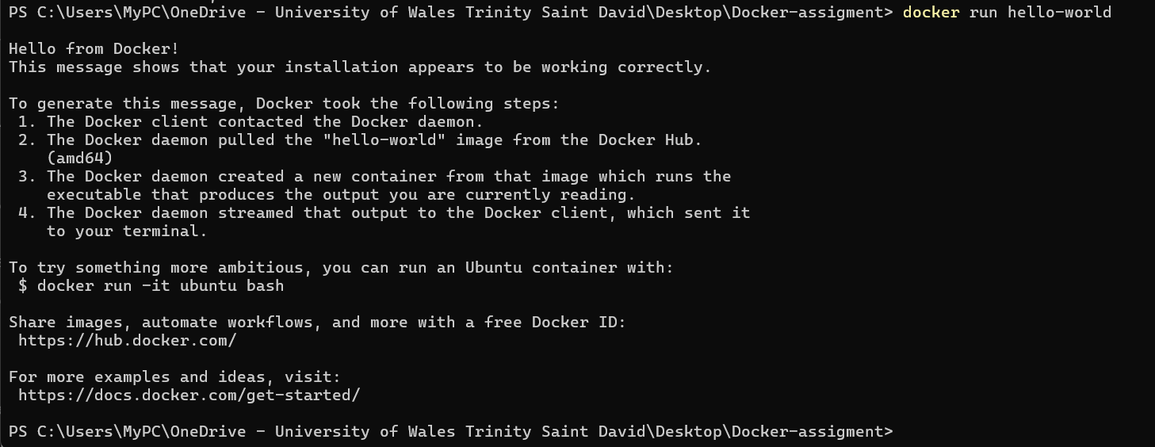Explanation
The Hello World image is downloaded from Docker Hub and launched within a container using the docker run hello-world command. The successful output attests to the proper operation of the Docker Client, Docker Daemon, image download and container execution.

3.2 Docker Image Development
Application code, runtime libraries, configuration files and dependencies needed to run an application are all contained in read-only Docker images. Docker files, which use a series of instructions to automate the image-building process are used to construct images. Because Docker images are kept in layers. it is possible to manage storage effectively and rebuild them more quickly when changes are made. This layered architecture facilitates quick application deployment across various cloud environments and enhances portability [6], [10].

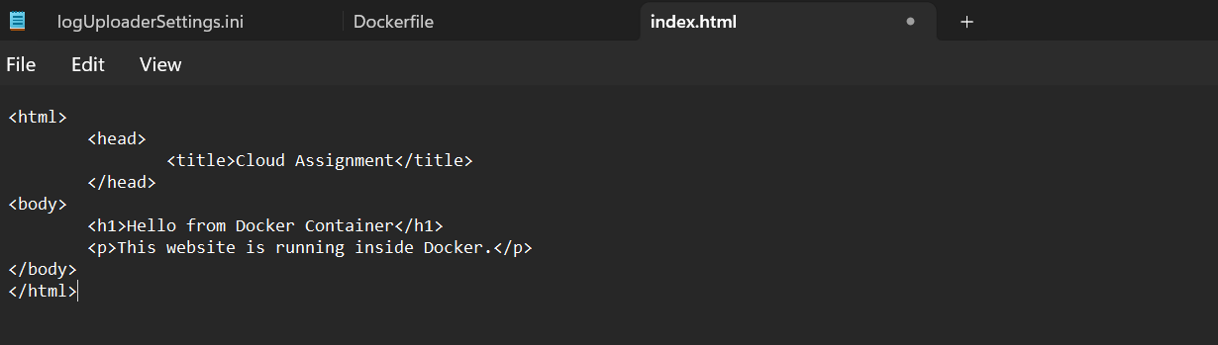
Explanation
The program to be installed within the Docker container was a straightforward HTML webpage. The application content that is copied into the Nginx web server is this webpage.

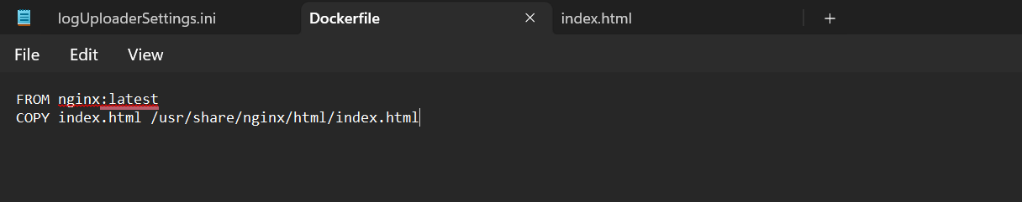
Explanation
The instructions for creating the Docker image are contained in the Docker file. The custom HTML file is copied into the Nginx web directory using the official Nginx image as the foundation image. The Docker file guarantees consistent deployment and automates the production of images.
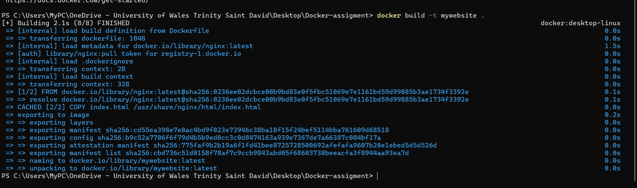
Explanation
Docker build -t mywebsite command was used to create the Docker image. Docker produced an image named mywebsite that is prepared for deployment after successfully carrying out the Docker file instructions.

3.3 Docker Image Verification
Docker saves an image in the local image repository when it has been created. Docker image management commands allow developers to confirm the generation of images. Before deployment, image verification verifies that the right repository, tag, image ID and image size were created. In order to create containers or upload to Docker Hub, this step makes sure that the necessary application image is available [6], [7].
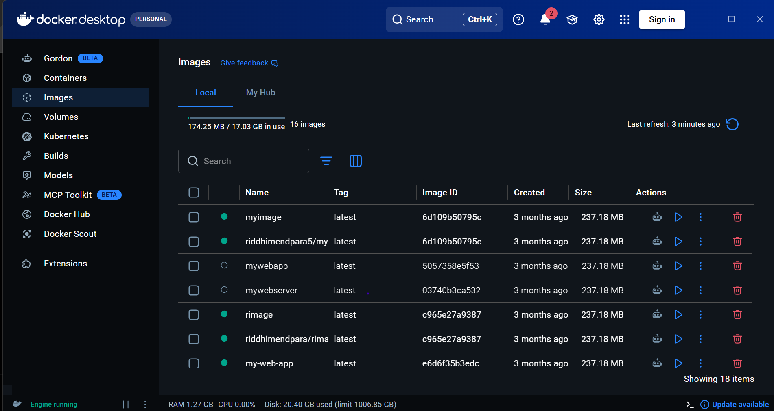Explanation
All locally accessible Docker images are shown via the docker desktop. This image shows all the image list with image names, tags, image IDs, creation time and image size.

3.4 Docker Container Deployment
An active instance of a Docker image is called a Docker container. Containers share the host operating system kernel but offer separate execution contexts. Docker maps application ports, distributes resources and starts the program inside the container during deployment. When compared to conventional virtual machines, this lightweight deployment architecture allows for quicker application startup and effective resource usage [4], [6].
Explanation
Port 8080 was already assigned to another running container, an error occurred. This illustrates Docker's port management system, which limits the number of containers that can bind to a given host port unless several ports are set up.
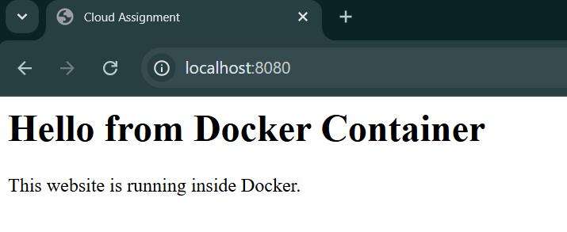
Explanation
The Docker container was successfully started after the port conflict was resolved. The custom HTML webpage running inside the Nginx container was visible when http://localhost:8080 was opened, indicating successful deployment.
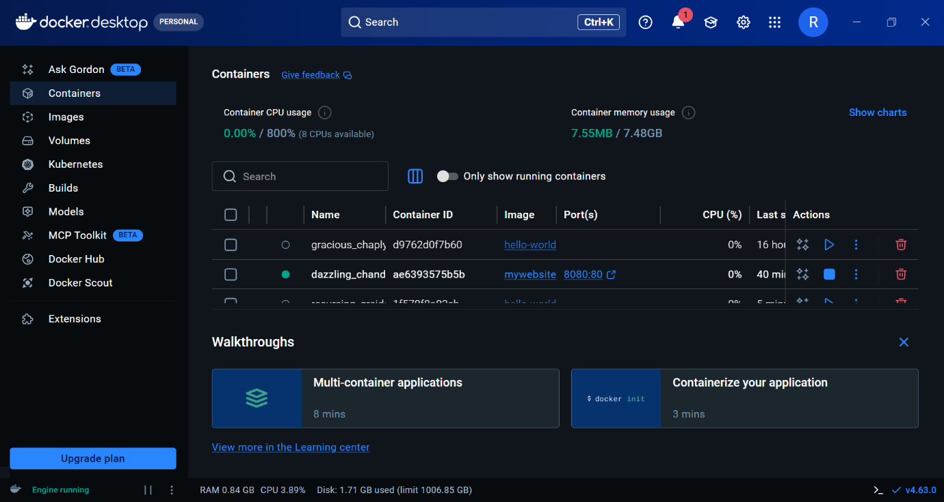
Explanation
The successful operation of the mywebsite container is verified by Docker Desktop. Administrators may keep an eye on container activities by seeing the container status, image name, mapped ports, CPU utilisation and memory consumption.
Explanation
All of the active Docker containers are listed via the docker ps command. The output displays the container ID, running status, image name, mapped ports and verifies that the mywebsite container is operational.

3.5 Container Verification and Monitoring
Upon deploying a Docker container, it is essential to check that the application is working properly and that the container is performing as intended. Docker offers various integrated tools that enable developers and system administrators to check container status, examine active processes, confirm network connectivity and assess resource usage. Routine container checks aid in confirming that the implemented application stays stable, reachable and accessible to users. Monitoring helps in detecting configuration problems and unsuccessful deployments, runtime behaviour before they impact application performance [4], [6].
Monitoring Docker can be done with command-line tools like docker ps, docker logs and docker inspect, in addition to the Docker Desktop graphical interface. These tools offer important details such as the container status, image name, port mappings, execution logs, CPU and memory utilization and network setup. Through constant observation of these factors, developers can swiftly resolve issues, enhance resource usage and sustain dependable containerized applications in cloud settings [4], [6].
Efficient container validation and oversight are vital procedures in cloud-native application deployment, as they enhance system reliability, ease maintenance and guarantee that applications function effectively following deployment. These monitoring features enable proactive management of systems and enhance the security, availability and performance of cloud applications based on Docker [4], [6].

3.6 Chapter Summary
Docker technologies were covered in this chapter along with examples of how to use them in real-world scenarios. Before utilising a Docker file to create a custom Docker image, Docker was successfully installed and verified. Docker Desktop and Docker commands were used to evaluate the image, deploy it as a running container, and monitor it. Docker's capacity to deliver portable, effective and reliable application deployment in contemporary cloud environments was shown by the web application's successful execution [4], [6].

Demonstration Video link Here:
https://youtu.be/ekaJ2sDuTZE

4. Cloud Computing Concepts

4.1 Introduction

Organisations may access flexible, scalable and affordable computing resources via the internet thanks to cloud computing. Technologies like load balancing, scalability and application gateways have become crucial for preserving high availability, enhancing system performance and guaranteeing dependable service delivery as cloud applications continue to grow in complexity and user demand. Together, these technologies handle growing traffic, distribute workloads effectively and shield apps from service disruptions. These fundamental ideas of cloud computing are covered in this chapter, along with their significance in contemporary cloud-native settings [12], [13] and [14].

4.2 Load Balancing

A method for dividing up incoming network traffic or application requests among several servers or computer resources is called load balancing. Its main goal is to ensure effective resource utilisation, enhanced application performance and high system availability without allowing any one server to become overwhelmed. Load balancing minimises response times and lowers the possibility of service outages during times of high demand by allocating workloads dynamically [12].

Depending on the needs of the application, cloud service providers use various load balancing methods. Round Robin, Least Connections, Weighted Round Robin and Dynamic Load Balancing are popular strategies. Better workload distribution and increased cloud efficiency are made possible by dynamic algorithms that continuously evaluate server performance and reroute requests to the most appropriate resources [12].

Improved fault tolerance, decreased downtime, increased scalability and an improved user experience are just a few advantages of effective load balancing. Requests can be automatically rerouted to healthy servers in the event that one server goes down, guaranteeing continuous service delivery. As a result, load balancing is becoming a crucial part of cloud computing architecture to support dependable and highly available applications [12].

4.3 Scalability

The capacity of a cloud system to adjust its computing resources in response to shifts in workload or user demand is known as scalability. It makes it possible for cloud apps to continue operating consistently even if the number of users, transactions or data processing jobs increases. One of the main features of cloud computing is scalability, which enables businesses to maximise resource utilisation while minimising operating expenses [13].

Both vertical scaling (scale-up) and horizontal scaling (scale-out) are commonly supported in cloud systems. While horizontal scaling adds new servers or application instances to better spread workloads, vertical scaling boosts the resources of an existing server by adding more CPU, memory or storage. Because it offers superior fault tolerance and facilitates high availability. Horizontal scaling is typically favoured in cloud-native designs [13].

Automatic scaling techniques are used by modern cloud platforms to track system performance and distribute more resources when predetermined thresholds are met. During times of low demand, this strategy guarantees effective resource utilisation while cutting needless infrastructure costs [13].

4.4 Application Gateway

A network element called an application gateway controls and protects, user and cloud-hosted application interactions. Application gateways function at the application layer (Layer 7 of the OSI model), which allows them to examine HTTP and HTTPS traffic before sending requests to backend services, in contrast to conventional network load balancers [14].

SSL termination, URL-based routing, session persistence, web application firewall (WAF) integration and intelligent request routing are just a few of the advanced features offered by application gateways. By routing requests to the most suitable backend resources, these features optimise traffic management, strengthen application security and improve user experience [14].

Application gateways simplify application management, increase overall system stability and shield backend services from direct exposure to external networks by serving as a safe entry point for cloud apps [14].

4.5 Relationship between Load Balancing, Scalability and Application Gateway

While load balancing, scalability and application gateways serve distinct purposes. They collaborate to provide dependable and effective cloud applications. Application gateways intelligently handle incoming requests while offering extra security and traffic management features, load balancing divides incoming traffic among several servers and scalability modifies available computing resources based on workload [12], [13] and [14].

For instance, the application gateway receives incoming requests and sends them to the load balancer when a cloud application encounters an unexpected spike in user traffic. The cloud platform then automatically grows resources to meet the increasing demand while the load balancer divides requests across several application instances. This integrated strategy lowers service interruptions, guarantees continuous availability and enhances performance [12], [13]. By combining these technologies, businesses can create robust cloud-native apps that can manage shifting workloads while preserving security, performance and effective resource use.

4.6 Chapter Summary
Three key cloud computing technologies—load balancing, scalability and application gateways were covered in this chapter. While scalability allows cloud platforms to dynamically distribute computer resources in response to workload demands, load balancing increases system availability by dividing incoming requests among several servers. Through application-layer request management, application gateways improve security and offer intelligent traffic routing. When combined, these technologies produce secure, scalable and highly available cloud infrastructures that can host contemporary cloud-native applications. Organisations can enhance application performance, maximise infrastructure utilisation and provide dependable services to users in dynamic cloud environments by combining their utilisation [12], [13] and [14].

5. Driving Forces of cloud Computing and Serverless Computing

5.1 Introduction

Cloud computing has transformed the way businesses develop and deploy applications due to its flexible, scalable and cost-effective computing resources. Serverless computing allowing developers to build applications without overseeing the foundational server infrastructure has become increasingly popular because of the rising demand for digital services [15], [16].

5.2 Driving Forces of Cloud Computing
The requirement for scalability, cost effectiveness, flexibility and high availability is what is driving the expansion of cloud computing. Cloud services allow businesses to lower hardware expenses, increase business continuity and access computer resources on demand. Because of these benefits cloud computing is become a necessary technology for contemporary companies [15].

5.3 Serverless Computing
In serverless computing, servers and infrastructure are automatically managed by the cloud provider. Only application code is deployed by developers. Resource allocation and automated scaling are handled by the platform. Organisations can only pay for the resources they utilise thanks to this strategy, which also lowers operational complexity [15], [16].

5.4 AWS Lambda and Azure Functions
Popular serverless platforms that run application code in response to events like file uploads or API requests are AWS Lambda and Microsoft Azure Functions. Both services reduce infrastructure maintenance and are appropriate for contemporary cloud applications since they automatically grow in response to workload demand [15].

5.5 Serverless Computing vs Containerisation
While both serverless computing and containerisation make it easier to deploy applications. they take different approaches to management. While serverless computing eliminates infrastructure management and automatically scales resources. Containerisation offers more control over the application environment. Serverless computing is best suited for event-driven workloads, while containerisation is appropriate for long-running applications [15], [16].

5.6 Chapter Summary
The primary motivators for cloud computing were covered in this chapter, along with an explanation of serverless computing. Additionally, it compared serverless computing with containerisation and introduced AWS Lambda and Azure Functions. By enhancing scalability, flexibility, and effective resource utilisation, these technologies serve contemporary cloud applications [15], [16].

6. Conclusion
This study looked at the core ideas of cloud computing, focusing on serverless computing, virtualisation, containerisation, and Docker technologies. It explained how virtualisation provides the architecture for cloud infrastructure, while containerisation offers a simple and efficient way to develop and implement modern cloud-native programs. Docker technologies, such as Docker images, Docker files, Docker Hub, Storage, networking and demonstrate their importance in simplifying application development and management [1], [4], and [6].
Important cloud computing ideas like load balancing, scalability and application gateways were also covered in the research, emphasising how these technologies cooperate to enhance application performance, dependability, and resource utilisation. Additionally, the purpose of serverless computing and the reasons for cloud computing were investigated using AWS Lambda and Microsoft Azure Functions. Serverless computing is suitable for workloads that are event-driven, while containerisation offers more flexibility for long-running applications [12], [13], [15] and [16]. A comparison of serverless computing and containerisation showed that both technologies offer significant advantage depending on the needs of the application.
All things considered, the combination of theoretical debate and real-world Docker implementation shows that contemporary cloud technologies allow businesses to create scalable, secure and effective apps while lowering infrastructure complexity. Technologies like Docker and serverless computing will continue to be crucial for facilitating digital transformation and the creation of dependable cloud-based services as cloud computing develops.

7. Reference
[1] I. Odun-Ayo, O. Ajayi and C. Okereke, "Virtualization in Cloud Computing: Developments and Trends," 2017 International Conference on Next Generation Computing and Information Systems (ICNGCIS), pp. 24, 2017. . DOI: 10.1109/icngcis.2017.10.
[2] A. J. Younge and G. C. Fox, "Advanced Virtualization Techniques for High Performance Cloud Cyberinfrastructure," 2014 14th IEEE/ACM International Symposium on Cluster, Cloud and Grid Computing, pp. 583, 2014. . DOI: 10.1109/ccgrid.2014.93.
[3] J. Zhang, "Cloud Security Analysis Based on Virtualization Technology," 2022 International Conference on Big Data, Information and Computer Network (BDICN), pp. 519, 2022. . DOI: 10.1109/bdicn55575.2022.00101.
[4] S. Agrawal and D. Singh, "Study Containerization Technologies like Docker and Kubernetes and their Role in Modern Cloud Deployments," 2024 IEEE 9th International Conference for Convergence in Technology (I2CT), pp. 1, 2024. . DOI: 10.1109/i2ct61223.2024.10543986.
[5] D. Mubanda et al, "Evaluating Docker Container Security through Penetration Testing: A Smart Computer Security," 2023 International Conference on Communication, Security and Artificial Intelligence (ICCSAI), pp. 415, 2023. . DOI: 10.1109/iccsai59793.2023.10421124.
[6] K. Mahalakshmi, "Exploring Large Scale Docker Image Vulnerability and Storage Performance Analysis Using High Performance Container-Based Docker Environment," 2024 International Conference on System, Computation, Automation and Networking (ICSCAN), pp. 1, 2024. . DOI: 10.1109/icscan62807.2024.10894527.
[7] M. Aldiabat, Q. M. Yaseen and Q. A. Ein, "An Efficient Random Forest Classifier for Detecting Malicious Docker Images in Docker Hub Repository," IEEE Access, pp. 1, 2024. . DOI: 10.1109/access.2024.3506663.
[8] S. Watanabe, "Data Backup System with No Impact on Business Processing Utilizing Storage and Container Technologies," 2025 IEEE 41st International Conference on Data Engineering (ICDE), pp. 4568, 2025. . DOI: 10.1109/icde65448.2025.00354.
[9] A. Mousa et al, "In-Depth Network Security for Docker Containers," 2023 14th International Conference on Computing Communication and Networking Technologies (ICCCNT), pp. 1, 2023. . DOI: 10.1109/icccnt56998.2023.10307493.
[10] N. Zhao et al, "Large-Scale Analysis of Docker Images and Performance Implications for Container Storage Systems," IEEE Trans. Parallel Distrib. Syst., vol. 32, (4), pp. 918, 2021. . DOI: 10.1109/tpds.2020.3034517.
[11] E. Hadzhyiev et al, "Application of Docker Compose for Constructing the Infocommunication System for Online Processing of Astronomical Images," 2025 15th International Conference on Advanced Computer Information Technologies (ACIT), pp. 629, 2025. . DOI: 10.1109/acit65614.2025.11185586.
[12] T. M. Tawfeeg et al, "Cloud Dynamic Load Balancing and Reactive Fault Tolerance Techniques: A Systematic Literature Review (SLR)," IEEE Access, vol. 10, pp. 71853, 2022. . DOI: 10.1109/access.2022.3188645.
[13] J. Wu, Q. Liang and E. Bertino, "Improving Scalability of Software Cloud for Composite Web Services," 2009 IEEE International Conference on Cloud Computing, pp. 143, 2009. . DOI: 10.1109/cloud.2009.75.
[14] K. Nishikawa, K. Oki and A. Matsuo, "SaaS Application Framework Using Information Gateway Enabling Cloud Service with Data Confidentiality," 2012 19th Asia-Pacific Software Engineering Conference, pp. 334, 2012. . DOI: 10.1109/apsec.2012.133.
[15] G. G. Hegde, V. V. Murthy and M. A. K. Sab, "Serverless Computing: The Future of Cloud Infrastructure and Development," 2025 Third International Conference on Emerging Applications of Material Science and Technology (ICEAMST), pp. 1166, 2025. . DOI: 10.1109/iceamst67459.2025.11336042.
[16] R. Nathiya, "Enhancing Advanced Model Architecture in Serverless Architecture to Improve Security," 2025 8th International Conference on Trends in Electronics and Informatics (ICOEI), pp. 653, 2025. . DOI: 10.1109/icoei65986.2025.11013761.
[17] A. Hebbar et al, "Performance Comparison of Virtualization Methods," 2022 IEEE International Conference on Cloud Computing in Emerging Markets (CCEM), pp. 43, 2022. . DOI: 10.1109/ccem57073.2022.00015.

