
Electronic System Design
Weather and Air Quality Logging System
STAPLETON Ryan (SAFRAN SEATS) | [Date] | [Course title]

Table of Contents
1.0 Introduction 2
2.0 Background Research 3
3.0 Component Comparison and Selection 4
3.1 Air Temperature Sensors 4
3.1.1 RTD Sensor 4
3.2 Humidity Sensors 5
3.2.1 Voltage Humidity Sensor 5
3.3 Sunlight Brightness Monitoring 6
3.3.1 Solar Panel 6
3.4 UV Level Monitoring 7
3.4.1 UV Diode 7
3.5 Wind Direction/Speed 8
3.5.1 Ultrasonic Wind Meter 8
3.6 VOC Monitoring 9
3.6.1 Bosch BME680 9
3.7 GPS 10
3.7.1 L80-M39 GPS Receiver 10
3.8 PIC Microcontroller 11
3.8.1 PIC18F45K50 11
3.9 Enclosure 12
4.0 Prototype Schematics 13
5.0 Easy PC Schematic 14
6.0 Build Costs 15
6.0 Improvements 16
7.0 Conclusion 17
References 18

Introduction
In an era where climate variability and environmental changes are becoming increasingly significant, the need for accurate and timely weather data has never been more crucial. Understanding the local weather patterns over an extended period is essential for various applications, ranging from agriculture and urban planning to disaster preparedness. This assignment focuses on the development of a 14-day weather station, an innovative project that aims to provide comprehensive and real-time weather information for a specific location.
Weather stations have traditionally been pivotal tools for meteorologists and researchers, offering valuable insights into temperature fluctuations, humidity levels, atmospheric pressure changes, and other meteorological parameters. However, the conventional weather stations often lack the ability to provide extended forecasts beyond a few days. This limitation inspired the development of a 14-day weather station, which not only monitors current conditions but also utilizes advanced sensing technologies and data analysis techniques to predict and display weather patterns for the upcoming two weeks.
The primary objectives of this assignment include the design, construction, and implementation of a 14-day weather station. The station will be equipped with a range of sensors to measure meteorological variables such as temperature, humidity, barometric pressure, wind speed, and precipitation. Additionally, the project aims to incorporate advanced data processing algorithms and models to generate accurate weather forecasts for the 14-day period, providing users with a comprehensive understanding of the upcoming weather conditions.

Background Research
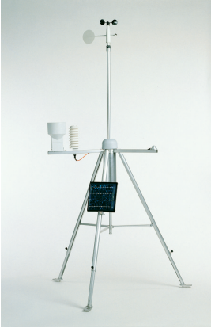 | 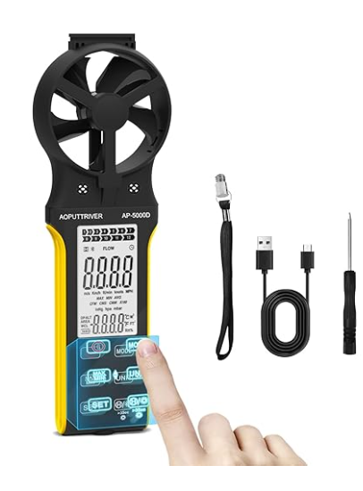 | 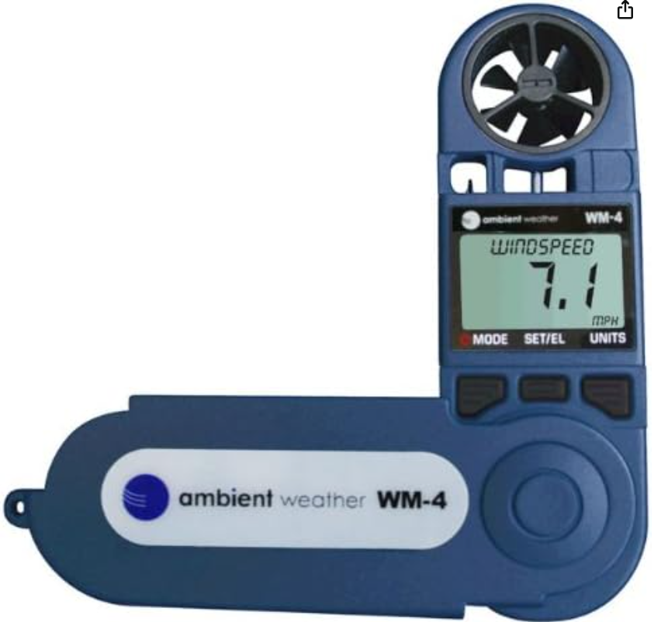
- [1] Wind QMW102/WMS302, WXT530  - Pressure BARO-1QML  - Air temperature, relative humidity HMP155  - Solar radiation QMS101/SP Lite2, QMS102/CMP3,  - QMN101/NR Lite2  - Precipitation QMR101, QMR102  - Soil/Water temperature QMT103, QMT107, QMT110  - Soil moisture ML2x | [2] CFM Meter HVAC Anemometer, Rechargeable Anemometer Handheld with Touch Screen, CFM Meter 0-999900 ft3/min with Temp, Backlight, Data Hold for Air Volume, HVAC Vents, Sailing, Shooting | [3]Ambient Weather WM-4 Handheld Weather Station w/Wind speed, Direction, Temperature, Humidity, Compass, Dew Point, Comfort Index, Psychrometer

There are various types of weather stations available to meet various needs. For example, the first weather station shown in the table above is one of the higher end models on the market. This particular device can measure all aspects of weather, from wind speed and direction, to temperature and humidity and even solar radiation. This model is aimed for more professional applications compared to the others shown.
The other two devices shown are for more enthusiast applications, such as hikers, sailors/fishermen. These devices can measure certain aspects of the weather, such as wind speed, air temperature and air volume. However, these devices are less accurate than the higher end system discussed previously.

Component Comparison and Selection

3.1 Air Temperature Sensors
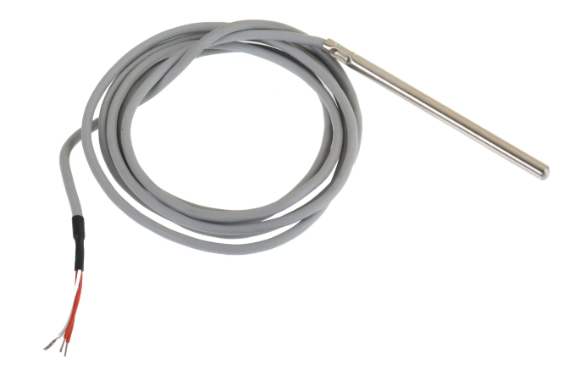 | 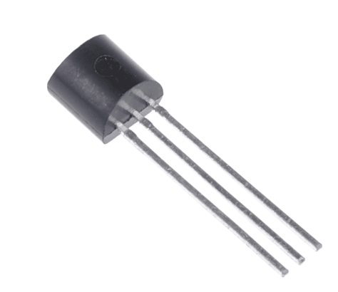 | 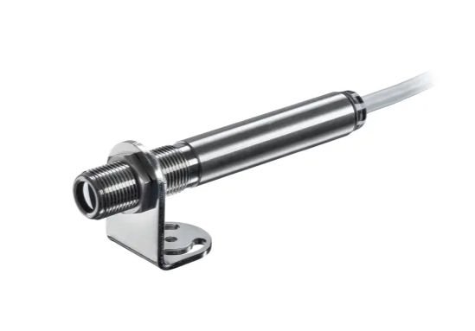
• [4]High stability sensing element with a precision output  • IEC 60751 Class A accuracy/tolerance  • Temperature measurement range of -50 to +250°C  • Rigid corrosion resistant 304 stainless steel sheath for protection of sensing element  • Silicone rubber lead insulation can withstand a wide temperature range and offers flexibility, resistance to oils and solvents and good weathering properties. | - [5]Temperature range: -40 to +110°C (LM35C), 0 to +100°C (LM35D)  - Accuracy: ±0.75°C (Typical)  - Calibrated directly in Celsius (Centigrade)  - Sensor Gain (Output): 10mV/°C  - Low self-heating, 0.08°C in still air  - Supply voltage: +4V to +30Vdc | - [6]Temperature Range -50 to 1030°C  - Optical Resolution 15:1  - Analogue output 0-10/0-1V or Type K with Alarm  - Smart LED indication  - Free (Android/Windows) software for download

3.1.1 RTD Sensor
The sensor chosen to monitoring the air temperature is an RTD. There a many advantages to using an RTD, and this RTD in particular.
RTD’s are highly accurate and provide great stability throughout the whole of their temperature range. They also provide great precision, allowing for repeatable readings on a consistent basis.
RTD’s also produce very little heat when operating, preventing interference of readings. This is vital for accurate readings to be taken.
The RTD selected is also corrosion resistant, which is required when it is exposed to the elements when taking readings. This also protects the sensing element, which aids in the longevity of the sensor.

3.2 Humidity Sensors
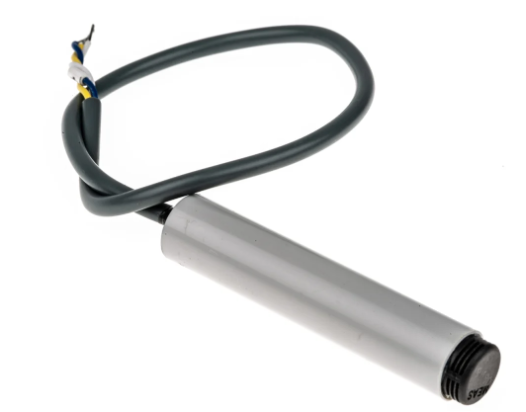 | 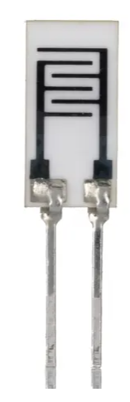 | 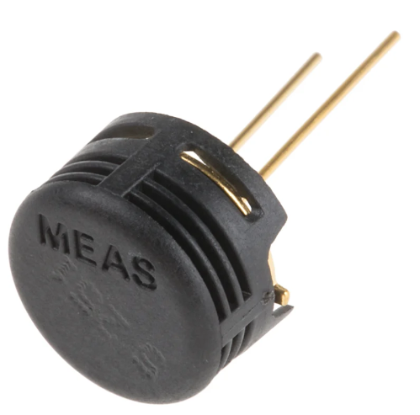
• [7] Full interchangeability  • Compact size  • Very low temperature dependence  • Not affected by water immersion  • Suitable for 3 to 10 V dc supply voltage | [8]The RS PRO Humidity Sensor is designed to deliver high performance across wide range measurements with a strong level of stability and accuracy.  - Small, lightweight design  - Fast response time  - Operating Humidity Range 20 - 90% RH  - Strong stability | • [9]Lead free  • High reliability with long-term stability  • Low temperature coefficient  • Fast response time  • Full interchangeability with no calibration required in standard conditions  • Instantaneous desaturation after long periods in saturation phase  • Compatible with automatized assembly processes, including Pb free wave soldering and reflow processes  • Individual marking for compliance to stringent traceability requirements  • Part may be washed with distilled water

3.2.1 Voltage Humidity Sensor
The sensor chosen for monitoring air humidity is a voltage humidity sensor.
There are many advantages to selecting this type of sensor. Firstly, these sensor are compact in design and take up very little room. This is ideal for the type of data logger being developed due to one requirement being portability.
These sensors also provide real time monitoring, allowing the system to meet the data logging requirements. Data about the air humidity can be taken in any interval required due to its real time processing.
Voltage humidity sensors allow for simple integration. With a low operating voltage of 3V, and only 3 pins, these sensors can be easily integrated into the weather station device. This particular humidity sensor is also through hole mounted, allowing for simple but secure mounting techniques.
Finally, these sensors are reliable and provide great longevity. These sensors are more than capable of recording data for the period required.

3.3 Sunlight Brightness Monitoring
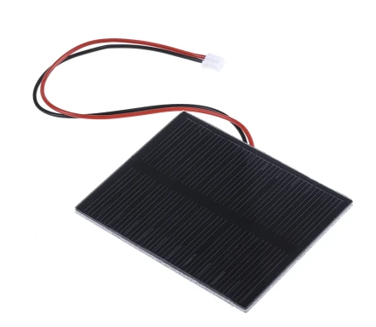 | 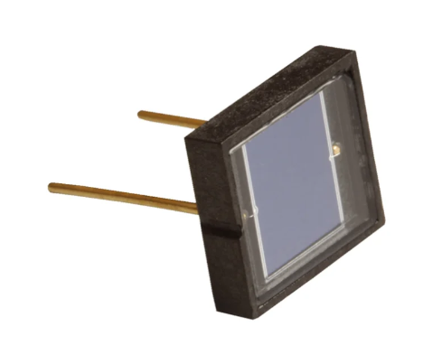 | 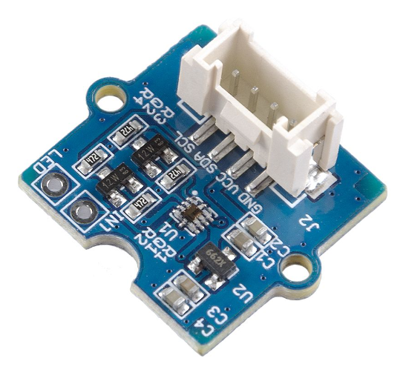
• [10]Maximum load voltage  • Open circuit voltage 8.2V  • Typical current 100mA  • Typical voltage 5.5V | - [11]100% Internal QE  - Ultra High RSH  - Planar Diffused Series:  - IR Suppressed  - High Speed Response  - High Stability  - Excellent UV response  - APPLICATIONS  - Pollution Monitoring  - Medical Instrumentation  - UV Exposure Meters  - Spectroscopy  - Water Purification  - Fluorescence | - [12]Multi-channel digital light sensor: can detect visible light and infrared light  - Wide spectrum detection range: 280-950nm  - Easy to use: I2C Interface(7-bit), compatible with Grove port, just plug-and-play  - Programmable configuration: Versatile for various applications  - Low power consumption: 3.3/5V Supply, suitable for many microcontrollers and SBCs

3.3.1 Solar Panel
The method selected for monitoring sunlight brightness levels is to repurpose the use of a solar panel.
Some of the advantages of doing so is a solar panel is a direct relationship with sunlight intensity. Therefore, if the sunlight brightness increases, then the voltage output of the solar panel will increase.
Solar panels also provide real time monitoring, similar to that of a humidity sensor. This will allow for immediate feedback of the sunlight brightness.

3.4 UV Level Monitoring
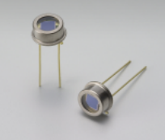 |  | 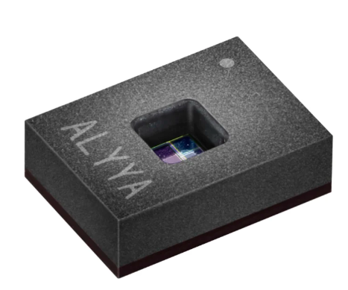
- [13]Features of the S1223 PIN photodiodes:  - TO-5 package  - Through-hole mounting  - Operating temperature: -40 to +100 °C  - High sensitivity  - High reliability | - [11]100% Internal QE  - Ultra High RSH  - Planar Diffused Series:  - IR Suppressed  - High Speed Response  - High Stability  - Excellent UV response  - APPLICATIONS  - Pollution Monitoring  - Medical Instrumentation  - UV Exposure Meters  - Spectroscopy  - Water Purification  - Fluorescence | - [14]Usable for fluorescence light conditions  - Mobile applications  - Integrated temperature sensor

3.4.1 UV Diode
A UV Photodiode will be used to measure UV levels. There are various advantages to using a photodiode over other methods.
UV photodiodes are specifically designed to be sensitive to ultraviolet light. They can accurately detect and measure UV radiation, making them well-suited for applications that require monitoring of UV exposure.
UV photodiodes can provide real-time measurements of UV radiation levels, allowing for timely responses to changing environmental conditions.
Photodiodes are generally compact and can be integrated into small devices or systems.
UV photodiodes can provide analog or digital output, depending on the specific model and application requirements. This flexibility allows for compatibility with different types of electronic systems.

3.5 Wind Direction/Speed
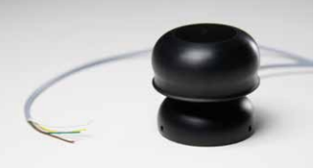 | 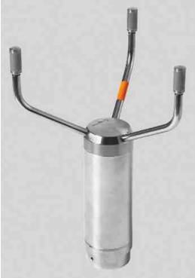 | 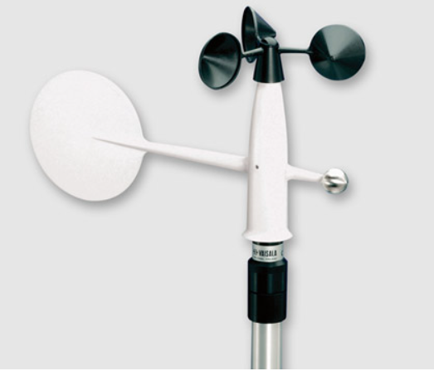
- [15]Wind Speed Range: 0.5 - 45 m/s or 0.5 - 25 m/s (1.12 to 100 mph or 0 to 56 mph)  - Accuracy: 0.1 m/s at 10 m/s (0.22 in. at 22 mph)  - Threshold: 0.5 m/s (1.12 mph) | - [16]Accurate and Maintenance-free  - Measurement Based on Ultrasound  - Standard and Heated Models | - [17]Compact and light design is optimal for mobile applications  - Low power consumption  - Fast and linear response to wind  - Choice of one-wiper or two-wiper potentiometer models

3.5.1 Ultrasonic Wind Meter
The component selected to measure wind direction and speed is an ultra-sonic wind meter. There are many advantages to using this component over others. One of these advantages is that an ultra-sonic win meter doesn’t have any moving parts. Due to this, these sensors very durable and low maintenance. As there are no moving mechanical parts, it is unlikely to break due to mechanical failure.
Another advantage to these sensors is their accuracy. These sensors have very high accuracy and high precision due to the lack of friction between mechanical components.
These sensors also have I high response time, providing real-time data. This will allow the data to be recorded and stored as required by the specifications.
Finally, as these sensors are solid state, this makes them resistant to environmental conditions such as ice, sand, or dust. This makes them suitable for use in harsh or remote locations where traditional anemometers might face challenges.

3.6 VOC Monitoring
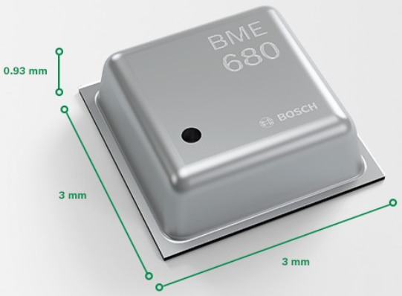 | 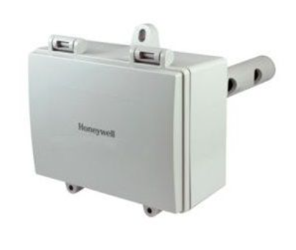 | 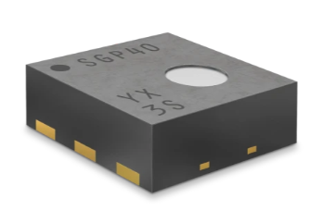
- [18]Pressure: 300...1100 hPa  - Humidity 0…100%  - Temperature: -40…85°C | - [19]Measures total VOCs  - High sensitivity and fast response  - Stable long-term operation  - 0 to 2000 ppm CO2 equivalent output signal  - Internal menu for easy setup  - Analog stepped output for relative air quality indication  - Linear output for logging and control | - [20]Processed output 0-500 VOC Index  - Measurement range 0 – 1000 ppm  - Response time (τ63%) < 10s  - Device-to-device var. ±15 % m.v.  - Limit of detection < 0.05 ppm of ethanol equivalents or < 10 % of concentration set point, whichever is larger

3.6.1 Bosch BME680
The sensor selected for monitoring air quality is the Bosch BME680. There are many advantages to using this sensor in weather monitoring systems.
Firstly, The BME680 combines four essential environmental sensing capabilities—gas, humidity, pressure, and temperature—into a single compact package. This integration simplifies the design process and reduces the need for multiple sensors in an application.
This sensor is also very versatile. This sensor has ability to measure a range of environmental parameters makes it versatile for a variety of applications, including air quality monitoring, weather stations, indoor climate control, and IoT devices.
The BME680 provides accurate and reliable measurements, enabling users to obtain trustworthy data for their applications.

3.7 GPS
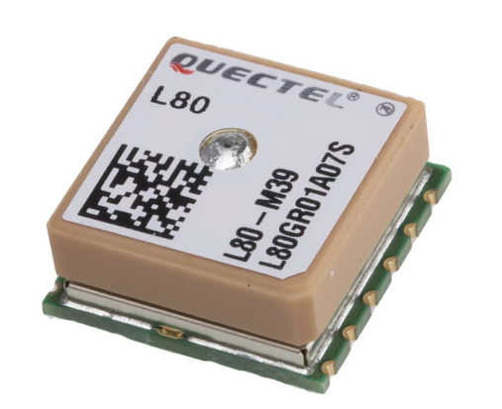 | 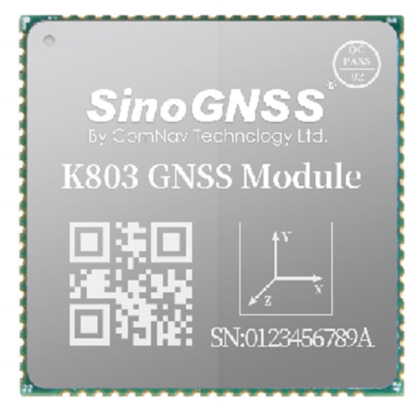 | 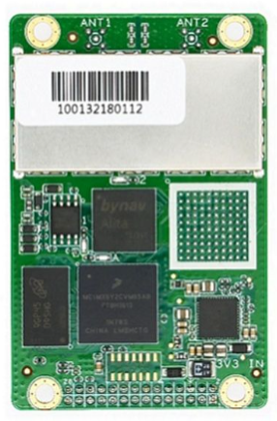
• [21]Compact package  • Embedded patch antenna  • High performance  • High precision  • High sensitivity: -165 dBm (tracking)  • Low power consumption  • 66 acquisition channels  • 22 tracking channels  • EASY™ AGPS Technology (Embedded Assist System)  • AlwaysLocate™ Technology | - [22]GPS L1/L2/L5, BeiDou B1/B2/B3, GLONASS L1/L2, Galileo E1/E5a/E5b, QZSS, IRNSS, SBAS  - BeiDou Global Signal B1C, B2a, B2b1  - Support L-Band and PPP4  - Support INS+GNSS navigation  - Surface-mounted design and small size to integrate High-performance floating-point arithmetic Industry-leading low power consumption  - Internal adaptive anti-interference algorithm | - [23]Based on Bynav GNSS Baseband ASIC Alita and RFIC Ripley.  - Support full-constellation, full-frequency RTK positioning and dual-antenna heading  - Support modern signal systems such as BDS-3 and Galileo.  - Enhanced connection options including serial, CAN and Ethernet.  - Support on-board SD card to back-up local data.  - Extra low latency  - Optimal performance in multi path mitigation, anti-interference and anti-blockage.  - 9~36V wide voltage input, overcurrent and reverse connection protection  - Two RS232 serial ports and one RJ45 Ethernet port

3.7.1 L80-M39 GPS Receiver
The L80-M39 is designed to provide accurate positioning information using signals from the GPS satellite constellation. It supports various satellite navigation systems, including GPS, GLONASS, and Beidou.
The L80-M39 is highly sensitive, enabling it to provide accurate positioning even in challenging environments with weak satellite signals.
This GPS receiver is compact in size, reducing the footprint of the weather station, improving transportability.

3.8 PIC Microcontroller
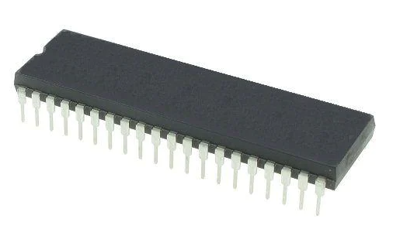 | 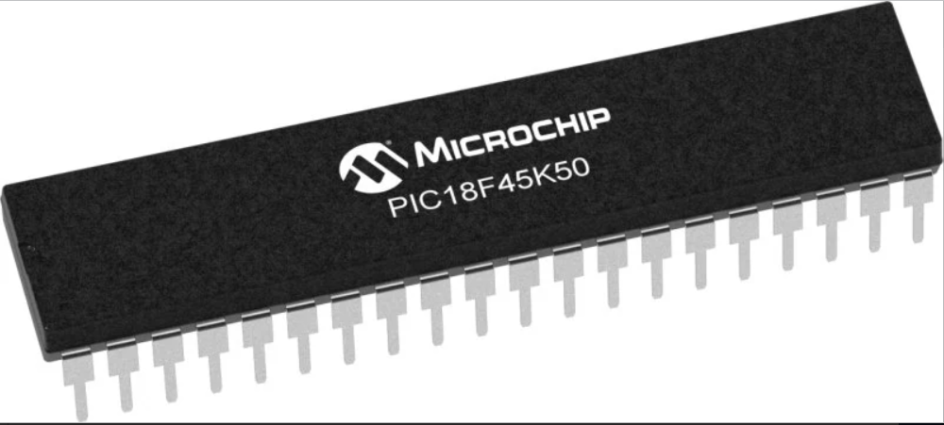 | 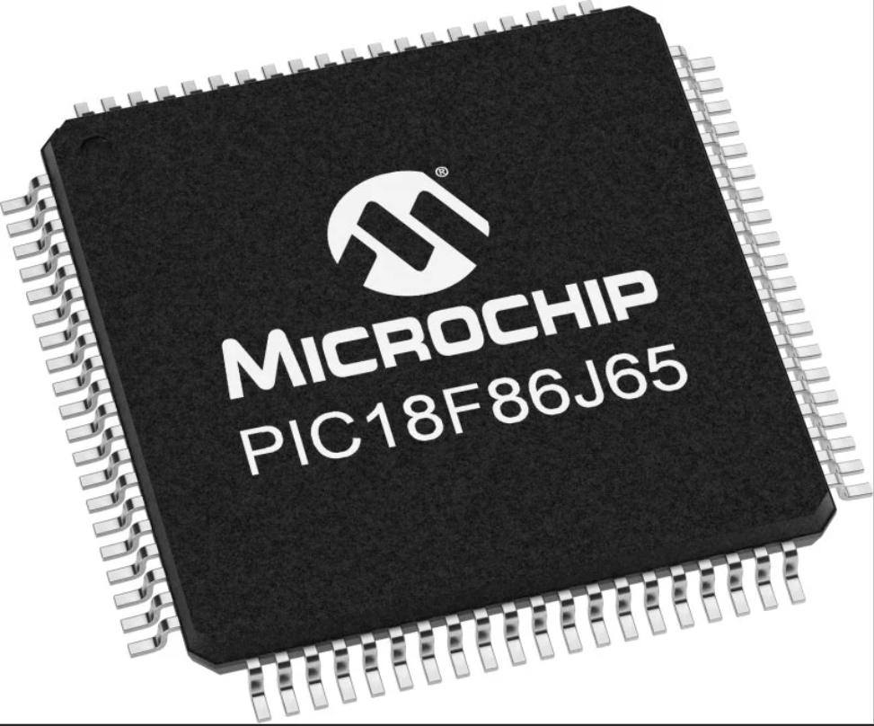
- [22]Program Memory Size: 32 kB  - Data RAM Size: 1 kB  - Package/Case: PDIP-40  - Maximum Clock Frequency: 40 MHz  - ADC Resolution: 10 bit  - Number of I/Os: 32 I/O  - Supply Voltage - Min: 2 V  - Supply Voltage - Max: 3.6 V | - [23]High performance PIC18 core with 8x8 Hardware Multiply  - Flash Program Memory with self-read/write capability  - 256 Bytes of integrated EEPROM  - Internal 48MHz Oscillator with USB Accuracy -Via Active Clock Tuning from USB Host  - Universal Serial Bus 2.0 Module  - Enhanced Capture Compare PWM (ECCP) Module with up to 4 outputs  - Integrated Temperature Indicator Module | - [24]IEEE 802.3 compatible Ethernet Controller  - Fully Compatible with 10/100/1000Base-T networks  - Integrated MAC and 10BASE-T PHY  - Up to 96KB Flash  - 8 KB Ethernet Buffer  - Support for Unicast, Multicast and Broadcast packets

3.8.1 PIC18F45K50
The microcontroller selected for the weather station is the PIC18F45K50. The reasons for selecting this microcontroller are as follows.
The PIC18F45K50 is part of the PIC18 family, known for its high-performance capabilities. It operates at relatively high clock speeds and has features that make it suitable for demanding applications.
It comes with a significant amount of Flash memory, allowing for the storage of relatively large programs. Ample program memory is crucial for applications with extensive code requirements.
One of the notable features of the PIC18F45K50 is its integrated USB 2.0 Full-Speed (12 Mbps) peripheral. This is beneficial for applications requiring USB communication, such as USB-enabled devices or interfacing with computers.
The PIC18F45K50 is designed with power efficiency in mind. It offers low-power modes and features that can help extend battery life in battery-powered applications.

3.9 Enclosure
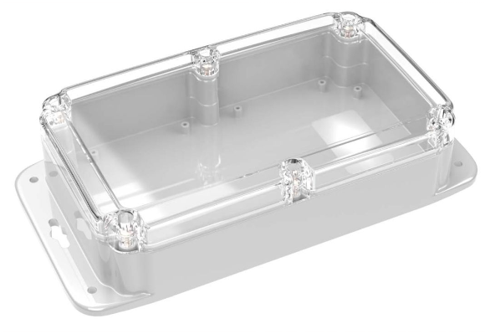
- ML-57F Weatherproof NEMA Enclosure
- Meets IP65, IP66, IP67 & IP68 specifications based on NEMA/UL Type rating conversion
- Weatherproof and waterproof

Prototype Schematics
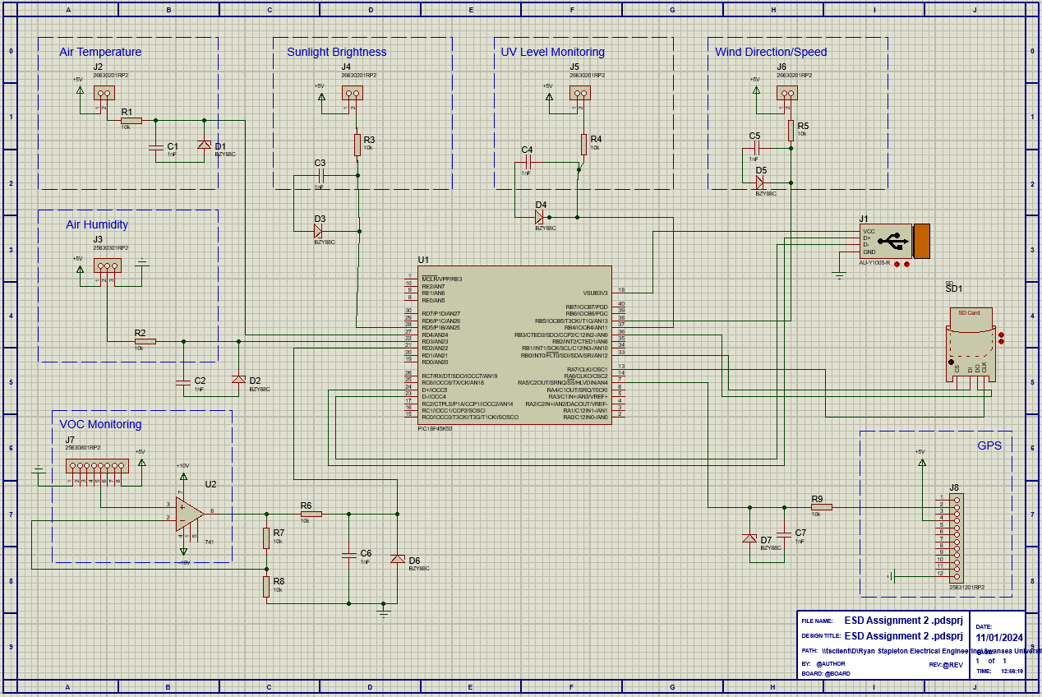

Easy PC Schematic
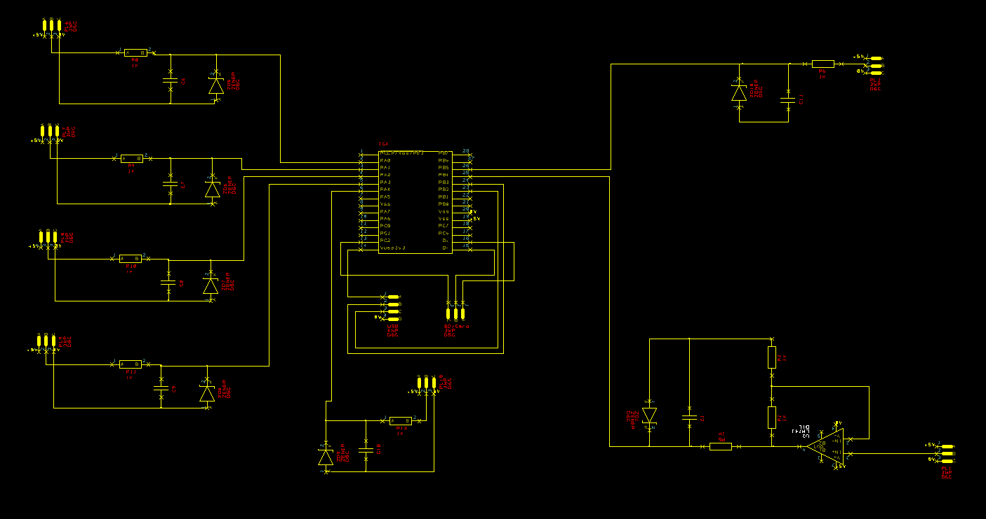
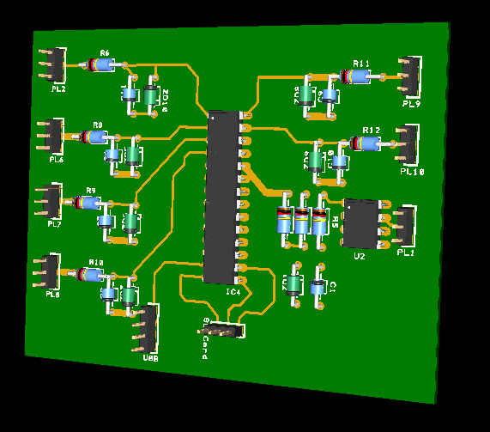

Build Costs
Component | Cost | QTY | Total Cost
RS PRO PT100 RTD Sensor, 6mm Dia, 100mm Long, 3 Wire, Probe, Class A +200°C Max | £33.73 | 1 | £33.73
TE Connectivity Humidity Sensor, Voltage Output, Through Hole Mount, Analogue, ±5%RH, 3 Pins | £62.82 | 1 | £62.82
Seeed Studio 0.5W Kit solar panel | £3.60 | 1 | £3.60
OSI Optoelectronics, UV-035DQC UV Si Photodiode, Through Hole Ceramic | £58.01 | 1 | £58.01
Ultra-Low-Power Ultrasonic wind meter (ULP STD) | £432.30 | 1 | £432.30
Bosch BME680 | £8.61 | 1 | £8.61
Quectel L80-M39 GPS Receiver | £13.26 | 1 | £13.26
PIC18F45J10-I/P | £2.97 | 1 | £2.97

6.0 Improvements
There are various improvements that could be made to the weather station. These improvements are as follows.
Calibration: Regularly calibrate sensors to ensure accurate readings. Calibration helps maintain the precision of measurements, especially for sensors like temperature, humidity, and barometric pressure.
Additional Sensors: Depending on your goals, consider adding more sensors to measure additional parameters such as wind speed, wind direction, UV radiation, or precipitation. This expansion can provide a more comprehensive view of the local weather conditions.
Wireless Connectivity: Implement wireless communication protocols (e.g., Wi-Fi or Bluetooth) to transmit data to a computer, mobile device, or a cloud-based platform. This allows for remote monitoring and data storage, providing easy access to weather information.
Power Efficiency: Optimize power consumption by incorporating low-power components and implementing sleep modes for sensors and microcontrollers. This is especially important for battery-powered setups, ensuring longer operational periods.
Data Logging: Enhance data storage capabilities by integrating a microSD card or other storage solutions. This allows for the collection of historical weather data, facilitating trend analysis and long-term observations.
Weatherproofing: Protect the sensors and electronic components from the elements by using weatherproof enclosures. This helps maintain the integrity of the equipment and ensures accurate readings in adverse weather conditions.

Conclusion
Throughout this assignment, we engaged in a systematic exploration of sensor technologies, microcontroller programming, and data analytics, amalgamating these elements to manifest a functional weather station. Beyond its technical attributes, the emphasis was placed on creating a user-friendly and pragmatic tool.
The utility of our weather station extends beyond its technical capabilities. It serves as a valuable resource for farmers optimizing crop cycles, urban planners anticipating potential weather-related challenges, and individuals seeking enhanced decision-making tools for their daily activities.
As we bring this project to a close, it is essential to recognize the commendable collective effort and the tangible impact our 14-day weather station can have on diverse sectors. This initiative not only signifies the convergence of technology and meteorology but also underscores the practical applications of acquired skills in the realm of data science and environmental monitoring.
This conclusion, therefore, signifies not just the termination of a project but the initiation of a trajectory where the skills cultivated will propel us toward future technological endeavors. With a firm foundation established, we are well-equipped to embrace forthcoming challenges and contribute to the technological landscape.

References

[1] | "Vaisala," [Online]. Available: https://docs.vaisala.com/v/u/B211006EN-D/en-US. [Accessed 30 December 2023].
[2] | "Amazon UK," [Online]. Available: https://www.amazon.co.uk/Anemometer-Protective-Temperature-Windsurfing-Activities/dp/B0CH9DLLNH?ref_=ast_sto_dp&th=1. [Accessed 30 December 2023].
[3] | "Amazon UK," [Online]. Available: https://www.amazon.co.uk/dp/B00540I7WO/ref=as_li_tl?ie=UTF8&linkCode=gs2&linkId=227b04232f6b16718556e5a1c3aff436&creativeASIN=B00540I7WO&tag=ukaccount01c5-21&creative=9325&camp=1789. [Accessed 30 December 2023].
[4] | "RS Components UK," [Online]. Available: https://uk.rs-online.com/web/p/rtd-sensors/3730372?gb=s. [Accessed 2 January 2024].
[5] | "RS Components," [Online]. Available: https://uk.rs-online.com/web/p/temperature-humidity-sensor-ics/5335878?gb=s. [Accessed 5 January 2024].
[6] | "RS Components," [Online]. Available: https://uk.rs-online.com/web/p/infrared-temperature-sensors/2410168?gb=s. [Accessed 5 January 2024].
[7] | "RS Components UK," [Online]. Available: https://uk.rs-online.com/web/p/temperature-humidity-sensor-ics/8937247?gb=s. [Accessed 2 January 2024].
[8] | "RS Components," [Online]. Available: https://uk.rs-online.com/web/p/temperature-humidity-sensor-ics/2465635?gb=s. [Accessed 5 January 2024].
[9] | "RS Components UK," [Online]. Available: https://uk.rs-online.com/web/p/temperature-humidity-sensor-ics/8937082?gb=s. [Accessed 5 January 2024].
[10] | "RS Components UK," [Online]. Available: https://uk.rs-online.com/web/p/solar-panels/1793740?gb=s. [Accessed 2 January 2024].
[11] | "RS Components UK," [Online]. Available: https://uk.rs-online.com/web/p/photodiodes/1837165?gb=s. [Accessed 5 January 2024].
[12] | "Seeed Studio," [Online]. Available: https://www.seeedstudio.com/Grove-Sunlight-Sensor.html. [Accessed 5 January 2024].
[13] | "RS Components UK," [Online]. Available: https://uk.rs-online.com/web/p/photodiodes/4155722?gb=s. [Accessed 2 January 2024].
[14] | "RS Components UK," [Online]. Available: https://uk.rs-online.com/web/p/colour-light-sensor-ics/2724082?gb=s. [Accessed 6 January 2024].
[15] | "Calypsoinstruments.com," [Online]. Available: file:///C:/Users/RStaple/Downloads/23_EN_ULP_STD_Datasheet.pdf. [Accessed 2 January 2024].
[16] | "Calright Instruments," [Online]. Available: https://calright.com/product/vaisala-wmt700-series-ultrasonic-wind-sensors/. [Accessed 6 January 2024].
[17] | "Vaisala," [Online]. Available: https://www.vaisala.com/en/products/weather-environmental-sensors/wind-sensor-wm30. [Accessed 6 January 2024].
[18] | "Bosch Sensor Tec," [Online]. Available: https://www.bosch-sensortec.com/products/environmental-sensors/gas-sensors/bme680/#description. [Accessed 2 January 2024].
[19] | "Honeywell," [Online]. Available: https://buildings.honeywell.com/us/en/products/by-category/sensors/particle-counters/c7364b-tvoc-air-quality-sensor. [Accessed 6 January 2024].
[20] | "Sensirion," [Online]. Available: https://www.sensirion.com/products/catalog/SGP40/. [Accessed 6 Janaury 2024].
[21] | "RS Components UK," [Online]. Available: https://uk.rs-online.com/web/p/gnss-gps-modules/9084085?gb=s. [Accessed 2 January 2024].
[22] | "Microchip," [Online]. Available: https://ww1.microchip.com/downloads/aemDocuments/documents/OTH/ProductDocuments/DataSheets/39682E.pdf. [Accessed 3 January 2024].
[23] | "Microchip," [Online]. Available: https://www.microchip.com/en-us/product/PIC18F45K50. [Accessed 6 January 2024].

