

Eco Bike Hub Case Study

by
Farhan Sajid Rahman (1802359)
Lecturer
Beverley Holland
Module
ACCA 7002 – Database Systems
Course
MSc Software Engineering

14th January 2022

Table of Contents
Eco Bike Hub Case Study 0
Table of Contents 1
0. Abstract 2
1. Introduction 2
2. SQL vs. NoSQL 2
3. Eco Bike Hub Database 3
3.1 Performance Tuning (Indexes) 3
3.1.1 Customer table 3
3.1.2 Store 3
3.1.3 Secondary Index three 3
3.2 Distributed Database Solution 4
4. Conclusion 4
5. Appendices 5
5.1 Appendix A – Eco Bike Hub Scenario [8] 5
5.2 Appendix B – Entity Relationship Diagram of Eco Bike Hubs 6
6. References 7

Glossary:
ERD = Entity Relationship Diagram
SQL = Structured Query Language
NoSQL = Non-Structured Query Language
CRUD = Create, Read, Update, Delete
ACID = Atomicity, Consistency, Isolation, and Durability.

0. Abstract
A database was designed and built from requirements that were set by Eco Bike Hub, a bicycle service which involves renting, repairing, trading and purchasing of bicycle parts. The document also looks into why SQL is a better choice for building of the database over NoSQL, reasons being that SQL has support of ACID properties that keep data integrity and a safety bed for errors to not commit if a failure occurs. Furthermore, the database then looks into having performance enhancing features implemented into the database with secondary indexes, where lastly a distributed database design is considered for Eco Bike Hub based on the case study.

1. Introduction
A company that goes by Eco Bike Hubs provide bicycle services of which includes rental of bicycles, repairments, custom builds, trading in bicycles and bicycle parts have been open since the late 90’s and has branched up from two to ten stores across South Wales. From the growth of stores, their current database provision no longer supports their business model needs and require an updated solution.
Referring from the scenario given by Eco Bike Hubs as seen in 5.1 appendix A, an analysis was made to identify the requirements of the information given and a database schema was built upon it for the proposal to Eco Bike Hubs.

2. SQL vs. NoSQL
As Eco Bike Hubs have requested, this section goes through giving some clarity of using an SQL database versus a NoSQL database.
The main important difference between both is that SQL is relational while NoSQL is not relational, and in effect they both result in two different types of database implementations where data is stored and accessed differently [1]. With the introduction of NoSQL, the main purpose brought is for handling an abundance of unstructured data, whereas SQL as the name suggests is for structured data and in a relational database, it requires defining the schema of how the data will be composed [2]. A relational database is when there is an existing relationship between two tables with at least one attribute linked to another. With this concept it brings part of the design for data to be normalized, where this stage of designing a database returns removal of redundant data through breaking it down into different tables [3]. Normalizing data is important for prevention of removal of anomalies when it comes to the data being handled by CRUD operations in SQL, where in result efficiency of the database is improved alongside effectiveness [4]. Moreover, one of the focuses on SQL was partly for the reduction in duplication of data, optimizing the database performance as well as the storage usage [5].
Furthermore, it should be mentioned that with NoSQL, it does not interpret ACID properties. The acronym of ACID is atomicity, consistency, isolation, and durability. These ACID properties convey the importance towards data integrity in a database, as well as attesting the data is in protection of corruption from a failure to keep it valid even when an issue occurs. This is in relation to transactions, where the changes will not be committed to the master database until the transaction is over within a single instance. In relation to Eco Bike Hubs database, it is suited for SQL due to dealing with customer and overall private information, meaning it would be important to keep data integrity and protection against corruption [6].

3. Eco Bike Hub Database
The database was first planned from a schema that was built through an ERD with use of Visio database model diagram software. See 5.2 appendix B of the ERD diagram for the proposed solution to Eco Bike Hubs. In the database schema, normalization to third normal form was considered and included involvement of suitable attributes with primary and foreign keys.
This section will go through discussion of the implementation for performance tuning with indexes, adding a transaction to address problems raised by Eco bike hubs and a look into a proposition for a distributed database solution.

3.1 Performance Tuning (Indexes)
Within the Eco Bike hub database, the tables were looked over and three appropriate secondary indexes were considered and implemented. The purpose of this was for allowing a more efficient and quicker method of accessing records in the Eco Bike hub database as this acts as a pointer to specific data for faster retrieval [7].

3.1.1 Customer table
The first secondary index that can be considered was with the customer table. As there will be many customers being input to the database for their order or service, an index was considered and added. This table does contain a ‘CustomerID’ as primary key, however the ID of the customer would not be identified until the query is made involving other information. In order to speed up the querying of the customer data, a secondary index being introduced with a column like the DateOfBirth. The reasoning to this is due to that this dataset would not be regularly changing, and only ever edited if a customer were to enter it wrong. Example given for this secondary index is querying a customer name where the DateOfBirth value is set to a date.

3.1.2 Store
Looking further at the tables it was decided that another secondary index would be suitable within the Store table. As the company Eco Bike hub is expanding and building more stores in different cities, there will start to be several records included from several different cities. The column which would have a secondary index would be ‘StoreCity’, it will produce a better speed of outputting queries with tables joined linked with the city.

3.1.3 Secondary Index three
The final secondary index identified in the database is in the RepairService table. Reasons behind this is because there will likely be many of the same repair service needed. A query to support the mechanic in providing the information for repairing several bikes with the same problem can have the service being extra productive. To speed up the query for this, the ‘RepairDescription’ would be added as a secondary index to find bicycles with the same problem faster.

3.2 Distributed Database Solution
From the proposed requirements by eco bike hub’s case study, it has also been asked to come up with a proposed distributed database design for allowing their information to be distributed.
An appropriate fragmentation schema based on the requirements of the case study of Eco Bike hub is to have horizontal fragmentation of the customer table, the reason behind this is because customers may be in a different part of the city to either purchase or rent a bike. For the store also,

4. Conclusion
In conclusion of the project, an ERD was created from the case scenario of Eco Bike Home and an SQL database was created with implementations of all tables, populating records and performance enhancing features including indexes. A clarification was also given as to why SQL was chosen over NoSQL, partly due to the capability of having data integrity and protection from corruption and failure, and also having the removal of redundant data to save storage and elimination of anomalies. The document then goes into looking at performance enhancing with identifying secondary indexes, and then a focus into a distributed database design.

5. Appendices

5.1 Appendix A – Eco Bike Hub Scenario [8]
“Eco Bike Hubs” are a small chain of independent shops trading in bicycles, parts, repairs, and bicycle hire. They pride themselves on offering a flexible service to cyclists that suit most needs and pockets. Their main aim is to work for the good of the environment and they therefore promote recycling. They are able to offer full bicycle services, bicycle repairs, custom builds of mountain bikes (using recycled frames), selling or trading of good quality second-hand bicycles and they also offer a rental service where cycles can be booked out on a half day, full day, or weekly basis. They operate Monday to Saturday.
“Eco Bike Hubs” operates from medium size buildings or shops, and all have purpose-built cycle workshops attached. The main activities of the day involve dealing with customer requests and booking in cycles for various customer service or repair. As they also offer a trade service it is also necessary to log customer requests (i.e., to search for specialised frames parts etc) and to keep a track of anything they sell for customers. Finally, they need to have a mechanism to keep track of cycle rentals as they feel this could become a growing branch of the business.
The stores have been open since the late 90’s and the business has grown from two stores in the centre of Swansea to ten stores across South Wales. As the business continues to grow the company’s current database provision will not support their business model needs.
Each store has:
- A member staff that will look after customer bookings be they sales, services, or repairs.
- Mechanics who look after and log the service or repair work. Customer’s bicycles must be tracked from front of shop through to repairs and back to customer.
- Customers wishing to trade are handled at each store by one member of staff, but a member of staff must not have more than 20 trade customers assignment at any given time.
- Customers can hire bicycles when required and if available, but dates and time must be recorded.

5.2 Appendix B – Entity Relationship Diagram of Eco Bike Hubs
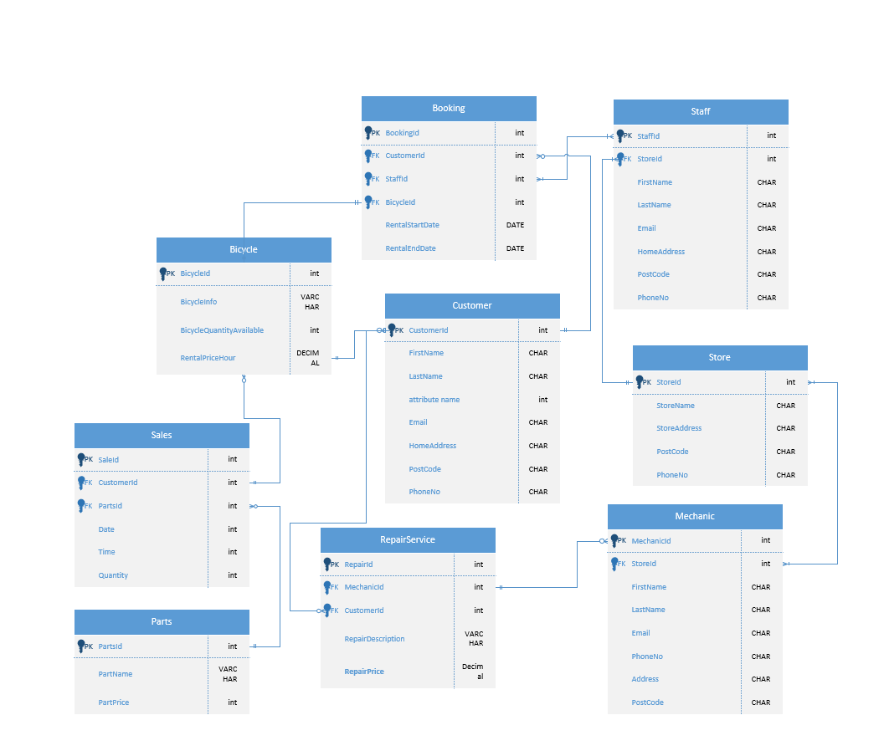
An ERD displaying a database schema for Eco Bike Hubs.

6. References

[1] | R. Vettor, G. Warren, N. P N, A. Liu, R. D. Coulter, M. Veloso and N. Schonning, “Relational vs. NoSQL data,” Microsoft, 30 November 2021. [Online]. Available: https://docs.microsoft.com/en-us/dotnet/architecture/cloud-native/relational-vs-nosql-data. [Accessed 8 January 2022].
[2] | “What is a Database?,” Oracle, 27 February 2019. [Online]. Available: https://www.oracle.com/uk/database/what-is-database/. [Accessed 8 January 2022].
[3] | A. Balter, “Mastering Microsoft Access 2007 Development,” Indianapolis, Sams Publishing, 2007, p. 115.
[4] | T. J. (. Wang and H. Du, “Accounting For The Benefits Of Database Normalization,” American Journal of Business Education, vol. 3, no. 1, p. 42, 2010.
[5] | B. Anderson and B. Nicholson, “SQL vs. NoSQL Databases: What's the Difference?,” IBM, 15 June 2021. [Online]. Available: https://www.ibm.com/cloud/blog/sql-vs-nosql. [Accessed 8 January 2022].
[6] | D. GC, “A Critical Comparison of NOSQL Databases in the Context of Acid and Base,” Culminating Projects in Information Assurance, pp. 3-11, 2016.
[7] | “Secondary indexes,” Oracle, 31 January 2002. [Online]. Available: https://docs.oracle.com/cd/E17275_01/html/programmer_reference/am_second.html. [Accessed 8 January 2022].
[8] | B. Holland, “Assignment Brief,” University of Wales Trinity Saint David, Swansea, 2021-2022.

