
Assessment 1

Title: Marketing Strategy Portfolio

Name: Patel Harikrushna
Student ID: 2432869
Module Name: Marketing Management
Module Code: LCMB7024
Lecturer’s Name: Dr. Jayalakshmi Gopalkrishna

Term 1

TABLE OF CONTENTS
Element 1: STDP Analysis for the New Brand Concept 1
Introduction to Tesco and the New Brand Concept 1
Market Trends and Consumer Behaviour Justifying TescoKart 1
STDP analysis 2
Targeting Strategy 3
Differentiation Strategy 3
Positioning Strategy 4
Element 2: Marketing Mix (7Ps) 6
Product 6
Price 6
Place 7
Promotion 8
People 8
Process 9
Physical Evidence 9
Element 3: Marketing Strategy Pitch 11
Element 4: Reflection 12
My Learning Journey Initiation 12
Applying Theoretical Frameworks to Practical Brand Development 12
Research Challenges and Methodological Learnings 12
Professional Skills Development and Future Application 12
Evaluation and Improvement Scopes 13
References 14
Appendices: Element 3: Marketing Strategy Pitch 17

Element 1: STDP Analysis for the New Brand Concept

Introduction to Tesco and the New Brand Concept
Tesco Plc is considered the UK’s biggest grocery retailer, with 13.5% holding of the online market and 86.5% of the offline market presence (Adainsight, 2025). TescoKart in this context proves to be the new brand extension, which aims at the related potential growth of the B2B logistics and e-commerce fulfilment sector. The proposed venture strategically plans for leveraging the full third-party logistics service solutions with the included warehousing, order processing, cold-chain management, and last-mile delivery services for the growing online platforms, subscription channels, and marketplace.

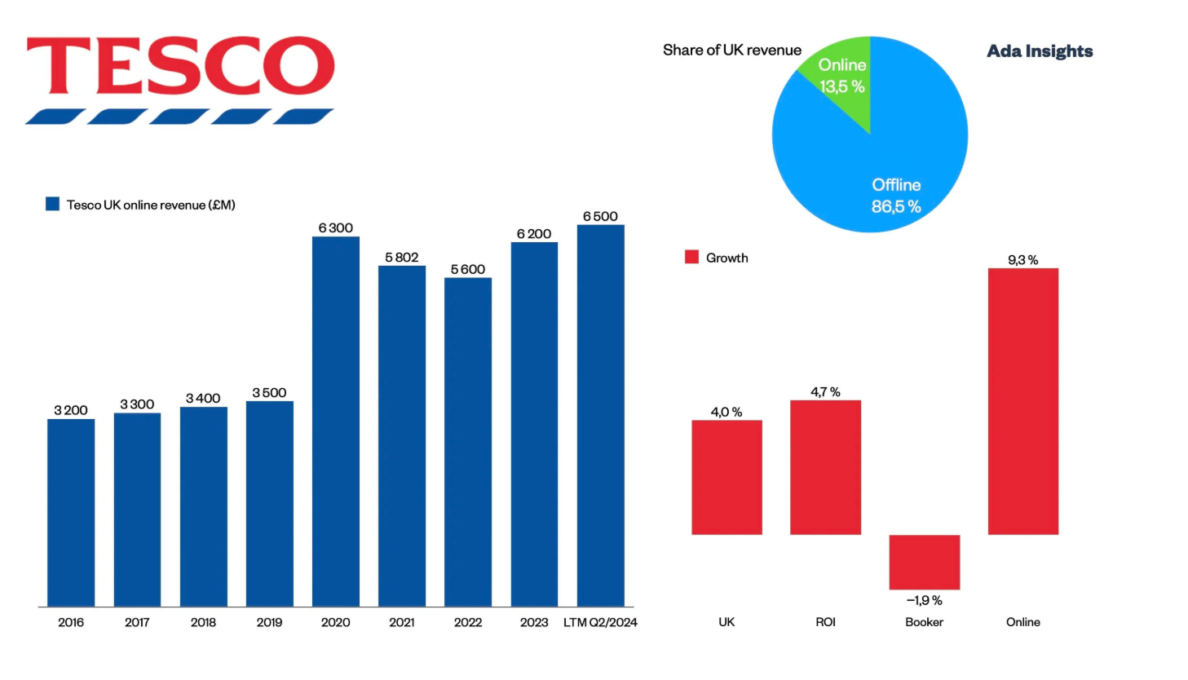
Figure 1: Tesco online sales UK
(Source: Adainsight, 2025)

Market Trends and Consumer Behaviour Justifying TescoKart
The study report of Mordor Intelligence (2025) well articulates that the UK e-commerce logistics market is projected to experience significant growth from USD 20.76 billion in 2025 to USD 27.76 billion by the year of 2030 with a contextual CAGR of 5.94%. This is well associated with the key factors of automation, labour shortages, and cross-border expansion, with the related rising consumer demand for fast delivery (Mordorintelligence, 2025). The contextual drivers of the customer expectation for delivery speed, subscription economy growth, and the outsourced fulfilment market have contributed to the exponential growth. The study of Mondaq (2025) demonstrates that consumers expect 3.5-day delivery, with 25% switching if delays occur. The trends prove to be a substantial opportunity market for TescoKart with the technology-enabled 3PL provider (Mondaq, 2025).

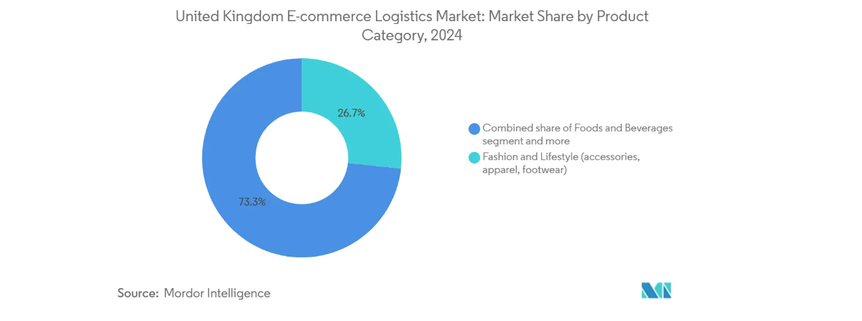
Figure 2: UK e-commerce growth
(Source: Mordorintelligence, 2025)

STDP analysis
Segmentation
For TescoKart, four primary segments have been identified based on demographic, behavioural, and needs-based characteristics.
Segment 1: SME D2C brands comprise the businesses of fashion, beauty, homeware, and consumer electronics sectors with an annual revenue between £500,000 and £10 million. These businesses mostly perform 500 to 5000 orders monthly and define the requirements for the flexible, scalable fulfilment solutions with the key pricing models (Myers, 1996).
Segment 2: Subscription Services and Meal Kit Companies comprises enterprises offering recurring delivery models, notably those with cold-chain capabilities. This industry needs very dependable, planned supply periods and specialist-controlled temperature management (Restuccia et al. 2016).
Segment 3: Online Marketplaces and Multi-Seller Platforms consist of third-party sellers operating on platforms such as Amazon, eBay, and independent marketplaces who seek to diversify their fulfilment options beyond platform-specific services (Dibb and Simkin, 2008).
Segment 4: Established Retailers Expanding Online includes traditional brick-and-mortar retailers with revenues exceeding £10 million who are scaling their digital operations and require enterprise-level fulfilment infrastructure without the capital investment of building proprietary distribution networks.

Targeting Strategy
TescoKart strategically targets the small and medium enterprises for direct-to-consumer organisations and subscription-based businesses. This has proven to be the most contextual and relevant for focusing on the segments, as these are growing rapidly in the UK e-commerce market dynamics. The study report of Profile Tree (2025) well demonstrates that UK SMEs mostly depend on customer retention due to the rising consumer acquisition costs, which is up to 15% on the reduction of the profit margins. Digital tools further contributed towards the improvement of loyalty as companies using social media notice the significant increment of the retention rate by 23% (Profiletree, 2025). Further subscription models also help towards the reduction of the churn rate by 45% and the rising consumer lifetime value by 38%. Whereas the secondary target consumer for TescoKart includes online marketplace sellers who require providers with the highest sales volume potential.

Differentiation Strategy
TescoKart differentiates itself from competitors such as Amazon FBA, DHL E-commerce Solutions, and XPO Logistics with four specific value offerings. First, utilising Tesco's enormous physical footprint enables hybrid fulfilment models where inventory can be held in both regional distribution hubs and local stores, permitting same-day and next-day delivery over 95% of UK postcodes (Lawrence et al. 2018). This store-as-hub concept is almost impossible for pure-play logistics competitors to replicate without huge capital commitment. With over 600 electric delivery vehicles already deployed and commitments to expand this fleet, TescoKart can offer genuinely lower-carbon delivery options. Merchant-friendly integrating technology tackles a significant pain point in the 3PL sector. TescoKart will supply pre-built interfaces with key e-commerce sites such as Shopify, WooCommerce, and Magento, along with complete APIs for custom solutions.
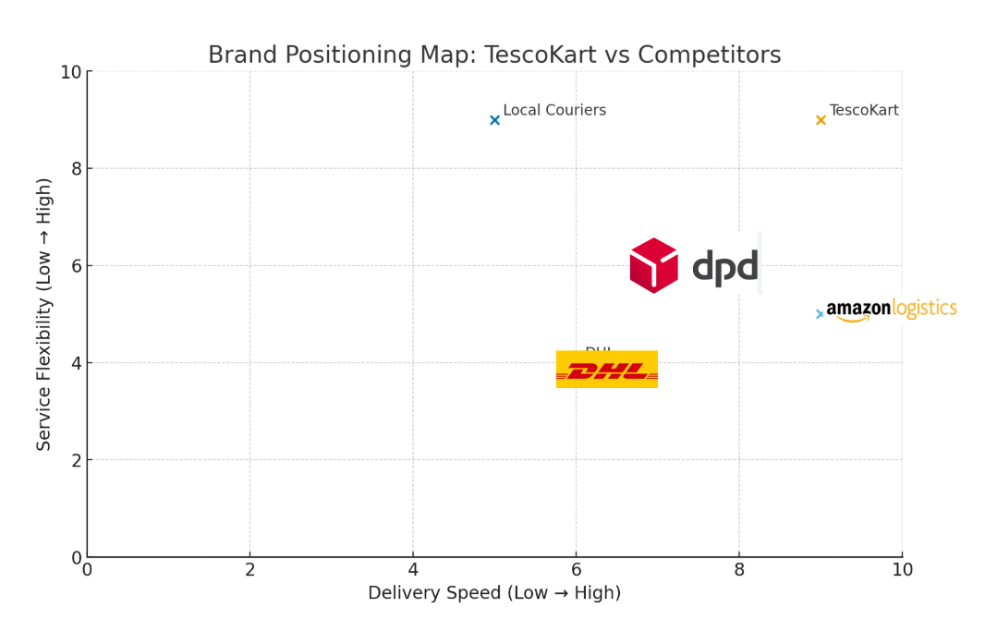
Figure 3: Brand positioning map
(Source: Self-created)

Positioning Strategy
TescoKart seeks to position itself as the “Trusted Growth” partner for the UK e-commerce merchants. This strategic positioning approach is associated with the key data-driven choices. The study report of Nttdata (2025) defines that market uncertainty has effectively contributed towards the change of how shippers and 3PLs function together (Nttdata, 2025). About half of the shippers and most 3Ls require the most collaborative and strong association for the overall improvement of cost and service.
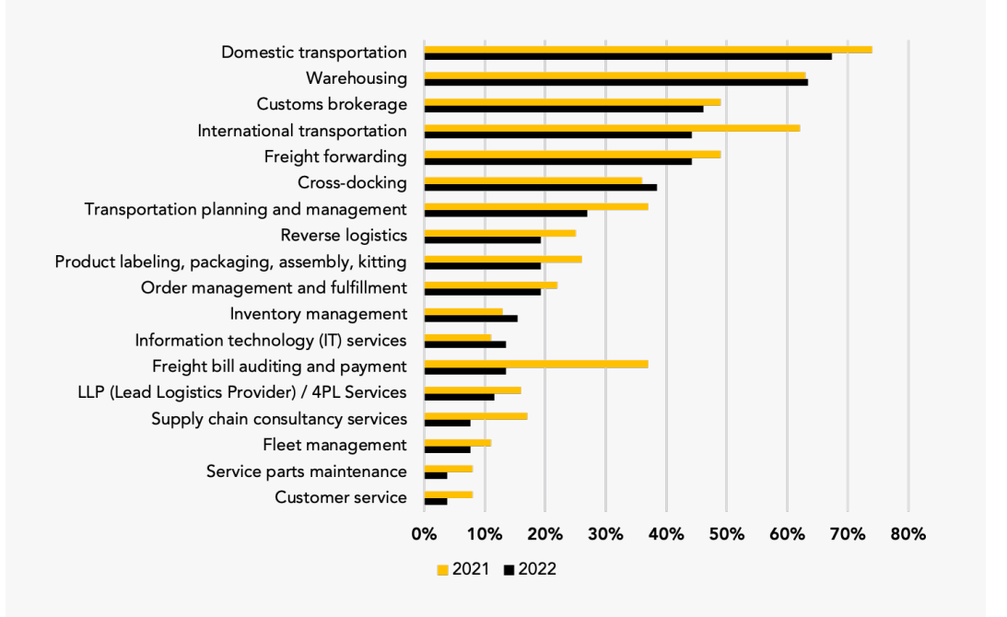
Figure 4: Shippers' preference for logistics services
(Source: Nttdata, 2025)

Element 2: Marketing Mix (7Ps)

Product
TescoKart’s product strategy effectively contributed towards the focus on the offering of the most complete and flexible 3PL services. The initial Starter Tier is contextually designed for the new or small e-commerce businesses that manage about 100-1000 orders per month. This pack provides the most essential services, which include the standard storage facility of Tesco’s existing regional distribution centres. Whereas the second Growth Tier package effectively provides services to the SMEs who manage about 1000-10000 orders monthly. This package adds the key essential features, such as the multi-location inventory, distribution, and same-day delivery services in the key major cities, with the association of the utilisation of the store-based micro-fulfilment with the inclusion of advanced technological assistance, such as AI. The final Enterprise Tier package is aimed towards the large merchants that process over 10000 orders per month. It delivers the key customised solutions, which include resolute account managers, priority picking slots, and white-label delivery options.

Price
TescoKart’s contextual pricing strategy effectively focuses on the clear, predictable, and overall competitive in the UK 3PLs market dynamics. The overall storage fees are made as per the pallet per week or the per cubic metre for the smaller merchants, and the rate of £8–12 per pallet is lower than the overall industry standards average of £10–15. Pick and Pack fees are made in the range of £2.50- 3.50 per order, mostly associated with how many items are required for the overall handling capacity. Even the delivery charges depend on the overall parcel size, weight, and the speed, with the associated costs of the next-day delivery charges of £3.95 -- 5.95 and the related same-day delivery pricing of the range of £7.95 -- 9.95. Further, the technology association costs cover the monthly platform access, which ranges from £99to £ 499 depending on the integration requirements. According to Redstagfulfillment (2025), fulfillment fees mostly cover about 25-35% for each of the orders, and hidden fees are common as most of the merchants compare the total costs more cautiously (Redstagfulfillment, 2025).
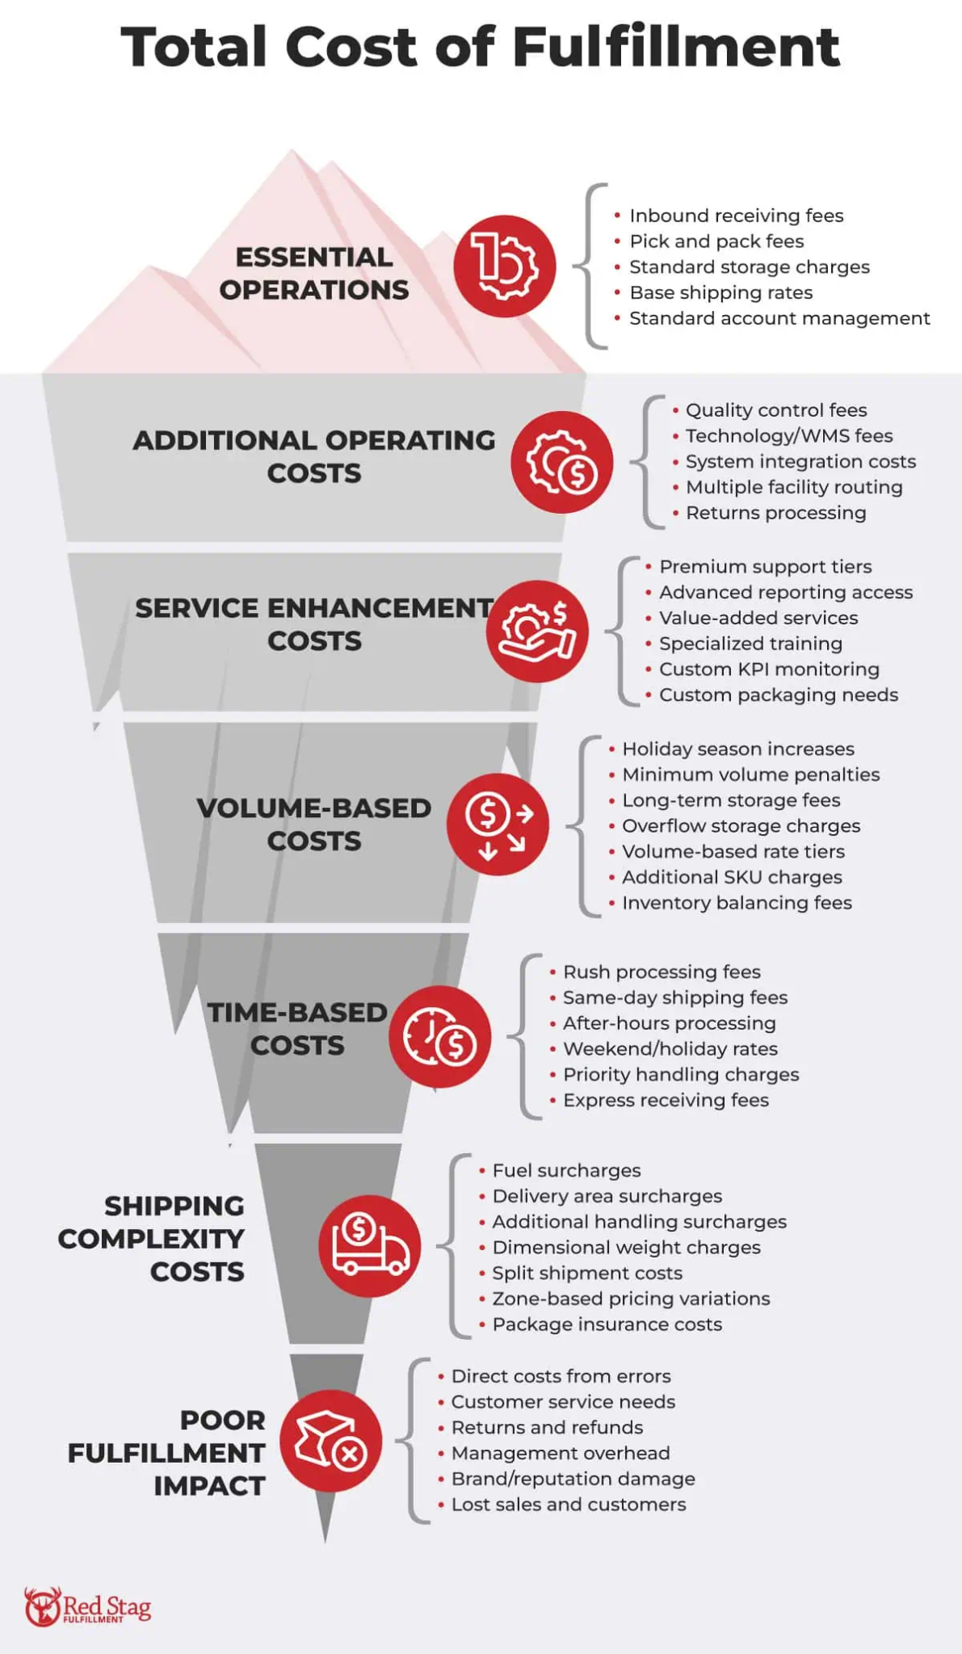
Figure 5: Pricing models for fulfilment business
(Source: Redstagfulfillment, 2025)

Place
TescoKart's place strategy uses Tesco’s overall strong physical network across the UK by effectively turning the existing retail and contextual distribution sites into a competitive logistics system. The distribution network operates in three levels. Regional distribution centres, urban micro-fulfilment centres and last-mile delivery routes. Tesco operates 20 key distribution centres across England and Scotland, offering both the key ambient and temperature-controlled storage facilities (Keller, 2013). The strategy even includes store-based micro-fulfilment, where space inside larger Tesco Extra and Superstore centres is used for holding fast-moving products for merchants. Around 150 Tesco stores in busy cities such as London, Manchester, Birmingham, Leeds, and Glasgow function as forward-stocking points.

Promotion
TescoKart’s strategic approach of promotion effectively includes the key B2B marketing initiatives. The key aspect includes content marketing, which is regarded as the focus and contributes towards positioning TescoKart as the key stronger leader in the space of e-commerce logistics. The study report of Content Marketing Institute (2025) further defines that 59% of B2B marketers associate the effectiveness of content marketing with the strong quality and skilled teams, although only 12% exceed their goals. Digital advertising targets merchant audiences through highly segmented LinkedIn campaigns reaching business owners (Contentmarketinginstitute, 2025). Partnerships with Shopify, WooCommerce, and BigCommerce position TescoKart as a recommended fulfilment partner. Trade engagement builds credibility and industry presence through participation in key e-commerce and logistics events, including the E-commerce Expo, Internet Retailing Conference, and UKWA Annual Conference.
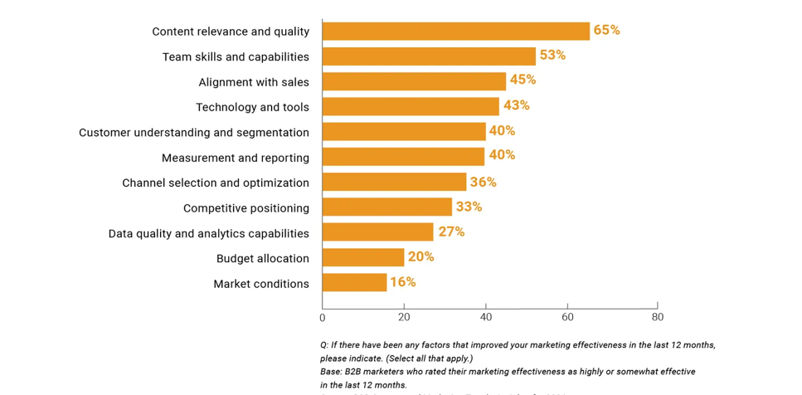
Figure 6: Factors improved B2B effectiveness.
(Source: Contentmarketinginstitute, 2025)

People
People regret the key success factor for TescoKart. Merchant success managers function as specialised relationship stewards for Growth and Corporate tier clients, providing consulting help on inventory optimising, seasonality preparation, and services design. Warehouse operations teams undergo comprehensive training on the merchant-specific requirements, including quality standards, packaging specifications, and special handling instructions, which vary significantly from Tesco’s retail operations (Aaker, 2001). TescoKart implements performance incentive structures aligning team compensation with key performance indicators, including order accuracy.
TescoKart’s customer support was effectively performed through the tiered system. In this context, level 1 strategically manages simple processes such as orders, stock management, and the basic requirements for managing the consumer chat and communication. Whereas the level 2 attitudes towards the deal-making of the complex problems. In level 3, the technical experts are to fix the issues related to the service failures. Successful cultural integration between Tesco’s retail operations and TescoKart’s new venture determines the requirements for careful change management.

Process
TescoKart’s contextual process approach is associated with effective efficiency, standardisation, and related flexibility for catering to each of the merchants’ requirements. Its onboarding system is proven to be the key step and is designed to be completed within two to three weeks, which is faster than the usual industry standard of 8-12 weeks. Inventory management processes effectively use Tesco’s advanced warehouse management system, adapted for the multi-merchant operations (Schiffman et al. 2008). The system supports multiple inventory accounting methods, including FIFO and LIFO. Order fulfilment processes operate on clearly defined service level agreements with performance guarantees. Standard processing follows a streamlined workflow: order receipt and validation (within 15 minutes of merchant transmission); inventory allocation and pick list generation; picking and quality verification. For custom integrations, TescoKart leverages the comprehensive API documentation, sandbox testing environments, and resolute integration support engineers.

Physical Evidence
Given the intangible character of logistical services, physical evidence in TescoKart's design for services produces concrete expressions of quality, professionalism, and brand identification. TescoKart and retailer co-branding options let businesses keep brand visibility through unboxing events using customised packaging materials such as containers, mailers, wrapping paper, and tape (Kusdiana and Yulita, 2024). This relates to the research study findings of Packaging Tech Today (2025), that online shoppers show packaging shapes loyalty: 41% (+14%) repurchase after premium unboxing, 42% (+9%) share visually appealing packaging on social media, and 60% (+6%) prefer eco-friendly options (Packagingtechtoday, 2025). Technology interfaces serve as primary physical evidence touchpoints, requiring intuitive design and professional presentation.
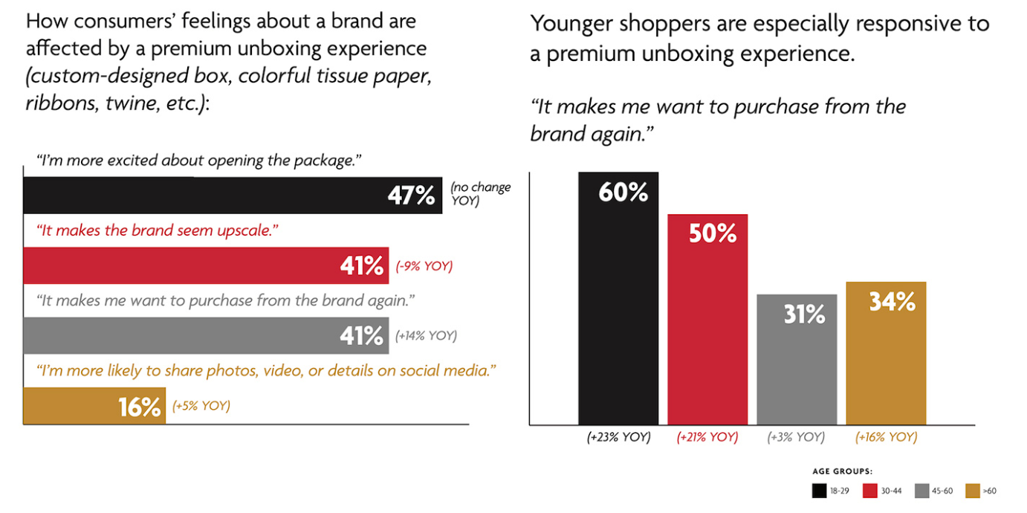
Figure 7: Premium box packaging effectiveness
(Source: Packagingtechtoday, 2025)

Element 3: Marketing Strategy Pitch
(Refer to the appendix)

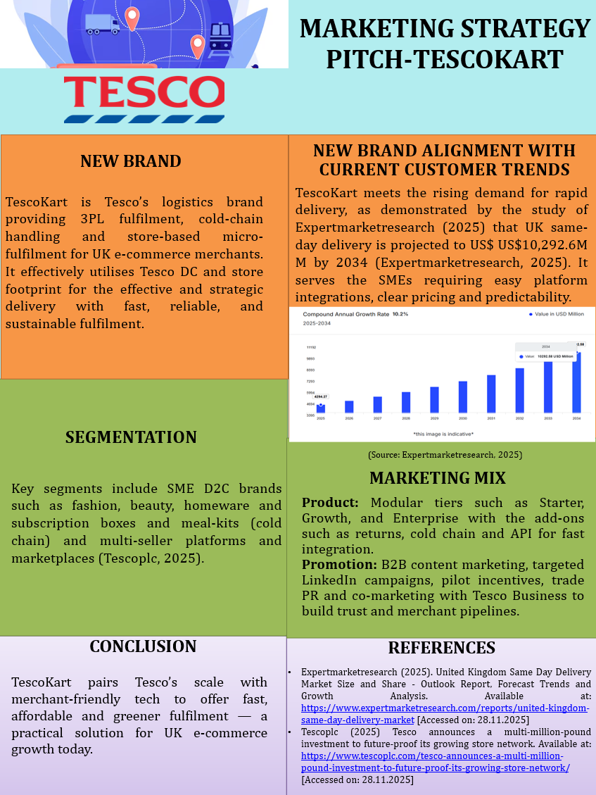

Element 4: Reflection

My Learning Journey Initiation
TescoKart has been conceptualised as a new brand, which has challenged me to think strategically about development, market positioning, and integrated marketing communications for the brand. When I first initiated the assignment, I approached it with a straightforward approach, creating a logistics service for Tesco. Though as I delved deeper, I acknowledged that a genuine, viable brand concept requires more thinking as regards market dynamics and customer needs.

Applying Theoretical Frameworks to Practical Brand Development
The greatest challenge and learning come from the application of the key structured frameworks for realistic scenarios. Using the STDP model effectively forced me to move beyond the innovative idea and strategically pursue the aspect of why TescoKart would succeed. I learned that segmentation is not associated with the demographics, but also the identification of the key acute, underserved requirements, such as SME D2C brands, which are struggling with scalable fulfilment. The contextual 7Ps framework was proven to be the most relevant framework, which proved to be effective for the evaluation of service-based brands such as TescoKart. This analysis attributed the core product as the start, the real differential in the marketing aspect (Coleman et al. 2021).

Research Challenges and Methodological Learnings
The most significant aspect of the overall project efforts was the dedicated research, which proved to be challenging. The sourcing of credible and most relevant market data was posed as challenging for validating the opportunity, but time-consuming. I even learned the usage of multiple sources for building a robust case. The main methodological insight was the key gap between the secondary data and primary customer insight. In the future, I would complement desk research with the primary methods as short surveys targeting SME owners for the analysis of niche forum discussions (Hartmann et al. 2023).

Professional Skills Development and Future Application
The project approached contextually and contributed to the course of professional marketing skills and capabilities. The analytical skills were the most effective attribute, which sharpened the market segmentation analysis. Even the strategic synthesis was developed by weaving the key insights from the various frameworks in a more concentrated plan for ensuring the position of ‘Trusted growth partner” in every aspect of the marketing mix. The strategic communication technique was the most pertinent transforming capability. The overall marketing pitch provided the key compelling approach in compiling the concise narrative (Stephan and Meyer, 2023).

Evaluation and Improvement Scopes

The first area includes the pitch draft, which was overly descriptive and lacked the key persuasive aspects that reduced its impact and clarity for the audience. This proved to be the key aspect of the learning in terms of audience adaptation; investors require the most contextual need for a compelling narrative about the potential opportunity. Secondly, while the financial underpinning of the key pricing strategy was only formulated with a limited financial analysis, it would have further improved the strategic rationale.

References
Element 1
Adainsights (2025). Online grocery driving growth for Tesco in the UK. Available at: https://adainsights.com/blog/online-grocery-driving-growth-for-tesco-in-the-uk [Accessed on: 03.12.2026]
Browne, W.G. (1974). Inside marketing management. Industrial Marketing Management, 3(5), pp.259-266.
Dibb, S. and Simkin, L. (2008). Market segmentation success: Making it happen! Routledge.
Lawrence J, G., McDaniel, C., Monique, R., Koffel, L., Bethann, T., and C Hyatt, J. (2018). Introduction to Business.
Mordorintelligence (2025). The UK E-Commerce Logistics Market Report. Available at: https://www.mordorintelligence.com/industry-reports/united-kingdom-e-commece-logistics-market [Accessed on: 03.12.2026]
Myers, J.H. (1996). Segmentation and positioning for strategic marketing decisions. (No Title).
Nttdata (2025). Third-Party Logistics Study. Available at: https://us.nttdata.com/en/-/media/assets/reports/3pl-2022-study.pdf [Accessed on: 01.12.2026]
Restuccia, M., de Brentani, U., Legoux, R., and Ouellet, J.F. (2016). Product life‐cycle management and distributor contribution to new product development. Journal of Product Innovation Management, 33(1), pp.69-89.
Element 2
Aaker, D.A. (2001). Developing business strategies. John Wiley & Sons.
Contentmarketinginstitute (2025). Takeaways and Insights From the 2026 B2B Content and Marketing Trends Report. Available at: https://contentmarketinginstitute.com/b2b-research/b2b-content-marketing-trends-research
Hague, P. (2019). The business models handbook: Templates, theory, and case studies. Kogan Page Publishers.
Keller, K.L. (2013). Building, Measuring, and Managing Brand Equity.
Kotler, P. and Armstrong, G.M., (2010). Principles of marketing. Pearson Education India.
Kusdiana, Y. and Yulita, R. (2024). The Role of Marketing Mix (7P) Strategy Towards Customer Satisfaction. INVEST: Jurnal Inovasi Bisnis dan Akuntansi, 5(1), pp.9-16.
Mondaq (2025). Online Shoppers Overwhelmingly Expect Free Shipping on Timetable Nearly Half of Companies Can't Meet. Available at: https://www.mondaq.com/uk/marine-shipping/1497582/online-shoppers-overwhelmingly-expect-free-shipping-on-timetable-nearly-half-of-companies-cant-meet-alixpartners-2024-home-delivery-study-says[Accessed on: 03.12.2026]
Packagingtechtoday (2025). Study Finds E-commerce Packaging Choices Impact Purchasing Decisions. Available at: https://www.packagingtechtoday.com/featureds/study-finds-e-commerce-packaging-choices-impact-purchasing-decisions/ [Accessed on: 01.12.2026]
Profiletree (2025). Small Business Revenue Statistics: Hard Facts for UK Business Growth. Available at: https://profiletree.com/small-business-revenue/ [Accessed on: 03.12.2026]
Redstage fulfillment (2025). 3PL pricing explained: a complete cost guide for 2025. Available at: https://redstagfulfillment.com/3pl-pricing-explained/ [Accessed on: 03.12.2026]
Schiffman, L., Bednall, D., O'Cass, A., Palandino, A., Ward, S. and Kanuk, L. (2008). Consumer Behaviour. Frenchs Forest, Australia.
Whistl (2025). The Rise of the Subscription Model. Available at: https://www.whistl.co.uk/8516/4571/7262/Whistl_Subscription_Boxes_Fact_sheet_final.pdf [Accessed on: 01.12.2026]
Element 3
Expertmarketresearch (2025). United Kingdom Same Day Delivery Market Size and Share - Outlook Report, Forecast Trends and Growth Analysis. Available at: https://www.expertmarketresearch.com/reports/united-kingdom-same-day-delivery-market [Accessed on: 28.11.2025]
Tescoplc (2025) Tesco announces a multi-million-pound investment to future-proof its growing store network. Available at: https://www.tescoplc.com/tesco-announces-a-multi-million-pound-investment-to-future-proof-its-growing-store-network/ [Accessed on: 28.11.2025]
Element 4
Coleman, B.M., Bunch, J.C., Thoron, A.C., and Roberts, T.G. (2021). Examining the Effects of Reflection Type and Abstraction Order on Students' Scientific Reasoning Skills During Experiential Learning. Journal of Agricultural Education, 62(2), pp.13-26.
Hartmann, A., Vinke-de Kruijf, J. and Van Weesep, R., (2023). Asking the right questions: The role of reflection for learning in and between projects. International Journal of Project Management, 41(5), p.102494.
Stephan, A. and Meyer, G., (2023). Growing Together in a European Project: A Dyadic Mentor-Mentee Reflection. In Mentoring in Nursing through Narrative Stories Across the World (pp. 777-785). Cham: Springer International Publishing.

