
DBA Quantitative Research Methods
Module Assignment Submission
Student Name: | Carol Vaughan-Roberts
Student Number: | 1604568
Module No: | LCDB7004
Lecturer Name: | Theodoros Panagiotidis
Module Title: | Quantitative Research Methods
Number of words | 7367

Statement of Confirmation of Authenticity

By the act of making this submission, the student declares that this is the work of the student named above. The work has not, in whole or in part, been knowingly presented elsewhere for assessment, or where assessment has been built on a previous assessment, this has been identified. Where materials have been used from other sources it has been properly acknowledged. If this statement is untrue, the student acknowledges that an assessment offence has been committed.
Attention is drawn to the plagiarism and unfair practice policies of both the University and of ILM.
Table of Contents

Introduction 4
Hypothesis 7
Aims 7
Research Objectives 7
Problem statement 7
Research Questions 7
Literature review 8
Synchronous and Asynchronous learning 9
Social Status 10
Studying environment 12
Methodology 13
Histograms 14
Pearson Correlation 14
Kendall’s Tau 15
Spearman's rho 15
ANOVA 16
Why use different models 16
Data generation 18
Participants 18
Data analysis 20
Suitable area to study 20
Education suffering in respect to age and level of education 21
Overall experience 22
ANOVA 24
Kendall's tau_b findings 26
Spearman’s findings 26
Technical Skills 28
Conclusion and Recommendations 30
References 32
Appendix 1 38

.

Has the sudden switch to online teaching made a negative impact on students’ education?

Introduction

The world has been turned inside out by COVID-19. Every aspect of life has been altered. Our way of life and how we communicate with one another, how we work and collaborate, and how we get around and travel are all factors. Our lives have been impacted in every way. The choices made and choices to come will be among the most significant in years. They will have a long-term impact on people all over the world. Students who have already been left behind will almost certainly feel the consequences of the pandemic's effects, whether through a lack of life-saving vaccines, an increased risk of violence, or a disruption in their education (Unicef, 2020). This study is looking at a small group of students in and around London to see if students forced to study at home online will have a decline in their education, and the effect this sudden switch has had on them.
As social distancing rules have led to a more virtual existence, both personally and professionally, the pandemic has transformed how we work, learn, and communicate. In the meantime, children, young people, and learners have used paper-based materials offered by their organisation, online learning materials, or a combination of both to conduct remote learning at home. As the COVID-19 situation is constantly evolving, organisations are in different phases of developing safe, effective, and efficient plans academic year (ETI, 2020). Over 1.6 billion students in 190 countries have had their educations disrupted so far according to The United Nations Educational, Scientific and Cultural Organisation, this equates to 90 percent of the world's school-aged children.
Alternatives to school education is distance education, such as television or radio programmes, and online learning, which are being used in some countries where schools are closed as a containment measure. Furthermore, only about half of all families in the world have online access. Only 38 percent of rural households have television, compared to 73 percent of urban households. The pandemic has the potential to trigger a learning crisis, keeping the most disadvantaged children behind. (Unicef, 2020).
Children's academic success, safety, and social lives are all jeopardised by closures, according to educators who have worked with remote learning (Robson, 2020). They claim that digitising a school is far more difficult than digitising a workplace, and that it adversely impacts low-income students and students with special needs.
Some experienced remote learning teachers have some warnings for schools to considering when going online. The large percentage of families with children have access to high-speed internet, but there are still significant differences in access based on parental income, race, and educational attainment. Families of low-income are more likely to use mobile phones to access the internet and may not be able to use more sophisticated learning software that requires a tablet or computer. Educators say it is not uncommon for siblings to attempt to finish their schoolwork on a single mobile phone or just do not have the equipment needed (Ahrends & Corban, 2021).
Parents play an important role in their children's education, and higher levels of parental involvement are constantly linked to improved educational results. However, involving all parents in activities that support children's learning can be difficult, particularly if parents' own educational experiences were not positive. Younger students require a great deal of assistance when learning online. Parents may need to help their child turn on a device, log into an app, remember passwords, read directions, click in the correct location, type responses, and remain on engaged, which can be extremely difficult when there is more than one child and/or the parent also has to work from home. Even though there are many excellent teachers, not all of them are prepared for take their classes to the online. Students need more plainly written topics and directions in online lessons (Goldstein, 2020).
Children's charities report that disadvantaged households are being "shut out" of education because they cannot bear the expenses of online schooling. Javed Khan, the CEO of Barnardo's, said that "urgent action" was required to make access to the internet more accessible. According to Ofcom, six percent of UK households are unable to afford broadband, although five percent are unable to pay their mobile phone bills (BBC, 2021).
The Department for Education (DfE) announced that 54,000 4G routers had been distributed to low-income households. A government programme to distribute one million computers to schoolchildren has distributed 801,524 devices, but many students are also unable to access the internet because schools remain closed due to the pandemic (GOV.UK, 2001). According to a survey conducted by Ofcom in 2020, between one million and 1.8 million children do not have access to a laptop, desktop computer, or tablet at home. (Ofcom, 2020). Low-income families are often less likely to have broadband access at home, depending more on costly mobile phone data plans at a point when paying for weekly food and energy bills is already difficult.

Universities are different from schools as they are self-governed and accountable for their actions, that they make in response to the coronavirus pandemic. One university's actions may not be the best for another. The UK government are working with the sector to ensure that students around the country get the best education possible. Many find it difficult to study at all through this time of confusion. Despite the reality of these issues, for students’ anxieties can feel unachievable at times, there is one thing all can be confident of and that is it is something all need to do together (Simone, 2020). Everyone having to balance a lot of problems at the same time, and anxiety and frustration are perfectly understandable under these situations. A need to find opportunities to get self-motivated. Rekindle a curiosity by going through old notes and newly updated content, or by looking for similar video lectures online. Effort such as setting aside some time per day for this and creating a designate space in your home for learning (Simone, 2020).

There is a major divide that must be bridged between a well-planned online course and a classroom-based course. Lecturers need to use apps to facilitate class meetings, materials sharing, and other communication tools for the former. There's a distinction between a well-planned online class versus one that has been thrown together, just like there is between a student who wants to study in a classroom setting and one who expects to take an online course. Kevin Carey the vice president for education policy and knowledge management at a think tank for New America said, “I think it’s going to be a real challenge Hopefully students will be able to engage from their childhood bedroom, or wherever they are.” (Krupnick, 2020).

Hypothesis
Students forced to study at home online will have a decline in their education.

Aims
The main aims of the study are to identify the issues faced by students with the sudden switch to online education. The challenges of having the correct environment and equipment to achieve their qualifications. The most used means to deliver education has been online platforms. Students who do not have access to the required environment for studying at home, have fewer options for continuing their studies. This study looks at a small group of students and what they face in having had to study online. This study looks at how students believe situation has affected their studies.

Research Objectives
To identify the issues faced by students with online education.
To determine the discourses associated with online education.
To examine how students studying online have respond to their circumstances.

Problem statement
To highlight the discourses and problems that students in and around London have faced with online education.

Research Questions
Did the swich to online study have a negative effect?

Have student’s education been affected by the change of their study environment?

Does the age of the student have an effect on the overall experience of online education?

Literature review

Traditionally, educational institutions such as schools, colleges, and universities all over the world focus solely on conventional instructional techniques, such as, face-to-face lectures in a classroom setting. Even though many academic divisions have begun to use mixed learning, however most of them presented face to face. Covid-19's abrupt emergence shocked the whole world. With it being deemed a pandemic by the World Health Organization. This situation posed a challenge to the global education infrastructure, requiring educators to quickly transition to an online language of instruction. However, transitioning from a conventional classroom to online distance education takes time and there is a lot to learn! (Finger, 2020). Many academic institutions were unprepared for this transformation, but they had no choice but to transition fully to online education. This study will look at the effects of online learning students have faced in this moment of crisis. It's a major, transformative change to move all current courses online in a matter of days. In general, a complete online course necessitates a comprehensive lesson plan, instructional resources such as audio and video, and technology support staff.
There are a variety of tools available for online education, but they can also cause of many issues for students. These challenges and complexities can steam form the new technologies used include things like download glitches, installation issues, password issues, audio and video issues, and so on. Maintaining student’s involvement and commitment is a difficult task when the lecturer's personal contact is absent or minimal. Technology-mediated learning has lower learning commitment than face-to-face learning, which is a strong determinant for learning outcome. (Panigrahi, et al., 2018).
Students need to bring what they have learned into practise before the learning experience can have its full effect. Students may find it difficult to practise and understand online content because it is often theoretical. Course material that is not up to scratch is also a big concern. The key barriers to online learning, according to students, are a sense of tradition, technical issues, and difficulties understanding intended outcomes (Dhawan, 2020). Students were found to be underprepared to align their jobs, families, and personal interactions with their study lives in an online learning atmosphere in a study (Parkes, et al., 2015). Furthermore, students were found to be unprepared for a variety of e-learning and academic-type skills. In addition, pupils are unprepared to use Learning Management Systems (van Rooij & Zirkle, 2016).

Synchronous and Asynchronous learning
The concept of using a computer and the internet to provide course materials in Technologically Enabled Learning Environments, as well as to facilitate connectivity and assessment by Synchronous and Asynchronous Communication. An example of an online learning theory is Tools for Cooperation, which mostly uses asynchronous methods. Self-guided lesson modules, pre-recorded video materials, virtual libraries, lecture notes, and public message forums or social media sites are all examples of asynchronous online learning. Synchronous online education happens where students and staff members are physically isolated and communicate remotely over the internet at fixed hours. A look was taken into the phenomena of synchronous online classes in a study(Hrastinski, 2008).
Students will benefit tremendously from online learning. Its biggest selling point, ease, is creating a discrepancy between asynchronous and synchronous types in education, which can have a variety of negative implications. In some universities, there has been a move toward asynchronous activities at the detriment of synchronous practises, which could deny students of two essential advantages of schooling, personal and social development, as well as deteriorate learning outcomes. The advantages and drawbacks of both modes are shown in Sistek-Chandler, (2020) The need for a holistic approach to online education realised in an additive immersive model in a mixed learning format is demonstrated in Sistek-Chandler(2020) research. (Sistek-Chandler, 2020). Many educators are worried that this asynchronous movement, which focuses solely on structured knowledge building, would rob students of the two most valuable benefits of schooling, personal and social growth, and lead to a reduction in learning outcomes (Gillett-Swan, 2017). Online teachers are concerned that online students have lost their psychological, in the online world, civic, humanistic, and civic qualities become distanced, solitary, impersonal, and unemotional (Serdyukov & Sistek-Chandler, 2015).
Asynchronous learning is more robust than synchronous learning, effective in terms of time and lets students concentrate with their own assignments, synchronous learning broadens the role and importance of information, aids in doing things more relevant, allows for its enhancement by engagement with others, and engages students taking part in group activities that mimic real-world circumstances, training them, so they will be prepared for life and work. To summarise, each mode generates unique learning environments based on personal interests (Sistek-Chandler, 2020).

Social Status
Students in online education, especially those who are poorly prepared and vulnerable, underachieve and have negative outcomes on average. In online coursework, differences in educational achievement between social classes are much broader than in conventional academic work. In online education, frequent and meaningful student-instructor engagement is a primary determinant of success; students happiness, learning, and outcomes all rise because of it (Protopsaltis & Baum, 2019). More student-instructor engagement is needed by online students, and the culture of online educators is pushing for a stronger emphasis on such interaction to resolve a commonly known shortcoming of existing online services (Protopsaltis & Baum, 2019). This method has been made more complex for people with socioeconomic disadvantages when some studies found that people with disadvantages are not well provided for even during regular periods (Öksüz & Brubaker, 2020). Nevertheless, online education, distance learning, open learning can be useful for students and scholars (Allen, et al., 2002) (Tanhan, 2020) in the same time causing some problems and drawbacks (Tanhan, 2020).
The third major complicating factor in online/distance education was inequity in learning opportunities, which was linked to both evaluation and review, as well as different socio-economic characteristics of the students, according to a study reported by (Doyumğaç, et al., 2021). According to the findings, inequity in learning opportunity, the third major complicating trend in online/distance education, was linked to both assessment and examination, as well as various socioeconomic characteristics of the students. Any participants reported that they either lacked or did not have the tools available for online education. Prior research has showed that online classes, facilities, or research may cause some basic flaws for some undergraduate students, for example not being able to follow and grasp the subject because of the situation and social disparities, as well as a failure to finish homework and examinations due to a lack of resources. (Yao & Chen, 2020). This showed that in online or distance education, technologies should be used with caution (Wang, et al., 2020).
Many low-income students lack the basic technology needed to learn online, such as a laptop and a secure internet service, as well as a quiet space in which to study and complete examinations. Some pupils, particularly those from lower socioeconomic backgrounds, care leavers, students with caring obligations, and those with disabilities, may be seriously hampered by the change to online learning, according to social mobility experts (Hall & Batty, 2020). According to a survey commissioned by the National Union of Students, one-fifth of students face access issues, and more than half of students who use educational software report that they lack the resources they need to pursue their studies. (Hall & Batty, 2020). There are, still, challenges to overcome. Any Students who do not have access to a reliable internet connection or technologies find it impossible to partake in digital learning; this gap persists across boundaries and disciplines socioeconomic classes within regions (Li & Lalani, 2020). According to OECD results, although 95 percent of students in Switzerland, Norway, and Austria have access to a computer for schoolwork, only 34 percent of students in Indonesia do. In the United States, there is significant gap amid people from affluent and disadvantaged circumstances: while almost all advantaged 15-year-olds have confirmed they have access to a computer, nearly 25 percent from underprivileged areas do not (Schleicher, 2018). Despite the fact that some schools and states, such as those in New South Wales and Australia, have given wireless equipment to students who need it, some people are fearful that the pandemic will exacerbate the digital divide. (Li & Lalani, 2020).
The changing digital world is portrayed in a recent United Nations Conference on Trade and Development (UNCTD) 2020 report. The global transformation to a digital economy has been driven by the coronavirus epidemic, which has sped up the adoption of digital technologies, software, and services. This has just highlighted the huge difference for those who are connected and those who are not, showing how far behind many people are in terms of digital adoption. UNCTAD’s technology and logistics director, Shamika Sirimanne states that “Inequalities in digital readiness hamper the ability of large parts of the world to take advantage of technologies that help us cope with the coronavirus pandemic by staying at home,” (UNCTAD, 2020).

Studying environment
Teachers and parents alike face additional challenges, such as conditioning students to engage in online learning. Internal and external influences may also contribute to the formation of these barriers. Internal considerations include issues that arise in the student's home life, like the members of the family interfering (younger and older siblings); this aspect makes it difficult for students to concentrate on their studies. One reason is a less favourable home learning environment, in which family members' behaviours create disturbances, reducing the attention required to comprehend the subject matter. When using an educational application in an online classroom to introduce instruction, external considerations such as disruptions from other students occur. Students converse with one another on subjects irrelevant to the subject matter being discussed. As a result, interactive courses become overcrowded and inconvenient to participate(Rasmitadila et al., 2020).
Outside of academia, the public is still wary of online learning. “Americans' general appraisal of Internet-based educational services is tepid at best,” according to a Gallup poll from 2013 (Saad & Busteed, 2013). Although they accept the wider diversity of opportunities and value available as opposed to conventional face-to-face schooling, they also conclude it offers lower-quality training, less stringent grading, and assessment, and is thus less trustworthy to employers. They concluded that students were more prone to failure or discontinue the online classes than from face-to-face classes, and that students who attend online courses in the first semesters are much lower probability of attending school in subsequent time periods. Students who achieved more credits online had a lower probability of receiving a degree or move to a four-year university (Xu & Jaggars, 2014). The researchers looked at data from more than 51,000 students at 34 community and technical colleges and discovered that while students with higher educational experience were more likely to enrol in online courses, they were also substantially more likely to fail or drop out than students taking standard face-to-face classes (Shea & Bidjerano, 2016).
Even though higher education achievement rates are higher for women. than men, the research on gender disparities remains mixed. Several studies have shown no differences in learning outcomes between males and females in online classes, although others have reported that women do slightly higher than men (Price, 2006). Peer-reviewed reports have reaffirmed the value of student-instructor engagement as a core component of success that contributes to improved student success and achievement. According to a 2011 review of twenty-three online classes of two community colleges, frequent and meaningful engagement allows online students to spend more time and do well academically. (Jaggars & Xu, 2013). Students thought they discovered more in classes with high student-instructor teacher, according to a 2014 study of sixty graduate online students, suggesting yet again that students learn more where both students and teachers actively interact. (Joyner, et al., 2014).
Not only have researchers discovered that social interaction improves results, but they have also shown that a lack of interpersonal engagement can be negative. A three-year analysis by Cole, et al. (2014) looked at graduate and undergraduate student satisfaction with online learning at a university and found that the key cause of student discontent was a lack of contact with teachers and other students (Mehall, 2020).

Methodology

The truth of data that exists and that the analysis seeks is known as ontology. Truth of reality is a fully empirical method of obtaining responses to study questions. As a result, to find answers to the research problems, this study used quantitative methods as the methodology and positivism as the ideology. A Quantitative method gaining data through a survey is what was used to measure, rank, and categorise, identifying patterns and make generalisations. Quantitative analysis is a technique of collecting and analysing numerical evidence. It can be used to find patterns and make comparisons, predict, test causal relationships, and extrapolate results to broader populations.(Bhandari, 2021).
To examine the perspectives of students who were forced to switch to online learning, quantitative analysis would be used, with data represented by numbers and graphs and mathematical methods to explain it. The sample is of primary origin. The participants were selected to have as much gender and age balance as possible. The aim of gathering quantitative statistics is to validate the theory, which can then be used to correctly measure the results and extract several statistical insights. The analysis is analytical, with the aim of assessing the significance of online learning during periods of turmoil and pandemics such as the Covid-19. Based on previous research, the issues associated with online learning as well as potential solutions were established.
The finding is shown in a mixture of presentation methods percentages are helpful because they make comparing items very easy, but do not give a lot of detail. Hence differing measure have been used.

Histograms
A frequency (histograms) distribution as an overview of all distinct values in some variable and the number of times they occur. Most of the time, frequency distributions are used to summarise categorical variables. This is since metric variables have a lot of different values. As a result, one could have colossal tables and graphs that do not have much insight into the data. Histograms are the way to go in this situation since they visualise frequencies with intervals of values rather than individual values(Cherry, 2019). This was found to be a very useful analysis tool.
The mathematical approach for determining the frequency of a relationship between two quantitative variables correlation analysis was also used. A high correlation indicates a close relationship between two or more variables, while a low correlation indicates that the variables are barely associated. To put it another way, it's the method of analysing the intensity of the interaction using statistical evidence. This method is inextricably linked to linear regression analysis, which is a mathematical method for modelling the relationship between a dependent variable, called the answer, and one or more explanatory or independent variables.(Ranganathan et al., 2018).

Pearson Correlation
Pearson Correlation is a statistical method for determining how strong an association between two variables is. The variables you're looking for what should be continuous, normally distributed, linearly connected, and free of outliers. The variables can also have a similar distribution across their respective ranges. There are assumptions in every mathematical system. In order for mathematical methods to produce correct results, the data must satisfy those properties. Continuous, Normal Distribution, Linearity, No Outliers, and Similar Spread Across Range are some of the Pearson Correlation hypotheses. In the following case, Pearson Correlation can be used. When one wants to know how two variables are related, and the variables of interest in are continuous. There are no covariates in the study(Benesty et al., 2009).

Kendall’s Tau
Kendall's tau is a mathematical formula for determining the frequency of a relationship between two variables. The variables of interest can be constant or ordinal, and their relationships should be monotonic. In order for mathematical methods to produce correct results, the data must satisfy those properties. Kendall's Tau makes the following assumptions: (a) constant or ordinal, and (b) monotonicity. The variables of interest must be either continuous or ordinal. The term "continuous" refers to a variable that can take on any reasonable value. Age, weight, height, test scores, survey scores, yearly salary, and so on are all examples of constant variables. If there are outliers in the results, Kendall's Tau is often used for correlation on continuous data. Ordinal variables are groups of things that have a natural order about them. For example, education level (GDE/Bachelors/Masters/PhD), income level (if classified as high, medium, or low), and so on(Badii et al., 2014).

Spearman's rho
The intensity of a relationship between two variables is measured using Spearman's rho. The variables of concern should be continuous or ordinal, and their relationships should be monotonic. Much like the Kendall’s Tau there are assumptions and in order for mathematical methods to produce correct results, the data must satisfy those properties.
Spearman's Rho is based on the following assumptions: ordinal or continuous Monotonicity is the second factor to consider. In the following scenario, Spearman's Rho can be used: (a) To know how two variables are linked. (b) The variables of concern are ordinal or continuous with outliers. (c). The only have two factors to work with. When looking for a regression test to examine the relationship between two variables. It was used to look at regression test to examine the relationship between two variables. Also, checking for a discrepancy between two variables or forecasting one variable using another variable are examples of other kinds of analyses (prediction)(Badii et al., 2014).

ANOVA
A one-way study of variance (ANOVA) is sufficient in many testing cases, most notably where you have three or more groups or factors to compare to see whether they vary substantially on any result. The two-sample t test is extended in this process (Acock, 2010).
ANOVA is a mathematical method for determining whether the means of three or more populations are identical. The two most basic situations are as follows:

- One-way ANOVA for matching 3 plus categories on a single variable: Do all students from universities A, B, and C have the same mean IQ?
- A series of tests Is the mean ranking for beer A, B, and C the same for everyone?

Why use different models
Data were analysed with statistical software package for social sciences (SPSS) 26. The most widely used metric for defining the relationship between two variables is Pearson correlation. If a random variable X has samples ^{x}₁…^{x}_{n} and a random variable Y has samples ^{x}₁…^{x}_{n}, the (sample Pearson) similarity of the two variables is, where $\overline{x}$ and $\overline{y}$ are the sample means of X and Y, respectively. Pearson correlation, while widely used, only calculates the frequency of a linear interaction between two variables. It is indeed likely that two variables have a powerful non-linear interaction but a low Pearson correlation. Two non-parametric approaches for calculating the interaction between two random variables are presented in this article: Spearman’s rho and Kendall’s tau.
The Spearman's rho is more vulnerable to data errors and inconsistencies. Kendall's tau has a lower gross error sensitivity and asymptotic deviation when the data is normal. Both can be done in real time. Kendall tau values are typically greater than Spearman rho values.
This research would look at students' viewpoints on the complexities of learning in an online delivery method rather than the conventional face-to-face method during the pandemic COVID-19. An online survey with a methodological inquiry was used to achieve the objectives. An online survey is a collection of structured and unstructured questions about a specific topic that participants respond through the internet, usually by filling out a form (Paudel, 2021). This is a convenient platform to connect participants while taking up less time. Since only one form of data could not meet the research's overall requirements, the study used both main and secondary sources of data. The primary data was gathered using an anonymous survey questionnaire sent to students at school and in higher education who had been switched to online education due to the pandemic. References, textbooks, papers, and other database materials were used to gather the secondary data. To ensure the results' relevance and reliability, the data and methods were summarised. Due to time and scope limitations, it was not possible to include all students in this report. It was important in this case to make sure the sample was representative. As a result, 31 school age and 31 universities students were chosen at random as the study's sample. The survey questionnaire is in the appendix, with closed and multi choice questions prepared in Google form was sent as a link to the selected participants via Facebook messenger and email. Only sixty-two people replied to the survey questions. The data for this study was collected and recorded in a Google Form database, which the researcher reviewed and analysed after collecting responses from all of the participants. After gathering all of the replies, the data was analysed just use a simple mathematical method percentage, followed by a descriptive analysis, and the findings were then addressed. The data was analysed using a social science statistical software kit (SPSS 29).

Data generation
An experiment is a type of assessment process wherein one or more independent variables are controlled and their influence on one or maybe more dependent variables is calculated. Creating a series of measures to test a theory is known as experimental design. To begin, the author had to think about the scale of the study, how many people will be included in the study? The more samples available to use, the higher the predictive power of the study, which determines how confident one can be with the results. The questionnaire is composed by ten questions, quantitative Multiple choice questions and rating scale questions and multiple-choice questions. The questionnaire has been realized and made available, in an electronic form. The student-set that took part in the survey was completed by sixty-three.

Participants
Participants who took part in online lessons were purposefully surveyed to ensure an appropriate diversity of opinion among groups. Surveys were designed by authors a university student. Participants of the study were asked to email the survey to two student peers. This allowed for relatively quick data collection across multiple academic years school, college, and university student, and across academic majors. Demographic information such race, or financial information was not taken from the students was to increase likelihood of students completing survey in a short amount of time. Survey questions were designed to assess students of different academic levels view on the effect the sudden switch to online education had on them. 54% (n=34) students were female 46% (n=29) male of which 27%(n=22) where of school age 27 percent (n=5) college students and 46%(n=36) of university degree level. A more detailed brake down can be seen in figure 1. The questionnaire was completed in an anonymous manner.

Gender Age Crosstabulation
 |  |  | Age |  |  |  |  | Total
 |  |  | 12 | 12-17 | 18-24 | 25-39 | 40-61
Gender | Male | Count | 5 | 6 | 2 | 8 | 8 | 29
 |  | by % | 17.2% | 20.7% | 6.9% | 27.6% | 27.6%
 | Female | Count | 8 | 3 | 3 | 12 | 8 | 34
 |  |  | 23.5% | 8.8% | 8.8% | 35.3% | 23.5%
Total |  | Count | 13 | 9 | 5 | 20 | 16 | 63
 |  | by % | 20.6% | 14.3% | 7.9% | 31.7% | 25.4%
Figure 1. The gender and age of participants

As shown in figure 1 students from differing levels of education took part in the study. Each student was informed about the study's overview and encouraged to participate as soon as they were contacted. Overall, sixty-three students that participated. The parents of the primary school participants answered the survey.
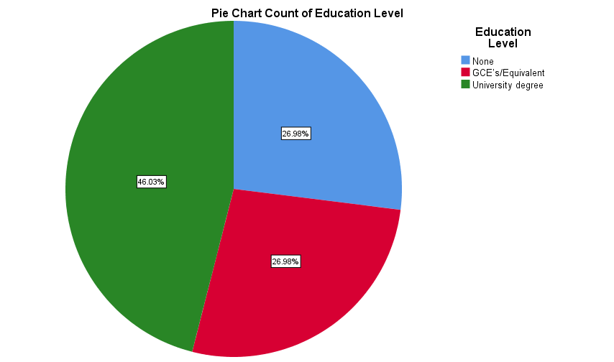
Figure 2. The educational level of participants

Data analysis
Studying at home was an adjustment that had to be made due to the closures of the education facilities, it is critical to create an effective learning environment that promotes good academic, physical, and emotional wellness. With a little foresight and preparation, creating a learning environment that is ideal. Figure 3 shows the frequency and percentage of participants that felt they did not have a suitable area to study in.

Suitable area to study

Suitable Study Area
 | Frequency | Valid Percent
No | 28 | 44.5
Yes | 35 | 55.5
Total | 63 | 100.0
Figure 3. Having a suitable area to study

A good learning environment is important. An area with good lighting, a pleasant working environment with little disruptions and close to a stable power supply (Maria Airth, 2020). Unfortunately, just over 44% (n=28) of the participants did not feel that they had a suitable area to study in.
Correlation for suitable study area N= 63
 |  | SA | OE
Suitable Study Area (SA) | Pearson Correlation |  | .54**
Overall Experience (OE) | Pearson Correlation | .54**
**. Correlation is significant at the 0.01 level (2-tailed).
Figure 4. Overall experience of online study with a suitable study area

A Pearson correlation was conducted to examine the relationships between having a suitable area to study (M = 0.56, SD = 0.50) and overall experience (M = 2.33, SD = 1.22) with online education. A Pearson's r data analysis revealed a strong correlation between overall experience, r (61) =.54 = p .000. 29% of students study area suitable affected their overall satisfaction with online education. See figure 4 and 5.
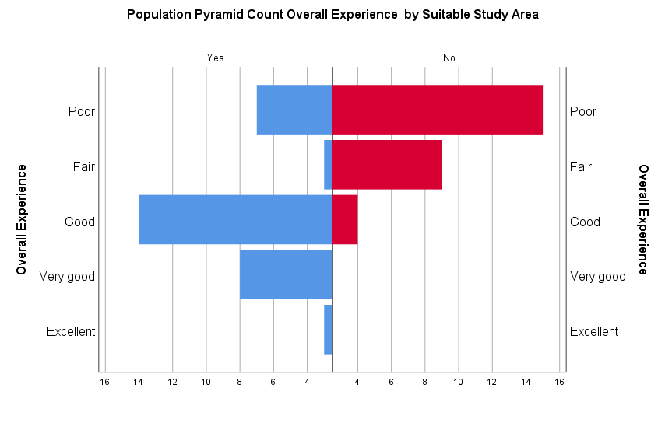

Figure 5. Overall experience of online study with a suitable study are

Education suffering in respect to age and level of education

In this Pearson correlation test the author examined the relationships between age (M = 3.27, SD = 1.51), level of education (M = 2.19, SD = 0.84), and if the participants education has suffered (M = 0.62, SD = 0.49). Age was more strongly negatively correlated to education suffered, r (61) = -.38, = p .002, whereas is a strong correlation age and level of education, r (61) = .83, = p .01. Educational suffered and Educational level have a moderate negative correlation r (61) = -.25 = p .05. These findings indicated that level of education explains much more of the variability in education suffering than age does. The effect size for education level (r².36) indicated that the level of those who education level accounted for the portion (36%) of the variability of their education suffering.

Correlations if education has suffered N=63
 |  | Age | ES | EL
Age | Pearson Correlation |  | -.384** | .827**
Education has suffered (ES) | Pearson Correlation | -.384** |  | -.252*
Education level (EL) | Pearson Correlation | .827** | -.252*
**. Correlation is significant at the 0.01 level (2-tailed).
*. Correlation is significant at the 0.05 level (2-tailed).
Figure 6. Correlation of education suffering in respect to age and level of education

Overall experience
Below is a pie chart providing a visual display of the distribution of students over all experience of being educated online during the COVID-19 pandemic.

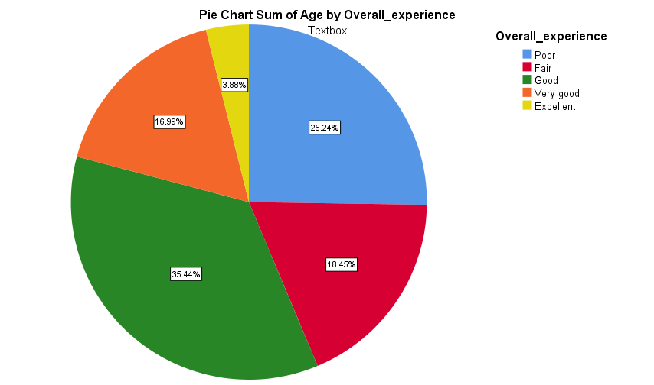
Figure 7. overall experience

It was assumed that the age of students would not influence the overall experience to being educated at home. A Pearson correlation revealed an important association between a student’s age and their overall experience, with r (61) = 0.41, p =.001, according to a Pearson correlation. This positive and relatively strong correlation rejects the theory, showing that a student’s age does contribute to their other all experience. See figure 7.
We hypothesised that the age of student’s effects their overall experience of being educated online. A simple linear regression found that age was a significant predictor of overall experience, t (61) 3.49, p .001. Specifically, the model predicted that the younger the student in age (M = 3.25; SD = 1.51) the lower the overall experience level (M = 2.33; SD = 1.22), and as the age groups progress in age the student overall experience has increased. See figure 8.
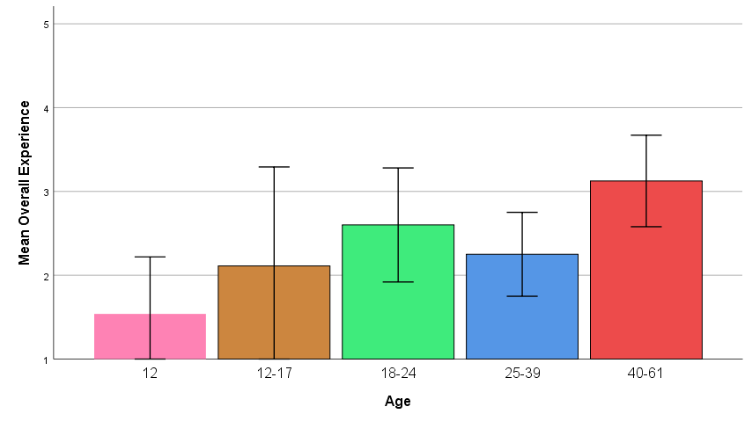
Correlations with age and overall experience N=63
 |  | A | OE
Age (A) | Pearson Correlation |  | .408**
Overall experience (OE) | Pearson Correlation | .408**
**. Correlation is significant at the 0.01 level (2-tailed).
Figure 8. Correlation between age and overall experience

ANOVA
A one-way ANOVA uses the following null and alternative hypotheses: H 0 (null hypothesis): μ 1 = μ 2 = μ 3 = … = μ k (all the population means are equal) H 1 (alternative hypothesis): at least one population mean is different from the rest (Acock, 2010).
An experimental design was assessed using a factorial ANOVA to see if a student’s educational level has a bearing on the effect of not having a suitable study area. It was found that not having a suitable place to study affected students more M = 0.59; = SD = 0.71 than the sudden change to online education M = 0.86; SD = 0.69 for students of degree level and M=0.94; SD = 0.75 for students for GSE and equivalent. F (2. 57) = p .92. See figure 9.

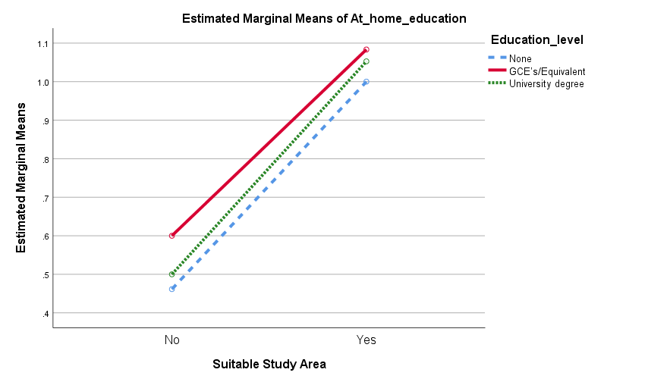
Figure 9 Suitable study area and switch to study at home
It was found that there was is a significant link between having no study area (M = 0.50; SD = 0.58) and the students education level (M = 1.06; SD = 0.72). F (2. 57) = 6.91, p = .11. See figure 10 and 11.
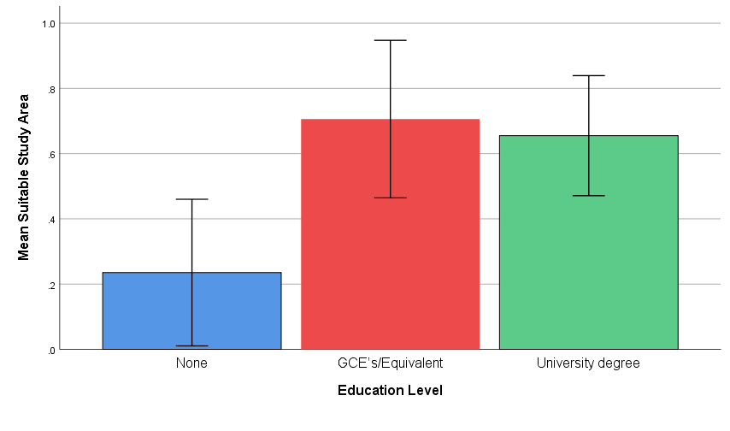
Figure 10. Link between having an area to study and student’s education level
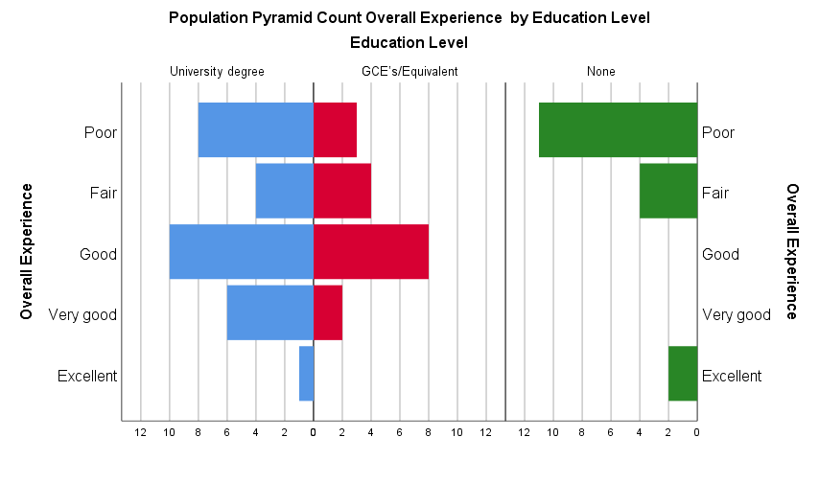
Figure 11. Link between having an area to study and student’s education level

Kendall's tau_b findings
Kendall's tau_b is calculated by using the following formula $τ=\frac{n_{c-n_{d}}}{n(n-1)/2}$ (Berg, 2020)
After conducting a Kendall tau_b correlation it was found that there is a very significant and positive correlation between student’s having a suitable place to study and their overall experience of having to study online $φ_{b }=.49 =p .001$. There was also significate positive correlation between student’s having a suitable place to study and the student’s level of education $φ_{b }=.28 =p .02$. A significant negative correlation was found with student’s not having an area to study and their education suffering $φ_{b }= -.45 =p .001$. The education level of a student has shown to have a significant correlation on their overall experience $φ_{b }=.27 =p .01$. The participants showed that the swich to online education overall has had a very significant negative correlation on their education $φ_{b }=-.56 =p .001$. The educational level had a significant negative correlation on student’s education $φ_{b }=-.23 =p .05$.

Spearman’s findings
To calculate Spearman's rho the formula is $r_{R} =$1- $\frac{6\sum_{i}^{n}{=1 d_{i}^{2}}}{n(n^{2 }-1)}$ (O'Loughlin, 2019).
The same data was used to conduct a Spearman's rho correlation it was found that there is a significant positive correlation between student’s having a suitable place to study and their overall experience of having to study online r_{s} (61) = .54, p< .001. There was also significate positive correlation between student’s having a suitable place to study and the student’s level of education r_{s} (61) = .30, p .02. However, a significant negative correlation was found with student’s not having an area to study and their education suffering r_{s} (61) = -.45, p<.001. The education level of a student has shown to have a significant correlation on their overall experience r_{s} (61) = .31, p .02. The participants showed that the swich to online education overall has had a very significant negative correlation with their education suffering r_{s} (61) = -.63, p <.001. The educational level had a significant negative correlation on student’s education r_{s} (61) = -.25, p .05.
For both Kendall's tau_b and Spearman's rho see figure 11
Correlations N63
 |  |  | SSA | OE | EL | ES
Kendall's tau_b | Suitable study area (SSA) | Correlation Coefficient |  | .488** | .284* | -.444**
 |  | Sig. (2-tailed) |  | 0.000 | 0.018 | 0.000
 | Overall experience (OE) | Correlation Coefficient | .488** |  | .274* | -.562**
 |  | Sig. (2-tailed) | 0.000 |  | 0.012 | 0.000
 | Education Level (EL) | Correlation Coefficient | .284* | .274* |  | -0.231
 |  | Sig. (2-tailed) | 0.018 | 0.012 |  | 0.053
 | Education has suffered (ES) | Correlation Coefficient | -.444** | -.562** | -0.231
 |  | Sig. (2-tailed) | 0.000 | 0.000 | 0.053
Spearman's rho | Suitable study area (SSA) | Correlation Coefficient |  | .535** | .301* | -.447**
 |  | Sig. (2-tailed) |  | 0.000 | 0.017 | 0.000
 | Overall experience (OE) | Correlation Coefficient | .535** |  | .305* | -.625**
 |  | Sig. (2-tailed) | 0.000 |  | 0.015 | 0.000
 | Education level (EL) | Correlation Coefficient | .301* | .305* |  | -0.248
 |  | Sig. (2-tailed) | 0.017 | 0.015 |  | 0.050
 |  | N | 63 | 63 | 63 | 63
 | Education has suffered | Correlation Coefficient | -.447** | -.625** | -0.248
 |  | Sig. (2-tailed) | 0.000 | 0.000 | 0.050
**. Correlation is significant at the 0.01 level (2-tailed).
*. Correlation is significant at the 0.05 level (2-tailed).
Figure 11. Correlation of suitable space to study and overall experience using the Kendall’s and Spearman methods

Technical Skills
This study did not investigate in death the technical skills of the participants however, it was found that 30 percent of participants thought the experience of switching to online education help them gain new technical skills as can be seen in figure 10.

New Technical Skills
 | Frequency | Valid Percent
No | 44 | 70
Yes | 19 | 30
Total | 63 | 100.0
Figure 10. Learning new technical skills

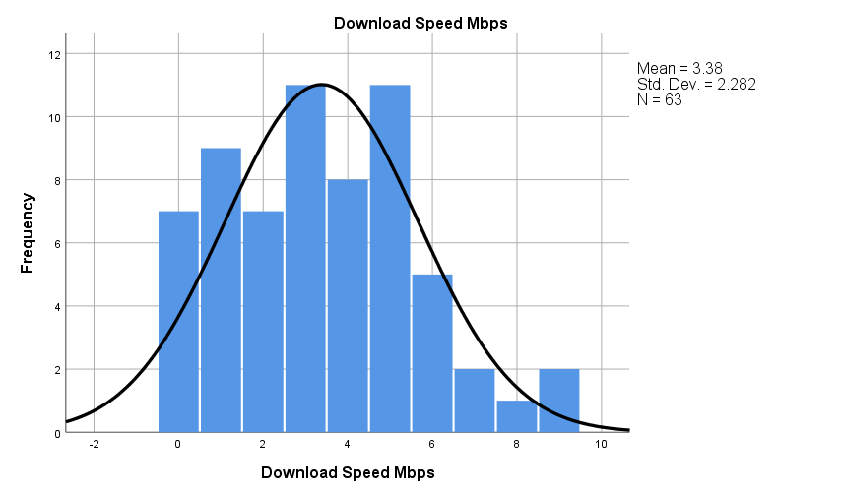
Figure 11. Histogram of participants internet speed.
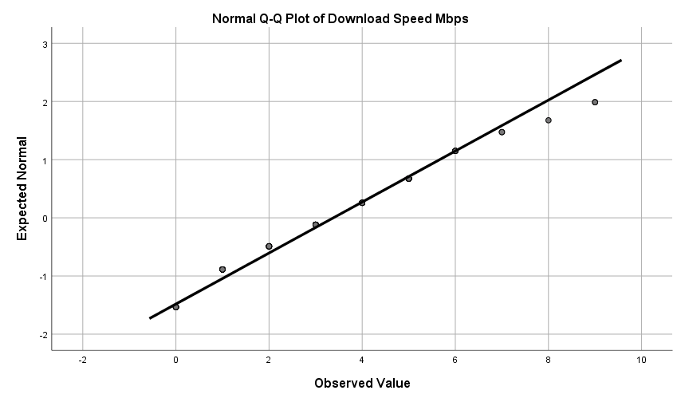
Figure 12. Histogram of participants internet speed.

A Shapiro-WiIk's test (p .05) and a visual inspection of their histograms, normal Q-Q plots and box plots showed that the students have an approximately normally distributed of internet speed, with a skewness of 0.386 (SE 0.302) and a kurtosis of - 0.311 (SE 0.595). See figures 11,12 and 13 (Berg, 2020).
Tests of Normality
 | Shapiro-Wilk
 | Statistic | df | Sig.
Download Speed Mbps | 0.952 | 63 | 0.015
a. Lilliefors Significance Correction
Figure 13. Normality test internet speed

Research conducted by Batez (2021) in China on 360 students looking into this area revealed that there are discrepancies between students' reported ICT skills and the ICT skills required for online education, with students estimating their ICT skills to be greater than what is required for online learning (p 0.05). There is also a connection among student satisfaction with online education and their ICT skills, indicating that students with more ICT experience are more comfortable with online learning (p 0.05)(Batez, 2021).
The advancement of knowledge literacy, digital creation, digital science, and digital identity management were all fields where students' self-assessment of digital competences fell short. Furthermore, students' technical competences have been found to be related to past encounters in their digital world in daily life. Students were more likely to develop high self-perceived digital competence in other digital fields relevant to their education if their self-perceived digital competence levels were higher based on coping with daily life digital activities.(Martzoukou et al., 2020). Students forced to study at home online will have a decline in their education.

Conclusion and Recommendations

The COVID-19 lockdown has caused major disruption to academic processes all around the world. The aim of this study was to identify the issues faced by students with the sudden switch to online education during this pandemic. Despite the fact that a large number of students use interactive tools for studying, many of them remain dissatisfied due to a variety of issues relating to the environment they have the study in.
Recommendation to the executive, policymakers, and governing bodies. A standardised academic strategy should be established for universities, colleges, and schools to maintain the learning process in the event of an emergency. During potential health crises, all educational institutions should have access to infrastructural facilities to regulate the automated learning process. To strengthen the education sector and provide instruction to stakeholders, suitable funding must be assured. To provide a supportive learning environment for students from the most disadvantaged sections of society, a tailored engagement approach is needed. The implementation of multi-pronged solutions to create an education infrastructure that is adaptable, which will safeguard capacity growth for young people's productivity, is a need of the hour. Since socioeconomic status is an important predicting the level of some satisfaction, students should be supported with grants to improve their socioeconomic status for access and usage.
The majority of educational institutions around the world have switched from traditional to online learning. The objective of this research was to determine student satisfaction with online learning as well as the factors that influence satisfaction. The findings showed that there is a connection between student satisfaction their level of education which is also linked to age. It has been determined that University students are more content with online education then when opposed to school age students. Having a suitable study environment is another important aspect that influences satisfaction.
This demonstrates that younger and lower level educated students need more care and assistance. As a result, high-class services that respond to the educational needs of younger students and students who are environmental challenged must be formulated to address access and utilisation issues. Many students' school years have been saved thanks to online schooling, and educational institutions around the world should incorporate an online learning curriculum into their programmes to cope with unexpected circumstances.

References

Acock, A. C., 2010. Analysis of variance. In: A Gentle Introduction to Statsa third edition. Los Angeles: Stata Press, pp. 201 - 241.
Ahrends, J. & Corban, L., 2021. New survey: Families lack digital tools for home learning and worry more about costs. [Online]
Available at: https://cpag.org.uk/news-blogs/news-listings/new-survey-families-lack-digital-tools-home-learning-and-worry-more-about
[Accessed 23rd March 2021].
Allen, M., Bourhis , J., Burrell, N. & Mabry, E., 2002. Comparing student satisfaction with distance education to traditional classrooms in higher education: A meta-analysis. The American Journal of Distance Education,. The American Journal of Distance Education, 16(2), pp. 83-97.
Badii, A. et al. (2014) ‘Non-Parametric Correlation and Its Application in Scientific Research’, International Journal of Good Conscience Agosto, 9(2).
Batez, M. (2021) ‘ICT skills of university students from the faculty of sport and physical education during the COVID-19 pandemic’, Sustainability (Switzerland), 13(4), pp. 1–13. doi: 10.3390/su13041711
BBC, 2021. Digital divide 'locking children out of education'. [Online]
Available at: https://www.bbc.co.uk/news/uk-england-55816686
[Accessed 24th March 2021].
Benesty, J. et al. (2009) ‘Pearson correlation coefficient’, in Springer Topics in Signal Processing. Springer Science and Business Media B.V., pp. 1–4. doi: 10.1007/978-3-642-00296-0_5.
Berg, R. G. v. d., 2020. Kendall’s Tau – Simple Introduction. [Online]
Available at: https://www.spss-tutorials.com/kendalls-tau/
[Accessed 12th May 2021].
Berg, R. G. v. d., 2020. SPSS Shapiro-Wilk Test – Quick Tutorial with Example. [Online]
Available at: https://www.spss-tutorials.com/spss-shapiro-wilk-test-for-normality/
[Accessed 12th May 2021].
Benesty, J. et al. (2009) ‘Pearson correlation coefficient’, in Springer Topics in Signal Processing. Springer Science and Business Media B.V., pp. 1–4. doi: 10.1007/978-3-642-00296-0_5.
Cherry, K. (2019) How Frequency Distributions Are Used In Psychology Research. Available at: https://www.verywellmind.com/what-is-a-frequency-distribution-2795187 (Accessed: 3 May 2021).
Dhawan, S., 2020. Online learning: A panacea in the time of COVID-19 crisis. Journal of Educational Technology Systems, 49(1), pp. 5-22.
Doyumğaç, İ., Tanhan, A. & Kiymaz, M. S., 2021. Understanding the Most Important Facilitators and Barriers for Online Education during COVID-19 through Online Photovoice Methodology. International Journal of Higher Education, 10(1), pp. 166-190.
ETI, 2020. SAFEGUARDING: Remote and blended learning challenges and approaches. [Online]
Available at: https://www.etini.gov.uk/sites/etini.gov.uk/files/publications/safeguarding-challenges-and-approaches.pdf
[Accessed 23rd March 2021].
Finger, L., 2020. How COVID Changed Our Classrooms? A Self-Experiment Of Online Teaching.. [Online]
Available at: https://www.forbes.com/sites/lutzfinger/2020/05/14/how-covid-changed-our-classrooms-a-self-experiment-of-online-teaching/?sh=6fbe52162c5d
[Accessed 27th March 2021].
Gillett-Swan, J., 2017. The Challenges of Online Learning Supporting and Engaging the Isolated Learner. Journal of Learning Design, 10(1), pp. 20-30.
Goldstein, D., 2020. Coronavirus Is Shutting Schools. Is America Ready for Virtual Learning?. [Online]
Available at: https://www.nytimes.com/2020/03/13/us/virtual-learning-challenges.html
[Accessed 22nd March 2021].
GOV.UK, 2001. Laptops and tablets data. [Online]
Available at: https://explore-education-statistics.service.gov.uk/find-statistics/laptops-and-tablets-data/2021-week-4
[Accessed 24th March 2021].
Hall, R. & Batty, D., 2020. 'I can't get motivated': the students struggling with online learning. [Online]
Available at: https://www.theguardian.com/education/2020/may/04/i-cant-get-motivated-the-students-struggling-with-online-learning
[Accessed 29th March 2021].
Hrastinski, S. (2008) ‘The potential of synchronous communication to enhance participation in online discussions: A case study of two e-learning courses’, Information & Management, 45(7), pp. 499–506.
Jaggars, S. S. & Xu, D., 2013. Predicting Online Student Outcomes From a Measure of Course Quality CCRC Working Paper No. 57). New York, Community College Research Center Teachers College, Columbia University.
Joyner, S. A. et al., 2014. The importance of student-instructor connections in graduate level online courses. Journal of Online Learning and teaching, 10(3), pp. 436-445.
Krupnick, M., 2020. Forced off campus by coronavirus, students aren’t won over by online education. [Online]
Available at: https://www.pbs.org/newshour/education/forced-off-campus-by-coronavirus-students-arent-won-over-by-online-education
[Accessed 25th March 2021].
Li, C. & Lalani, F., 2020. The COVID-19 pandemic has changed education forever. This is how. [Online]
Available at: https://www.weforum.org/agenda/2020/04/coronavirus-education-global-covid19-online-digital-learning/
[Accessed 29th March 2021].
Maria Airth (2020) How to Create a Good Study Space for Online Learning, Study.com. Available at: https://study.com/academy/popular/how-to-create-a-good-study-space-for-online-learning.html (Accessed: 30 April 2021).
Martzoukou, K. et al. (2020) ‘A study of higher education students’ self-perceived digital competences for learning and everyday life online participation’, Journal of Documentation, 76(6), pp. 1413–1458. doi: 10.1108/JD-03-2020-0041.

Mehall, S., 2020. Purposeful Interpersonal Interaction in Online Learning: What is it and How is it Measured?. Online Learning, 24(1), pp. 182-204.
Ofcom, 2020. Connected Nations 2020 UK report. [Online]
Available at: https://www.ofcom.org.uk/__data/assets/pdf_file/0024/209373/connected-nations-2020.pdf
[Accessed 24th March 2021].
Öksüz, E. E. & Brubaker, M. D., 2020. Deconstructing disability training in counseling: a critical examination and call to the profession.. Journal of Counselor Leadership and Advocacy, 7(2), pp. 163-175..
O'Loughlin, E., 2019. How To... Calculate Spearman's Rank Correlation Coefficient (By Hand). [Online]
Available at: https://www.youtube.com/watch?v=DE58QuNKA-c
[Accessed 12th May 2021].
Panigrahi, R., Srivastava, P. R. & Sharma, D., 2018. Online learning: Adoption, continuance, and learning outcome—A review of literature. International Journal of Information Management, Volume 43, pp. 1 - 14.
Parkes, M., Stein, S. & Reading, C., 2015. Student preparedness for university e-learning environments. Internet and Higher Education, Volume 25, pp. 1 - 10.
Paudel, P., 2021. Online Education: Benefits, Challenges and Strategies During and After COVID-19 in Higher Education. International Journal on Studies in Education, 3(2), pp. 70-85.
Price, L., 2006. Gender differences and similarities in online courses: Challenging stereotypical views of women. Journal of Computer Assisted Learning, 22(5), p. 349–359.
Protopsaltis, S. & Baum, S., 2019. Does online education live up to its promise? A look at the evidence and implications for federal policy. Center for Educational Policy Evaluation..
Ranganathan, S. et al. (2018) Encyclopedia of bioinformatics and computational biology, Encyclopedia of Bioinformatics and Computational Biology: ABC of Bioinformatics. doi: 10.1016/c2016-1-00174-8.
Rasmitadila et al. (2020) ‘The perceptions of primary school teachers of online learning during the covid-19 pandemic period: A case study in Indonesia’, Journal of Ethnic and Cultural Studies, 7(2), pp. 90–109. doi: 10.29333/ejecs/388.
Robson, D., 2020. From their academic success to their social skills and mental health, the pandemic is a crisis for today’s children – and the fallout may follow them for the rest of their lives.. [Online]
Available at: From their academic success to their social skills and mental health, the pandemic is a crisis for today’s children – and the fallout may follow them for the rest of their lives.
[Accessed 23rd March 2021].
Saad, L. & Busteed, B., 2013. In U.S., Online Education Rated Best for Value and Options Viewed as weakest in terms of trusted grading and acceptance by employers. [Online]
Available at: https://news.gallup.com/poll/165425/online-education-rated-best-value-options.aspx
[Accessed 30th March 2021].
Schleicher, A., 2018. PISA Insights and Interpretations. [Online]
Available at: http://www.oecd.org/pisa/PISA%202018%20Insights%20and%20Interpretations%20FINAL%20PDF.pdf
[Accessed 29th March 2021].
Serdyukov, P. & Sistek-Chandler, C., 2015. Communication, Collaboration and Relationships in the Online College Class: Instructors' Perceptions.. Journal of Research in Innovative, 8(1).
Shea, P. & Bidjerano, T., 2016. A national study of differences between online and classroom-only community college students in time to first associate degree attainment, transfer, and dropout.. Online Learning, 20(3), pp. 14-15.
Simone, E., 2020. Studying in times of COVID-19. [Online]
Available at: https://london.ac.uk/news-and-opinion/student-blog/studying-times-covid-19
[Accessed 24th March 2021].
Sistek-Chandler, C. M., 2020. Asynchronous/Synchronous Through Synchronous and Asynchronous Instructional Methods. In: P. Serdxukov, ed. Exploring Online Learning. Hershcy : IGI Global Information Science Reference, pp. 1 - 34.
Tanhan, A., 2020. COVID-19 Sürecinde Online Seslifoto (OSF) Yöntemiyle Biyopsikososyal Manevi ve Ekonomik Meseleleri ve Genel İyi Oluş Düzeyini Ele Almak: OSF’nin Türkçeye Uyarlanması.. Electronic Turkish Studies, 15(4).
UNCTAD, U. N. C. o. T. a. D., 2020. Coronavirus reveals need to bridge the digital divide. [Online]
Available at: https://unctad.org/news/coronavirus-reveals-need-bridge-digital-divide
[Accessed 29th March 2021].
Unicef, 2020. How COVID-19 is changing the world A statistical perspective, Volume I. [Online]
Available at: https://data.unicef.org/resources/how-covid-19-is-changing-the-world-a-statistical-perspective/
[Accessed 22 March 2021].
van Rooij, S. W. & Zirkle, K., 2016. Balancing pedagogy, student readiness and accessibility: A case study in collaborative online course development. The Internet and Higher Education, Volume 28, pp. 1 - 7.
Wang, C., Z, C., Yue, X. G. & McAleer, M., 2020. Risk Management of COVID-19 by universities in China. Journal of Risk and Financial Management, 13(2), p. 36.
Xu , D. & Jaggars, S., 2014. What We Know About Online Course Outcomes. Journal of Higher Education, 85(5, Sep-Oct)), pp. 633-659.
Yao, H. & Chen, J., 2020. Rethinking online mental health services in China during the COVID-19 epidemic. Asian journal of psychiatry, Volume 50, p. 102015.

Appendix 1

Questionnaire

Hi all, I am asking if any of you can help by taking part in my survey on education online. It should take no more than 5 minutes. It is for school and University students. If there is more than one student in your household it can be answered by all. It is anonymous so no worries there.
See attached link to take part.
Thank you in advance.

Has the sudden switch to online teaching made a negative impact on students’ education?

- Gender Male / Female

- What age rang do you fall into?
- Under 12 years old
- 12-17 years old
- 18-24 years old
- 25-39 years old
- 40-61 years old

- What is the highest degree or level of school you have completed?
- No schooling completed
- GCE’s/Equivalent
- University degree

- Do you have a suitable place/area to study at home? Yes/No

- What is your internet download speed? To check internet speed, see link. https://broadbandtest.which.co.uk/

- 5 - 7Mbps
- 8 – 15Mbps
- 16 – 23 Mbps
- 24 - 31 Mbps
- 32 - 39 Mbps
- 40 – 47 Mbps
- 48 – 55 Mbps
- 56 – 63 Mbps
- 64 – 71 Mbps
- 72 -79 Mbps

- Do you think your education at home has…?

- Improved
- Stayed the same
- Declined

- Do you think your education has suffered due to the swich to online education? Yes/No

- Do you have access to the internet…?
- 24hours
- 18
- 12
- 6
- Less than 6
- Other

- What positives did with the online education? Please tick the top 3.
- No travel times
- Much more comfortable
- Easier to concentrate
- Learn new technical skills
- Reduce your carbon footprint
- Self-paced learning

- Overall, how would you rate the experience of online education?
- Excellent
- Very good
- Good
- Fair
- Poor

