

Student Name: Mahabub Islam
Student ID: 2407067
Lecturer: Dian Mayasari
Programme: Master of Business Administration
Module: Marketing Management
Module code: LCMB7024
Word: 2667
Date of Submission: 19th November 2025

Table of Contents
Introduction 1
Element 1: Segmentation, Targeting, Differentiation, and Positioning (STDP) Analysis for a New Brand Concept of HP 2
Company & Brand Concept 2
STDP Analysis: 2
Element 2: Marketing Mix (4Ps) 4
Element 4: Reflection 8
1. Skills and Insights gained: 8
2. Consideration of pitch preparation and delivery: 9
3. Learning Outcomes and Challenges: 9
4. Future Improvements: 9
5. Overall Reflection: 10
Conclusion 11
References 12
Element 3: Appendix 13

Introduction
This report unveils the new sustainable printing brand of HP, EcoPrint, which is intended to fulfil the current business requirements by having an eco-friendly innovation. It examines strategic market segmentation, marketing mix, and value creation for the customer, and how HP balances between sustainability and profitability and changing consumer expectations.

Element 1: Segmentation, Targeting, Differentiation, and Positioning (STDP) Analysis for a New Brand Concept of HP

Company & Brand Concept
HP, Inc. is a multinational company that specialises in printing, personal computing, and imaging solutions. The new brand being proposed is HP EcoPrint, which is a print service managed carefully to suit the small and medium-sized enterprises (SMEs) in need of affordability and sustainability. This brand is a bundle of HP hardware, hardware subscription-based services, cloud analytics and supplies of the circular economy. New trends like the development of sustainable business activities and the development of subscription and remote/hybrid working environments contribute to the timeliness of this offering. To illustrate, according to the estimates, the managed print services market is predicted to reach UK 89.26 billion by 2030, due to sustainability requirements and digital processes (Grand View Research, 2024). In the meantime, HP focuses on minimising carbon footprint and paper waste, which are part of its Sustainable Impact programmes (HP Inc., 2024).

STDP Analysis:
1. Segmentation (S)
We segment the market by:
- Yearly turnover: SME (10-500 employees), mid-market (500-2,000 employees), large (>2,000 employees).
- Industry sector: professional services, education and healthcare, finance/banking, government/public sector.
- Location: North America (the largest portion), Europe, and Asia-Pacific (the highest growth rate) (Mordor Intelligence, 2025).
- Preferential service model: hardware acquisition, managed-print subscription, cloud/IoT-enabled solutions.
- Sustainability interest: high-ESG interest firms, moderate-ESG interest firms, and low-priority firms.
2. Targeting (T):
The main market is SMEs in professional services and education industries, based in North America and Europe, with 50-500 employees, cost-conscious, and interested in predictable operating budgets and dedicated to sustainability objectives. SMEs are an underserved niche in the managed print services and have a high-growth potential (Mordor Intelligence, 2025). These organisations do not always have complete in-house print-fleet knowledge and, as such, are interested in outsourced and smooth subscription services with a well-known brand, such as HP. Mid-market companies (500-2,000 employees) with explicit ESG requirements will serve as a secondary target, while the primary focus is on SMEs in the go-to market.
3. Differentiation (D):
The differentiations made by HP EcoPrint include:
- A sustainability-focused offer: recycled-content materials, carbon-neutral print-on-demand services, transparent waste/reduction status reports – based on the sustainability history of HP (HP Inc., 2024).
- A full-service model subscribed to with a single payment: equipment, materials, monitoring, analytics and automatic refill – one fee with no hardware purchases required, and no individualised services as is the case with the competitors.
- AI/IoT-powered analytics/workflow: real-time usage, mobile/remote printing, predictive supply replacement and device diagnostics – increasingly demanded with the trend of hybrid work (Mordor Intelligence, 2025).
- Established brand and international presence: The credibility and trust of the HP brand and international network services bring credibility and trust.
- SME-friendly design: The EcoPrint is designed with large businesses in mind: it is simplified, scalable, has a transparent ROI, and is a product targeted at smaller companies.

4. Positioning (P)
Positioning statement:
- The HP EcoPrint is the managed-print subscription service, delivering HP-quality hardware, cloud-accelerated analytics and circular-economy supplies to small and medium businesses that want to reduce print expenses, waste and old hardware, unlike conventional print-fleet approaches that impose on you the unseen costs, waste and obsolete hardware.
EcoPrint has been positioned as the cost-optimised and sustainable managed print service for SMEs in the market. The brand promise is focused on being ESG-compliant and operationally efficient instead of being the cheapest printer only. Essential features Sustainable, trustworthy, efficient, transparent, hassle-free. The competitor base consists of the conventional print hardware vendors, other managed print service providers, and in-house IT departments. EcoPrint is differentiated on the basis of integrating sustainability, subscription ease and higher analytics under the trusted brand HP. The marketing strategy will focus on the cost-saving aspect (cut print volume up to 40%), sustainable impact (cut paper waste and carbon footprint), simple onboarding, and monthly prices. First pilot offers (e.g., 3-device Starter Kit + analytics trial + sustainability report) will create the case studies and will transform into full subscriptions.

Element 2: Marketing Mix (4Ps)
The table below is the marketing mix (4Ps) of the new proposed brand HP EcoPrint in line with the overall brand strategy.
1. Product
HP EcoPrint is an edible-print service providing a combination of hardware, consumables, analytics on the cloud, and sustainability options in a subscription package. The physical aspect involves the energy-efficient printers and multi-function devices of HP that are produced with recycling materials and rewrapped to be reused by the circular economy (HP Inc., 2024). The service element offers monitoring of the fleet, automatic supplies refill, cloud/IoT analytics on the use pattern, and sustainability reporting (HP Inc., 2024). Such a product approach is aligned to the trend of as-a-service models and the sustainability requirement: the global managed-print services (MPS) market is expected to have UK 89.26 billion in 2030, with a CAGR of about 10.1% in 2024 (Grand View Research, 2024). We can create value for the customer by making EcoPrint more than just hardware by positioning EcoPrint as a full-service solution instead of merely hardware, which is control of costs, ease of use and less harmful to the environment. It is targeting SMEs, and the product will have ten-tier options (such as a 3-device starter kit, a 5-device standard, and a 10-device advanced) to expand and demonstrate clear ROI. Other product details: secure print release, remote/mobile printing (essential in hybrid working), consumables recycling/drop-off and certified carbon-neutral print (HP Inc., 2020). These characteristics support the brand differentiation (sustainability + subscription + analytics) and the positioning as the cost-optimised, managed-print service, which is sustainable for SMEs.
2. Price
EcoPrint uses a subscription-based tier model. A subscription fee covers hardware lease/rent, supplies, monitoring and support, and a sustainability report. Based on fleet size and service level, price is Starter (3 devices), Business (5 devices), Growth (10 devices), or Enterprise (15+ devices). The subscription model meets consumer need for predictable costs and shifts capital expense (hardware) to operating expenditure. Market study shows that cloud pricing, hybrid, and subscription models fuel managed print services growth (Mordor Intelligence, 2025). The monthly fee includes volume-based use restrictions (e.g., 1,000 pages per device) with usage overages and simple upgrade options, which is a huge concern with clients. The price campaign reflects the brand's value proposition: affordable, eco-friendly, and simple. In the beginning, incentives like a free 3-month trial with analytics and a sustainability impact report may encourage adoption. Premium support, comprehensive analytics dashboard, and carbon-offset certification may also be offered as freemium upgrades. The pricing should reflect HP's premium brand position and provide a cost advantage over unmanaged printing. The margin model benefits from consumables resale, service contracts, and data analytics, which provide recurring income.
3. Place
HP's worldwide printing supply chain, channel partner network, and cloud infrastructure will power EcoPrint distribution and service delivery. The HP reseller/distributor system will provide hardware, qualified HP channel partners will configure and onboard, and HP or partner service centres will monitor, analyse, and satisfy supplies. The go-to-market strategy will concentrate on direct + partner hybrid: HP direct to major clients and channel partners to SMEs, with local responsiveness and managed onboarding. Remote cloud-based monitoring makes the portal/dashboard digital and supply shipping automated. HP will provide a plug-and-play solution with remote services and no on-site installation for SMEs, who value ease and minimal IT costs. Due to its worldwide reach, HP enjoys dependability and reach benefits. HP will utilise logistic businesses to recycle spent cartridges, contributing to the circular economy. Thus, physical hardware, local service support, digital dashboard accessibility, and worldwide fulfilment provide the brand promise of hassle-free sustainable print management.
4. Promotion
EcoPrint will appeal to SMEs and investors, highlighting cost management, sustainability, and HP. Potential 40% printing cost savings is a serious concern. Use your print fleet for ESG, forecastable monthly cost, and zero-waste printing. Digital marketing will include white papers, case studies, and blog posts that demonstrate managed print service ROI and sustainability, which is relevant given industry growth and ESG drivers (Grand View Research, 2024). Channels: HP website, webinars, LinkedIn SME decision-makers (IT manager, operations manager, sustainability officer), trade fair (workplace solutions, sustainability forum). HP reseller co-branding and webinars for partner promotion. Pilot programs will serve as promotional proof points (e.g., Customer X saved US$Y in year one and decreased paper consumption by 33%). PR and thought leadership: HP PR releases emphasise sustainability (HP Inc., 2024), therefore EcoPrint will fit in to provide credibility. Incentives: referral program, free pilot trial, device rollout loyalty awards. Customers' old printers can be traded in for discounts on the initial subscription fee. Monthly dashboard reports including print consumption, trash reduction, cost savings, and carbon offset figures may be utilised as retention programs and give marketing narratives to consumers. Thus, the promotion strategy supports differentiation (sustainability + analytics), positioning (the sustainable, cost-optimized print partner), and audience demands (cost-efficient, ESG-aligned SMEs).
Brand Strategy Alignment:
All 4Ps will support EcoPrint's brand approach. A sustainable, subscription-based solution that addresses consumer pain points (unnoticed print prices, waste, complexity) and utilises the managed print services industry achieves product fit (Grand View Research, 2024; Mordor Intelligence, 2025). The pricing model simplifies services and provides a predictable monthly cost, supporting value. Place component uses HP network and digital service supply for ease, dependability, and scalability, which SMEs need. The marketing clearly communicates cost savings and ESG effect and uses modern corporate sustainability, remote work printing, and service plan trends. EcoPrint connects the four factors, making it unique in a competitive market where sustainability, digital transformation, and service-based business models are growing.
Implementation Considerations:
HP must train reseller partners in the subscription model (no longer using hardware sales incentives), establish cloud/analytics infrastructure (usage data, predictive supplies fulfilment, sustainability measurements), design explicit pricing levels and pilot offers to SME segments, develop marketing content that emphasises cost and sustainability, and establish consumable recycling logistics. Subscriber growth, churn rate, print volume reduction, paper waste reduction, corporate carbon footprint, and renewal rate should be KPIs. Since SMEs may lack internal IT/print-fleet competence, onboarding and customer success should prioritise simplicity, speed, and ROI. Flexible pricing must be regional. To gain SME trust, case studies and endorsements are essential. HP Inc. (2024) provides the required credibility with its sustainability credentials.
Finally, HP EcoPrint's marketing mix will support the brand's mission of providing SMEs with viable and sustainable cost-effective managed print solutions. A inefficient and costly printing facility becomes an efficient ESG-based service with the product. New client preferences are met via subscription pricing. The multi-channel location approach scales delivery and service. Promotion is a believable, segmented value narrative. These 4Ps provide a single EcoPrint go-to-market, which should help HP expand in managed print services and add customer and investor value.

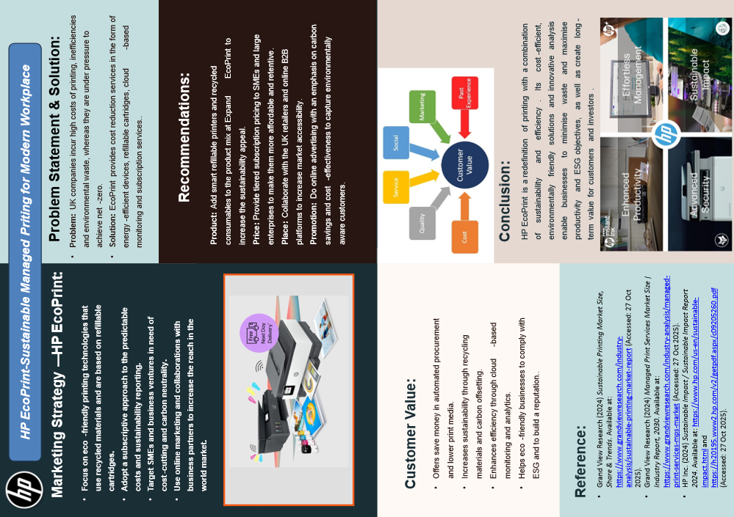
Element 3

Element 4: Reflection
Transformative learning occurred throughout HP EcoPrint's brand idea and marketing strategy development. The procedure improved my strategic marketing knowledge and gave me professional and analytical abilities.
I was thrilled and challenged to create a new brand for HP, an international firm. Marketability and creativity have to be balanced. I had to make certain decisions to have the proposed EcoPrint brand meet a consumer need for a sustainable, cost-effective, and environmentally friendly printing solution and match HP's corporate values and long-term sustainability goals.

1. Skills and Insights gained:
During this project, I have acquired a variety of skills: strategic analysis, creativity, and professional presentation skills.
- Strategic thinking:
I learnt to use the STDP framework (Segmentation, Targeting, Differentiation, and Positioning) to identify prospective markets and create a clear brand statement.
- Analytical skills:
Accurate market data from Statista, Gartner, and HP sustainability reports enhanced my ability to apply trends and consumer insights.
- Development of a marketing strategy:
To develop a marketing plan, I gained understanding of the marketing mix (4Ps). A pricing approach based on perceived environmental value helped position items and brands.
- Communication and persuasion:
Practiced and presented marketing pitches to improve confidence in public speaking and persuasion. I learnt to simplify complex ideas into engaging stakeholder presentations.

2. Consideration of pitch preparation and delivery:
Presenting the marketing pitch was one of the characteristics of this experience. Initially, the fear of expressing my ideas under time pressure intimidated me. Nevertheless, I was able to work out my structure and style of delivery after several rehearsals and peer feedback sessions.
- I understood the need to tell a story in the process of making a brand idea memorable.
- Visual elements, including graphics to explain sustainability metrics, facilitated the audience's appeal.
- I learnt to approach potential investors with initiative, particularly when they enquire about the market's viability and differentiation.
During this process, I also learnt that clarity and confidence often prevail over technical jargon when arguing with a business audience.

3. Learning Outcomes and Challenges:
The biggest challenge was balancing originality and reality. I first prioritised creativity above prices and technology. I changed my approach and created an ambitious and viable brand after further study.
Time management was another issue, especially when obtaining secondary data. I also realised the need of a research log and SWOT and PESTLE frameworks to organise material.

4. Future Improvements:
In case I wanted to do the same project in the future, I would:
- I would do primary research, such surveys or interviews, to better understand customer sentiments towards sustainable technologies.
- I would improve my data visualisation skills to provide more complicated market insights.
- Appeal to listeners using story-driven pitching strategies.
- Collaborate with individuals from diverse academic or cultural backgrounds to get diverse perspectives.

5. Overall Reflection:
Overall, this project allowed me to combine new brand thinking with evidence-based strategy. It also highlighted the necessity to include ethical and environmental factors in marketing choices like product creation and promotion.
Above all, I gained confidence in my ability to communicate strategic ideas clearly and persuasively. The experience has given me critical awareness, adaptability, and leadership for future marketing efforts.

Conclusion
All in all, the proposed HP EcoPrint brand will be able to incorporate sustainability and innovation to satisfy the increasing need for printing environmentally friendly solutions. The brand determines the strength of the market position of HP through the use of strategic marketing, differentiation, and creation of customer value, besides supporting long-term environmental and ethical objectives.

References
Grand View Research (2024) Managed Print Services Market Size | Industry Report, 2030. Available at: https://www.grandviewresearch.com/industry-analysis/managed-print-services-mps-market (Accessed: 27 October 2025).
HP Inc. (2024) 2024 Sustainable Impact Report. Available at: https://h20195.www2.hp.com/v2/getpdf.aspx/c09205260.pdf (Accessed: 27 October 2025).
Mordor Intelligence (2025) Managed Print Services Market Size, Growth Drivers 2025. Available at: https://www.mordorintelligence.com/industry-reports/managed-print-services-market (Accessed: 27 October 2025).
Grand View Research (2024) Managed Print Services Market To Reach $89.26 Bn By 2030. Available at: https://www.grandviewresearch.com/press-release/global-managed-print-services-mps-market (Accessed: 27 October 2025).
Mordor Intelligence (2025) Managed Print Services Market Size, Growth Drivers 2025-2030. Available at: https://www.mordorintelligence.com/industry-reports/managed-print-services-market (Accessed: 27 October 2025).
HP Inc. (2020) HP Advances Sustainable Printing with Managed Print Service. Available at: https://www.hp.com/us-en/newsroom/press-releases/2020/hp-advances-sustainable-printing-with-managed-print-service.html (Accessed: 27 October 2025).

