Object Analysis: Pillar of the Boatmen
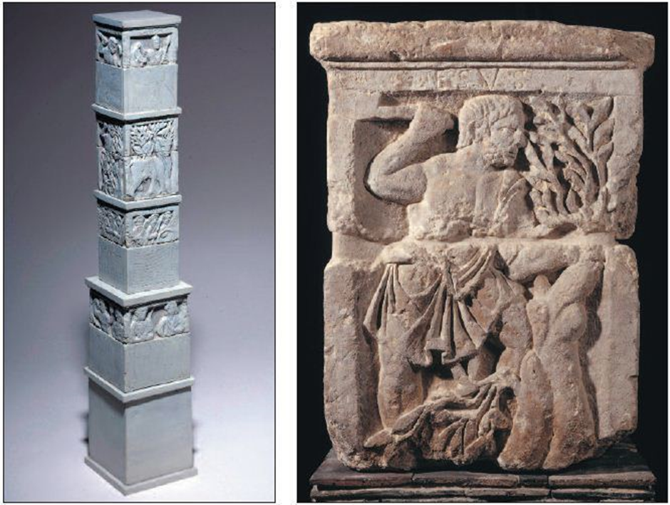
Figure 1. Varma. Pillar of the Boatmen. [Photograph]. Alchetron (2018)
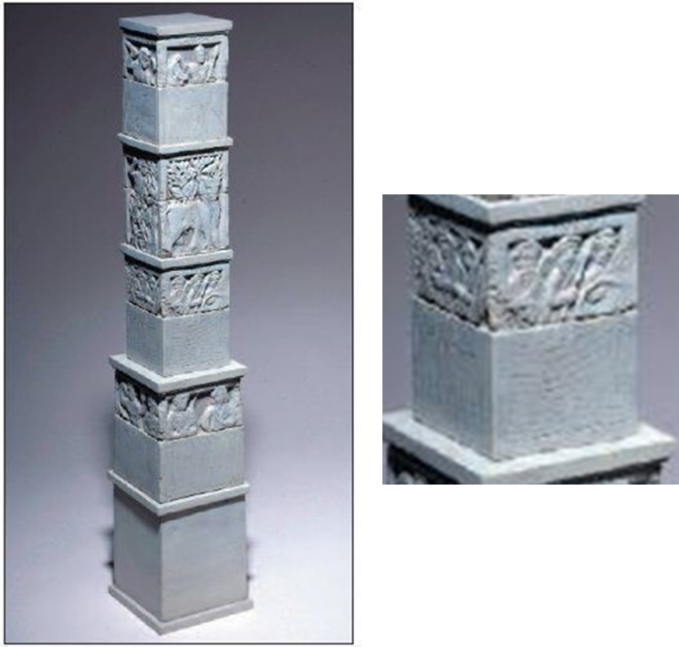
Figure 2. Varma. Pillar of the Boatmen. [Photograph]. Alchetron (2018)

The Principate system that Augustus installed during his rise to power ushered in many changes towards Roman policy. Specially, its management of the various provinces within its boundaries, as well as the lifestyle of the populace. However, the Principate also caused a change in not only the political aspect of Roman society but also that of the cultural and religious domain . The issue for modern scholars is understanding this change in the religious aspect of local cultures due to the contemporary lack of local literary sources. The few sources that we have are mostly Roman and provide an external view which helps little in understanding local cultures and their belief systems.
The Pillar of the Boatmen however provides us with a unique insight into the religious understanding and change that had occurred within the province of Gallia Lugdunensis during the Principate period. The reason for this is because the Pillar of the Boatmen can provide insight into the local culture for two primary reasons. Firstly, it was erected in the Roman city of Lutetia (modern day Paris) by a local guild of boatman in the first century AD during the reign of the Emperor Tiberius, thus providing a local contemporary perspective of their religious beliefs. Secondly the Pillar has present on it a number of deities that are both ‘Roman’ and local. Given the Pillar’s origin and commission these would have been chosen by the local boatman and therefore reflected to some degree their Religious beliefs and understanding . This work as a result of this unique insight will examine key areas of the Pillar of the Boatman namely, the chosen Gods that were placed on the Pillar and that of the manner in which they Gods were depicted.

Originally the object stood at about five meters in height, just under one meter in width at its base and approximately with a width of 0.75 meters at its apex and is constructed from limestone that was quarried from a local source. The Pillar itself consisted of four tiers with a total of 16 panels. The top and bottom tiers are discernible due to their size, however the exact rotational order is not known and there is some speculation that they may not have been stacked as shown in figure 1, and existed instead as two altars of similar size . Although the exact ordering and placement of the stones cannot be known, the Pillar was obviously of high quality and the cost of its commission would have been great and therefore was of great important to the work’s patrons . The cost of the work infers that the significance of the Gods’ chosen would have been reflective of the deities’ importance to that local community within Lutetia, and which deities it was important to honour in the local belief system since the instigation of the Principate. Charniguet and Lombard-Jourdan remark that the power and wealth of the guild is reflected in a panel on the pillar. This panel depicts the patrons parading with arms and weapons as shown in figure 2, bearing arms was a privilege granted by the Romans and is reflecting the fact that the patrons were both trusted as well as connected to the Roman governing system . The Pillar of the Boatmen then becomes representative of this new system of belief that has been created within this area of Gallia Lugdunensis since the Principate system was begun. This is because the patrons as indicated by the panel have been integrated into the new Roman system sufficiently enough to be granted a major privilege whilst retaining their belief in local deities. Therefore, the Pillar of the Boatmen becomes a microcosm of the new belief system and a structure of dedication that is existed within this area of Gallia Lugdunensis, with the Guild of the Boatmen representing the ‘Gallic people’ who have embraced both Roman rule and the Principate system.

The Pillar of the Boatmen also demonstrates that local belief systems that existed before the Roman conquest continued within the province of Gallia Lugdunensis. This is shown by the presence of the Gallic deities Cernunnos, Smertrios, Esus and Tarvos Trigaranos all of which are depicted on separate panels indicating that each one was individually important to the local belief system, and were chosen for their importance by the Guild of Boatmen . The Pillar also includes Roman deities such as Jupiter and Vulcan who are depicted in a fairly Roman style version, the God Mars is also present standing next to a female deity who has large round ear rings and flowing garment positioned over one shoulder which maybe have the Goddess Venus . The inclusion of these deities are clear indicators that the Principate system has not replaced the local belief system, but that the local population have creolised their belief system with the Roman’s keeping their local deities but also accepting Roman deities and practices into their belief system. The Pillar also has an inscription dedicating it to the Emperor Tiberius and the God Jupiter on behalf of the Guild of Boatmen. This important because the inscription is in Latin and follows the typical Roman style of a dedication inscription . This means that within this area the local population had accepted the Roman style of dedication to the Emperor and the use of Latin for offerings to the Gods but with their own deities present as well.

The depictions of the gods and the inscriptions depicting who they are demonstrates the current belief system in place, and changes that have come in the Gallic belief as well during the Principate period. The key feature of interest with the Pillar of the Boatmen is that Gallic deities are present without a Roman connotation or associations with their own Gallic names, and are depicted in a more Gallic than Roman style. The primary Gallic god of interest to modern scholars is that of Cernunnos the ‘Horned God’ within the Celtic belief system. Cernumnos is of great interest because this depiction of Cernumnos is the only one with an accompanying inscription naming the god as Cernumnos. The name itself is non-Roman and is Gallic in origin meaning that what is present on the Pillar of the Boatmen is an entirely Gallic deity being depicted in a creolised fashion but under its original name . The depiction and naming of Cernumnos is a strong indication that unlike the perception that is usually presented of the Gallo-Romano culture in the Principate system of it being nearly entirely a form of Interpretatio romana such as Pollini presents in his work on Gallo-Romano religion . This situation according to this model as Pollini presents, should be that Gallic deities are interpreted by the Romans and then either named using a Roman deity’s name or creating a new composite deity and that is the situation that we should find on the Pillar of the Boatmen. This is simply not the case. A prime example of this is that of the Gallic deity Smertrios, who is was equated with the Roman god Mars, evidence of this interpretation can be seen at a spring sanctuary near Trier, which was dedicated to ‘Mars Smertrios’ . The Pillar of the Boatmen however clearly, shows Smertrios being worship separately form that of Mars at least during the period when the pillar was constructed, as evidence that Mars and Smertrios are depicted on two completely separate panels and Smertrios is depicted with his name as shown in figure 1 .
The Pillar of the Boatmen then is of great importance for understanding the religious nature within a Province during the Principate period as it provides unique insight into the local understanding and interpretation of religion. It demonstrates that local belief systems were not destroyed nor were they completely amalgamated into the Roman belief system or reinterpreted to fit into Roman understanding. What occurs is that of unique creolised system of belief, the new Roman deities that have been introduced do not supplant the local deities, but are accepted into the belief system and worshiped amongst the population. The other aspect of this creolised system is the accepting of Roman style use of dedications and Latin that has grown under the Principate model, local deities continued to be worshiped but this new form of worship was now being used by the local to express their beliefs . The Pillar of the Boatmen therefore is a microcosm of the new creolised belief system that has occurred in the city of Lutetia and the province of Gallia Lugdunensis. It shows that the local deities are still worshiped along with Roman deities within a new form. Therefore, this creolisation is not a directed effort on anyone party’s part but a result of greater interaction and the integration of the local population into a larger more structured system with the introduction of the Principate.

Bibliography

Modern Scholarship
Bober, P. F. (1951.) “Cernunnos: Origin and Transformation of a Celtic Divinity.” American Journal of Archaeology, vol. 55, no. 1, pp. 13–51.
BUSSON, D. (1998). Carte archéologique de la Gaule 75, 75. Paris, Ed. Acad. des Inscriptions et Belles-Lettres.
Charniguet, A and Lombard-Jourdan, A. (2009.) Cernunnos, Deer god of the Gauls. France, Paris: LAROUSSE.
de Libero, L. (2006.) “Principate.” Available at: https://referenceworks-brillonline-com.ezproxy.uwtsd.ac.uk/entries/brill-s-new-pauly/principate-e1008720?s.num=0&s.f.s2_parent=s.f.book.brill-s-new-pauly&s.q=principate [Accessed: 27/02/2019]
Green, M. J. (1992.) Dictionary of Celtic Myth and Legend. United Kingdom, London: Thames & Hudson
Haussler R. (2012.) Interpretatio Indigena. Re-Inventing local cults in a global world. mediterraneo antico xv,1-2 pp. 143-174
Höcker, C. (2006.), “Pillar, monumental” Available at: https://referenceworks-brillonline-com.ezproxy.uwtsd.ac.uk/entries/brill-s-new-pauly/pillar-monumental-e12224520?s.num=0&s.f.s2_parent=s.f.book.brill-s-new-pauly&s.q=Pillar+of+the+Boatmen [Accessed: 27/02/2019]
Jufer, N. and Luginbühl, T. (2001.) Les dieux gaulois: répertoire des noms de divinités celtiques connus par l'épigraphie, les textes antiques et la toponymie. France, Paris: Editions Errance.
Koch, J. (2006). Celtic Culture: A Historical Encyclopedia. Unites States, California: ABC-Clio Inc.
Pollini, J. (2002.) Gallo-Roman Bronzes and the Process of Romanization: The Cobannus Hoard, in series Monumenta Graeca et Romana. Netherlands, Leiden: Brill Publishing
Saragoza, F. (2003.) "Le Pilier des nautes retrouvé". Archéologia 398. pp. 15-27
Varma, P. (2018.) Pillar of the Boatmen. [Photograph]. Alchetron. Available at: https://alchetron.com/Pillar-of-the-Boatmen [Accessed: 11/03/2019]

de Libero 2006
Saragoza 2003: 15-20
Saragoza 2003: 15-17
Höcker 2006
Charniguet and Lombard-Jourdan 2009: 13-19
Bober 1951: 14-30
Busson 1998: 450-460
Bober 1951: 13-20
Koch 2006: 395-397
Pollini, J. 2002: 90-126
Jufer, N. and Luginbühl, T. 2001
Busson 1998: 450-460
Haussler 2012: 144-150

