

Academic Report
Module Name: Introduction to Public Health.

Module Number: LCHS4008.
Student Name: Gillian Gibbs (2508019).
Lecturer Name: Ziko Shepherd.
Submission Date: 21 April 2026.

Confidentiality Statement:
This document is intended for internal use and should not be distributed without permission.
Abstract:
This report provides a comprehensive analysis of stroke, focusing on its measurement, monitoring, and control. Key determinants and risk factors are explored, alongside public health consequences and strategies to support health and well-being.
Stroke: A Public Health Report

Table of Contents
Introduction 1………………………………………..4
Measurement, Monitoring and Control of Stroke 1…..4
Key Determinants and Risk Factors 1………………….7
Public Health Consequences of Stroke 1……………….9
Strategies to Support Health and Well-being 1…………..10
Conclusion 1………………………………………………….11
References 1.…………………………………………………..12

Introduction
A stroke is a dangerous non-communicable disease that happens when the blood supply to the brain is cut off, causing damage or death to brain cells. It is often divided into two types: haemorrhagic stroke, which is brought on by bleeding inside the brain, and ischaemic stroke, which is brought on by a blockage in arteries. Stroke represents a major global health burden, with approximately 12.2 million incidences occurring annually worldwide (World Health Organisation, 2023). In the United Kingdom (UK), over 100,000 individuals experience a stroke yearly, noted as the fourth leading cause of death and long-term disability (Stroke Association, 2024). Common signs and symptoms include sudden unilateral body weakness, aphasia, confusion, and visual disturbances, often identified using the FAST (Face, Arms, Speech, Time) framework (Warlow et al., 2019; NHS, 2024). Despite advances in treatment, stroke continues to impose significant health and economic challenges. This report critically examines the measurement, monitoring and control of stroke, explores its key determinants, and evaluates strategies to improve health and well-being.

Measurement, Monitoring and Control of Stroke

Key epidemiological factors, including incidence, prevalence, mortality, and morbidity rates, are used to measure stroke. While prevalence is the total number of people who previously had a stroke, incidence is the number of new cases within a specified time frame. Mortality rates measure stroke-related deaths, whereas stroke-related long-term impairment and lower quality of life are reflected in morbidity. (Bonita et al., 2020). In the UK, approximately 38000 stroke-related deaths occur yearly, and 1.4 million stroke survivors now live with the effects of stroke (Stroke Association, 2024).

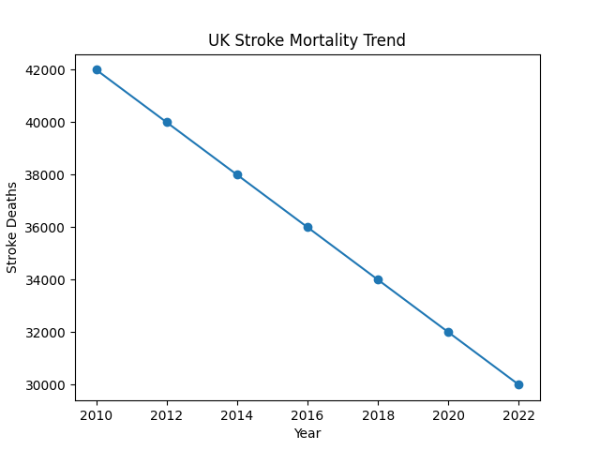
Figure 1: UK Stroke Mortality Trend (2010–2022)
(Source: Adapted from Office for National Statistics, 2023)

While these measures are essential for understanding the scale of the disease, they often fail to capture the wider socio-economic burden. Therefore, additional indicators, such as disability-adjusted life years and healthy life expectancy (DALYs/HALEs), are increasingly used to assess broader impact (Ferrari et al., 2024; Murray, 2022).
In the UK, stroke is monitored through national systems such as NHS Digital and the SSNAP (Sentinel Stroke National Audit Programme), which collect detailed data on patient outcomes and service performance. These systems allow healthcare providers to evaluate the quality of care and identify regional disparities (SSNAP, 2021). However, limitations exist, including potential underreporting and variations in data collection, particularly among disadvantaged populations. This can lead to an incomplete understanding of the true burden of stroke.
Globally, stroke monitoring is supported by the World Health Organisation, although inconsistencies in reporting standards between countries can reduce comparability. This is particularly evident in low- and middle-income countries, where limited healthcare infrastructure can affect data accuracy (Feigin et al., 2021).

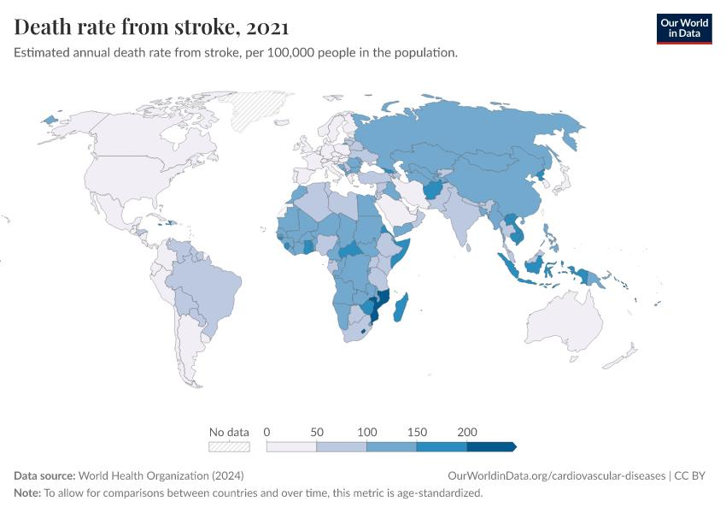
Figure 2: Global Death Rate from Stroke per 100,000 Population (2021)
(Source: Reproduced from World Health Organisation,2024; Our World in Data, 2024)

The control of stroke is guided by the “3 Ps” of public health: prevention, protection and promotion. Prevention strategies focus on reducing modifiable risk factors such as hypertension, smoking and poor diet. Research shows that controlling blood pressure alone could prevent a significant proportion of strokes (O’Donnell et al., 2016). However, prevention efforts are often limited by socioeconomic inequalities that restrict access to healthy lifestyles.
Protection involves early detection and rapid treatment, including emergency stroke services and thrombolysis. Public awareness campaigns such as FAST have improved recognition of symptoms, but delays in seeking medical help remain a challenge (Bray et al., 2018). Promotion focuses on long-term health education and policy initiatives designed to improve population health. While these strategies have reduced mortality rates, increasing prevalence due to ageing populations continues to place pressure on healthcare systems.

Key Determinants and Risk Factors
Stroke is influenced by a combination of non-modifiable and modifiable risk factors, as well as broader social drivers of health. Non-modifiable factors include age, gender, genetics and ethnicity. Age is the most significant factor, with stroke risk increasing significantly after 55 (Dahlgren and Whitehead, 1991; Feigin et al., 2024).
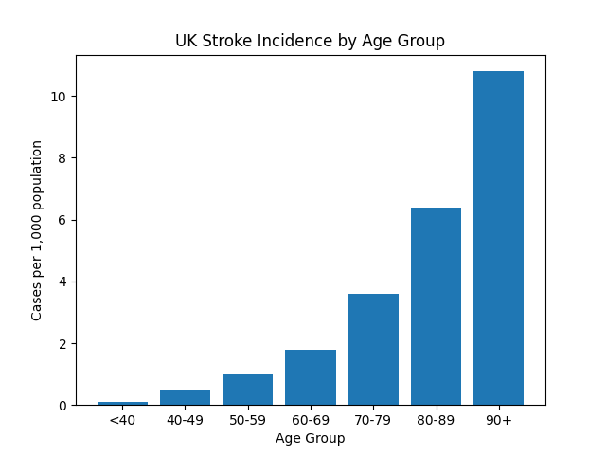

Figure 3: UK Stroke Incidence per 1,000 Population by Age Group
(Source: Adapted from Stroke Association, 2024; Office for National Statistics, 2024)

Although men are more likely to experience stroke, women often face worse outcomes due to longer life expectancy and different risk profiles. Genetic predisposition and ethnicity also play a role, with certain groups at higher risk due to both biological and environmental factors (Feigin et al., 2021; Zeraatiannejad et al., 2024).

Modifiable risk factors such as individual lifestyle, poverty, education, housing quality and employment are central to prevention strategies. Hypertension is the most significant, contributing to both ischaemic and haemorrhagic strokes (Feigin et al., 2024; O’Donnell et al., 2016). Smoking damages blood vessels and increases clot formation, while excessive alcohol consumption raises blood pressure. Obesity and physical inactivity are linked to conditions such as diabetes, which further increase stroke risk. Poor diet, particularly high salt and fat intake, also contributes to hypertension and cardiovascular disease.

However, focusing solely on individual lifestyle choices overlooks the influence of wider non-medical health drivers. Factors such as income, education and access to healthcare significantly affect exposure to risk factors and the ability to manage them. Individuals from lower socioeconomic backgrounds are more likely to experience higher rates of smoking, poor nutrition and limited access to preventive care (Marmot et al., 2020). Environmental factors, including access to healthy food and safe spaces for physical activity, further influence health behaviours.
Critically, the World Stroke Organisation (2025) emphasises that public health interventions that focus solely on behaviour change may be insufficient if structural and social inequalities are not addressed. Therefore, reducing stroke incidence requires a comprehensive approach that combines individual-level interventions with broader population-wide policy measures to improve socioeconomic conditions.

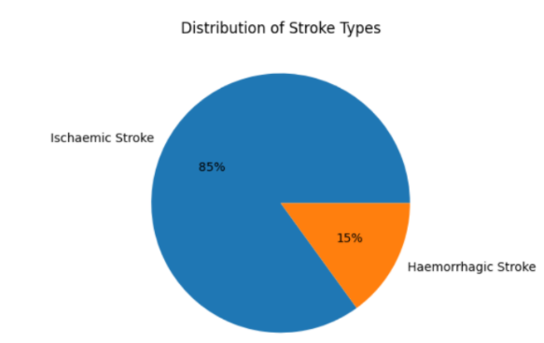
Figure 4: Distribution of Stroke Types (Ischemic and Haemorrhagic Stroke).
(Source: Adapted from World Health Organisation, 2024; Stroke Association, 2024.)

Public Health Consequences of Stroke

Stroke has significant short- and long-term consequences for individuals, communities and healthcare systems. In the short term, stroke can cause severe neurological impairments, including paralysis, speech difficulties and cognitive dysfunction, often requiring immediate hospitalisation. Although advances in treatment have improved survival rates, this has resulted in more individuals living with long-term disabilities (Feigin et al., 2025).
Ongoing consequences include reduced mobility, chronic health conditions and psychological effects such as depression and anxiety. These outcomes can significantly reduce quality of life and increase dependence on caregivers (Hackett and Pickles, 2014). Many stroke survivors require ongoing rehabilitation and support, placing emotional and financial strain on families.
At a societal level, stroke contributes to reduced workforce participation and productivity. This has wider economic implications, particularly when individuals are unable to return to work. In the UK, stroke places a substantial financial burden on the NHS and social care services (Stroke Association, 2024).
Healthcare systems face increasing pressure due to ageing populations and improved survival rates. This increases demand for acute care, rehabilitation services and long-term support. Without effective prevention strategies, the burden of stroke is likely to continue rising, highlighting the importance of sustainable healthcare planning (World Stroke Organisation, 2025).

Strategies to Support Health and Well-being
Supporting individuals affected by stroke requires a multidisciplinary and holistic approach. Rehabilitation is a key component of recovery, involving physiotherapy, occupational therapy and speech and language therapy. Evidence indicates that early and appropriately intensive rehabilitation significantly improves functional outcomes, independence, and activities of daily living (Langhorne et al., 2017; Wei et al., 2024). However, access to these services is not always equitable, leading to disparities associated with socioeconomic status, geography and broader healthcare factors, resulting in unequal recovery (Chavez et al., 2024).
Community-based integrated support plays an important role in promoting long-term well-being. Services provided by organisations such as the Stroke Association offer emotional support, education and practical assistance to help individuals adjust to life after stroke. Such services are particularly important in addressing the psychological and social consequences of the condition (NICE, 2023; NHS England, 2022).
Preventive strategies are essential in reducing the risk of recurrent stroke. These include lifestyle changes such as improved diet, increased physical activity and smoking cessation, alongside medical management of conditions such as hypertension and diabetes (O’Donnell et al., 2016; Bushnell et al., 2024). However, maintaining these changes can be challenging without ongoing support.
Public health campaigns continue to raise awareness of stroke symptoms and encourage early intervention. While these campaigns have been effective, their impact varies across different population groups (Bray et al., 2018). Therefore, targeted culturally appropriate interventions are needed to ensure wider reach and effectiveness.
To improve outcomes, strategies must address upstream impediments, including socioeconomic inequality and access to healthcare, reflecting the social drivers of health (Dahlgren and Whitehead, 1991; Marmot et al., 2020). A more equity-focused approach consistent with proportionate universalism is essential to ensure that individuals benefit from available support (Marmot et al., 2020).

Conclusion
In conclusion, stroke remains a major public health issue with a significant impact on individuals and healthcare systems. This report has critically examined how stroke is measured, monitored and controlled, highlighting both strengths and limitations of current approaches. The impact of modifiable and non-modifiable risk factors has been explored, alongside the influence of broader social determinants on health outcomes. The report has also demonstrated the substantial consequences of stroke and the pressure it places on healthcare services.
To reduce the burden of stroke, public health strategies must prioritise prevention, early intervention and equitable access to care. It is recommended that greater emphasis be placed on reducing health inequalities, improving access to screening and increasing investment in rehabilitation and integrated community support services. A comprehensive and synthesised approach will be essential in improving outcomes and reducing the overall impact of stroke on society.

References
Bonita, R., Beaglehole, R. and Kjellström, T. (2020). Basic epidemiology. 2nd edition. Geneva: World Health Organisation.
Bray, B.D., Ayis, S., Campbell, J., Hoffman, A., Roughton, M., Tyrell, P.J., Wolfe, C.D.A., and Rudd, A.G. (2018)’ Associations between the organisation of stroke services, process of care, and mortality in England’, BMJ Open, 8(e019827). Available at: https://doi.org/10.1136/bmjopen-2017-019827 (Accessed: 15 April 2026).
Bushnell, C., Kernan, W.N., Sharrief, A.Z., Chaturvedi, S., Cole, J.W., Cornwell, W.K., Cosby-Gaither, C., Doyle, S., Goldstein, L.B., Lennon, O., Levine, D.A., Love, M., Miller, E., Nguyen-Huynh, M., Rasmussen-Winkler, J., Rexrode, K.M., Rosendale, N., Sarma, S., Shimbo, D. and Simpkins, A.N. (2024). 2024 Guideline for the Primary Prevention of Stroke: A Guideline from
the American Heart Association/American Stroke Association. Stroke, 55(12). Available at: https://doi.org/10.1161/str.0000000000000475. (Accessed 20 April 2026).
Chavez, A.A., Simmonds, K.P., Venkatachalam, A.M. and Ifejika, N.L. (2023). Health Care Disparities in Stroke Rehabilitation. Physical Me:dicine and Rehabilitation Clinics of North America, 35(2), pp.293-303. Available at: https://doi.org/10.1016/j.pmr.2023.06.030. (Accessed: 15 April 2026).
Dahlgren, G. and Whitehead, M. (1991). Policies and strategies to promote social equity in health. Stockholm: Institute for Futures Studies.
Feigin, V. et al. (2021) ‘Global, regional, and national burden of stroke and its risk factors, 1990–2019: A systematic analysis for the global burden of disease study 2019’, The Lancet Neurology, 20(10), pp. 795–820. doi:10.1016/s1474-4422(21)00252-0.
Feigin, V.L., Brainin, M., Norrving, B., Martins, S.O., Pandian, J., Lindsay, P., Grupper, M.F., and Rautalin (2025) World Stroke Organisation: Global Stroke Fact Sheet 2025. 20, (2). https: //doi.org/10.1177/17474930241308142
Ferrari, A.J., Santomauro, D.F., Aali, A., Abate, Y.H., Abbafati, C., Abbastabar, H., Abd ElHafeez, S., Abdelmasseh, M., Abd-Elsaam, S., Abdollahi, A., Abdullahi, A., Abegaz, K.H., Abeldaño Zuñiga, R.A., Aboagye, R.G., Abolhassani, H., Abreu, L.G., Abualruz, H., Abu-Gharbieh, E., Abu-Rmeileh, N.M. and Ackerman, I.N. (2024). Global incidence, prevalence, years lived with disability (YLDs), disability-adjusted life-years (DALYs), and healthy life expectancy (HALE) for 371 diseases and injuries in 204 countries and territories and 811 subnational locations, 1990–2021: a systematic analysis for the Global Burden of Disease Study 2021. Lancet, 403(10440). Available at: https://doi.org/10.1016/S0140-6736(24)00757-8 (Accessed 20 April 2026).
GBD2021, Stroke Risk Factor Collaborators (2024).’Global, regional, and national burden of stroke and its risk factors, 1990-2021: a systematic analysis for the Global Burden of Diseases Study 2021’, The Lancet Neurology, 23(10), pp. 973=1003. doi: 10.1016/S1474-4422(24)00369-7.:
Hackett, M.L. and Pickles, K. (2014). ‘Part I: frequency of depression after stroke: an updated systematic review and meta-analysis of observational studies’, International Journal of Stroke, 9(8), pp. 1017–1025.
Langhorne, P., Bernhardt, J. and Kwakkel, G. (2017). ‘Stroke rehabilitation’, The Lancet, 389(10078), pp. 1693–1702.
Marmot, M. et al. (2020). Health equity in England: The Marmot Review 10 years on. London: Institute of Health Equity.
Murray, C.J.L. (2022). The Global Burden of Disease Study at 30 years. Nature Medicine, [online] 28(10), pp.2019–2026. Available at: https://doi.org/10.1038/s41591-022-01990-1. (Accessed: 16 April 2026).
NHS England (2022). National service model for an integrated community stroke service. London: NHS England. Available at: https://www.england.nhs.uk/wp-content/uploads/2022/02/stroke-integrated-community-service-february-2022.pdf (Accessed: 15 April 2026).
NHS (2024). Stroke. Available at: https://www.nhs.uk/conditions/stroke/ (Accessed: 14 April 2026).
NICE (2023). Stroke rehabilitation in adults (NICE guideline NG236). London: NICE. Available at: https://www.nice.org.uk/guidance/ng236 (Accessed: 15 April 2026).
O’Donnell, M.J. et al. (2016). ‘Risk factors for stroke’, The Lancet, 388(10046), pp. 761–775.
Office for National Statistics (2023). Deaths registered in England and Wales: 2022 (cause of death data). London: ONS. Available at: https://www.ons.gov.uk/peoplepopulationandcommunity/birthsdeathsandmarriages/deaths/bulletins/deathsregistrationsummarytables/2022
(Accessed: 15 April 2026).
Office for National Statistics (2024) Estimates of the population for the UK, England and Wales, Scotland and Northern Ireland - Office for National Statistics, Office for National Statistics. Available at: https://www.ons.gov.uk/peoplepopulationandcommunity/populationandmigration/populationestimates/datasets/populationestimatesforukenglandandwalesscotlandandnorthernireland ( Accessed: 15 April 2026).
Our World in Data (2024). Death rate from stroke, 2021. Data source: World Health Organisation. Available at: https://ourworldindata.org/cardiovascular-diseases (Accessed: 15 April 2026).
SSNAP (2021) Sentinel Stroke National Audit Programme. Available at: https://www.strokeaudit.org/. (Accessed: 20 April 2026).
Stroke Association (2024). UK stroke statistics. Available at: https://www.stroke.org.uk/stroke/statistics (Accessed: 15 April 2026).
Warlow, C., van Gijn, J., Dennis, M., Wardlaw, J., Bamford, J., Hankey, G., Sandercock, P., Pinkel, G., Langhorne, P., Sudlow, C. and Rothwell, P. (2019). Warlow’s Stroke: Practical Management. 4th edition. Hoboken: Wiley-Blackwell.
Wei, X., Sun, S., Zhang, M. and Zhao, Z. (2024). A systematic review and meta-analysis of clinical efficacy of early and late rehabilitation interventions for ischemic stroke. BMC Neurology, 24, 91. Available at: https://doi.org/10.1186/s12883-024-03565-8. (Accessed 15 April 2026).
World Health Organisation (2023). Stroke. Available at: https://www.who.int/news-room/fact-sheets/detail/stroke (Accessed: 15 April 2026).
World Health Organisation (2024). Global Health Estimates (GHE). Available at: https://www.who.int/data/global-health-estimates (Accessed: 15 April 2026).
World Stroke Organisation (2025). Pragmatic policy interventions to prevent stroke: averting a global health crisis. Geneva: World Stroke Organisation. Available at: https://www.world-stroke.org/assets/downloads/WSO_Prevention_policy_FINAL_signoff_Jan_2025.pdf (Accessed: 16 April 2026).
Zeraatiannejad, Y., Asadabadi, M., Kamran, H. and Shafiee, A. (2024) ‘The role of genetics in stroke risk and outcome’, Clinical and Experimental Hypertension, 15(6), p.1-234.Available at: https://doi:10.3390/genes15061234. (Accessed: 20 April 2026).

