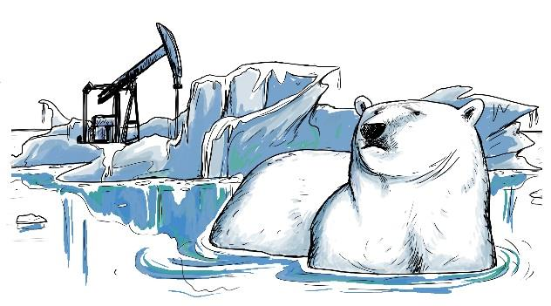

Arctic Offshore Drilling
Offshore oil and gas reserves, primarily along coastlines in Alaska, California, Louisiana, and Texas, account for a large proportion of the oil and gas supply in the United States. In August 2015, President Obama authorized Royal Dutch Shell to expand drilling off Alaska’s northwest coast. His decision brought into sharp relief the different, oftentimes competing views on the expansion of offshore drilling.
Many proponents of offshore drilling argue that tapping into the vast amount of oil and gas reserves in the Arctic will help shore up national security interests for the United States, bolster its economy and workforce, and offer Americans a reliable, safe supply of oil. According to Robert Bryce, senior fellow at the Manhattan Institute for Policy Research, there are “enormous amounts of recoverable energy resources in the Arctic. The Department of Energy estimates them at something on the order of 400 billion barrels of oil equivalent in natural gas and oil. That’s four times the crude oil reserves of Kuwait.” Framed this way, drilling in the Arctic presents a way for Americans to mitigate risks from dependence on foreign oil and build the local and national economies by creating jobs and supplying cheap oil.
A competing point of view charges that offshore oil drilling poses immense risk to the environment while reinforcing a reliance on dirty, environmentally unfriendly sources of energy. Critics claim that industrial activity associated with offshore drilling in the Arctic could harm native animals, including polar bears, walruses, seals, and whales already jeopardized by climate warming and declining levels of sea ice. Environmentalists argue that oil companies have not demonstrated the capability to clean up an oil spill in water obstructed by ice. Furthermore, they contend, extracting oil only perpetuates a fossil-fuel economy and will contribute dangerously to rising global temperature thereby exacerbating climate change.
“Granting Shell the permit to drill in the Arctic was the wrong decision, and this fight is far from over,” said Michael Brune, executive director of the Sierra Club. “The people will continue to call on President Obama to protect the Arctic and our environment.”
Discussion Questions:
1. Do you find one framing of the situation more compelling than the other? Why? In what ways do your own beliefs or opinions affect your perspective on this issue?
2. If you were in President Obama’s position, how might the different ways of framing this issue affect your decision-making process?
3. Is it possible to make an objective decision in the case of Arctic drilling? How might you come to a decision that is both reasonable and ethically defensible?
4. Can you think of other ethical dilemmas that are unexplored or absent in these dominant, competing frames of offshore drilling? How might these additional issues affect the decision to drill in the Arctic?
5. Do you think there are unintended or undesirable consequences of framing Arctic drilling as an “either-or” issue, i.e. as one that pits environmentalists against business leaders? Why or why not?
6. Can you think of an example of another contentious issue that has been framed in an “either-or” way? What would be an ethically ideal way to resolve this issue and why?
Resources:
Obama’s Alaska controversies: Denali, oil drilling, climate change http://www.mercurynews.com/nation-world/ci_28732579/obamas-alaska-controversies-denali-oil- drilling-climate-change
Does allowing Arctic offshore drilling undermine Obama’s climate efforts? http://www.pbs.org/newshour/bb/allowing-arctic-offshore-drilling-undermine-obamas-climate- efforts/
U.S. lets Shell drill for oil off Alaska http://www.usatoday.com/story/money/business/2015/08/17/shell-arctic-alaska/31890239/
Feds allow Shell to drill for oil in Arctic Ocean off Alaska http://www.seattletimes.com/seattle-news/environment/feds-allow-shell-to-drill-for-oil-in-arctic- ocean-off-alaska/

Banning Burkas: Freedom or Discrimination?

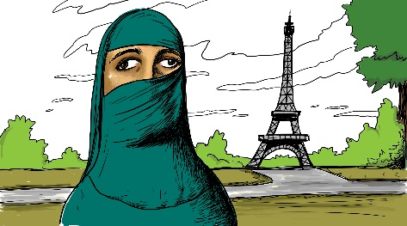

In September 2010, the French Parliament passed a bill prohibiting people from concealing their faces in public areas. While this law applied to all citizens and all forms of face covering, it became known as France’s “burka bill” because the rhetoric surrounding the bill targeted Muslim women who wore burkas—religious garments covering the face and body—in public.
French lawmakers argued that the law was important for the separation of church and state and for the emancipation of women. Similar to the 2004 bill that outlawed the use of conspicuous religious symbols in public schools, including Muslim headscarves and Christian crosses, this law sought to further remove religious expression and iconography from public spaces in France. Some legislators argued that the burka was a harmful symbol of gender inequality that forced women to assume a subservient status to men in public. According to them, the law freed women from a discriminatory, patriarchal subculture.
However, some in the French Muslim community saw the bill as an infringement of religious freedom and an act of cultural imperialism. They argued that French legislators were imposing their idea of gender equality onto their culture. Many of them, including some women, argued that wearing burkas actually emancipated women from the physical objectification so common in Western culture. A number of women protested the bill by dressing in burkas and going to the offices of lawmakers who supported the legislation. Other reports from individual women suggested that the law created a more hostile atmosphere for Islamic women in France. One of these women critiqued the bill, stating, “My quality of life has seriously deteriorated since the ban...the politicians claimed they were liberating us; what they've done is to exclude us from the social sphere.”
The law was challenged in 2014 and taken to the European Court of Human Rights. The court upheld the legality of the law.
Discussion Questions:
1. Lawmakers might argue that they were creating a more pluralistic society by banning all forms of religious expression in public places, whereas detractors might argue that the ban does just the opposite. Which side do you agree with, and why?
2. Should all religious practices be tolerated in a free society? Are there limits to what you think should be allowed? Explain your reasoning.
3. Do you think your home country should implement a ban on face coverings in public? Why or why not?
4. Should religious garments and iconography from all faith traditions be banned in public schools as occurred in France in 2004? Why or why not?
5. According to some accounts, the law inspired instances of people acting violently against women who continued to wear burkas. Do the principles of separation of church and state and the emancipation of women outweigh these consequences? Defend your position.
Resources:
France’s burqa ban: women are ‘effectively under house arrest’ http://www.theguardian.com/world/2011/sep/19/battle-for-the-burqa
France’s burka bill - background to a bitter debate http://www.english.rfi.fr/france/20100526-sarkozy-and-burka
France’s burka ban is a victory for tolerance http://www.telegraph.co.uk/news/worldnews/europe/france/8444177/BurkaFranceNational- FrontMarine-Le-PenMuslimFadela-AmaraAndre-Gerinhijab.html
French Senate votes to ban Islamic full veil in public http://www.bbc.com/news/world-europe-11305033
Pourquoi No Burqa? https://www.sandala.org/blog/pourquoi-no-burqa

“Blurred Lines” of Copyright

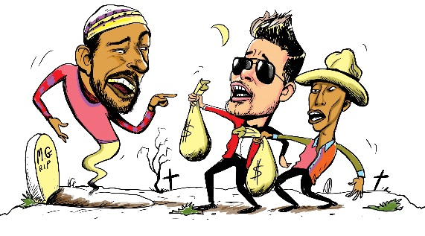
In 2013, Robin Thicke and Pharrell Williams co-produced the run-away hit single “Blurred Lines,” earning them over $16 million in sales and streaming revenues. The music video has been viewed hundreds of millions of times on YouTube and Vevo, and has been parodied numerous times as well. Despite its popularity, the similarity of “Blurred Lines” to Marvin Gaye’s 1977 hit song “Got to Give It Up” sparked controversy. The family of artist Marvin Gaye was outraged; they believed Gaye’s work was stolen. Thicke filed a preemptive lawsuit to prevent the Gaye family from claiming any share of royalties. However, Thicke also stated in public interviews that he was influenced by Marvin Gaye and, specifically, “Got to Give It Up” when he co-composed “Blurred Lines” with Williams.
In response, the Gaye family sued Williams and Thicke. Contradictions were apparent in Thicke’s account. In an interview with GQ, he stated that he co-wrote “Blurred Lines.” But in court he claimed that he was too high in the studio, and that Williams had in fact composed the song, and he had lied earlier in order to get credit. Williams claimed that, although Gaye’s music had influenced him in his youth, he did not copy Gaye’s song in his composition.
In March 2015, the jury ruled in favor of the Gaye estate, stating that while Williams and Thicke did not directly copy “Got to Give It Up,” there was enough of a similar “feel” to warrant copyright infringement. Gaye’s heirs were awarded $7.4 million in damages, the largest amount ever granted in a music copyright case.
While many commentators agreed with this verdict, others were concerned that it could negatively affect song writing within an entire genre. Musicologist Robert Fink, for example, stated that this verdict had the potential to set a precedent for“fencing off our shared heritage of sounds, grooves, vibes, tunes, and feels.” Musicians, artists, and writers often note that previous works influence them in their creative process, and that there is very little that is completely original. Thicke and Williams did not see the musical influence of Gaye as copyright infringement, but rather as inspiration that spurred them to create a new, original single.
Discussion Questions:
1. Do you think the Gaye family should own the rights to the “feel” of “Got to Give It Up” in addition to specific lyrics, melodies, harmony, etc.? Why or why not?
2. What distinctions can you identify among sampling, appropriating, and stealing components of a song?
3. This court case is one among many over the past decade that have placed limits on song- writing and musical composition. Do you think it is important to provide these legal protections for artists even if it means hindering artistic creativity and the new works that might come from musical influence? Explain your reasoning.
4. Should authors, musicians, and other artists acknowledge all of the influences on their work, regardless of the degree of influence? Why or why not?
5. If you purchase a song and then recognize that it is appropriating an earlier work, you are not legally obligated to stop listening, but are you obligated ethically? Explain your reasoning.
Resources:
Robin Thicke, Pharrell Williams and a Blurry Copyright Law? http://www.nytimes.com/roomfordebate/2015/03/17/robin-thicke-pharrell-williams-and-a-blurry- copyright-law
Blurred Lines' Verdict: How It Started, Why It Backfired on Robin Thicke and Why Songwriters Should Be Nervous http://www.billboard.com/articles/business/6502023/blurred-lines-verdict-how-it-started-why-it- backfired-on-robin-thicke-and
Blurred Lines, Ur-Lines and Color Lines http://musicologynow.ams-net.org/2015/03/blurred-lines-ur-lines-and-color-line.html
The Blurred Lines of Copyright Infringement Become Even Blurrier as the Robin Thicke v. Marvin Gaye’s Estate Lawsuit Continues http://www.mbhb.com/pubs/xpqPublicationDetail.aspx?xpST=PubDetail&pub=271

Cadavers in Car Safety Research

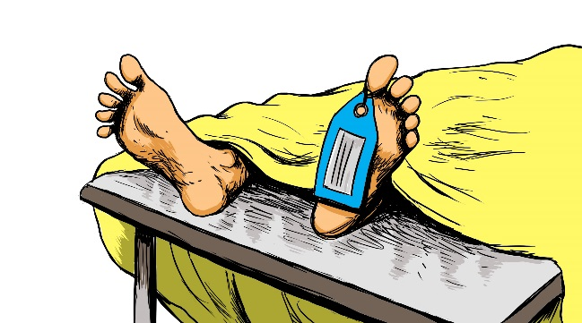

In 1993, it was widely disclosed that research engineers at Heidelberg University in Germany had used 200 adult and child cadavers in simulated car crash tests. The researchers argued that the use of human cadavers was necessary to study the actual effects of these crashes on the body. They insisted that the research would save lives because it would help engineers design safer cars.
There was significant public outcry against this practice from numerous groups. The ADAC, Germany’s largest automobile club, issued a statement challenging the research on ethical grounds: “In an age when experiments on animals are being put into question, such tests must be carried out on dummies and not on children’s cadavers.” Rudolph Hammerschmidt, spokesman for the Roman Catholic German Bishops’ Conference similarly decried the practice, arguing, “Even the dead possess human dignity...this research should be done with manikins.” Political leaders also weighed in on the debate. Klaus von Trotha, research minister of Baden-Wuerttemberg state, questioned the study: “Our constitution guarantees freedom in scientific research. But the constitution also guarantees the protection of human dignity.”
The university defended its research by pointing to the results. Dr. Rainer Mattern, the head of Heidelberg University’s forensic pathology department, responded to public reaction against the use of child cadavers, arguing, “The tests have saved lives of other children.”
When it was revealed that similar tests were being conducted in the United States at Wayne State University, some U.S. officials offered their support. George Parker, the associate administrator for research at the National Highway Traffic Safety Administration argued, “We need that type of data to find out how people are injured in crashes to know what areas of the body are injured under what conditions.” He added that human subjects were necessary to determine the validity of the data gathered from crash test dummies: “If you didn’t do this testing, you wouldn’t know what limits to put on dummies for crash tests.”
For many, the debate ultimately hinged on whether the research yielded information not attainable from crash dummies and whether or not the families gave their consent to the use of the cadavers.
Discussion Questions:
1. According to those opposing the research, what harm is done by conducting crash tests with cadavers? According to researchers, what is the harm done by not doing the research? 2. Who are the moral agents involved in this case? Who are the subjects of moral worth? Explain your reasoning. 3. Do you think the idea of human dignity applies equally to the living and the dead? Why or why not? 4. To what degree should family members have full capacity to make decisions or give consent on behalf of their deceased relatives? To what degree should other considerations, such as communal values or legal restrictions, be taken into account?
5. How does research using cadavers compare to organ donation? Do you think one is more ethically permissible than the other? Explain your reasoning.
6. How does animal testing compare to this case?
Resources:
German University Said to Use Corpses in Auto Crash Tests
http://www.nytimes.com/1993/11/24/world/german-university-said-to-use-corpses-in-auto-crash- tests.html
German University Must Prove Families OK’d Tests on Cadavers http://www.deseretnews.com/article/322514/GERMAN-UNIVERSITY-MUST-PROVE-FAMILIES-OKD- TESTS-ON-CADAVERS.html?pg=all
Auto Safety Crash Testing Ignites Furor: Germany: The program uses human bodies. U.S. tests using cadavers at 3 universities are disclosed. http://articles.latimes.com/1993-11-25/news/mn-60691_1_safety-tests
University Promises to Prove it Had Relatives’ OK to Use Bodies http://www.apnewsarchive.com/1993/University-Promises-To-Prove-It-Had-Relatives-OK-To-Use- Bodies/id-fe2ecda0c83ffada0d56c232b3a9433b

Apple Suppliers & Labor Practices
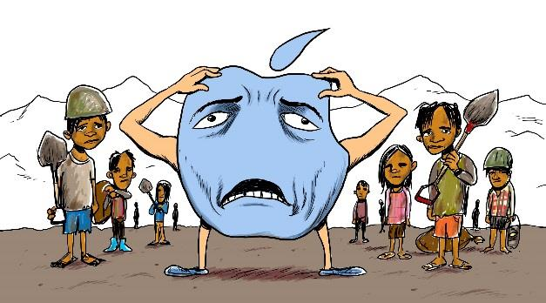

With its highly coveted line of consumer electronics, Apple has a cult following among loyal consumers. During the 2014 holiday season, 74.5 million iPhones were sold. Demand like this meant that Apple was in line to make over $52 billion in profits in 2015, the largest annual profit ever generated from a company’s operations. Despite its consistent financial performance year over year, Apple’s robust profit margin hides a more complicated set of business ethics. Similar to many products sold in the U.S., Apple does not manufacture most its goods domestically. Most of the component sourcing and factory production is done overseas in conditions that critics have argued are dangerous to workers and harmful to the environment.
For example, tin is a major component in Apple’s products and much of it is sourced in Indonesia. Although there are mines that source tin ethically, there are also many that do not. One study found workers—many of them children—working in unsafe conditions, digging tin out by hand in mines prone to landslides that could bury workers alive. About 70% of the tin used in electronic devices such as smartphones and tablets comes from these more dangerous, small-scale mines. An investigation by the BBC revealed how perilous these working conditions can be. In interviews with miners, a 12-year- old working at the bottom of a 70-foot cliff of sand said: “I worry about landslides. The earth slipping from up there to the bottom. It could happen.”
Apple defends its practices by saying it only has so much control over monitoring and regulating its component sources. The company justifies its sourcing practices by saying that it is a complex process, with tens of thousands of miners selling tin, many of them through middle-men. In a statement to the BBC, Apple said “the simplest course of action would be for Apple to unilaterally refuse any tin from Indonesian mines. That would be easy for us to do and would certainly shield us from criticism. But that would also be the lazy and cowardly path, since it would do nothing to improve the situation. We have chosen to stay engaged and attempt to drive changes on the ground.”
In an effort for greater transparency, Apple has released annual reports detailing their work with suppliers and labor practices. While more recent investigations have shown some improvements to suppliers’ working conditions, Apple continues to face criticism as consumer demand for iPhones and other products continues to grow.
Discussion Questions:
1. Do you think Apple should be responsible for ethical lapses made by individuals further down its supply chain? Why or why not?
2. Should Apple continue to work with the suppliers in an effort to change practices, or should they stop working with every supplier, even the conscientious ones, to make sure no “bad apples” are getting through? Explain your reasoning.
3. Do you think consumers should be expected to take into account the ethical track record of companies when making purchases? Why or why not?
4. Can you think of other products or brands that rely on ethically questionable business practices? Do you think consumers are turned off by their track record or are they largely indifferent to it? Explain.
5. Would knowing that a product was produced under ethically questionable conditions affect your decision to purchase it? Explain with examples.
6. If you were part of a third-party regulating body, how would you deal with ethically questionable business practices of multinational corporations like Apple? Would you feel obligated to do something, or do you think the solution rests with the companies themselves? Explain your reasoning.
Resources:
Apple ‘failing to protect Chinese factory workers’ http://www.bbc.com/news/business-30532463
How Apple could make a $53 billion profit this year http://money.cnn.com/2015/07/17/technology/apple-earnings-2015/
Global Apple iPhone sales from 3rd quarter 2007 to 2nd quarter 2016 (in million units) http://www.statista.com/statistics/263401/global-apple-iphone-sales-since-3rd-quarter-2007/
Despite successes, labor violations still haunt Apple http://www.theverge.com/2015/2/12/8024895/apple-slave-labor-working-conditions-2015
Reports – Supplier Responsibility – Apple https://www.apple.com/supplier-responsibility/progress-report/

Apple - Ethical Fading
Ethical fading occurs when we are so focused on other aspects of a decision that its ethical dimensions fade from view.

Offshore drilling - Framing
Framing describes how our responses to situations, including our ethical judgments, are impacted just by how those situations are posed or viewed.

Banning the Burkha -All is Not Relative
Relativism is the belief that a harmful act is ‘right’ if the perpetrator claims it is ‘right,’ but what is right and what is wrong is not always relative.

Pharell and Blurred Lines - Appropriation & Attribution
Attribution is giving credit where credit is due. Appropriation is the complex borrowing of ideas, images, symbols, sounds, and identity from others.

